**Result:**

*Admissions:*

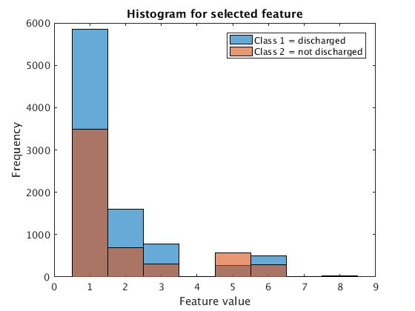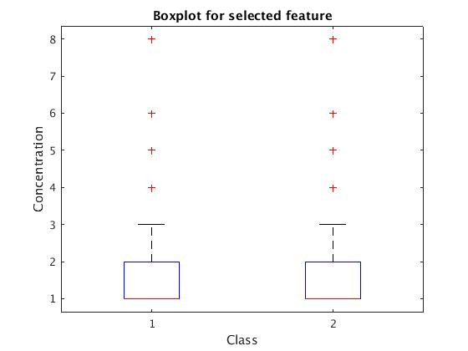

Figure 1,2: Histogram and Box Plot for Admissions Type; 1 = Emergency, 2 = Urgent, 3 = Elective, 4 = Newborn, 5 = Not Available, 6: NULL, 7 = Trauma Center, 8 = Not Mapped

*Age:*

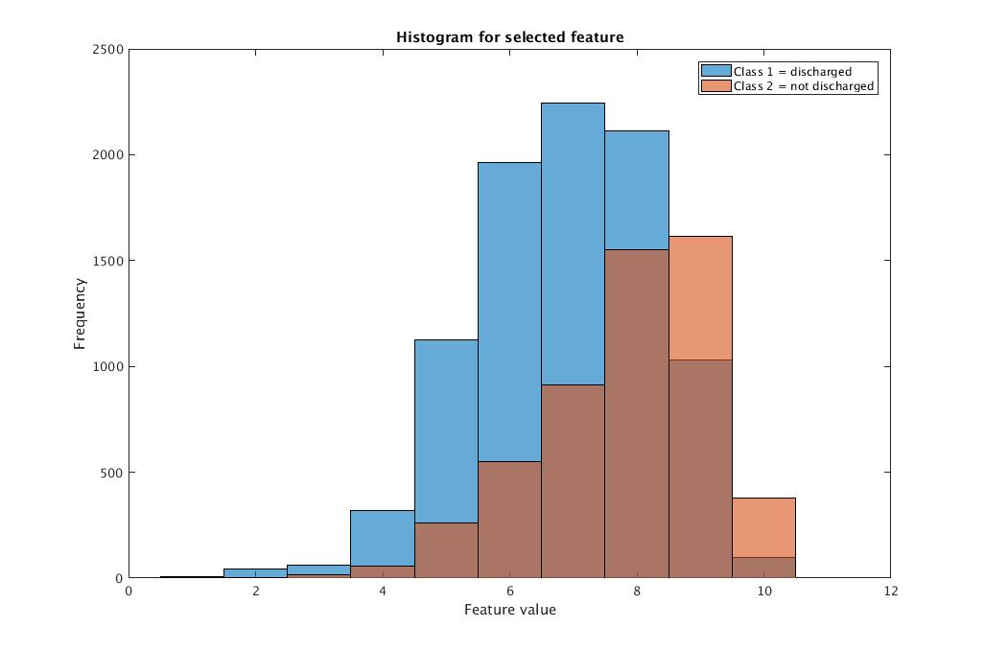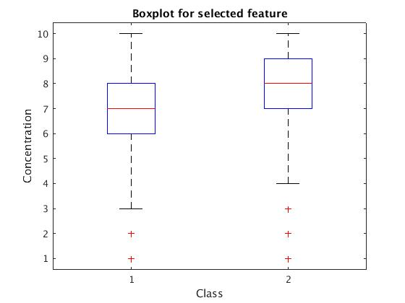

Figure 3,4: Histogram and Box Plot for Age; 1 = (0-10), 2 = (10-20), 3 = (20-30), 4 = (30-40), 5 = (40-50), 6 = (50-60), 7 = (60-70), 8 = (70-80), 9 = (80-90), 10 = (90-100)

*Gender:*

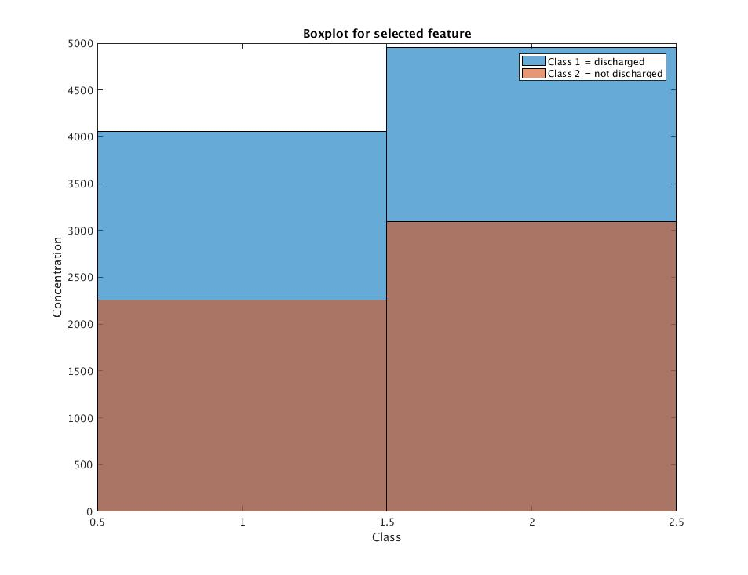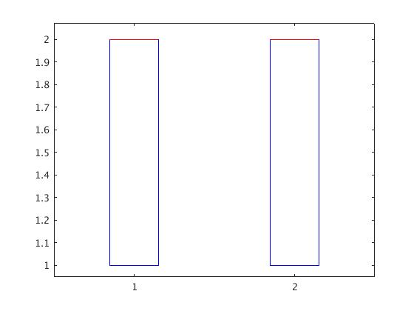

Figure 5,6: Histogram and Box Plot for Gender; Male = 1, Female = 2

*Medication:*

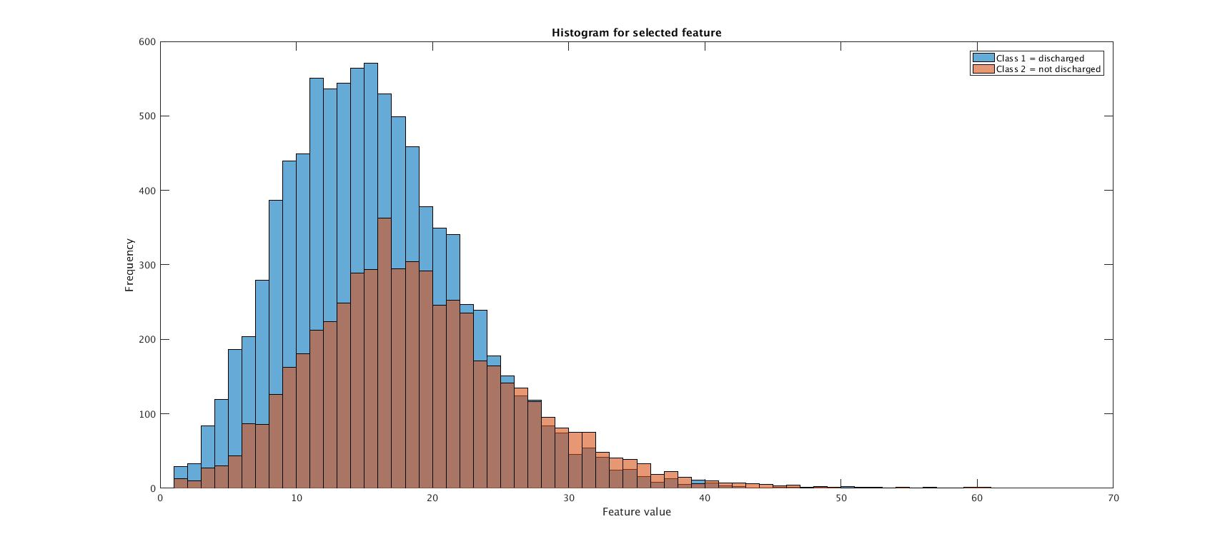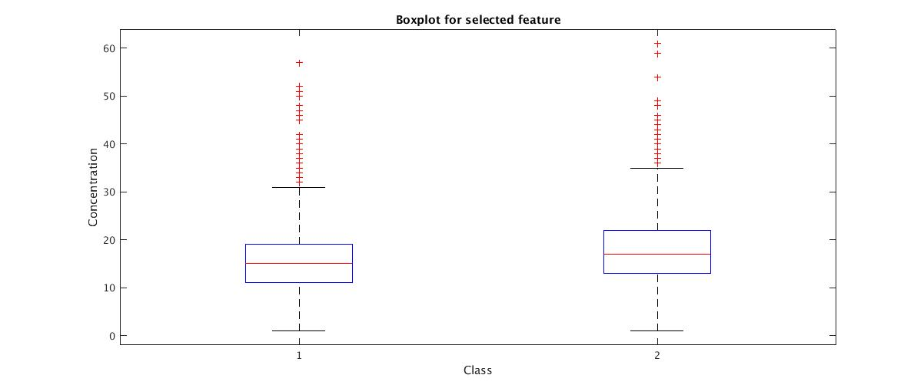

Figure 7,8: Histogram and Box Plot for Medication

*Procedure:*

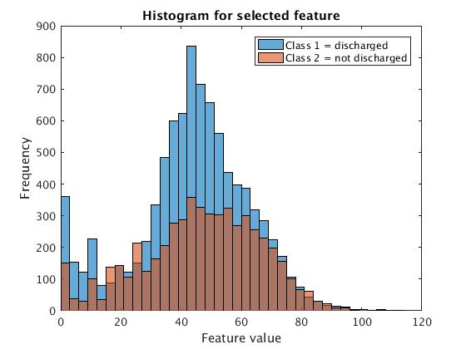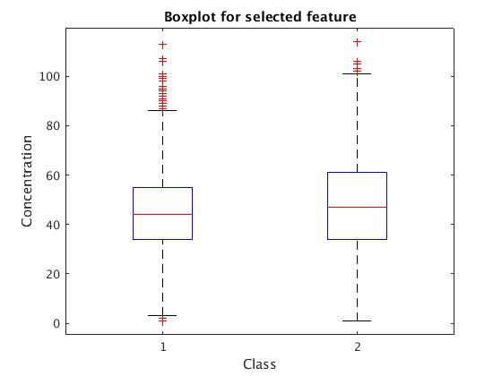

Figure 9,10: Histogram and Box Plot for Procedure

*Readmission:*

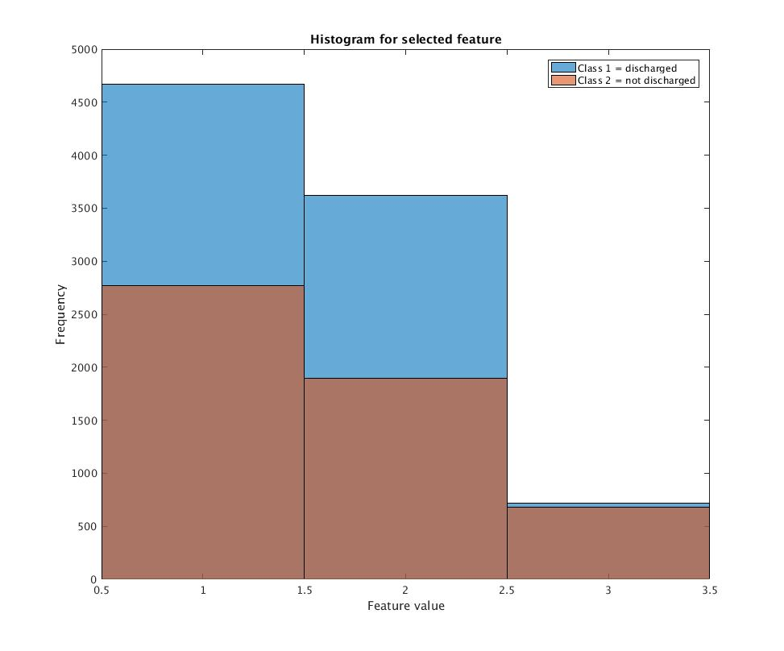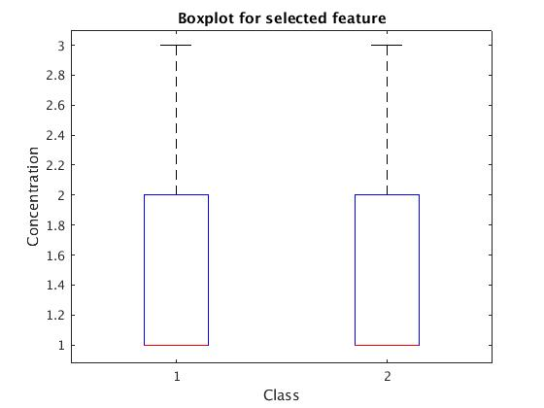

Figure 11,12: Histogram and Box Plot for Readmission; 1 = NO, 2 = >30, 3 = <30

*A1CResult:*

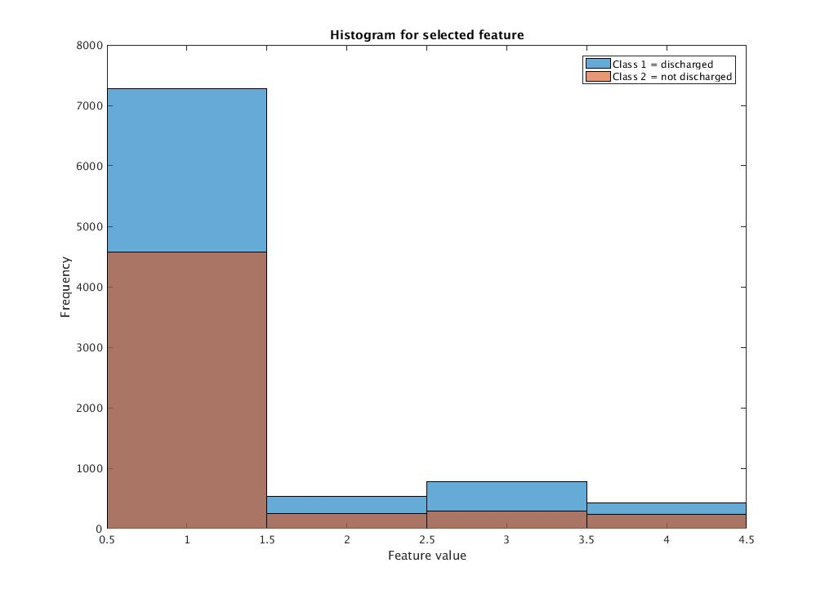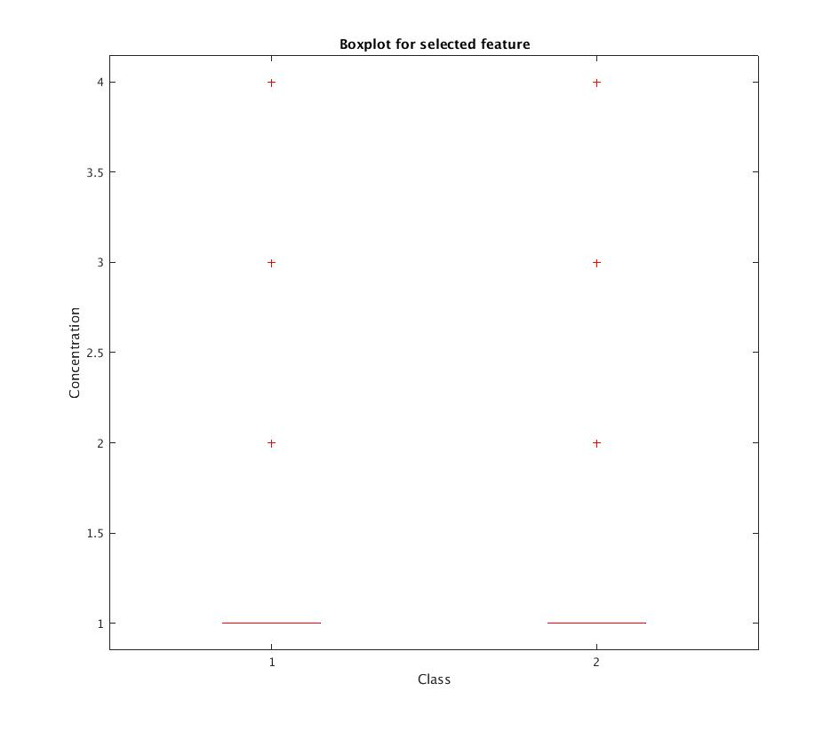

Figure 12,13: Histogram and Box Plot for Result: 1 = None, 2 = Norm, 3 = >8, 4 = >7

*Time:*

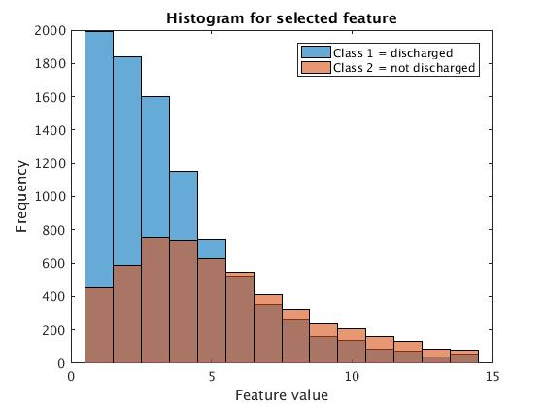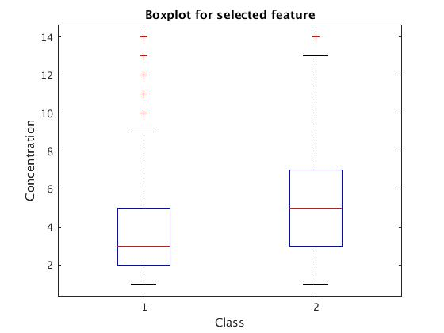

Figure 14,15: Histogram and Box Plot for Time

Discussion: