Working flow:

- Landing page: Newsstand with blank articles (empty database table)
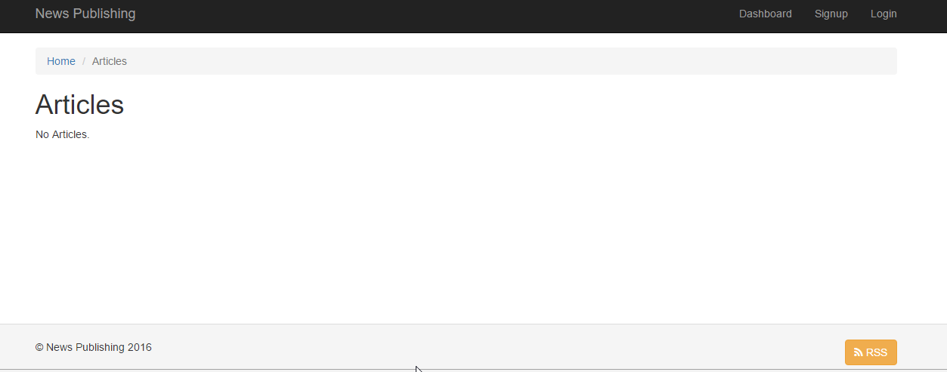

- Click on Signup link to create a user:
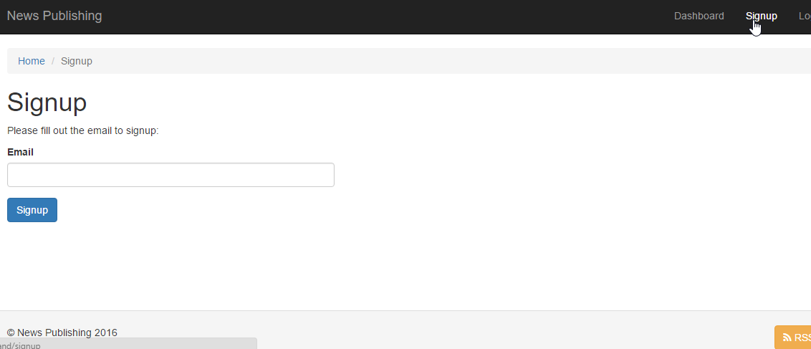
- The confirmation link will be sent in email id provided:

- After click confirmation link user will be login and change password page will open.
- My Article link will appear on header. Where registered user can go and create, view or delete articles.
- The active articles that are not deleted, will be shown on newsstand home page in descending order top 10.
- On click of any article detail view page will appear, where user can export pdf.
- In the footer there is a RSS link, which can be used to subscribed for rss feed.

Layer and component interaction:

Components
Components are initialized at beginning of application and can be accessed all over the application.
These are placed inside <root>\common\components folder.
yiii\base\Component
BasicUtils
BasicUtils Component contains functions, which will be used all over the application.

Modules
All modules are placed inside <root>/backend/modules/ folder.
Modules folder structure:
<Module Name>/
<Module Name>/<Module Name>.php
<Module Name>/controllers/<Controller Name>Controller.php
<Module Name>/models/<Model Name>.php
<Module Name>/view/<Controller Name>/<view file name>.php
Where controllers contains all business logic. Models are having relation with tables when it extends from activerecords in yii2. I have created 1 more layer before using in model NewsActiveRecords. And view files are for frontend representation.

Common library and inherited classes
Common libraries, components and classes that are inherited from framework are stored inside:
common/newslibrary/NewsController

Layout Files:
Main layout wrapper file for view is <root>/backend/views/layouts/main.php.

Mail templates:
Mail templates are inside <root>/common/mail folder.

Configuration:
Configurations are placed inside <root>/common/config/ and <root>/backend/config/ folder.
- Main-local.php, contains db connection information, and phpmailer settings.
- Params.php, contains static parameters used everywhere in application.
- main.php, contains configuration of modules, components, url routing structure etc.

Controller Inheritance
\yii\web\Controller
common\components\newslibrary\NewsController
backend\modules\<ModuleName>\controllers\<ControllerName> Controller

Model Inheritance
\yii\db\ActiveRecord
common\components\ newslibrary \ NewsActiveRecords
backend\modules\<ModuleName>\models\<ModelName>

Assets Inheritance
yii\web\AssetBundle
<root>/backend/assets/AppAsset

Css folder | Js foder | Images folder
<root>/css | <root>/js | <root>/images

