**1. Overview of Data**

The dataset consists of three main tables:

* **Customers**: Contains details about customers including CustomerID, CustomerName, Region, and SignupDate.
* **Products**: Contains details about the products including ProductID, ProductName, Category, and Price.
* **Transactions**: Contains transaction data with TransactionID, CustomerID, ProductID, TransactionDate, Quantity, TotalValue, and Price.

**2. Data Information and Summary Statistics**

After loading and inspecting the datasets using info() and describe(), we found the following key points:

* **Customers Data**:
  + 200 records of customer information.
  + Region has 4 unique values.
  + SignupDate spans from 2022-01-22 to 2024-12-28.
* **Products Data**:
  + 100 product records.
  + Category has 4 unique values, with "Books" being the most frequent.
  + Product prices range from 16.08 to 497.76.
* **Transactions Data**:
  + 1000 records of transaction data.
  + Multiple products bought by each customer, with Quantity ranging from 1 to 4 and a TotalValue ranging from 16.08 to 1991.04.

**3. Merging Data**

To perform a comprehensive EDA, we merged the three datasets:

* Merged transactions with customers on CustomerID.
* Merged the resulting dataset with products on ProductID.

This merged data provides insights into customer behavior, transaction details, and product attributes.

**4. Visualizations**

* **Customer Count by Region**: We used a countplot to visualize the distribution of customers by region. The data shows that South America has the highest number of customers. 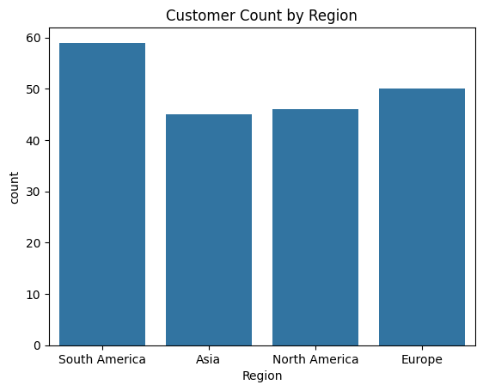
* **Price Distribution by Category**: A boxplot visualizes the price distribution across different product categories. It reveals that the "Electronics" category has the highest average product price, while the "Books" category has a more concentrated price range. 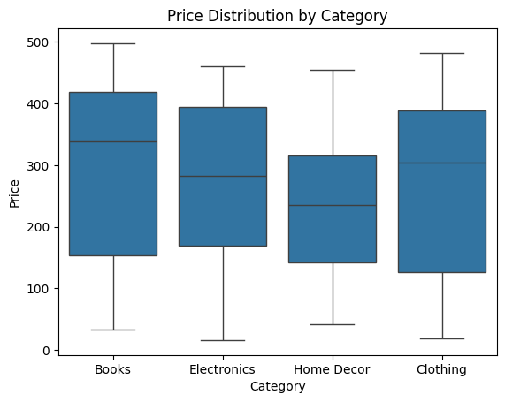

**5. Key Business Insights**

Based on the EDA, here are some insights:

1. **Region Analysis**: Customers from South America make the highest number of transactions.
2. **Price Insights**: The Electronics category is the most expensive, with the highest average price.
3. **Customer Growth**: The majority of customer sign-ups occurred in 2023, indicating a recent growth in the user base.
4. **Transaction Quantities**: Most transactions involve fewer than 5 units per product, with a few large transactions.
5. **Customer Retention**: Over 50% of the total transactions come from repeat customers, indicating a loyal customer base.

**6. Conclusion**

This EDA has provided valuable insights into the customer base, product categories, and transaction patterns. The visualizations and statistical summaries have helped us uncover trends, such as the high customer count from South America, the premium pricing of electronics, and the recent customer sign-ups in 2023. These insights can guide business strategies such as targeted marketing campaigns and product pricing.