A

PROJECT REPORT

ON

**EQUITY ANALYSIS OF COMPANIES IN IT INDUSTRY**

at

**Religare Broking Ltd.**

IN FULFILLMENT OF TWO YEARS FULL TIME

MASTER OF BUSINESS ADMINISTRATION (MBA)

SUBMITTED TO

Department of Management

Khandesh College Education Society's

**INSTITUTE OF MANAGEMENT & RESEARCH, JALGAON**

SUBMITTED BY

**NEHA KANTILAL CHAVAN**

MBA (FINANCE)

(Exam Seat No- 838228)

Under the Guidance of

**Mrs. Jayashree Chaudhari**



**KBC NORTH MAHARASHTRA UNIVERSITY, JALGAON (MS) INDIA**

(2023-24)

**DECLARATION**

I **Neha Kantilal Chavan** a student of KCES’s Institute of Management and Research, Jalgaon pursuing a Master of Business Administration (MBA), hereby declare that the Summer Internship Project report entitled **Equity Analysis of Companies in IT Industry** at Religare Broking Ltd., is an authentic work carried out by me under the guidance and supervision of **Mrs.** **Jayashree Chaudhari,** during the period 17th Aug. 2023 to 17th Oct. 2023.

I further declare that this project report is based on my original work and has not been submitted, either in part or full, for the award of any other degree or diploma in this institution or elsewhere.

Date:-

Place: Jalgaon

Neha Kantilal Chavan

(Exam Seat No.-838228)

KCES’s IMR, Jalgaon

**Acknowledgment**

I express my sincere gratitude and appreciation to all those who have contributed to the successful completion of my Summer Internship Project, entitled **"Equity Analysis of Companies in IT Industry,"** undertaken during the [2023-24] as part of my Masters of Business Administration (MBA) program at KCES’s Institute of Management and Research, Jalgaon.

I would like to extend my heartfelt thanks to **Mrs. Jayashree Chaudhari**, my project guide, for her valuable guidance, mentorship, and unwavering support throughout the duration of the internship. Her insights, constructive feedback, and encouragement significantly enriched my learning experience and helped shape the quality of this project.

I would also like to express gratitude to Dr. Parag Narkhede, MBA Coordinator, and Prof. Mamata Dahad, Head of Management Department and Prof. Dr. B.V. Pawar, Director for the encouragement and support provided throughout the internship period.

I am also thankful to **Mr. Sandip Shisode Sir** of Religare Broking Ltd., for providing me with the necessary resources, exposure, and a conducive environment to carry out my internship. His willingness to share knowledge and expertise has been instrumental in enhancing my understanding of the practical aspects of business administration.

I appreciate the cooperation and assistance received from all those who directly or indirectly contributed to the successful completion of this project. Their support has been invaluable in shaping my professional growth and enhancing my practical skills.

Lastly, I would like to express my heartfelt thanks to my family and friends for their continuous support, encouragement, and understanding throughout this internship journey.

Date:-

Place: Jalgaon

Neha Kantilal Chavan

(Exam Seat No.-838228)



**TABLE OF CONTENT**

|  |  |  |
| --- | --- | --- |
| CHAPTER | TOPIC NAME | PAGE NO. |
| 1. | Introduction | 6 |
| 2. | Company Profile | 18 |
| 3. | Research Methodology | 27 |
| 4. | Literature Review | 30 |
| 5. | Data Analysis & Interpretation | 31 |
| 6. | Findings | 54 |
| 7. | Suggestions | 55 |
| 8. | Conclusion | 57 |
| 9. | Bibliography | 58 |

**Chapter 1.: - INTRODUCTION**

India is a developing country. Nowadays many people are interested to invest in financial markets, especially on equities to get high returns, and to save tax in an honest way. Equities are playing a major role in the contribution of capital to the business from the beginning. Since the introduction of the shares concept, a large number of investors are showing interest in investing in the stock market.

In an industry plagued with scepticism and a stock market increasingly difficult to predict and contend with, if one looks hard enough there may still be a genuine aid for the day trader and short-term investor.

The price of security represents a consensus. It is the price at which one person agrees to buy and another agrees to sell. The price at which an investor is willing to buy or sell depends primarily on his expectations. If he expects the security's price to rise, he will buy it; if the investor expects the price to fall, he will sell it. These simple statements are the cause of a major challenge in forecasting security prices, because they refer to human expectations.

**Investor v/s Trader:** People can make money in equity market by investing or trading or both. However, to avoid the disappointment of losing money, customers should make very prudent and informed decisions.

"Investors" put their money into stocks for a long term. This is under the principle that over time, the underlying investment will increase in value, and the investment will be profitable. On the other hand, "Traders" take a proactive approach to their investing. They follow or predict a trend in the stock and use strategies like buy-low, sell-high and make profits.

Though there is really no right or wrong type of stock trading, it is necessary for investors to identify which type of trading is right for them. They can make a great amount of money either way, however, they must consider their time frame, risk, and how much work you want to put into it.

While traders can make more money much faster, they are required to do more work and monitoring than the typical investor. Determine what type of trader you want to be, and then make sure that the people you take guidance from have the same goals as you.

* **Top players in Indian IT sector:**

|  |  |  |
| --- | --- | --- |
| **Name** | **Market Cap (Rs Lakh**  **Crore)** | **Employee Headcount**  **(Approx.)** |
| Tata Consultancy  Service | 13.06 | 6,00,000 |
| Infosys | 6.12 | 3,36,294 |
| HCL Technologies | 3.43 | 2,25,944 |
| Wipro Limited | 2.16 | 2,45,000 |
| LTIMindtree Ltd. | 1.59 | 82,000 |
| Tech Mahindra  Ltd. | 1.26 | 1,52,400 |
| MphasiS Ltd. | 0.468 | 29,473 |
| Persistent | 0.453 | 22,500 |
| Oracle Fin Serve | 0.358 | 8,001 |
| Coforge Limited (New) | 0.323 | 21,815 |

**Definition of ‘Equity Market’:**

The market in which shares are issued and traded, either through exchanges or over-the-counter markets also known as the stock market, it is one of the most vital areas of a market economy because it gives companies access to capital and investors a slice of ownership in a company with the potential to realize gains based on its future performance.

* **Indian IT sector:**

The information technology sector can broadly be classified into: -

1.**IT- Software**- These companies help in the development and implementation of different software for their clients worldwide. This software could be for documentation, security services, banking software’s etc.

2. **ITeS Business Process Outsourcing (BPO)** – Major Corporations across the world outsources their back-office operations to some companies. E.g. Employee payroll for a US company’s global workforce is maintained by an Indian BPO. Slowly the definition is expanding to Human resources, accounting, logistics, legal processes etc.

3. **IT- Hardware and peripherals** - The stuff which can be actually seen and touched, and would likely break if we threw it out, is hardware. This would include laptops, desktops, Storage devices, Networking devices, LCD, printers etc.

4. **IT- Education** - This segment provides training for employment in the other segments. This would include companies providing various certification courses, like Java, Oracle etc. These companies also provide training for employees in the corporate sector. Recently, some companies have also expanded this service to cater to schools and colleges.

In the last few years Indian IT industry has seen tremendous growth. Destinations such as Bangalore, Hyderabad and Gurgaon have evolved into global IT hubs. Several IT parks have come up at Bangalore, Hyderabad, Chennai, Pune, Gurgaon etc. These parks offer Silicon Valley type infrastructure. In the light of all the factors that have added to the strength of Indian IT industry, it seems that Indian success story is all set to continue.

**CONTRIBUTION OF INFORMATION TECHNOLOGY IN INDIAN ECONOMY:** The growth in the service sector in India has been led by the IT–ITES sector, contributing substantially to increase in GDP, employment, and exports.

The sector has increased its contribution to India's GDP from 1.2% in FY1998 to 7.5% in FY2023.

The contribution of India's IT industry to economic progress has been quite significant. The rapidly expanding socio-economic infrastructure has proved to be of great use in supporting the growth of Indian information technology industry.

The flourishing Indian economy has helped the IT sector to maintain its competitiveness in the global market. Revenue in the IT Services market is projected to reach US $26.45bn in 2024. IT Outsourcing dominates the market with a projected market volume of US$10.51bn in 2024. Revenue is expected to show an annual growth rate (CAGR 2024-2028) of 12.98%, resulting in a market volume of US$43.09bn by 2028.

The growth and prosperity of India's IT industry depends on some crucial factors. These factors are as follows:

I. India is home to a large number of IT professionals, who have the necessary skill and expertise to meet the demands and expectations of the global IT industry.

1. The cost of skilled Indian workforce is reasonably low compared to the developed nations. This makes the Indian IT services highly cost efficient, and this is also the reason as to why the IT enabled services like business process outsourcing and knowledge process outsourcing have expanded significantly in the Indian job market.

1. India has a huge pool of English-speaking IT professionals. This is why the English- speaking countries like the US and the UK depend on the Indian IT industry for outsourcing their business processes.

The emergence of Indian information technology sector has brought about sea changes in the Indian job market. The IT sector of India offers a host of opportunities of employment. With IT biggies like Infosys, Cognizant, Wipro, Tata Consultancy Services, Accenture and several other IT firms operating in some of the major Indian cities, there is no scarcity of job opportunities for the Indian software professionals. The IT enabled sector of India absorbs a large number of graduates from general stream in the BPO and KPO firms. All these have solved the unemployment problem of India to a great extent.

**Future of Information Technology**:

IT will continue to gain momentum; telecom and wireless will follow the trend. The immense expansion in networking technologies is expected to continue into the next decade also. IT will bring about a drastic improvement in the quality of life as it impacts application domains and global competitiveness. Technologies that are emerging are Data Warehousing, Data Mining and AI. They involve collecting data to find patterns and testing hypothesis in normal research. Software services that are being used in outsourcing will go a long way.

**Meaning of Equity**: Equity is the ownership interest of investors in a business firm. Investors can own equity shares in a firm in the form of common stock. Equity ownership in the firm means that the original business owner no longer owns 100% of the firm but shares ownership with others. On a company’s balance sheet, equity is represented by the common stock and paid-in capital.

**Equity analysis**: Equity analysis is researching and analyzing equities, or stocks. These stocks trade on various stock markets such as the BSE, NSE, New York Stock Exchange, NASDAQ, AMEX or foreign stock markets.

Equity analysts are usually employed by financial firms that have equity research departments made up of numerous analysts, each of which focuses on being an "expert" in a particular industry. There are numerous industries within the 10 sectors. Those 10 sectors are the consumer discretionary, consumer staples, energy, industrials, financials, healthcare, materials, information technology, and telecommunications and utilities sectors.

On a daily basis, equity research analysis closely "follow", or monitors a number of stocks. For example, a PC hardware equity research analyst would probably spend a great deal of time monitoring the business of Dell Computer and any news that may affect dell.

**Investors purchase equity shares with two basic objectives:**

1. To make capital profits by selling shares at higher prices.

2. To earn dividend income.

These two factors are affected by lots of factors. An investor has to carefully understand and analyse all these factors. There are basically two approaches to study security prices and valuation i.e. fundamental analysis and technical analysis.

The value of common stock is determined in large measure by the performance of the firm that issued the stock. If the company is healthy and can demonstrate strength and growth, the value of the stock will increase. When values increase then prices follow and returns on an investment will increase. However, just to keep the savvy investor on their toes, the mix is complicated by the risk factors involved. Fundamental analysis examines all the dimensions of risk exposure and the probabilities of return and merges them with broader economic analysis and greater industry analysis to formulate the valuation of a stock.

**Valuation of Equity**:

The methods used to analyse securities and market investment decision falls into two very broad categories:

* Technical Analysis
* Fundamental Analysis

**MEANING OF TECHNICAL ANALYSIS**: A method of evaluating securities by analyzing statistics generated by market activity, such as past prices and volume. Technical analysts do not attempt to measure a security's intrinsic value, but instead use charts and other tools to identify patterns that can suggest future activity.

A Technical analyst believes that share prices are determined by the demand and supply forces operating in the market. These demand and supply forces in turn are influenced by a number of fundamental factors as well as certain psychological or emotional factors. Many of these factors cannot be quantified. The combined impact of all these factors is reflected in the share price movement. A technical analyst therefore concentrates on the movement of share prices. He claims that by examining past share price movements future share prices can be accurately predicted. Technical analysis is the name given to forecasting techniques that utilize historical share price data.

The rationale behind technical analysis is that share price behavior repeats itself over time and analysts attempt to derive methods to predict this repetition. A technical analyst looks at the past share price data to see if he can establish any patterns. He then looks at current price data to see if any of the established patterns are applicable and, if so, extrapolations can be made to predict future price movements. Although past share prices are the major data used by technical analysts, other statistics such as volume of trading and stock market indices are also utilized to some extent.

The basic premise of technical analysis is that prices move in trends or waves which may be upward or downward. It is believed that the present trends are influenced by the past trends and that the projection of future trends is possible by an analysis of past price trends. A technical analyst, therefore, analyses the price and volume movements of individual's securities as well as the market index. Thus, technical analysis is really a study of past or historical price and volume movements so as to predict the future stock price behavior.

• **MEANING OF FUNDAMENTAL ANALYSIS:**

Fundamental analysis is a method of forecasting the future price movements of a financial instrument based on economic, political, environmental and other relevant factors and statistics that will affect the basic supply and demand of whatever underlies the financial instrument. Fundamental analysis is the cornerstone of investing. The basic philosophy underlying the fundamental analysis is that if an investor invests re.1 in buying a share of a company, how much expected returns from this investment he has. It insists that no one should purchase or sell a share on the basis of tips and rumours. The fundamental approach calls upon the investors to make their buy or sell decision on the basis of a detailed analysis of the information about the company, about the industry, and the economy. Fundamental analysis is really a logical and systematic approach to estimating the future dividends and share price. It is based on the basic premise that share prices are determined by a number of fundamental factors relating to the economy, industry and company. Hence, the economy fundamentals, industry fundamentals and company fundamentals have to be considered while analyzing a security for investment purpose.

Fundamental analysis is, in other words, a detailed analysis of the fundamental factors affecting the performance of companies. Each share is assumed to have an economic worth based on its present and future earning capacity. This is called its intrinsic value or fundamental value. The purpose of fundamental analysis is to evaluate the present and future earning capacity of a share based on the economy, industry and company fundamentals and thereby assess the intrinsic value of the share. The investor can then compare the intrinsic value of the share with the prevailing market price to arrive at an investment decision. If the market price of the share is lower than its intrinsic value, the investor would decide to buy the share as it is under-priced. The price of such a share is expected to move up in future to match its intrinsic value.

**Fundamental analysis thus involves three steps: -**

1. Economy Analysis.

2.Industry Analysis.

3.Company Analysis.

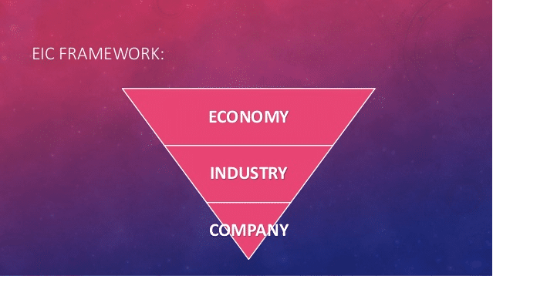

**ECONOMY ANALYSIS**: The performance of a company depends on the performance of the economy. If the economy is booming, income rise, demand for goods increases, and hence the industries and companies in general trend to be prosperous. On the other hand, if the economy is in recession, the performance of companies will be generally bad. Investors are concerned with those variables in the economy which affect the performance of the company in which they intend to invest. A study of these economic variables would give an idea about future corporate earnings and the payment of dividends and interest to investors.

Here are some of the key economic variables that an investor must monitor as part of his fundamental analysis:

1. Growth Rates of National Income
2. Inflation
3. Interest Rates
4. Exchange rates
5. Infrastructure
6. Economic and Political Stability

**INDUSTRY ANALYSIS**:

An industry is a group of firms that have similar technological structure of production and produce similar products and Industry analysis is a type of business research that focuses on the status of an industry or an industrial sector (a broad industry classification, like "manufacturing"). Irrespective of specific economic situations, some industries might be expected to perform better, and share prices in these industries may not decline as much as in other industries. This identification of economic and industry specific factors influencing share prices will help investors to identify the shares that fit individual expectations.

**COMPANY ANALYSIS:**

Company analysis is the final stage of fundamental analysis. The economy analysis provides the investor with a broad outline of the prospects of growth in the economy.

Industry analysis helps the investor to select the industry in which investment would be rewarding. Now he has to decide on the company in which he should invest his money. Company analysis provides the answer to this question.

Company analysis deals with the estimation of return and risk of individual shares. This calls for information. Many pieces of information influence investment decisions. Information regarding companies can be broadly classified into two broad groups: internal and external. Internal information consists of data and events made public by companies concerning their operations. The internal information sources include annual reports to shareholders, public and private statements of officers of the company, the company's financial statements, etc. External sources of information are those generated independently outside the company. These are prepared by investment services and the financial press. In company analysis, the analyst tries to forecast the future earnings of the company because there is strong evidence that earnings have a direct and powerful effect upon share prices. The level, trend and stability of earnings of a company, however, depend upon a number of factors concerning the operations of the company.

i. Financial Statements

ii.Analysis of Financial Statements

iii. Leverage ratios and Profitability Ratios

iv. Assessment of Risk

**Chapter 2: - COMPANY PROFILE**



**Religare Broking Limited (RBL)** is a wholly owned subsidiary of Religare Enterprises Limited (REL) and is one of the market leading securities firms in India serving over 10 lakh clients across both Offline and Online platforms. Through its extensive footprint extending to over 400 cities, the company offers broking services in Equity, Currency and Commodity (through its subsidiary Religare Commodities Limited) as well as depository participant services.

RBL is a member of the NSE, BSE, and MSEI and a depository participant with NSDL and CDSL. RBL also offers TIN facilitation & PAN facility at select branches - a unique service to help an individual with PAN, TAN and TDS/TCS returns related requirements. In addition, RBL is an NSDL-appointed enrolment agency for Aadhaar UID (Unique Identification Number) and an AMFI-registered mutual fund distributor.

The platform has been endorsed by various awards. The Head of Retail Distribution of RBL was conferred with the ‘Top Equity Personality of the Year’ award at The BSE Commodity Equity Outlook (CEO) Weekend Awards 2017. RBL was awarded the ‘Top Performer in New Account Opened (Non- Bank Category)’ at the NSDL Star Performer Awards 2017.

To know more, visit our [Retail Broking w](http://www.religareonline.com/)ebsite.

**Products & Services**

Religare broking offering following products & services:

* Equity
* ETF (Exchange Traded Funds)
* Commodity
* Life Insurance
* NCD (Non-Convertible Debentures)
* Mutual Fund
* Debt/fixed Income
* IPO
* General Insurance
* Derivatives
* Currency
* Care Health Insurance
* Global Investing
* NPS (National Pension System)

**Services: -**

* Tax Information Network (TIN) Services
* Demat Account
* Category-I Registrar & Share Transfer Agent

(RTA) Service

* Trading Account
* Mutual Fund Distributor
* Digital Signatures Certificate (DSC)

**Company Overview: -**



**1.Profile of TCS (Tata Consultancy Services):** TCS is an Indian multinational Information Technology(IT) Services, business solutions and outsourcing services. Company headquartered in Mumbai, Maharashtra. TCS is a subsidiary of the Tata Group and is listed on the Bombay Stock Exchange and the National Stock Exchange of India.

It is one of India’s most valuable companies and it is the largest India-based IT services company till now.

**2000 to present:**

By 2004, TCS's e-business activities were generating over US$500 million in annual revenues. On 25 August 2004 TCS became a publicly listed company.

In 2005 TCS became the first India-based IT services company to enter the bioinformatics market.

In 2006 TCS designed an ERP system for the Indian Railway Catering and Tourism Corporation.

In 2008 TCS undertook an internal restructuring exercise which aimed to increase the company's agility.

TCS entered the small and medium enterprises market for the first time in 2011, with cloud-based offerings. On the last trading day of 2011, TCS overtook RIL to achieve the highest market capitalization of any India-based company.

**I**n the 2011/12 fiscal year TCS achieved annual revenues of over U$10 billion for the first time.

TCS is the market leader in IT sector in India and other major companies like Wipro, Infosys, Accenture and IBM are the major market share in the economy. The revenue of TCS is now US $28.90 billion, it is more than the other major companies.

**Type** Public (BSE: 532540)

Subsidiary of Tata Group

**Founded** 1968

**Headquarters** Mumbai, India

**Key people**  **Ratan Tata** (Chairman)

**Krithi Krithivasan** (CEO & MD)

**Santos Marco** (Executive Director)

**Samir Seksaria** CFO)

**Industry** Software services

**Products** TCS Bancs Products,

Digital Certification Products,

Healthcare Management Systems,

IT consulting, IT services, Outsourcing.

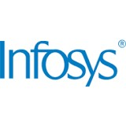

**2. Profile of Infosys:**  Infosys Limited (NYSE: INFY) was started in 1981 by seven people with US$250.Today, they are a global leader in consulting, technology and outsourcing with revenues of US$ 18.55 billion (FY23). Many of the world’s most successful organizations rely on Infosys to deliver measurable business value. Infosys provides business consulting, technology, engineering and outsourcing services to help clients in over 56 countries build tomorrow’s enterprise.

Our award-winning Infosys Labs and its breakthrough intellectual property can be leveraged as a co-creation engine to accelerate innovation across the enterprise.

Infosys pioneered the Global Delivery Model (GDM), based on the principle of taking work to the location where the best talent is available, where it makes the best economic sense, with the least amount of acceptable risk. Continued leadership around GDM enables Infosys to drive extraordinary efficiencies and free up clients’ resources for strategic transformation or innovation initiatives.

Infosys has a global footprint with 69 offices and 87 development centers in US, India, China, Australia, Japan, Middle East, UK, Germany, France, Switzerland, Netherlands, Poland, Canada and many other countries. Infosys and its subsidiaries have 3,36,294 employees as on June 2023.

Infosys gives back to the community through the Infosys Foundation that funds learning and education.

**Type**  Public (BSE 500209)

**Founded in**  July 2, 1981

**Founder (s)**  N. R. Narayana Murthy, Nandan M. Nilekani.

S. Gopalkrishnan

S.D. Shibulal

K. Dinesh

N.S. Raghavan

Ashok Arora

**Headquarter** Bangalore, India

**Industry** Software services

**Products**  IT Services



**3. Profile of HCL: -**

HCL Technologies is one of more than 3,000 technology companies in the Bloomberg database. HCL Technologies is one of the major companies with revenue of more than 1014 Indian billion rupees, a market capitalization of more than $47.73 billion, and a compounded annual growth rate 23 per cent during the past five years.

HCL Technologies is one of three businesses which are separately listed in India –falling under the corporate umbrella of HCL Enterprise with combined annual 2023 revenues of US$12.76 billion. HCL Enterprise was founded in 1976 and is one of India's original IT garage startups. HCL Technologies formed in 1991 when HCL's R&D business was spun off to focus on the growing IT services industry. They have decided to vast their features in Information Technology all over the world. Over the last 20 years, HCL has expanded its service portfolio in IT applications (custom applications for industry solutions and package implementation), IT infrastructure management, and business process outsourcing, while maintaining and affecting product engineering. HCL Technologies is the first Indian IT garage start-up. It is also the first company to address the needs of Indian Consumer Market.

**Type**  Public

**Traded as**  BSE: - 532281

NSE: - HCLTECH

**Industry**  IT services, IT consulting

**Founded On**  November 12, 1991

**Founders**  Shiv Nadar

Vineet Nayar

**Key people** Shiv Nadar (Chairman & CSO)

C Vijaykumer (CEO & Joint MD)

Shikhar Malhotra (Director)

**Services**  IT, business consulting and outsourcing services

**Revenue**  US$ 13.1 billion (Apr 2023)

**Website**  [www.hcltech.com](http://www.hcltech.com/)

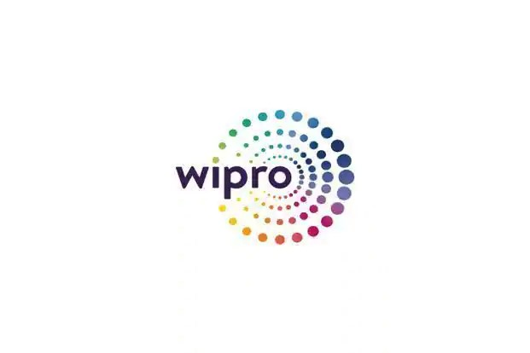

**4. Profile of Wipro Ltd.:-**

Wipro Limited (NYSE: WIT, BSE: 507685, NSE: WIPRO) is a leading technology services and consulting company focused on building innovative solutions that address clients’ most complex digital transformation needs.

We leverage our holistic portfolio of capabilities in consulting, design, engineering, operations, and emerging technologies to help clients realize their boldest ambitions and build future-ready, sustainable businesses.

A company recognized globally for its comprehensive portfolio of services, strong commitment to sustainability and good corporate citizenship, they have over 245,000 dedicated employees serving clients across 65 countries.

They deliver on the promise of helping our customers, colleagues, and communities thrive in an ever-changing world

**Type**  Public

**Traded as**  BSE: - 507685

NSE: - WIPRO

**Industry**  IT services, IT Consulting

**Founded On**  December 29, 1945

**Founder** M.H.Hasham Premji

**Key People** Rishad Premji (Executive Chairman)

Srini Pallia (CEO& MD)

Azim H. Premji (founder Chairman)

**Services**  Applications, AI, Business process, Cloud, Consulting, and Cyber Security.

**Revenue**  US$ 11.01billion (Apr 2023)

**Website** [www.wipro.com](http://www.wipro.com)

**Chapter 3.: -Research Methodology**

Research design or research methodology is the procedure of collecting, analyzing and interpreting the data to diagnose the problem and react to the opportunity in such a way where the costs can be minimized, and the desired level of accuracy can be achieved to arrive at a particular conclusion. The sample of the stocks for the purpose of collecting secondary data has been selected on the basis of Random Sampling. The stocks are chosen in an unbiased manner and each stock is chosen independent of the other stocks chosen. The stocks are chosen from the IT sector. The sample size for the number of stocks is taken as 3 for fundamental analysis of stocks as fundamental analysis is very exhaustive and requires detailed study.

**Objectives of the study: -**

The objective of this project is to deeply analyse our Indian IT sector for investment purpose by monitoring the growth rate and performance on the basis of historical data. The main objectives of the Project study are:

1. To analyse the financial health of selected IT companies stock.
2. To examine the growth of IT sector in Indian capital market.
3. To prepare comparative study of top IT companies.
4. To find out the potentiality of selected companies through current ratios.
5. To check companies' performance on the basis of historical data.
6. To study and examine the relevance of fundamental analysis in the investment decisions making process.
7. The primary objective of equity research is to analyse the earnings persistence.

**Scope of the study:**

The scope of the study is identified and during the study is conducted. The project is based on tools like fundamental analysis and ratio analysis. Further, the study is based on last five years.

1. The analysis is made by taking into consideration three companies i.e. TCS, Infosys & HCL Technologies.
2. The scope of the study is limited to a period of five years.
3. The scope is limited to only the fundamental analysis of the chosen stocks

**Limitations:**

1. This study has been conducted purely to understand Equity analysis for investors.
2. The study is restricted to three companies based on Fundamental analysis.
3. The study is limited to the companies having equities.
4. Detailed study of the topic was not possible due to limited size of the project.
5. Suggestions and conclusions are based on the limited data of five years.
6. The future is uncertain.

**Source of Data: -**

Sources of data may be classified into primary and secondary sources. Primary sources are original sources from which the researcher directly collects data from its own.

**Primary Data: -** I have collected primary data by doing observation and asking questions to the employees who are working there.

**Secondary data: -** has been collected from various sources to analyse the fundamentals. The secondary data are collected from the BSE, NSE, moneycontrol.com, articles, journals and various websites etc.

**Research Method: -**

The descriptive method is used for the study.

**Sample Size:**

For these three IT companies are selected which are listed under Indian stock market.

**Introduction: -** A literature review is an evaluative report of studies found in the literature related to ourselected area. The review should describe, summarize, evaluate and clarify this literature. It should give a theoretical basis for the research and help us to determine the nature of our own research. Select a limited number of works that are central to our area rather than trying to collect a large number of works that are not as closely connected to our topic area. A literature review goes beyond the search for information and includes the identification and articulation of relationships between literature and our field of research. While the form of the literature review may vary with different types of studies, the basic purposes remain constant:

1. Provide a context for the research
2. Justify the research
3. Ensure the research hasn't been done before (or that it is not just a "replication study")
4. Show where the research fits into the existing body of knowledge
5. Enable the researcher to learn from previous theory on the subject
6. Illustrate how the subject has been studied previously
7. Highlight flaws in previous research
8. Outline gaps in previous research
9. Show that the work is adding to the understanding and knowledge of the field
10. Help refine, refocus or even change the topic.

**Chapter 4.: -Literature Review**

There is a vast body of literature by eminent scholars and financial experts on different aspects of the stock market. The literature available on the stock market mainly deals with various aspects such as stock market efficiency, stock pricing, stock valuation and stock market operations. The review of the available literature shows that although there are a number of studies on the different aspects of capital market, there is no specific comprehensive study on the attitudes, aspirations and perceptions of individual investors. Here is given the following literature by the eminent scholars and financial experts: -

According to Sameer Yadav (2017), on a study of stock market volatility in India, the

investments are increasing day by day and hence the volatility estimation has to be emerged to

plunge the funds in an appropriate manner.

• M.Raju (2019) has conducted a research on Stock market volatility of BSE and NSE in Indian

Economy. The paper talks about the global standards before considering a stock volatility and also

the NSE and BSE movements.

• Silpa KS, Arya mol J, Dr. A S Ambily (2017) have done a fundamental analysis of selected IT

companies listed at NSE. The analysis covers three parts in the study as economic analysis, Industry

analysis and company analysis. The paper advises to hold the shares and prevent undervaluation.

According to Sameer Yadav (2017), on a study of stock market volatility in India, the

investments are increasing day by day and hence the volatility estimation has to be emerged to

plunge the funds in an appropriate manner.

• M.Raju (2019) has conducted a research on Stock market volatility of BSE and NSE in Indian

Economy. The paper talks about the global standards before considering a stock volatility and also

the NSE and BSE movements.

• Silpa KS, Arya mol J, Dr. A S Ambily (2017) have done a fundamental analysis of selected IT

companies listed at NSE. The analysis covers three parts in the study as economic analysis, Industry

analysis and company analysis. The paper advises to hold the shares and prevent undervaluation.

According to Sameer Yadav (2017), on a study of stock market volatility in India, the

investments are increasing day by day and hence the volatility estimation has to be emerged to

plunge the funds in an appropriate manner.

• M.Raju (2019) has conducted a research on Stock market volatility of BSE and NSE in Indian

Economy. The paper talks about the global standards before considering a stock volatility and also

the NSE and BSE movements.

• Silpa KS, Arya mol J, Dr. A S Ambily (2017) have done a fundamental analysis of selected IT

companies listed at NSE. The analysis covers three parts in the study as economic analysis, Industry

analysis and company analysis. The paper advises to hold the shares and prevent undervaluation.

* According to Sameer Yadav (2017), on a study of stock market volatility in India, the investments are increasing day by day and hence the volatility estimation has to be emerged to plunge the funds in an appropriate manner.
* M.Raju (2019) has conducted a research on Stock market volatility of BSE and NSE in Indian Economy. The paper talks about the global standards before considering a stock volatility and also the NSE and BSE movements.
* Silpa KS, Arya mol J, Dr. A S Ambily (2017) have done a fundamental analysis of selected IT companies listed at NSE. The analysis covers three parts in the study as economic analysis, Industry analysis and company analysis. The paper advises to hold the shares and prevent undervaluation.
* Adnan Miski (2016) on a comparative analysis of financial records between Software and Biopharmaceutical corporations stated the importance of liquidity ratio, EPS ratio, Profitability ratio and return on common Equity

**Chapter 5. :-Data Analysis & Interpretation**

**Financial analysis:**

The best source of financial information about a company is its own financial statements. This is a primary source of information for evaluating the investment prospects in the company’s stock. Financial statement analysis is the study of a company’s financial statement from various viewpoints. The statement gives the historical and current information about the company’s operations. Historical financial statement helps to predict the future and the current information aids to analyse the present status of the company. The two main statements used in the analysis are Balance sheet and Profit and Loss Account. The balance sheet is one of the financial statements that companies prepare every year for their shareholders. It is like a financial snapshot, the company's financial situation at a moment in time. It is prepared at the year end, listing the company's current assets and liabilities. It helps to study the capital structure of the company. It is better for the investor to avoid a company with excessive debt component in its capital structure.

From the balance sheet, liquidity position of the company can also be assessed with the information on current assets and current liabilities.

**Ratio analysis:**

Ratio is a relationship between two figures expressed mathematically. Financial ratios provide numerical relationship between two relevant financial data. Financial ratios are calculated from the balance sheet and profit and loss account. The relationship can be either expressed as a percent or as a quotient. Ratios summarize the data for easy understanding, comparison and interpretations. Ratios for investment purposes can be classified into profitability ratios, turnover ratios, and leverage ratios. Profitability ratios are the most popular ratios since investors prefer to measure the present profit performance and use this information to forecast the future strength of the company. The most often used profitability ratios are return on assets, price earnings multiplier, price to book value, price to cash flow, and price to sales, dividend yield, return on equity, present value of cash flows, and profit margins.

**a) Return on Assets (ROA)**

ROA is computed as the product of the net profit margin and the total asset turnover ratios.

**ROA = (Net Profit/Total income) x (Total income/Total Assets)**

This ratio indicates the firm's strategic success.

Companies can have one of two strategies: cost leadership, or product differentiation. ROA should be rising or keeping pace with the company's competitors if the company is successfully pursuing either of these strategies, but how ROA rises will depend on the company's strategy. ROA should rise with a successful cost leadership strategy because the company’s increasing operating efficiency.

An example is an increasing, total asset, turnover ratio as the company expands into new markets, increasing its market share. The company may achieve leadership by using its assets more efficiently. With a successful product differentiation strategy, ROA will rise because of a rising profit margin.

**b) Return on Investment (ROI)**

ROI is the return on capital invested in business, i.e., if an investment Rs. 1 crore in men, machines, land and material is made to generate Rs. 25 lakhs of net profit, then the ROI is 25%. The computation of return on investment is as follows:

**Return on Investment (ROI) = (Net profit/Equity investments) x 100**

As this ratio reveals how well the resources of a firm are being used, higher the ratio, better are the results.

The return on shareholder’s investment should be compared with the return of other similar firms in the same industry. The inert-firm comparison of this ratio determines whether the investments in the firm are attractive or not as the investors would like to invest only where the return is higher.

1. **Return on Equity**

Return on equity measures how much an equity shareholder's investment is actually earning. The return on equity tells the investor how much the invested rupee is earning from the company. The higher the number, the better is the performance of the company and suggests the usefulness of the projects the company has invested in. The computation of return on equity is as follows:-

**Return on equity = (Net profit to owners/value of the specific owner's Contribution to the business) x 100**

The ratio is more meaningful to the equity shareholders who are invested to know profits earned by the company and those profits which can be made available to pay dividend to them.

1. **Earnings per Share (EPS)**

This ratio determines what the company is earning for every share. For many investors, earnings are the most important tool. EPS is calculated by dividing the earnings (net profit) by the total number of equity shares. The computation of EPS is as follows:

**Earnings per share = Net profit/Number of shares outstanding**

The EPS is a good measure of profitability and when compared with EPS of similar other companies, it gives a view of the comparative earnings or earnings power of a firm.EPS calculated for a number of years indicates whether or not earning power of the company has increased.

1. **Dividend per Share (DPS):**

The extent of payment of dividends to the shareholders is measured in the form of dividend per share. The dividend per share gives the amount of cash flow from the company to the owners and is calculated as follows: -

**Dividend per share = Total dividend payment / Number of shares outstanding**

The payment of dividend can have several interpretations to the shareholder. The distribution of dividend could be thought of as the distribution of excess profits/abnormal profits by the company. On the other hand, it could also be negatively interpreted as lack of investment opportunities. In all, dividend payout gives the extent of inflows to the shareholders from the company.

1. **Dividend Payout Ratio:**

From the profits of each company a cash flow called dividend is distributed among its shareholders. This is the continuous stream of cash flow to the owners of shares, apart from the price differentials (capital gains) in the market. The return to the shareholders, in the form of dividend, out of the company's profit is measured through the payout ratio. The payout ratio is computed as follows:

**Payout Ratio = (Dividend per share / Earnings per share) * 100**

The percentage of payout ratio can also be used to compute the percentage of retained earnings. The profits available for distribution are either paid as dividends or retained internally for business growth opportunities. Hence, when dividends are not declared, the entire profit is ploughed back into the business for its future investments.

**g)Dividend Yield:**

Dividend yield is computed by relating the dividend per share to the market price of the share. The market place provides opportunities for the investor to buy the company’s share at any point of time. The price at which the share has been bought from the market is the actual cost of the investment to the shareholder. The market price is to be taken as the cum-dividend price. Dividend yield relates the actual cost to the cash flows received from the company. The computation of dividend yield is as follows: -

**Dividend yield = (Dividend per share / Market price per share) * 100**

High dividend yield ratios are usually interpreted as undervalued companies in the market. The market price is a measure of future discounted values, while the dividend per share is the present return from the investment. Hence, a high dividend yield implies that the share has been under priced in the market. On the other hand, a low dividend yield need not be interpreted as overvaluation of shares. A company that does not pay out dividends will not have a dividend yield and the real measure of the market price will be in terms of earnings per share and not through the dividend payments.

**h) Price/Earnings Ratio (P/E):**

The P/E multiplier or the price earnings ratio relates the current market price of the share to the earnings per share. This is computed as follows: -

**Price/earnings ratio = Current market price / Earnings per share.**

This ratio is calculated to make an estimate of appreciation in the value of a share of a company and is widely used by investors to decide whether or not to buy shares in a particular company. Many investors prefer to buy the company's shares at a low P/E ratio since the general interpretation is that the market is undervaluing the share and there will be a correction in the market price sooner or later. A very high P/E ratio on the other hand implies that the company's shares are overvalued, and the investor can benefit by selling the shares at this high market price.

**i) Debt-to-Equity Ratio:**

Debt-Equity ratio is used to measure the claims of outsiders and the owners against the firm’s assets.

**Debt-to-equity ratio = Outsiders Funds / Shareholders Funds**

The debt-equity ratio is calculated to measure the extent to which debt financing has been used in a business. It indicates the proportionate claims of owners and the outsiders against the firm’s assets. The purpose is to get an idea of the cushion available to outsiders on the liquidation of the firm.

* **Data analysis of Tata Consultancy Services: -**

1. Debt to Equity ratio = Long term debts/ Equity share holder fund
2. EPS = Earnings available to Equity share holder/ No of Equity shares
3. Current ratio= current assets/ current liability
4. P/E ratio= Market value per share/ Earning per share

1. **Debt to Equity ratio = Long term debts/ Equity share holder fund**

**Table Showing Debt to equity ratio of TCS**

|  |  |  |  |  |  |
| --- | --- | --- | --- | --- | --- |
| Year | Mar’23 | Mar’22 | Mar’21 | Mar’20 | Mar’19 |
| Debt to  Equity Ratio | 0.00 | 0.00 | 0.00 | 0.00 | 0.00 |

**Analysis:** Researchers see that debt-to-equity ratio in Mar 2019to 2023 is zero.

**Interpretation:** Debt to equity ratio of company is nill till 2023. A high debt/equity ratio generally means that a company has been aggressive in financing its growth with debt. This can result in volatile earnings as a result of the additional interest expense.

1. **EPS = Earnings available to Equity share holder/ No of Equity shares**

For the year ended 2022/2023= 39,106/365.91 = 106.88

For the year ended 2021/2022 = 38,187/365.91 = 103.24

For the year ended 2020/2021 = 30,960/369.91 = 82.78

For the year ended 2019/2020 = 33,260/375.24 = 88.64

For the year ended 2018/2019 = 30,065/375.24 = 79.34

**Table showing EPS of TCS (in Rs. Cr.)**

|  |  |  |  |  |  |
| --- | --- | --- | --- | --- | --- |
| Year | Mar’23 | Mar’22 | Mar’21 | Mar’20 | Mar’19 |
| EPS | 106.88 | 103.24 | 82.78 | 88.64 | 79.34 |

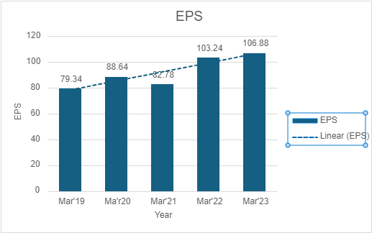

**Graph showing EPS of TCS**

**Analysis:** From the above table it can be seen that EPS of company in 2018/2019 was 79.34 and it is increased in the next year in 2019/2020 by 11.72%. And there was decrease in EPS in the year 2020/2021 by 7.07%. Again, EPS increases by 3.53% in March 2023 as compared to its previous year.

**Interpretation:** From the above graph it can be seen that EPS of company is increasing from 2019 but there was a small decrease in 2021 because of some factors and again company has performed well in EPS.

**iii) P/E ratio = Market price of share / EPS**

For the year ended 2022/2023 = 31.06

For the year ended 2021/2022 = 29.4

For the year ended 2020/2021 = 36.8

For the year ended 2019/2020 = 34.4

For the year ended 2018/2019 = 25.0

(in Rs. Cr.)

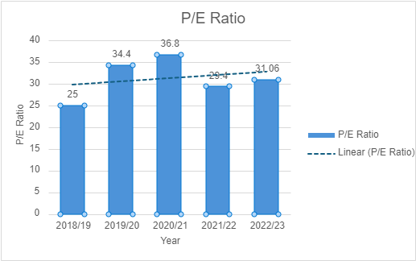

**Graph showing P/E ratio of TCS**

**Analysis:** From the above calculation it can be seen that price earnings ratio of company was increased from 25.00 in 2018/19 to 34.4 in 2019/20. In next financial year 2020/21 it increased to 36.8 and it is decreased in next year to 29.4 and again increase to 31.06.

**Interpretation:** Researcher sees that there was up and down in P/E ratio of the company from 2018/19 to 2022/23.

**iv) Current ratio= Current assets/ Current liability**

**Table showing current ratio of TCS**

|  |  |  |  |  |  |
| --- | --- | --- | --- | --- | --- |
| Year | Mar’23 | Mar’22 | Mar’21 | Mar’20 | Mar’19 |
| Current Ratio | 2.36 | 2.49 | 2.92 | 3.30 | 4.18 |

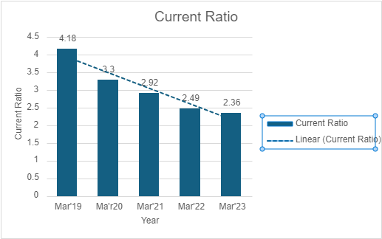 **Graph showing current ratio of TCS**

**Analysis:** The above table shows current ratio of the company which is 4.18:1 in Mar 19 and decreased to 3.30:1 in next year Mar 2020. And is decreased till 2023 to 2.36:1.

**Interpretation:** The higher the current ratio, the more capable the company is of paying its obligations. A ratio under 1 suggests that the company would be unable to pay off its obligations if they came due at that point. So, for TCS, the current ratio shows that they have more current assets than current liability. As graph shows, they have potential to pay its obligation so short-term solvency for TCS is strong.

• **Data Analysis of Infosys: -**

1. **Debt to Equity Ratio = Long Term Debts/ Equity shareholders fund**

1. **EPS = Earnings available to Equity share holder/ No of Equity shares**

For the year ended 2022/2023= 24,095/418.08 = 57.63

For the year ended 2021/2022 = 22,110/420.95 = 52.52

For the year ended 2020/2021 = 19,351/424.24 = 45.61

For the year ended 2019/2020 = 38.96

For the year ended 2018/2019 = 35.26

**Table showing EPS of Infosys (in Rs. Cr.)**

|  |  |  |  |  |  |
| --- | --- | --- | --- | --- | --- |
| Year | Mar 23 | Mar 22 | Mar 21 | Mar 20 | Mar 19 |
| EPS | 57.63 | 52.52 | 45.61 | 38.96 | 35.26 |

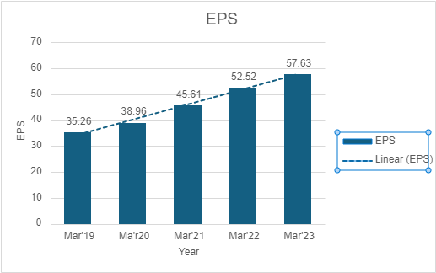

**Graph showing EPS of Infosys**

**Analysis:** From above table it is analysed that in Mar 19, EPS of Infosys company was 35.26 and in Mar 20 it is increased to 38.96 and again in next year Mar 21 it is increased to 45.61 and continue increasing to 57.63 in 2023.

**Interpretation:** EPS of Infosys is increasing continuously from Mar 19 to Mar 23 which is a good indicator for the growth of the company as well as for investors.

**iii) Current ratio= Current assets/ Current liability**

**Table showing current ratio of Infosys**

|  |  |  |  |  |  |
| --- | --- | --- | --- | --- | --- |
| Year | Mar 23 | Mar 22 | Mar 21 | Mar 20 | Mar 19 |
| Current Ratio | 1.90 | 2.10 | 2.74 | 2.88 | 3.00 |

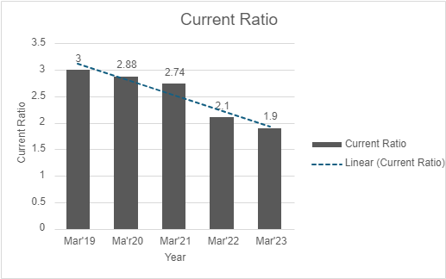

**Graph showing current ratio of Infosys**

**Analysis:** Table shows the Current ratio of Infosys which is 3.00:1 in Mar 2019 and decreased to 2.88:1 in Mar 20. And in after that it is decreased to 2.74:1 in Mar 21 and decrease to 1.90:1 in Mar 2023.

**Interpretation:** In FY 23, the company’s current ratio stood at 1.90. The marginal decline in the ratio can be ascribed to a relatively higher percentage increase in current liabilities compared to current assets.

**iv) P/E ratio= Market value per share/ Earning per share (EPS)**

For the year ended 2022/2023 = 28.19

For the year ended 2021/2022 = 25.4

For the year ended 2020/2021 = 37.2

For the year ended 2019/2020 = 28.7

For the year ended 2018/2019 = 19.1

(In Rs.Cr.)

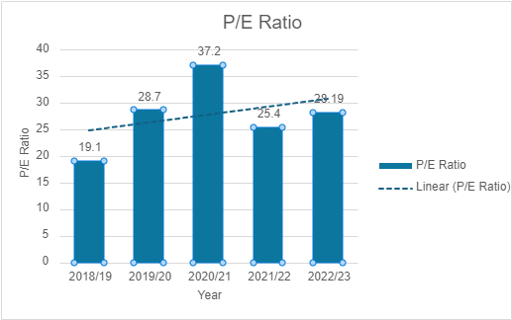

**Graph Showing P/E ratio of Infosys**

**Analysis:** From the above table it is analysed that in 2018/19, P/E ratio was 19.1 and then after it is increased to 28.7 in 2019/20 and in next year again it is increased to 37.20 and but in 2021/22 it is decreased to 25.4 & again slightly increase to 28.19 in 2023.

**Interpretation:** The above graph shows that from the year 2018/19 to 2020/21 the P/E Ratio of Infosys is increased but in 2021/22 it is decreased

* **Data analysis of HCL Technologies:**

**i) Debt to Equity ratio = Long term debts/ Equity share holder fund**

**Table showing Debt to equity ratio of HCL Technologies (in Rs.)**

|  |  |  |  |  |  |
| --- | --- | --- | --- | --- | --- |
| Year | Mar’23 | Mar’22 | Mar’21 | Mar’20 | Mar’19 |
| Ratio | 0.00 | 0.01 | 0.00 | 0.00 | 0.00 |

**Analysis:** Above table shows that in 2021/22 debt to equity ratio was 0.01 and in next and year it is again 0.00.

**Interpretation:** Table shows continuous decrease in debt to equity ratio till 2023.

**ii) EPS = Earnings available to Equity share holder/ No of Equity shares: -**

For the year ended 2022/2023 = 42.32

For the year ended 2021/2022 = 40.10

For the year ended 2020/2021 = 32.22

For the year ended 2019/2020 = 33.06

For the year ended 2018/2019 = 59.69

**Table showing EPS of HCL Technologies (in Rs.)**

|  |  |  |  |  |  |
| --- | --- | --- | --- | --- | --- |
| Year | Mar’23 | Mar’22 | Mar’21 | Mar’20 | Mar’19 |
| EPS | 42.32 | 40.10 | 32.22 | 33.06 | 59.69 |

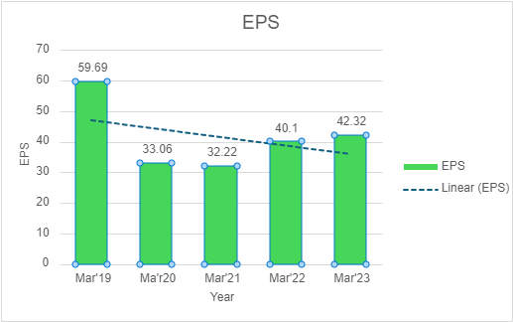

**Graph showing EPS of HCL Technologies**

**Analysis:** Above table shows that in the year Mar 2019 the companies EPS is 59.69, but in next two years it is decrease. And in the year Mar 21-23 it again increased from 40.1 to 42.32 rupees.

**Interpretation:** From the above graph sees that EPS of company is good and it is but it is fluctuating.

**iii) Current ratio= Current assets/ Current liability**

**Table showing current ratio of HCL Technologies**

|  |  |  |  |  |  |
| --- | --- | --- | --- | --- | --- |
| Year | Mar’23 | Mar’22 | Mar’21 | Mar’20 | Mar’19 |
| Current Ratio | 2.68 | 2.97 | 2.77 | 1.69 | 2.93 |

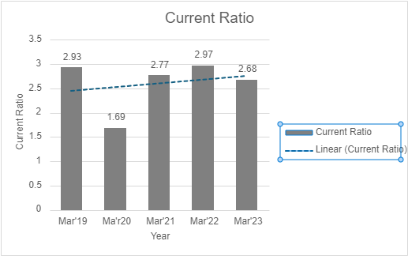

**Graph Showing Current ratio of HCL Technologies**

**Analysis:** From the above table it shows the current ratio of HCL which was 2.93 in Mar 19 is decrease in Mar 20, but afterwards it increasing till Mar 23.

**Interpretation:** The above analysis shows the current ratio of HCL from five years which is increasing and decreasing every year, in Mar 22 it is in better position.

**iv) P/E ratio = Market value per share/ Earning per share (EPS) (in Rs.)**

For the year March 2023 = 19.86

For the year March 2022 = 23.40

For the year March 2021 = 23.96

For the year March 2020 = 10.72

For the year March 2019 = 7.28

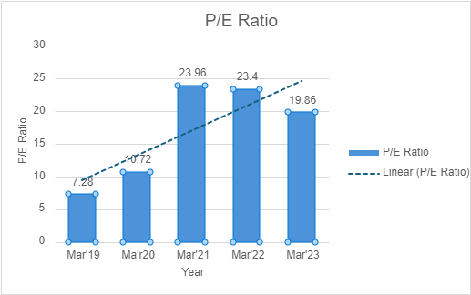

**Graph showing P/E ratio of HCL Technologies.**

**Analysis:** Above table shows P/E ratio of HCL technologies is in upward trend till Mar 22, but in Mar 23 it is decreased to 19.86.

**Interpretation:** Above graph shows EPS of company that has given good return to shareholders and performed well in Mar 21 but after that it is decreased, lower the P/E ratio between 20-25 indicate that it is good for investing.

* **Data analysis of Wipro Ltd.:-**

**i) Debt to Equity ratio = Long term debts/ Equity share holder fund**

**Table showing Debt to equity ratio of Wipro Ltd.(in Rs.)**

|  |  |  |  |  |  |
| --- | --- | --- | --- | --- | --- |
| Year | Mar’23 | Mar’22 | Mar’21 | Mar’20 | Mar’19 |
| Ratio | 0.08 | 0.14 | 0.13 | 0.11 | 0.10 |

**Analysis:** Above table shows that in Mar 19, companies’ debt to equity ratio is 0.10, but after it increase by 0.01 till Mar 22, and then is decrease to 0.08.

**Interpretation:** The table shows that volatility in the debt to equity ratio.

**ii) EPS = Earnings available to Equity share holder/ No of Equity shares: -**

For the year ended 2022/2023 = 16.75

For the year ended 2021/2022 = 22.20

For the year ended 2020/2021 = 17.81

For the year ended 2019/2020 = 14.88

For the year ended 2018/2019 = 12.67

**Table showing EPS of Wipro Ltd. (in Rs.)**

|  |  |  |  |  |  |
| --- | --- | --- | --- | --- | --- |
| Year | Mar’23 | Mar’22 | Mar’21 | Mar’20 | Mar’19 |
| EPS | 16.75 | 22.20 | 17.81 | 14.88 | 12.67 |

**Graph showing EPS of Wipro Ltd.**

**Analysis:** The above table shows that EPS of Wipro from Mar 19-22 is increasing, but in 23 it is decrease to16.75.

**Interpretation**: The above graph shows that the EPS of Wipro is increasing, which is good for investors, except March 23.

**iii) Current ratio= Current assets/ Current liability**

|  |  |  |  |
| --- | --- | --- | --- |
|  |  |  |  |

**Table showing current ratio of Wipro Ltd.**

|  |  |  |  |  |  |
| --- | --- | --- | --- | --- | --- |
| Year | Mar’23 | Mar’22 | Mar’21 | Mar’20 | Mar’19 |
| Current Ratio | 2.86 | 2.23 | 2.50 | 2.78 | 2.96 |

**Graph Showing Current ratio of Wipro Ltd.**

**Analysis:** The above table shows that the current ratio is 2.96:1 in Mar 19 and it is decrease to 2.23:1 in Mar 22.But in Mar 23 it is again increase to 2.86.

**Interpretation**: The current ratio of Wipro is ideal for all the 5 years, because it is above 2, which shows that it has more current assets than current liabilities.

**iv) P/E ratio = Market value per share/ Earning per share (EPS) (in Rs.)**

For the year March 2023 = 21.4

For the year March 2022 = 17.9

For the year March 2021 = 32.7

For the year March 2020 = 23.6

For the year March 2019 = 15.7

**Graph showing P/E ratio of Wipro Ltd.**

**Analysis:** The P/E ratio of Wipro Ltd. is 15.7 in Mar 19 and in next 4 years it is fluctuating. In the year Mar 21 it is 32.7.

**Interpretation:** The ideal P/E ratio for investing is between 20-25. Below it is also ideal for investors. So by analysing the graph we can interpret that it is good for investors except Mar 21.

**Chapter 6.: -FINDINGS**

From the study equity analysis on IT industry and data analysis and interpretations of the ratios of three companies the following findings have been given:

1. IT/Ites industry has led India's economic growth and this sector's contribution to the national GDP has risen from 5.8 % in 2008-09 to an estimated 7.5% in 2022-23.
2. HCL Technologies is found with a better current ratio as compared to other companies. As it proves that the company is more capable of paying its obligations than others.
3. Increasing EPS indicate good earnings.
4. The stock prices always take a correction after a major climb.
5. The P/E ratio of all the selected companies is increasing year after year with some variations in it.
6. The overall performance of the companies is good, and there is a continuous flow of project business. The companies are continuing their drives for volume with a continuous focus on profitability.
7. By analyzing the current trend of Indian Economy and IT Industry I have found that being a developing economy there is lot of scope for growth and this industry still has to cross many levels so there are huge opportunities to invest in.
8. The Debt to Equity ratio of all the three companies is 0.00 which shows that the companies financial position is strong and it is not burdened with the debt payments.

**Chapter 7.: - Suggestions**

By analyzing the IT industry with the help of fundamental analysis, it has been revealed that this industry has a lot of potential to grow. So, recommending investing in IT industry with no doubt is going to be a good and smart option because this industry is booming like never before not only in India but all over the world.

 There are various factors which effects on stock market, so an investor must be aware of all those.

Short term investors should look at various support and resistance of stocks to buy or sell and make profit.

 An investor must take research about stock of company and its previous data before investing.

 Current ratio must be improved by company, and it should be in ideal ratio 2:1 so that there are possibilities to meet the current obligations for the company.

 Companies which are not very popular in the stock market must adopt some strategies for investors to encourage them to invest in their company.

*  **Few Suggestions for “Right Stock Selection”**

There are three factors which an investor must consider for selecting the right stocks.

* **Business:** An investor must look into what kind of business the company is doing, visibility of the business, its past track record, capital needs of the company for expansion etc.

* **Balance Sheet:** The investor must focus on its key financial ratios such as earnings per share, price-earnings ratio, debt-equity ratio, dividends per share etc. and he must also check whether the company is generating cash flows.

* **Bargaining:** This is the most important factor which shows the true worth of the company. An investor needs to choose valuation parameters which suit its business.

**Investment rules:**

1. Invest for long term in equity markets.
2. Align your thought process with the business cycle of the company.
3. Set the purpose for investment.
4. long term goals should be the objective of equity investment.
5. Disciplined investment during market volatility helps attain profits.
6. Planning, Knowledge and Discipline are very crucial for investment.

**Chapter 8.: -Conclusion**

Global recession had an effect on the growth of the IT industry, but it was a short-term phenomenon. The industry is bouncing back. One factor favoring this point is that India has become a hot destination for companies of diverse nature to invest in.

Inspite of it being a tough year for all the companies across the globe, Indian market has given good performance as compared to other companies in the world. A continuous effort at cost cutting and improving productivity will help the companies in making reasonable profits despite the impact of higher commodity prices and weaker rupee.

The analysis gives an optimistic view about the industry and its growth which recommends the investors to keep a good watch on the major players to benefit in terms of returns on their investments.

**Chapter 9.: -BIBLIOGRAPHY**

REFERENCES:

[1] Sameer Yadav (2017), A Study of stock market volatility in India, GJRA - GLOBAL JOURNAL FOR

RESEARCH ANALYSIS, Vol 6, Issue 4.

[2] M. Raju (2019), A Research on the Stock market volatility of BSE and NSE in Indian Economy,

International Journal of Recent Technology and Engineering (IJRTE) ISSN: 2277-3878, Volume-

8 Issue-2, July 2019.

[3] Silpa KS, Arya mol J, Dr. A S Ambily (2017), A Fundamental analysis of selected IT companies

listed at NSE, Jour of Adv. Research in Dynamical and Control Systems,Volume 9, SI 5, 2017.

# [1] Sameer Yadav (2017), A Study of stock market volatility in India, GJRA - GLOBAL JOURNAL FOR RESEARCH ANALYSIS, Vol 6, Issue 4.

# 

# [2] M. Raju (2019), A Research on the Stock market volatility of BSE and NSE in Indian Economy, International Journal of Recent Technology and Engineering (IJRTE) ISSN: 2277-3878, Volume-8 Issue-2, July 2019.

# 

# [3] Silpa KS, Arya mol J, Dr. A S Ambily (2017), A Fundamental analysis of selected IT companies listed at NSE, Jour of Adv. Research in Dynamical and Control Systems, Volume 9, SI 5, 2017.

[4] Adnan Miski (2016), A Comparative analysis of financial records between Software and

Biopharmaceutical corporations, International Journal of Scientific & Engineering Research,

Volume 7, Issue 2, February-2016, ISSN 2229-5518

# Book: -

1.’’Investment Management-Security Analysis and Portfolio Management’’ by V.K. Bhalla in 17th Edition published by S. Chand,2011

Websites: -

* Moneycontrol.com
* Official websites of the given companies
* www.nseindia.com
* www.bseindia.com