**Name: PAVAN ARJUN PATIL**

**Roll no:103**

**Practical No:5**

**Practical Name:Use git pull to get your partners change into your repository.verify That you have the new file**

--------------------------------------------------------------------------

comp@com135 MINGW64 ~ (master)

$ cd pavan03

$ git pull https://github.com/Pavanpatil973/pavan03.git

remote: Enumerating objects: 7, done.

remote: Counting objects: 100% (7/7), done.

remote: Compressing objects: 100% (5/5), done.

remote: Total 6 (delta 0), reused 0 (delta 0), pack-reused 0

Unpacking objects: 100% (6/6), 1.91 KiB | 70.00 KiB/s, done.

From https://github.com/Pavanpatil973/pavan03

* branch HEAD -> FETCH_HEAD

Updating 0e186e0..bc1e94b

Fast-forward

Home.html | 5 +++++

master1.txt | 1 +

2 files changed, 6 insertions(+)

create mode 100644 Home.html

create mode 100644 master1.txt

**Before Pull and merge on remote repository:**

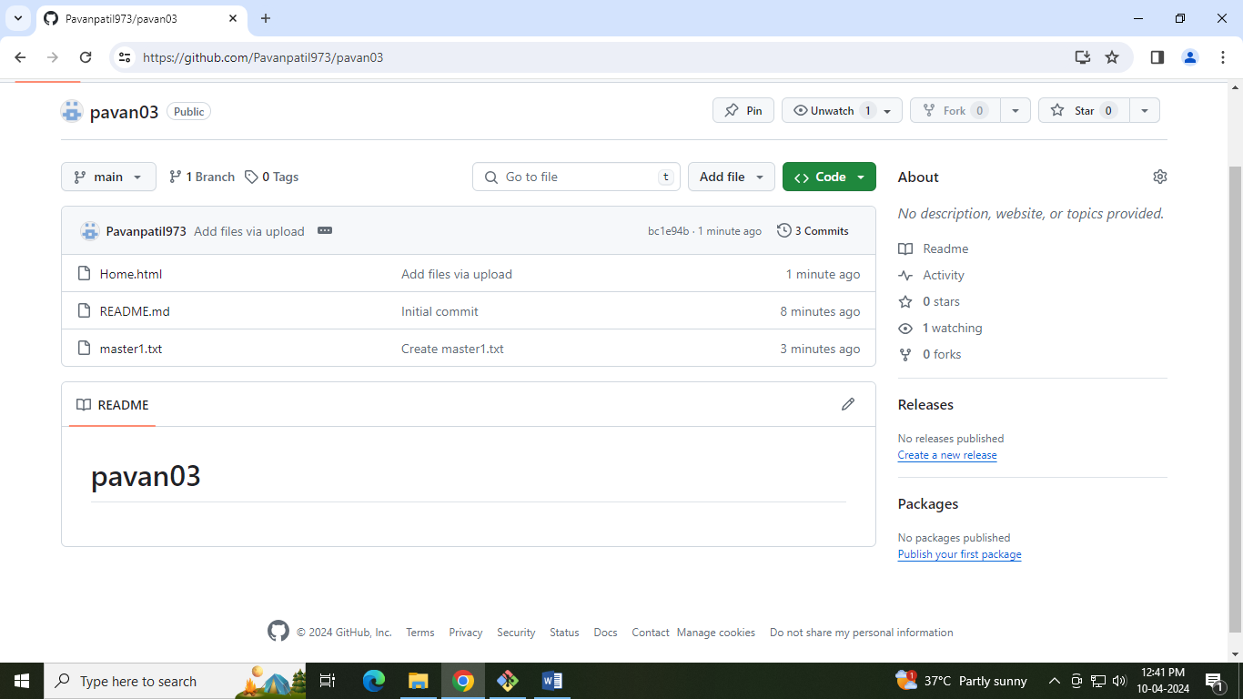

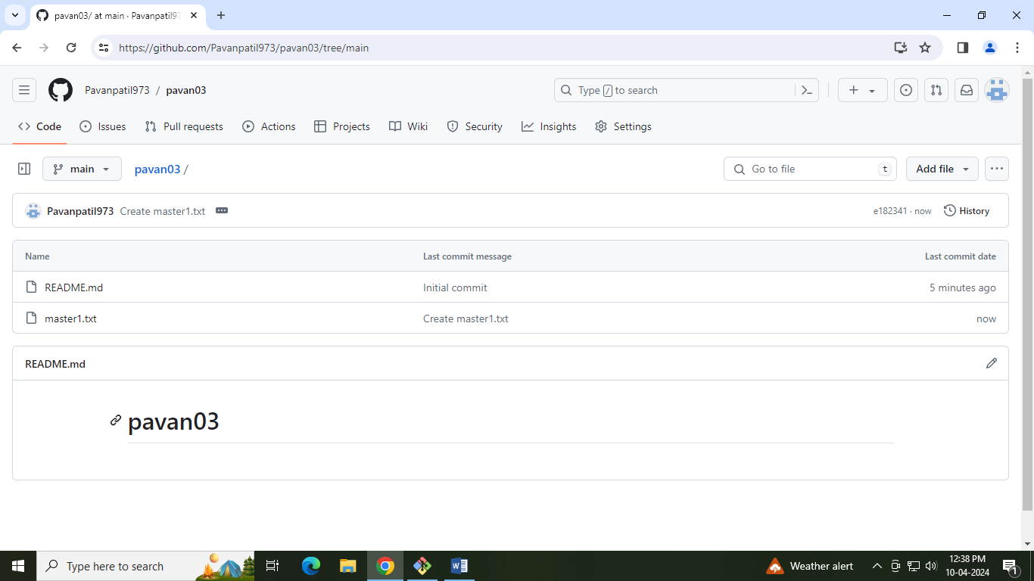

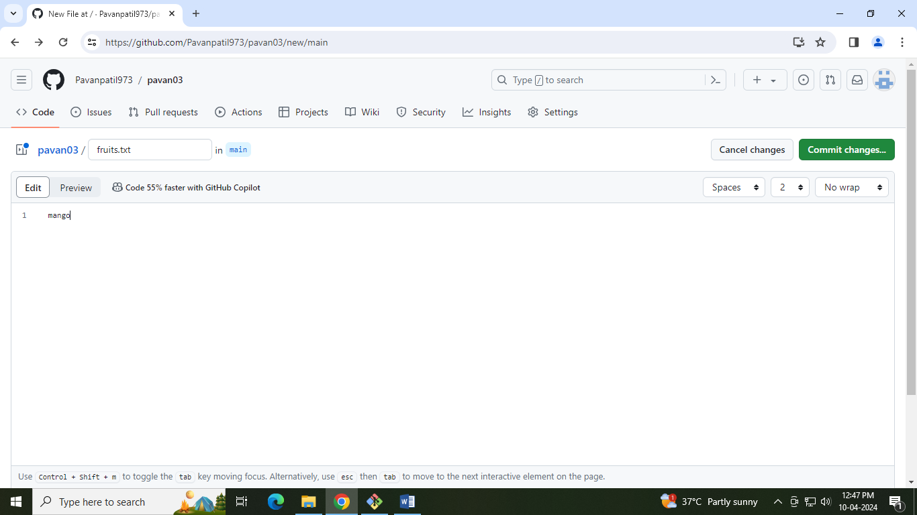

Performing pull request:-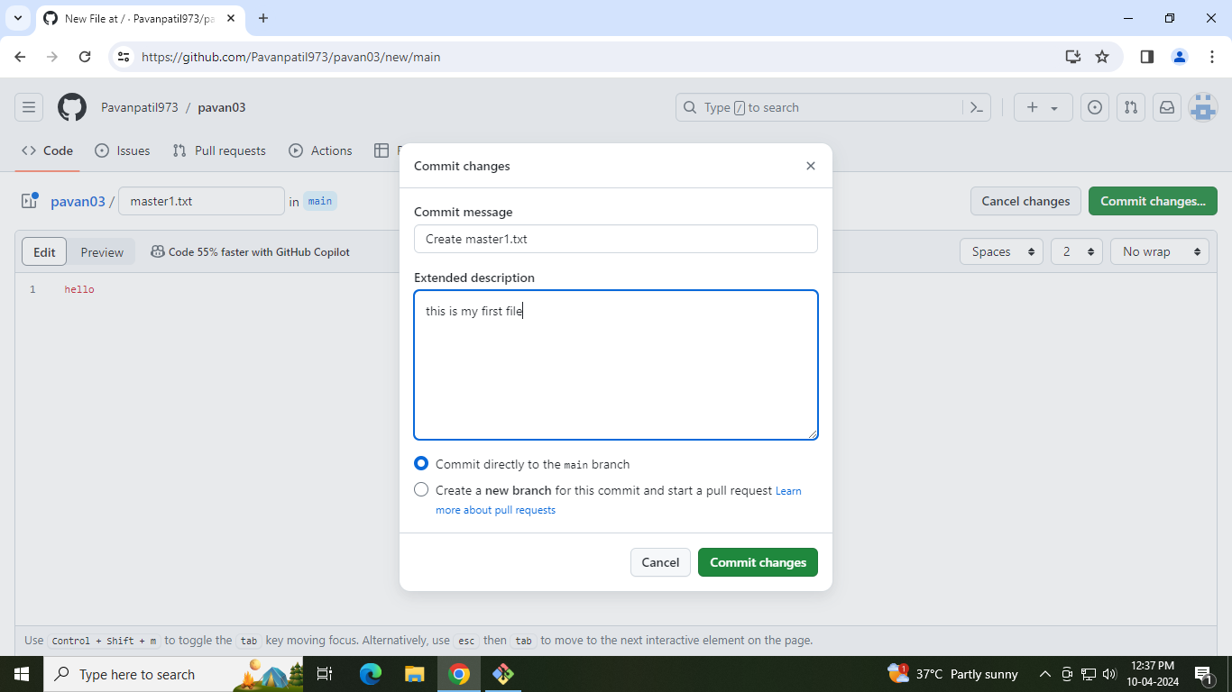

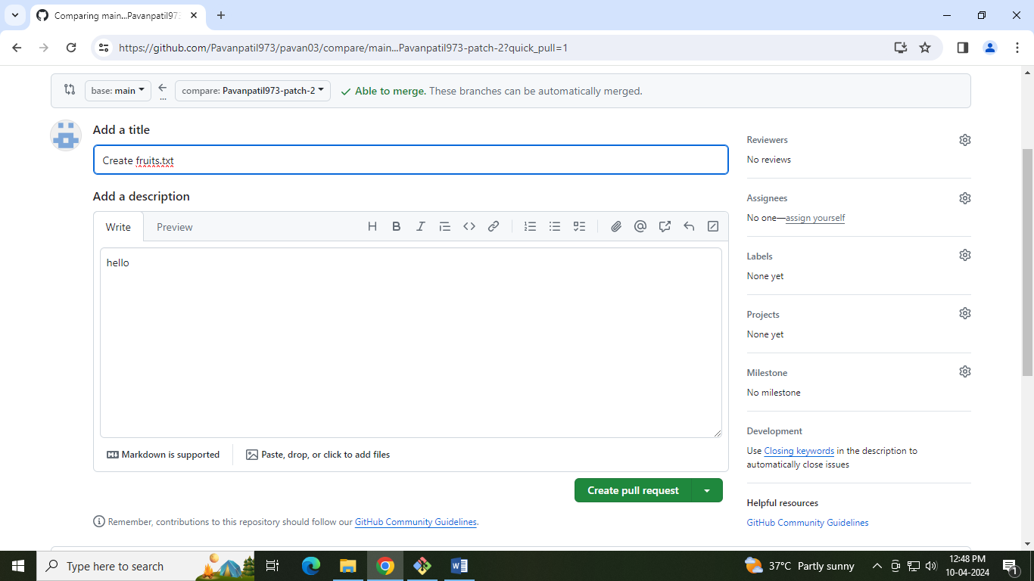

After pull performing on remote repository at primary branch (main):-

