Practical 3

Create table salestable(product varchar(10) not null, quarter varchar(10) not null, region varchar(20) not null, sales int not null);

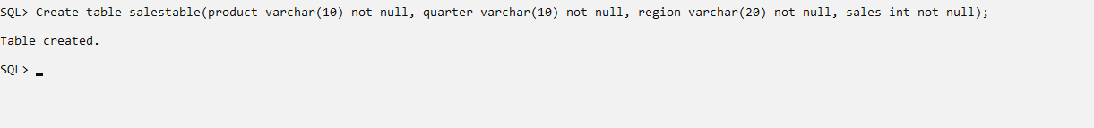

Insertion of values:

Insert into salestable values(‘A’, ‘Q1’, ‘EUROPE’, 10);

Insert into salestable values(‘A’, ‘Q1’, ‘AMERICA’, 20);

Insert into salestable values(‘A’, ‘Q2’, ‘EUROPE’, 20);

Insert into salestable values(‘A’, ‘Q2’, ‘AMERICA’, 50);

Insert into salestable values(‘A’, ‘Q3’, ‘AMERICA’, 20);

Insert into salestable values(‘A’, ‘Q4’, ‘EUROPE’, 10);

Insert into salestable values(‘A’, ‘Q4’, ‘AMERICA’, 30);

Insert into salestable values(‘B’, ‘Q1’, ‘EUROPE’, 40);

Insert into salestable values(‘B’, ‘Q1’, ‘AMERICA’, 60);

Insert into salestable values(‘B’, ‘Q2’, ‘EUROPE’, 20);

Insert into salestable values(‘B’, ‘Q2’, ‘AMERICA’, 10);

Insert into salestable values(‘B’, ‘Q3’, ‘AMERICA’, 20);

Insert into salestable values(‘B’, ‘Q4’, ‘EUROPE’, 10);

Insert into salestable values(‘B’, ‘Q4’, ‘AMERICA’, 40);

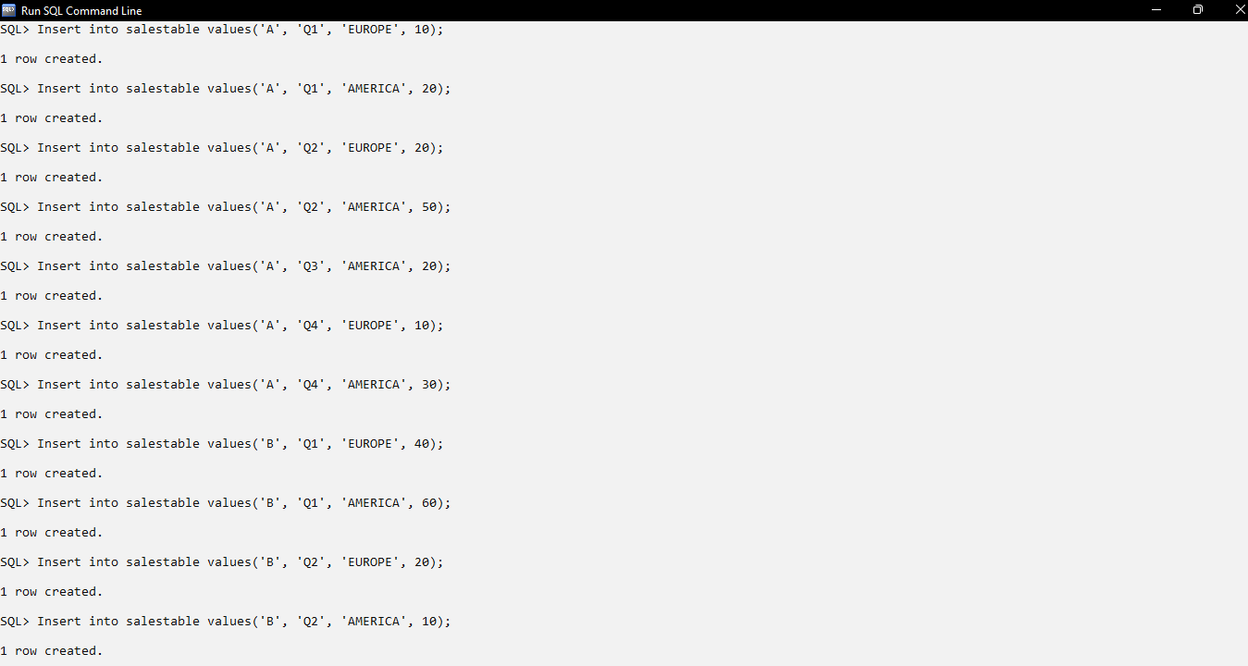

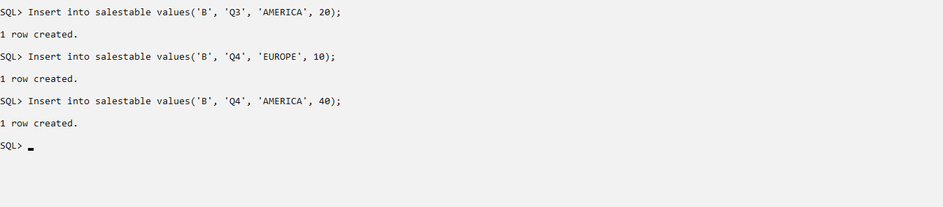

3) Select \* from salestable;

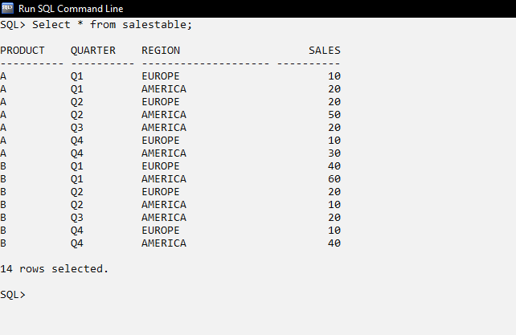

4) SELECT QUARTER , REGION, SUM(SALES) FROM SALESTABLE GROUP BY CUBE (QUARTER, REGION);

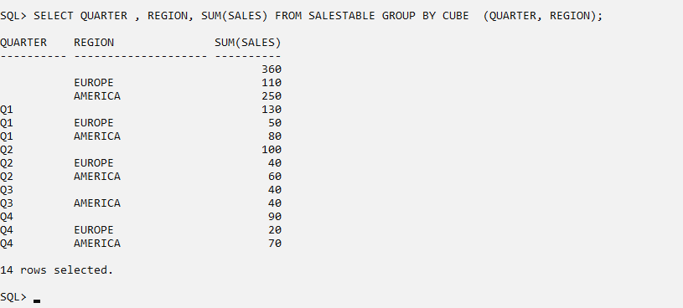

5) SELECT QUARTER , REGION, SUM(SALES) FROM SALESTABLE GROUP BY ROLLUP (QUARTER, REGION);

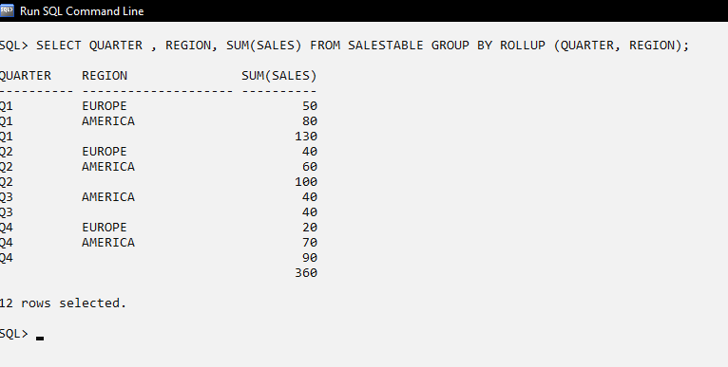

6) SELECT QUARTER , REGION, MIN(SALES) FROM SALESTABLE GROUP BY ROLLUP (QUARTER, REGION);

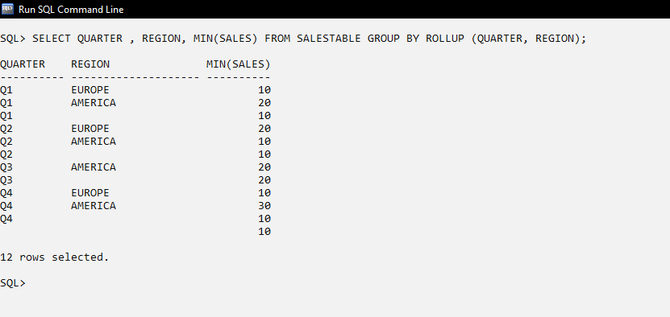

7) SELECT QUARTER , REGION, MAX(SALES) FROM SALESTABLE GROUP BY ROLLUP (QUARTER, REGION);

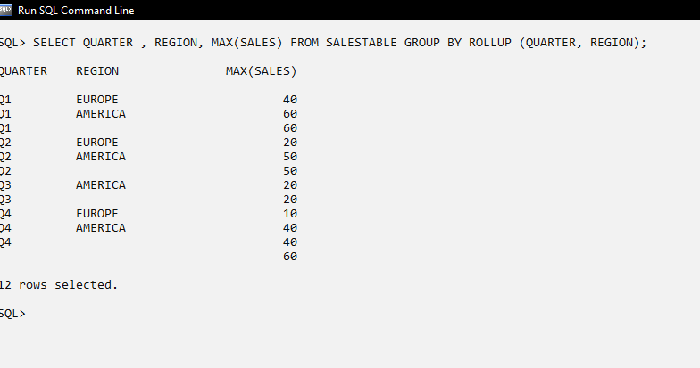

8) SELECT QUARTER , REGION, AVG(SALES) FROM SALESTABLE GROUP BY ROLLUP (QUARTER, REGION);

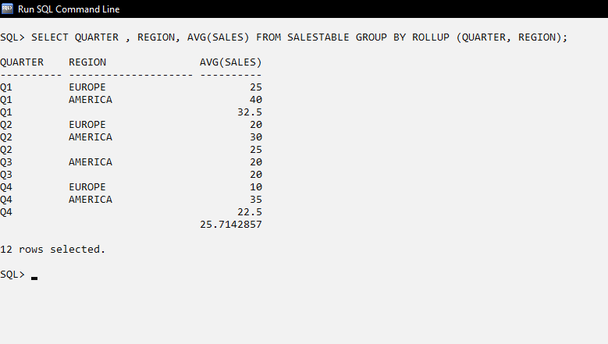

9) Display the total sales of ‘A’ product sold across all the regions. (slice operation).

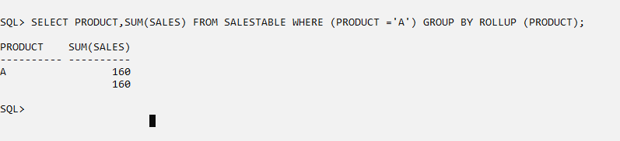

10) Display the total sales due to the ‘B’ product for Europe region (Dice operation).

