**PROJECT REPORT ON**

**“ONLINE CINEMA BOOKING”**



**A Project Report**

**Submitted to the Rajasthan Technical University,Kota**

**In partial fulfillment of the requirement for the degree of B.TECH**

**Submitted to: Submitted By:**

**Mr. MahenderBeniwal Abhijeet Daga(12ESKCS004) Aman Agarwal(12ESKCS012)**

**Komal Motwani(12ESKCS060)**

**Department of Computer science**

**Swami Keshvanand Institute of Technology,**

**Management &Gramothan,Jaipur**

**Acknowledgement**

The ability to help and patience to exercise diligence and provide support is a quality admonished by very few.Any job in this would however trivial or tough can not be accomplished without the assistance of the others.We would thereby take the opportunity to express our indebtedness to people who have helped us to accomplish this task.The present line of accomplishment is not a formality but an honest word of appreciation that has exactly been felt by during our training.

We would like to thanks Mr. MahenderBeniwal for providing support and the opportunity to work in this organization.

Last but not least we would like to thanks all “SKIT” faculty who have directly or indirectly helped and coorperated in accomplishing this project.

**Preface**

The project report is submitted for the partial fulfillment of Bachelor of Technology degree from Rajasthan Technical University,Kota Rajasthan.

The project report has been prepared as per the requirement of the syllabus of B.Tech course structure under which the students are required to undertake the training.

During this period, we had very touching experiences.

Now we take the opportunity to present the project report and sincerely hope that it will be as much knowledge enhancing to the readers as it was to use during the development work and the compilation of the report.

**TABLE OF CONTENTS**

1. Introduction
2. Tools and technologies used
   1. Java server pages
   2. MYSQL Server 5.0
   3. Apache tomcat server 7.0.62
   4. Eclipse version 4.2.2
3. System requirement specification
   1. Functional system requirements
   2. Non-functional system requirements
   3. Software quality attributes
   4. System interface
4. Database description
5. Project Screen-shots
6. System Design
   1. Activity Diagram
   2. Component Diagram
   3. Use-Case Diagram
   4. DFD Diagram
7. Bibliography & References

**Introduction**

The system lets the staff to view and book tickets online through a internet connection,it can work on any operating system without much specific needs. The system has two modules, user and administrator module. The user module enables user to view, login and book tickets after checking the availability at various cinema halls across the city and also lets them choose their seat through a seat matrix shown.The user can as well provide a feedback related to the website or the booking process.

The admin module provides the facility to modify the data regarding the shows screened currently and update the records as per need and on a timely basis.

**2.Tools and technologies Used**

* FRONT END-Advance java
* BACK END-My SQL
* SERVER-Apache Server
* BROWSER-Google chrome/Firefox
* OS- Windows 8/7
  1. **Java Server Pages**
* JavaServer Pages (JSP) is a server-side programming technology that enables the creation of dynamic, platform-independent method for building Web-based applications.
* The JSP pages are easier to maintain than servlet because we can separate designing and development.
* A JSP container works with the Web server to provide the runtime environment and other services a JSP needs.
  1. **MYSQL**
* MySQL is the most popular Open Source Relational SQL database management system.
* MySQL handles a large subset of the functionality of the most expensive and powerful database packages.
* It provides a very high performance. It can run on unix, Window and Mac OS.
* It is used for the internet application as it provides good speed and is very secure.
* MySQL is customizable.The open-source GPL license allows programmers to modify the MySQL software to fit their own specific environments.

**2.3Apache server 7.0.62**

* It is an open source web server developed by apache group.
* Apache is the servlet container that is used in implementation for the java servlet and java server pages technologies.
* Web servers like Apache tomcat support only web components.
* To develop a web application with jsp/servlet installs any web server like JRun,Tomcat etc. to run your application.

**2.4Eclipse 4.2.2**

* **Java Eclipse is an open source project that brings together programmers of many different languages**
* Via a Java plugin system, it allows programmers in various languages such as Java, C, C + +, Perl, Python, PHP to collaborate with the minimum of difficulty.
* **Eclipse is a powerful cross platform development tool based on Java.**

**3.System Requirement Specification**

3.1Functional System Requirements:

This section gives a functional requirement that is applicable to bigscreenshows.com.

There are two sub modules in this phase:

* User Module
* Admin Module

The functionality of each module is as follows:

* User Module: The user can select any movie from the display or can also sort the movies according to particular theatres. The booking procedure will proceed as the user selects the movie, number of tickets and seats selected(if available).
* Administrator Module: The admin would have the privileges to add movies to display, change pictures , change timings for the shows , update theatres , update the website information, add promos etc.

The features that are available to the Administrator are:

* The administrator has all the possible privileges for the web-application.
* Can view the accounts.
* Update information about the theatres,shows.
* Add/delete list of movies.

The features available to the user are:

* Can view the list of different type of movies available.
* Can view the movies soon to be released.
* Can view the different cinemas where he can go for movie under the list of cities.
* Can write a feedback for the admin.

3.2 Non-Functional System Requirements:

3.2.1. Performance Requirements:

Some performance requirements identified is listed below:

* The database shall be able to accommodate a minimum of 10,000 records of bookings.
* The software shall support use of multiple users at a time.
* There are no other specific performance requirements that will affect development.

3.2.2.Safety requirements:

The database may get crashed at any certain time due to virus or operating system failure. Therefore, it is required to take the database backup.

3.2.3.Security Requirements:

Some of the factors that are identified to protect the software from accidental or malicious access, use, modification, destruction, or disclosure are described below. Keep specific log or history data sets

* Assign certain function to different module.
* Restrict communication between some areas of the program.
* Check data integrity for critical variables.
* Later version of the software will incorporate encryption techniques in the user/licence authentication process.
* Communication needs to be restricted when the application is validating the user or license. (i.e., using https).

3.3.Software Quality Attributes:

The Quality of the system is maintained in such a way so that it can be very user friendly to all the users.

The software quality attributes are assumed as under:

* Accurate and hence reliable.
* Secured.
* Fast speed.
* Compatibility with various operating systems.

3.4. Hardware and software requirements

3.4.1. Hardware requirements:

* Intel Pentium-IV Processor
* 256 MB RAM or higher
* 40 GB HDD or higher

3.4.2. Software requirements:

* Microsoft Windows XP
* Database: MYSQL
* Apache Tomcat Server
* My Eclipse IDE
* Dreamviewer

3.4.3.Communication Interface:

The customer must connect to internet to access the website through:

* Dialup Modem of 52kbps
* Broadband Internet
* Or all sort of internet networks

|  |
| --- |
|  |

**4. DATABASE DESCRIPTION**

**INPUT DATA / STRUCTURE:**

Study of manual system of operation has provided the basic data and their formats which have

been suitably modified to be used in a database environment. The data to be used in the system are stored in various tables. The number of tables used & their structure are decided upon keeping in mind the logical relation in the data available. The database design specifies:

(a) The various tables to be used

(b) Data to store in each table

(c) Format of the fields & their types

The database consists of several tables. Following are those which are mainly used to store the data.Description of each table and its data structure is given below:

Table 1: admin_data

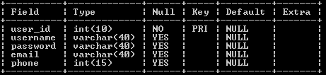

Table 2: cinema_master

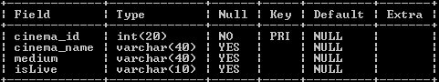

Table 3: city_master

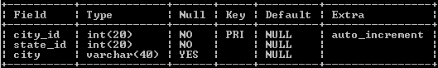

Table 4: movie_master

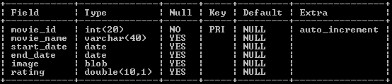

Table 5: show_time

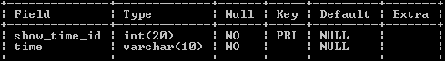

Table 6:state_master

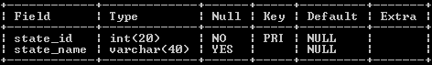

Table 7:theatre_of_city

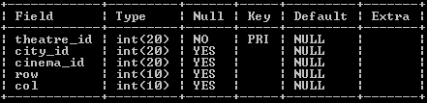

Table 8:theatre_show_time

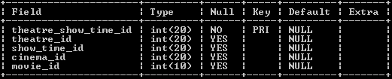

Table 9:ticket_rate

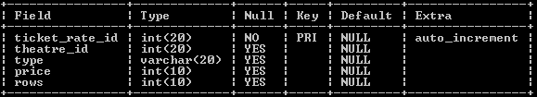

Table 10:user_selected

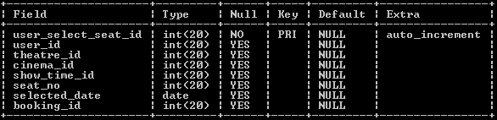

Table 11:user_table



**5. Snapshots:**

**Movies Listing:**

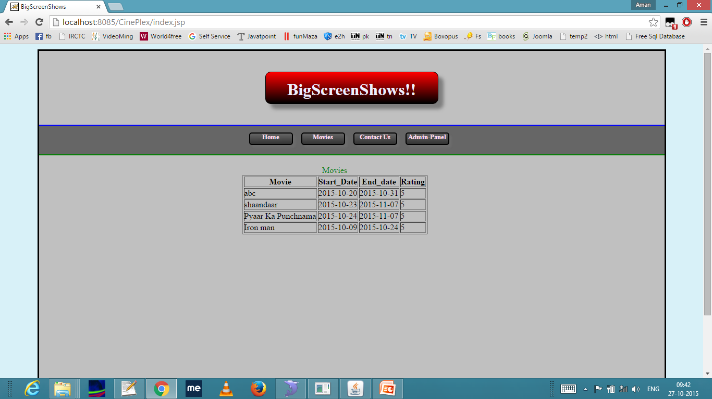

**City Selection:**

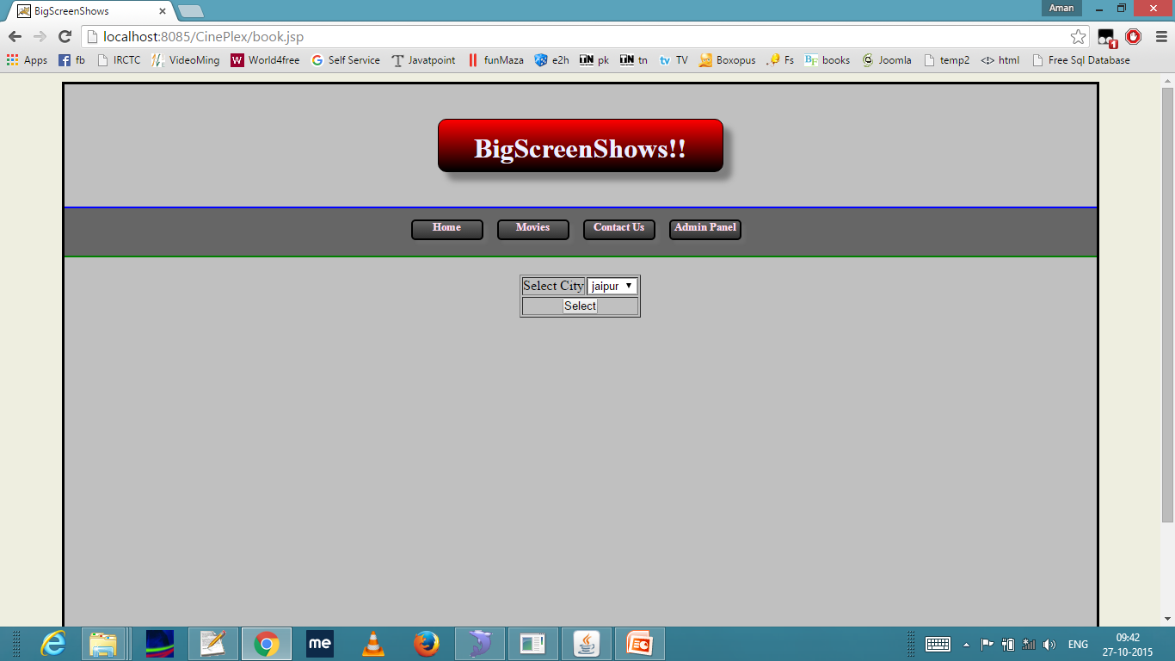

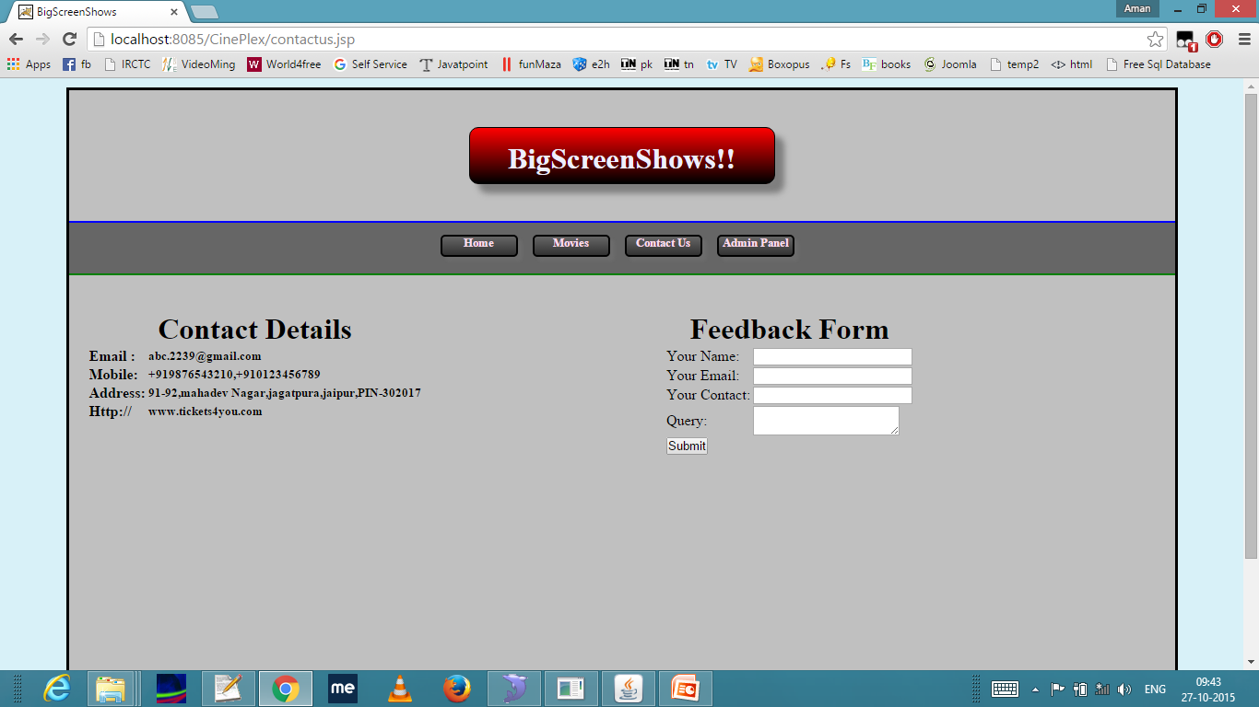

**Login Page:**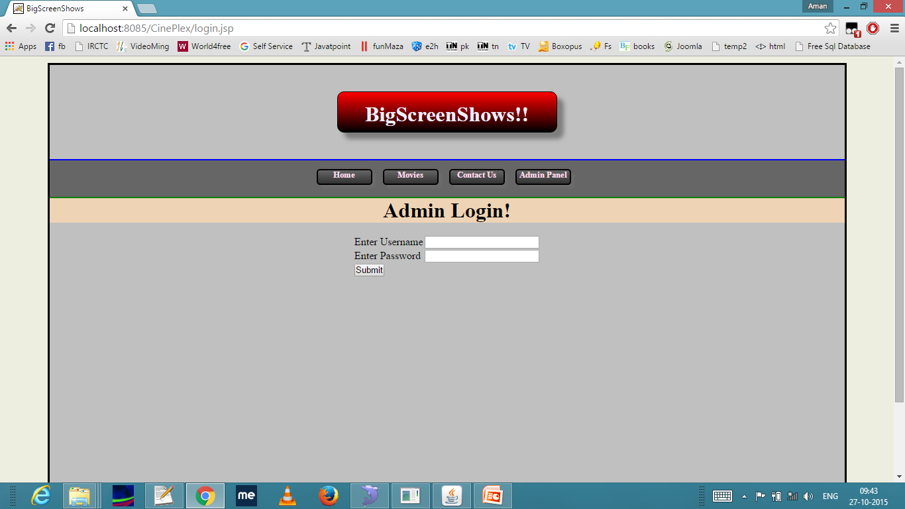

**Registeration:**

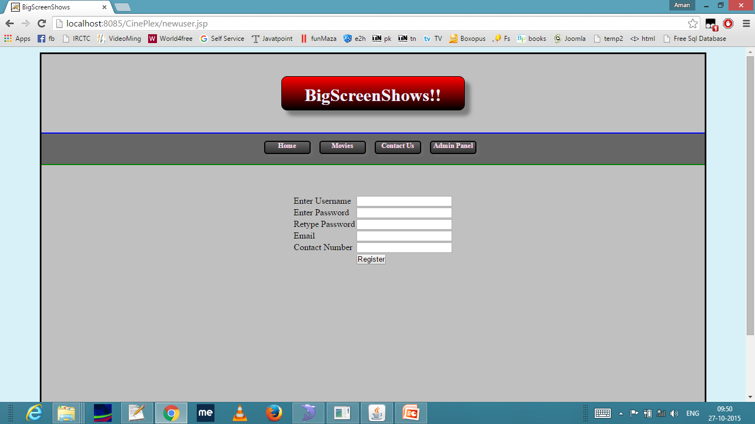

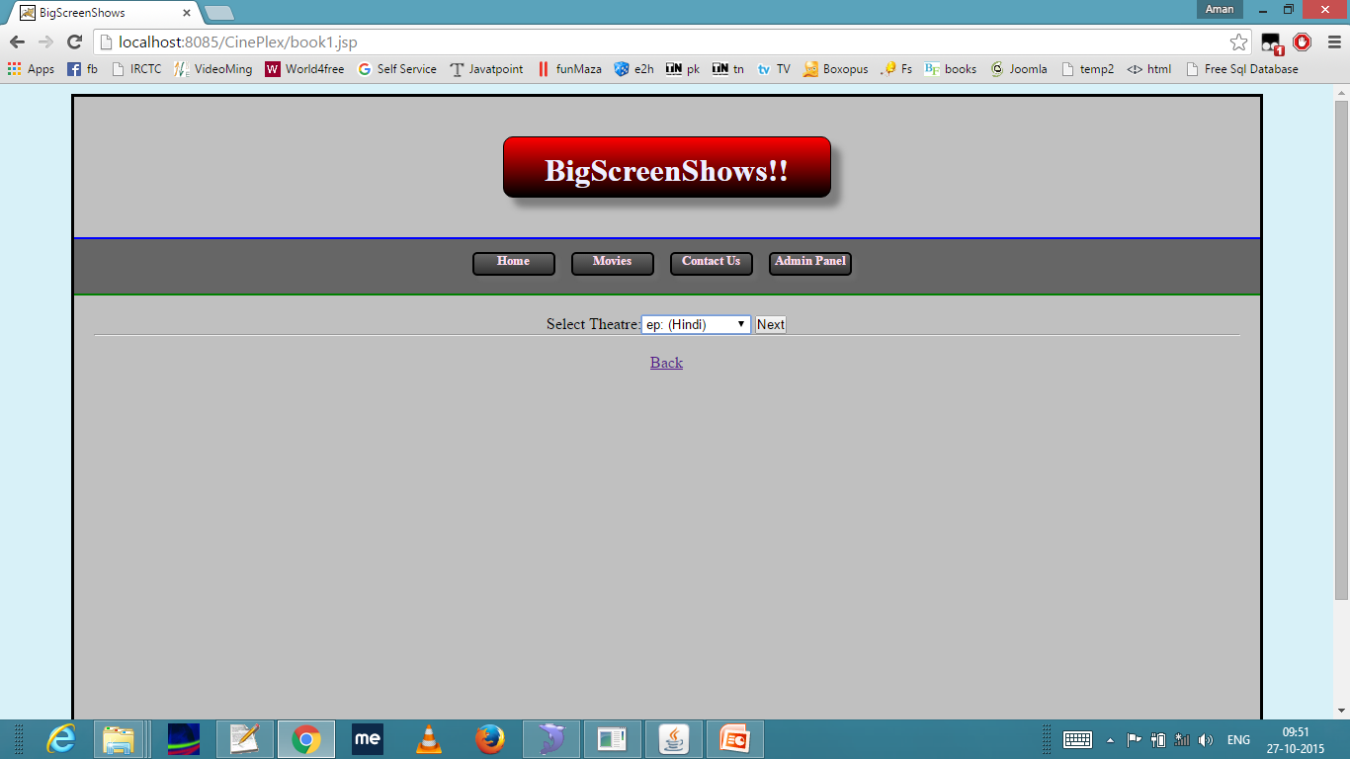

**Movie Selection:**

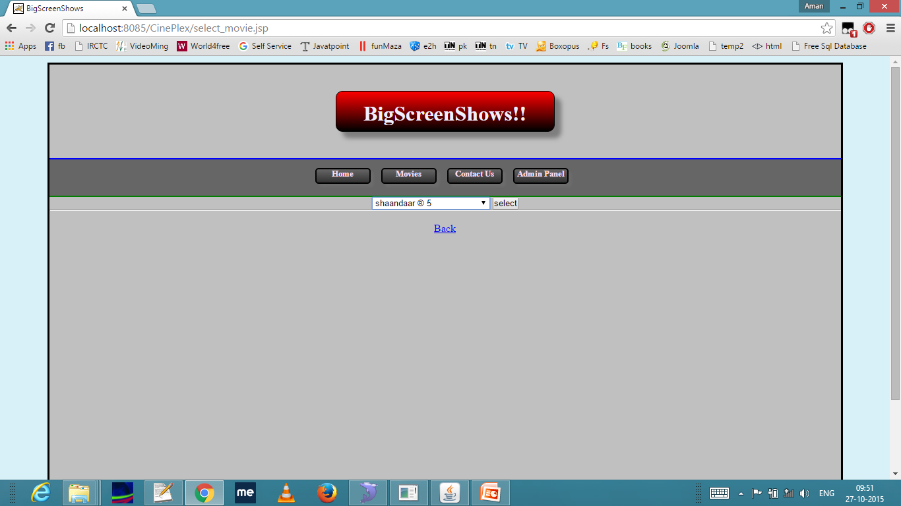

**Date Selection:**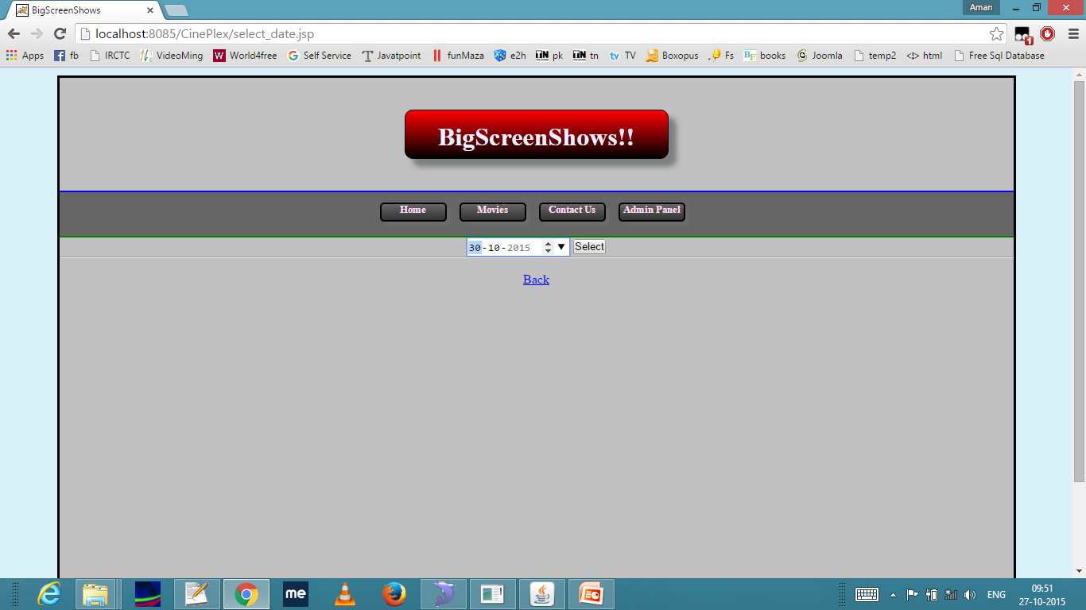

**Time Selection:**

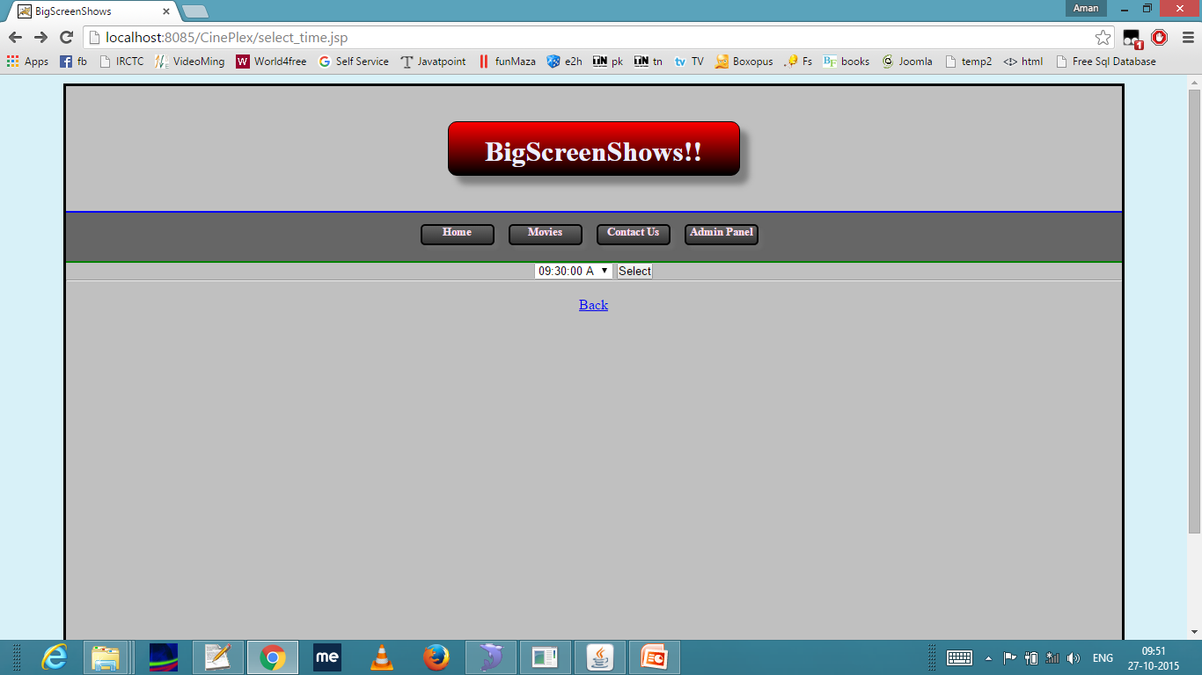

**Seat Matrix:**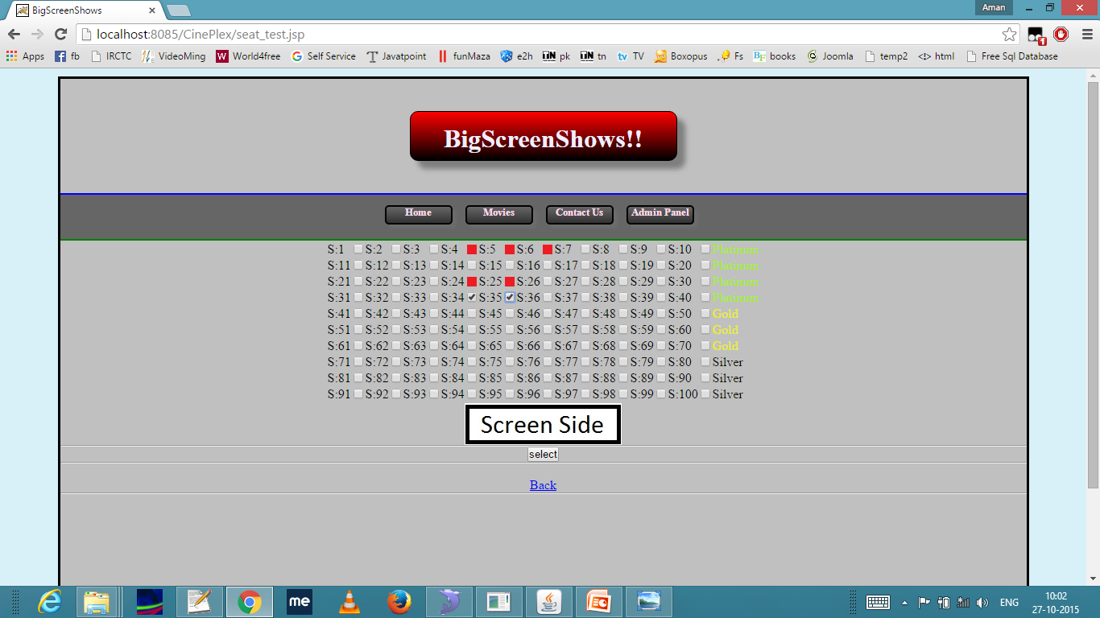

**Order Summary:**

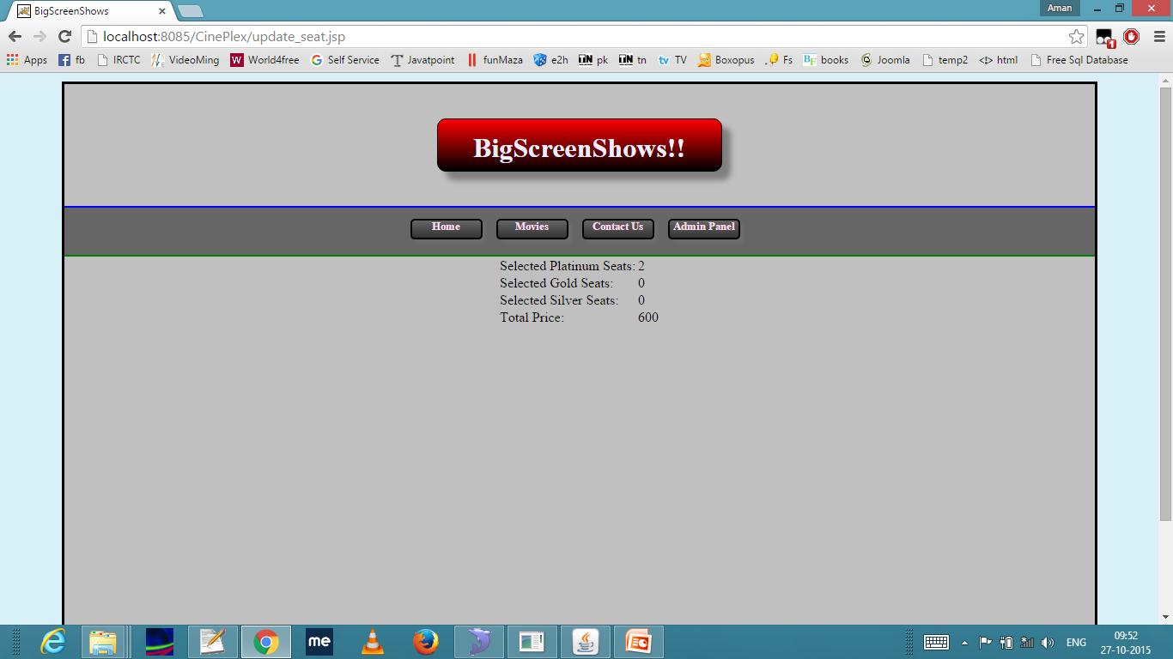

**Admin Login:**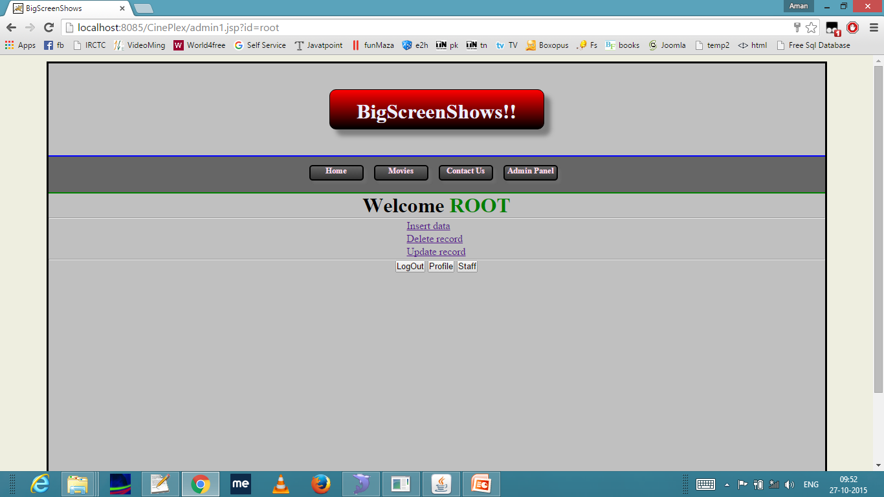

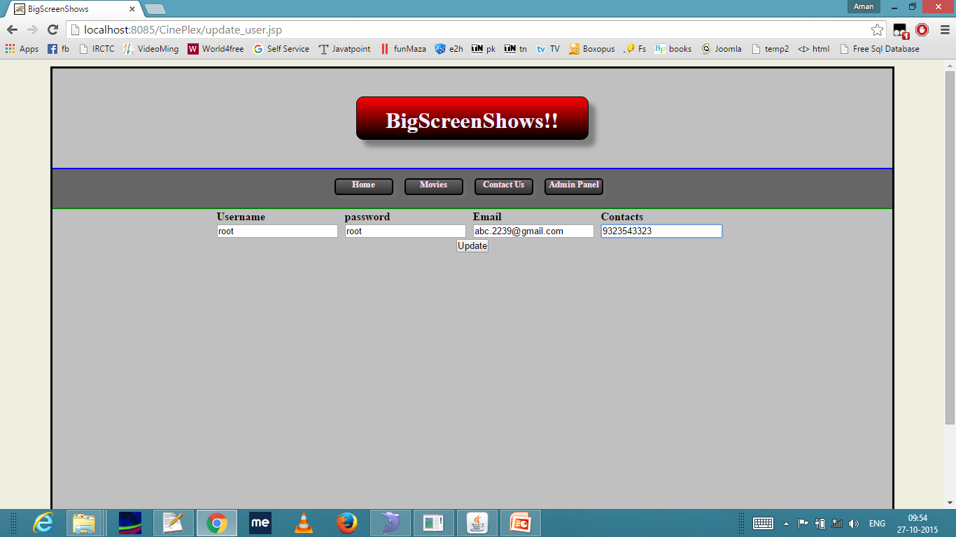

**Insert details:**

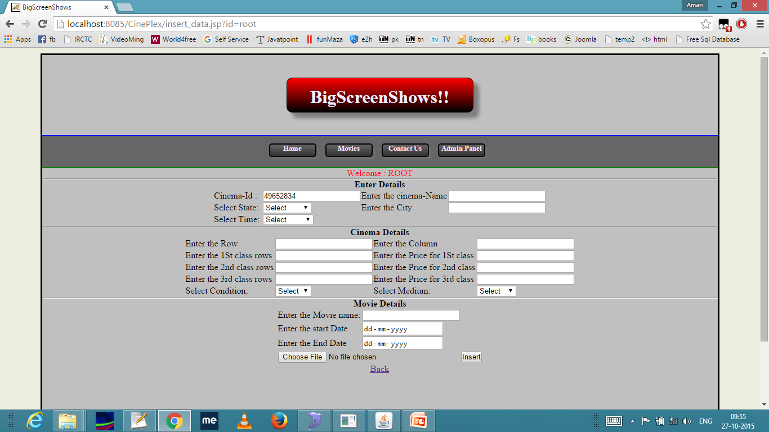

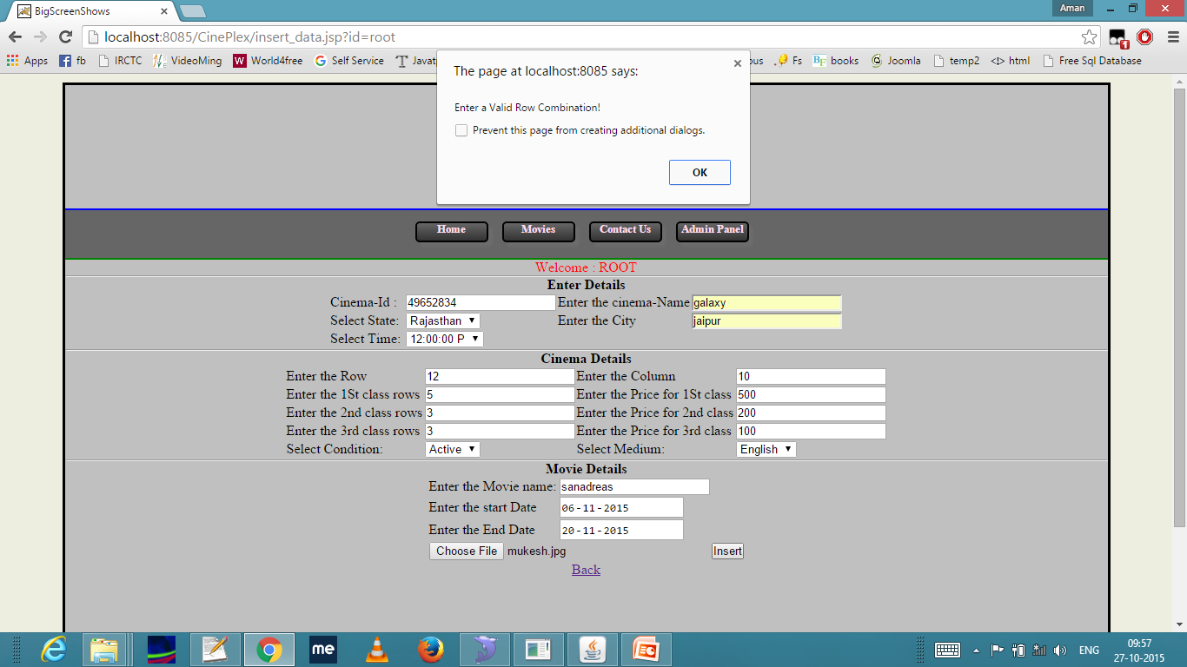

**Deleting Record:**

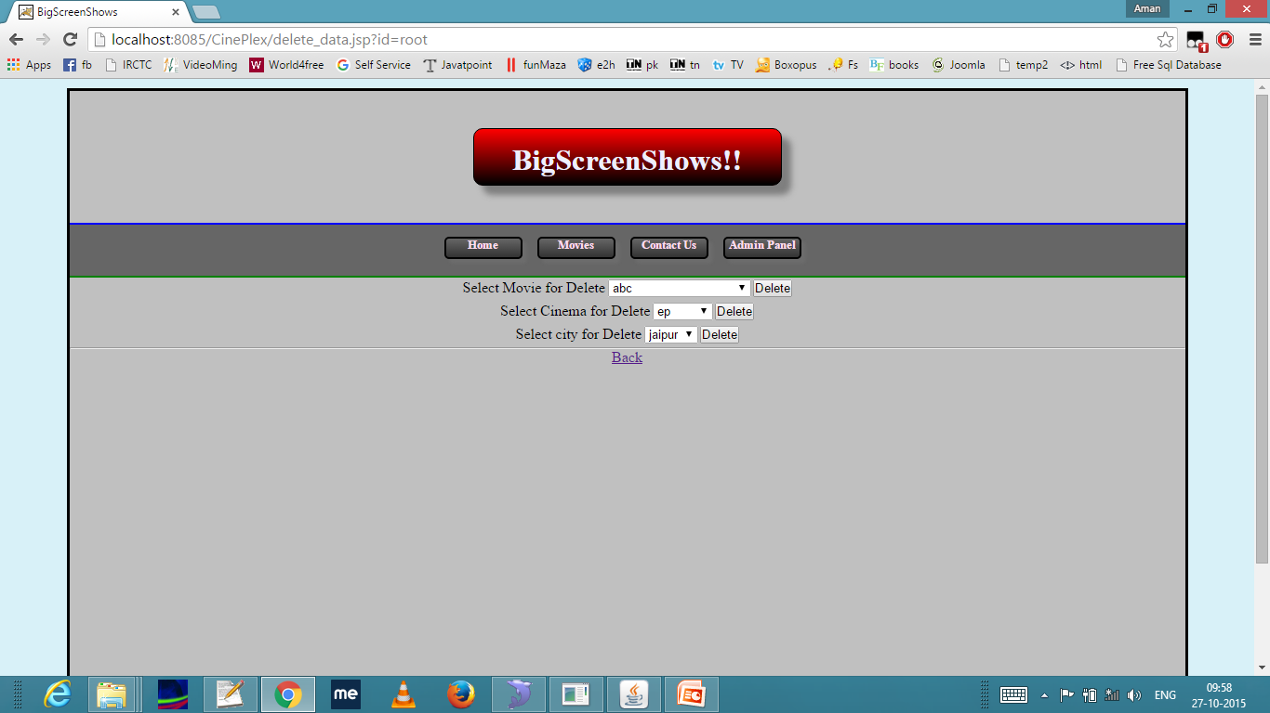

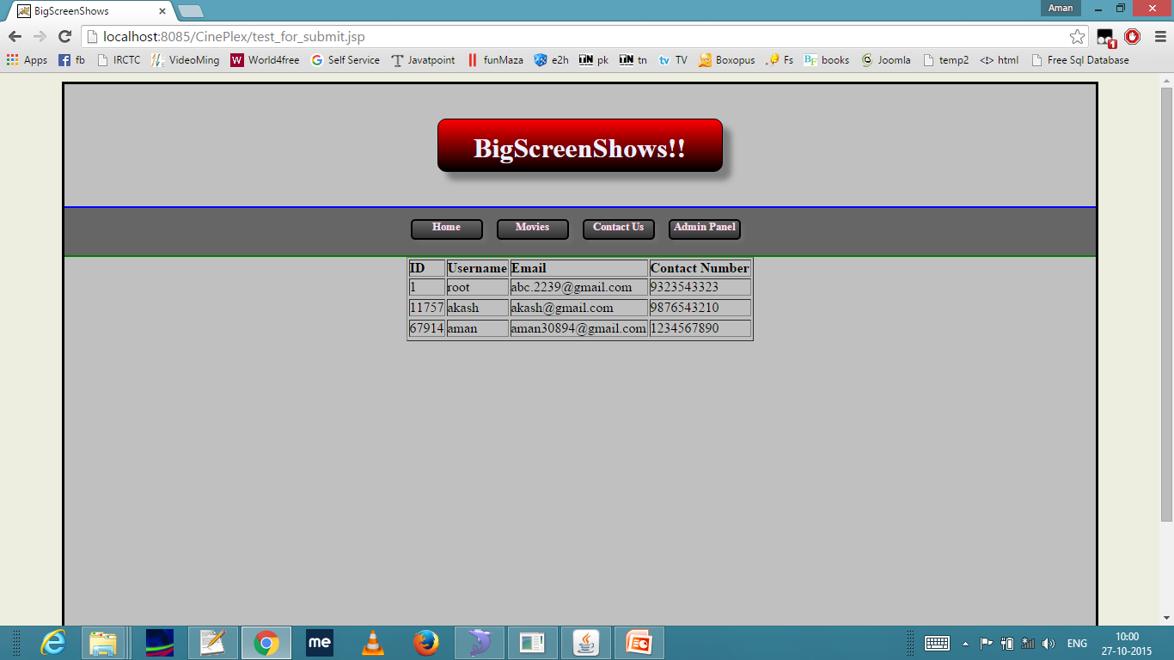

**7. System Design**

**7.1:- Activity Diagram**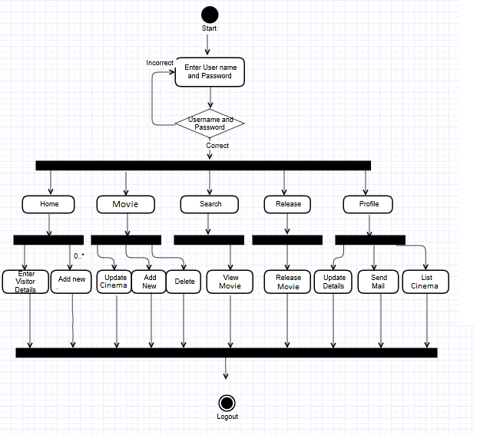

**7.2:-Component Diagram**

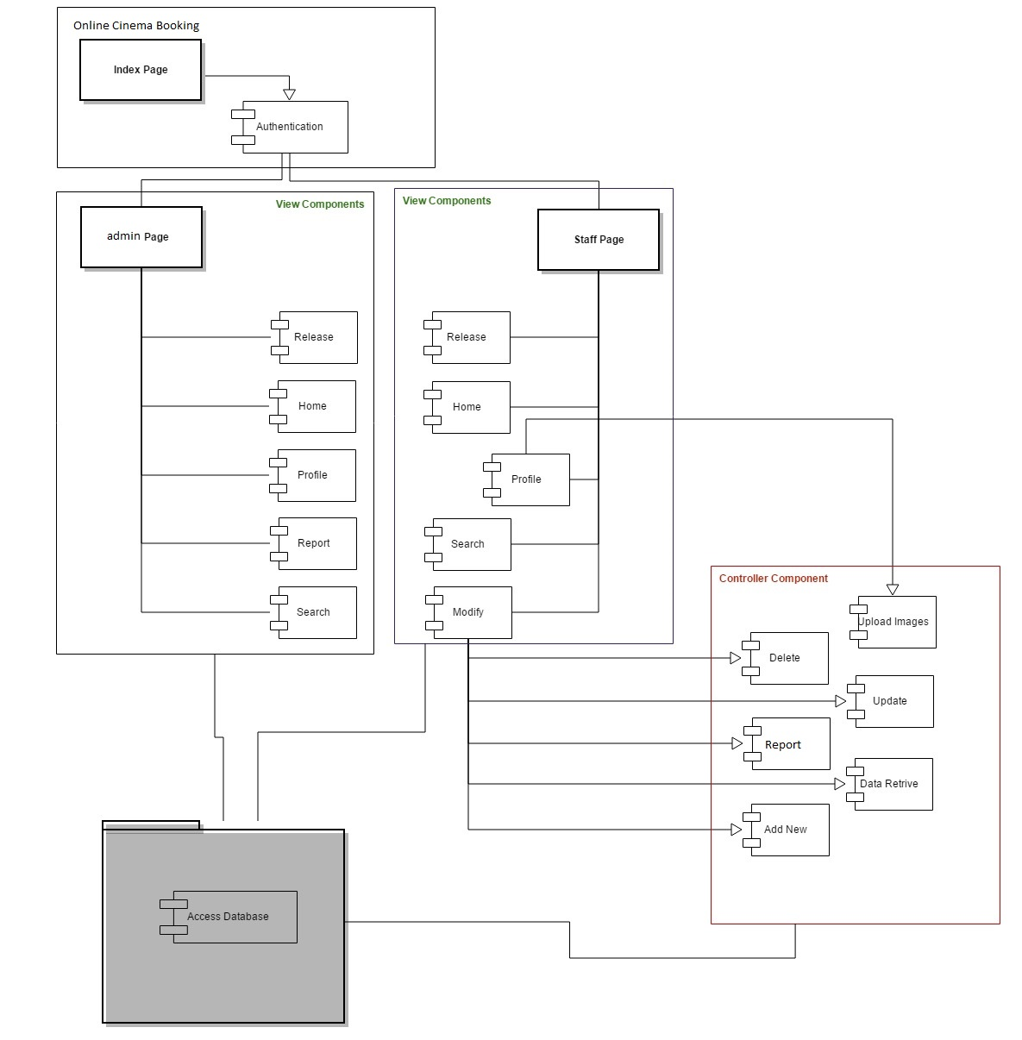

**7.3:-Use-Case Diagram**

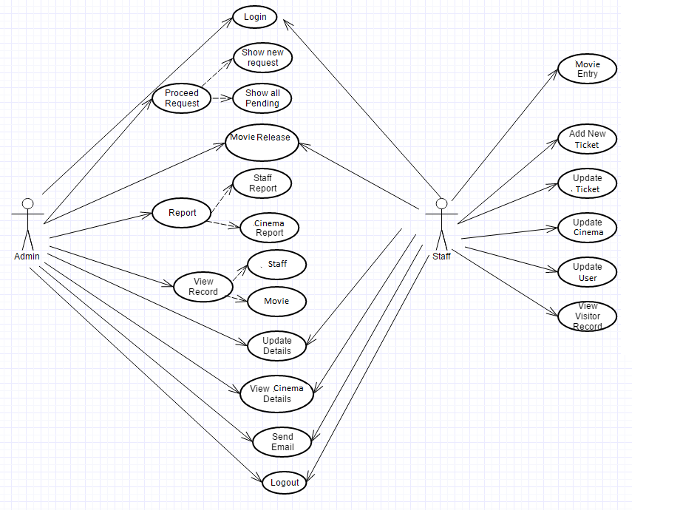

**7.4:-DFD Diagram**

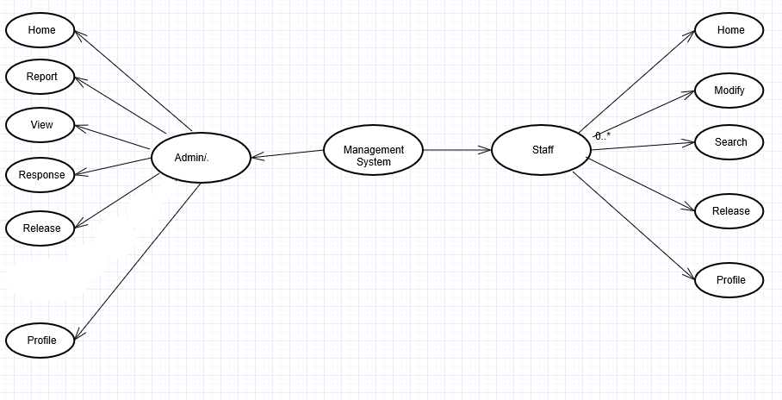

**8. Bibliography and References**

1. <http://www.functionx.com/sqlserver/> (SQL-server tutorial)
2. http://www.w3schools.com (Many Tutorials Available)
3. <http://www.javatpoint.com>
4. Java server pages,Oreily Publications
5. Database design:Korth
6. Professional Java Server Programming J2EE Edition, Wrox Press Ltd.
7. HTML- The Complete Reference, Tata Mc Graw-Hill Edition.
8. Java Server Pages,Oreily Publications.