Week 2 SQL Assignment Report
Name: komal panda
College: SOA

Q1. Write a query to display all columns and rows from the customer's table.
SQL Query:
SELECT * FROM customers;
Output Screenshot:
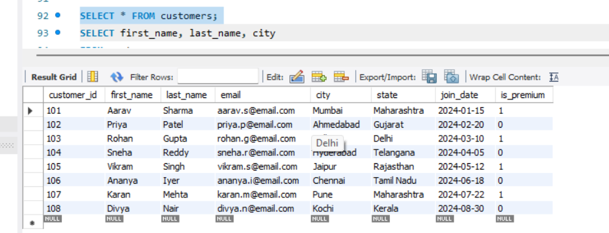
Explanation:
The SELECT * statement is used to retrieve all columns and all rows from the customers table.
- SELECT is the SQL command used to retrieve data from a database.
- * (asterisk) represents all columns in the table.
- FROM customers specifies that the data should be fetched from the customers table.

Q2. Retrieve only the first_name, last_name, and city of all customers.
SQL Query:
SELECT first_name, last_name, city
FROM customers;
Output Screenshot:
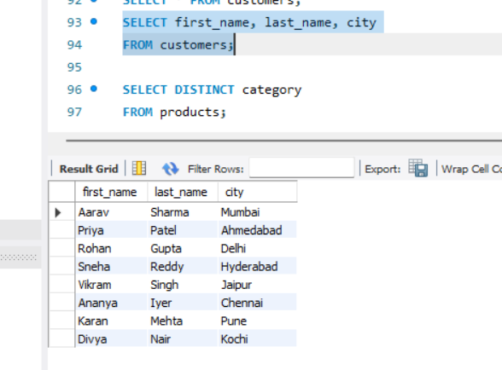
Explanation:
This query retrieves only the first name, last name, and city of all customers from the customers table.
- SELECT is used to retrieve specific data from a table.
- first_name, last_name, and city are the columns to be displayed.
- FROM customers specifies that the data should be retrieved from the customers table.

Q3. List all unique categories available in the products table.
SQL Query:
SELECT DISTINCT category FROM products;
Output Screenshot:
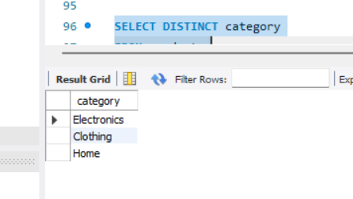
Explanation:
This query displays all unique product categories available in the products table.
- SELECT is used to retrieve data from a table.
- DISTINCT removes duplicate values and returns only unique records.
- category is the column that stores the product category.
- FROM products specifies that the data should be retrieved from the products table.

Q4. Identify the Primary Key of each table in the schema. Explain why a Primary Key must be unique and NOT NULL.
Primary Keys of Each Table
Table Name | Primary Key
customers | customer_id
products | product_id
orders | order_id
order_items | item_id

Explanation:
A Primary Key uniquely identifies each record in a table. Every row must have a different Primary Key value to avoid duplicate records and ensure that each record can be uniquely identified.
A Primary Key cannot contain NULL values because every record must have a unique identifier. If a Primary Key were NULL, the database would not be able to uniquely identify that record.

Q5. What constraints are applied to the email column in the customers table? What would happen if you tried to insert a duplicate email?
SQL Query:
INSERT INTO customers
(customer_id, first_name, last_name, email, city, state, join_date, is_premium)
VALUES
(109, 'Test', 'User', 'aarav.s@email.com', 'Delhi', 'Delhi', '2024-09-01', TRUE);
Output Screenshot:
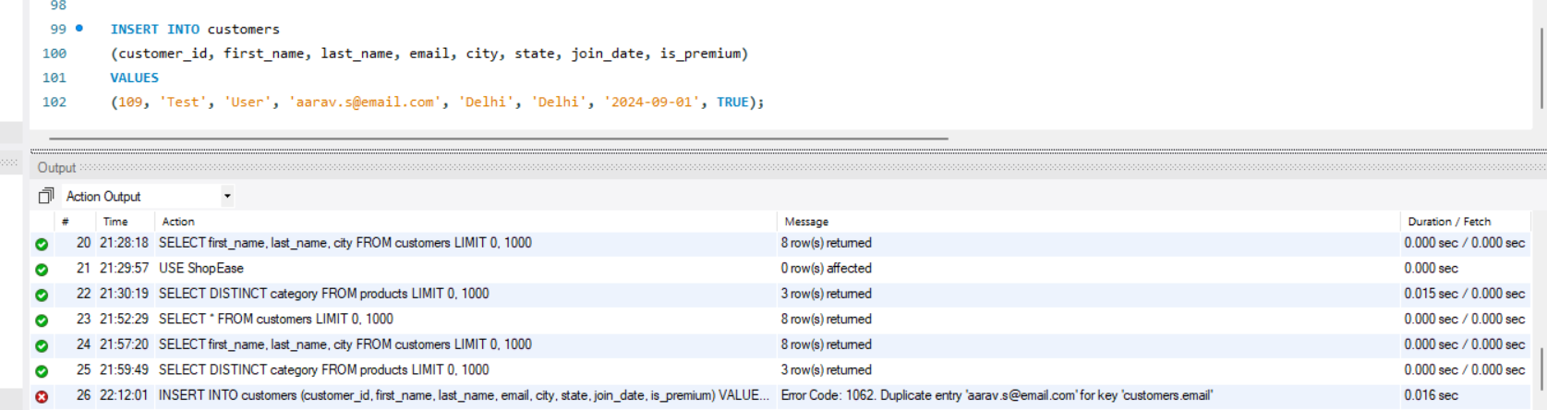
Explanation:
The email column in the customers table has the following constraints:
- UNIQUE: Ensures that each customer has a unique email address. Duplicate email values are not allowed.
- NOT NULL: Ensures that every customer record must have an email address. The email field cannot be left empty (NULL).
When attempting to insert a customer with an email address that already exists in the table (for example, aarav.s@email.com), the database rejects the insertion and displays a Duplicate Entry error because of the UNIQUE constraint.

Q6. Try inserting a product with unit_price = -50. What happens and which constraint prevents it? Write both the INSERT statement and explain the error.
SQL Query:
INSERT INTO products
(product_id, product_name, category, brand, unit_price, stock_qty)
VALUES
(209, 'Wireless Mouse', 'Electronics', 'Logitech', -50, 100);
Output Screenshot:
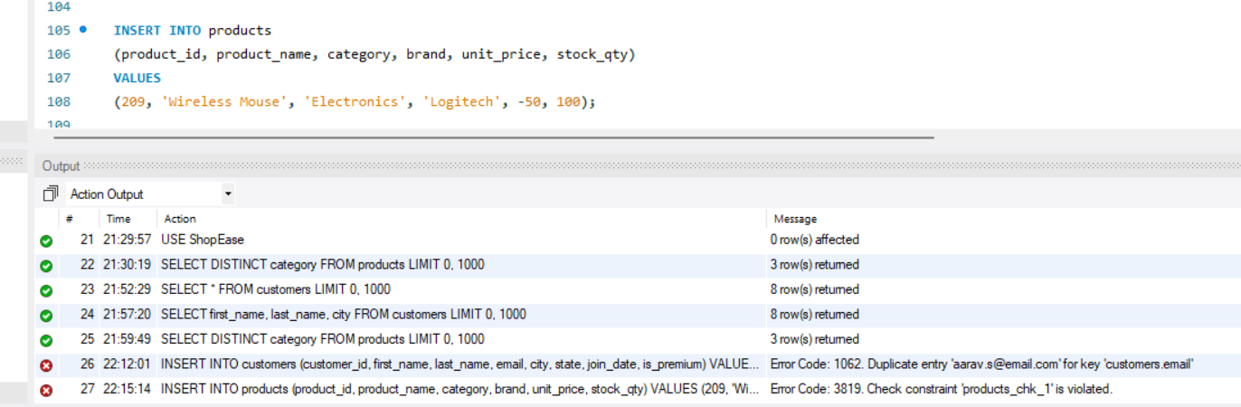
Explanation:
The above query attempts to insert a product with a negative unit price (-50) into the products table.
However, the products table has the following constraint on the unit_price column:
CHECK (unit_price > 0)
This CHECK constraint ensures that the unit price must always be greater than 0. Since -50 is less than 0, the database rejects the insertion and generates an error.
This constraint helps maintain data integrity by preventing invalid product prices from being stored in the database.

Q7. Retrieve all orders with status = 'Delivered'.
SQL Query:
SELECT *
FROM orders
WHERE status = 'Delivered';
Output Screenshot:
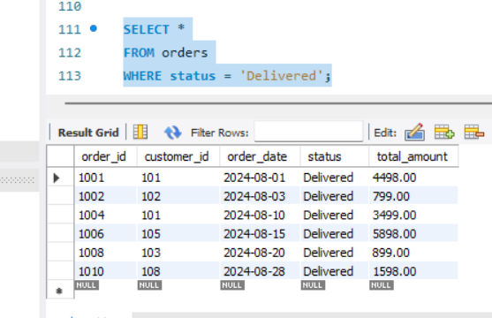
Explanation:
This query retrieves all records from the orders table where the order status is 'Delivered'.
- SELECT * retrieves all columns from the table.
- FROM orders specifies that the data should be retrieved from the orders table.
- WHERE status = 'Delivered' filters the records and returns only those orders whose status is Delivered.

Q8. Find all products in the 'Electronics' category with a unit_price greater than ₹2000.
SQL Query:
SELECT *
FROM products
WHERE category = 'Electronics'
AND unit_price > 2000;
Output Screenshot:
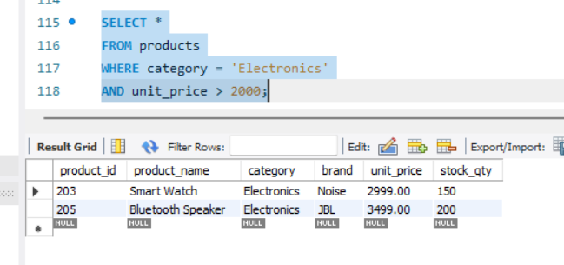
Explanation:
This query retrieves all products from the products table that belong to the Electronics category and have a unit price greater than ₹2000.
- WHERE filters the records based on the given conditions.
- AND ensures that both conditions are satisfied.

Q9. List all customers who joined in the year 2024 and belong to the state 'Maharashtra'.
SQL Query:
SELECT *
FROM customers
WHERE join_date BETWEEN '2024-01-01' AND '2024-12-31'
AND state = 'Maharashtra';
Output Screenshot:
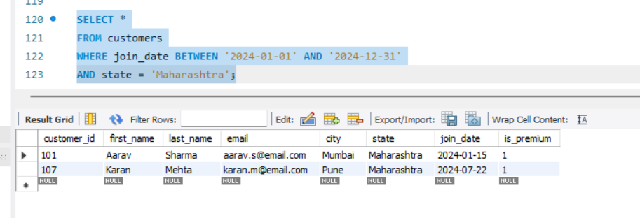
Explanation:
This query retrieves all customers who joined in 2024 and belong to the state Maharashtra.
- WHERE filters the records based on the given conditions.
- AND ensures that both conditions are satisfied.

Q10. Find all orders placed between '2024-08-10' and '2024-08-25' (inclusive) that are NOT cancelled.
SQL Query:
SELECT *
FROM orders
WHERE order_date BETWEEN '2024-08-10' AND '2024-08-25'
AND status <> 'Cancelled';
Output Screenshot:
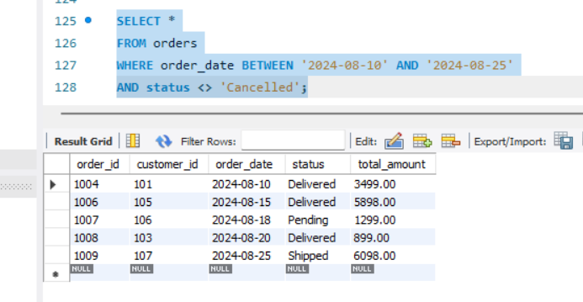
Explanation:
This query retrieves all orders placed between 10 August 2024 and 25 August 2024 that are not cancelled.
- BETWEEN filters orders within the specified date range.
- status <> 'Cancelled' excludes cancelled orders.

Q11. Explain what the index idx_orders_date does. Write a sample query that benefits from it.
SQL Query:
SELECT *
FROM orders
WHERE order_date BETWEEN '2024-08-01' AND '2024-08-31';
Output Screenshot:
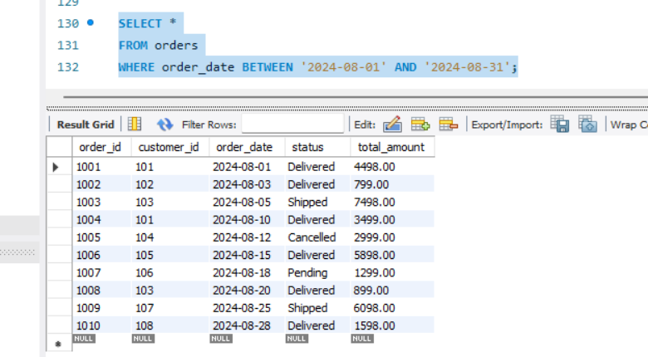
Explanation:
The idx_orders_date index is created on the order_date column. It helps the database find records based on the order date more quickly without scanning the entire table, improving query performance.

Q12. Explain whether YEAR(join_date)=2024 uses an index and rewrite it in an index-friendly way.
SQL Query:
SELECT *
FROM customers
WHERE join_date BETWEEN '2024-01-01' AND '2024-12-31';
Output Screenshot:
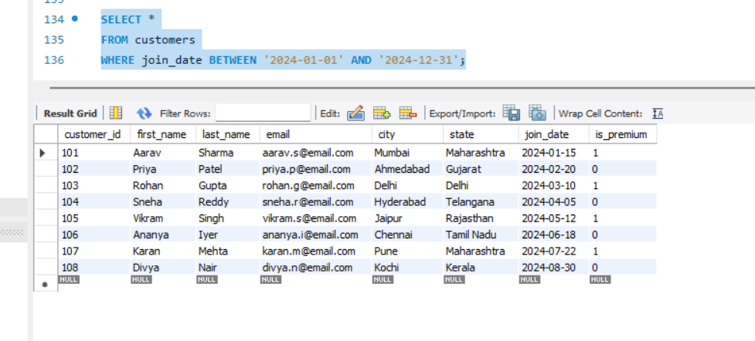
Explanation:
The query YEAR(join_date) = 2024 does not use the index efficiently because the YEAR() function is applied to the join_date column.

Q13. Count the total number of orders.
SQL Query:
SELECT COUNT(*) AS total_orders
FROM orders;
Output Screenshot:
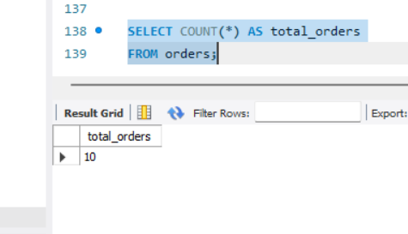
Explanation:
This query counts the total number of records in the orders table.
- COUNT(*) counts all rows in the table.
- AS total_orders gives a meaningful name to the output column.

Q14. Find total revenue from Delivered orders.
SQL Query:
SELECT SUM(total_amount) AS total_revenue
FROM orders
WHERE status = 'Delivered';
Output Screenshot:
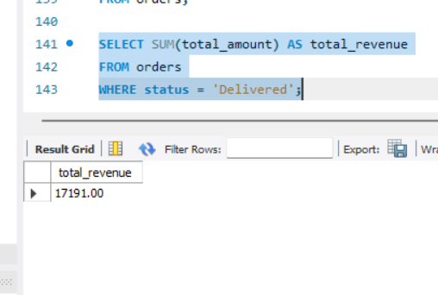
Explanation:
This query calculates the total revenue generated from all Delivered orders.
- SUM(total_amount) adds the total amount of all delivered orders.
- WHERE status = 'Delivered' includes only delivered orders in the calculation.

Q15. Calculate average unit_price of products in each category.
SQL Query:
SELECT category, AVG(unit_price) AS average_price
FROM products
GROUP BY category;
Output Screenshot:
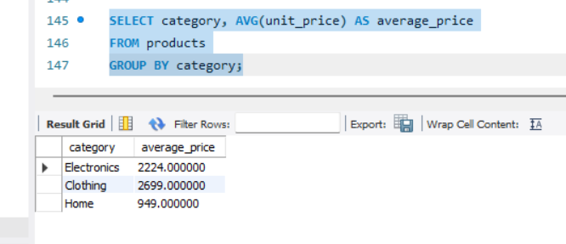
Explanation:
This query calculates the average unit price of products for each category.
- AVG(unit_price) calculates the average price.
- GROUP BY category groups the products based on their category before calculating the average.

Q16. For each order status, find order count and total revenue.
SQL Query:
SELECT status,
COUNT(*) AS order_count,
SUM(total_amount) AS total_revenue
FROM orders
GROUP BY status
ORDER BY total_revenue DESC;
Output Screenshot:
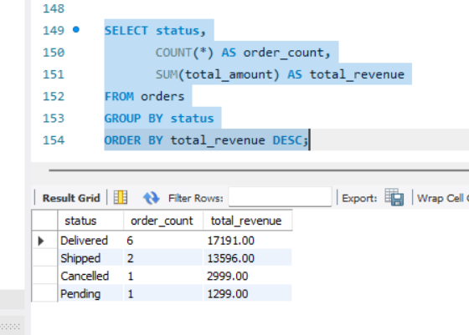
Explanation:
This query calculates the total number of orders and total revenue for each order status using GROUP BY.
The results are sorted in descending order of total revenue using ORDER BY.

Q17. Find MAX and MIN priced product in each category.
SQL Query:
SELECT category,
MAX(unit_price) AS highest_price,
MIN(unit_price) AS lowest_price
FROM products
GROUP BY category;
Output Screenshot:
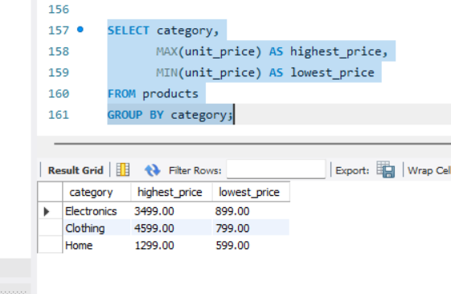
Explanation:
This query finds the highest and lowest product price in each category.
MAX() returns the maximum price, MIN() returns the minimum price, and GROUP BY groups the products by category.

Q18. Categories where average unit_price > ₹2000.
SQL Query:
SELECT category, AVG(unit_price) AS average_price
FROM products
GROUP BY category
HAVING AVG(unit_price) > 2000;
Output Screenshot:
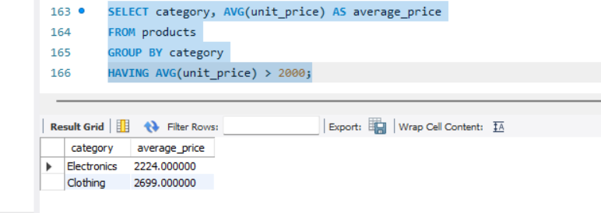
Explanation:
This query calculates the average unit price for each product category and displays only those categories whose average price is greater than ₹2000.
The HAVING clause filters the grouped results based on the average price.

Q19. INNER JOIN: orders with customer details.
SQL Query:
SELECT o.order_id,
o.order_date,
c.first_name,
c.last_name,
o.total_amount
FROM orders o
INNER JOIN customers c
ON o.customer_id = c.customer_id;
Output Screenshot:
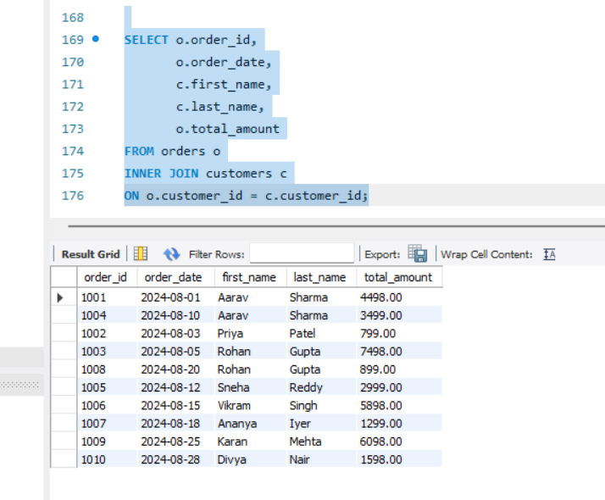
Explanation:
This query uses an INNER JOIN to combine the orders and customers tables based on the customer_id.
It displays the order details along with the corresponding customer's first name and last name.

Q20. LEFT JOIN: all customers and their orders.
SQL Query:
SELECT c.customer_id,
c.first_name,
c.last_name,
o.order_id,
o.order_date,
o.status
FROM customers c
LEFT JOIN orders o
ON c.customer_id = o.customer_id;
Output Screenshot:
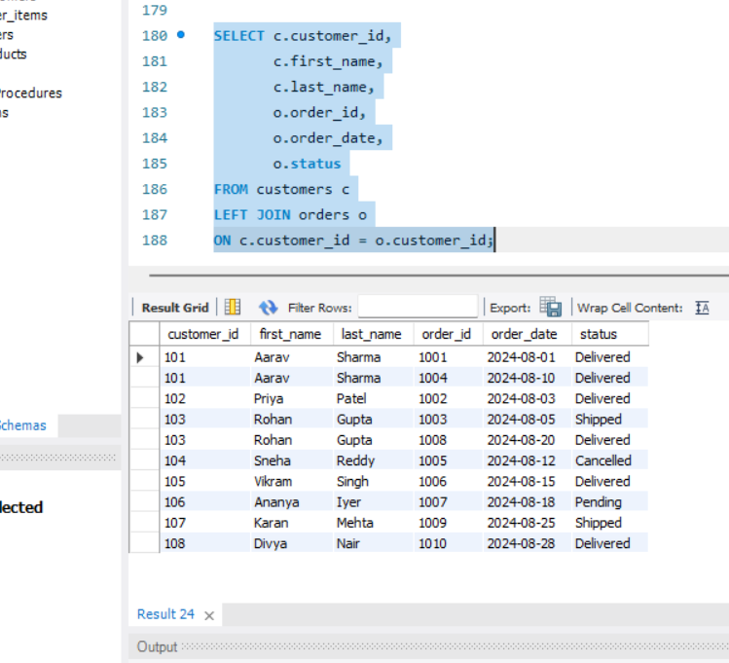
Explanation:
This query uses a LEFT JOIN to display all customers and their corresponding orders.
If a customer has no orders, the order-related columns are displayed as NULL.

Q21. JOIN across orders, order_items and products.
SQL Query:
SELECT o.order_id,
p.product_name,
oi.quantity,
oi.unit_price,
oi.discount_pct
FROM orders o
INNER JOIN order_items oi
ON o.order_id = oi.order_id
INNER JOIN products p
ON oi.product_id = p.product_id;
Output Screenshot:
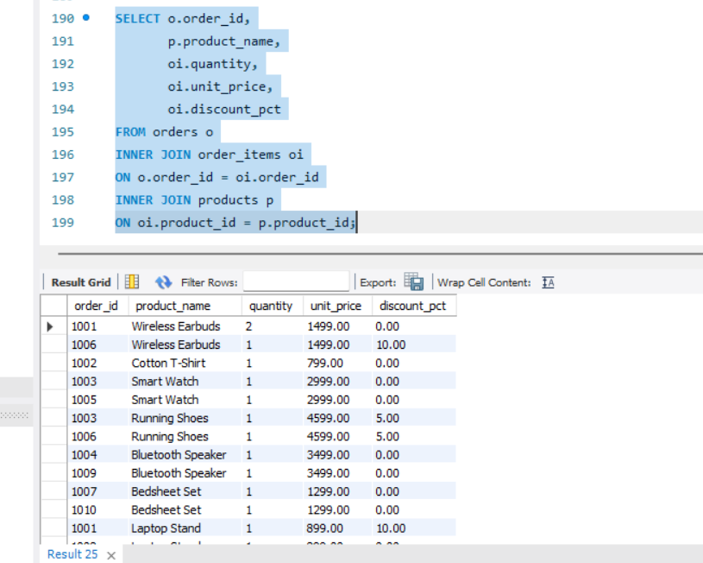
Explanation:
This query joins the orders, order_items, and products tables to display details of each ordered product.
It retrieves the order ID, product name, quantity, unit price, and discount for every order item

Q22. Explain LEFT JOIN vs RIGHT JOIN. When use FULL OUTER JOIN?
• LEFT JOIN returns all records from the left table (customers) and the matching records from the right table (orders). If there is no matching order, the order columns contain NULL.
• RIGHT JOIN returns all records from the right table (orders) and the matching records from the left table (customers). If there is no matching customer, the customer columns contain NULL.
• FULL OUTER JOIN returns all records from both tables, matching where possible. If there is no match on either side, the missing columns are filled with NULL. It is useful when you want to see all customers and all orders, including unmatched records.

Q23. Identify all Foreign Keys and explain inserting invalid customer_id.
SQL Query:
INSERT INTO orders
(order_id, customer_id, order_date, status, total_amount)
VALUES
(1011, 999, '2024-09-01', 'Pending', 1500.00);
Output Screenshot:
Explanation:
Foreign Key Relationships
- orders.customer_id → customers.customer_id
- order_items.order_id → orders.order_id
- order_items.product_id → products.product_id
If you try to insert an order with customer_id = 999, the database will reject the insertion because 999 does not exist in the customers table. This violates the Foreign Key constraint.

Q24. CASE statement for product price tiers.
SQL Query:
SELECT product_name,
unit_price,
CASE
WHEN unit_price < 1000 THEN 'Budget'
WHEN unit_price BETWEEN 1000 AND 3000 THEN 'Mid-Range'
ELSE 'Premium'
END AS price_tier
FROM products;
Output Screenshot:
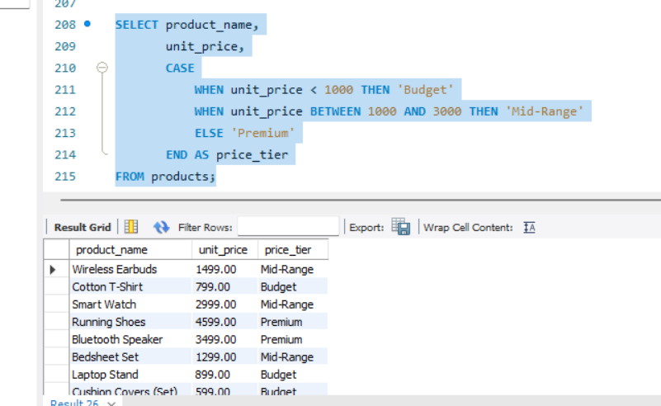
Explanation:
This query uses the CASE statement to classify products into Budget, Mid-Range, and Premium price categories based on their unit_price.
CASE works like an IF-ELSE statement in SQL and returns the appropriate price tier for each product.

Q25. CASE with aggregate: Delivered vs Not Delivered.
SQL Query:
SELECT
SUM(CASE WHEN status = 'Delivered' THEN 1 ELSE 0 END) AS Delivered_Orders,
SUM(CASE WHEN status <> 'Delivered' THEN 1 ELSE 0 END) AS Not_Delivered_Orders
FROM orders;
Output Screenshot:
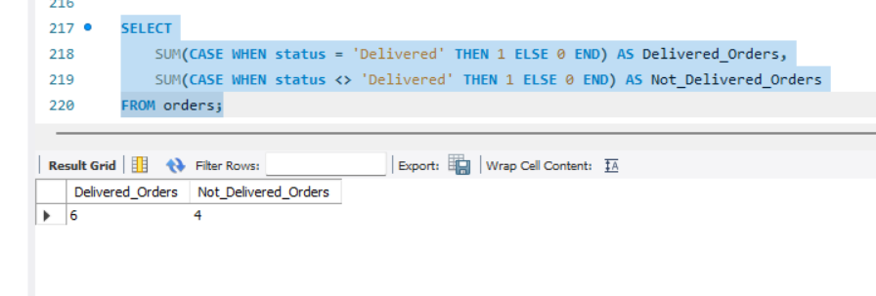
Explanation:
This query uses the CASE statement with the SUM() function to count Delivered and Not Delivered orders in a single row.
CASE assigns 1 to matching records and 0 to others, while SUM() calculates the total count.

Q26. Explain ACID properties with example.
ACID properties ensure that database transactions are reliable and maintain data integrity.
A — Atomicity
A transaction is treated as a single unit. Either all operations succeed or none of them are applied.
Example: In a bank transfer, money is deducted from Account A and added to Account B. If the second step fails, the deduction is also rolled back.
C — Consistency
The database moves from one valid state to another valid state.
Example: If a customer places an order, related records such as order details and stock updates must remain consistent with database rules and constraints.
I — Isolation
Multiple transactions running at the same time should not interfere with each other.
Example: Two customers purchasing the same product simultaneously should not cause incorrect stock calculations.
D — Durability
Once a transaction is committed, the changes are permanently saved.
Example: After an online payment is confirmed, the order remains recorded even if the server crashes immediately afterward.
Q27. Write a transaction using BEGIN/COMMIT/ROLLBACK
This transaction inserts a new order, adds two order items, and updates the stock quantity of the purchased products.
If all statements execute successfully, the transaction is saved using COMMIT. If any statement fails, ROLLBACK is used to undo all changes, ensuring data consistency.
