**Customer Onboarding**

**Application**



| **Document Information and Revision History** | |
| --- | --- |
| FileName | Customer Onboarding Application |
| Document Owner | Komal Gangajalia |
| Last File Saved Date | 24th Oct 2018 |

Table of Contents

1. Background 3

1.1. Purpose of this document 4

1.2. Component used for this Application 5

1.3. Overview of Custoemr Onboarding 6

1.4.Database Structure 3

Purpose of this Document

The purpose of this document is to provide a high-level description of the design components necessary to build customer onboarding application. The document will include core components of the application, architectural overview and database design.

**Customer Details:**

It is used to Onboard a new customer, amend existing customer details and allows to remove the data from the application.

Please note, when we delete customer information from the application it will get disappear from the application. However, inside database it will remain as it is, so in future if we want to retrieve the report we can retrieve it.

**Component Used to Build Application:**

| Component | Description |
| --- | --- |
| Technology | ASP.NET Core MVC |
| Framework | .NET Core 2.1 |
| OS | Windows 10 Pro 6.3 (X64) |
| Architecture | MVC |
| Database | Microsoft SQL Server 2016 (SP1) (KB3182545) - 13.0.4001.0 (X64) |

**Overview of Customer Application**

Customer Detail

This form allows user to view the existing customer details.

It also, allows user to amend or delete the existing customer details.

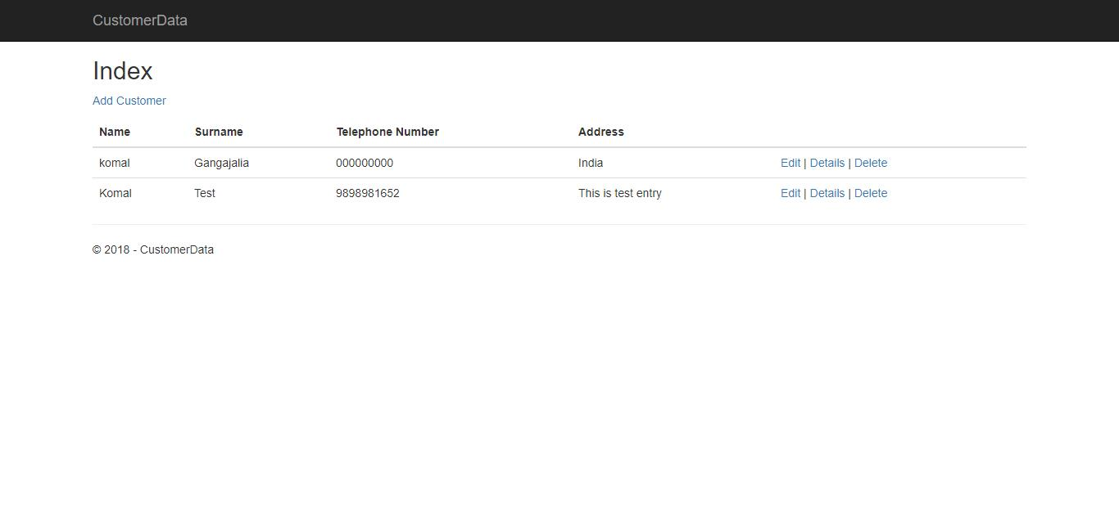

Add Customer

This Form Allows end user to onboard new customer.

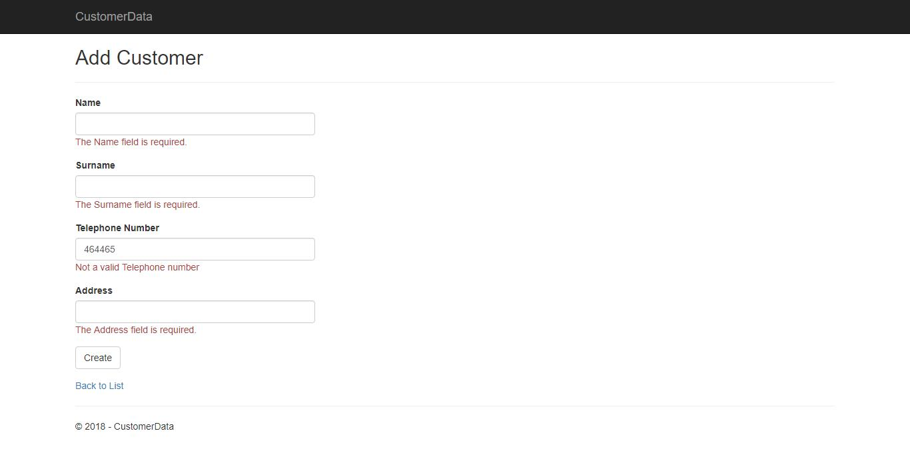



Edit Customer

This Form allows user to amend existing customer data.

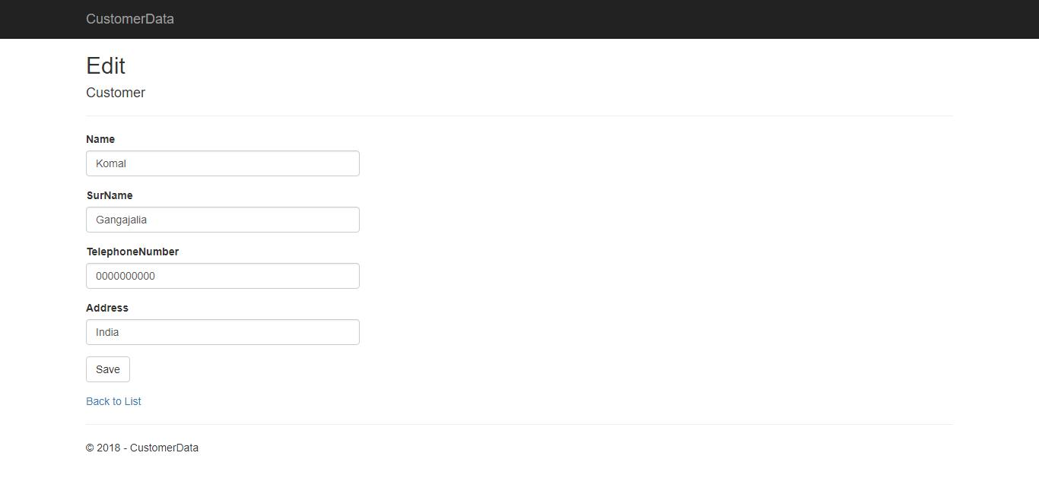

Delete Customer

This form allows to soft delete existing customer details from the application

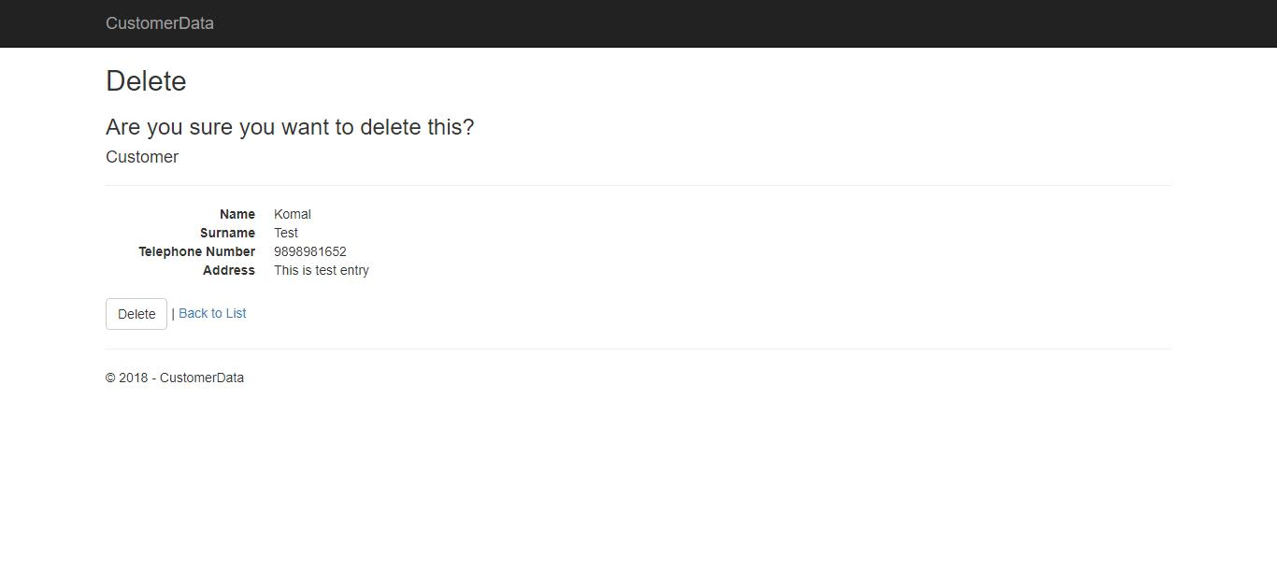



**Database Structure**

Table

Dbo.Customer

Stored Procedure

1. spAddCustomer
2. spDeletecustomer
3. spGetAllcustomer
4. spUpdatecustomer

