Exersice11
Que1:Devlop a movie thetre booking simulator that manages a 3*3 seating grid layout the program should accept user row and column selection and change that seats satus keywords from “o”(open) to “x”(reserved)

seats = [
["O", "O", "O"],
["O", "O", "O"],
["O", "O", "O"]
]

def display_seats():
print("\nSeating Layout:")
for row in seats:
print(" ".join(row))
display_seats()
row = int(input("Enter row (1-3): "))
column = int(input("Enter column (1-3): "))
row -= 1
column -= 1
if seats[row][column] == "O":
seats[row][column] = "X"
print("Seat reserved successfully!")
else:
print("Sorry, that seat is already reserved.")

display_seats()
Output:

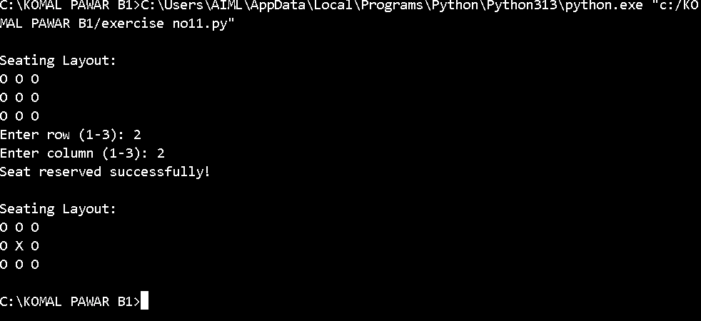
Que.2: create adaily class schedule grid where each row represent an hour slot and column correspond to day of week , allowing users to view or overwrite subject topics dynamically

days = ["Monday", "Tuesday", "Wednesday", "Thursday", "Friday"]
hours = ["9 AM", "10 AM", "11 AM", "12 PM", "1 PM"]
schedule = [["Free" for _ in days] for _ in hours]
def display_schedule():
print("\nDaily Class Schedule")
print("-" * 70)
print(f"{'Time':<10}", end="")
for day in days:
print(f"{day:<12}", end="")
print()
for i, hour in enumerate(hours):
print(f"{hour:<10}", end="")
for j in range(len(days)):
print(f"{schedule[i][j]:<12}", end="")
print()
while True:
display_schedule()
print("\n1. View subject")
print("2. Overwrite subject")
print("3. Exit")
choice = input("Enter your choice: ")
if choice == "1":
day = input("Enter day: ").capitalize()
hour = input("Enter hour (e.g. 10 AM): ").upper()
if day in days and hour in [h.upper() for h in hours]:
row = [h.upper() for h in hours].index(hour)
column = days.index(day)
print(f"Subject: {schedule[row][column]}")
else:
print("Invalid day or hour.")
elif choice == "2":
day = input("Enter day: ").capitalize()
hour = input("Enter hour (e.g. 10 AM): ").upper()
subject = input("Enter new subject/topic: ")
if day in days and hour in [h.upper() for h in hours]:
row = [h.upper() for h in hours].index(hour)
column = days.index(day)
schedule[row][column] = subject
print("Schedule updated successfully!")
else:
print("Invalid day or hour.")
elif choice == "3":
print("Exiting schedule manager.")
break
else:
print("Invalid choice.")
Output:
