# Bansilal Ramnath Agarwal Charitable Trust’s

Vishwakarma Institute of Technology, Pune-37

*(Autonomous Institute of Savitribai Phule Pune University)*



**Department of Computer Engineering**

|  |  |
| --- | --- |
| **Division** | **CS TY B** |
| **Batch** | **3** |
| **GR no.** | **12320165** |
| **Roll no.** | **83** |
| **Name** | **Komal Mahadev Potdar** |

**Assignment No. 2**

**Title:** Setting up small computer networks and Hands on networking commands:Set up a small wired and wireless network of 2 to 4 computers using Hub/Switch/Access point. It includes installation of LAN Cards, Preparation of Cables/ Installation and Configuration of Access Point, Assigning unique IP addresses and use of ping utility. Hands on for network commands - ping, pathping, ipconfig/ifconfig, arp, netstat, nbtstat, nslookup, route, traceroute/tracert, nmap.

**Description:**

#### **1. ipconfig**

**Description:**  
Displays all current TCP/IP network configuration values and refreshes Dynamic Host Configuration Protocol (DHCP) and Domain Name System (DNS) settings.

**Syntax:**  
ipconfig

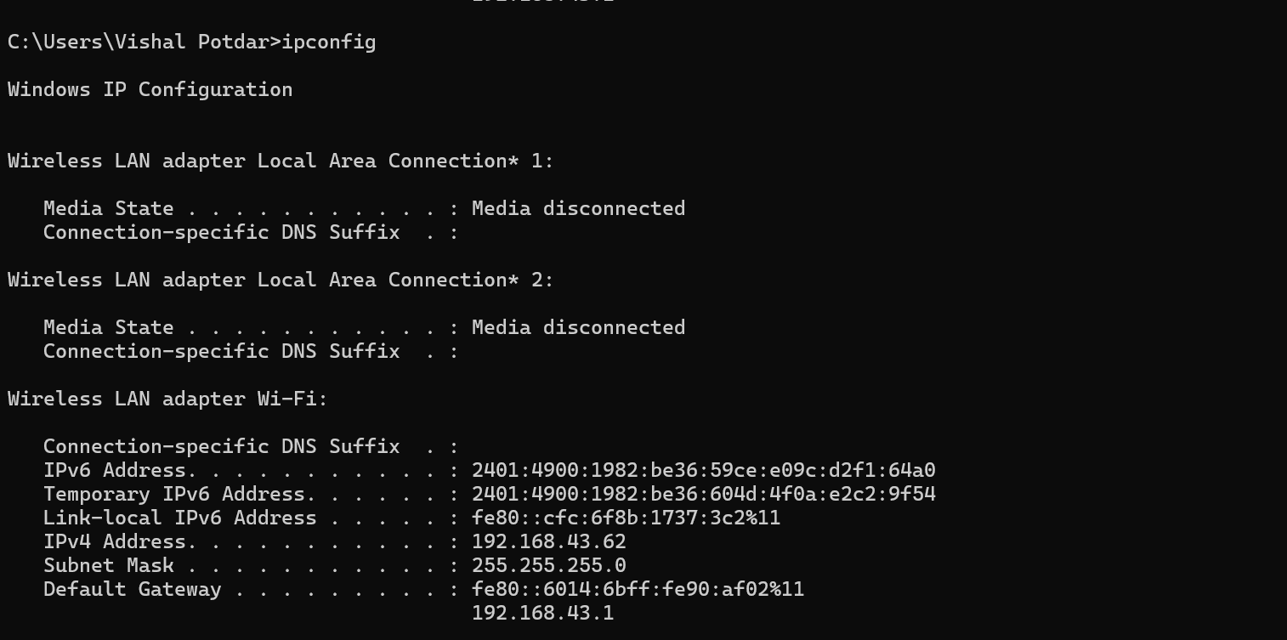

**Output:**  
The command provides information such as IP address, subnet mask, and default gateway for each network adapter.

#### **2. ping**

**Description:**  
Sends ICMP Echo Request messages to verify the reachability of a networked device.

**Syntax:**  
ping followed by the hostname or IP address

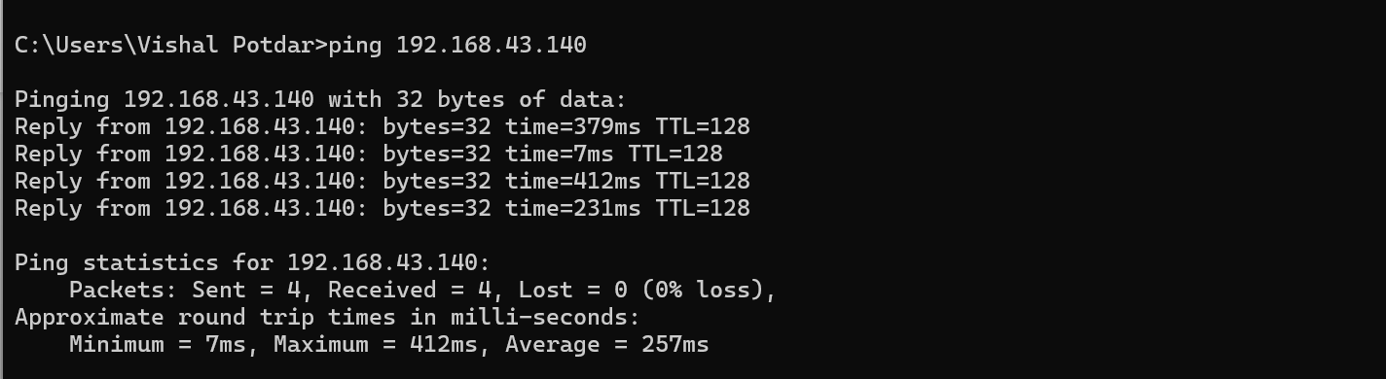

**Output:**  
Displays response time and success/failure of the echo request.

#### **3. tracert**

**Description:**  
Determines the route taken by packets to reach a destination.

**Syntax:**  
tracert followed by the hostname or IP address

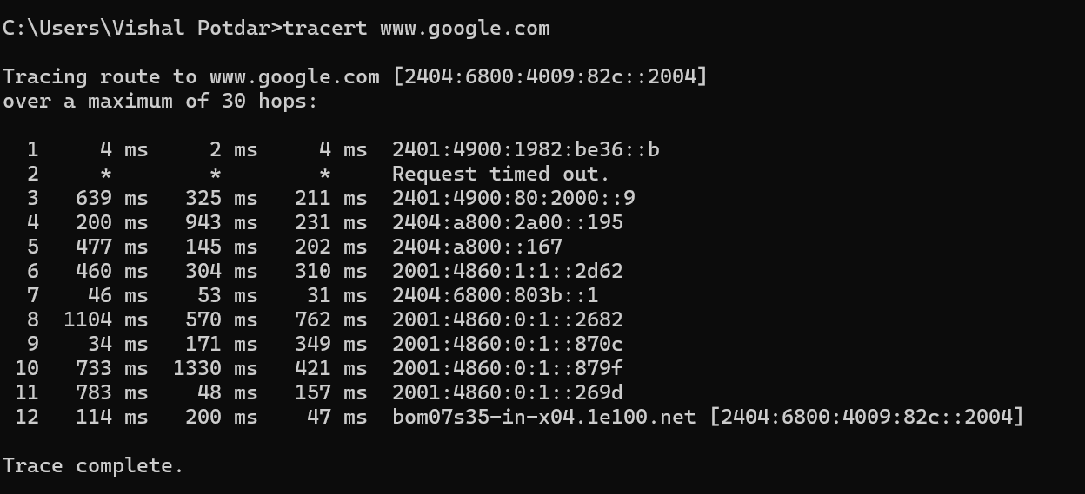

**Output:**  
Shows the path of the packet and the delay between each hop.

#### **4. netstat**

**Description:**  
Displays network connections (incoming and outgoing), routing tables, interface statistics, masquerade connections, and multicast memberships.

**Syntax:**  
netstat

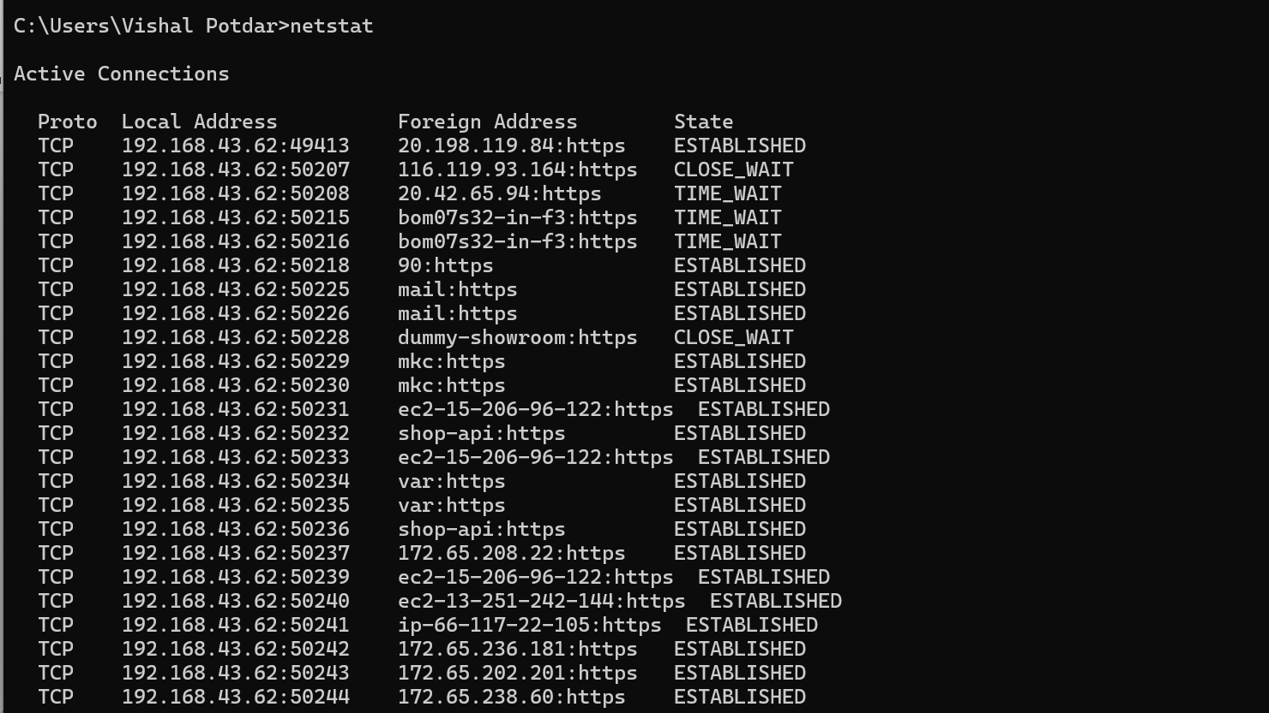

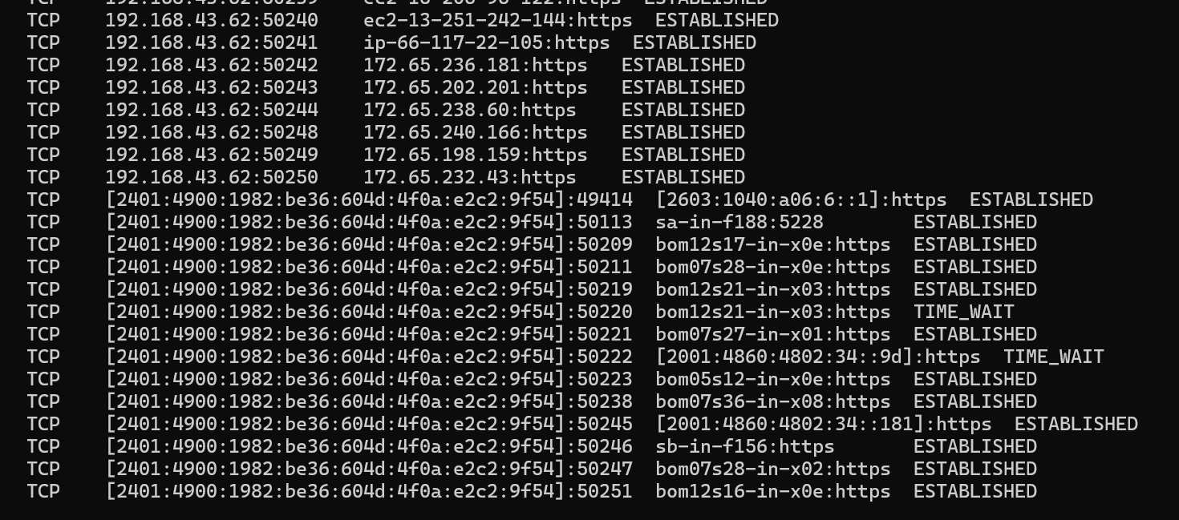

**Output:**  
Lists all active connections and listening ports.

#### **5. nbtstat**

**Description:**  
Displays NetBIOS over TCP/IP (NetBT) protocol statistics, NetBIOS name tables for both the local computer and remote computers, and the NetBIOS name cache.

**Syntax:**  
nbtstat followed by options

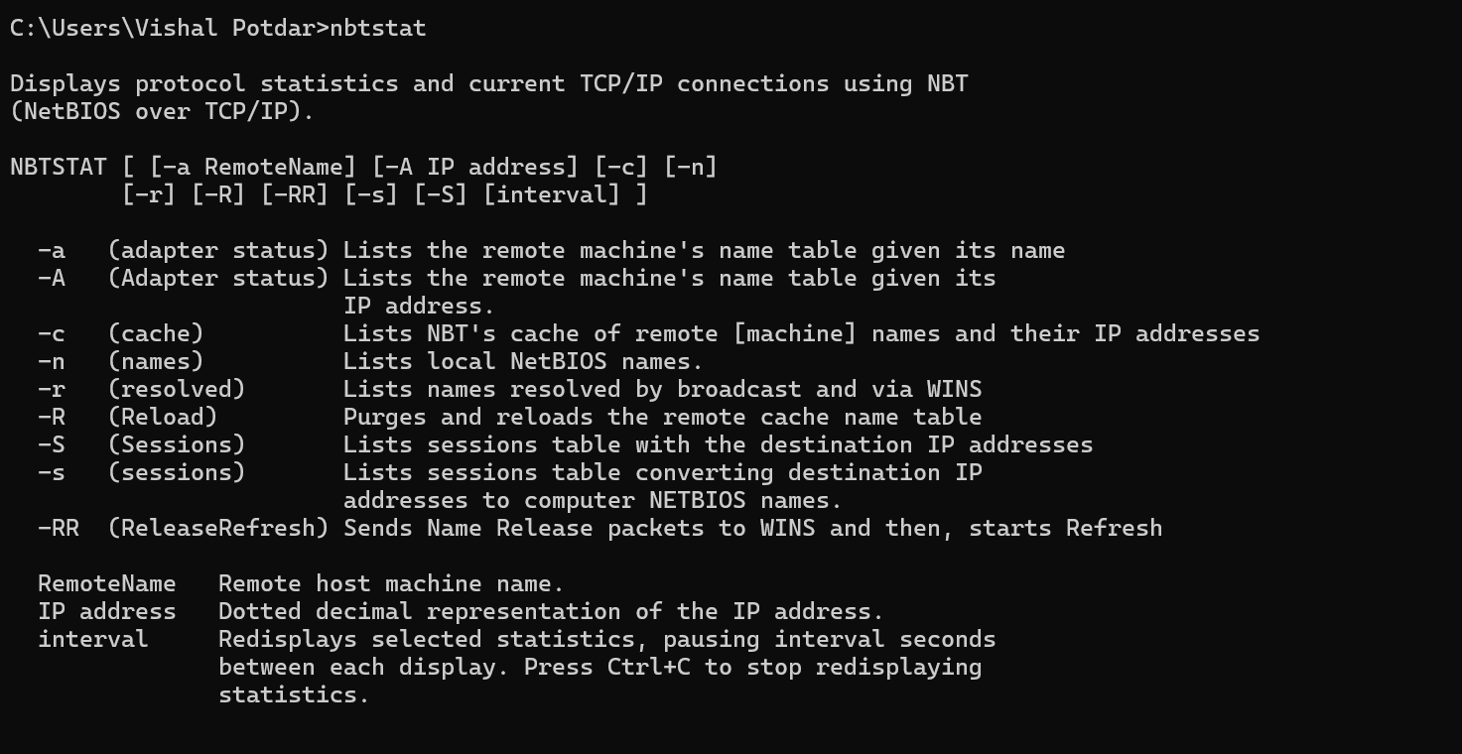

**Output:**  
Provides NetBIOS names and their associated IP addresses.

#### **6. arp**

**Description:**  
Displays and modifies the IP-to-Physical address translation tables used by address resolution protocol (ARP).

**Syntax:**  
arp followed by options

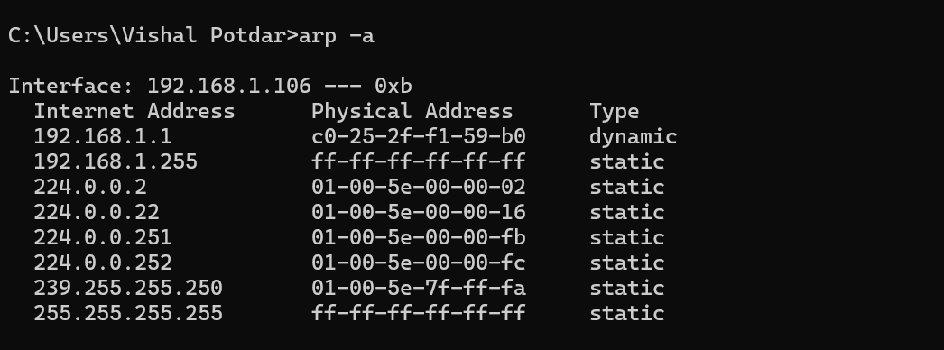

**Output:**  
Lists the ARP table entries.

#### **7. pathping**

**Description:**  
Combines the functionality of ping and tracert to provide information about network latency and packet loss.

**Syntax:**  
pathping followed by the hostname or IP address

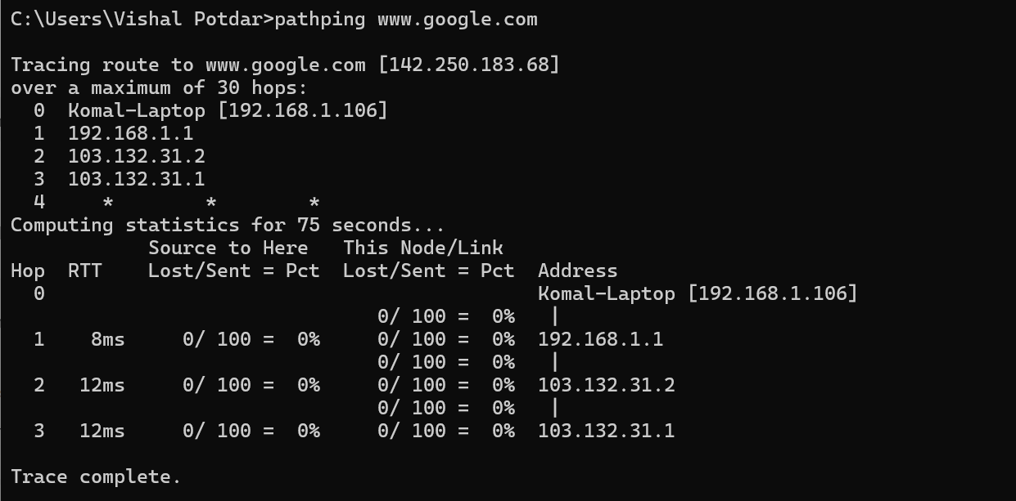

**Output:**  
Displays the route and measures the degree of packet loss along the path.

#### **8. nslookup**

**Description:**  
Queries DNS to obtain domain name or IP address mapping.

**Syntax:**  
nslookup followed by the hostname or IP address

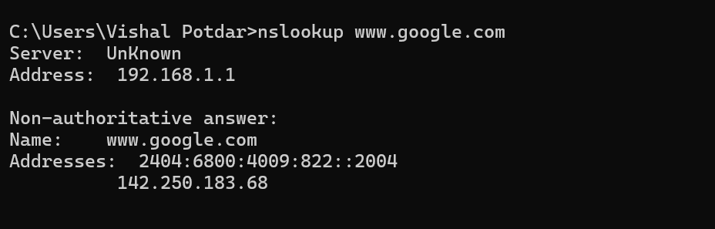

**Output:**  
Provides the IP address associated with a domain name.

#### **9. route**

**Description:**  
Displays and modifies the IP routing table.

**Syntax:**  
route followed by command, destination, and gateway

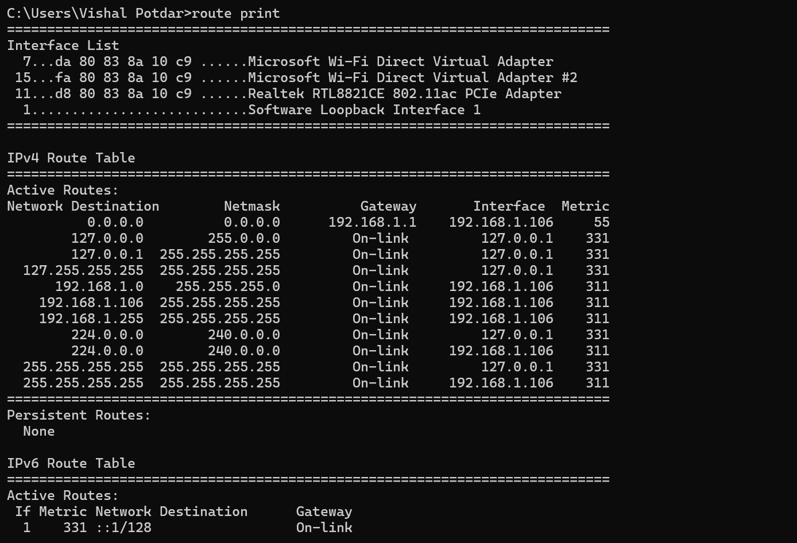

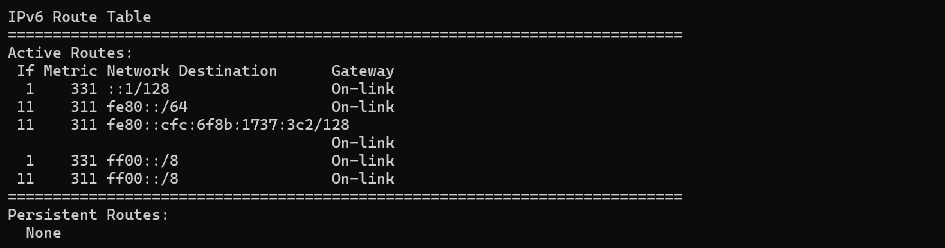

**Output:**  
Shows the routing table.

#### **10. nmap**

**Description:**  
Network exploration tool and security/port scanner.

**Syntax:**  
nmap followed by options and target

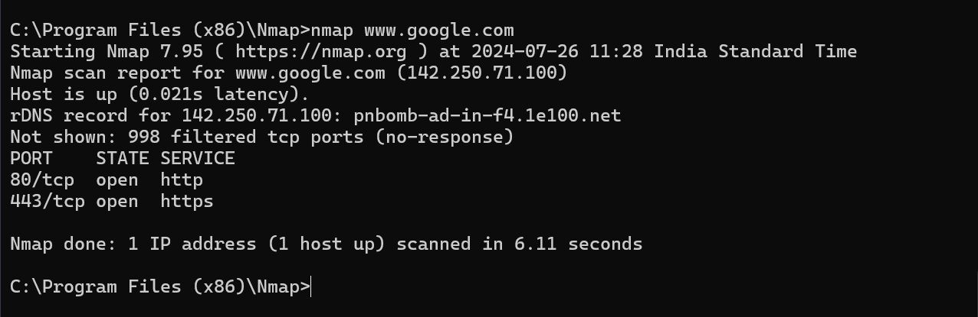

**Output:**  
Scans the network and provides information about devices and services.

### **Conclusion**

In this practical assignment, we set up a small wired and wireless network, installed LAN cards, prepared cables, and configured an Access Point. We assigned unique IP addresses to each device and verified connectivity with the ping utility. Additionally, we used various networking commands like ipconfig, ping, tracert, netstat, nbtstat, arp, pathping, nslookup, route, and nmap to analyze and troubleshoot the network. This hands-on experience enhanced our understanding of network configuration and management.