Peripheral devices are those devices that are linked either internally or externally to a computer. These devices are commonly used to transfer data. The most common processes that are carried out in a computer are entering data and displaying processed data. Several devices can be used to receive data and display processed data. The devices used to perform these functions are called peripherals or I/O devices

INPUT DEVICES

The input devices are used for supplying program and data to the memory. In other words, the computer system reads the program and the data from the input devices. Most common input devices are the keyboard and mouse.

Following are some of the important input devices which are used in a computer −

* Keyboard
* Mouse
* Joy Stick
* Light pen
* Track Ball
* Scanner
* Graphic Tablet
* Microphone
* Magnetic Ink Card Reader(MICR)
* Optical Character Reader(OCR)
* Bar Code Reader
* Optical Mark Reader(OMR)

Keyboard

The keyboard is the most common and very popular input device which helps to input data to the computer. The layout of the keyboard is like that of the traditional typewriter, although there are some additional keys provided for performing additional functions.

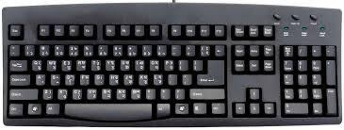

Keyboards are of two sizes 84 keys or 101/102 keys, but now keyboards with 104keys or 108 keys are also available for Windows and Internet.

The keys on the keyboard are as follows −

|  |  |
| --- | --- |
| **Category** | **Keys & Description** |
| 1.Typing keys | These keys include the letter keys (A-Z) and digit keys (09) which generally give the same layout as that of typewriters. |
| 2.NumericKeypad | It is used to enter the numeric data or cursor movement. Generally, it consists of a set of 17 keys that are laid out in the same configuration used by most adding machines and calculators. |
| 3.FunctionKeys | The twelve function keys are present on the keyboard which are arranged in a row at the top of the keyboard. Each function key has a unique meaning and is used for some specific purpose. |
| 4.Control keys | These keys provide cursor and screen control. It includes four directional arrow keys. Control keys also include Home, End,Insert, Delete, Page Up, Page Down, Control(Ctrl), Alternate(Alt),Escape(Esc). |
| 5.SpecialPurpose Keys | Keyboard also contains some special purpose keys such as Enter, Shift, CapsLock, Num Lock, Spacebar, Tab, and Print Screen. |

Mouse

The mouse is the most popular pointing device. It is a very famous cursor-control device having a small palm size box with a round ball at its base, which senses the movement of the mouse and sends corresponding signals to the CPU when the mouse buttons are pressed.

Generally, it has two buttons called the left and the right button and a wheel is present between the buttons. A mouse can be used to control the position of the cursor on the screen, but it cannot be used to enter text into the computer.

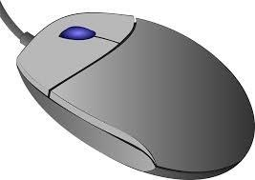

Advantages

* Easy to use
* Not very expensive
* Moves the cursor faster than the arrow keys of the keyboard.

Joystick

The joystick is also a pointing device, which is used to move the cursor position on a monitor screen. It is a stick having a spherical ball at its both lower and upper ends. The lower spherical ball moves in a socket. The joystick can be moved in all four directions.

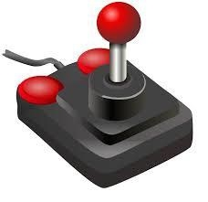

The function of the joystick is similar to that of a mouse. It is mainly used in Computer Aided Designing (CAD) and playing computer games.

Light Pen

Lightpen is a pointing device similar to a pen. It is used to select a displayed menu item or draw pictures on the monitor screen. It consists of a photocell and an optical system placed in a small tube.

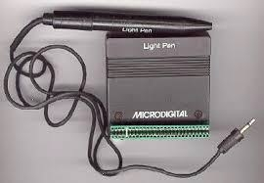

When the tip of a light pen is moved over the monitor screen and the pen button is pressed, its photocell sensing element detects the screen location and sends the corresponding signal to the CPU.

TrackBall

A trackball is an input device that is mostly used in notebook or laptop computer, instead of a mouse. This is a ball which is half inserted and by moving fingers on the ball, the pointer can be moved.

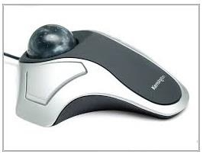

Since the whole device is not moved, a trackball requires less space than a mouse. A trackball comes in various shapes like a ball, a button, or a square.

Scanner

The scanner is an input device, which works more like a photocopy machine. It is used when some information is available on paper and it is to be transferred to the hard disk of the computer for further manipulation.

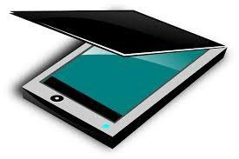

Scanner captures images from the source which are then converted into a digital form that can be stored on the disk. These images can be edited before they are printed.

Digitizer

The digitizer is an input device which converts analog information into digital form. The digitizer can convert a signal from the television or camera into a series of numbers that could be stored in a computer. They can be used by the computer to create a picture of whatever the camera had been pointed at.

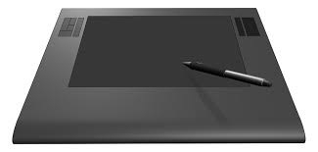

The digitizer is also known as Tablet or Graphics Tablet as it converts graphics and pictorial data into binary inputs. A graphics tablet as digitizer is used for fine works of drawing and image manipulation applications.

Microphone

The microphone is an input device to input sound that is then stored in a digital form.

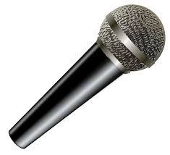

The microphone is used for various applications such as adding sound to a multimedia presentation or for mixing music.

Magnetic Ink Card Reader (MICR)

MICR input device is generally used in banks as there are a large number of cheques to be processed every day. The bank's code number and cheque number are printed on the cheques with a special type of ink that contains particles of magnetic material that are machine readable.

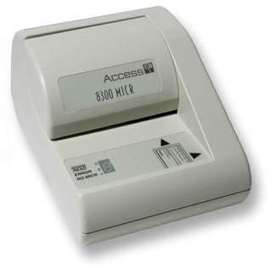

This reading process is called Magnetic Ink Character Recognition (MICR). The main advantages of MICR are that it is fast and less error-prone.

Optical Character Reader (OCR)

OCR is an input device used to read a printed text.

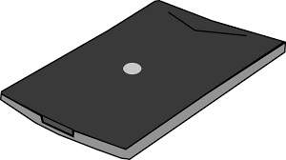

OCR scans the text optically, character by character, converts them into a machine-readable code, and stores the text on the system memory.

BarCode Readers

BarCode Reader is a device used for reading bar coded data (data in the form of light and dark lines). Barcoded data is generally used in labeling goods, numbering the books, etc. It may be a handheld scanner or may be embedded in a stationary scanner.

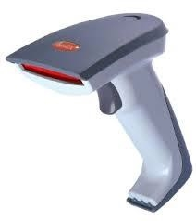

Bar Code Reader scans a barcode image, converts it into an alphanumeric value, which is then fed to the computer that the bar code reader is connected to.

Optical Mark Reader (OMR)

OMR is a special type of optical scanner used to recognize the type of mark made by pen or pencil. It is used where one out of a few alternatives is to be selected and marked.

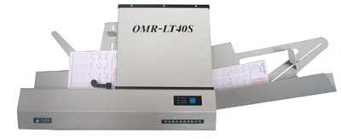

OUTPUT DEVICES

Output devices are used for displaying or recording the results computed by the computer. Most common output devices are the CRT display, printer, and plotter.

Following are some of the important output devices used in a computer.

* Monitors
* Graphics Plotter
* Printer

## Monitors

Monitors, commonly called a **Visual Display Unit** (VDU), are the main output device of a computer. It forms images from tiny dots, called pixels that are arranged in a rectangular form. The sharpness of the image depends upon the number of pixels.

There are two kinds of viewing screen used for monitors.

* Cathode-Ray Tube (CRT)
* Flat-Panel Display

## Cathode-Ray Tube (CRT) Monitor

The CRT display is made up of small picture elements called pixels. The smaller the pixels, the better the image clarity or resolution. It takes more than one illuminated pixel to form a whole character, such as the letter ‘e’ in the word help.

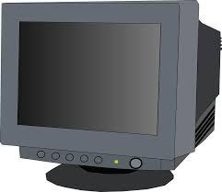

A finite number of characters can be displayed on a screen at once. The screen can be divided into a series of character boxes - fixed location on the screen where a standard character can be placed. Most screens are capable of displaying 80 characters of data horizontally and 25 lines vertically.

There are some disadvantages of CRT −

* Large in Size
* High power consumption

## Flat-Panel Display Monitor

The flat-panel display refers to a class of video devices that have reduced volume, weight and power requirement in comparison to the CRT. You can hang them on walls or wear them on your wrists. Current uses of flat-panel displays include calculators, video games, monitors, laptop computer, and graphics display.

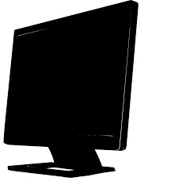

The flat-panel display is divided into two categories −

* **EmissiveDisplays** − Emissive displays are devices that convert electrical energy into light. For example, plasma panel and LED (Light-Emitting Diodes).
* **Non-EmissiveDisplays** − Non-emissive displays use optical effects to convert sunlight or light from some other source into graphics patterns. For example, LCD (Liquid-Crystal Device).

## Printers

The printer is an output device, which is used to print information on paper.

There are two types of printers −

* Impact Printers
* Non-Impact Printers

## Impact Printers

Impact printers print the characters by striking them on the ribbon, which is then pressed on the paper.

Characteristics of Impact Printers are the following −

* Very low consumable costs
* Very noisy
* Useful for bulk printing due to low cost
* There is physical contact with the paper to produce an image

These printers are of two types −

* Character printers
* Line printers

## Character Printers

Character printers are the printers which print one character at a time.

These are further divided into two types:

* Dot Matrix Printer(DMP)
* Daisy Wheel

## Dot Matrix Printer

In the market, one of the most popular printers is Dot Matrix Printer. These printers are popular because of their ease of printing and economical price. Each character printed is in the form of a pattern of dots and head consists of a Matrix of Pins of size (5*7, 7*9, 9*7 or9*9) which come out to form a character which is why it is called DotMatrix Printer.

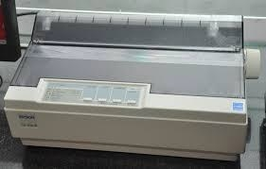

## Advantages

* Inexpensive
* Widely Used
* Other language characters can be printed

## Disadvantages

* Slow Speed
* Poor Quality

## Daisy Wheel

Head is lying on a wheel and pins corresponding to characters are like petals of Daisy (flower) which is why it is called Daisy Wheel Printer. These printers are generally used for word-processing in offices that require a few letters to be sent here and there with very nice quality.

### Advantages

* More reliable than DMP
* Better quality
* Fonts of character can be easily changed

### Disadvantages

* Slower than DMP
* Noisy
* More expensive than DMP

## Line Printers

Line printers are the printers which print one line at a time.

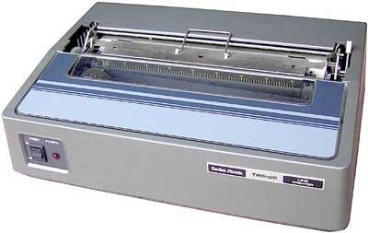

These are of two types −

* Drum Printer
* Chain Printer

## Drum printer

This printer is like a drum in shape hence it is called a drum printer. The surface of the drum is divided into a number of tracks. Total tracks are equal to the size of the paper, i.e. for a paper width of 132characters, the drum will have 132 tracks. A character set is embossed on the track. Different character sets available in the market are 48character set, 64 and 96 characters set. One rotation of drum prints one line. Drum printers are fast in speed and can print 300 to 2000 lines per minute.

### Advantages

* Very high speed

### Disadvantages

* Very expensive
* Characters fonts cannot be changed

## Chain Printer

In this printer, a chain of character sets is used, hence it is called chain Printer. A standard character set may have 48, 64, or 96 characters.

### Advantages

* Character fonts can easily be changed.
* Different languages can be used with the same printer.

### Disadvantages

* Noisy

## Non-impact Printers

Non-impact printers print the characters without using the ribbon. These printers print a complete page at a time, thus they are also called as Page Printers.

These printers are of two types −

* Laser Printers
* Inkjet Printers

Characteristics of Non-impact Printers

* Faster than impact printers
* They are not noisy
* High quality
* Supports many fonts and different character size

## Laser Printers

These are non-impact page printers. They use laser lights to produce the dots needed to form the characters to be printed on a page.

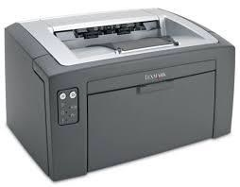

### Advantages

* Very high speed
* Very high-quality output
* Good graphics quality
* Supports many fonts and different character size

### Disadvantages

* Expensive
* Cannot be used to produce multiple copies of a document in a single printing

## inkjet printer

Inkjet printers are non-impact character printers based on relatively new technology. They print characters by spraying small drops of ink onto paper. Inkjet printers produce high-quality output with presentable features.

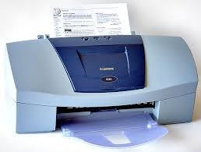

They make less noise because no hammering is done and these have many styles of printing modes available. Color printing is also possible. Some models of Inkjet printers can produce multiple copies of printing also.

### Advantages

* High-quality printing
* More reliable

### Disadvantages

* Expensive as the cost per page is high
* Slow as compared to a laser printer