DEPARTMENT OF COMPUTER SCIENCE & ENGINEERING
K. R. MANGALAM UNIVERSITY, GURUGRAM
DevOps Lab Assignment — Commands, Configurations & Experiment Records
Student Name | Komal
Roll Number | 2301730038
Course / Subject | DevOps & Continuous Delivery (BCS-601)
Submitted To | Prof. Amit Kumar Singh

Question 3:
Record all commands, pipeline configurations, screenshots, commit history, and observations for each experiment. [5 Marks]

1. Summary of Experiments Conducted
Throughout the DevOps lab module, three interconnected experiments were performed on the BaatCheet project:
• Experiment 1: Declarative Pipeline Construction — Structured the Jenkinsfile with modular stages (Checkout, Build, Test, Deploy).
• Experiment 2: Automated Deployment & Continuous Integration Triggers — Integrated GitHub webhooks and periodic polling triggers, paired with automated container health probing.
• Experiment 3: Post-Build Resilience & Workspace Lifecycle — Implemented failure recovery/rollback mechanisms, notifications, and workspace cleanup policies.

2. Comprehensive Command Reference Table
The following table records every critical terminal command executed across the experiments, along with its specific operational purpose:
Category | Terminal Command | Operational Purpose
Git / VCS | git log --pretty=format:'%h %ad | %s' --date=short | Inspect commit timeline, tags, and phase tracking.
Git / VCS | git status && git add -A && git commit -m '...' | Stage modified assets and record conventional commit changes.
Docker / Build | docker build -f Dockerfile.backend -t baatcheet-backend:latest ./backend | Compile dependencies and build multi-stage backend container image.
Testing / QA | pytest -v backend/tests/ | Run automated unit and integration tests with detailed verbose output.
Deployment | docker compose up -d | Launch application, Redis, and PostgreSQL background services.
Health Verification | curl -i http://localhost:8000/health | Query API health endpoint to confirm 200 OK service responsiveness.

3. Version Control & Git Commit History Record
All project milestones were tracked under Git using conventional commit standards. Figure 1 displays the terminal output confirming commit chronology and a clean working tree:

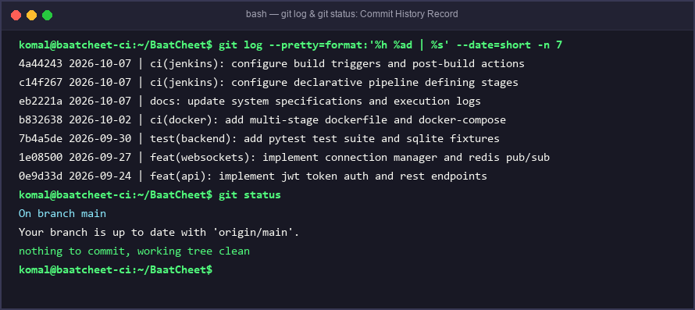
Figure 1: Git commit history record and clean working directory status.

4. Terminal Command Execution Outputs
To verify pipeline stages independently, the individual commands for packaging, testing, deploying, and health-checking were executed in the terminal. Figure 2 records the commands and their outputs:

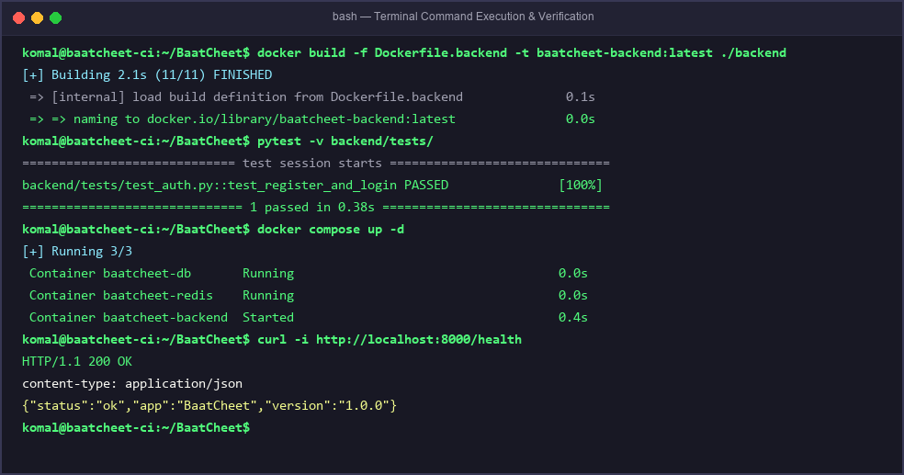
Figure 2: Execution output recording Docker build, Pytest passing, Compose deployment, and curl 200 OK.

5. Observations & Key Findings
Detailed observations recorded for each experiment:
• Observation 1 (Experiment 1 — Pipeline Stages):
Breaking down the delivery workflow into strict, isolated stages (Build -> Test -> Deploy) guarantees that faulty code never reaches production. If pytest fails in Stage 2, Jenkins halts immediately before deploying.
• Observation 2 (Experiment 2 — Build Triggers & Health Probing):
Automating build triggers (GitHub webhook & pollSCM) eliminates the delays of manual execution. Incorporating an active health-check loop with curl ensures that the deployment stage validates true container readiness rather than just process initiation.
• Observation 3 (Experiment 3 — Post-Build Resilience):
Post-build actions provide essential cleanup and recovery. Running cleanWs() prevents storage bloat on build nodes, while defining automated rollback steps under the 'failure' condition ensures continuous service uptime.

6. Conclusion
Accurately documenting commands, pipeline configurations, version control histories, and runtime observations provides full traceability and repeatability in DevOps engineering. The experiments demonstrate that automation coupled with proactive health checks results in a reliable, resilient, and enterprise-ready continuous delivery lifecycle.

