**Acknowledgement**

We are pleased to present **“Smart Tender Management System Using Blockchain”** projectand takethis opportunity to express our profound gratitude to all those people who helped us in completion of this project.

We thank our college for providing us with excellent facilities that helped us to complete and present this project. We would also like to thank the staff members and lab assistants for permitting us to use computers in the lab as and when required.

We express our deepest gratitude towards our project guide for his/her valuable and timely advice during the various phases in our project. We would also like to thank him/her for providing us with all proper facilities and support as the project co-coordinator. We would like to thank him/her for support, patience and faith in our capabilities and for giving us flexibility in terms of working and reporting schedules.

We would like to thank all our friends for their smiles and friendship making the college life enjoyable and memorable and family members who always stood beside us and provided the utmost important moral support. Finally, we would like to thank everyone who has helped us directly or indirectly in our project.

**TABLE OF CONTENT**

|  |  |
| --- | --- |
| Sr. No. | Contents |
| 1  1.1  1.2  1.3  1.4 | **PROJECT OVERVIEW**  Introduction  Scope and Objective  Modules and its Description  Existing System & Proposed System |
| 2  2.1 | **PROJECT ANALYSIS**  Gantt Chart |
| 3  3.1 | **PROJECT LIFECYCLE**  Project Lifecycle Details |
| 4  4.1  4.2  4.3  4.4  4.5  4.6 | **PROJECT DESIGN**  E-R Diagram  Use Case Diagram  Sequence Diagram  Activity Diagram  Data Flow Diagram  System Architecture |
| 5  5.1 | **SNAPSHOTS**  Project Snapshots |
| 6  6.1  6.2 | **PROJECT IMPLEMENTATION**  Project Implementation Technology  Feasibility Report |
| 7  7.1 | **CODING**  Project Coding |
| 8  8.1  8.2  8.3 | **TESTING**  Testing  Levels of Testing  Test Cases |
| 9  9.1  9.2  9.3 | **ADVANTAGES & LIMITATIONS**  Advantages  Limitations  Features |
| 10  10.1 | **CONCLUSION**  Project Conclusion |
| 11  11.1 | **BIBIIOGRAPHY**  Website Links |

**PROJECT OVERVIEW**

Introduction

Nowadays, organizations such as agriculture, healthcare, financial services, and even the government sector have started to implement blockchain. Even so, the tendering sector is incompetent to benefit from this new blockchain technology. If tender management is done wrongfully it may lead to huge losses in case of faulty practices. This may include favouring contractors, improper record maintenance, lack of transparency, hacking, data modification, and other similar issues.

To resolve tender management issues, here we use blockchain technology to make sure that it helps in maintaining security and efficiency. With encryption coupled with indisputable block-based architecture, the transaction management blockchain is fully secured.

Here, we make use of blockchain technology to secure transaction-based documents along with transactions such as tender documents, applications, bid proposals, company profiles, past records, approving officer details, and rejection details to ensure a completely transparent tendering process.

Scope and Objective

In today’s world Information Technology has become the backbone of any organization when looking forward to offering better services and gaining a competitive advantage. Blockchain has the power to change business industries. Blockchain-sourced transactions have a unique chronological code and cryptography that stores and secures the data permanently.

Smart Tender Management System assigns timestamps to each block of a chain in order to avoid data tampering and fraud. So, the high-level data protection system decreases the likelihood of internal and external data manipulation. This kind of technology could be effective in raising success, reducing risks in complex contracts, and strengthening the process.

This technology focuses on a model tailored to reduce corruption in tendering while ensuring efficiency and openness. Transparency can be further strengthened by involving blockchain technology

Modules and their Description

The system comprises of 2 major modules with their sub-modules as follows:

**Admin**

**Manage Tender**

* admin can add, update, delete and view Tenders
* can update Company Details
* able to view Tender Details
* can upload photos and documents

**View Proposals**

* **Ongoing Tenders**
* admin can view Tender Details of ongoing tenders
* can view applications, bid proposals, or Company Profile
* able to update Status Shortlist, Approve and Reject proposals
* **Past Tenders**
* can view all the past Tender Details
* view Applications, Bid Proposals, or Company Profile
* able to view the status of past tenders

**View Transactions:**

* can choose Tender to view their transaction
* able to check if any kind of tempering/modification has happened in bids/applications etc.

**Company**

**Register:** the company must first register to login into the application

**Login:** company will have to log in using their email and password once they have registered.

**Profile:** the company can view their profile and if required they can update it.

**Change Password:** company can also change their password.

**Tenders**

* List all Ongoing Tenders in which they are yet to participate.
* the company can view Tender Details
* company is able to upload their applications or Proposals etc.

**My applications**

- List of all Tenders in which the company has participated in

- can view Tender Details

- able to update My applications and documents

- company can view the status

Existing System & Proposed System

* Problem with current scenario
* Traditional technologies lack security and transparency, which are critical issues since they may expose data to tampering.
* There are a number of security requirements for a tendering system that cannot be addressed simply by creating and bidding contracts on a central database.
* Drawbacks of the existing system
* Existing systems do not eliminate the risk of data manipulation by third parties.
* There’s no data security and data protection which increases the chances of threats in complex contracts.

**PROPOSED SYSTEM**

* Smart Tender Management System runs on the blockchain platform, which will process all the transactions in a contract; hence, middlemen are not required for executing the transactions.
* In the digital domain, the smart tender system expanded the capabilities of electronic transaction systems.
* The security and accessibility necessary for this sort of application may be handled using technologies such as blockchain, a decentralized database.
* Blockchain and smart tenders have enormous potential for creating such an ecosystem.
* Smart Tenders System enables trustworthy transactions and agreements to be performed among disparate, anonymous participants without the requirement for a centralized authority, legal system, or external enforcement mechanism.

Gantt Chart

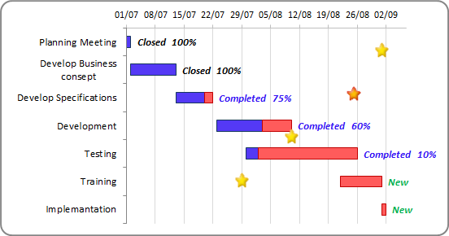

Project Lifecycle Details

## **Waterfall Model**

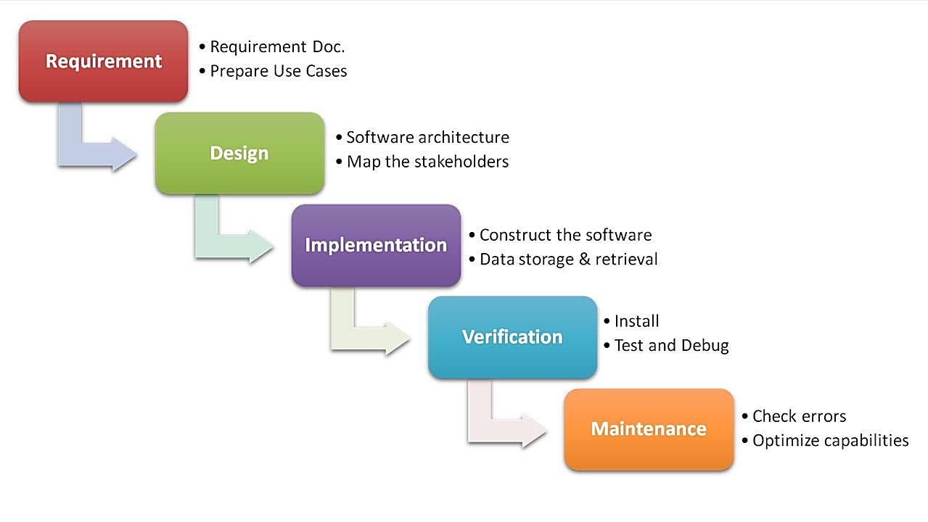

##### 

##### **Description**

The waterfall Model is a linear sequential flow. In which progress is seen as flowing steadily downwards (like a waterfall) through the phases of software implementation. This means that any phase in the development process begins only if the previous phase is complete. The waterfall approach does not define the process to go back to the previous phase to handle changes in requirement. The waterfall approach is the earliest approach that was used for software development.

**PROJECT DESIGN**

E-R Diagram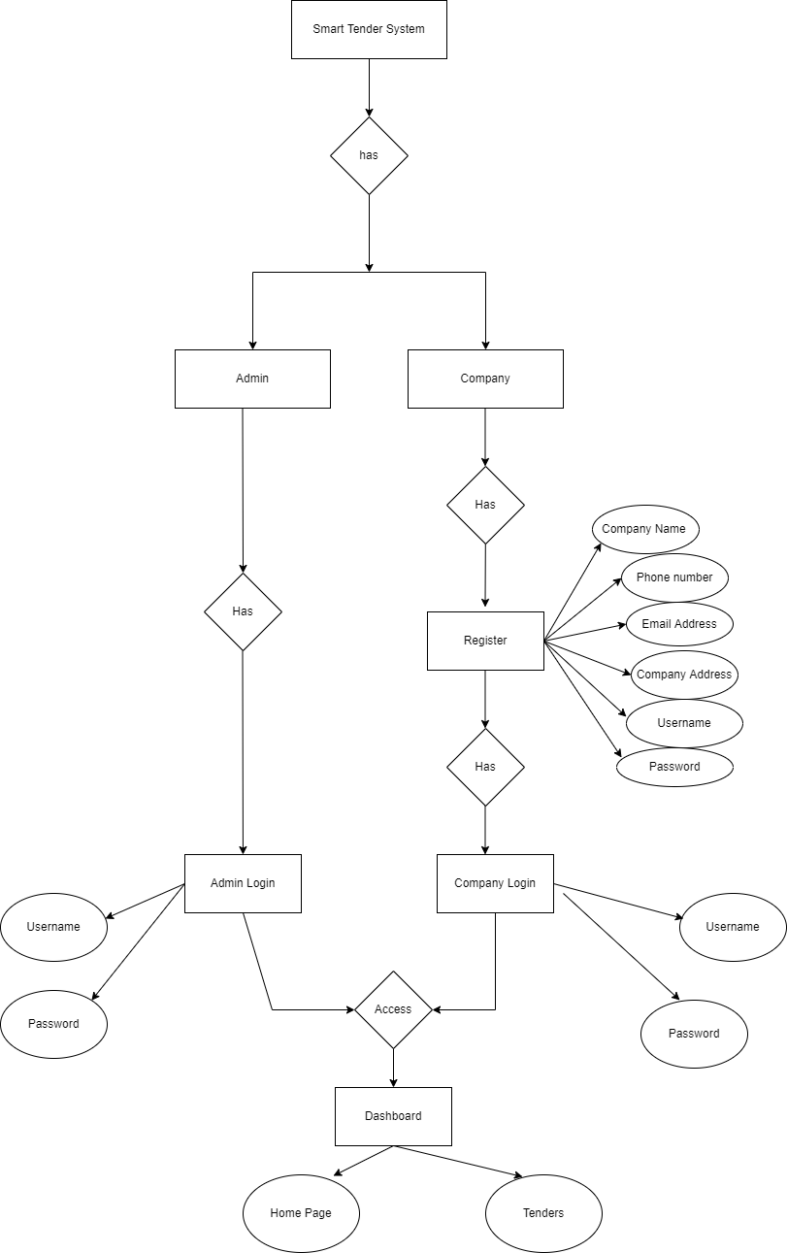

Use Case Diagram

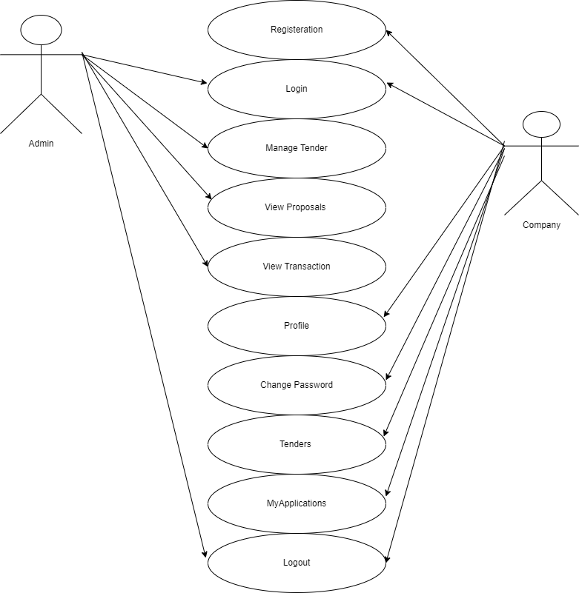

**Fig. Use Case Diagram**

Sequence Diagram

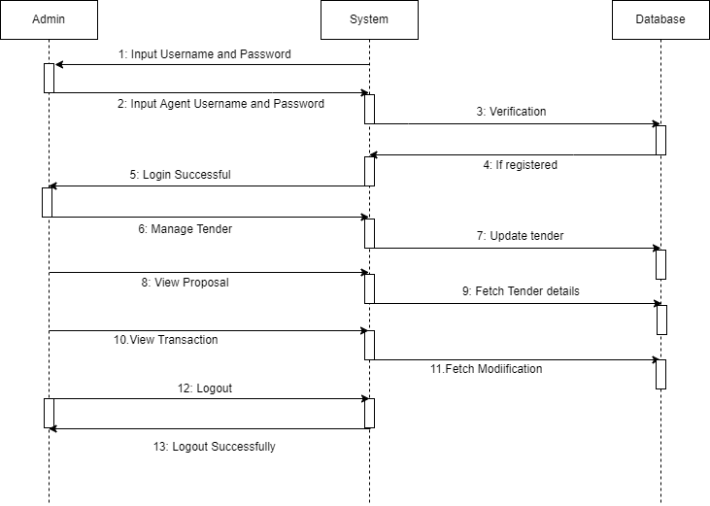

**Fig. Sequence Diagram of Admin**

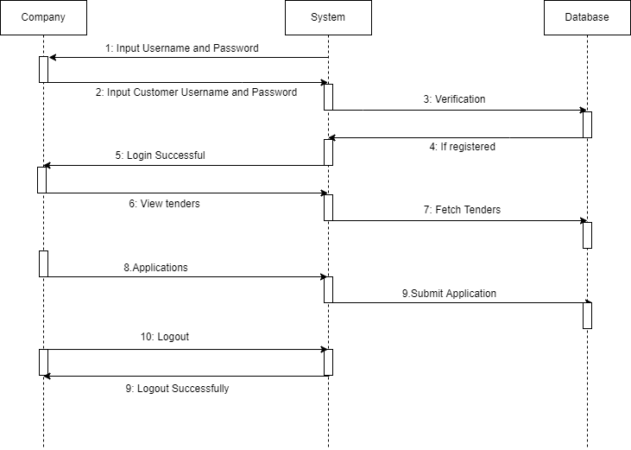

**Fig. Sequence Diagram of Company**

Activity Diagram

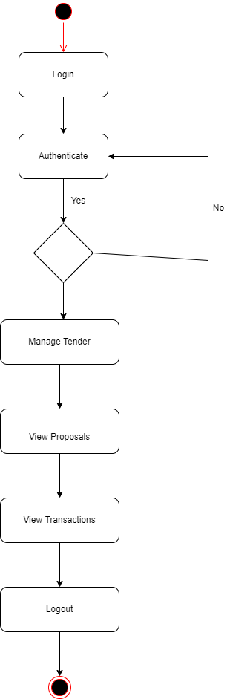

**Fig. Activity Diagram of Admin**

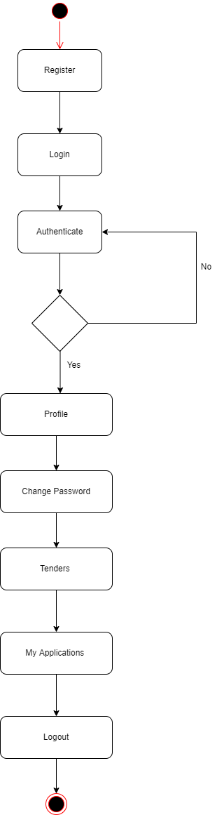

**Fig. Activity Diagram of Admin**

Class Diagram

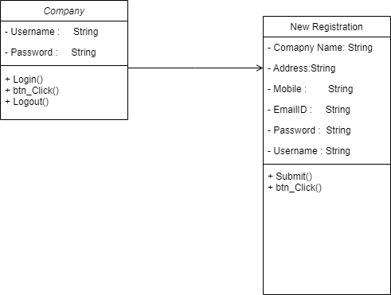

Data Flow Diagram (DFD’s)

A data flow diagram is graphical tool used to describe and analyze movement of data through a system. These are the central tool and the basis from which the other components are developed. The transformation of data from input to output, through processed, may be described logically and independently of physical components associated with the system. These are known as the logical data flow diagrams. The physical data flow diagrams show the actual implements and movement of data between people, departments and workstations. A full description of a system actually consists of a set of data flow diagrams. Using two familiar notations Yourdon, Gane and Sarson notation develops the data flow diagrams. Each component in a DFD is labeled with a descriptive name. Process is further identified with a number that will be used for identification purpose. The development of DFD’s is done in several levels. Each process in lower level diagrams can be broken down into a more detailed DFD in the next level. The lop-level diagram is often called context diagram. It consists a single process bit, which plays vital role in studying the current system. The process in the context level diagram is exploded into other process at the first level DFD.

The idea behind the explosion of a process into more process is that understanding at one level of detail is exploded into greater detail at the next level. This is done until further explosion is necessary and an adequate amount of detail is described for analyst to understand the process.

Larry Constantine first developed the DFD as a way of expressing system requirements in a graphical from, this lead to the modular design.

A DFD is also known as a “bubble Chart” has the purpose of clarifying system requirements and identifying major transformations that will become programs in system design. So it is the starting point of the design to the lowest level of detail. A DFD consists of a series of bubbles joined by data flows in the system.

DFD SYMBOLS:

In the DFD, there are four symbols

1. A square defines a source(originator) or destination of system data
2. An arrow identifies data flow. It is the pipeline through which the information flows
3. A circle or a bubble represents a process that transforms incoming data flow into outgoing data flows.
4. An open rectangle is a data store, data at rest or a temporary repository of data

Process that transforms data flow. Source or Destination of data

Data flow

Data Store

CONSTRUCTING A DFD:

Several rules of thumb are used in drawing DFD’s:

1. Process should be named and numbered for an easy reference. Each name should be representative of the process.
2. The direction of flow is from top to bottom and from left to right. Data traditionally flow from source to the destination although they may flow back to the source. One way to indicate this is to draw long flow line back to a source. An alternative way is to repeat the source symbol as a destination. Since it is used more than once in the DFD it is marked with a short diagonal.
3. When a process is exploded into lower level details, they are numbered.
4. The names of data stores and destinations are written in capital letters. Process and dataflow names have the first letter of each work capitalized

A DFD typically shows the minimum contents of data store. Each data store should contain all the data elements that flow in and out.

Questionnaires should contain all the data elements that flow in and out. Missing interfaces redundancies and like is then accounted for often through interviews.

#### SAILENT FEATURES OF DFD’s

1. The DFD shows flow of data, not of control loops and decision are controlled considerations do not appear on a DFD.
2. The DFD does not indicate the time factor involved in any process whether the data flows take place daily, weekly, monthly or yearly.
3. The sequence of events is not brought out on the DFD.

TYPES OF DATA FLOW DIAGRAMS

1. Current Physical
2. Current Logical
3. New Logical
4. New Physical

CURRENT PHYSICAL:

In Current Physical DFD process label include the name of people or their positions or the names of computer systems that might provide some of the overall system-processing label includes an identification of the technology used to process the data. Similarly, data flows and data stores are often labels with the names of the actual physical media on which data are stored such as file folders, computer files, business forms or computer tapes.

CURRENT LOGICAL:

The physical aspects at the system are removed as much as possible so that the current system is reduced to its essence to the data and the processors that transform them regardless of actual physical form.

NEW LOGICAL:

This is exactly like a current logical model if the user were completely happy with the user were completely happy with the functionality of the current system but had problems with how it was implemented typically through the new logical model will differ from current logical model while having additional functions, absolute function removal and inefficient flows recognized.

NEW PHYSICAL:

The new physical represents only the physical implementation of the new system.

**RULES GOVERNING THE DFD’S**

PROCESS

1. No process can have only outputs.
2. No process can have only inputs. If an object has only inputs than it must be a sink.
3. A process has a verb phrase label.

**DATA STORE**

1. Data cannot move directly from one data store to another data store, a process must move data.
2. Data cannot move directly from an outside source to a data store, a process, which receives, must move data from the source and place the data into data store
3. A data store has a noun phrase label.

**SOURCE OR SINK**

The origin and /or destination of data.

1. Data cannot move direly from a source to sink it must be moved by a process
2. A source and /or sink has a noun phrase land

DATA FLOW

1. A Data Flow has only one direction of flow between symbols. It may flow in both directions between a process and a data store to show a read before an update. The later it usually indicated however by two separate arrows since these happen at different type.
2. A join in DFD means that exactly the same data comes from any of two or more different processes data store or sink to a common location.
3. A data flow cannot go directly back to the same process it leads. There must be at least one other process that handles the data flow produce some other data flow returns the original data into the beginning process.
4. A Data flow to a data store means update (delete or change).
5. A data Flow from a data store means retrieve or use.

Data Flow Diagrams (DFD’s)

***Smart Tender Management*** DB

0.0

User

Database

DATABASE DETAIL

Query

Process

Request

1.0

User

Query

Database

Feedback For

User

Check for user

Requirement

User need

Relevant

Data

1.1

LEVEL 1 DFD

Accept

Query

2.0

User

Check Availability of or for query processing

Process

Query

Give request to user

Via ***Smart Tender Management*** DB

Give info about DB

2.1

2.2

Query

LEVEL 2 DFD: PREDICTION

System Architecture

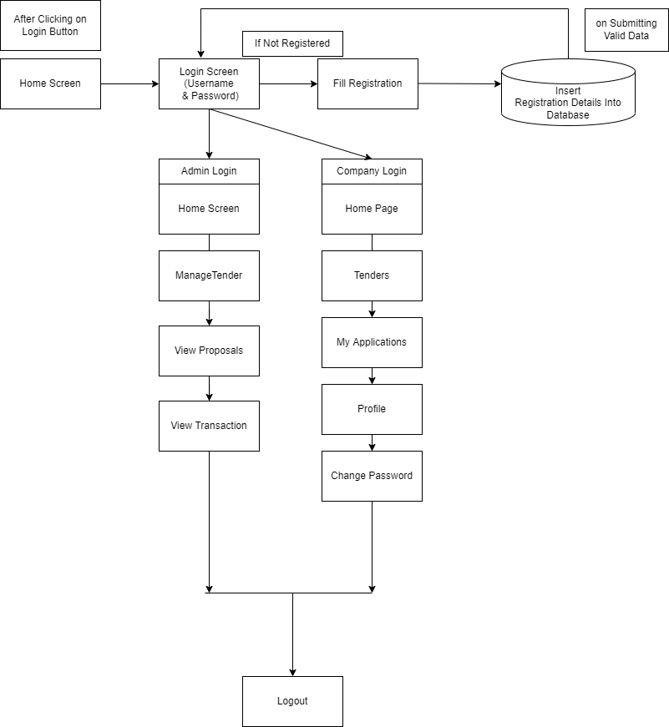

Snapshots

**PROJECT IMPLEMENTATION**

Project Implementation Technology

The Project is designed and developed in Django Framework. We used Django Framework for coding of the project. Created and maintained all databases into MySQL Server, in that we create tables, write query for store data or record of project.

* **Hardware Requirement:**
* Processor –Core i3
* Hard Disk – 160 GB
* Memory – 1GB RAM
* Monitor
* **Software Requirement:**
* Windows 7 or higher
* Python
* Django framework
* MySQL database

**OVERVIEW OF TECHNOLOGIES USED**

INTRODUCTION

Python is a powerful multi-purpose programming language created by Guido van Rossum. It has simple easy-to-use syntax, making it the perfect language for someone trying to learn computer programming for the first time. This is a comprehensive guide on how to get started in Python, why you should learn it and how you can learn it. However, if your knowledge of other programming languages and want to quickly get started with Python. Python is a general-purpose language. It has wide range of applications from Web development (like: Django and Bottle), scientific and mathematical computing (Orange, SymPy, NumPy) to desktop graphical user Interfaces (Pygame, Panda3D). The syntax of the language is clean and length of the code is relatively short. It's fun to work in Python because it allows you to think about the problem rather than focusing on the syntax.

Features of Python Programming:

* A simple language which is easier to learn  
  Python has a very simple and elegant syntax. It's much easier to read and write Python programs compared to other languages like: C++, Java, C#. Python makes programming fun and allows you to focus on the solution rather than syntax.  
  If you are a newbie, it's a great choice to start your journey with Python.
* Free and open-source  
  You can freely use and distribute Python, even for commercial use. Not only can you use and distribute software’s written in it, you can even make changes to the Python's source code.  
  Python has a large community constantly improving it in each iteration.
* Portability  
  You can move Python programs from one platform to another, and run it without any changes.  
  It runs seamlessly on almost all platforms including Windows, Mac OS X and Linux.
* Extensible and Embeddable  
  Suppose an application requires high performance. You can easily combine pieces of C/C++ or other languages with Python code.  
  This will give your application high performance as well as scripting capabilities which other languages may not provide out of the box.
* A high-level, interpreted language  
  Unlike C/C++, you don't have to worry about daunting tasks like memory management, garbage collection and so on.  
  Likewise, when you run Python code, it automatically converts your code to the language your computer understands. You don't need to worry about any lower-level operations.
* Large standard libraries to solve common tasks  
  Python has a number of standard libraries which makes life of a programmer much easier since you don't have to write all the code yourself. For example: Need to connect MySQL database on a Web server? You can use MySQLdb library using import MySQLdb .  
  Standard libraries in Python are well tested and used by hundreds of people. So, you can be sure that it won't break your application.
* Object-oriented  
  Everything in Python is an object. Object oriented programming (OOP) helps you solve a complex problem intuitively.  
  With OOP, you are able to divide these complex problems into smaller sets by creating objects.

Features of Python Programming:

Web Applications

You can create scalable Web Apps using frameworks and CMS (Content Management System) that are built on Python. Some of the popular platforms for creating Web Apps are: Django, Flask, Pyramid, Plone, Django CMS.

Sites like Mozilla, Reddit, Instagram and PBS are written in Python.

Scientific and Numeric Computing

There are numerous libraries available in Python for scientific and numeric computing. There are libraries like: SciPy and NumPy that are used in general purpose computing. And, there are specific libraries like: EarthPy for earth science, AstroPy for Astronomy and so on.

Also, the language is heavily used in machine learning, data mining and deep learning.

Creating software Prototypes

Python is slow compared to compiled languages like C++ and Java. It might not be a good choice if resources are limited and efficiency is a must.

However, Python is a great language for creating prototypes. For example: You can use Pygame (library for creating games) to create your game's prototype first. If you like the prototype, you can use language like C++ to create the actual game.

Good Language to Teach Programming

Python is used by many companies to teach programming to kids and newbies.

It is a good language with a lot of features and capabilities. Yet, it's one of the easiest languages to learn because of its simple easy-to-use syntax.

Syntax Overview

Simple Elegant Syntax  
  
Programming in Python is fun. It's easier to understand and write Python code. Why? The syntax feels natural. Take this source code for an example:

a = 2

b = 3

sum = a + b

print(sum)

Even if you have never programmed before, you can easily guess that this program adds two numbers and prints it.

Not overly strict  
  
You don't need to define the type of a variable in Python. Also, it's not necessary to add semicolon at the end of the statement.

Python enforces you to follow good practices (like proper indentation). These small things can make learning much easier for beginners.

Expressiveness of the language  
  
Python allows you to write programs having greater functionality with fewer lines of code. Here's a link to the source code of [Tic-tac-toe game](http://pastebin.com/7LTkj2V5) with a graphical interface and a smart computer opponent in less than 500 lines of code. This is just an example. You will be amazed how much you can do with Python once you learn the basics.

Great Community and Support  
  
Python has a large supporting community. There are numerous active forums online which can be handy if you are stuck. Some of them are:

[Learn Python subreddit](https://www.reddit.com/r/learnpython)

[Google Forum for Python](https://groups.google.com/forum/#!forum/comp.lang.python)

[Python Questions - Stack Overflow](http://stackoverflow.com/tags/python)

# Django documentation

Django is a high-level Python Web framework that encourages rapid development and clean, pragmatic design. Built by experienced developers, it takes care of much of the hassle of Web development, so you can focus on writing your app without needing to reinvent the wheel. It’s free and open source.

# Features of Django

* Rapid Development
* Secure
* Scalable
* Fully loaded
* Versatile
* Open Source
* Vast and Supported Community

## Rapid Development

Django was designed with the intention to make a framework which takes less time to build web application. The project implementation phase is a very time taken but Django creates it rapidly.

## Secure

Django takes security seriously and helps developers to avoid many common security mistakes, such as SQL injection, cross-site scripting, cross-site request forgery etc. Its user authentication system provides a secure way to manage user accounts and passwords.

## Scalable

Django is scalable in nature and has ability to quickly and flexibly switch from small to large scale application project.

## Fully loaded

Django includes various helping task modules and libraries which can be used to handle common Web development tasks. Django takes care of user authentication, content administration, site maps, RSS feeds etc.

## Versatile

Django is versatile in nature which allows it to build applications for different-different domains. Now a days, Companies are using Django to build various types of applications like: content management systems, social networks sites or scientific computing platforms etc.

## Open Source

Django is an open source web application framework. It is publicly available without cost. It can be downloaded with source code from the public repository. Open source reduces the total cost of the application development.

## Vast and Supported Community

Django is a one of the most popular web frameworks. It has widely supportive community and channels to share and connect.

WAMP Server

Introduction

WAMP is a Windows OS based program that installs and configures Apache web server, MySQL database server, PHP scripting language, phpMyAdmin (to manage MySQL database’s), and SQLiteManager (to manage SQLite database’s). WAMP is designed to offer an easy way to install Apache, PHP and MySQL package with an easy to use installation program instead of having to install and configure everything yourself. WAMP is so easy because once it is installed it is ready to go. You don’t have to do any additional configuring or tweaking of any configuration files to get it running.   
  
 There are usually two reasons why someone chooses to install WAMP. They are looking to install WAMP for development purposes or to run their own server.

## WAMP Server Contains

PHP Admin

Allows you to change or add users and for making new databases phpMyAdmin is a free software tool written in [PHP](http://php.net/), intended to handle the administration of MySQL over the World Wide Web. phpMyAdmin supports a wide range of operations with MySQL. The most frequently used operations are supported by the user interface (managing databases, tables, fields, relations, indexes, users, permissions, etc.), while you still have the ability to directly execute any SQL statement.

## Features

* Intuitive web interface
* Support for most MySQL features:
* Browse and drop databases, tables, views, fields and indexes.
* Create, copy, drop, rename and alter databases, tables, fields and indexes.
* Maintenance server, databases and tables, with proposals on server configuration.
* Execute, edit and bookmark any SQL-statement, even batch-queries.
* Manage MySQL users and privileges
* Manage stored procedures and triggers.
* Import data from CSV and SQL
* Export data to various formats: CSV, SQL, XML, PDF, ISO/IEC 26300 - OpenDocument Text and Spreadsheet, Word, LATEX and others
* Administering multiple servers
* Creating PDF graphics of your database layout
* Creating complex queries using Query-by-example (QBE)
* Searching globally in a database or a subset of it
* Transforming stored data into any format using a set of predefined functions, like displaying BLOB-data as image or download-link
* And much more...

SQL Server and Database System

[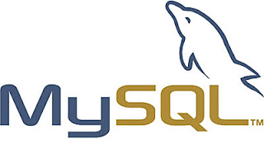](http://3.bp.blogspot.com/-hcXp5q9oGoE/T5AyhOV8hII/AAAAAAAAACc/rRFD6ZGLXIg/s1600/mysql_logo.jpg)

SQL Server is a relational database management system from [Microsoft](http://searchwinit.techtarget.com/definition/Microsoft) that's designed for the enterprise environment. SQL Server runs on T-SQL (Transact -SQL), a set of programming [extension](http://searchcio-midmarket.techtarget.com/definition/extension)s from [Sybase](http://searchenterpriselinux.techtarget.com/definition/Sybase) and Microsoft that add several features to standard SQL, including transaction control, exception and error handling, row processing, and declared variables.

[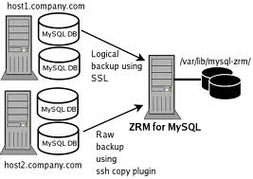](http://2.bp.blogspot.com/-egH2pu30ZB0/T5AyqeF1dsI/AAAAAAAAACk/zXjm80gCM-A/s1600/images.jpg)

Generically, any [database management system (DBMS)](http://www.webopedia.com/TERM/D/database_management_system_DBMS.html) that can respond to queries from [client machines](http://www.webopedia.com/TERM/C/client.html) formatted in the [SQL](http://www.webopedia.com/TERM/S/SQL.html) language. When capitalized, the term generally refers to either of two database management products from [Sybase](http://www.webopedia.com/TERM/S/Sybase.html) and [Microsoft](http://www.webopedia.com/TERM/M/Microsoft.html). Both companies offer [client-server](http://www.webopedia.com/TERM/C/client_server_architecture.html) DBMS products called SQL Server.

## Using WAMP as a Development Server

You can use WAMP to develop and test websites locally on their own computer instead of having to get a web hosting account to develop with. Most people will be using WAMP for development purposes such as learning how to create websites with HTML, PHP, and MySQL.

Using WAMP as a Production Server

WARNING: WAMP was designed to be a testing and development server, not an actual production server. WAMP does not come with any real security in place so it offers no protection from any kind of attack. Any 10-year-old with access to the internet can easily hack your WAMP server.

If your website(s) have highly sensitive data (such as credit card numbers, social security numbers, user ids, passwords, etc.), you need to take this in consideration before your put this information online. Unless you are an experienced system administrator and can configure WAMP to be more secure, you should never user WAMP for a production server.

MySQL Configuration

To begin [MySQL](http://www.mysql.com/) installation, first download latest version of Essentials as an MSI package.

During MySQL installation, select Typical installation and use default configuration values except for Sign-Up where you probably want to select Skip Sign-Up. When Setup Wizard is completed, make sure the option Configure the MySQL Server now is set. For MySQL Server Instance Configuration, select Standard Configuration. Next, you must set option Include Bin Directory in Windows PATH. This setting is crucial, otherwise a required library, libMySQL.dll, will not be found later during Apache startup.

Finally, enter a proper root password. There is no need to neither enable remote root access nor create an Anonymous Account.

Please inspect messages during MySQL startup and verify that MySQL has been started successfully. Then, you must reboot the system. Otherwise, the required librarylibMySQL.dll will not be found during Apache startup when Apache is trying to load Apache's PHP module and Apache will, perhaps a bit confusingly, complain that it is unable to load the PHP's MySQL library, php_mysql.dll. Therefore, it is necessary to reboot the system at this stage and then continue to PHP configuration.

## **PHP Configuration**

[PHP](http://www.php.net/) for Windows must be installed from the [zip package](http://www.php.net/downloads.php), not using the installer because the installer does not work correctly when setting up the configuration files. Download the latest Windows binary version from the 5.x release series.

Create folder C:\Program Files\PHP5 and unzip the downloaded package there. Then, in folder C:\Program Files\PHP5 you need to copy the file php.ini-recommended asphp.ini and make two changes into the php.ini file. Change extension_dir to:

extension_dir = "C:/Program Files/PHP5/ext/"

and also uncomment the following line:

extension=php_mysql.dll

That is all what is needed for PHP configuration. Additionally, however, if you wish to run PHP from the command line it would be useful to add its installation directory to Windows PATH but for WAMP to operate it is not required. After Apache is installed and configured, also PHP configuration can be tested.

Coding

FEASIBILITY REPORT

Feasibility Studyis a high level capsule version of the entire process intended to answer a number of questions like: What is the problem? Is there any feasible solution to the given problem? Is the problem even worth solving? Feasibility study is conducted once the problem clearly understood. Feasibility study is necessary to determine that the proposed system is Feasible by considering the technical, Operational, and Economical factors. By having a detailed feasibility study the management will have a clear-cut view of the proposed system.

The following feasibilities are considered for the project in order to ensure that the project is variable and it does not have any major obstructions. Feasibility study encompasses the following things:

* Technical Feasibility
* Economic Feasibility
* Operational Feasibility

In this phase, we study the feasibility of all proposed systems, and pick the best feasible solution for the problem. The feasibility is studied based on three main factors as follows.

* Technical Feasibility

In this step, we verify whether the proposed systems are technically feasible or not. i.e., all the technologies required to develop the system are available readily or not.

Technical Feasibility determines whether the organization has the technology and skills necessary to carry out the project and how this should be obtained. The system can be feasible because of the following grounds:

* All necessary technology exists to develop the system.
* This system is too flexible and it can be expanded further.
* This system can give guarantees of accuracy, ease of use, reliability and the data security.
* This system can give instant response to inquire.

Our project is technically feasible because, all the technology needed for our project is readily available.

**Operating System :** Windows 7 or higher

**Languages :** python

**Database System :** My SQL 5.6

**Documentation Tool :** MS - Word

* Economic Feasibility

Economically, this project is completely feasible because it requires no extra financial investment and with respect to time, it’s completely possible to complete this project in 6 months.

In this step, we verify which proposal is more economical. We compare the financial benefits of the new system with the investment. The new system is economically feasible only when the financial benefits are more than the investments and expenditure. Economic Feasibility determines whether the project goal can be within the resource limits allocated to it or not. It must determine whether it is worthwhile to process with the entire project or whether the benefits obtained from the new system are not worth the costs. Financial benefits must be equal or exceed the costs. In this issue, we should consider:

* The cost to conduct a full system investigation.
* The cost of h/w and s/w for the class of application being considered.
* The development tool.
* The cost of maintenance etc...

Our project is economically feasible because the cost of development is very minimal when compared to financial benefits of the application.

* Operational Feasibility

In this step, we verify different operational factors of the proposed systems like man-power, time etc., whichever solution uses less operational resources, is the best operationally feasible solution. The solution should also be operationally possible to implement. Operational Feasibilitydetermines if the proposed system satisfied user objectives could be fitted into the current system operation.

* The methods of processing and presentation are completely accepted by the clients since they can meet all user requirements.
* The clients have been involved in the planning and development of the system.
* The proposed system will not cause any problem under any circumstances.

Our project is operationally feasible because the time requirements and personnel requirements are satisfied. We are a team of four members and we worked on this project for three working months.

**TESTING**

As the project is on bit large scale, we always need testing to make it successful. If each components work properly in all respect and gives desired output for all kind of inputs then project is said to be successful. So the conclusion is-to make the project successful, it needs to be tested.

The testing done here was System Testing checking whether the user requirements were satisfied. The code for the new system has been written completelyusing python as the coding language, Django as the interface for front-end designing. The new system has been tested well with the help of the users and all the applications have been verified from every nook and corner of the user.

Although some applications were found to be erroneous these applications have been corrected before being implemented. The flow of the forms has been found to be very much in accordance with the actual flow of data.

Levels of Testing

In order to uncover the errors present in different phases we have the concept of levels of testing. The basic levels of testing are:

Client Needs Acceptance Testing

Requirements System Testing

Design Integration Testing

Code Unit Testing

A series of testing is done for the proposed system before the system is ready for the user acceptance testing.

The steps involved in Testing are:

* **Unit Testing**

Unit testing focuses verification efforts on the smallest unit of the software design**,** the module**.** This is also known as “Module Testing”**.** The modules are tested separately**.** This testing carried out during programming stage itself**.** In this testing each module is found to be working satisfactorily as regards to the expected output from the module**.**

* **Integration Testing**

Data can be grossed across an interface**;** one module can have adverse efforts on another**.** Integration testing is systematic testing for construction the program structure while at the same time conducting tests to uncover errors associated with in the interface. The objective is to take unit tested modules and build a program structure**.** All the modules are combined and tested as a whole**.** Here correction is difficult because the isolation of cause is complicate by the vast expense of the entire program. Thus in the integration testing stop**,** all the errors uncovered are corrected for the text testing steps**.**

* **System testing**

System testing is the stage of implementation that is aimed at ensuring that the system works accurately and efficiently for live operation commences. Testing is vital to the success of the system. System testing makes a logical assumption that if all the parts of the system are correct, then goal will be successfully achieved.

* **Validation Testing**

At the conclusion of integration testing software is completely assembled as a package, interfacing errors have been uncovered and corrected and a final series of software tests begins**,** validation test begins**.** Validation test can be defined in many ways**.** But the simple definition is that validation succeeds when the software function in a manner that can reasonably expected by the customer. After validation test has been conducted one of two possible conditions exists.

One is the function or performance characteristics confirm to specifications and are accepted and the other is deviation from specification is uncovered and a deficiency list is created. Proposed system under consideration has been tested by using validation testing and found to be working satisfactorily.

* **Output Testing**

After performing validation testing, the next step is output testing of the proposed system since no system could be useful if it does not produce the required output in the specified format. Asking the users about the format required by them tests the outputs generated by the system under consideration. Here the output format is considered in two ways, one is on the screen and other is the printed format. The output format on the screen is found to be correct as the format was designed in the system designed phase according to the user needs.

For the hard copy also the output comes as the specified requirements by the users. Hence output testing does not result any corrections in the system.

* **User Acceptance Testing**

User acceptance of a system is the key factor of the success of any system. The system under study is tested for the user acceptance by constantly keeping in touch with the prospective system users at the time of developing and making changes wherever required.

Test Cases

**Registration:**To begin with login, user need to register by filling up basic registration details. There are multiple fields in registration page and every field has to fill by user. User cannot use character in the login id field.

**Login: -**Login id and password are kept compulsory fields, and if the id or password doesn’t match then it will show an error message.

**VALIDATION CRITERIA**

1.      In each form, no field which is not null able should be left blank.

2.      All numeric fields should be checked for non-numeric values. Similarly, text fields like names should not contain any numeric characters.

3.      All primary keys should be automatically generated to prevent the user from entering any existing key.

4.      Use of error handling for each Save, Edit, delete and other important operations.

5.      Whenever the user Tabs out or Enter from a text box, the data should be validated and if it is invalid, focus should again be sent to the text box with proper message.

**ADVANTAGES OF PROJECT**

**Advantages:**

* The Smart Tender Management System lowers the likelihood of third-party manipulation. Furthermore, the absence of a mediator in smart tenders saves money.
* It is encrypted, and cryptography protects all papers from unauthorized access.
* It automates the system using computer protocols, saving hours of time in several business processes.

**Limitations**

* It's nearly impossible to change smart contract processes, and every programming defect becomes time-consuming and costly to fix.
* Even though contracts contain terms that are not always understood, smart tenders are not always capable of dealing with vague terms and conditions.

**Features**

1. Load Balancing:

Since the system will be available only the admin logs in the amount of load on server will be limited to time period of admin access.

1. Easy Accessibility:

Records can be easily accessed and store and other information respectively.

1. User Friendly:

The website/application will be giving a very user-friendly approach for all user.

1. Efficient and reliable:

Maintaining the all secured and database on the server which will be accessible according the user requirement without any maintenance cost will be a very efficient as compared to storing all the customer data on the spreadsheet or in physically in the record books.

1. Easy maintenance:

**Smart Tender Management System Using Blockchain is** design as easy way. So maintenance is also easy.

**CONCLUSION**

This was our project of System Design about “**Smart Tender Management System Using Blockchain”** developed in Django in Python programming language. The Development of this system takes a lot of efforts from us. We think this system gave a lot of satisfaction to all of us. Though every task is never said to be perfect in this development field even more improvement may be possible in this application. We learned so many things and gained a lot of knowledge about development field. We hope this will prove fruitful to us.

**BIBLIOGRAPHY**

* **Websites**
* en.wikipedia.org