Question 1:

Write a python program to accept two strings from user.

1.Print one of the string in uppercase and the other in lowercase.

2.Calculate sum of the length of the strings.

3.Remove ‘as’ from the given string “New drivers have twice as many accidents as experienced drivers”

Question 2:

Write a Python program which accepts a sequence of comma-separated numbers from user and generate a list and a tuple with those numbers.

Question 3:

Write a python program to give the following pattern

*

* *

* * *

* * * *

* * * * *

Question 4:

Write a Python program to count the number 4 in a given list.

Question 5:

Write a python program to insert any fruit in the given tuple and remove the last fruit from the tuple. Print tuple.

(‘banana’,’mango’,’apple’,’kiwi’)

Question 6:

Write a Python program to check if a number is positive, negative or zero.

Question 7:

Write a python program to:

dict = {"brand": "Ford","model": "Mustang","year": 1964}

1.Print all keys

2.Print all values

3.Change value of year to 1980 and print

4.Remove model from the dictionary and print

Question 8:

What will be the output of the following:

for i in range(10):

print(i)

Answer:

num1 = 11

num2 = 22

print(num1 * num2 / num2)

Answer:

x = {1,2,3,4}

y = {3,4,5}

print(x.difference(y))

Answer:

Question 9:

Write html code for the given form

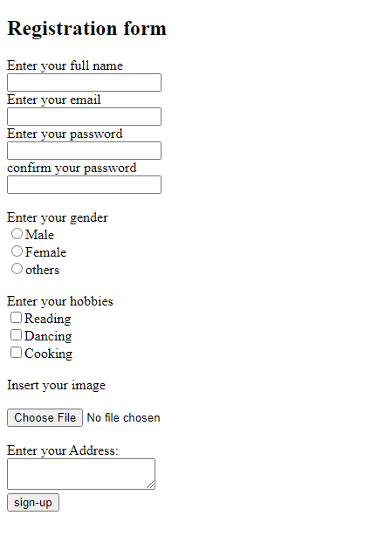

Question 10:

Write sql queries for the following:

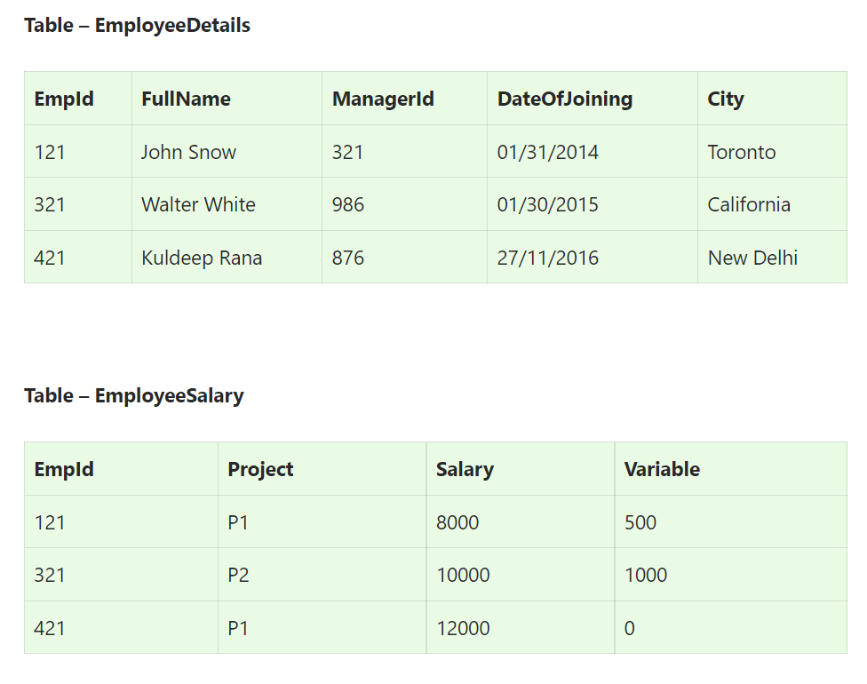

**Q1. Write an SQL query to fetch the employee details whose name is ‘Kuldeep Rana ‘.**

**Q2. Write an SQL query to find the maximum, minimum, and average salary of the employees.**

**Q3.** **Write an SQL query to find the employee id whose salary lies in the range of 9000 and 15000.**

**Q5. Write an SQL query to get the employee details whose salary is 8000?**