1. **Create a mapping which will remove the $ symbol from the salary column of source file and store the target salary value in number .**

**Source**

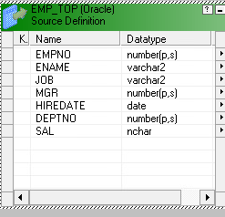  
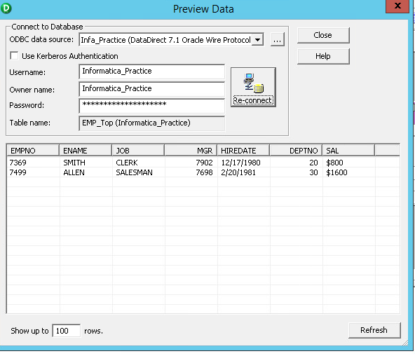

**Target**  
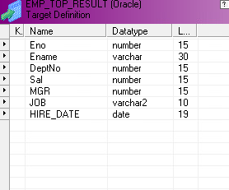

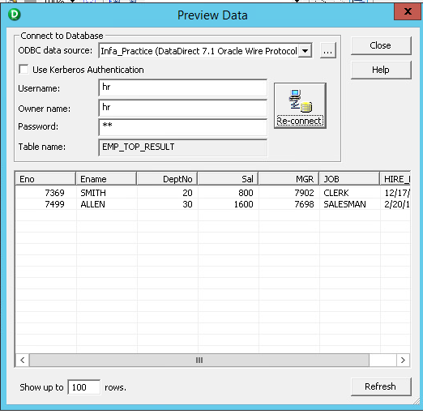

Mapping:

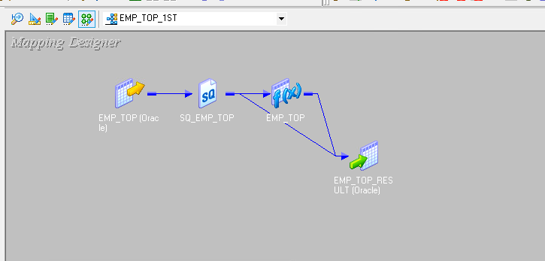

Expression:

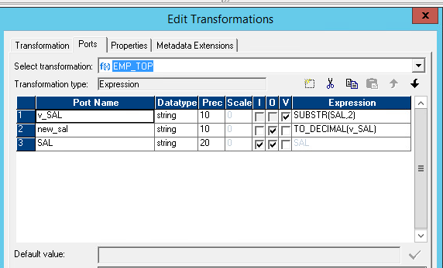

Workflow:

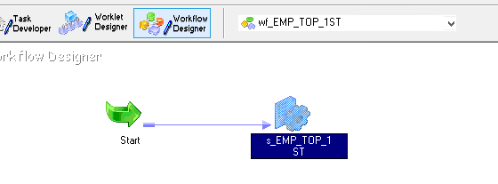

1. Read the emp table of the scott schema and load only those records into the target table where the sal value is less than 3000 and reject other rows.

Source:

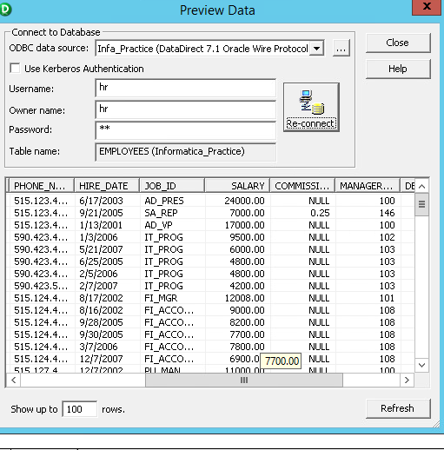

Mapping:

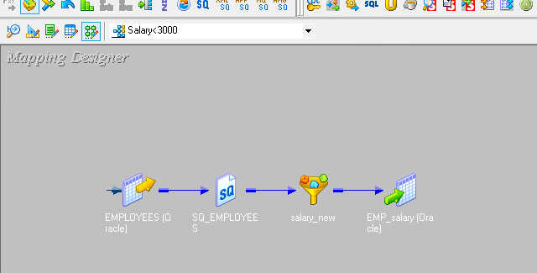

Transformation:

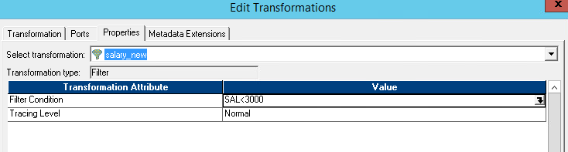

Target:

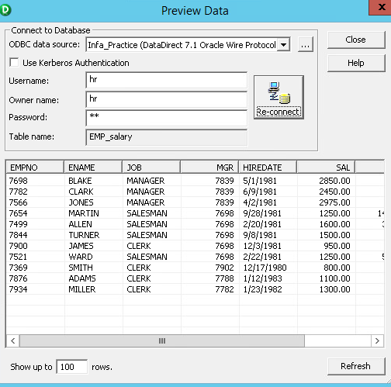

1. **Count** the no of vowels present in ename column of EMP table as shown below.

**Target:**

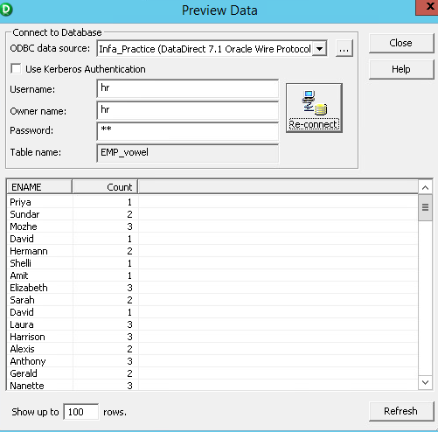

Mapping:

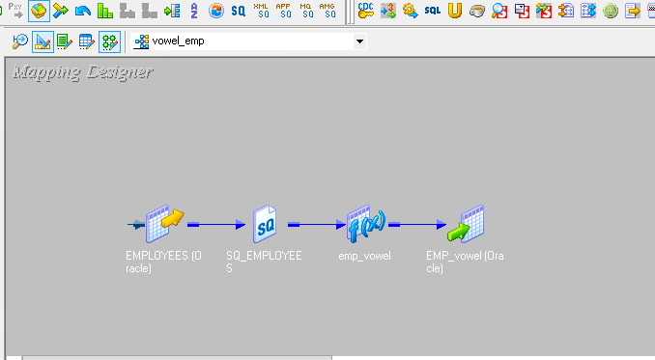

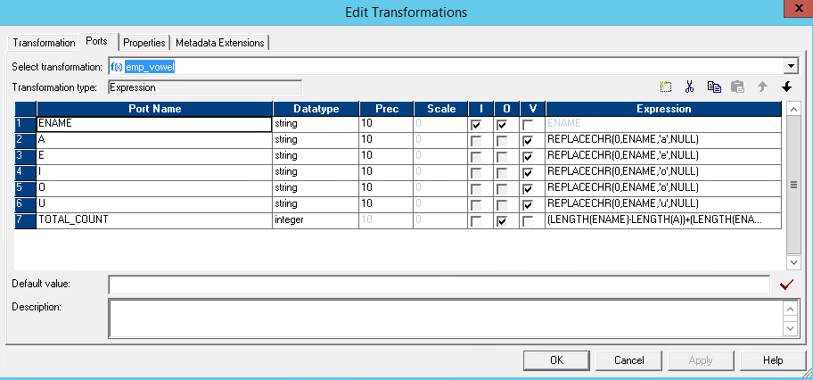

4. emp data is coming in a flat file. There are  some special symbols like @,%,$,#,&  got added in empno column along with the actual data. Create a mapping to remove those special characters ?

**empno in source**

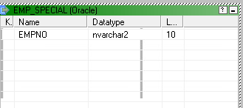

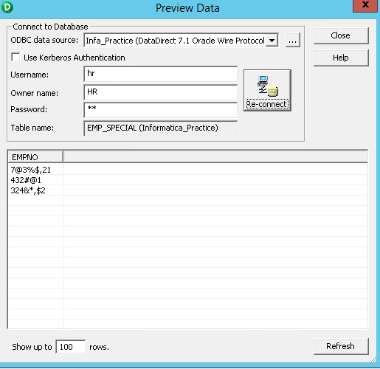

**In target**  
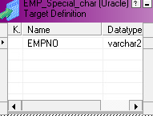

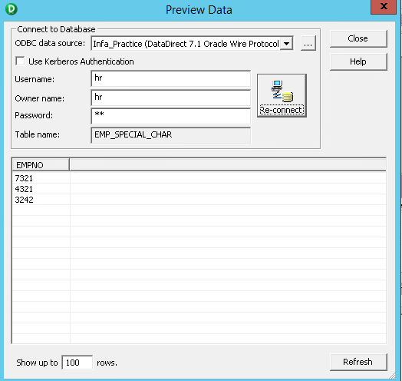

Mapping:

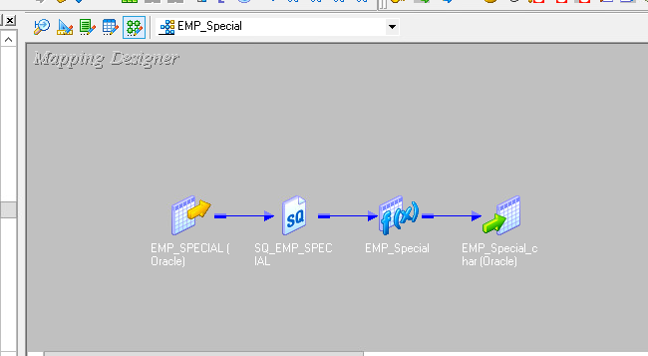

Expression:

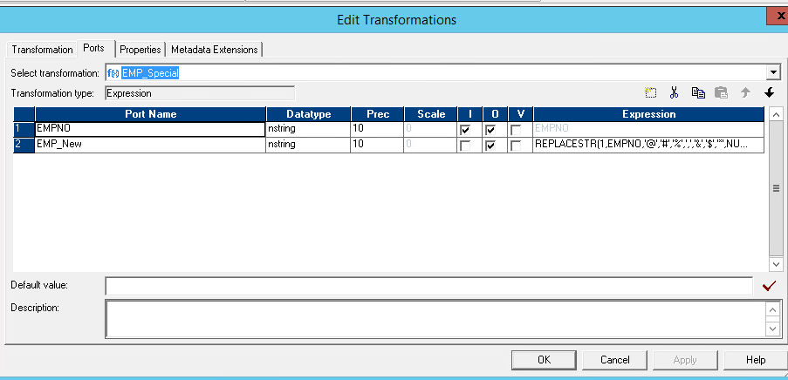

**5.** Suppose you are importing a flat file emp.csv and hire_date colummn is in numeric and the format of the date value is like 20101111 .

Create a mapping to convert it to date,with a format 'YYYYMMDD'.

