Name: Komal Madhav Tile
Prn No: 124B2E027
College Name: Pimpri Chinchwad College of Engineering

Automotive ECU Simulator

1. Introduction
The Automotive ECU Simulator is a Linux-based multi-process embedded system simulation project that demonstrates how different Electronic Control Units (ECUs) communicate over a Controller Area Network (CAN) bus inside a vehicle. The project simulates real-time sensor communication, fault detection, OBD-II diagnostics, alert generation, and limp-home safety control without requiring physical automotive hardware.
Modern vehicles contain multiple ECUs responsible for controlling engine systems, braking systems, transmission systems, and battery management. This project recreates that architecture using C programming, POSIX threads, shared memory, semaphores, FIFO communication, and inter-process synchronization.
The project is designed for learning embedded systems, operating systems concepts, IPC mechanisms, and automotive communication systems.

2. Problem Statement
Modern automotive systems depend on multiple ECUs communicating continuously over a CAN bus. Testing these systems on real hardware can be expensive, complex, and risky.
The main problem addressed in this project is:
- Simulating automotive ECU communication without physical hardware.
- Detecting faults in real time using threshold-based monitoring.
- Generating Diagnostic Trouble Codes (DTCs) similar to real OBD-II systems.
- Implementing safe communication between multiple processes.
- Demonstrating operating system concepts such as threads, signals, shared memory, semaphores, and FIFO-based IPC.
This simulator provides a low-cost educational platform for understanding automotive embedded systems.

3. Objectives
The main objectives of the project are:
- To simulate multiple automotive ECUs using independent Linux processes.
- To implement CAN bus communication using shared memory.
- To perform real-time fault detection using sensor thresholds.
- To generate OBD-II Diagnostic Trouble Codes (DTCs).
- To implement inter-process communication using FIFOs and semaphores.
- To demonstrate multi-threading and synchronization concepts.
- To create a safe limp-home mechanism during critical faults.
- To log diagnostic events and generate reports automatically.

4. Technologies Used
Technology | Purpose
C Programming | Core implementation language
POSIX Threads | Multi-threading support
Shared Memory | Virtual CAN bus communication
POSIX Semaphores | Synchronization between ECUs
Named FIFO Pipes | IPC communication
Linux Signals | Fault injection and process control
GCC & Makefile | Compilation and build management
OBD-II DTC Standards | Fault code generation

5. System Architecture
The project consists of multiple ECU processes connected through a simulated CAN bus implemented using shared memory.
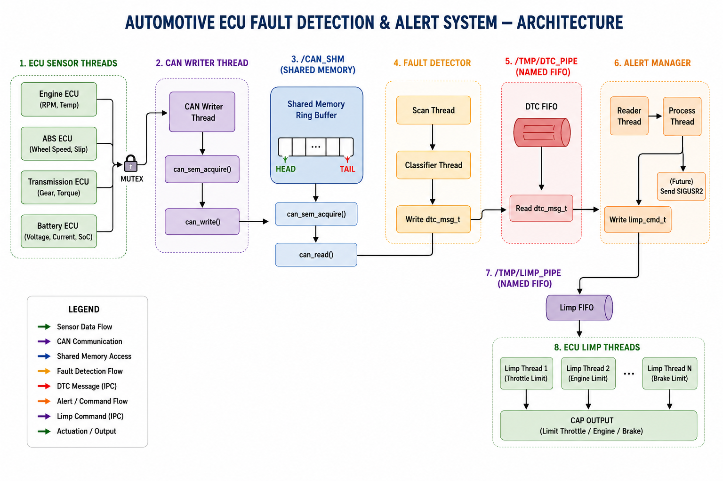

Main Components
- Gateway Process
- Engine ECU
- ABS ECU
- Transmission ECU
- Battery ECU
- Fault Detector
- Alert Manager
- OBD Logger

Working Flow
- ECUs generate sensor data.
- Data is written to the CAN shared memory bus.
- Fault detector scans incoming sensor values.
- If abnormal values are found, DTCs are generated.
- Alert manager sends limp-home commands.
- OBD logger stores logs and reports.

6. Project File Description

6.1 Source Files (src/)

gateway.c
This is the main controller process of the system.
Functions:
- Creates child ECU processes using fork().
- Executes binaries using execv().
- Handles Linux signals.
- Creates communication channels.
- Supervises all running processes.
- Sends periodic snapshots to the logger.
Importance: Acts as the central coordinator of the complete automotive simulation.

ecu_engine.c
Simulates the Engine ECU.
Functions:
- Generates engine RPM values.
- Simulates engine temperature.
- Controls throttle values.
- Creates multiple threads for sensor simulation.
- Injects faults using SIGUSR1.
Generated Faults:
- High RPM
- Overheating
DTC Examples:
- P0300
- P0217

ecu_abs.c
Simulates the ABS (Anti-lock Braking System) ECU.
Functions:
- Generates wheel speed data.
- Calculates slip ratio.
- Detects wheel abnormalities.
- Supports limp-home control.
Generated Fault:
- High wheel slip.
DTC Example:
- C0040

ecu_trans.c
Simulates the Transmission ECU.
Functions:
- Controls gear information.
- Simulates transmission torque.
- Detects gear lock conditions.
Generated Fault:
- Gear stuck at neutral.
DTC Example:
- P0700

ecu_battery.c
Simulates the Battery Management ECU.
Functions:
- Generates battery voltage.
- Monitors current flow.
- Calculates State of Charge (SoC).
- Detects low battery conditions.
Generated Fault:
- Low voltage.
DTC Example:
- P0562

fault_detector.c
This module continuously scans the virtual CAN bus.
Functions:
- Reads CAN frames from shared memory.
- Compares sensor values with thresholds.
- Generates DTC messages.
- Classifies fault severity.
- Sends alerts through FIFO.
Importance: Acts as the diagnostic brain of the system.

alert_manager.c
Handles safety-related operations.
Functions:
- Receives DTC alerts.
- Sends limp-home commands.
- Limits ECU operation during faults.
- Prevents unsafe vehicle conditions.
Importance: Provides fault response and safety management.

obd_logger.c
Responsible for storing diagnostic information.
Functions:
- Reads messages from pipes.
- Stores DTC logs in dtc.log.
- Creates report.txt.
- Updates fault counters.
Importance: Provides monitoring and report generation.

dtc.c
Contains DTC lookup tables and helper functions.
Functions:
- Maps sensor faults to DTC codes.
- Provides diagnostic descriptions.
- Supports OBD-II standards.

7. Include Files Description

can_bus.h
Defines CAN frame structures and helper functions for CAN communication.

sensor.h
Contains sensor data structures, threshold structures, and limp-home command definitions.

config.h
Stores IPC names, file paths, default thresholds, and system constants.

dtc.h
Defines DTC message structures and severity levels.

ecu_semaphore.h
Provides semaphore API declarations for synchronization.

8. IPC Module Description

can_shared_memory.c
Implements shared memory communication using:
- shm_open()
- mmap()
Purpose: Creates a virtual CAN bus ring buffer shared between all ECUs.

semaphore.c
Implements POSIX semaphores.
Purpose: Controls synchronized access to the CAN bus.

message_queue.c
Creates FIFO communication for DTC alerts.
Purpose: Transfers fault messages between modules.

fifo_comm.c
Implements limp-home communication using FIFO pipes.
Purpose: Sends safety commands to ECUs.

9. Configuration File

thresholds.conf
This file stores runtime sensor threshold values.
Examples:
- Maximum engine RPM
- Maximum engine temperature
- Maximum ABS slip ratio
- Minimum battery voltage
Advantages:
- Easy runtime modification
- No recompilation required
- Flexible testing environment

10. Working of the System

Step 1: System Startup
Gateway creates shared memory, semaphores, and FIFO channels.

Step 2: ECU Initialization
All ECUs attach to the CAN bus and start generating sensor values.

Step 3: CAN Communication
Sensor values are written into shared memory.

Step 4: Fault Detection
Fault detector checks sensor values against thresholds.

Step 5: DTC Generation
If abnormal values are found, DTC codes are generated.

Step 6: Alert Handling
Alert manager sends limp-home commands.

Step 7: Logging
OBD logger stores events in log files.

11. Fault Injection
The project supports manual fault injection using Linux signals.
Examples:
kill -USR1 $(pgrep -x ecu_engine)
kill -USR1 $(pgrep -x ecu_abs)
Purpose:
- Testing diagnostics
- Verifying DTC generation
- Simulating real automotive failures

12. IPC Mechanisms Used
IPC Method | Usage
Shared Memory | CAN bus simulation
Semaphores | Synchronization
FIFO Pipes | Alert communication
Anonymous Pipes | Logger communication
Signals | Fault injection and control

13. Advantages of the Project
- No physical automotive hardware required.
- Demonstrates real-time ECU communication.
- Useful for embedded systems learning.
- Demonstrates Linux system programming.
- Supports fault testing safely.
- Modular and scalable design.
- Realistic OBD-II fault simulation.

14. Limitations
- Simplified CAN implementation.
- Limited fault types.
- No graphical user interface.
- Linux dependent implementation.
- Basic synchronization model.

15. Future Scope
Possible future improvements include:
- Adding a graphical dashboard.
- Implementing real CAN protocol frames.
- Supporting more ECUs.
- Integrating machine learning for predictive maintenance.
- Cloud-based diagnostic monitoring.
- Adding cybersecurity protection.
- Real hardware integration using Arduino or Raspberry Pi.

16. Conclusion
The Automotive ECU Simulator successfully demonstrates the working principles of modern automotive embedded systems using Linux system programming concepts. The project simulates multiple ECUs communicating through a virtual CAN bus using shared memory and IPC techniques.
It provides practical understanding of:
- Multi-process programming
- Thread synchronization
- Shared memory communication
- FIFO-based IPC
- Fault detection systems
- OBD-II diagnostics
- Embedded automotive architectures
The project is highly useful for students learning embedded systems, operating systems, automotive electronics, and real-time communication systems. It provides a strong foundation for developing advanced automotive diagnostic and control systems in the future.

