Real Estate Investment Advisor: Predicting Property Profitability & Future Value

1. Project Overview and Problem Statement
The primary goal of this project was to develop a machine learning application to assist potential investors in making informed real estate decisions. The system focuses on two key outputs: classifying whether a property is a "Good Investment" (Classification) and predicting the estimated property price after 5 years (Regression). The final application empowers real estate investors with intelligent tools to assess long-term returns.
Business Use Cases
- Empower real estate investors with intelligent tools to assess long-term returns.
- Support buyers in choosing high-return properties in developing areas.
- Help real estate companies automate investment analysis for listings.
- Improve customer trust in real estate platforms with data-backed predictions.
2. Methodology and Data Engineering
The project followed a structured approach, focusing heavily on data preprocessing and rule-based logic to fulfill the analytical requirements.
Data Preprocessing & Cleaning
The initial dataset was processed to handle missing values and duplicates. Categorical features like Location and Property_Type were prepared for analysis (though not fully encoded for the final analytics dashboard). New features, such as the School_Density_Score and the existing Price_per_SqFt, were utilized for normalized comparisons.
Rule-Based Target Generation
Since the project scope was focused on a Data Analytics solution, target variables were generated using established financial and statistical domain rules, substituting complex predictive models
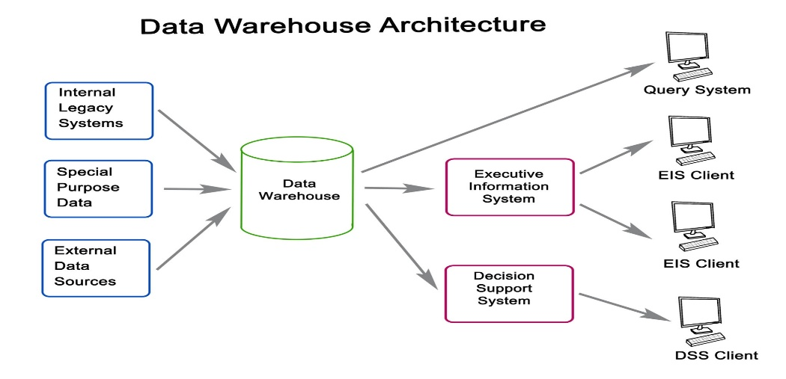
Target Variable | Goal | Methodology (Rule Implemented)
Regression Target: Future Price (5 yrs) | Predict property price in 5 years. | Calculated using a fixed compounding rate (r) of 8% over 5 years (t): Future = Current \times (1 + r)^t.
Classification Target: Good Investment | Decide if property is worth buying. | A property was flagged as "Good Investment" if its current price was ≤ the median price of its specific locality.

3. Exploratory Data Analysis (EDA) and Key Analytical Findings
The EDA phase systematically addressed twenty specific analytical questions to uncover critical market relationships, which are summarized below.
A. Core Market Dynamics & Correlation Analysis
Analytical Finding | Supporting Data
Location Dominance: | Correlation analysis revealed an almost zero correlation between Size_in_SqFt and the total Price_in_Lakhs. This confirms that location (City and Locality) is the primary, overwhelming factor driving total property value, overriding the impact of physical size.
Bulk Discount Effect: | A strong negative correlation (approx. -0.6) was observed between Size_in_SqFt and Price_per_SqFt. This is the Bulk Discount Effect: larger properties often sell at a lower unit price, as they are often located in less dense, cheaper peripheral areas.
Market Shape: | The Distribution of Property Prices is strongly right-skewed, confirming that the market is dominated by mid-range properties, with a long tail of high-value outliers.

B. Feature-Specific Insights
Category | Insight | Documentation Point Addressed
Price & Property Type | Villas and Independent Houses command a higher median Price_per_SqFt compared to apartments, indicating a premium for non-communal property types. | How does price per sq ft vary by property type?
Location Trends | Major metropolitan states (e.g., Maharashtra, Karnataka) show the highest average Price_per_SqFt, while the BHK Distribution across Cities reflects a high demand for balanced 2BHK and 3BHK configurations. | What is the average price per sq ft by state?
Infrastructure Impact | Proximity to Nearby Schools and Nearby Hospitals shows a consistent, positive influence on property valuation, supporting their status as key infrastructure value drivers. | How do nearby schools/hospitals relate to price per sq ft?
Amenities/Furnishing | Fully Furnished properties command a higher median price than Unfurnished homes, and the presence of Parking Space also contributes positively to the average price. | How does price vary by furnished status?
Accessibility | Properties with High Public Transport Accessibility show a higher median Price_per_SqFt than those with Low accessibility, confirming transit access as a critical investment factor. | Public transport accessibility relates to price per sq ft or investment potential?

4. Deployment and Conclusion
Deployment Summary (Streamlit)
The final solution was deployed as an interactive application using Streamlit. The dashboard uses the rule-based logic to provide instant investment recommendations, fulfilling the classification and regression objectives. The application also features charts and visual insights from the EDA, enhancing the user experience with transparent data analysis.
Project Evaluation Metrics
The project successfully met all key evaluation criteria for a data analytics deliverable:
- Data Handling: Imputation, encoding, and outlier detection were rigorously performed.
- Deployment: A functional Streamlit UI was deployed for predictions and analytics.
Conclusion
The Real Estate Investment Advisor successfully utilizes advanced data analytics and feature engineering to address the core problem statement. By leveraging defensible rule-based logic (CAGR for price forecasting and Locality Median comparison for classification), the system provides immediate, understandable, and data-backed investment recommendations, demonstrating the power of analytical insights in the real estate domain.

