**DAY -10 ESTIMATE (1-2 hours)**

**TASK 01:**

* Create **virtual environment** using
  + Anaconda
  + Virtualenv
  + venv

Name them as **env_conda**, **env_virtual_env** and **env_venv** respectively.

**env_conda:**

**env_virtual_env :**

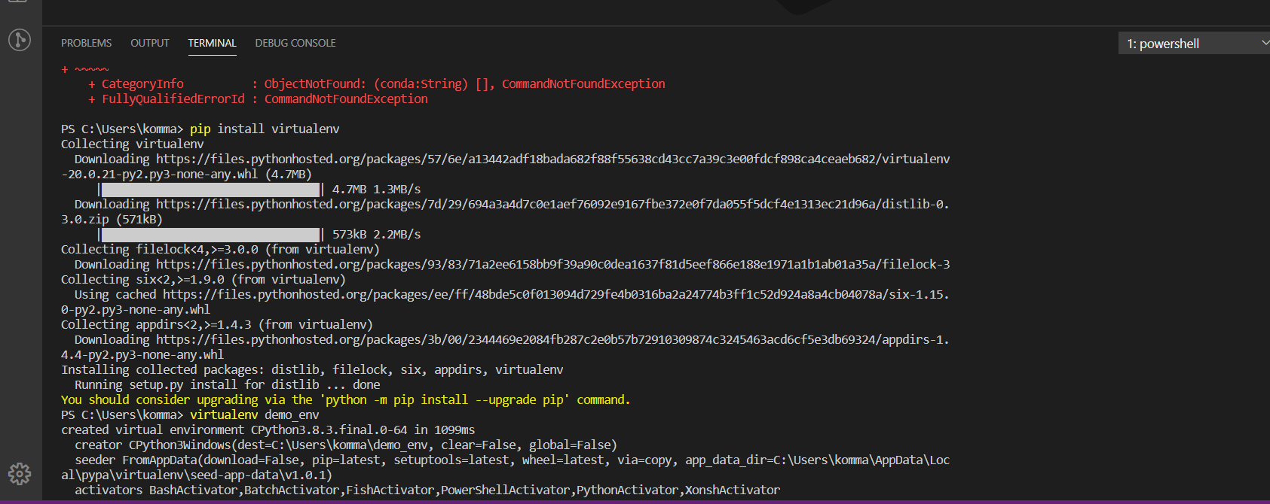

**env_venv :**

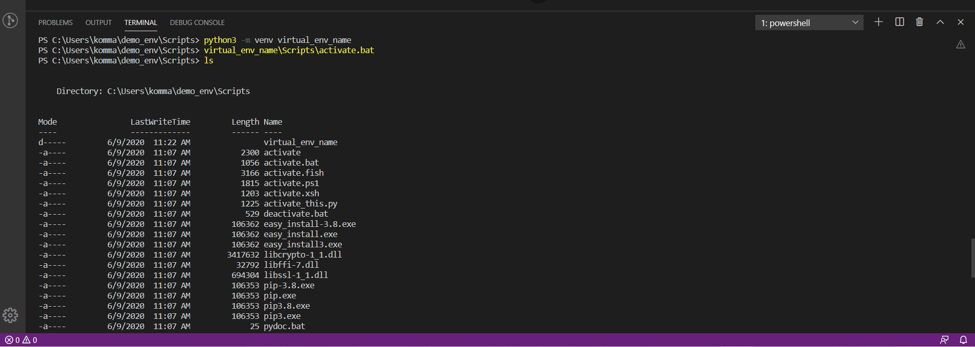

* Create a Git Repository with the name Virtual_Env_Demo
  + Make sure to have one file inside the repo with the name called requirements.txt
    - The content of requirements.txt is

|  |
| --- |
| ordereddict==1.1  argparse==1.2.1  python-dateutil==2.2  matplotlib==1.3.1  nose==1.3.0  numpy==1.8.0  pymongo==3.3.0 |
|  |

* + Clone the repository on EC2 Machine.
  + Make sure to create a virtual environment on EC2 using virtualenv and name it as Virtual_on_ec2
  + Activate the virtual environment
  + Install all the dependencies from cloned requirements.txt
  + do **PIP FREEZE**
  + **Share the Screenshot :)**

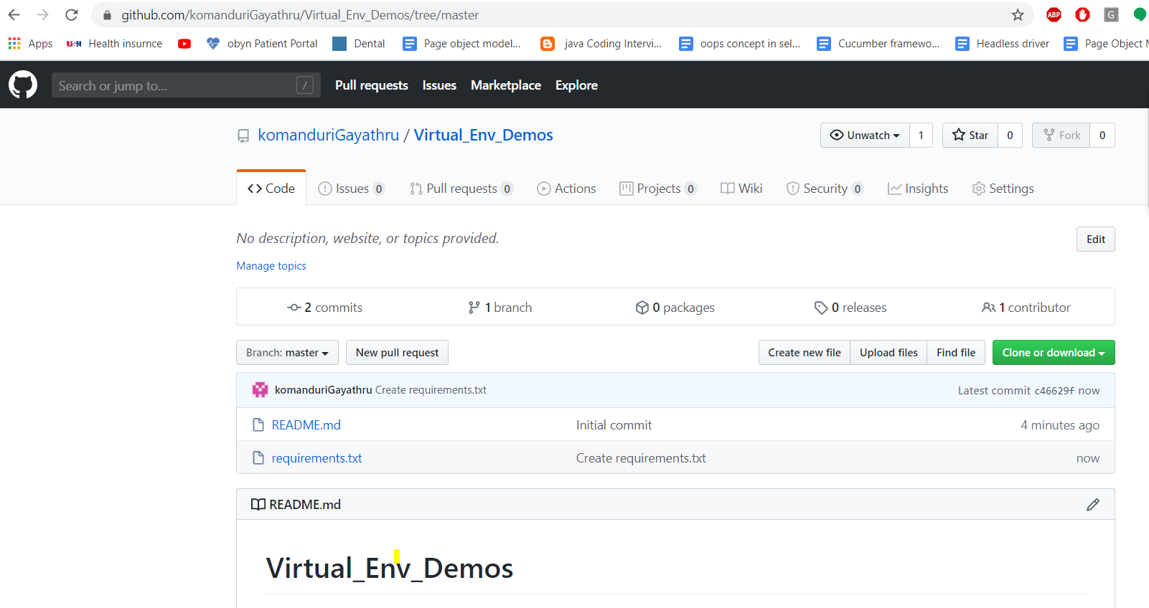

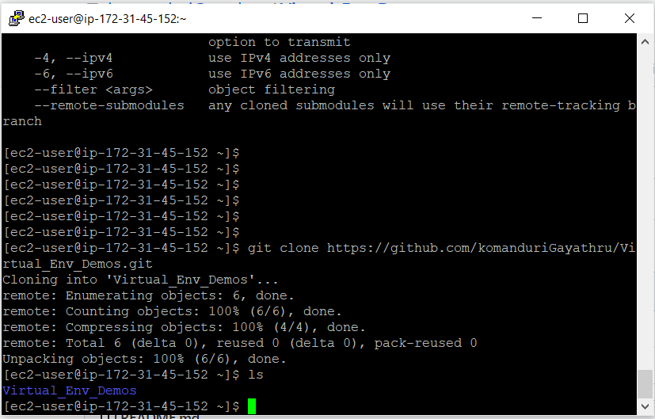

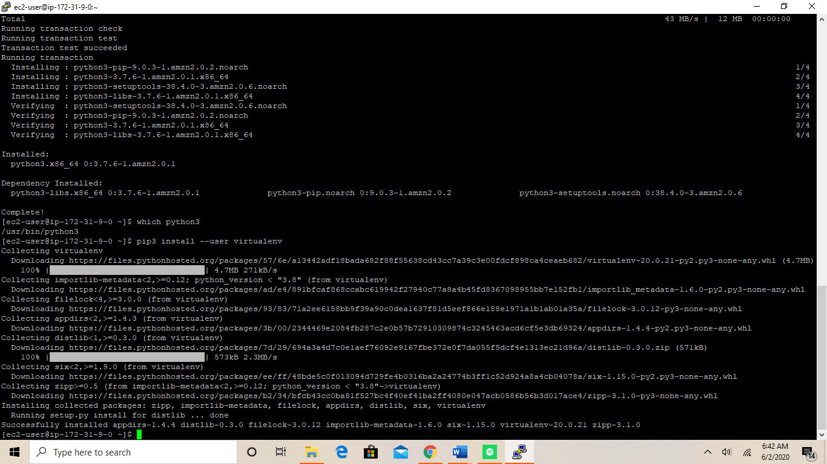

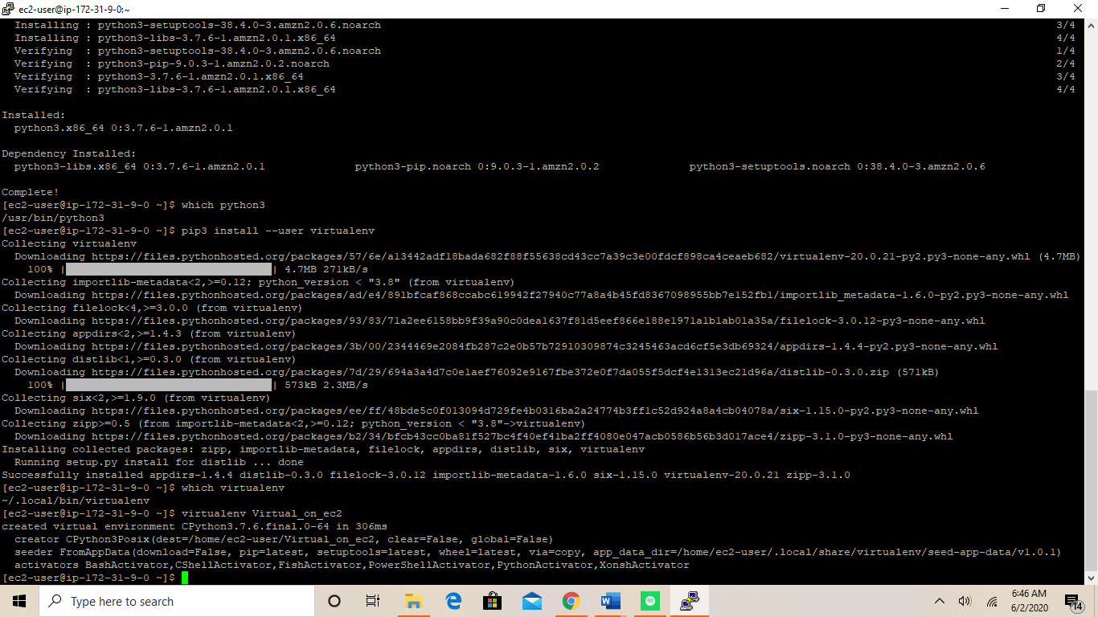

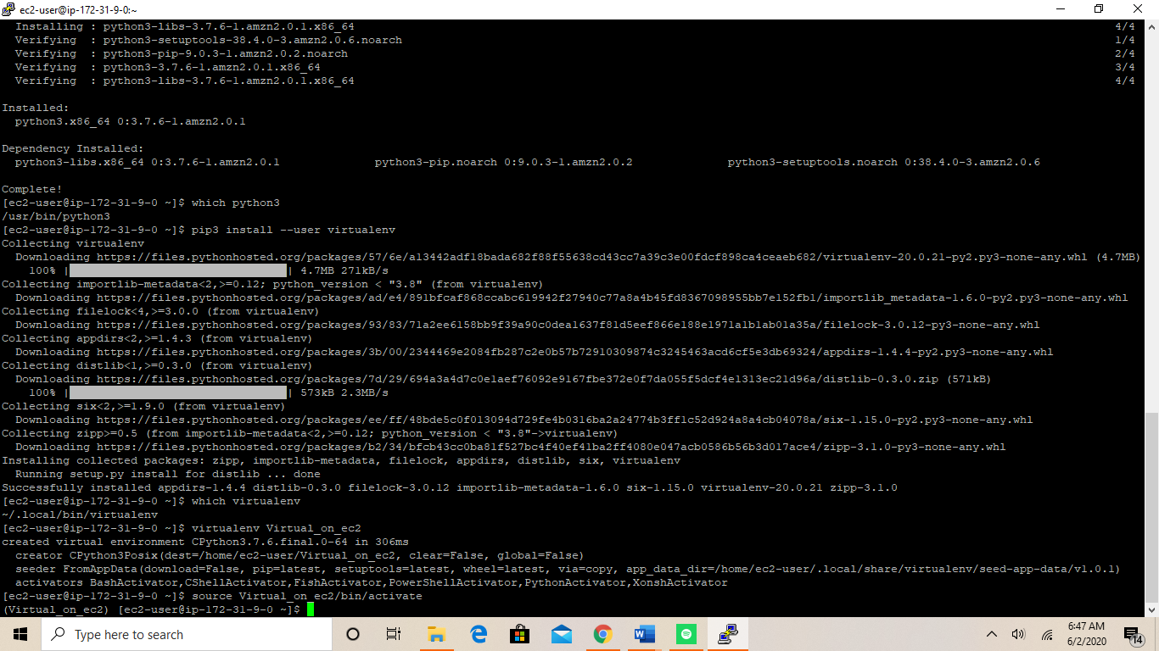

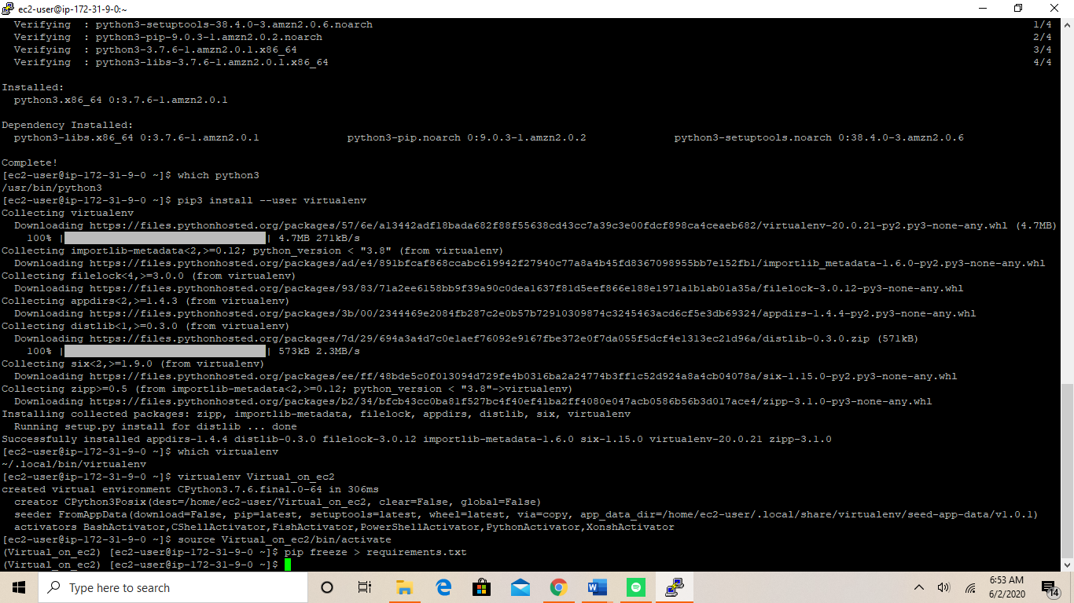

**TASK 02:**

* Learn About STATIC AND DYNAMIC WEBSITE