Auto Insurance Claim Fraud Detection Using Machine Learning
In this Article,I clearly explained how to Identify the frauds in Auto Insurance claims using machine learning techniques.Let us understand the problem statement clearly.Below is the problem statement in order to Identify the Fraud in Auto insurance claims.

Problem statement:

Insurance fraud is a huge problem in the industry. It's difficult to identify fraud claims. Machine Learning is in a unique position to help the Auto Insurance industry with this problem.
In this project, we will have a dataset which has the details of the insurance policy along with the customer details. It also has the details of the accident on the basis of which the claims have been made.
In this example, we will be working with some auto insurance data to demonstrate how can we create a predictive model that predicts if an insurance claim is fraudulent or not.

Data Analysis:
In this data analysis phase first we will import necessary packages and import our data set from the csv file and then analyze the data using different visualization techniques.The below output shows how to import necessary packages.

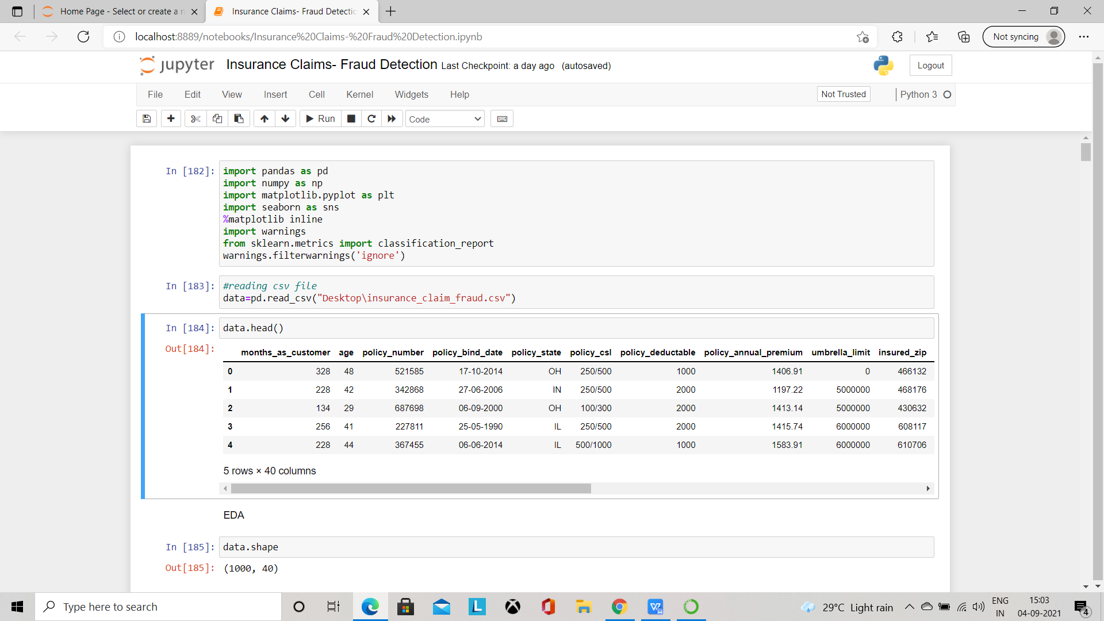

The above output clearly shows how to import necessary packages and how to the data set after importing it and as the above figure shows we have 1000 rows and 40 columns in our data set which includes our target column “Fraud_reported” which is a categorical column as it has two values Y and N so it is related to a CLASSIFICATION PROBLEM.So we use classification approaches in order to predict our model which we will see in the below Steps.

Exploratory Data Analysis(EDA):
In this step we will see how to do Exploratory Data Analysis or EDA on our data set.First let us start with checking null values in our Data set for this we use isna() or isnull() functions in order to find the null values.The null values can be identified as shown in the below outputs.
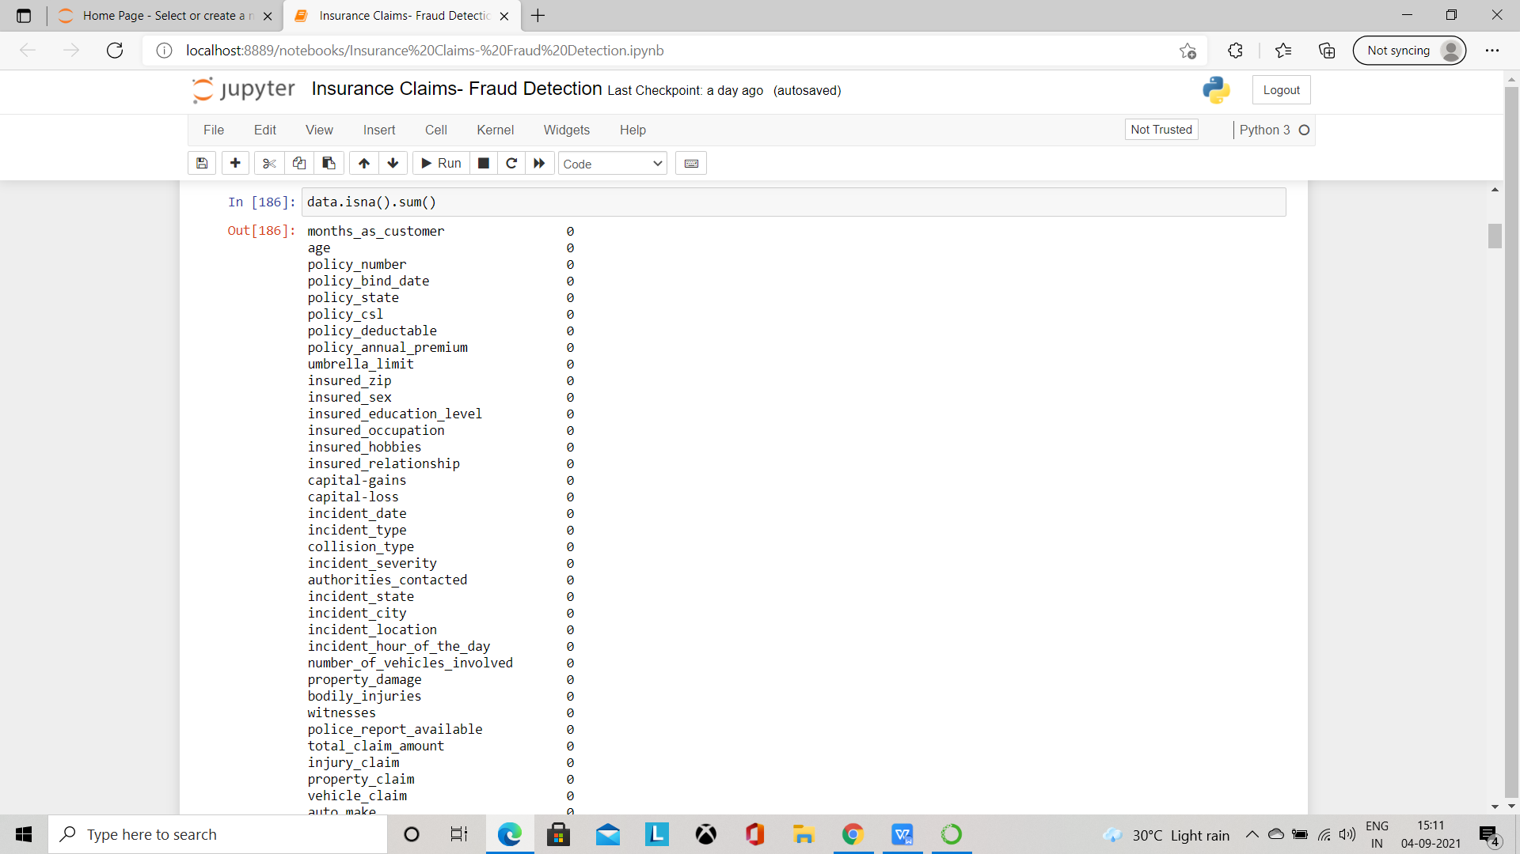

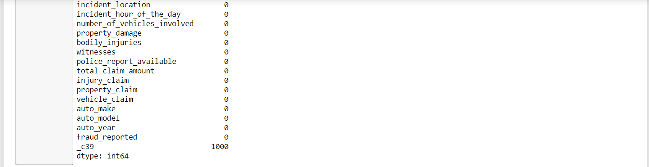

So from above output it clearly shows that there are missing values in the _c39 column which does not provide any information as all the 1000 rows in that column are having null values.So we can drop that column using dropna() function and by setting axis=1 which deletes the entire column.

After removing the null values we need to check whether we have any special characters like the ? symbol.Before that we can check the Data type of each column in our data set by using the below code.

After finding the data type of each column in our data set we were able to see that our target column which is fraud_detection is and Object data type which means It is a categorical type of data and a classification problem.So now let us proceed further in order to find special characters in our data set.For this let use a for loop to iterate over all the columns and we print the count of each column which is having the ? in it which is shown in below ouput.
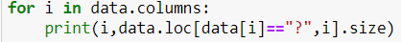

After running this code we will be able to find the columns that are having special characters in it as shown in below output.
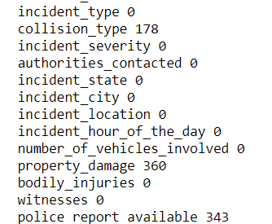

The above output gives a clear picture of the missing values in respective columns.So from the above output we can say that the columns collision_type,property_damage and police report available columns has the ? symbol in it.So it’s our task to replace the special characters in our data set.So in order to replace the ? symbol in our data set we use the value_counts() function to find the most frequently occurring value in that column and then replace the Special character with that data.The below is a sample code which shows how to replace the special character in ourdata set.

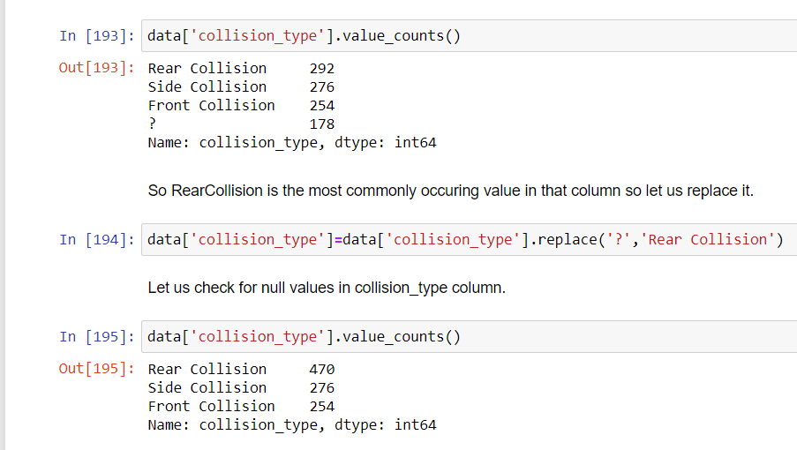

The above code is an example of how to replace the special characters in our data set.As shown in the above in the first line we identified the most frequently occurring element in our data set which is Rear Collision in our data set.So in the second step we replaced the ? symbol with Rear Collision count value and as shown in the third step we found out the the ? symbols has been replaced successfully and the same steps are followed in order to replace the ? symbols. Once done with replacing the missing values and special symbols its our task to remove the un necessary columns from our data set.For this first we can check the names of all the columns available in our data set by using dataset name.columns() function as shown below.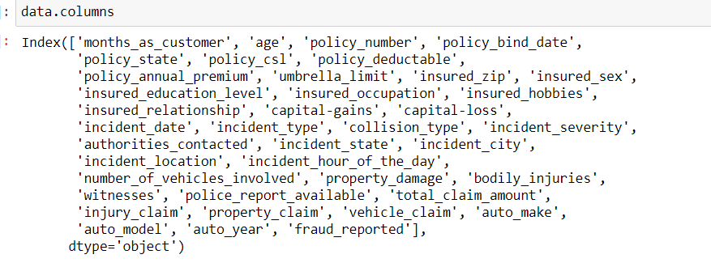

From this we can see that the columns policy_number,policy_bind_date,insured_zip,incident_location,incident_date,incident_state,incident_city,auto_make,auto_model,auto_year columns can be dropped as they do not provide much relevant information in our data set and we need to predict the fraud claims.So after removing the unwanted data we can plot a heatmap for all the correlations in our data set.As shown in the below Output.
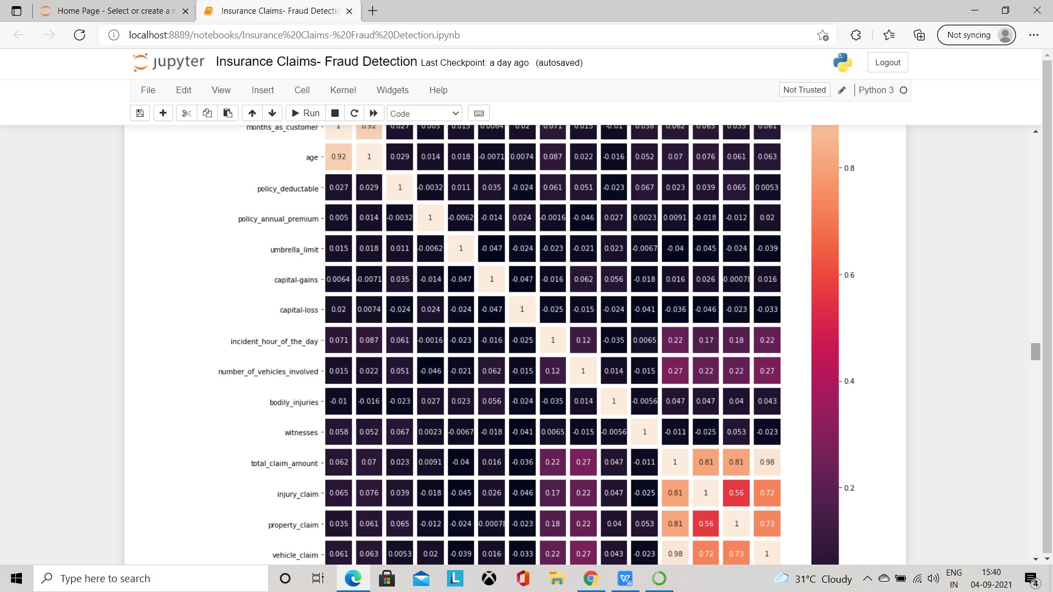

As shown in the above output we are not able to see the categorical columns so we will use Encoding techniques to convert categorical columns in to numerical columns for easy processing as our machine learning models does not under the categorical data.For this we use one of the encoding techniques which is label encoding.After applying the label encoding to our data set this is how the data looks like.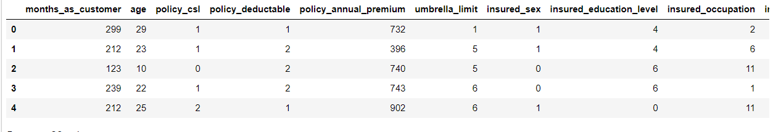

As shown in the above output our data set converted completely in to numerical which will be easy for processing.After doing the Label encoding we will check for class imbalance issue in our data set for the target column for that we import smote from imblearn oversampling module.In order to resolve the class imbalance issue we need to split our dataset in to two the target column in one variable and remaining columns in other variable.The below output shows that our data is balanced.
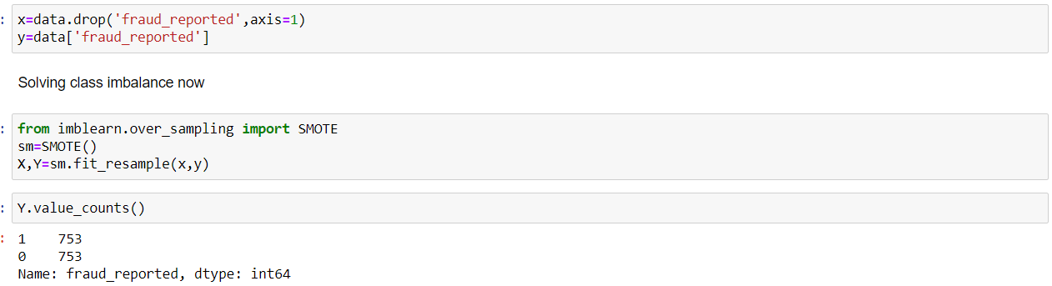
From the above output our data set is balanced and here ends the Exploratory data analysis.Next we need to Pre process our data in order to make the prediction.

Data Preprocessing:
In this Data Pre processing phase we will process our data set in order to make a predictive models.The pre processing phase includes the below steps:
- Finding best random state using one of the classifiers
- Using best random state to create train and test split

Finding best random state:
In this phase we will try to find out the best random state used for the data set in order to predict the model using any of the classifiers for our time being here I used the Decision Tree classifier which gives a Accuracy score of 85.3% with best random state of 180 which we will use for further model building.The output seen in below figure.
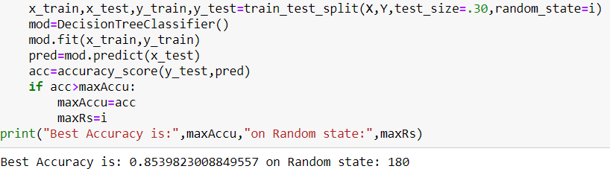

Using the best random State to create train and test split:
So in this step we will create train test split by using the random state 180 as shown below

We have did all the data preprocessing now we need to build a predictive model using classification algorithms.

Model Building:
In this step we will build a model which predicts the fraud done in the claims.For time being i used three classification algorithms.

- Decision Tree classifier
- Random Forest classifier
- Support vector classifier

The below is the accuracy score and confusion matrix of Decision Tree classifier.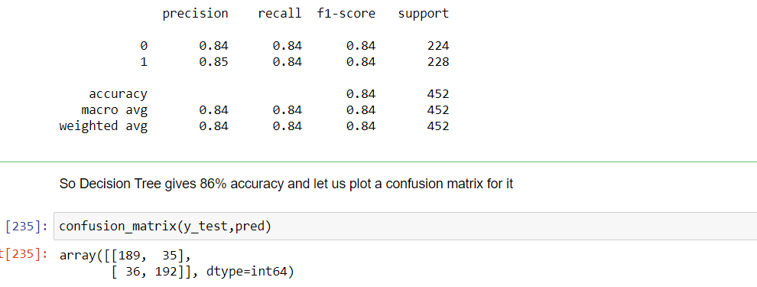

As shown in the above output we have 84% accuracy rate for decision Tree classifier.

The below is the accuracy score and Confusion matrix for Random Forest Classifier.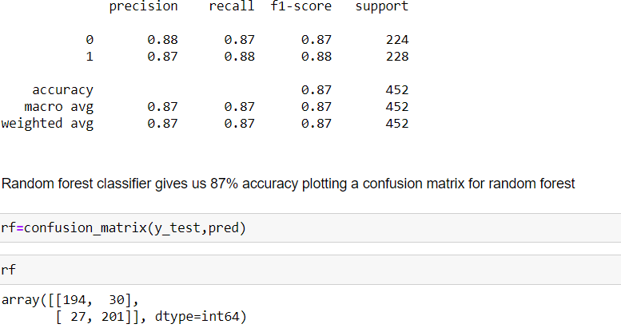

In the same way we calculate the Accuracy score and Confusion matrix for Support vector classifier as shown below
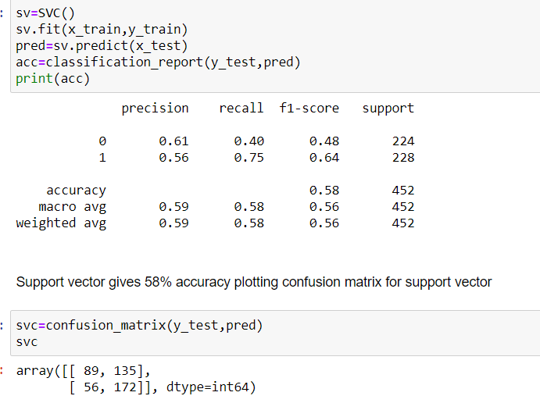

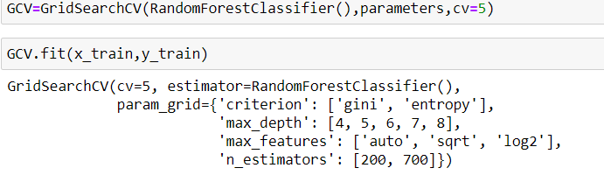
The above is the output of Hyper parameter tuning and below output shows how we will find the best accuracy.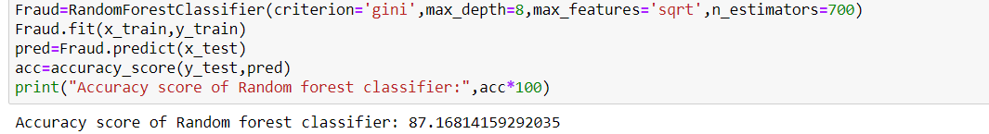

Plotting auc roc curve: For the best model we will plot the Auc roc curve as shown below 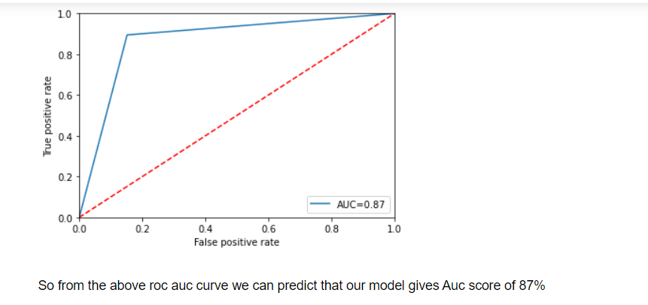

Conclusion Remarks:
Based on the above clear explanations and outputs we are able to predict the best of all the three models by following all the steps and by plotting Auc roc curve.Even though there are multiple classifiers we just used three for time being.

