Transformation from Rudrata Cycle to the Reliable Network
Group Leader Name  Net ID  email address | Vinit Mepani  vm759  vinit.mepani@rutgers.edu | Group Member Name  Net ID  email address

Abstract— In this project, we are transforming the Rudrata Cycle problem into the Reliable Network Problem. Given a Rudrata Cycle instance represented by a graph, where we need to determine a cycle that satisfies specific constraints, we compute the cycle that adheres to the reliability requirements. The output of the Rudrata Cycle solution, including the cycle, the budget matrix, and the reliability matrix r_{ij} serves as input for the Reliable Network Problem. In the Reliable Network, we construct a graph G(V, E) where the total cost of the edges does not exceed a given budget, and the graph satisfies the reliability constraints, ensuring that there are at least rijr_{ij}rij​ vertex-disjoint paths between every pair of nodes. The transformation is computationally feasible for small input sizes, with a time complexity of O(n²) for transforming the inputs to the Reliable Network.
Index Terms—algorithms, Rudrata Cycle, Reliable Network, computational complexity.

I. INPUT FORMAT

The input is provided in the form of a CSV file containing the distance matrix for a fully connected graph. The CSV file represents the distances between each pair of vertices, where each cell (i, j) corresponds to the distance between vertex i and vertex j. For a fully connected graph, all vertices are connected by edges, and all entries in the matrix are finite numbers, except for the diagonal entries D_{ii} , which are typically zero (indicating no distance to itself). The distance matrix will be a square matrix of size n × n where n is the number of vertices in the graph. The CSV file will have n rows and n columns, with each row representing the distances from a single vertex to all other vertices.
Input:
A SAMPLE INPUT CSV FILE
-3 | 4 | 5
-1 | -2 | 5
-2 | -4

II. OUTPUT FORMAT
An edge list of the corresponding graph G_{F}, and a drawing of G_{F}. If F is satisfiable, the corresponding independent set in G_{F} is specially marked in the drawing. Otherwise, display a message indicating the non-existence of an independent set of size m.
The edge list is stored as a CSV file at output.csv. Each edge is represented by two strings in a row. For example: the first row in the CSV file (Table II) encodes an edge (¬3.1,4.1) for the first clause ¬x₃∨ x₄∨ x₅ in F.

TABLE II
A SAMPLE OUTPUT CSV FILE
-3.1 | 4.1
-3.1 | 5.1
4.1 | 5.1
-1.2 | 2.2
-1.2 | 5.2
2.2 | 5.2
-2.3 | 4.3
4.1 | -4.3
2.2 | -2.3
The drawing picture is accessible at picture.png. Vertices in the independent set are red.

III. TRANSFORMATION
Describe your transformation in detail. The transformation algorithm from 3SAT to INDEPENDENT SET is provided in [1].

A. Construction of G_{F}
For each clause x ∨ y ∨ z in F, three vertices x.i,y.i,z.i are created and connected as a triangle in G_{F}, where i = 1,2,...,m is the clause index. Any two vertices that correspond to opposite literals are further connected in G_{F} to prevent choosing opposite literals. The INDEPENDENT SET instance is to find an independent set of size m in G_{F}. The time complexity of this construction is the construction time for triangles plus the connection of opposite literals, which is
O(m)+ O(m²) = O(m²).

B. Reconstruction of a 3SAT assignment
Given an independent set S of size m, by construction, it contains exactly one vertex for each variable. So assign x a value of True if S contains a vertex of positive label x.i, and a value of False if S contains a vertex of negative label −x.i.

C. Solving INDEPENDENT SET
Describe here if you use any tricks beyond plain-vanilla brute-force search.

IV. SAMPLE INPUT AND OUTPUT
List several insightful, interesting, and/or impressive examples. You can also include snapshots of your drawings (Figure
1).
V. PROGRAMMING LANGUAGE AND LIBRARIES USED
List all software tools used.
- Python 3.10
- JavaScript ES 6
- Matplotlib 3.8 [2]
- Numpy 1.26 [3]
- 3D Force-Directed Graph

VI. CONCLUSIONS
Explain what you have achieved in this project, and future work if any.
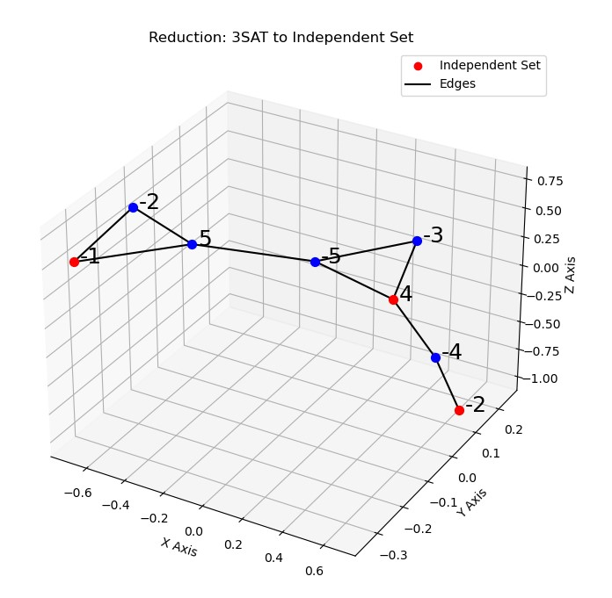
Fig. 1. G_{F} of Table I

REFERENCES
- Sanjoy Dasgupta, Christos H. Papadimitriou, and Umesh Vazirani. 2006. Algorithms (1st. ed.). McGraw-Hill, Inc., USA.
- J. D. Hunter, ”Matplotlib: A 2D Graphics Environment”, Computing in Science and Engineering, vol. 9, no. 3, pp. 90-95, 2007.
- Harris, C.R., Millman, K.J., van der Walt, S.J. et al. Array programming with NumPy. Nature 585, 357–362 (2020). DOI: 10.1038/s41586-0202649-2.

https://github.com/vasturiano/3d-force-graph

