Nickolas Komarnitsky

u0717854

01/19/2017

CS-2420

Assingment01 Analysis

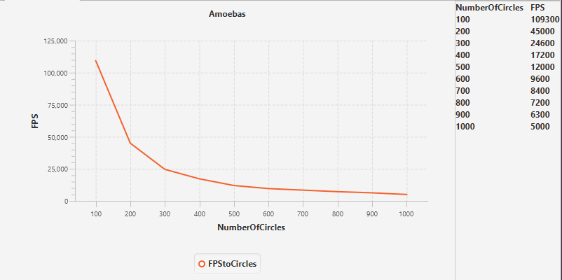

For my jiggler, I wrote a method called checkOverlapping(). Then in the jiggler.run() method I looped through every component in the panel that was added using the jigglers create circles method. However, I think that there must be a better way to determine if two objects are colliding that looping through all of them. The graph above shows that the FPS that I get decreased as more and more circles where added to the frame. For my test I simply had the runner create a new Frame and panel each time, running the jiggler to create the circles on the panel, then ending it after one second. It then grabs the number of circles and the number of frames and adds them into a hashmap that I then convert into xyData that I put into a graph. I think that there must be a better way of doing this