1. Title
Student Performance Analysis: Relationship Between Study Time and Academic Performance
2. Introduction
This project investigates whether study time is significantly related to students' academic performance. A synthetic dataset containing 100 student records was created for reproducible analysis.
3. Research Question
Does study time have a significant relationship with students' academic performance?
4. Methodology
The analysis used a synthetic dataset of 100 student records. Study time was treated as the predictor variable and final marks as the outcome variable. Descriptive statistics, Pearson correlation, and linear regression were used for the analysis. Statistical significance was evaluated at an alpha level of 0.05.
5. Results
Pearson correlation analysis indicated a statistically significant relationship between study time and final marks (p < 0.001). The linear regression coefficient for study time was 4.136, with an intercept of 39.579. The model produced an R² value of 0.523, indicating that study time explained approximately 52.3% of the variation in final marks in this synthetic dataset.
6. Visualization
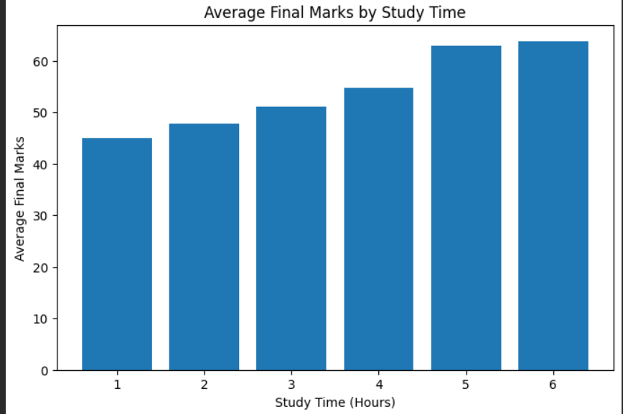
7. Conclusion
The analysis found a statistically significant positive relationship between study time and final marks in the synthetic dataset. The regression results suggest that higher study time was associated with higher predicted final marks. Since the dataset is synthetic, these findings should be considered an example of a reproducible analysis workflow rather than evidence about real students.
8. Reproducibility
The dataset, analysis notebook, and analysis preregistration are provided in the accompanying GitHub repository to support reproducibility.

