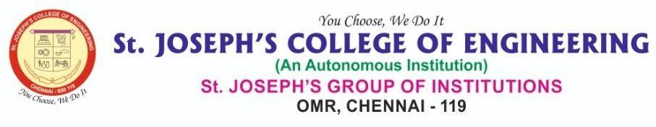

**DEPARTMENT OF INFORMATION TECHNOLOGY**

**AD1006 - Unnat Bharat Abhiyan (UBA)**

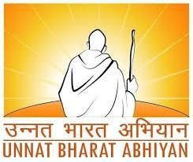

**Focusing Area:**

**DEVELOPING SELF HELP GROUPS**

**Ayimicheri, Kanchipuram District,Tamil Nadu**

**REPORT**

**Submitted by**

**Komathi T S (312322205086) Lavanya S (312322205089)**

# UBA Focusing Area Mapping with SDG and Justification

## Goal 1: No Poverty

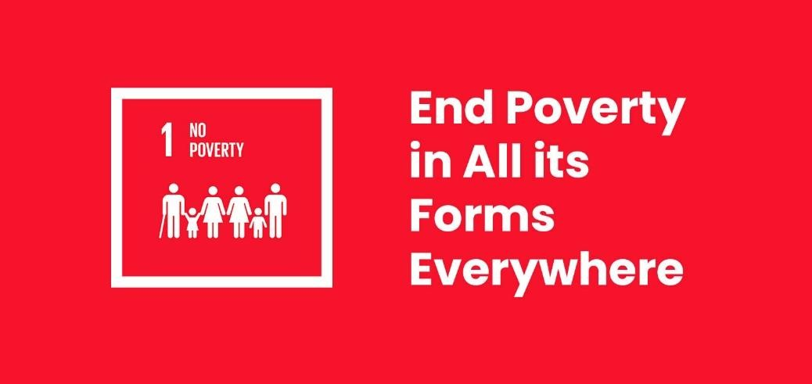

Promoting economic empowerment and financial inclusion through Self-Help Groups (SHGs) helps marginalized individuals, particularly women, lift themselves out of poverty by providing opportunities for income generation and access to financial resources.

1.4 Ensure equal access to ownership and control over land and other forms of property, inheritance, natural resources, appropriate new technology, and financial services.

## Goal 8: Decent Work and Economic Growth

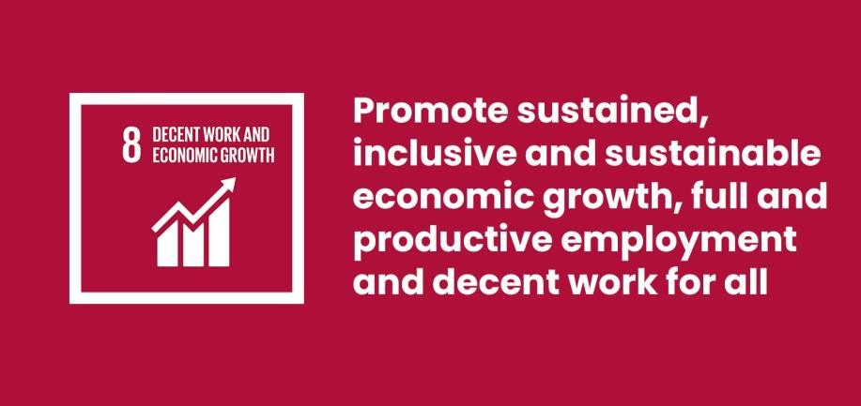

SHGs contribute to sustainable economic growth by fostering small-scale businesses and entrepreneurship, creating opportunities for decent work, particularly for women in rural and marginalized communities. They facilitate skills development and promote income-generating activities.

8.3 Promote development-oriented policies that support productive activities, decent job creation, entrepreneurship, creativity, and innovation, and encourage the formalization and growth of micro-, small-, and medium-sized enterprises.

# INTRODUCTION

Rural development stands at the heart of India’s mission for inclusive growth, especially with the majority of the population residing in villages. Empowering rural communities with tools for self-reliance is key to achieving sustainable socioeconomic transformation. As part of the Unnat Bharat Abhiyan (UBA) initiative, our student team from **St. Joseph’s College of Engineering** adopted **Ayimicheri village** in the **Kanchipuram district of Tamil Nadu**. With a population of over 1,100 people and agriculture as the primary occupation, the village presents both challenges and opportunities for development.

This year, our team focused on the theme **"Develop Self Help Groups (SHGs)"** with the objective of promoting women empowerment, financial independence, and community-based micro-entrepreneurship. SHGs are informal groups of individuals who come together to improve their economic and social status through mutual support and collaboration. These groups have been widely recognized for transforming the lives of rural women by providing them a platform for savings, credit, and small-scale business initiatives.

Through direct interaction with villagers and support from local leaders, the UBA team carried out a series of field activities that aimed to create awareness, build capacity, and initiate the formation of new SHGs in Ayimicheri.

Our activities included:

* Conducting household surveys to identify women interested in joining SHGs
* Organizing awareness sessions on SHG formation and government schemes
* Coordinating interactive sessions with successful SHG members from nearby areas
* Facilitating basic training on finance, marketing, and skill development

By the end of the intervention, several women came forward to form SHGs, with the long-term vision of starting local income-generating activities. Our mission is to nurture these groups and link them with financial institutions and support systems to ensure their sustainability and growth.

# OBJECTIVES OF THE PROJECT

The primary focus of this project under the Unnat Bharat Abhiyan was to empower women and economically weaker sections in the village of Ayimicheri by promoting the formation and functioning of Self Help Groups (SHGs). Rooted in the belief that collective effort and financial literacy can lead to sustainable development, our student team engaged with the local community to identify needs, build awareness, and create platforms for self-reliance. Based on field surveys, interactions with residents, and situational analysis, the following specific objectives were defined and implemented:

## Identification of Potential Members

To carry out household-level surveys to identify women and other interested individuals who would benefit from and be willing to participate in SHG activities.

## Awareness on SHG Concept and Benefits

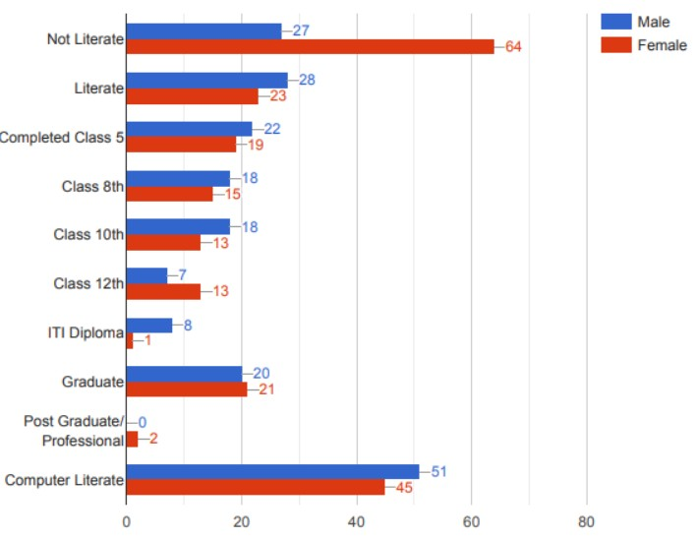To organize orientation sessions and informal meetings to educate villagers on the purpose, structure, and benefits of SHGs—including access to savings, credit, and community support systems.

## Facilitate Group Formation and Structure

To guide beneficiaries through the process of forming SHGs, including group registration, internal governance, and establishing regular meetings and savings practices.

## Skill Building and Entrepreneurship Development

To arrange training programs in tailoring, food processing, handicrafts, and other relevant vocations to support income generation among SHG members.

## Financial and Institutional Linkages

To connect the newly formed SHGs with local banks, microfinance institutions, and government welfare schemes to enable access to credit, subsidies, and support services.

## Promote Leadership and Collective Decision Making

To encourage women to take on leadership roles within their groups and actively participate in the economic and social development of their village.

## Sustain Long-Term Growth through Community Ownership

To initiate a system of community support and mentorship so that the SHGs continue to grow and operate effectively even after the completion of the project.

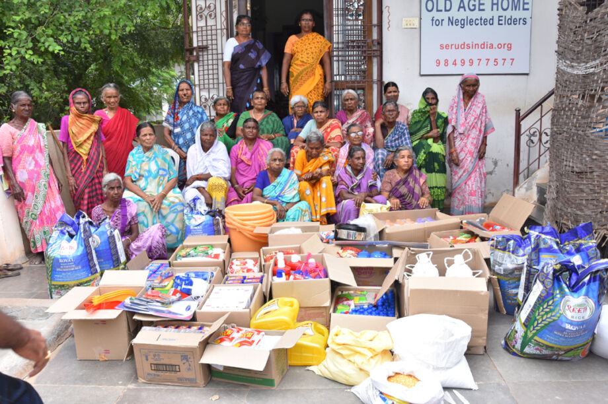

# VILLAGE PROFILE – Ayimicheri

Ayimicheriis a moderately populated rural village located in the Kanchipuram Taluk of Kanchipuram district, Tamil Nadu. It is situated approximately 10 kilometers from Walajabad and falls under the jurisdiction of the Ayimicheri Gram Panchayat. The village lies within a reasonable distance from urban amenities, being around 65 kilometers from Chennai, the state capital. The surrounding regions include Kanchipuram Block to the west, Sriperumbudur Block to the east, and Vembakkam Block to the southwest, making it well connected in terms of geography.

The total geographical area of Ayimicheri is **219.41 hectares**, with a population of **1,121 individuals**, comprising **541 males** and **580 females**, as per the latest records. The village has approximately **287 households**, with an average family size of 3 to 4 members. Tamil is the primary language spoken in the village, and a small segment of the youth is conversant in English, especially those pursuing higher education.

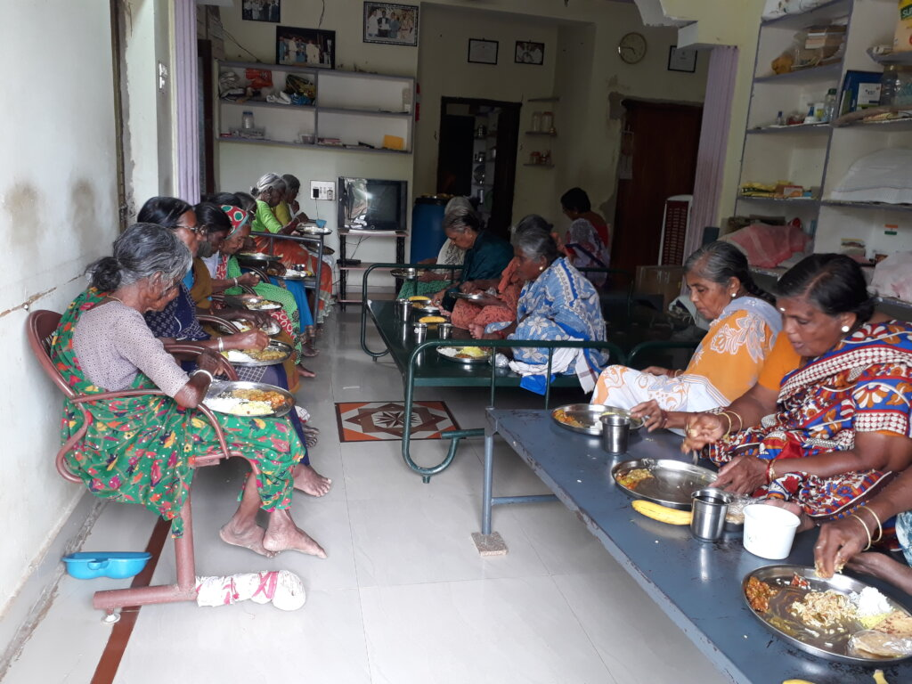

Agriculture remains the main occupation in Ayimicheri, with most residents engaged either as land-owning farmers or seasonal laborers. During the offseason, many villagers take up unskilled wage employment under government programs like the **Mahatma Gandhi National Rural Employment Guarantee Act (MGNREGA)**, which provides 100 days of guaranteed work annually. This dual nature of employment reflects the seasonal economic dependency of the village.

Educationally, while the village has access to a **primary school** and an **anganwadi center**, the literacy levels reflect room for improvement. Based on informal surveys and secondary data, male literacy is higher compared to female literacy, indicating a need for focused interventions in women’s education and vocational training. Ayimicheri also has access to a **Public**

**Distribution System (PDS)** shop and proximity to a **Primary Health Centre (PHC)**, ensuring that basic health and nutrition services are within reach. Transportation is fairly adequate, with bus services available within the village and access to a railway station within 100 km. However, despite these facilities, a lack of organized community development efforts—especially related to women empowerment and micro-enterprise—limits the village’s economic potential.

It was within this context that our UBA student team undertook the **“Develop Self Help Groups”** project, aiming to introduce structured SHG formation, skill development, and financial awareness to uplift the community, especially the women of Ayimicheri.

**BASELINE SURVEY AND IDENTIFICATION OF BASELINE**

**SURVEY AND IDENTIFICATION OF SHG BENEFICIARIES:**

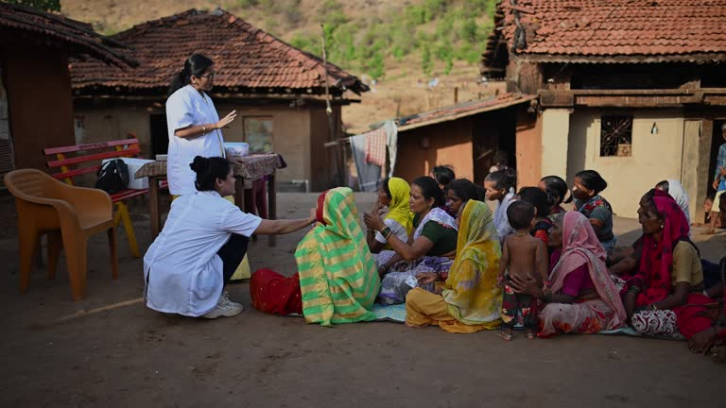

To gain a comprehensive understanding of the economic condition, livelihood patterns, and potential for self-help group formation in Ayimicheri, our UBA student team conducted a detailed door-to-door **baseline household survey**. The primary objective of this survey was to identify women and other eligible individuals interested in forming or joining SHGs, understand their existing skills, income levels, and willingness to engage in collective activities.

Covering all **287 households** in the village, the survey ensured a wide representation of the population. The data collected included household income, occupation, access to bank accounts, savings habits, vocational skills, and awareness of government welfare schemes. Through this, we identified a significant number of women—especially homemakers and agricultural laborers—who showed interest in forming SHGs to support their families and develop small-scale businesses.

In total, over **75 women** expressed readiness to join SHGs, of whom nearly

**40%** already possessed basic skills in tailoring, embroidery, cooking, and craftmaking. Many of these women were previously engaged in seasonal agricultural work and were seeking consistent income opportunities during the off-season.

## Observations

Several critical observations emerged from the survey. Most of the interested women belonged to low-income families with irregular income and limited access to financial services. Despite possessing useful skills, they lacked confidence, awareness, and support structures to monetize those skills.

Additionally, we noted that while a few households had previously been part of defunct SHGs, there was minimal understanding of the long-term financial and social benefits of properly managed SHGs. Women in the village also faced barriers such as lack of leadership training, limited mobility, and insufficient knowledge of government-backed financial schemes like **DAY-NRLM**, **Tamil Nadu State Rural Livelihood Mission**, and **Women Entrepreneurship Programs**.

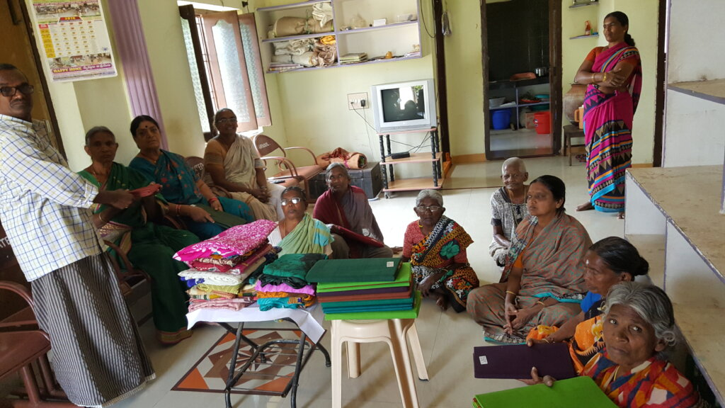

**CHALLENGES FACED BY POTENTIAL SHG MEMBERS:**



During the course of our household visits and interactive sessions, we identified the following key challenges:

* **Lack of Awareness:** Most women were unaware of the SHG concept, its benefits, or the availability of loans and subsidies through government schemes.
* **Financial Exclusion:** A majority of households did not have active savings habits or access to bank credit, limiting their ability to initiate entrepreneurial activities.
* **Social Constraints:** Cultural norms and gender roles limited women’s participation in decision-making and external group activities.
* **Skill Underutilization:** Though many women had basic vocational skills, these were not being used productively due to a lack of support and confidence.
* **Absence of Institutional Support:** There were no active NGO or cooperative linkages in the area to guide group formation, training, or microfinancing.

**GOVERNMENT SCHEMES FOR SELF HELP GROUPS AND**

**RURAL WOMEN EMPOWERMENT**

As part of our UBA intervention in Ayimicheri, a key focus was creating awareness among rural women and marginalized groups about government schemes that support the formation, funding, and growth of Self Help Groups (SHGs). During our baseline survey and village interactions, it was observed that while there was a growing interest in group-based entrepreneurship, awareness about existing schemes was extremely low.

To bridge this gap, our team collected updated information from both central and Tamil Nadu state government sources. These details were shared with the villagers through posters, leaflets, and one-on-one sessions conducted during awareness camps. The following are the major schemes that were introduced and explained to potential SHG beneficiaries:

## 1. Deendayal Antyodaya Yojana – National Rural Livelihoods Mission (DAY-NRLM)

A flagship program by the Ministry of Rural Development to support SHG formation, capacity building, and financial access.

* **Eligibility:** Rural women in SHGs registered through block-level nodal offices.
* **Benefits:** Revolving fund up to ₹15,000 and Community Investment Fund up to ₹1.10 lakh.
* **Support:** Regular handholding, training, and livelihood linkages.

## 2. Tamil Nadu State Rural Livelihood Mission (TNSRLM)

A state-level counterpart to DAY-NRLM, this mission empowers rural women by promoting entrepreneurship and collective action.

* **Eligibility:** Women residing in rural Tamil Nadu under BPL or vulnerable category.
* **Benefits:** Skill training, seed capital, and access to bank credit through linkage programs.
* **Special Feature:** SHG federations receive bulk orders for government supplies like school uniforms, food packets, etc.

## 3. Pradhan Mantri MUDRA Yojana (PMMY)

Provides micro-finance and collateral-free loans to SHG members for starting small businesses or expanding existing ventures.

* **Eligibility:** SHG members aged 18–65 with viable business ideas.
* **Loan Types:**

## o Shishu (up to ₹50,000) o Kishor (₹50,000–₹5 lakh) o Tarun (₹5 lakh–₹10 lakh)

• **Banks Involved:** Public, private, cooperative banks and micro-finance institutions.

**4. National Urban Livelihoods Mission – SHG Bank Linkage Scheme** Though originally meant for urban areas, some banks extend similar schemes to semi-rural settings like Ayimicheri.

* **Eligibility:** Registered SHGs with at least six months of savings record.
* **Benefit:** Easy access to working capital loans and credit enhancement.

## 5. Women Entrepreneurship Platform (WEP) by NITI Aayog

A digital platform to connect rural women entrepreneurs to training, mentorship, credit, and market support.

• **Support Offered:** Online registration, learning modules, and business development resources.

# ACTIVITES

As part of our initiative to empower women through the formation of Self Help Groups (SHGs) in Ayimicheri village, my team and I carried out a series of activities designed to raise awareness, build skills, and ensure long-term sustainability. These activities were carefully planned to directly address the needs of the women in the village while fostering a sense of community ownership and collective growth.

## Household Survey and Community Mapping

## On 25th January 2025, Under the Unnat Bharat Abhiyan scheme, @unnatbharatabhiyan_uba In our adopted village Maduramangalam, awareness on ill effects of using smokeless tobacco was educated among construction workers.. For the 100

Our first step was to visit all 287 households in the village to gather data on the socio-economic status of the residents. We conducted face-to-face interviews with women, explaining the project’s goals and documenting their interest in joining SHGs. The survey helped us identify the women who would most benefit from SHG membership and also revealed the existing gaps in financial literacy and access to resources.

## 2. Awareness Sessions on SHGs and Benefits

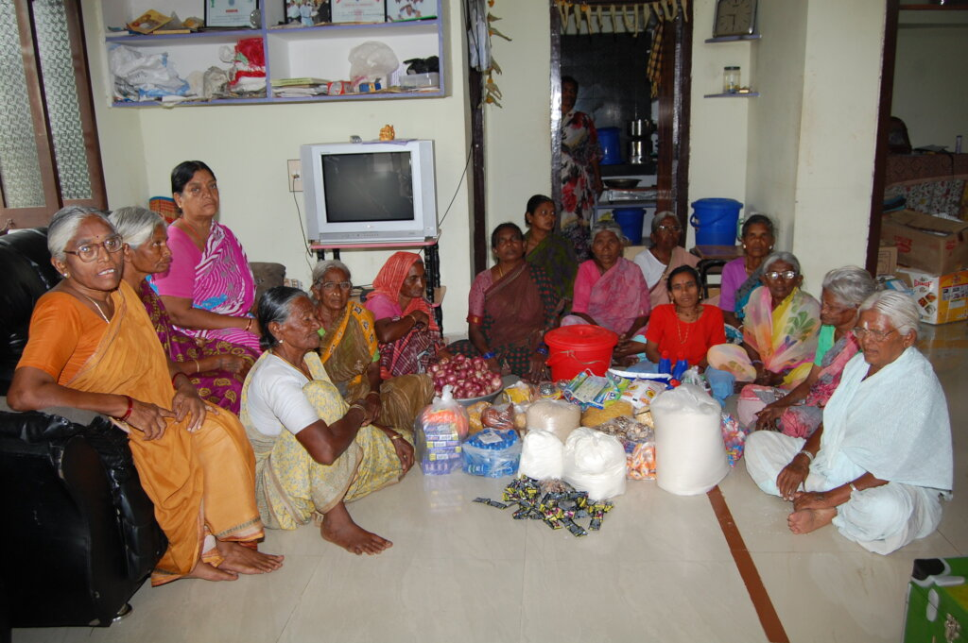

Following the survey, we held a series of awareness sessions in collaboration with the village Panchayat. These sessions took place in the community hall, where we used posters, charts, and success stories from neighboring villages to demonstrate the benefits of SHGs. We focused on how SHGs could help women gain access to credit, savings, and government schemes, encouraging participation from women who were initially skeptical.

## 3. Skill Development Workshops

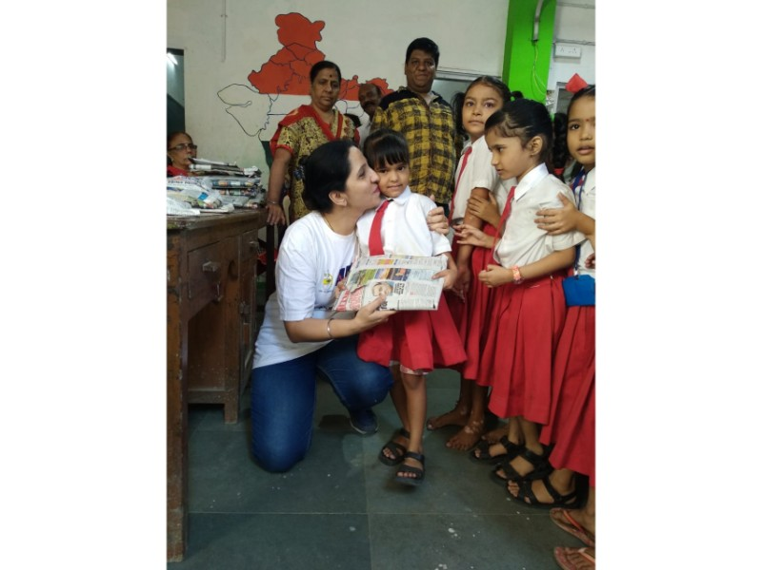

Recognizing the importance of skill-building for financial independence, we organized hands-on workshops in various fields, including tailoring, handicrafts, and food processing. Local experts were invited to provide training, and participants were encouraged to develop skills that could be monetized. These workshops were designed to be practical and relevant to the local market, ensuring that women could immediately begin generating income.

## 4. Group Formation and Capacity Building

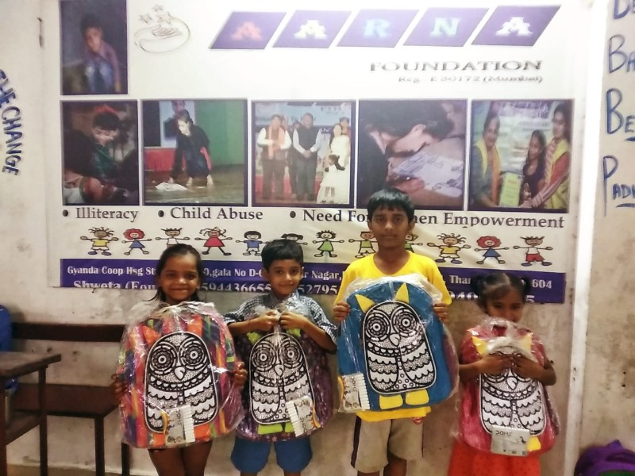

Once interest was generated, we helped women form SHGs. We provided guidance on setting up the internal structure of the groups, including selecting leaders, creating savings plans, and holding regular meetings. In parallel, we conducted leadership and financial literacy workshops to ensure that all members understood the importance of transparent record-keeping, group dynamics, and financial responsibility.

## 5. Linkage with Financial Institutions

To ensure the sustainability of the SHGs, we connected the groups with local banks and microfinance institutions. We provided support in completing the necessary documentation for loan applications and linked them to government schemes that could provide financial assistance. Our team facilitated the process by working closely with the banks and ensuring that the SHGs understood the requirements.

## 6. Community Engagement and Feedback

Throughout the entire process, we made sure to engage with the community through informal conversations. These interactions helped us understand the challenges women faced in their day-to-day lives and allowed us to address concerns that arose during the implementation phase. It also created a sense of trust and camaraderie, ensuring that the project was not just top-down but rooted in the needs and aspirations of the community.

## 7. Documentation and Reporting

We ensured that all activities were well-documented, including attendance, workshops conducted, financial transactions, and SHG progress. This documentation will serve as a valuable resource for future projects and will help in evaluating the impact of the work done in Ayimicheri.

In summary, each activity was carried out with the goal of building a sustainable, self-reliant community. We took ownership of the process from start to finish, from conducting surveys to facilitating workshops and linking SHGs with financial institutions. The hands-on approach allowed us to directly address the unique needs of the women in Ayimicheri, and the project has laid the groundwork for long-term change.

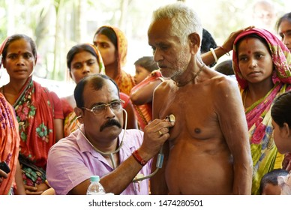

# CONCLUSION

Our journey as part of the Unnat Bharat Abhiyan (UBA) project in Ayimicheri was a transformative experience, both for us as student volunteers and for the community we engaged with. 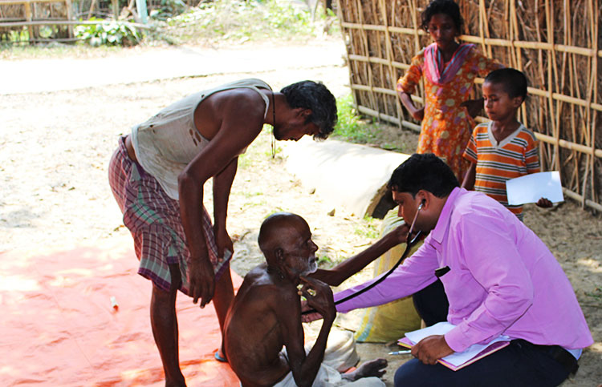

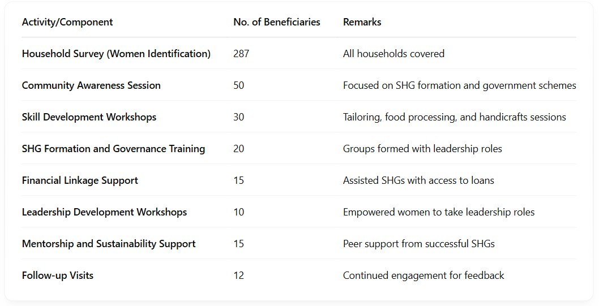

Through our household surveys, awareness sessions, skill development workshops, and support with government schemes, we gained meaningful insights into the challenges faced by the women and youth of Ayimicheri. We uncovered stories of resilience and brought attention to long-overlooked needs, empowering them with the tools they need to change their own futures.

Our efforts went beyond just data collection; we helped women establish Self Help Groups (SHGs), facilitated their access to financial resources, and worked on fostering leadership within the community. The project reinforced our belief that sustainable change starts with empowerment, equal access to resources, and dignity for all.

We are hopeful that the foundation we’ve built will continue to create positive change. With continued support from the Panchayat, local authorities, and future UBA teams, Ayimicheri can truly become a model for inclusive rural development. The skills, knowledge, and connections we've shared will help the community continue on a path to self-sufficiency.

We are thankful for the opportunity to serve and contribute to the vision of Unnat

Bharat Abhiyan: empowering villages through collective and compassionate action.

# “Our Journey in Ayimicheri”

***(Survey → Awareness → Boot Camp → Application Assistance)***

