

**FACULTY OF INFORMATION TECHNOLOGY**

**Programming 621**

**1st SEMESTER ASSIGNMENT**

**Name & Surname:** Tawana Kombora **ICAS/ITS No:** 402202621

**Qualification:** BSc I.T **Semester:** 1st **Module Name:** Programming 621

**Submission Date:**  31st May 2023

|  |  |  |  |
| --- | --- | --- | --- |
| **ASSESSMENT CRITERIA** | **MARK**  **ALLOCATION** | **EXAMINER MARKS** | **MODERATOR**  **MARKS** |
| **MARKS FOR CONTENT** | | | |
| **QUESTION ONE** | **30** |  |  |
| **QUESTION TWO** | **30** |  |  |
| **QUESTION THREE** | **30** |  |  |
| **TOTAL MARKS** | **90** |  |  |
| **MARKS FOR TECHNICAL ASPECTS** | |  |  |
| **1. TABLE OF CONTENTS**  Accurate numbering according to the numbering in text and page numbers. | **2** |  |  |
| **2. LAYOUT AND SPELLING**  Font – Calibri 12  Line Spacing – 1.0  Margin should be justified. | **3** |  |  |
| **3. REFERENCE**  According to the Harvard Method | **5** |  |  |
| **TOTAL MARKS** | **10** |  |  |
| **TOTAL MARKS FOR ASSIGNMENT** | **100** |  |  |
| **Examiner’s Comments:** | | | |
|  | | | |
|  | | | |
| **Moderator’s Comments:** | | | |
|  | | | |
|  | | | |
| **Signature of Examiner: Signature of Moderator:** | | | |

Table of Contents

QUESTION ONE 3

QUESTION TWO 6

QUESTION THREE 11

# QUESTION ONE

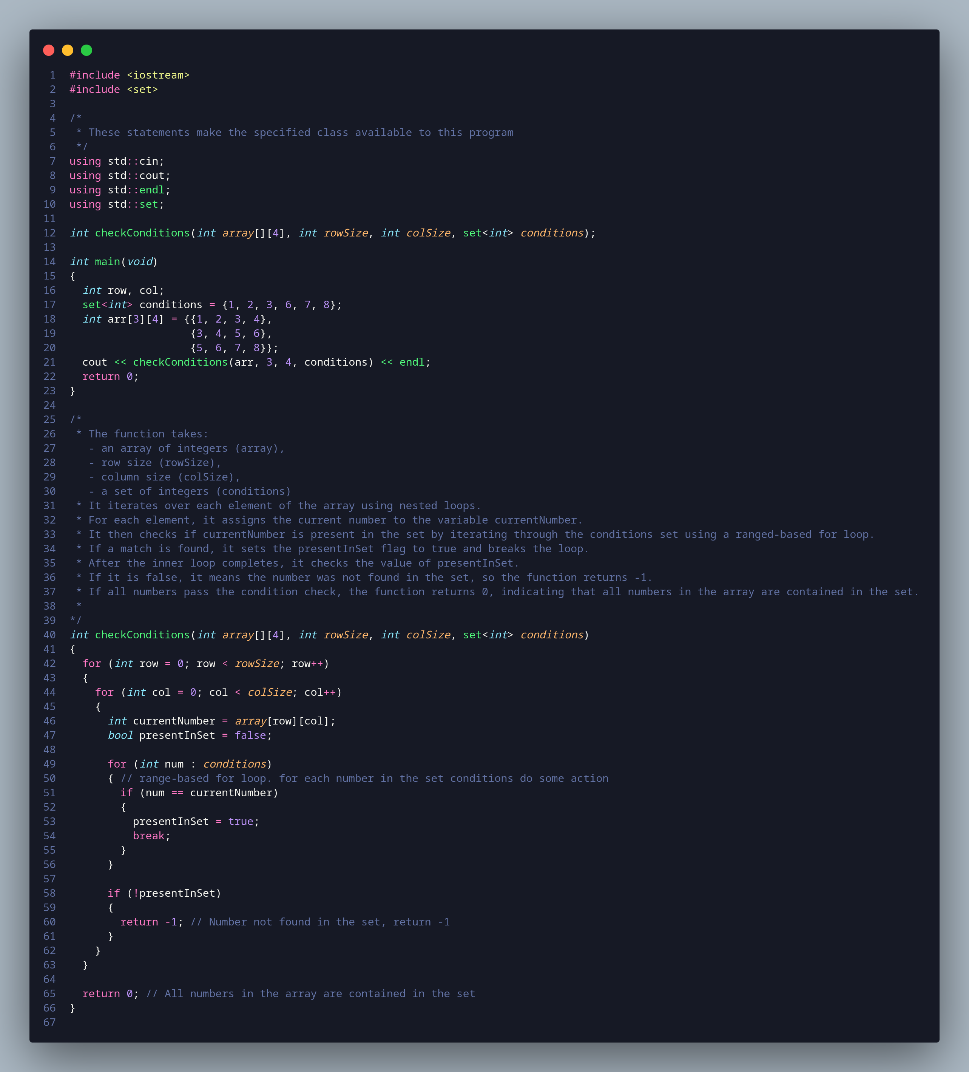

#include <iostream>

#include <set>

/*

* These statements make the specified class available to this program

*/

using std::cin;

using std::cout;

using std::endl;

using std::set;

int checkConditions(int array[][4], int rowSize, int colSize, set<int> conditions);

int main(void)

{

int row, col;

set<int> conditions = {1, 2, 3, 4, 5, 6, 7, 8};

int arr[3][4] = {{1, 2, 3, 4},

{3, 4, 5, 6},

{5, 6, 7, 8}};

cout << checkConditions(arr, 3, 4, conditions) << endl;

return 0;

}

/*

* The function takes:

- an array of integers (array),

- row size (rowSize),

- column size (colSize),

- a set of integers (conditions)

* It iterates over each element of the array using nested loops.

* For each element, it assigns the current number to the variable currentNumber.

* It then checks if currentNumber is present in the set by iterating through the conditions set using a ranged-based for loop.

* If a match is found, it sets the presentInSet flag to true and breaks the loop.

* After the inner loop completes, it checks the value of presentInSet.

* If it is false, it means the number was not found in the set, so the function returns -1.

* If all numbers pass the condition check, the function returns 0, indicating that all numbers in the array are contained in the set.

*

*/

int checkConditions(int array[][4], int rowSize, int colSize, set<int> conditions)

{

for (int row = 0; row < rowSize; row++)

{

for (int col = 0; col < colSize; col++)

{

int currentNumber = array[row][col];

bool presentInSet = false;

for (int num : conditions)

{ // range-based for loop. for each number in the set conditions do some action

if (num == currentNumber)

{

presentInSet = true;

break;

}

}

if (!presentInSet)

{

return -1; // Number not found in the set, return -1

}

}

}

return 0; // All numbers in the array are contained in the set

}

# QUESTION TWO

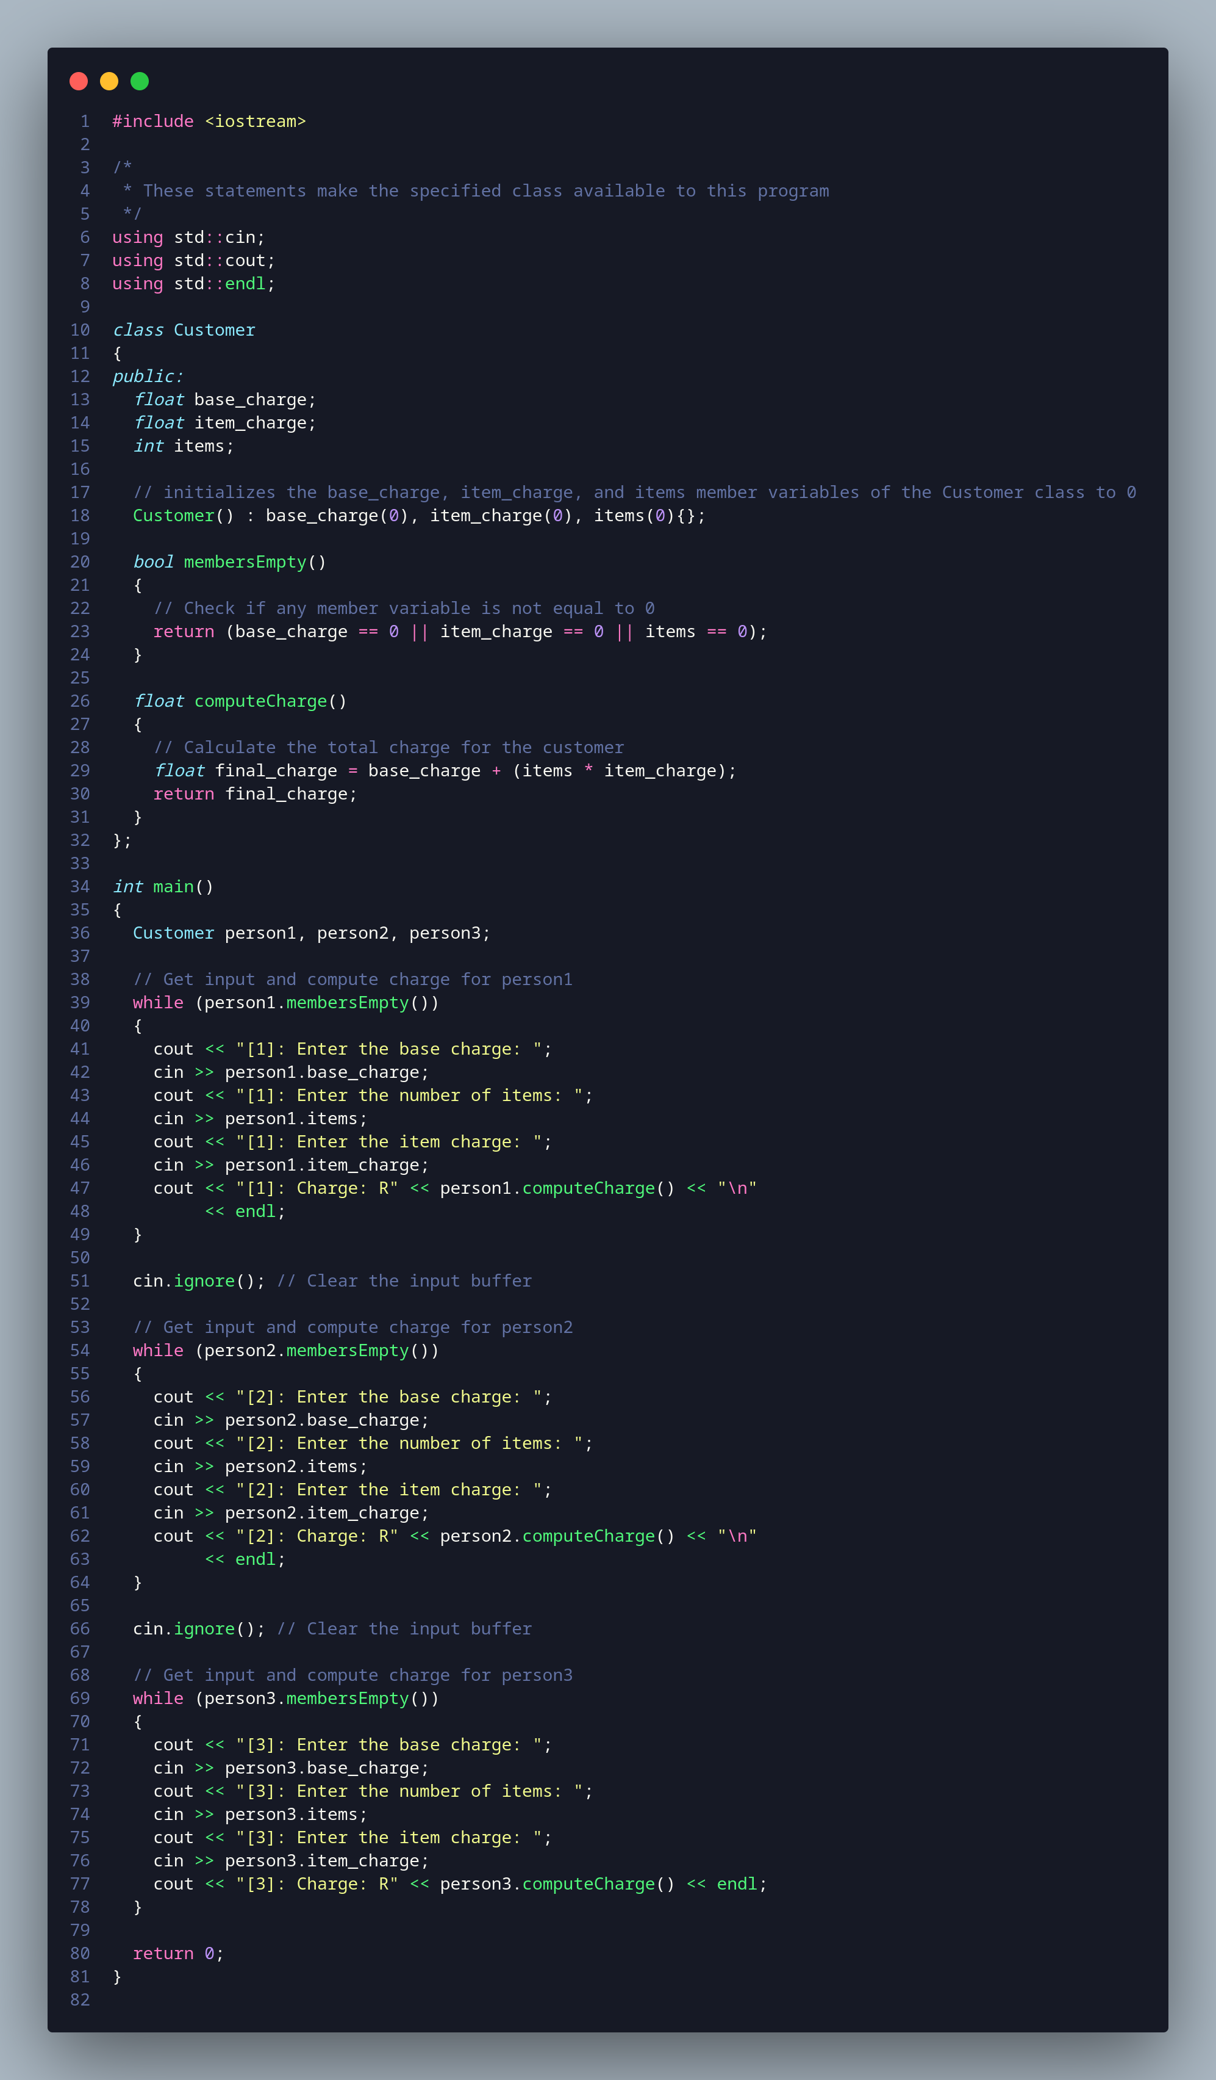

#include <iostream>

/*

* These statements make the specified class available to this program

*/

using std::cin;

using std::cout;

using std::endl;

class Customer

{

public:

float base_charge;

float item_charge;

int items;

// initializes the base_charge, item_charge, and items member variables of the Customer class to 0

Customer() : base_charge(0), item_charge(0), items(0){};

bool membersEmpty()

{

// Check if any member variable is not equal to 0

return (base_charge == 0 || item_charge == 0 || items == 0);

}

float computeCharge()

{

// Calculate the total charge for the customer

float final_charge = base_charge + (items * item_charge);

return final_charge;

}

};

int main()

{

Customer person1, person2, person3;

// Get input and compute charge for person1

while (person1.membersEmpty())

{

cout << "[1]: Enter the base charge: ";

cin >> person1.base_charge;

cout << "[1]: Enter the number of items: ";

cin >> person1.items;

cout << "[1]: Enter the item charge: ";

cin >> person1.item_charge;

cout << "[1]: Charge: R" << person1.computeCharge() << "\n"

<< endl;

}

cin.ignore(); // Clear the input buffer

// Get input and compute charge for person2

while (person2.membersEmpty())

{

cout << "[2]: Enter the base charge: ";

cin >> person2.base_charge;

cout << "[2]: Enter the number of items: ";

cin >> person2.items;

cout << "[2]: Enter the item charge: ";

cin >> person2.item_charge;

cout << "[2]: Charge: R" << person2.computeCharge() << "\n"

<< endl;

}

cin.ignore(); // Clear the input buffer

// Get input and compute charge for person3

while (person3.membersEmpty())

{

cout << "[3]: Enter the base charge: ";

cin >> person3.base_charge;

cout << "[3]: Enter the number of items: ";

cin >> person3.items;

cout << "[3]: Enter the item charge: ";

cin >> person3.item_charge;

cout << "[3]: Charge: R" << person3.computeCharge() << endl;

}

return 0;

}

# QUESTION THREE

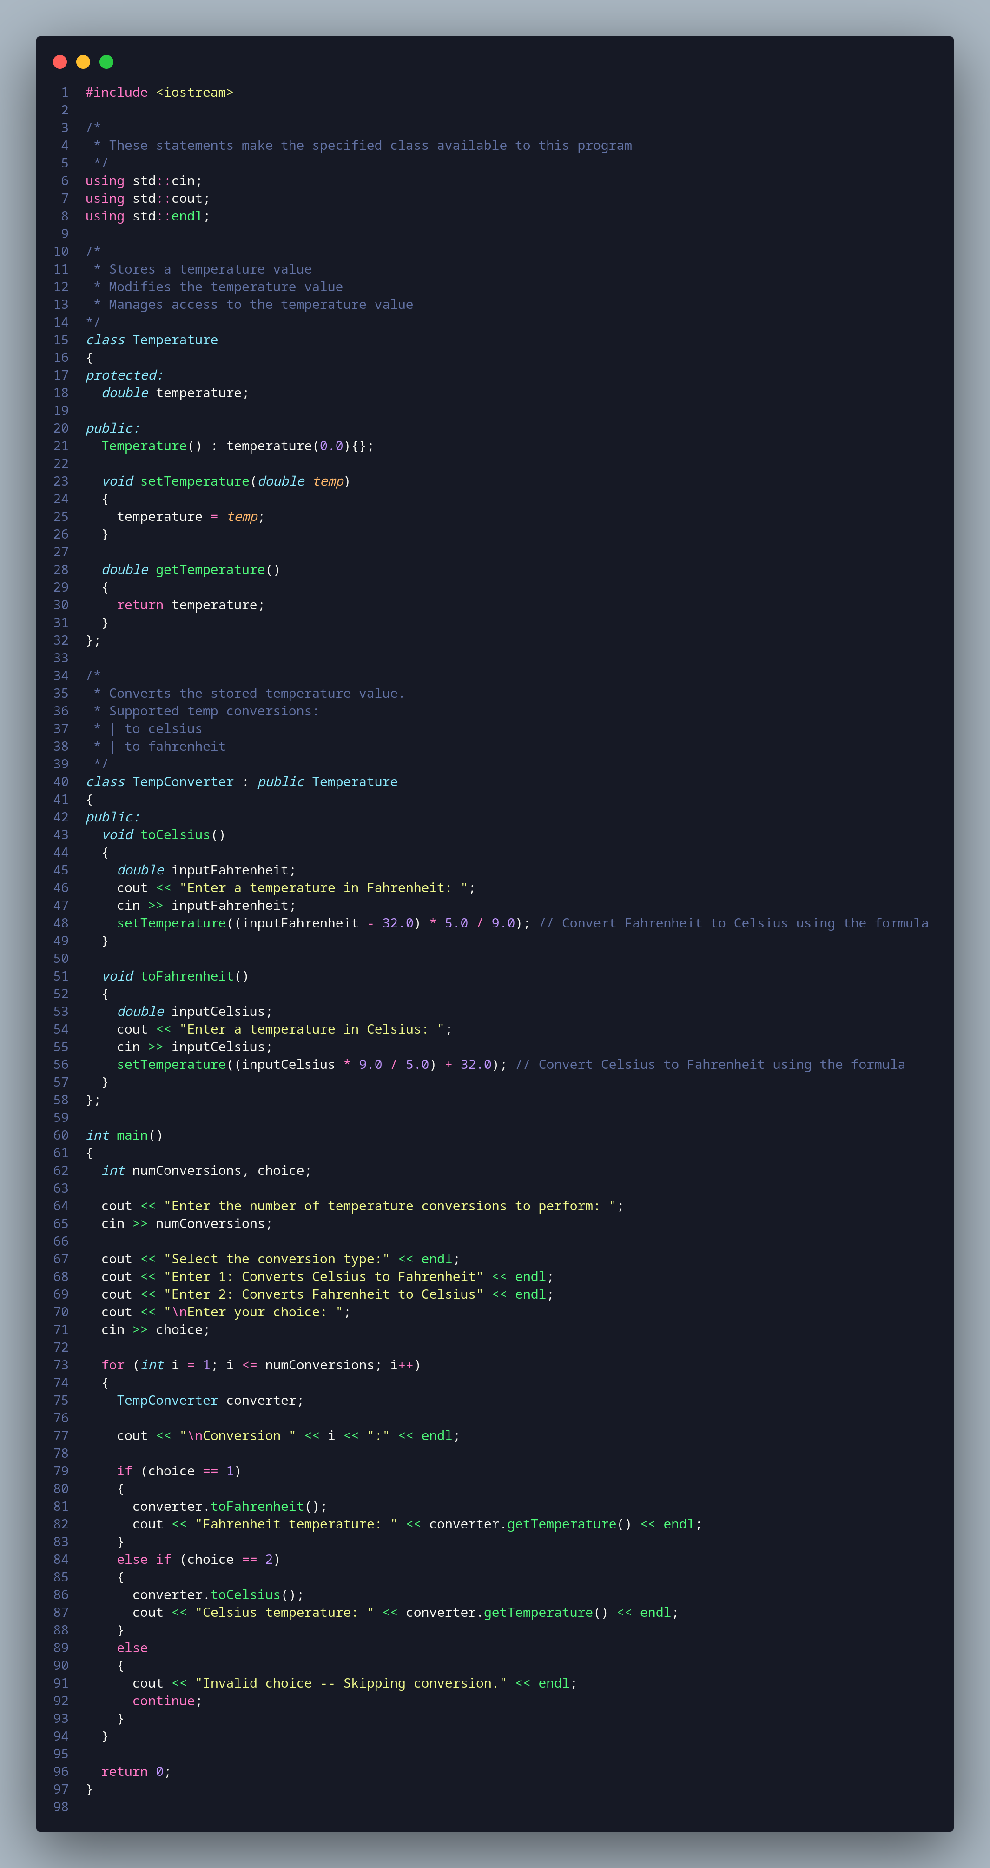

#include <iostream>

/*

* These statements make the specified class available to this program

*/

using std::cin;

using std::cout;

using std::endl;

/*

* Stores a temperature value

* Modifies the temperature value

* Manages access to the temperature value

*/

class Temperature

{

protected:

double temperature;

public:

Temperature() : temperature(0.0){};

void setTemperature(double temp)

{

temperature = temp;

}

double getTemperature()

{

return temperature;

}

};

/*

* Converts the stored temperature value.

* Supported temp conversions:

* | to celsius

* | to fahrenheit

*/

class TempConverter : public Temperature

{

public:

void toCelsius()

{

double inputFahrenheit;

cout << "Enter a temperature in Fahrenheit: ";

cin >> inputFahrenheit;

setTemperature((inputFahrenheit - 32.0) * 5.0 / 9.0); // Convert Fahrenheit to Celsius using the formula

}

void toFahrenheit()

{

double inputCelsius;

cout << "Enter a temperature in Celsius: ";

cin >> inputCelsius;

setTemperature((inputCelsius * 9.0 / 5.0) + 32.0); // Convert Celsius to Fahrenheit using the formula

}

};

int main()

{

int numConversions, choice;

cout << "Enter the number of temperature conversions to perform: ";

cin >> numConversions;

cout << "Select the conversion type:" << endl;

cout << "Enter 1: Converts Celsius to Fahrenheit" << endl;

cout << "Enter 2: Converts Fahrenheit to Celsius" << endl;

cout << "\nEnter your choice: ";

cin >> choice;

for (int i = 1; i <= numConversions; i++)

{

TempConverter converter;

cout << "\nConversion " << i << ":" << endl;

if (choice == 1)

{

converter.toFahrenheit();

cout << "Fahrenheit temperature: " << converter.getTemperature() << endl;

}

else if (choice == 2)

{

converter.toCelsius();

cout << "Celsius temperature: " << converter.getTemperature() << endl;

}

else

{

cout << "Invalid choice -- Skipping conversion." << endl;

continue;

}

}

return 0;

}

# References

Malik, D.S 2018. C++ Programming: Program Design including Data Structures. Eighth Edition. United Kingdom: Cengage Learning