EasyAttend QR and GPS Attendance Flowchart
Part 1 shows attendance-session creation, QR scanning, and the browser GPS permission check.
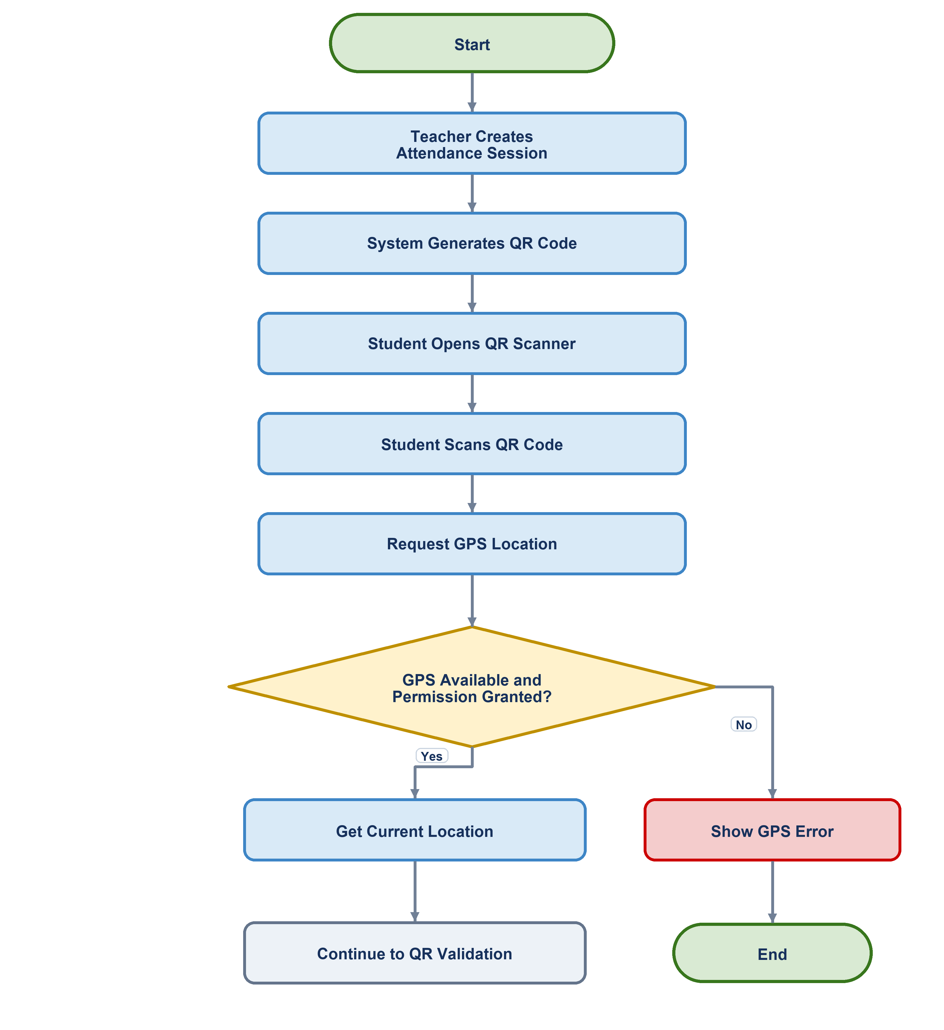

QR Location Validation and Attendance Recording
Part 2 shows QR validation, permitted-area validation, attendance recording, and each possible error outcome.
