EasyAttend Academic Structure Relationships
Academic years organize semesters and classes. Semesters organize subjects, while students are assigned to a semester and class.
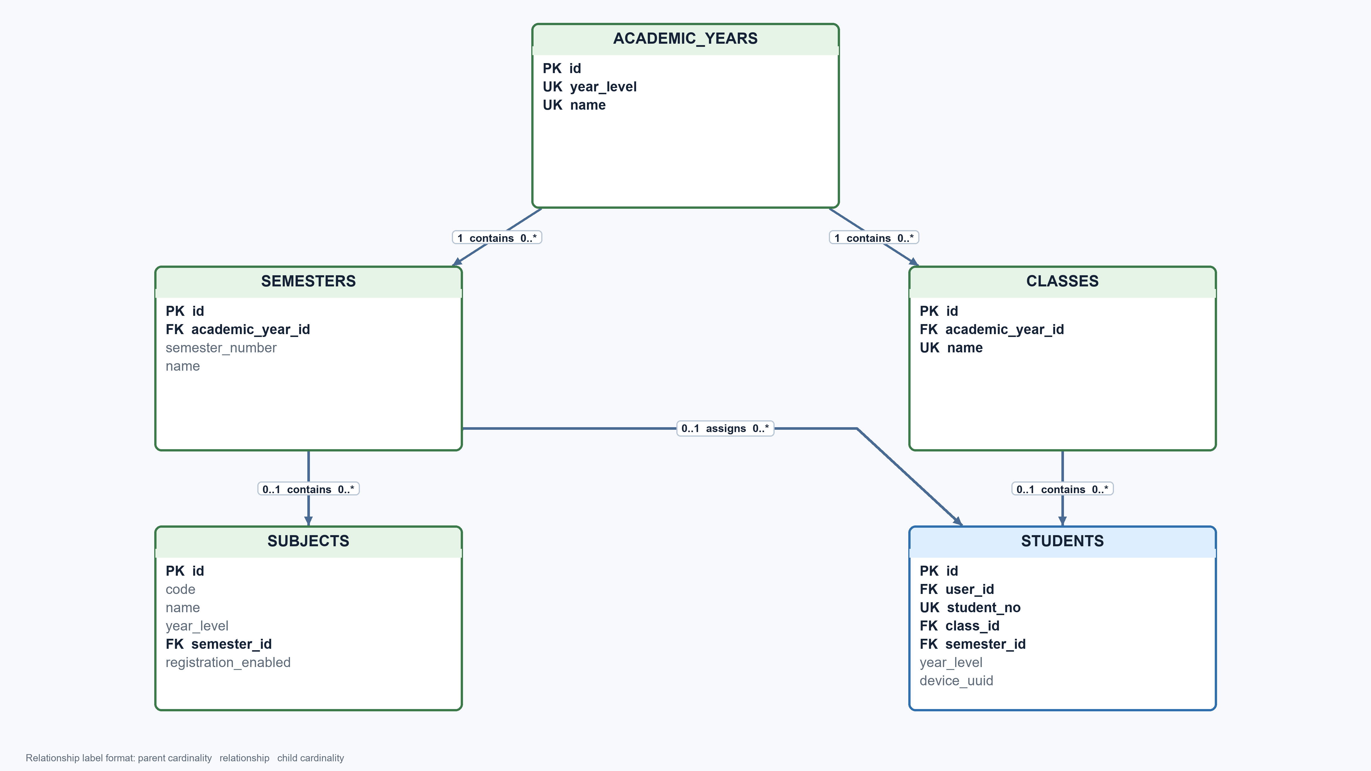

User Profile and Support Relationships
Users provide the shared login identity for student and teacher profiles. The same user record owns authentication tokens and receives notifications.
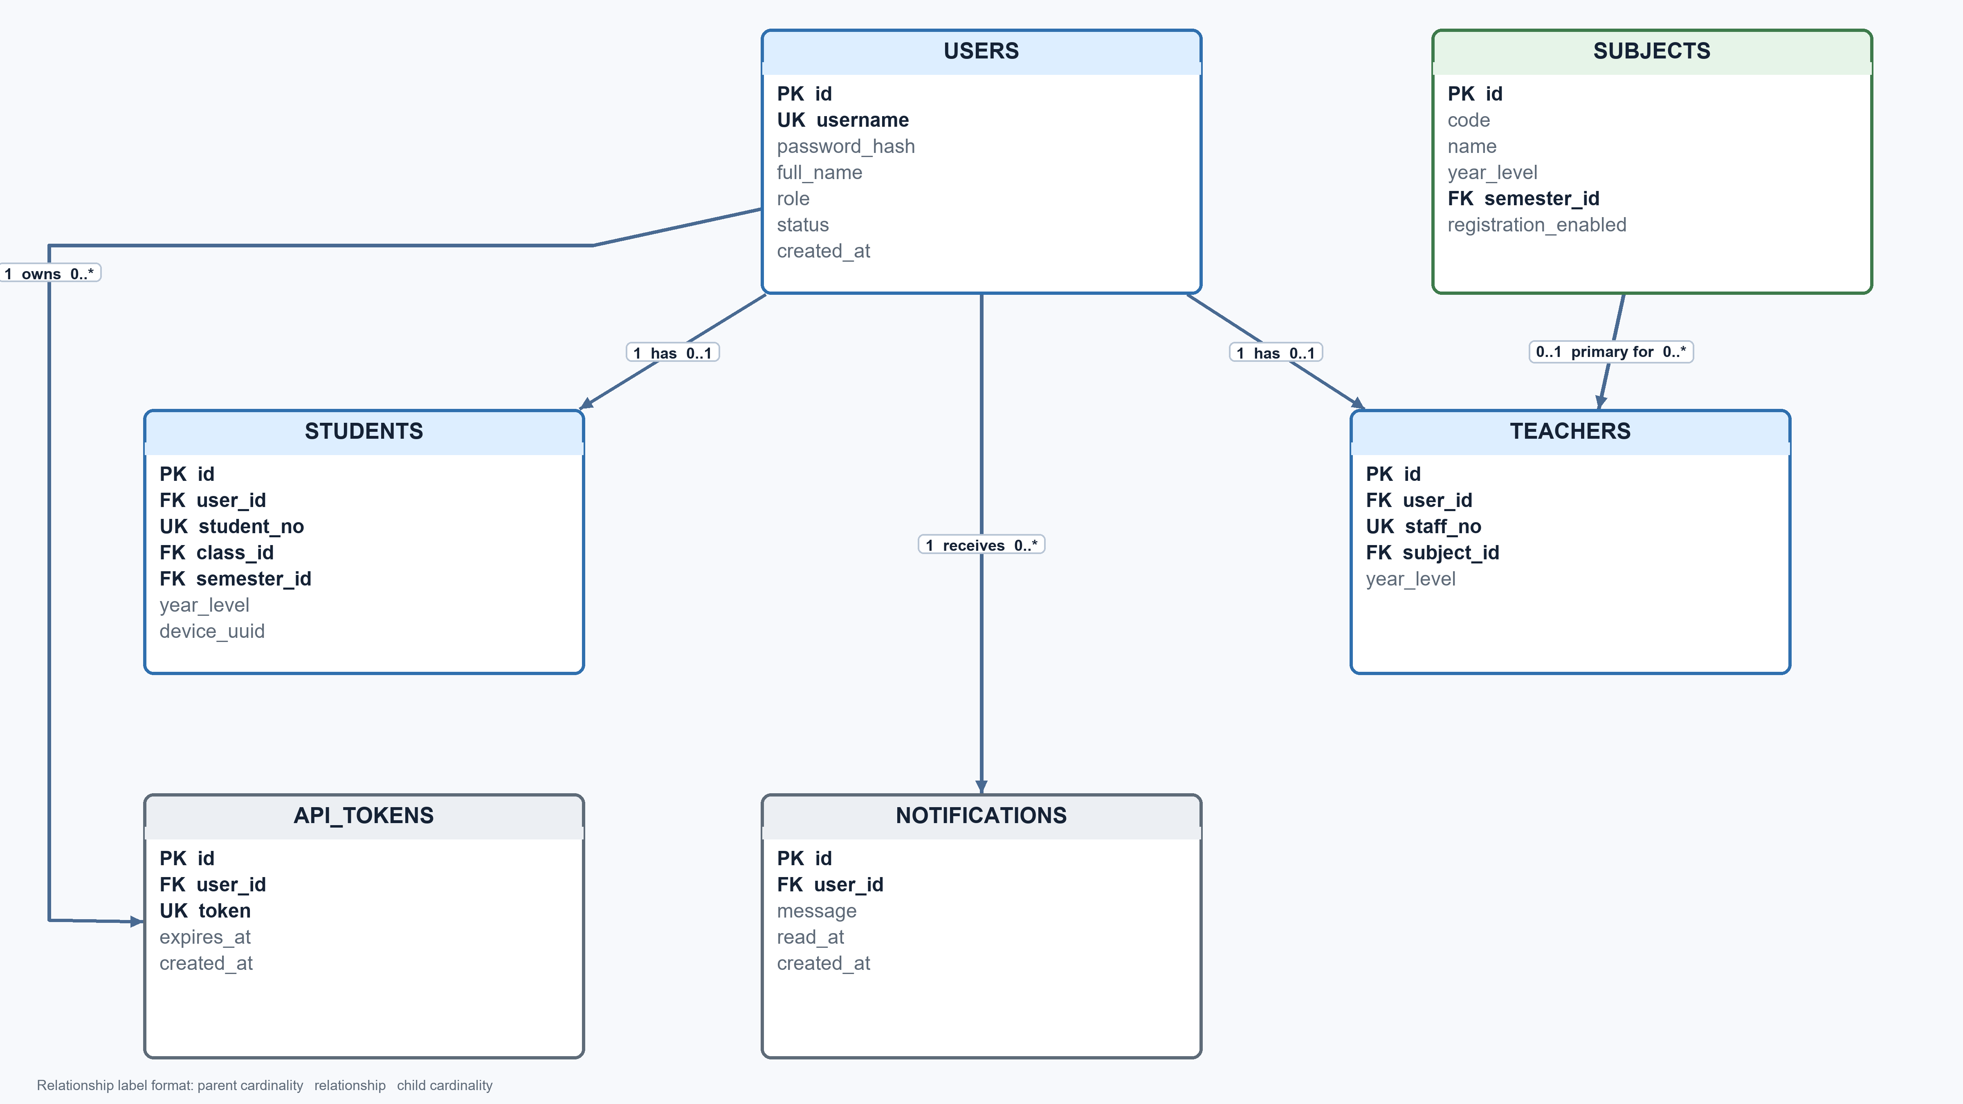

Teaching Assignment Relationships
Teacher term records connect a teacher to a semester and class. Teacher subject records then connect that term assignment to the subjects being taught.
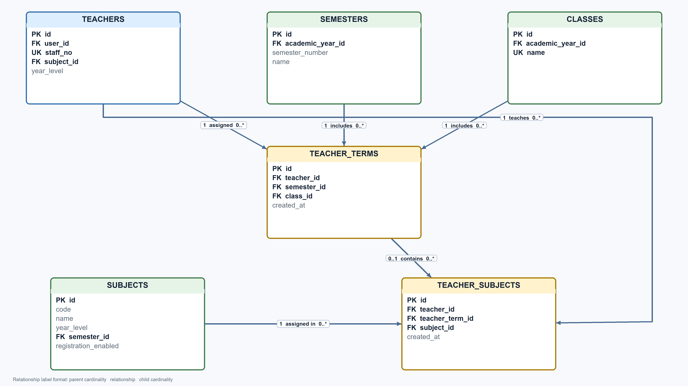

Scheduling and Attendance Session Relationships
Schedules connect teachers, subjects, and classrooms. Attendance sessions are created by teachers and may reference a schedule and an authorized teacher subject assignment.
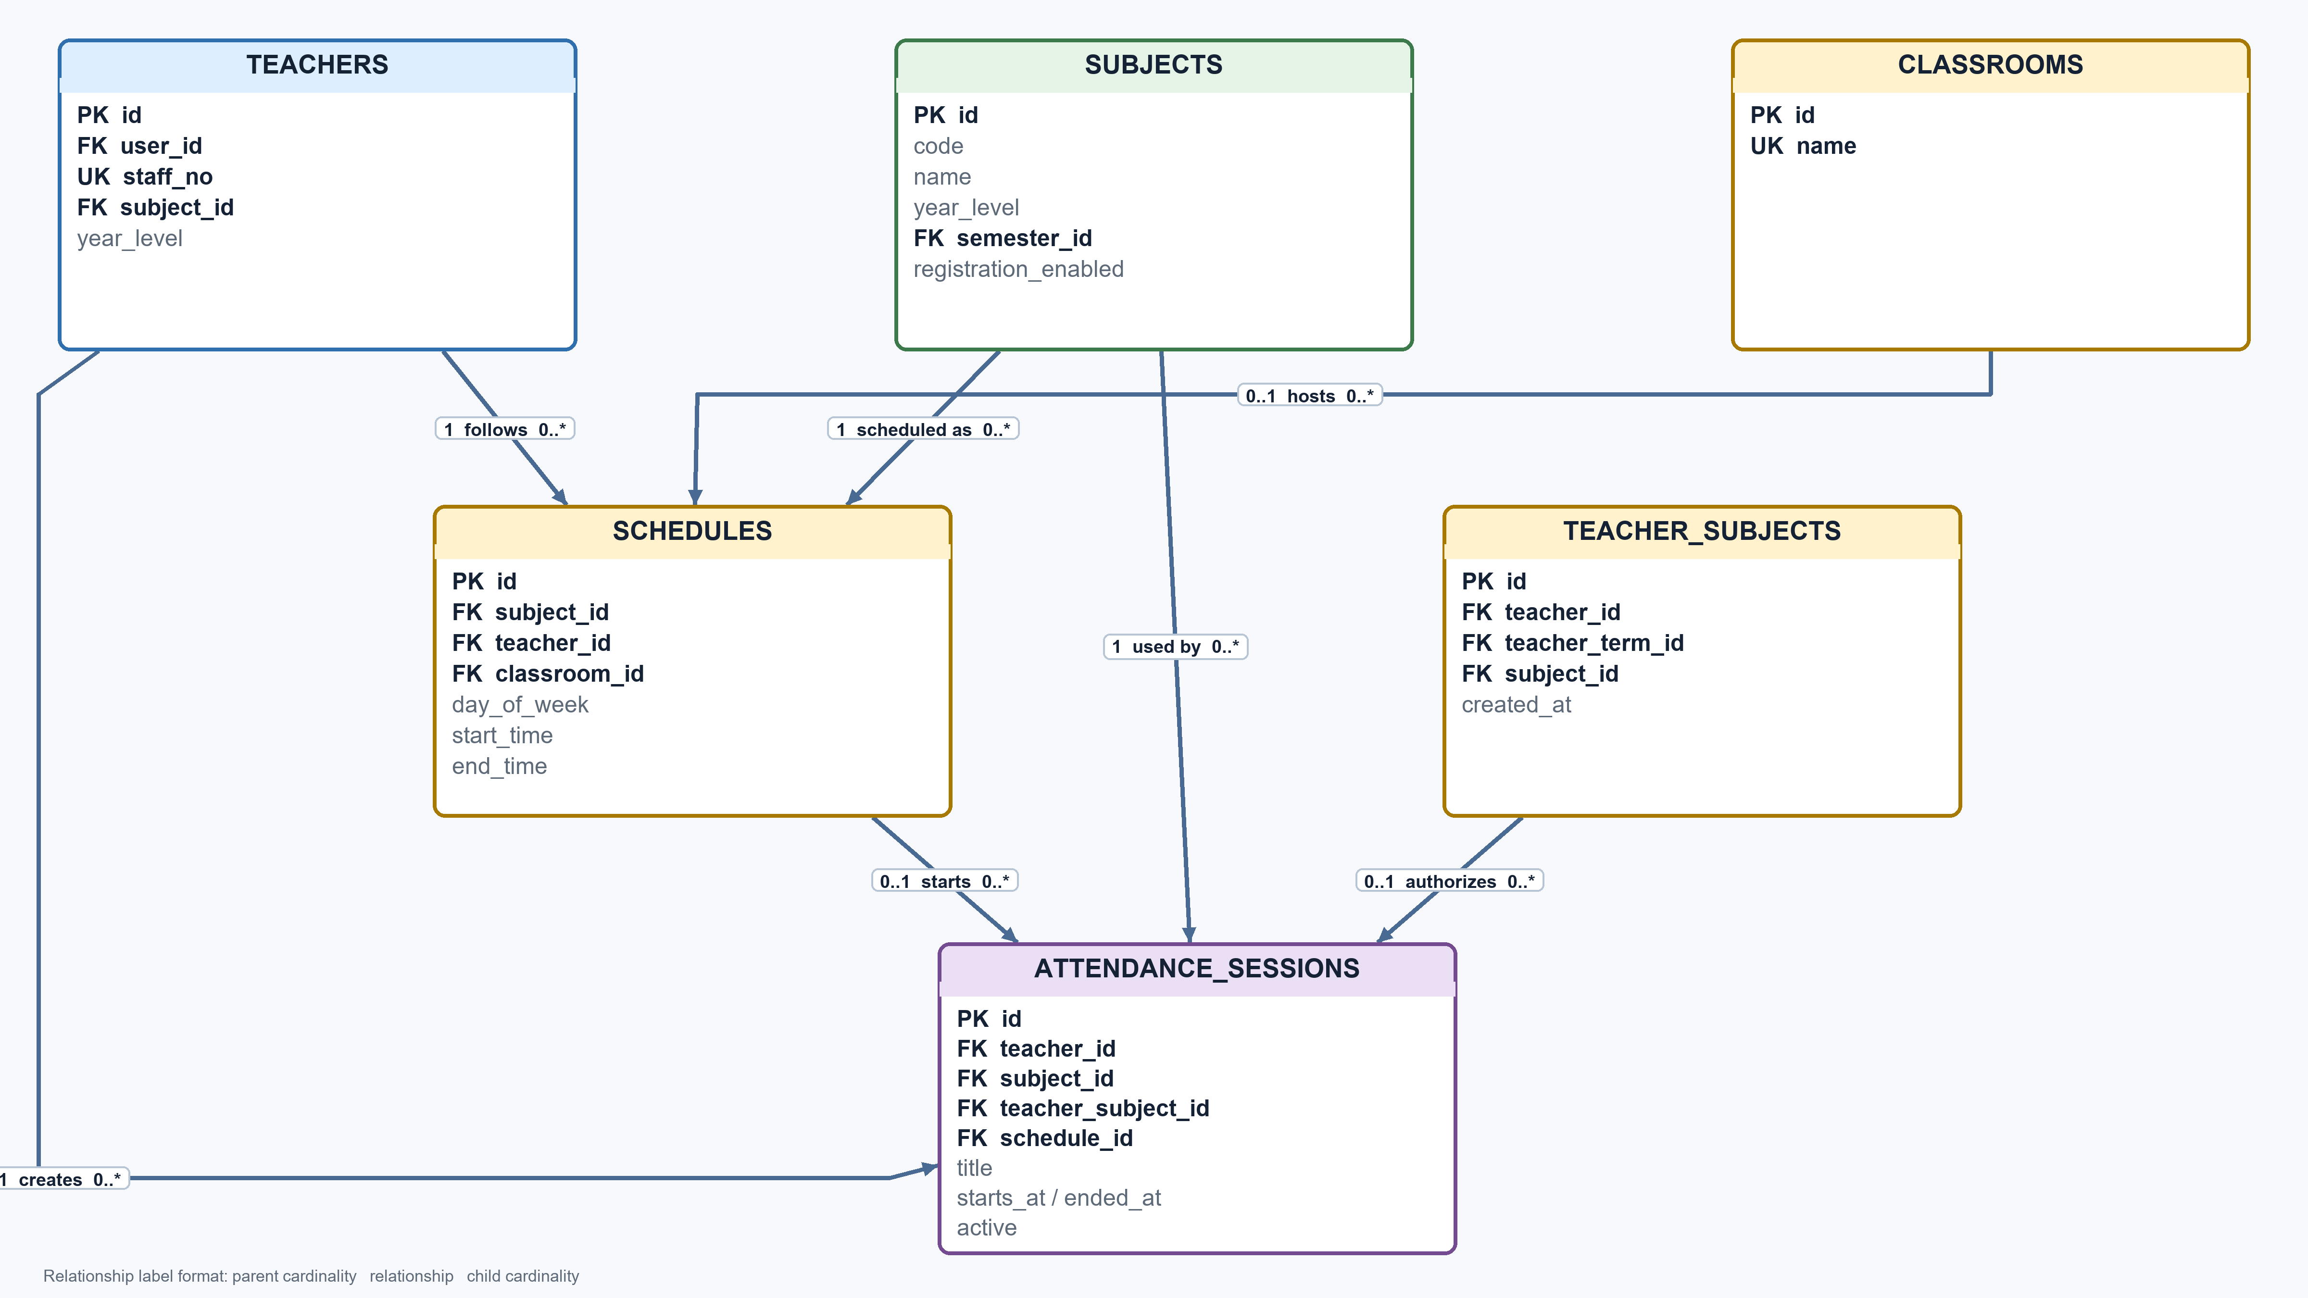

QR GPS and Student Attendance Relationships
An attendance session generates QR codes and attendance records. Each attendance record belongs to one student and stores GPS coordinates, accuracy, and distance from the configured classroom area.
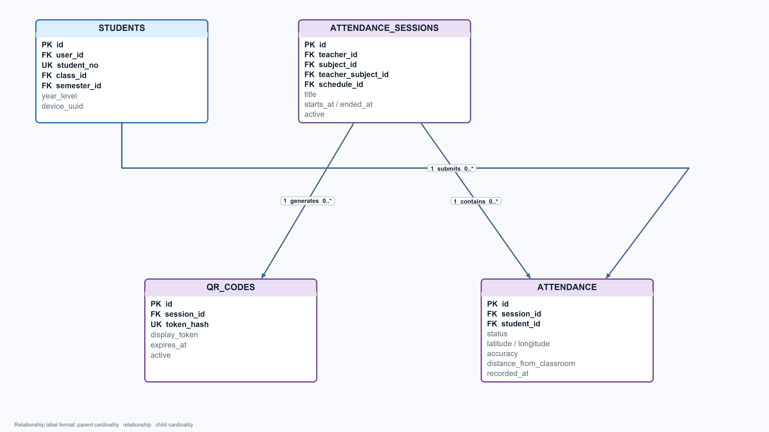

Complete Database Relationship Reference
This reference lists every foreign key relationship represented across the five diagrams. Cardinality is shown from the parent entity to the child entity.
Parent entity | Cardinality | Child entity | Foreign key | Relationship meaning
USERS | 1 to 0..1 | STUDENTS | students.user_id | A user may have one student profile
USERS | 1 to 0..1 | TEACHERS | teachers.user_id | A user may have one teacher profile
USERS | 1 to 0..* | NOTIFICATIONS | notifications.user_id | A user receives notifications
USERS | 1 to 0..* | API_TOKENS | api_tokens.user_id | A user owns API login tokens
ACADEMIC_YEARS | 1 to 0..* | SEMESTERS | semesters.academic_year_id | An academic year contains semesters
ACADEMIC_YEARS | 1 to 0..* | CLASSES | classes.academic_year_id | An academic year contains classes
SEMESTERS | 0..1 to 0..* | SUBJECTS | subjects.semester_id | A semester contains subjects
SEMESTERS | 0..1 to 0..* | STUDENTS | students.semester_id | Students are assigned to a semester
CLASSES | 0..1 to 0..* | STUDENTS | students.class_id | A class contains students
SUBJECTS | 0..1 to 0..* | TEACHERS | teachers.subject_id | A teacher may retain a primary subject
TEACHERS | 1 to 0..* | TEACHER_TERMS | teacher_terms.teacher_id | A teacher receives term assignments
SEMESTERS | 1 to 0..* | TEACHER_TERMS | teacher_terms.semester_id | A term assignment belongs to a semester
CLASSES | 1 to 0..* | TEACHER_TERMS | teacher_terms.class_id | A term assignment belongs to a class
TEACHERS | 1 to 0..* | TEACHER_SUBJECTS | teacher_subjects.teacher_id | A teacher teaches assigned subjects
TEACHER_TERMS | 0..1 to 0..* | TEACHER_SUBJECTS | teacher_subjects.teacher_term_id | A term assignment contains subject assignments
SUBJECTS | 1 to 0..* | TEACHER_SUBJECTS | teacher_subjects.subject_id | A subject appears in teaching assignments
SUBJECTS | 1 to 0..* | SCHEDULES | schedules.subject_id | A subject has scheduled periods
TEACHERS | 1 to 0..* | SCHEDULES | schedules.teacher_id | A teacher follows scheduled periods
CLASSROOMS | 0..1 to 0..* | SCHEDULES | schedules.classroom_id | A classroom hosts scheduled periods
TEACHERS | 1 to 0..* | ATTENDANCE_SESSIONS | attendance_sessions.teacher_id | A teacher creates attendance sessions
SUBJECTS | 1 to 0..* | ATTENDANCE_SESSIONS | attendance_sessions.subject_id | A session records attendance for a subject
TEACHER_SUBJECTS | 0..1 to 0..* | ATTENDANCE_SESSIONS | attendance_sessions.teacher_subject_id | An assignment authorizes a session
SCHEDULES | 0..1 to 0..* | ATTENDANCE_SESSIONS | attendance_sessions.schedule_id | A schedule may start attendance sessions
ATTENDANCE_SESSIONS | 1 to 0..* | QR_CODES | qr_codes.session_id | A session generates QR codes
ATTENDANCE_SESSIONS | 1 to 0..* | ATTENDANCE | attendance.session_id | A session contains attendance records
STUDENTS | 1 to 0..* | ATTENDANCE | attendance.student_id | A student submits attendance records

