Eshragh
Department of Computer Engineering
Course: Operating Systems
EEVDF Scheduler with Semaphore and Monitor
EEVDF Scheduling with Semaphore and Monitor
Comparative Scientific and Technical Report Based on Actual Repository Code
Student: Komeil Ramezani ID: 1403176020
Course Instructor: Majid shamshirgaran
November 2026

Table of Contents
3. Introduction 4
3.1 Objective and Scope 4
3.2 Methodology 4
3.3 Limitations 5
4. Introduction and Theoretical Foundations of the EEVDF Algorithm 5
4.1 Summary of Concepts 5
5. Problem Statement (PS) Report and Problem Description 6
6. Introduction to Semaphore and Monitor 6
7. Program Architecture and Structure 7
8. Explanation of the Actual Code Implementation 7
8.1 Semaphore Section 7
8.2 Monitor Section 9
8.3 Benchmark Runner 9
9. Review of Key Functions and Classes 10
10. Algorithm Pseudocode 10
11. Program Execution Flowchart 11
12. Task, Scheduling, and Result Tables 12
12.1 Equivalence Verification Across Three Workloads 12
12.2 Wall-Clock Time Overhead 13
13. Actual Program Output Charts and Figures 13
14. Analysis of Simulation Results 14
14.1 Why Are the Results Identical? 14
14.2 Synchronization Overhead 14
14.3 Code-Level Differences Across the Three Files 15
15. Comparison with RM and EDF Algorithms 15
15.1 Differences in Objectives and Assumptions 16
15.2 Requested Metrics and Code Support 16
16. Advantages and Limitations 17
16.1 Advantages 17
16.2 Limitations 17
16.3 Identified Code Issues and Inconsistencies 17
17. Conclusion 18
18. Scientific References 18
Appendix A: Execution Environment and Methodology 19

Note: To update the Table of Contents, right-click on it and select Update Field → Update entire table.

3. Introduction

3.1 Objective and Scope
This document is the technical report for the assignment “Implementing EEVDF Using Semaphore and Monitor”. The basis of this document is the file eevdf_sync_comparison.py, which places both implementations side by side in a single program and executes and compares them under an identical workload. To avoid repetition, detailed explanations of each method are provided in “EEVDF_Semaphore.docx” and “EEVDF_Monitor.docx”, while this document focuses on differences and comparison.
Interpretation of the Assignment Title: The provided file executes two independent implementations (Part 1 and Part 2) sequentially; at no point are the two mechanisms combined into a single unified scheduler. If the assignment prompt requires a “hybrid implementation” (e.g., Monitor for selection and Semaphore for CPU access), this file does not fulfill that requirement; please verify against the assignment prompt.

3.2 Methodology
All three code files were executed, and each produced identical output across three runs. In addition to the base workload, the comparative file was executed with two additional workloads (unequal weights and late arrival) by calling its own functions without modifying the code, and the wall-clock time overhead of both methods was measured over 30 consecutive runs.
Table 1 – Examined Files
File | Role | Usage in This Document
eevdf_sync_comparison.py | Comparative execution of Semaphore and Monitor (main file for this assignment) | Basis of this document
code.py | Standalone EEVDF + Semaphore | Code-level difference comparison
eevdf_monitor.py | Standalone EEVDF + Monitor | Code-level difference comparison

According to the README, the EEVDF_Semaphore_and_Monitor folder claims an “integrated implementation and comparative documentation of EEVDF with both methods”; the folder contents were not automatically accessible to the author, so only the provided file was examined.

3.3 Limitations
- The charts were generated by the author from actual logs and outputs; the program itself only prints text.
- No code comparing against RM and EDF was provided; Section 15 is theoretical.
- The exact assignment prompt was unavailable; Section 5 requires verification.

4. Introduction and Theoretical Foundations of the EEVDF Algorithm
The theoretical foundations of EEVDF are covered in full in “EEVDF_Semaphore.docx”. In this document, only the concepts required to understand the code are reviewed to avoid unnecessary repetition.

4.1 Summary of Concepts
- Weight: The relative CPU share of a process; represented by weight in the code and equal to 1 in all base runs.
- Virtual Runtime (vruntime): Increases by 1 / weight as the process executes; heavier processes “age” more slowly.
- Eligibility: A process is eligible if it has not moved ahead of the average virtual runtime of ready processes (vruntime <= avg_vruntime).
- Virtual Deadline: v_deadline = vruntime + slice / weight; among eligible processes, the smallest deadline is selected.
Table 2 – Mapping Theoretical Concepts to Code Variables
Theoretical Concept | Variable in Code
Virtual runtime | vruntime
Virtual deadline | v_deadline
Weight | weight
Request / time slice | slice
Average virtual runtime (approximation of V) | avg_vruntime

5. Problem Statement (PS) Report and Problem Description
Terminology Note: “PS” is interpreted here as Problem Statement; please notify if intended otherwise.
Problem: Implement EEVDF once with a Semaphore and once with a Monitor, run both under an identical workload, and print the outputs (execution order and Waiting, Turnaround, and Response metrics) side by side for comparison. The workload consists of the same three standard processes:
Table 3 – Workload Defined in the __main__ Section of eevdf_sync_comparison.py
Process | Arrival Time | Burst | Weight | Slice | Role
P1 (Heavy-Batch) | 0 | 4 | 1 | 4 | Heavy batch
P2 (Heavy-Batch) | 0 | 4 | 1 | 4 | Heavy batch
P3 (Interactive) | 1 | 2 | 1 | 1 | Latency-sensitive interactive

6. Introduction to Semaphore and Monitor
A Semaphore (Dijkstra, Ref. [7]) is an integer variable that provides mutual exclusion through atomic P (acquire) and V (release) operations; it is a low-level primitive whose correctness depends on disciplined usage by the programmer. A Monitor (Hoare, Ref. [8]) encapsulates shared data and its associated procedures, provides mutual exclusion implicitly, and handles waiting on conditions via condition variables. Details of each are covered in the other two documents.
Table 4 – Conceptual Comparison of Semaphore and Monitor
Feature | Semaphore | Monitor
Abstraction Level | Low (primitive tool) | High (structured construct)
Mutual Exclusion | Manual via acquire/release | Implicit via with condition
Conditional Waiting | Separate Event (turn_event) | Condition (wait/notify_all) inside the Monitor
Shared State | Scattered (global or passed) | Encapsulated in a single class
Common Error Risks | Forgetting release, wrong P/V order | Forgetting to re-check condition (properly handled in code)
In Python | threading.Semaphore | Lock + Condition via class convention

7. Program Architecture and Structure
The file consists of three sections: (1) Semaphore implementation (SemaphoreProcess class and run_semaphore_eevdf function), (2) Monitor implementation (EEVDFMonitor and MonitorProcess classes and run_monitor_eevdf function), and (3) Benchmark runner (print_metrics and __main__). The first two sections are completely independent and share no state.
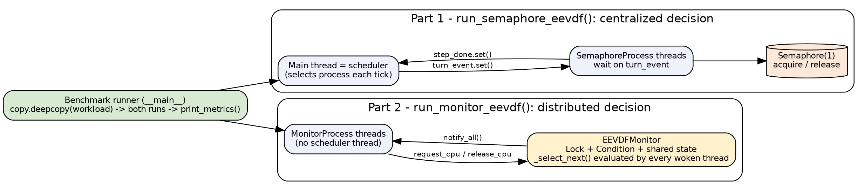
Figure 1 – Architecture of eevdf_sync_comparison.py: Two Independent Implementations and a Shared Runner
Table 5 – Structure of the Comparative File
Section | Class / Function | Location of EEVDF Decision
1. Semaphore | SemaphoreProcess, run_semaphore_eevdf | Main thread loop (centralized)
2. Monitor | EEVDFMonitor, MonitorProcess, run_monitor_eevdf | _select_next procedure inside Monitor (distributed)
3. Runner | print_metrics, __main__ | —

8. Explanation of the Actual Code Implementation

8.1 Semaphore Section
In this section, instead of using global variables, the Semaphore and the tick-completion Event are instantiated on each function call and passed to the process constructors; the clock is also a local variable of the function.
def run(self):
while not self.completed:
self.turn_event.wait()
if self.completed:
break

# Wait / P Operation on Binary Semaphore
self.sem.acquire()

self.remaining -= 1
self.vruntime += 1.0 / self.weight
time.sleep(0.01)

# Signal / V Operation on Binary Semaphore
self.sem.release()

self.turn_event.clear()
self.step_done.set()

while completed_count < n:
active = [p for p in processes if p.arrival <= current_time and not p.completed]
if not active:
timeline.append("IDLE")
current_time += 1
continue

# 1. Eligibility Filter (Lag >= 0)
avg_vruntime = sum(p.vruntime for p in active) / len(active)
eligible = [p for p in active if p.vruntime <= avg_vruntime] or active

# 2. Virtual Deadline Calculation
for p in eligible:
p.v_deadline = p.vruntime + (p.slice / p.weight)

eligible.sort(key=lambda x: (x.v_deadline, x.arrival))
selected = eligible[0]

if selected.first_run == -1:
selected.first_run = current_time

timeline.append(selected.pid.split()[0])
step_done.clear()
selected.turn_event.set()
step_done.wait()

current_time += 1

if selected.remaining == 0:
selected.completed = True
selected.completion_time = current_time
completed_count += 1
selected.turn_event.set()

8.2 Monitor Section
def request_cpu(self, thread):
with self.condition:
while True:
ready = [t for t in self.threads if t.arrival <= self.current_time and not t.completed]
if not ready and not self.cpu_busy:
self.timeline.append("IDLE")
self.current_time += 1
self.condition.notify_all()
continue

selected = self._select_next()
if not self.cpu_busy and selected == thread:
self.cpu_busy = True
if thread.first_run == -1:
thread.first_run = self.current_time
self.timeline.append(thread.pid.split()[0])
break
else:
self.condition.wait()

def release_cpu(self, thread):
with self.condition:
thread.remaining -= 1
thread.vruntime += 1.0 / thread.weight
self.current_time += 1

if thread.remaining == 0:
thread.completed = True
thread.completion_time = self.current_time

self.cpu_busy = False
self.condition.notify_all()

8.3 Benchmark Runner
def run_monitor_eevdf(workload_specs):
monitor = EEVDFMonitor()
processes = [
MonitorProcess(w['pid'], w['arrival'], w['burst'], w['weight'], w['slice'], monitor)
for w in workload_specs
]
for p in processes:
monitor.register(p)
for p in processes:
p.start()
for p in processes:
p.join()

return processes, " -> ".join(monitor.timeline)

if __name__ == "__main__":
workload = [
{'pid': 'P1 (Heavy-Batch)', 'arrival': 0, 'burst': 4, 'weight': 1, 'slice': 4},
{'pid': 'P2 (Heavy-Batch)', 'arrival': 0, 'burst': 4, 'weight': 1, 'slice': 4},
{'pid': 'P3 (Interactive)', 'arrival': 1, 'burst': 2, 'weight': 1, 'slice': 1},
]

sem_procs, sem_tl = run_semaphore_eevdf(copy.deepcopy(workload))
print_metrics("1. EEVDF with SEMAPHORE Synchronization", sem_procs, sem_tl)

mon_procs, mon_tl = run_monitor_eevdf(copy.deepcopy(workload))

9. Review of Key Functions and Classes
Table 6 – Classes and Functions in eevdf_sync_comparison.py
Name | Type | Responsibility
SemaphoreProcess | Class (Thread) | Process in Semaphore version; receives sem and step_done externally
run_semaphore_eevdf(workload_specs) | Function | Creates processes and runs scheduler loop; returns (processes, timeline)
EEVDFMonitor | Class | Shared Monitor with internal timeline; methods: register, _select_next, request_cpu, release_cpu
MonitorProcess | Class (Thread) | Process in Monitor version; loop: request → sleep(0.01) → release
run_monitor_eevdf(workload_specs) | Function | Creates Monitor and threads; returns (processes, timeline)
print_metrics(title, processes, timeline) | Function | Prints execution timeline, metrics table, and averages

10. Algorithm Pseudocode
PROGRAM EEVDF_SYNC_COMPARISON
workload <- [ (P1,0,4,1,4), (P2,0,4,1,4), (P3,1,2,1,1) ] // pid, arrival, burst, weight, slice
(procs1, tl1) <- run_semaphore_eevdf( deepcopy(workload) )
print_metrics('SEMAPHORE', procs1, tl1)
(procs2, tl2) <- run_monitor_eevdf( deepcopy(workload) )
print_metrics('MONITOR', procs2, tl2)

// Common EEVDF decision used by BOTH implementations
FUNCTION SELECT(ready):
avg <- mean(p.vruntime for p in ready)
elig <- { p in ready : p.vruntime <= avg } OR ready
FOR p in elig: p.v_deadline <- p.vruntime + p.slice / p.weight
RETURN argmin over elig of (v_deadline, arrival)

// Difference: WHO calls SELECT and HOW the tick is protected
SEMAPHORE: main thread calls SELECT each tick -> turn_event.set() -> thread does
sem.acquire(); tick; sem.release(); step_done.set()
MONITOR : every thread calls SELECT inside request_cpu() under the monitor lock;
winner sets cpu_busy; release_cpu() advances time and notify_all()

11. Program Execution Flowchart
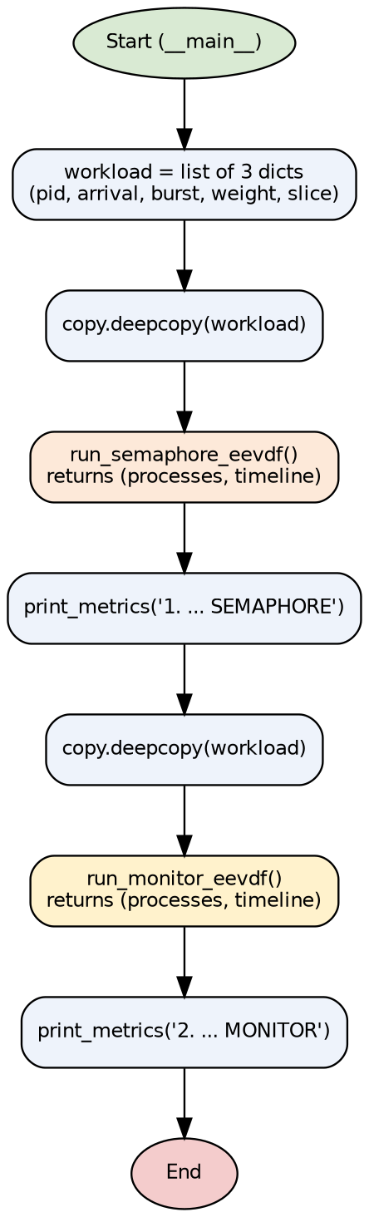
Figure 2 – Flowchart of the Benchmark Runner (__main__ Section)
The internal flowcharts for each of the two execution functions are provided in “EEVDF_Semaphore.docx” (scheduler loop) and “EEVDF_Monitor.docx” (thread lifecycle) and are not repeated here.

12. Task, Scheduling, and Result Tables
Table 7 – Program Output Timeline for Both Methods (Identical)
Method | Printed Execution Timeline
Semaphore | P1 → P3 → P2 → P3 → P1 → P2 → P1 → P2 → P1 → P2
Monitor | P1 → P3 → P2 → P3 → P1 → P2 → P1 → P2 → P1 → P2

Table 8 – Actual Results of Part 1: Semaphore
Process | Arrival | Burst | Slice | Completion | Turnaround | Waiting | Response
P1 (Heavy-Batch) | 0 | 4 | 4 | 9 | 9 | 5 | 0
P2 (Heavy-Batch) | 0 | 4 | 4 | 10 | 10 | 6 | 2
P3 (Interactive) | 1 | 2 | 1 | 4 | 3 | 1 | 0

Table 9 – Actual Results of Part 2: Monitor
Process | Arrival | Burst | Slice | Completion | Turnaround | Waiting | Response
P1 (Heavy-Batch) | 0 | 4 | 4 | 9 | 9 | 5 | 0
P2 (Heavy-Batch) | 0 | 4 | 4 | 10 | 10 | 6 | 2
P3 (Interactive) | 1 | 2 | 1 | 4 | 3 | 1 | 0

Table 10 – Printed Averages for Both Methods
Average | Semaphore | Monitor
Waiting | 4.00 | 4.00
Turnaround | 7.33 | 7.33
Response (Latency) | 0.67 | 0.67

12.1 Equivalence Verification Across Three Workloads
Table 11 – Comparison Results of Both Methods Across Three Workloads
Workload | Identical Timeline? | Identical Metrics? | Source
Base (3 processes) | Yes | Yes | Program output, 3 runs
Unequal weights 2:1:1 | Yes | Yes | Calling functions of this file (supplementary run)
Late arrival (idle) | Yes (3 × IDLE) | Yes | Calling functions of this file (supplementary run)

12.2 Wall-Clock Time Overhead
The total execution duration of each method (excluding printing) was measured using time.perf_counter over 30 consecutive runs on the base workload. The minimum possible time is 10 × 10 ms = 100 ms (total sleep duration).
Table 12 – Wall-Clock Time per Run (30 Runs; Author’s Measurement)
Statistic (ms) | Semaphore | Monitor
Median | 103.0 | 102.7
Mean | 103.0 | 103.7
Minimum | 102.6 | 102.3
Maximum | 103.9 | 128.1
Standard Deviation | 0.3 | 4.6

Table 13 – Measurement Stability Across Three Independent Sessions (ms)
Measurement Session | Semaphore | Monitor
Session 1 (20 runs): Mean | 103.6 | 102.7
Session 2 (20 runs): Mean / Max | 115.5 / 352.0 | 104.3 / 131.1
Session 3 (30 runs): Mean / Max | 103.0 / 103.9 | 103.7 / 128.1

13. Actual Program Output Charts and Figures
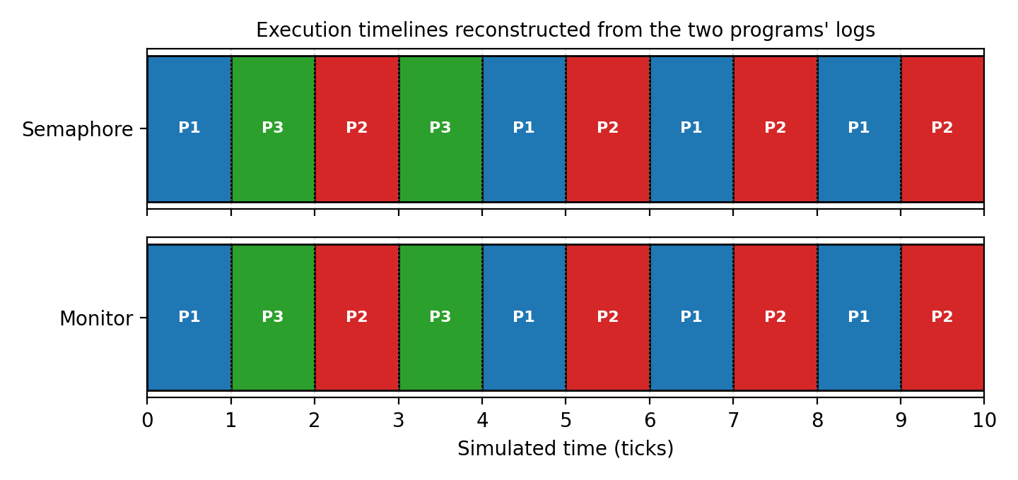
Figure 3 – Execution Timeline of Both Methods, Reconstructed from Each Program’s Actual Log
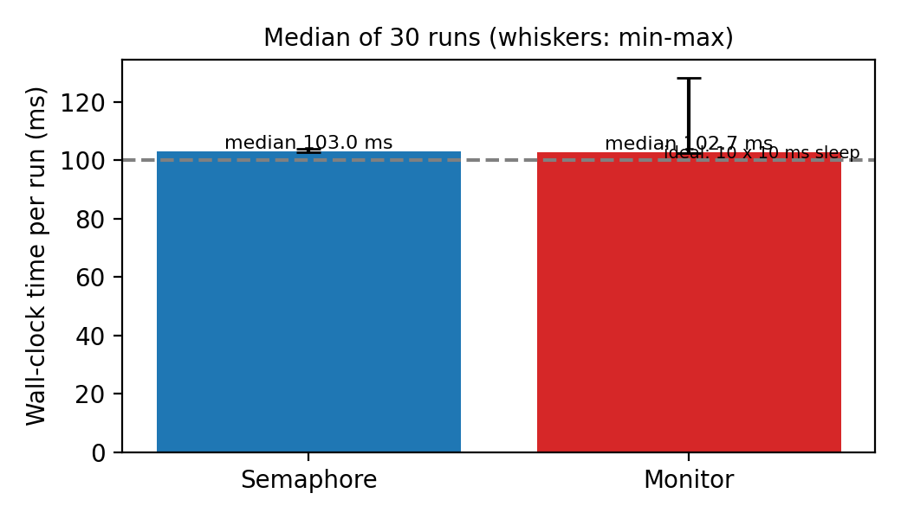
Figure 4 – Wall-Clock Time per Run (Median and Min-to-Max Range)
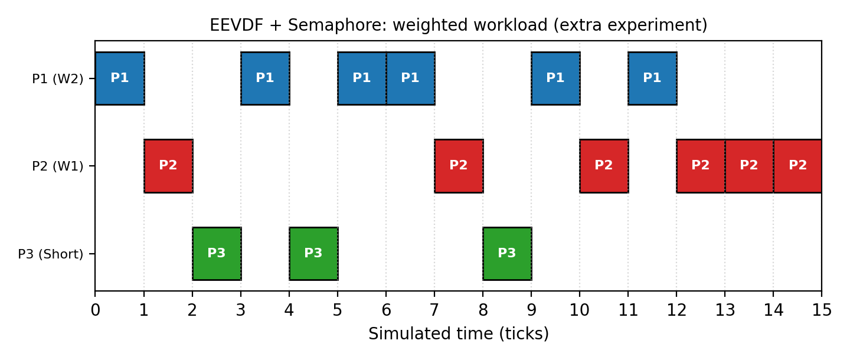
Figure 5 – Gantt Chart of the Weighted Workload (Both Methods Produced Identical Output)

14. Analysis of Simulation Results

14.1 Why Are the Results Identical?
Both methods share the exact same selection rule (simple arithmetic mean, v_deadline = vruntime + slice / weight, and tie-breaking by arrival); the synchronization mechanism merely determines who executes that rule and how. Because both methods run only one process at any given moment and advance the clock identically, the timeline and metrics must be identical—which our experiments confirmed.

14.2 Synchronization Overhead
The difference between medians is 0.3 ms over 10 ticks, or less than 0.1 ms per tick, and both methods take ≈ 2.9 ms above the 100 ms floor. This difference is indistinguishable from OS scheduling noise: the second measurement session recorded a 352 ms spike for Semaphore, showing that OS scheduling jitter exceeds the difference between the two methods. Therefore, neither method can be claimed to be faster. Theoretical costs (Monitor: broadcast wake-ups and repeated selection; Semaphore: two Event handshakes per tick) would only become measurable under a much larger workload.

14.3 Code-Level Differences Across the Three Files
Because the EEVDF logic is copy-pasted across all three files (there is no shared module), the versions have slightly diverged. The table below summarizes the actual differences:
Table 14 – Comparison of the Three Implementation Files
Aspect | code.py | eevdf_monitor.py | eevdf_sync_comparison.py
Decision Location | Main thread | Inside Monitor (each thread) | Part 1 like code.py; Part 2 like eevdf_monitor.py
sleep per Tick | 0.02 s | 0.02 s | 0.01 s
Tie-Breaking | v_deadline only | (v_deadline, arrival) | (v_deadline, arrival) in both parts
Semaphore / Event | Global | None | Local; passed to constructor
Clock | Global variable current_time | Monitor attribute | Local variable (Part 1) / Monitor attribute (Part 2)
Output | Per-event log + table | Per-event log + table | Timeline + table (no per-event log)
Idle Recording | None | None | IDLE in timeline
active_thread_id | — | Present (unused) | Removed

15. Comparison with RM and EDF Algorithms
In this assignment, two synchronization methods are compared using a single scheduling algorithm; therefore, comparing RM/EDF against EEVDF is independent of the synchronization method, and the contents of this section are theoretical and identical across all three documents.
Important Limitation: Files comparing EEVDF against RM and EDF (such as compare_schedulers.py mentioned in the README, and the EEVDF_vs_RM_EDF and RM_EDF_Gantt_Chart folders) were not among the files provided for preparing this document. Therefore, no empirical numbers or charts are reported for RM and EDF, and the comparison below is theoretical and qualitative. If you send those files, a quantitative comparison section will be added.

15.1 Differences in Objectives and Assumptions
EEVDF is a fair, proportional-share CPU scheduler whose task model consists of weighted processes. In contrast, RM and EDF are designed for real-time scheduling of periodic tasks defined by a period, worst-case execution time, and deadline (Ref. [5]). Therefore, a direct “better/worse” comparison without considering this fundamental difference in purpose is unscientific.
Table 15 – Theoretical Comparison of EEVDF with RM and EDF
Criterion | EEVDF | RM | EDF
Primary Objective | Fair CPU share and low latency | Meeting deadlines (real-time) | Meeting deadlines (real-time)
Task Model | Process with weight and slice | Periodic; deadline = period | Periodic or aperiodic; absolute deadline
Priority Type | Dynamic (from weight, vruntime, and virtual deadline) | Static (shorter period = higher priority) | Dynamic (earliest deadline)
Schedulability Condition | No schedulability analysis needed for proportional sharing | U ≤ n(2^(1/n) − 1) is sufficient (≈ 0.693 for large n) | U ≤ 1 (uniprocessor, deadline = period)
Overload Behavior | Proportional reduction of all processes’ shares | Low-priority tasks starve | Domino effect may occur
Fairness | Core design goal | Not guaranteed | Not guaranteed
Hard Deadline Guarantee | None; virtual deadline is an internal concept | Yes (if condition holds) | Yes (if condition holds)
Decision Overhead | O(n) in repository code; balanced tree in Linux | Low (static priority) | Medium (dynamic priority queue)

15.2 Requested Metrics and Code Support
The table below shows which comparison metrics can be extracted from the output of the provided code.
Table 16 – Code Support for Comparison Metrics
Metric | Support in EEVDF Code | Support for RM/EDF
CPU Utilization | Not directly reported; computable from log | No file provided
Completed Tasks Count | Yes (completed_count / final table) | No file provided
Waiting Time | Yes | No file provided
Response Time | Yes | No file provided
Turnaround Time | Yes | No file provided
Deadline Compliance | No; processes do not have deadlines | No file provided
Scheduling Overhead | No; only via separate wall-clock measurement | No file provided
Fairness in CPU Allocation | No; extractable from log | No file provided

16. Advantages and Limitations

16.1 Advantages
- Placing both methods in a single file with independently deep-copied workloads (copy.deepcopy) enables a fair and reproducible comparison.
- A shared print_metrics output format and timeline make visual comparison between the two methods straightforward.
- The Semaphore and Event in Part 1 are local; unlike code.py, the function has no dependency on global state and can be executed multiple times (in code.py, the global clock is not reset between runs; this was tested and verified in Section 16.3 of the Semaphore document).

16.2 Limitations
- The two implementations are not combined; the file is a “comparison” rather than a “hybrid implementation”.
- No equivalence assertion (assert) is checked automatically; verification relies solely on visual comparison of outputs.
- The benchmark does not measure overhead or wall-clock time; the findings in Section 12.2 are the author’s separate measurements.
- The workload is fixed and small (3 processes); comparison results cannot be generalized to heavy workloads.

16.3 Identified Code Issues and Inconsistencies
Table 17 – List of Identified Issues and Inconsistencies
# | Issue | Description | Origin
1 | Code Duplication | EEVDF logic is copied across three files, causing inconsistencies (tie-breaker, sleep, clock). | File comparison
2 | No True Hybrid Integration | The two mechanisms are never combined inside a single scheduler. | Code inspection
3 | Redundant Semaphore | In Part 1 as well, turn_event and step_done serialize process execution and acquire() never blocks. | Code inspection
4 | Missing try/finally | In SemaphoreProcess.run, if an error occurs between acquire and release, the semaphore is not released and the program deadlocks; Monitor with “with” has no such risk. | Code inspection
5 | Simple Mean, Per-Tick Deadline, Zero vruntime | Same simplified EEVDF limitations as the other two documents, in both parts. | Log + code inspection
6 | Timeline Recording in Monitor | timeline.append inside request_cpu occurs right after entry, whereas IDLE is recorded by whichever thread advances the clock; in the late-arrival test, three IDLE entries were recorded, matching Part 1. | Code inspection + execution
7 | Unused Variable | print_lock is defined at the top of the file but never used anywhere. | Code inspection

17. Conclusion
The file eevdf_sync_comparison.py demonstrates that under an identical selection rule, replacing a Semaphore with a Monitor does not alter the scheduling outcome: across three workloads, the timeline and metrics were identical (average Waiting 4.00, Turnaround 7.33, and Response 0.67 on the base workload). The differences lie in architecture and programming style: centralized decision-making with Event handshaking versus distributed decision-making with a Condition variable, and manual acquire/release control versus an implicit critical section. In empirical measurements, no reliable overhead difference was observed between the two methods. The main limitations of this assignment are code duplication and the lack of a true hybrid combination of the two mechanisms.

18. Scientific References
[1] I. Stoica and H. Abdel-Wahab, “Earliest Eligible Virtual Deadline First: A Flexible and Accurate Mechanism for Proportional Share Resource Allocation,” Technical Report TR-95-22, Old Dominion University, 1995.
[2] I. Stoica, H. Abdel-Wahab, K. Jeffay, S. K. Baruah, J. E. Gehrke, and C. G. Plaxton, “A Proportional Share Resource Allocation Algorithm for Real-Time, Time-Shared Systems,” Proc. 17th IEEE Real-Time Systems Symposium (RTSS), 1996.
[3] J. Corbet, “An EEVDF CPU scheduler for Linux,” LWN.net, 2023.
[4] M. Koutný, “EEVDF is the new (sched_)normal,” SUSE Labs, conference talk (link in repository README).
[5] C. L. Liu and J. W. Layland, “Scheduling Algorithms for Multiprogramming in a Hard-Real-Time Environment,” Journal of the ACM, vol. 20, no. 1, pp. 46–61, 1973.
[6] A. Silberschatz, P. B. Galvin, and G. Gagne, Operating System Concepts, Wiley (multiple editions).
[7] E. W. Dijkstra, “Cooperating Sequential Processes,” EWD123, 1965.
[8] C. A. R. Hoare, “Monitors: An Operating System Structuring Concept,” Communications of the ACM, vol. 17, no. 10, pp. 549–557, 1974.
[9] Python Software Foundation, “threading — Thread-based parallelism” (Semaphore, Condition, Event, Lock), Python 3 documentation.
Note: The bibliographic details above were recorded from the author’s memory and should be verified by the student against the original sources (page numbers, publisher, and exact edition year) for final academic citation.

Appendix A: Execution Environment and Methodology
Table 18 – Execution Environment
Item | Value
Language and Version | Python 3.12.3 (Linux)
Execution Command | python3 eevdf_sync_comparison.py
Base Execution | 3 runs; identical output
Supplementary Execution | Two workloads via calling the file’s functions (without modifying code)
Overhead Measurement | 30 consecutive runs of each method using perf_counter

