Exercise 6
Comparing the Monitor, Semaphore,
Dekker, and Peterson Algorithms
Comparison table • Figures and flowcharts • Pseudocode • Executable Python code

A focused supplement to the Comprehensive Process Synchronization study
Operating Systems — Process Synchronization
English Edition
November 2026

Table of Contents

In Microsoft Word, right-click this table of contents and choose “Update Field” to refresh the page numbers after editing.

About this exercise
Exercise 6 compares four synchronization mechanisms: Peterson, Dekker, semaphore, and monitor. This is the subject of the reference project (Barati, Eshragh Institute) and of Chapters 6–9 and 12 of the comprehensive Process Synchronization study (57 pages in English and 56 in Persian). This document is the focused version of that same exercise: only these four mechanisms, with the comparison table the assignment asks for (number of processes, flag array, turn, busy waiting, temporary back-off, complexity, mutual exclusion, progress, and bounded waiting), plus figures, flowcharts, pseudocode, executable Python code, and real output. Like Exercise 7, this supplement alone does not replace the comprehensive document; the professor's table column “more than 40 pages” is satisfied by the 56/57-page documents.

1 The problem: why is synchronization needed?
Two processes (or threads) each increment a shared counter 20,000 times. Without synchronization, the final result is usually less than 40,000, because counter = counter + 1 is three steps — load, increment, store — and two processes can load the old value and both store the same incremented value; one increment is lost. This is a race condition. The code that accesses the shared data is the critical section, and the four mechanisms in this document are four different ways of writing the entry and exit sections of that same critical section.
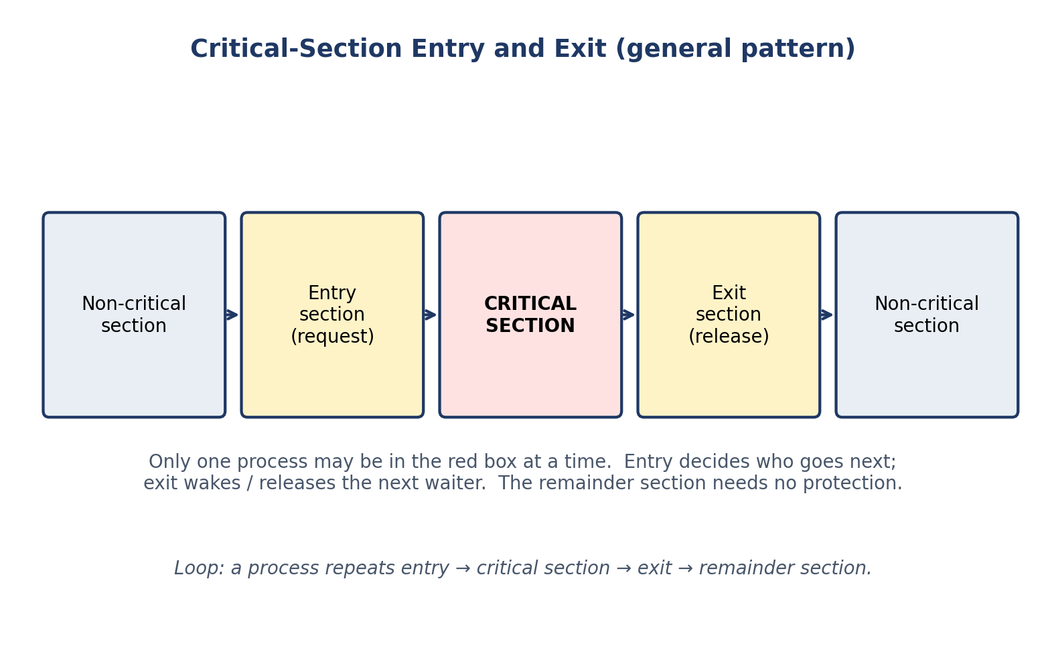
Figure 1. General structure of a process with a critical section: entry section, critical section, exit section, remainder section.
All four mechanisms must satisfy three properties: (1) mutual exclusion — at most one process in the critical section; (2) progress — if the critical section is free and someone wants to enter, the decision is made in finite time; (3) bounded waiting — a requesting process enters after a bounded number of overtakes. They differ in the tools they use to deliver these properties, and at what cost.

2 Peterson's algorithm (1981)
Gary Peterson published the simplest pure-software solution for two processes in 1981. Only two shared variables are needed: the flag array (intention to enter) and turn.
Pseudocode 1. Peterson's algorithm for process Pi.
shared boolean flag[2] = {false, false};
shared int turn; // 0 or 1

process Pi (i = 0 or 1, j = 1 - i):
loop forever:
flag[i] = true; // I want to enter
turn = j; // you go first
while (flag[j] == true and turn == j):
; // busy wait
// ---- critical section ----
... access shared data ...
flag[i] = false; // I am done

- flag[i] = true announces intent.
- turn = j politely gives priority to the other process; whoever writes turn last is the one who waits.
- while (flag[j] and turn == j) waits only while the other is interested and has priority. If the other is uninterested, it enters at once.
Short proof: both cannot be in the critical section together, because that would require turn to be both 0 and 1. Progress holds (if both are interested, exactly one sees turn favouring it) and bounded waiting holds with a bound of 1 overtake: while Pi waits, Pj can enter at most once before Pi.
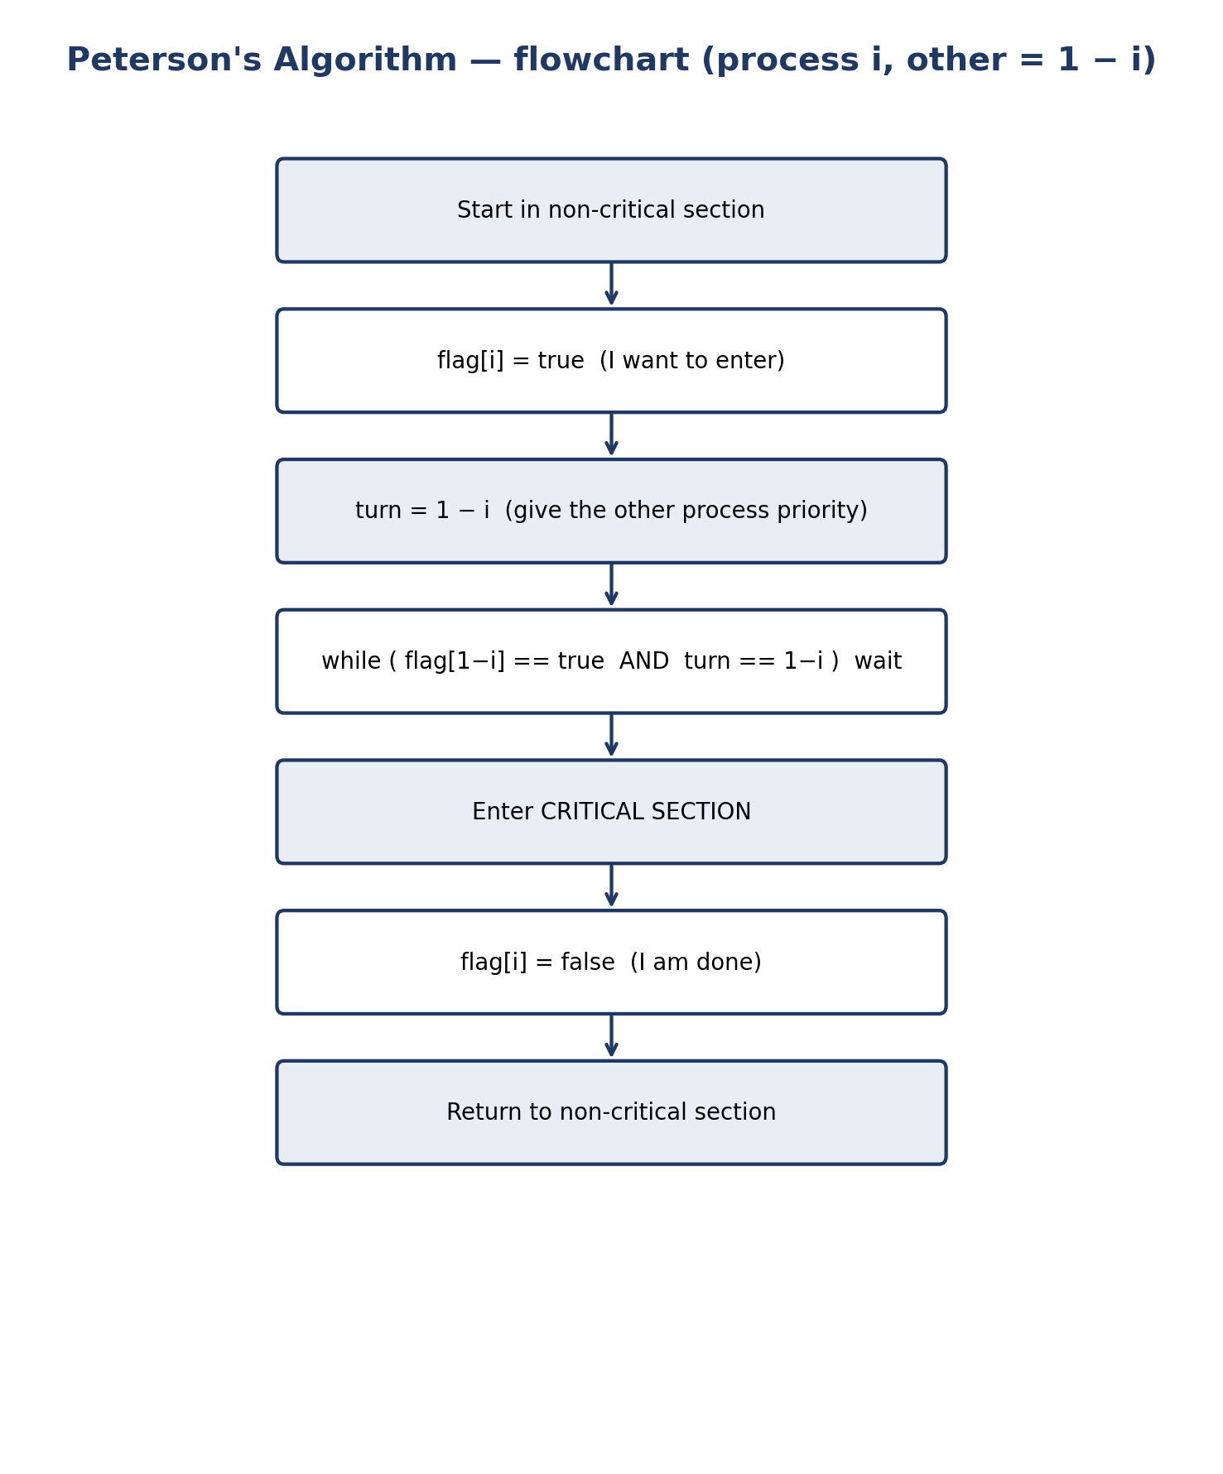
Figure 2. Flowchart of Peterson's algorithm for process Pi.
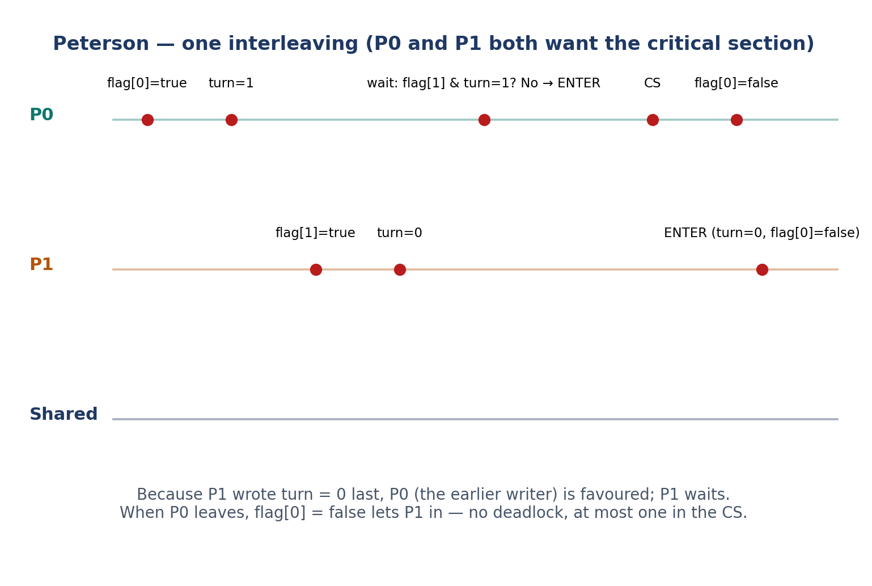
Figure 3. Peterson: a step-by-step interleaving in which P0 enters first and P1 waits.
Table 1. Trace of Peterson's algorithm.
Time | Event | flag[0] | flag[1] | turn | Who may enter
0 | Both in remainder section | false | false | — | Nobody needs to
1 | P0 sets flag, then turn | true | false | 1 | P0
2 | P1 sets flag, then turn | true | true | 0 | P0 (turn favours P0)
3 | P0 enters CS; P1 spins | true | true | 0 | P0 only
4 | P0 leaves, flag[0] = false | false | true | 0 | P1

3 Dekker's algorithm (1965)
Th. J. Dekker published the first known correct software solution to the two-process mutual-exclusion problem in 1965 — sixteen years before Peterson — and it is considerably more intricate: the waiting process must explicitly back off.
Pseudocode 2. Dekker's algorithm for process Pi.
shared boolean flag[2] = {false, false};
shared int turn = 0; // 0 or 1

process Pi (i = 0 or 1, j = 1 - i):
loop forever:
flag[i] = true;
while (flag[j] == true):
if (turn != i):
flag[i] = false; // temporary back-off
while (turn != i):
; // wait for my turn
flag[i] = true; // try again
// ---- critical section ----
... access shared data ...
turn = j; // hand the turn over
flag[i] = false;

Turn-taking: both raise their flags; the process whose turn it is not lowers its flag and waits until turn changes, and the other proceeds. The process in the critical section hands the turn over on exit (turn = j). The back-off is not an optimization: without it, if both set their flags before either tests, both spin forever (deadlock). Dekker satisfies all three properties, but its proof is longer and its back-off is more fragile: omitting the re-raise of flag or misplacing turn = j breaks the algorithm. Both algorithms assume that reads/writes of flag and turn are atomic and sequentially consistent; on modern hardware, plain variables do not give that guarantee, and atomic variables (C11 _Atomic) or a mutex must be used.
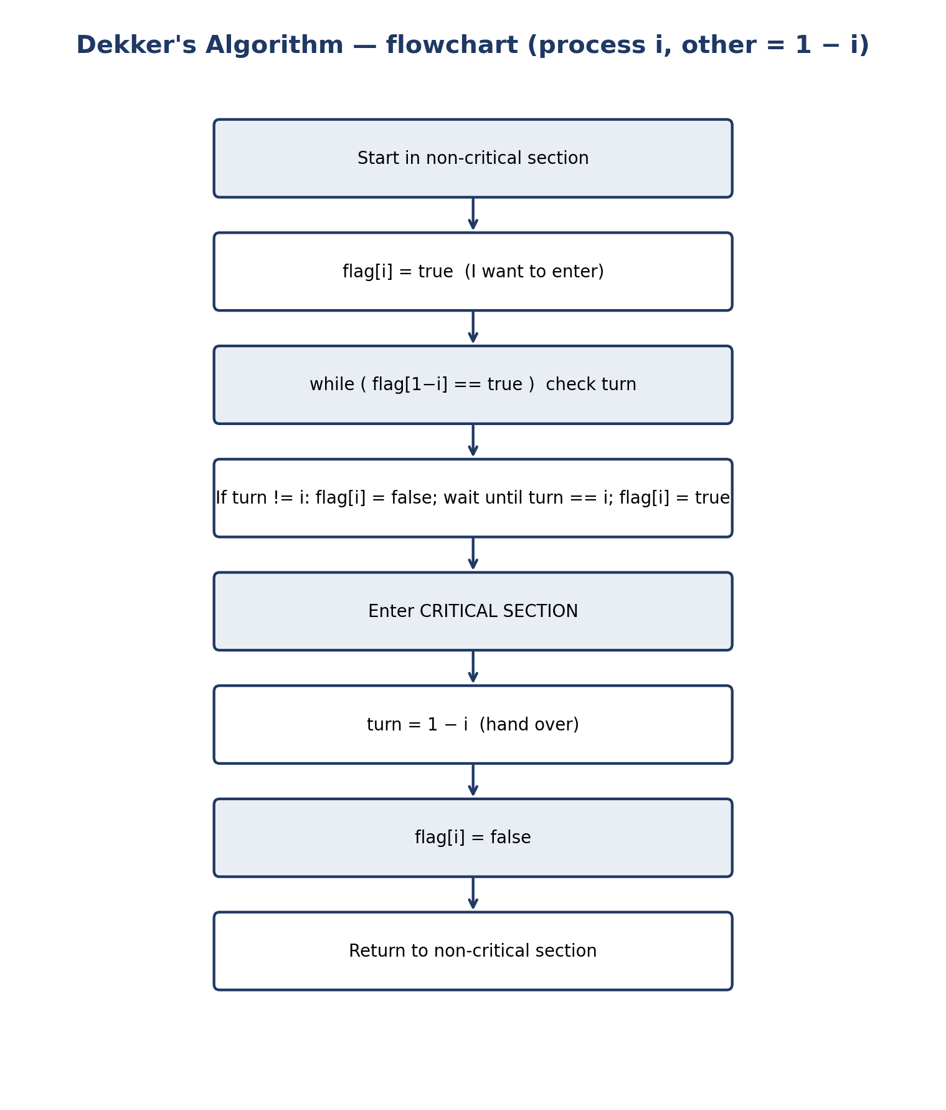
Figure 4. Flowchart of Dekker's algorithm for process Pi, showing the explicit back-off.

4 Semaphore
A semaphore, introduced by Dijkstra in the 1960s, is an integer variable accessible only through two atomic operations: wait (P) and signal (V). A binary semaphore (initial value 1) is used for mutual exclusion, and a counting semaphore (initial value N) for counting N identical resources.
Pseudocode 3. Semaphore operations and protecting a counter with a binary semaphore.
wait(S): // P(S), atomic
S = S - 1;
if (S < 0) block this process on S's queue;

signal(S): // V(S), atomic
S = S + 1;
if (S <= 0) wake one process from S's queue;

shared semaphore mutex = 1;
process i:
wait(mutex);
counter = counter + 1; // critical section
signal(mutex);

The fundamental difference from Peterson and Dekker is that a waiting process does not spin: it blocks, removed from the run queue until another process wakes it. That is why a semaphore works for any number of processes and wastes no CPU. But a semaphore does not prevent deadlock by itself: the programmer must pair wait and signal correctly; a forgotten signal blocks all later waiters forever, and acquiring semaphores in different orders creates a circular wait. Starvation freedom is not guaranteed either: it depends on the wait-queue discipline, and POSIX does not guarantee FIFO order.
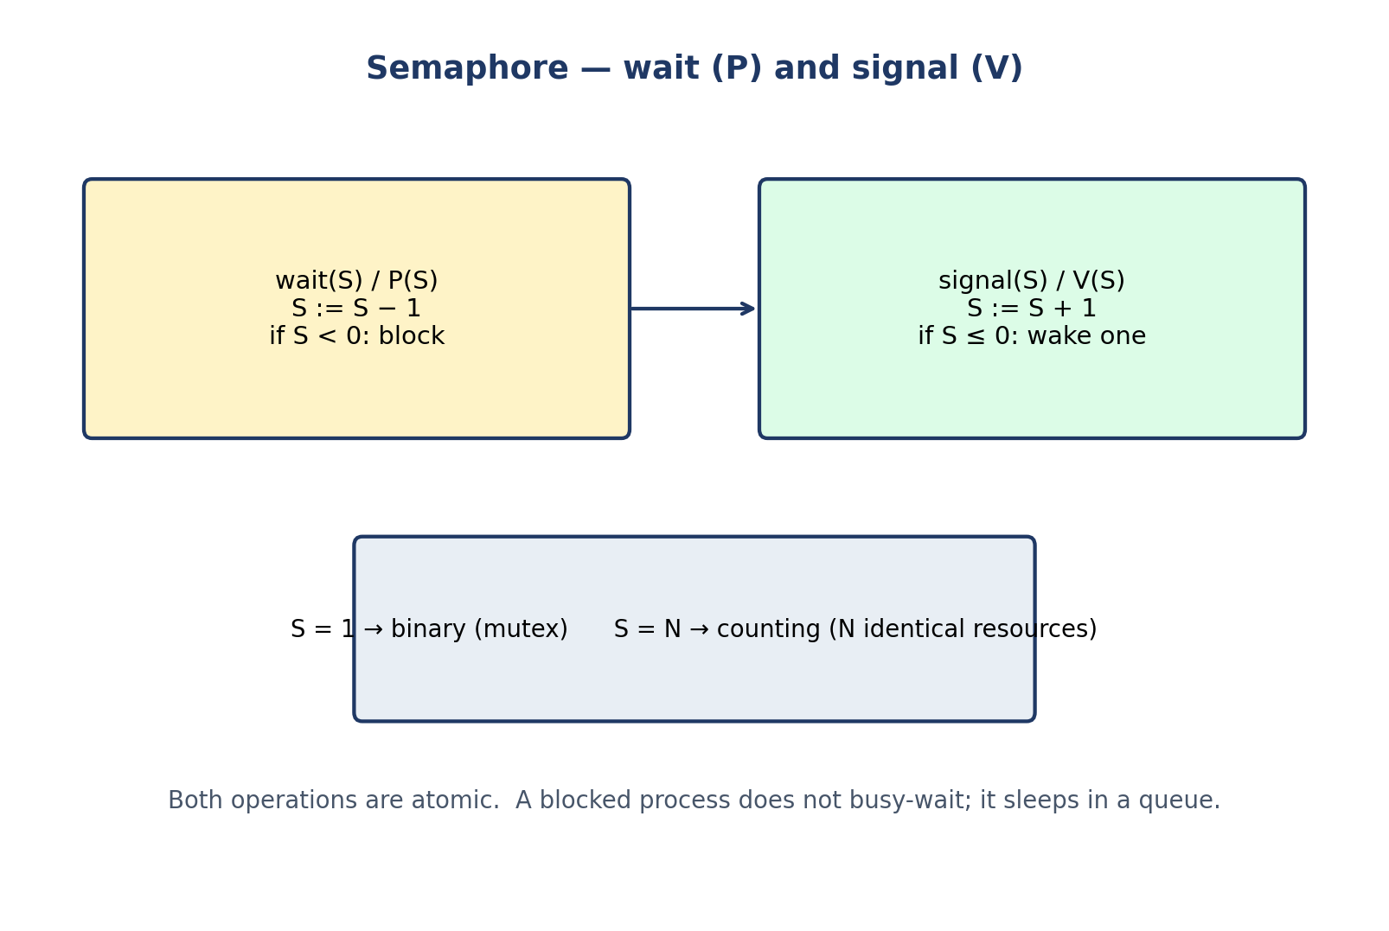
Figure 5. Semaphore: wait (P) and signal (V) operations; binary versus counting use.
Table 2. Trace of a binary semaphore with three processes (textbook convention: a negative value counts waiters).
Step | Operation | mutex value | State
1 | P1: wait(mutex) | 1 → 0 | P1 enters
2 | P2: wait(mutex) | 0 → −1 | P2 blocks
3 | P3: wait(mutex) | −1 → −2 | P3 blocks
4 | P1: signal(mutex) | −2 → −1 | P2 wakes
5 | P2: signal(mutex) | −1 → 0 | P3 wakes
6 | P3: signal(mutex) | 0 → 1 | Free

5 Monitor
A monitor, proposed by Brinch Hansen and Hoare in the early 1970s, is a high-level construct: it bundles shared data together with the procedures that operate on it, inside a module. Only the monitor's own procedures may touch its data, and at most one process may be executing inside a monitor at a time — mutual exclusion is automatic, and the programmer no longer places wait and signal calls around data by hand.
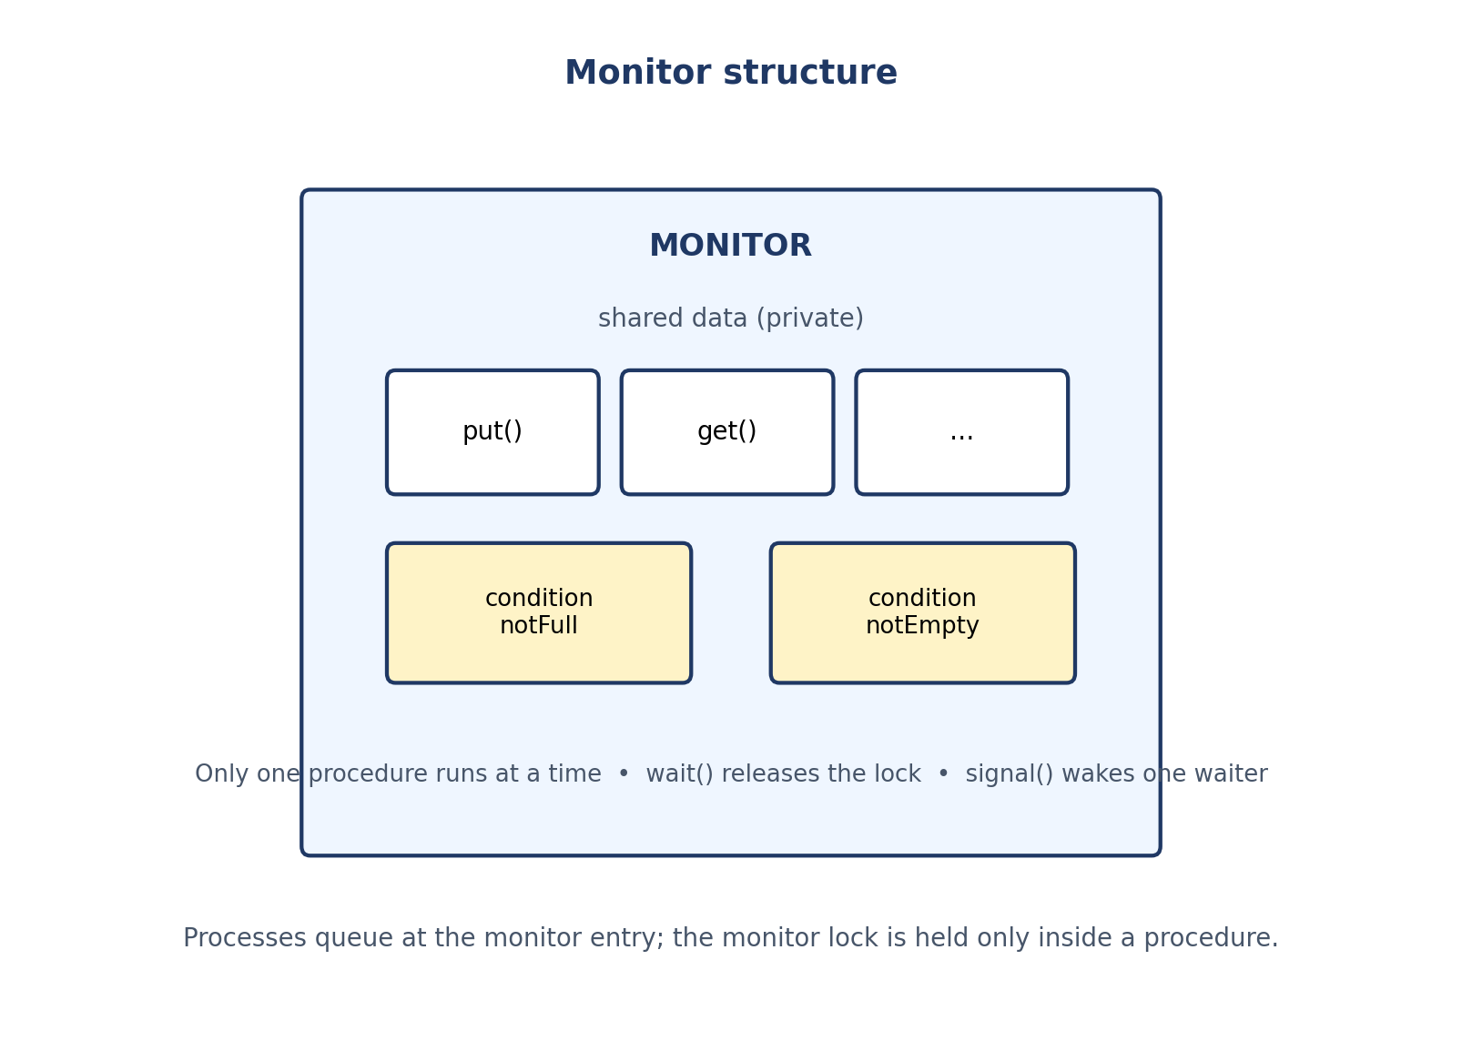
Figure 6. Monitor structure: private shared data, procedures with automatic mutual exclusion, and condition variables.
Pseudocode 4. Monitor: a counter and a bounded buffer.
monitor Counter:
private int value = 0;
procedure increment():
value = value + 1; // mutual exclusion is automatic

monitor BoundedBuffer:
condition notFull, notEmpty;
procedure put(item):
if count == N: wait(notFull); // releases the lock while waiting
insert item; count++;
signal(notEmpty);
procedure get():
if count == 0: wait(notEmpty);
remove item; count--;
signal(notFull);

A procedure that needs a condition to become true cannot simply wait inside the monitor while holding the lock, so monitors provide condition variables: wait(c) releases the lock and suspends the process, and signal(c) wakes one waiter. If no process is waiting, the signal has no effect and is not remembered — unlike a semaphore signal. That is why the condition must be re-tested in a while loop after waking (Mesa semantics, as in POSIX and Java); writing if instead of while is one of the commonest monitor bugs. There are two semantics: Hoare (the woken process runs immediately and the condition is guaranteed true) and Mesa (the signaller continues and the condition must be re-tested); all code in this document uses Mesa semantics. C has no native monitor and it must be built from a mutex and condition variables; Python is the same.
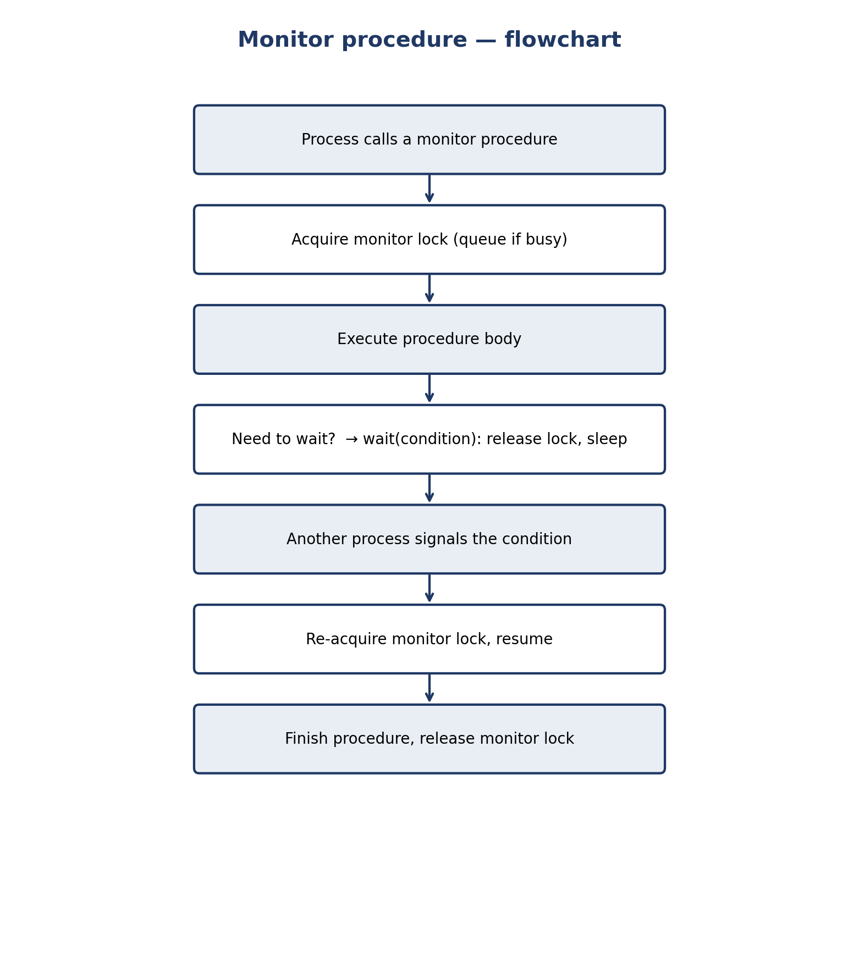
Figure 7. Flowchart of a monitor procedure call, including wait and signal.

6 Comprehensive comparison table — the table the assignment asks for
The rows of the table are exactly the ones in the assignment (number of processes, flag array, turn, busy waiting, temporary back-off, complexity, mutual exclusion, progress, bounded waiting), with a few extra rows (deadlock and starvation freedom, scalability, implementation requirements, main limitation) so the judgement is complete. Note that “flag array” and “turn” belong only to Peterson and Dekker; semaphore and monitor have the semaphore value and the monitor lock instead — writing “yes” for them in those rows would be wrong.
Table 3. Comprehensive comparison of Peterson, Dekker, semaphore, and monitor. Rows 2–10 are the ones asked for in the assignment.
Property | Peterson (1981) | Dekker (1965) | Semaphore | Monitor
Kind | Complete software algorithm | Complete software algorithm | General OS mechanism | High-level language mechanism
Number of processes | Exactly 2 | Exactly 2 | Any number | Any number
Flag array | ✓ Yes: flag[2] | ✓ Yes: flag[2] | ✗ No (has the semaphore value) | ✗ No (has the monitor lock)
Turn | ✓ Yes: turn (0 or 1) | ✓ Yes: turn (0 or 1) | ✗ No | ✗ No
Busy waiting | ✓ Yes — spins in the while test | ✓ Yes — spins in two nested loops | ✗ No — blocks | ✗ No — blocks
Temporary back-off | ✗ No — yielding is done by writing turn | ✓ Yes — lower flag, wait for turn, raise flag again | ✗ No (meaningless here) | ✗ No (meaningless here)
Complexity | Low: 4 lines; short proof | Medium: back-off loop; longer proof | Low conceptually; high in correct use | Medium: monitor + condition variables; the compiler helps
Mutual exclusion | Yes, proved (under sequentially consistent memory) | Yes, proved (under sequentially consistent memory) | Yes, with a correctly used binary semaphore | Yes, automatic: one procedure at a time
Progress | Yes | Yes | Yes, if used correctly | Yes, if used correctly
Bounded waiting | Yes, bound = 1 overtake | Yes, bound = 1 overtake | Not by itself; depends on queue discipline | Not by itself; depends on queue discipline
Deadlock freedom | Yes | Yes | No guarantee; a program can deadlock | No guarantee in general; a correct single monitor is free
Starvation freedom | Yes (follows from bounded waiting) | Yes | Only with a fair queue; POSIX does not guarantee it | Only with a fair queue discipline
Scalability | No: exactly 2 processes | No: exactly 2 processes | Yes: any number; counting to N resources | Yes: any number of processes
Implementation requirements | Shared memory + atomic, sequentially consistent access; no hardware instruction | Same as Peterson | Atomic wait/signal + wait queues | Language support for a lock + condition variables (built in C and Python)
Main limitation | 2 processes; busy waiting; depends on the memory model | Same as Peterson, plus a fragile back-off | Easy to misuse; a forgotten signal deadlocks | No native support in C; a signal with no waiter is lost

6.1 Peterson versus Dekker
Both use flag[2] and turn and satisfy all three properties. The difference is the entry test: Peterson has a single while and Dekker has a loop with an explicit back-off. Conclusion: Peterson is simpler, with a shorter proof, and is better for new explanations; Dekker matters historically, because it was the first correct solution and proved that a pure-software solution existed.

6.2 Semaphore versus monitor
Table 4. Semaphore versus monitor.
Aspect | Semaphore | Monitor
Level | Low-level OS/library mechanism | High-level language mechanism
Mutual exclusion | The programmer's job: pair wait/signal | Automatic: one procedure at a time
Waiting | wait on a semaphore | wait on a condition variable (releases the lock)
Signal | Remembered (the counter is incremented) | Lost if nobody is waiting
Typical bug | Forgotten signal → deadlock | if instead of while after wait → lost condition
Support in Python | threading.Semaphore | Not native; built from Lock + Condition

7 Executable code (Python) and real output
The file ex6_comparison_demo.py runs the same workload for all four mechanisms: two threads, each incrementing the counter 20,000 times; the expected value is 40,000. Experiment 0 (no synchronization) shows the race condition: the load and the store are written out with a scheduling point between them, so the unlucky interleaving that a real machine produces from time to time is seen deterministically. (An honest note: a bare counter[0] += 1 in CPython usually happens to give the right answer, because the GIL rarely switches inside those few bytecodes; that accidental correctness hides the race instead of removing it.) The program was run three times.
Listing 1. ex6_comparison_demo.py — one workload, four mechanisms.
#!/usr/bin/env python3
# -*- coding: utf-8 -*-
"""ex6_comparison_demo.py — Exercise 6: Peterson vs Dekker vs Semaphore vs Monitor.
Same workload for all four mechanisms: two threads increment a shared
counter NITER times each. Correct final value = 2 * NITER.

Run: python3 ex6_comparison_demo.py

Experiments:
0. No synchronization (baseline — shows the race condition)
1. Peterson's algorithm (flag + turn, busy waiting)
2. Dekker's algorithm (flag + turn + back-off, busy waiting)
3. Binary semaphore (threading.Semaphore(1), blocking)
4. Monitor (threading.Lock + Condition, blocking;
here the "monitor" is a tiny Counter class
whose only methods touch the shared data)

Same warning as in the documents: Peterson/Dekker are teaching
demos, not production code. CPython's GIL makes the plain bool/int
assignments work reliably in practice here, but Python gives no
memory-ordering guarantee like C11 _Atomic. In real programs use
threading.Lock / Semaphore (experiments 3-4).
"""
import threading
import time

NITER = 20_000
EXPECTED = 2 * NITER

def run_pair(name, worker):
counter = [0]
t0 = threading.Thread(target=worker, args=(0, counter))
t1 = threading.Thread(target=worker, args=(1, counter))
t0.start(); t1.start(); t0.join(); t1.join()
ok = "OK " if counter[0] == EXPECTED else "FAIL"
print(f"[{name:<10}] counter = {counter[0]} (expected {EXPECTED}) {ok}")
return counter[0]

def no_sync(_i, counter):
# Load-increment-store written out in full, with a scheduling
# point between the load and the store — exactly the unlucky
# interleaving a real machine produces from time to time.
# (A bare `counter[0] += 1` in CPython usually *happens* to
# give the right answer, because the GIL rarely switches
# inside those few bytecodes; that would hide the race.)
for _ in range(NITER):
value = counter[0] # load
time.sleep(0) # another thread may run here
counter[0] = value + 1 # store

def peterson(my_id, counter):
other = 1 - my_id
for _ in range(NITER):
flag[my_id] = True
turn[0] = other
while flag[other] and turn[0] == other:
time.sleep(0)
counter[0] += 1
flag[my_id] = False

def dekker(my_id, counter):
other = 1 - my_id
for _ in range(NITER):
flag[my_id] = True
while flag[other]:
if turn[0] != my_id:
flag[my_id] = False
while turn[0] != my_id:
time.sleep(0)
flag[my_id] = True
counter[0] += 1
turn[0] = other
flag[my_id] = False

sem = threading.Semaphore(1) # binary semaphore, initial value 1
def semaphore_worker(_i, counter):
for _ in range(NITER):
sem.acquire() # wait / P
counter[0] += 1 # critical section
sem.release() # signal / V

class CounterMonitor:
"""Tiny monitor: data is private; only increment() touches it;
the lock guarantees at most one thread inside at a time."""
def __init__(self):
self._lock = threading.Lock()
self.value = 0
def increment(self):
with self._lock: # enter monitor procedure
self.value += 1 # exit monitor procedure (lock released)

monitor = CounterMonitor()
def monitor_worker(_i, counter):
for _ in range(NITER):
monitor.increment()
counter[0] = monitor.value

if __name__ == "__main__":
print(f"Workload: 2 threads x {NITER} increments; expected = {EXPECTED}\n")
print("0. Baseline (no synchronization) — the race condition:")
run_pair("none", no_sync)
print("\n1-2. Software algorithms (busy waiting, 2 processes only):")
flag = [False, False]; turn = [0]
run_pair("peterson", peterson)
flag = [False, False]; turn = [0]
run_pair("dekker", dekker)
print("\n3-4. Blocking primitives (any number of processes):")
run_pair("semaphore", semaphore_worker)
run_pair("monitor", monitor_worker)
print("\nSummary: all four mechanisms give the exact final value;")
print("the baseline loses updates (the race condition).")
print("Peterson/Dekker spin while waiting; semaphore/monitor block.")

Run command.
python3 ex6_comparison_demo.py

Real output: Real output (actually run, not invented):
Real program output (third run; all three runs gave the same result).
Workload: 2 threads x 20000 increments; expected = 40000

0. Baseline (no synchronization) — the race condition:
[none ] counter = 20000 (expected 40000) FAIL

1-2. Software algorithms (busy waiting, 2 processes only):
[peterson ] counter = 40000 (expected 40000) OK
[dekker ] counter = 40000 (expected 40000) OK

3-4. Blocking primitives (any number of processes):
[semaphore ] counter = 40000 (expected 40000) OK
[monitor ] counter = 40000 (expected 40000) OK

Summary: all four mechanisms give the exact final value;
the baseline loses updates (the race condition).
Peterson/Dekker spin while waiting; semaphore/monitor block.

Reading the output: the baseline is 20000, not 40000 — exactly half; each pair of increments collapsed into one, because both threads loaded the same value. All four mechanisms gave exactly 40000. The order of the lines is the same in every run (the program runs sequentially), but the final value is guaranteed for each mechanism. In the Peterson and Dekker spin loops, time.sleep(0) only yields the GIL so the other thread can run; it does not change the algorithm.

8 Sample exercises and solutions

8.1 Exercise 1 — Does this algorithm satisfy the three properties?
Entry section with flag only, no turn: flag[i] = true; while (flag[j]) ; — critical section — flag[i] = false. Does it satisfy (a) mutual exclusion, (b) progress, (c) bounded waiting?
Solution. Solution.
(a) Yes: a process enters only when flag[j] is false. (b) No: if both set their flags before either tests, both spin forever while the critical section is free — deadlock. (c) No: the same scenario starves both indefinitely. Mutual exclusion alone is easy; progress is the property the flag-only attempt fails, and that is why turn (or a back-off) is needed.

8.2 Exercise 2 — Why is Dekker's back-off necessary?
Delete the back-off lines from Dekker (keep only while(flag[j]) ;) and run the scenario where both set their flags at the same time. What happens, and why?
Solution. Solution.
Both see flag[other] = true, both spin in the outer while, neither ever lowers its flag, and nobody enters — deadlock. The back-off is not an optimization; it is the mechanism that breaks the symmetric wait: the turn check makes exactly one of them back off and the other enter.

8.3 Exercise 3 — Semaphore versus monitor: the lost signal
In a bounded-buffer monitor, the producer signals notFull when the buffer is not full, while no consumer is waiting. Later a consumer arrives and finds the buffer empty. What happens? Compare with the semaphore full.
Solution. Solution.
In the monitor, the signal is lost: a signal with no waiter has no effect and is not remembered. The consumer waits on notEmpty until the next producer puts an item and signals again — a delay, but not a deadlock, because the state (count) is correct and the consumer re-tests its condition. With a semaphore, the signal increments full and is remembered; the next consumer passes wait(full) at once. This “remembered versus lost signal” difference is one of the most important distinctions between the two mechanisms, and the reason for while after wait in a monitor.

9 Conclusion
Peterson and Dekker prove that mutual exclusion is possible with software alone — with flag and turn, for two processes, with busy waiting and (in Dekker) a temporary back-off. Semaphore and monitor give the same guarantee for any number of processes and without spinning: a semaphore with atomic, blocking wait/signal, a monitor by enclosing data and procedures in a module with automatic mutual exclusion. The right choice depends on the problem: Peterson for two processes and a teaching proof; a semaphore for counting identical resources or signalling; a monitor for shared-data problems such as a bounded buffer. And remember the experiment in Section 7: without synchronization the counter was 20000, not 40000 — the race condition is real, and all four mechanisms remove it.

References
- A. Silberschatz, P. B. Galvin, and G. Gagne, Operating System Concepts, 10th ed., Wiley, 2018, chs. 6–7.
- G. L. Peterson, “Myths about the mutual exclusion problem”, Information Processing Letters, vol. 12, no. 3, pp. 115–116, 1981.
- Th. J. Dekker, reported in E. W. Dijkstra, “Cooperating sequential processes”, 1968; original solution 1965.
- E. W. Dijkstra, “Cooperating sequential processes”, 1965. Introduction of the semaphore.
- P. Brinch Hansen, “Operating System Principles”, Prentice-Hall, 1973; C. A. R. Hoare, “Monitors: an operating system structuring concept”, Communications of the ACM, vol. 17, no. 10, pp. 549–557, 1974.
- E. Barati (THE-ERPHUN), “Synchronization Mechanisms Comparison”, github.com/THE-ERPHUN/synchronization-mechanisms-comparison — reference project for the comparison style.
- Comprehensive Process Synchronization study (Persian/English), Process_Synchronization_Comparison_FA/EN.docx — Chapters 6, 7, 8, 9, and 12.

