Eshragh
Department of Computer Engineering
Course: Operating Systems
EEVDF Scheduler with Semaphore
EEVDF Scheduling with Semaphore
Scientific and Technical Report Based on Actual Repository Code
Student: Komeil Ramezani 1403176020
Course Instructor: Majid shamshirgaran
November 2026

Table of Contents
3. Introduction 4
3.1 Objective and Scope 4
3.2 Methodology and Examined Files 4
3.3 Repository Structure Based on README 4
3.4 Limitations of This Report 5
4. Introduction and Theoretical Foundations of the EEVDF Algorithm 5
4.1 Background and Significance of the Algorithm 5
4.2 Core Concepts and Equations 6
4.3 Mapping Theoretical Concepts to Code Variables 6
5. Problem Statement (PS) Report and Problem Description 7
5.1 Problem Statement 7
5.2 Experimental Workload 8
5.3 Definition of Metrics in Code 8
6. Introduction to Semaphore 8
7. Program Architecture and Structure 9
8. Explanation of the Actual Code Implementation 11
8.1 Global Objects 11
8.2 ProcessThread Class Constructor 11
8.3 Process Thread Execution Loop (run) 11
8.4 EEVDF Scheduler Loop 12
8.5 Metrics Calculation and main Section 13
9. Review of Key Functions and Classes 14
10. Algorithm Pseudocode 14
11. Program Execution Flowchart 16
12. Task, Scheduling, and Result Tables 17
13. Actual Program Output Charts and Figures 18
14. Analysis of Simulation Results 19
14.1 Tracing the Scheduler’s Decisions 19
14.2 Interpretation 19
14.3 Supplementary Experiment: Processes with Unequal Weights 20
14.4 Actual Role of the Semaphore: Observed Behavior 21
14.5 Reproducibility 21
15. Comparison with RM and EDF Algorithms 21
15.1 Differences in Objectives and Assumptions 21
15.2 Requested Metrics and Code Support 22
15.3 Summary of Comparison for Semaphore 22
16. Advantages and Limitations 23
16.1 Advantages 23
16.2 Limitations 23
16.3 Identified Code Issues and Inconsistencies 23
17. Conclusion 24
18. Scientific References 25
Appendix A: Execution Environment and Methodology 25

Note: To update the Table of Contents, right-click on it and select Update Field → Update entire table.

3. Introduction

3.1 Objective and Scope
This document is the technical report for the assignment “Implementing the EEVDF Scheduler Using a Semaphore” in the Operating Systems course. The basis of this document is the actual Python code of the assignment (file code.py), and no new implementation has been substituted for it. The objective is to (a) explain the algorithm and synchronization concepts used, (b) analyze how the code works line by line, (c) report and analyze the actual execution output of the program, and (d) candidly state the flaws and limitations of the code.

3.2 Methodology and Examined Files
The code was executed by the author, and the outputs were extracted from actual runs of the program. All Gantt and vruntime charts were generated from the logs of those same runs, not from hypothetical data. The table below shows the examined files.
Table 1 – Code Files Examined for This Document
File | Role | Usage in This Document
code.py | EEVDF + Semaphore implementation (main file for this assignment) | Basis of the entire document; executed three times
eevdf_monitor.py | EEVDF + Monitor implementation | For brief comparison only; has a separate document
eevdf_sync_comparison.py | Comparative execution of Semaphore and Monitor | For brief comparison only; has a separate document

Filename Note: The repository README refers to this program as eevdf_semaphore.py in the execution command, whereas the provided file is named code.py. In this document, the name code.py (the actually provided filename) is used; please verify the final name in the repository.

3.3 Repository Structure Based on README
The contents of the GitHub repository folders were not automatically accessible to the author (the site blocks automated access); therefore, the table below is compiled solely based on the README descriptions, and the contents of individual folders have not been verified except for the files directly provided.
Table 2 – Repository Structure Based on README (Unverified at File Level)
Folder (per README) | Claimed Work
EEVDF_Core_Algorithm | Pure Python EEVDF implementation, Lag and Virtual Deadline formulation, and pseudocode
EEVDF_vs_RM_EDF | Comparative simulation and benchmark of EEVDF against RM and EDF
EEVDF_with_Semaphore | EEVDF with Semaphore (threading.Semaphore) — subject of this document
EEVDF_with_Monitor | EEVDF inside a Monitor (threading.Condition)
EEVDF_Semaphore_and_Monitor | Comparative implementation and documentation of Semaphore and Monitor
RM_EDF_Gantt_Chart | Visual Gantt simulation for RM and EDF
Counter_thread_Process | System CPU and process status report (README description)
EEVDF_Animated / EEVDF_Simulation | Web-based interactive animation and simulation

3.4 Limitations of This Report
- No chart or image was provided from the repository itself; the program only produces text output in the console. All charts were created by the author from actual execution logs and have English labels.
- No code comparing against RM and EDF was provided; Section 15 is a theoretical comparison only.
- The exact assignment prompt (PDF file or instructor’s text) was unavailable; Section 5 is the author’s interpretation of the README and code and requires your confirmation.

4. Introduction and Theoretical Foundations of the EEVDF Algorithm

4.1 Background and Significance of the Algorithm
EEVDF (Earliest Eligible Virtual Deadline First) is a proportional-share resource scheduling algorithm first introduced in 1995 by Stoica and Abdel-Wahab and published as a technical report (Ref. [1]); the version for real-time and time-shared systems appears in the RTSS 1996 paper (Ref. [2]). The goal of the algorithm is for each process with weight w_i to receive a long-term CPU share proportional to its weight, while keeping the latency of short, interactive processes controllable.
According to the repository README, this algorithm replaced the CFS scheduler in the Linux kernel starting from version 6.6 (see Refs. [3] and [4]). In CFS, only “virtual runtime” was the selection criterion, whereas EEVDF introduces two new concepts: Eligibility and Virtual Deadline.

4.2 Core Concepts and Equations
If weight w_i and virtual runtime v_i are defined for process i, the “system virtual time” is defined as the following weighted average:
V = ( Σ w_i · v_i ) / ( Σ w_i )
The lag of each process equals the difference between the system virtual time and the process’s own virtual runtime:
lag_i = V − v_i
Process i is eligible if lag_i ≥ 0; meaning it has not fallen behind its fair share or is exactly equal to it. For each execution request of length r_i (the time slice), the virtual deadline is obtained from the following relation, where ve_i is the virtual time at which the request becomes eligible:
vd_i = ve_i + r_i / w_i
Selection Rule: Among eligible processes, the process with the smallest virtual deadline is executed. As a result, processes with a small slice (such as interactive tasks) have earlier virtual deadlines and reach the CPU faster, without compromising the long-term share of batch processes.

4.3 Mapping Theoretical Concepts to Code Variables
Table 3 – Mapping Theoretical EEVDF Concepts to Repository Code
Theoretical Concept | Symbol | Variable / Expression in Code | Description
Weight | w_i | weight | Constant during execution; 1 in all base runs
Virtual runtime | v_i | vruntime | Increases by 1.0 / weight after each tick
Request / slice | r_i | slice | time_slice parameter in constructor
Virtual time (V) | V | avg_vruntime | Simple (unweighted) mean of ready processes’ vruntime
Lag ≥ 0 | — | p.vruntime <= avg_vruntime | Eligibility condition
Virtual deadline | vd_i | v_deadline | vruntime + slice / weight; recomputed every tick

Note: The repository code is a simplified educational version of the algorithm. Its two differences from the theoretical definition (simple average instead of weighted average, and recomputing the deadline on each tick) are reported in detail in the “Advantages and Limitations” section. The algorithm’s logic has not been altered in this document.

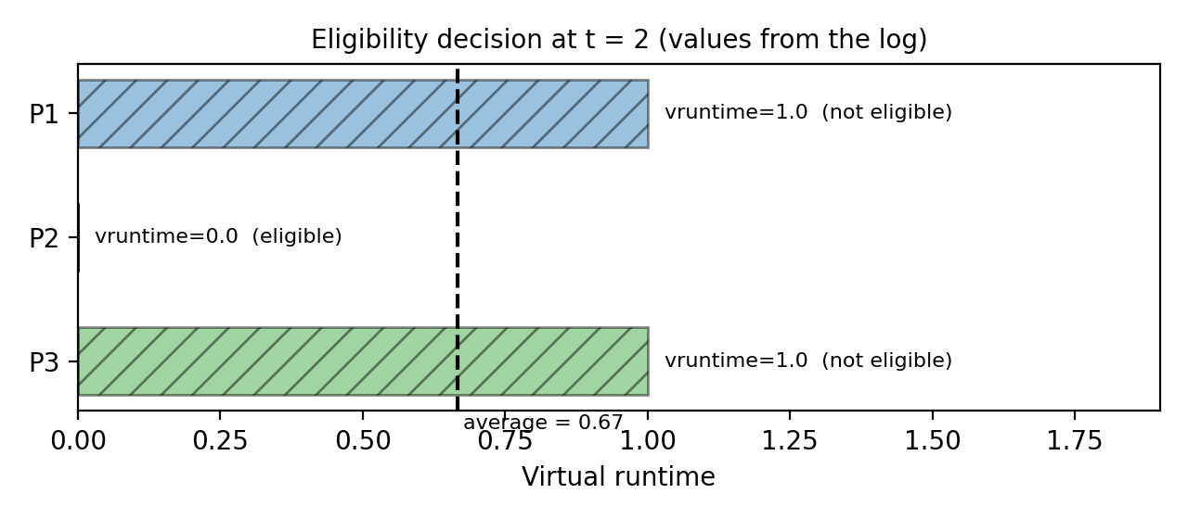
Figure 1 – Concrete Example of the Eligibility Decision at t = 2 (Values Reconstructed from the Semaphore Log)
At time t = 2, the vruntime of processes P1 and P3 is 1.0 and P2 is 0.0; the average is 0.67, making only P2 eligible. For this reason, even though P3’s virtual deadline at this instant (2.0) would have been shorter than P2’s (4.0), P3 is not eligible and P2 is selected (log: P2 with v_deadline = 4.0).

5. Problem Statement (PS) Report and Problem Description
Terminology Note: In this document, “PS” is interpreted as Problem Statement. If you intended something else (e.g., Proportional Share), please notify us.

5.1 Problem Statement
Based on the README and code, the problem is as follows: several processes (as threads) with specified arrival time, total execution time (burst), weight, and slice size must be scheduled using the EEVDF algorithm such that at any moment only one process uses the virtual CPU. Exclusive access to the CPU must be protected by a Binary Semaphore, and at the end, the average waiting, turnaround, and response times must be reported.

5.2 Experimental Workload
Table 4 – Workload Defined in the __main__ Section of code.py
Process | Arrival Time | Burst | Weight | Slice | Role
P1 (Heavy-Batch) | 0 | 4 | 1 | 4 | Heavy batch
P2 (Heavy-Batch) | 0 | 4 | 1 | 4 | Heavy batch
P3 (Interactive) | 1 | 2 | 1 | 1 | Latency-sensitive interactive

5.3 Definition of Metrics in Code
- Turnaround Time = completion_time − arrival
- Waiting Time = turnaround − burst
- Response Time = first_run − arrival
Each unit of simulation time (tick) corresponds to one iteration of the scheduler loop and one unit of processing.

6. Introduction to Semaphore
The Semaphore was introduced in 1965 by Dijkstra to synchronize concurrent processes (Ref. [7]). A semaphore is a non-negative integer variable accessible only through two atomic operations:
- Wait / P: If the semaphore value is positive, it decrements it by 1 and continues; otherwise, the process blocks. In Python: acquire().
- Signal / V: Increments the value by 1 and, if any process is waiting, wakes one up. In Python: release().
When the initial value of the semaphore is 1, we have a Binary Semaphore (similar to a mutex) and Mutual Exclusion is established. In the code: cpu_semaphore = threading.Semaphore(1). Its role is to protect the “critical section,” i.e., executing one tick on the CPU (Ref. [9]).
Table 5 – Specifications of the Semaphore Used in code.py
Property | Semaphore in This Code
Type | Binary (initial value 1)
P Operation | cpu_semaphore.acquire() before executing tick
V Operation | cpu_semaphore.release() after executing tick
Scope | Global variable shared among all threads
Waiting Behavior | Based on reading the code, never blocks (see Section 14.4)

An important note for scientific evaluation: in this implementation, process selection is performed by the scheduler loop via turn_event and scheduler_step_done events, not by the semaphore itself. The semaphore is merely a “secondary safeguard” for CPU access.

7. Program Architecture and Structure
The program consists of two categories of threads: (a) the main thread, which acts as the EEVDF scheduler, and (b) one thread per process (ProcessThread). Synchronization has two levels: handshaking via two Events between the scheduler and the process, and a binary Semaphore for the critical section.
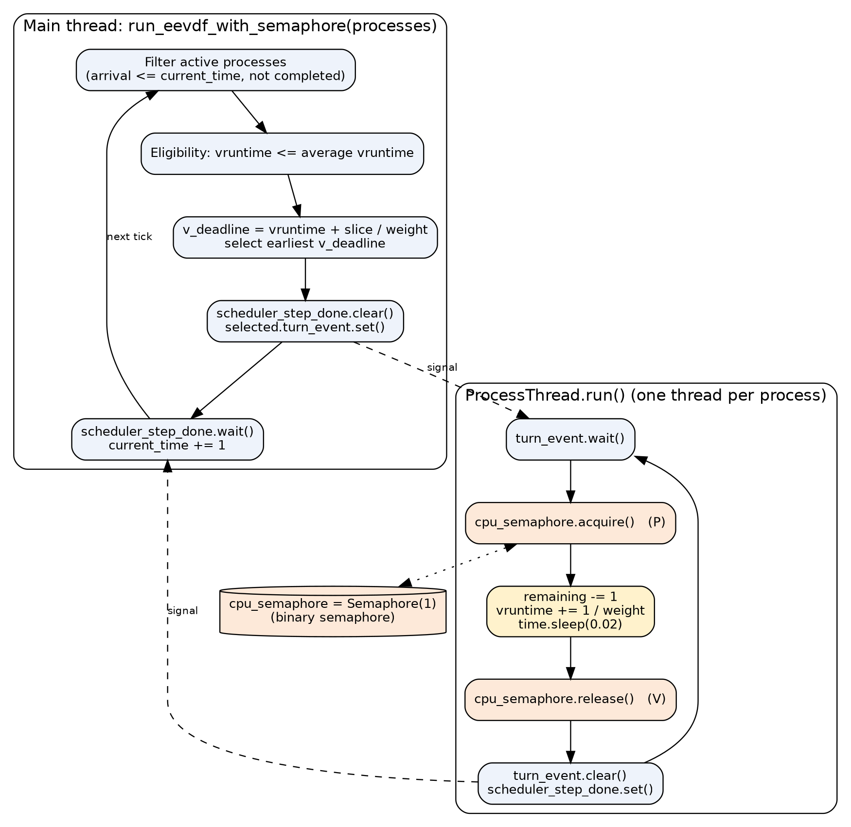
Figure 2 – Architecture of the EEVDF + Semaphore Program (Constructed from the Structure of code.py)
Table 6 – Synchronization Objects and Shared State in code.py
Global Object | Type | Purpose
cpu_semaphore | threading.Semaphore(1) | CPU mutual exclusion
print_lock | threading.Lock() | Prevents interleaved console output
current_time | int | Global simulation clock (only the scheduler increments it)
scheduler_step_done | threading.Event() | Signals end of a tick from process thread to scheduler
turn_event (in each ProcessThread) | threading.Event() | Signals turn from scheduler to process thread

8. Explanation of the Actual Code Implementation

8.1 Global Objects
import threading
import time

# Binary Semaphore to protect the Critical Section (CPU execution resource)
# Initial value of 1 ensures Mutual Exclusion (only one thread executes at a time)
cpu_semaphore = threading.Semaphore(1)

# Helper lock for clean console logging
print_lock = threading.Lock()

# Global simulation clock and synchronization event
current_time = 0
scheduler_step_done = threading.Event()

8.2 ProcessThread Class Constructor
Each process is a thread and, in addition to input parameters, has three groups of attributes: EEVDF attributes (vruntime and v_deadline), measurement attributes (completed, first_run, completion_time), and the turn event (turn_event).
class ProcessThread(threading.Thread):
def __init__(self, pid, arrival, burst, weight, time_slice):
super().__init__()
self.pid = pid
self.arrival = arrival
self.burst = burst
self.remaining = burst
self.weight = weight
self.slice = time_slice

# EEVDF specific attributes
self.vruntime = 0.0
self.v_deadline = 0.0

# Metrics tracking
self.completed = False
self.first_run = -1
self.completion_time = 0

# Thread synchronization event controlled by the EEVDF scheduler
self.turn_event = threading.Event()

8.3 Process Thread Execution Loop (run)
The thread remains blocked on turn_event.wait() until its turn arrives. Upon receiving its turn, it performs P on the semaphore, simulates one unit of processing (remaining -= 1, increments vruntime by 1 / weight, and calls time.sleep(0.02)), then performs V and notifies the scheduler.
def run(self):
while not self.completed:
# Wait until the EEVDF scheduler selects this thread
self.turn_event.wait()

if self.completed:
break

# --- Enter Critical Section (Wait / P Operation) ---
cpu_semaphore.acquire()

with print_lock:
print(
f"[Time {current_time:2d}] 🔒 Semaphore Acquired by {self.pid:<16} | "
f"vruntime: {self.vruntime:4.1f} | v_deadline: {self.v_deadline:4.1f}"
)

# Simulate 1 unit of CPU execution inside the critical section
self.remaining -= 1
self.vruntime += 1.0 / self.weight
time.sleep(0.02)

with print_lock:
print(
f"[Time {current_time + 1:2d}] 🔓 Semaphore Released by {self.pid:<16} | "
f"Remaining Burst: {self.remaining}"
)

# --- Exit Critical Section (Signal / V Operation) ---
cpu_semaphore.release()

# Reset turn event and notify the scheduler that the time unit is complete
self.turn_event.clear()
scheduler_step_done.set()

8.4 EEVDF Scheduler Loop
The core of the algorithm resides in the function run_eevdf_with_semaphore. On each tick: ready processes are filtered; eligible processes are determined by comparing vruntime with the simple average; virtual deadlines are calculated; the process with the smallest deadline is selected and executed via turn_event.set(); and the scheduler waits for the end of the tick via scheduler_step_done.wait().
while completed_count < n:
# Filter active processes that have arrived and are not yet completed
active_procs = [
p for p in processes if p.arrival <= current_time and not p.completed
]

if not active_procs:
current_time += 1
continue

# --- Step 1: Identify Eligible Processes (Lag >= 0) ---
# Processes whose virtual runtime is less than or equal to the average
avg_vruntime = sum(p.vruntime for p in active_procs) / len(active_procs)
eligible_procs = [p for p in active_procs if p.vruntime <= avg_vruntime]

if not eligible_procs:
eligible_procs = active_procs

# --- Step 2: Calculate Virtual Deadlines ---
# Formula: Virtual Deadline = vruntime + (Time Slice / Weight)
for p in eligible_procs:
p.v_deadline = p.vruntime + (p.slice / p.weight)

# Select the eligible process with the earliest virtual deadline
eligible_procs.sort(key=lambda x: x.v_deadline)
selected_proc = eligible_procs[0]

# Record first execution time for Response Time calculation
if selected_proc.first_run == -1:
selected_proc.first_run = current_time

# Signal the selected thread to acquire the semaphore and execute for 1 tick
scheduler_step_done.clear()
selected_proc.turn_event.set()

# Wait for the thread to release the semaphore and finish its tick
scheduler_step_done.wait()

current_time += 1

# Check if the process has completed its total burst time
if selected_proc.remaining == 0:
selected_proc.completed = True
selected_proc.completion_time = current_time
completed_count += 1
selected_proc.turn_event.set() # Unblock thread so it can exit the loop

8.5 Metrics Calculation and main Section
total_wait, total_turn, total_resp = 0, 0, 0
for p in processes:
turnaround = p.completion_time - p.arrival
waiting = turnaround - p.burst
response = p.first_run - p.arrival

total_turn += turnaround
total_wait += waiting
total_resp += response

if __name__ == "__main__":
# Define workload: two heavy batch tasks and one latency-sensitive interactive task
workload = [
ProcessThread(pid="P1 (Heavy-Batch)", arrival=0, burst=4, weight=1, time_slice=4),
ProcessThread(pid="P2 (Heavy-Batch)", arrival=0, burst=4, weight=1, time_slice=4),
ProcessThread(pid="P3 (Interactive)", arrival=1, burst=2, weight=1, time_slice=1),
]

9. Review of Key Functions and Classes
Table 7 – Functions and Classes in code.py
Name | Type | Input | Responsibility and Note
ProcessThread | Class (inherits from Thread) | pid, arrival, burst, weight, time_slice | Represents a process; holds EEVDF state and metrics
ProcessThread.__init__ | Constructor | Same as above | Initializes remaining = burst, vruntime = 0.0, first_run = -1
ProcessThread.run | Thread method | — | Waits for turn, acquire, runs 1 tick, release, signals completion
run_eevdf_with_semaphore | Function | processes | Scheduler loop, EEVDF selection, prints metrics table; uses global current_time
__main__ | Execution block | — | Defines 3-process workload and calls scheduler

10. Algorithm Pseudocode
The pseudocode below summarizes the exact logic in run_eevdf_with_semaphore and ProcessThread.run without adding anything to it.
ALGORITHM EEVDF_WITH_SEMAPHORE(processes)
cpu_semaphore <- Semaphore(1); current_time <- 0; done <- 0
START all process threads // each blocks on turn_event
WHILE done < n DO
active <- { p : p.arrival <= current_time AND NOT p.completed }
IF active is empty THEN current_time++ ; CONTINUE
avg <- mean( p.vruntime for p in active )
elig <- { p in active : p.vruntime <= avg } // if empty: elig <- active
FOR p in elig: p.v_deadline <- p.vruntime + p.slice / p.weight
sel <- element of elig with minimum v_deadline
IF sel.first_run = -1 THEN sel.first_run <- current_time
step_done.clear(); sel.turn_event.set()
step_done.wait() // sel runs ONE tick (see below)
current_time++
IF sel.remaining = 0 THEN
sel.completed <- TRUE; sel.completion_time <- current_time; done++
sel.turn_event.set() // let the thread terminate
JOIN all threads; PRINT metrics

PROCEDURE ProcessThread.run() // executed by every thread
WHILE NOT completed DO
turn_event.wait(); IF completed THEN BREAK
cpu_semaphore.acquire() // P
remaining--; vruntime += 1 / weight; sleep(0.02)
cpu_semaphore.release() // V
turn_event.clear(); step_done.set()

11. Program Execution Flowchart
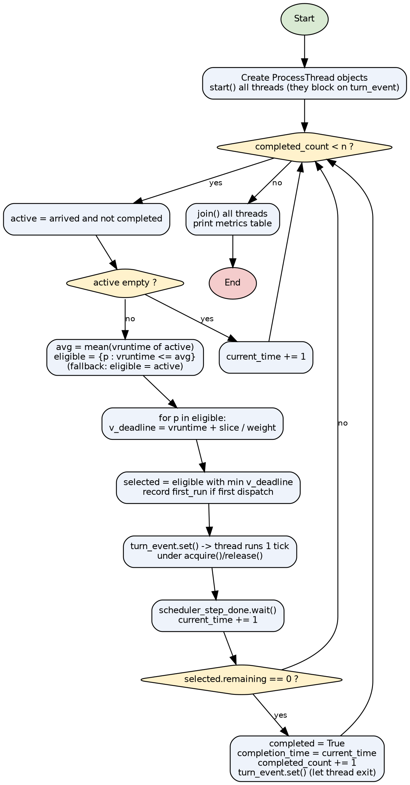
Figure 3 – Flowchart of the EEVDF Scheduler Execution in code.py (Main Thread Loop)
The internal body of the step “turn_event.set() → thread executes” consists of the four steps acquire, executing one tick, release, and scheduler_step_done.set() described in Sections 7 and 10.

12. Task, Scheduling, and Result Tables
The workload is given in Section 5.2. The table below is the actual list of “CPU dispatches” extracted from the program’s execution output.
Table 8 – Actual CPU Dispatch Log in the Execution of code.py
Tick Start Time | Process | vruntime | v_deadline | Tick End Time
0 | P1 (Heavy-Batch) | 0.0 | 4.0 | 1
1 | P3 (Interactive) | 0.0 | 1.0 | 2
2 | P2 (Heavy-Batch) | 0.0 | 4.0 | 3
3 | P3 (Interactive) | 1.0 | 2.0 | 4
4 | P1 (Heavy-Batch) | 1.0 | 5.0 | 5
5 | P2 (Heavy-Batch) | 1.0 | 5.0 | 6
6 | P1 (Heavy-Batch) | 2.0 | 6.0 | 7
7 | P2 (Heavy-Batch) | 2.0 | 6.0 | 8
8 | P1 (Heavy-Batch) | 3.0 | 7.0 | 9
9 | P2 (Heavy-Batch) | 3.0 | 7.0 | 10

Table 9 – Final Metrics Table (Actual Program Output)
Process | Arrival | Burst | Slice | Completion | Turnaround | Waiting | Response
P1 (Heavy-Batch) | 0 | 4 | 4 | 9 | 9 | 5 | 0
P2 (Heavy-Batch) | 0 | 4 | 4 | 10 | 10 | 6 | 2
P3 (Interactive) | 1 | 2 | 1 | 4 | 3 | 1 | 0

Table 10 – Averages Printed by the Program
Metric | Value
Average Waiting Time | 4.00
Average Turnaround Time | 7.33
Average Response Time | 0.67

Table 11 – Quantities Derived from Output (Author’s Calculation, Not Direct Program Output)
Derived Quantity | Value | Calculation Method
Total Duration (Makespan) | 10 ticks | Latest completion time (P2)
CPU Utilization | 100% | 10 execution ticks out of 10 ticks; no idle instant in log
CPU Share: P1 / P2 / P3 | 40% / 40% / 20% | Burst of each process ÷ 10
Context Switches | 9 | Process changes across 10 consecutive dispatches in log
Completed Tasks Count | 3 of 3 | Final table

13. Actual Program Output Charts and Figures
The program itself does not generate charts. The charts below were created by a separate script parsing the log text of this exact execution (without any manual values).
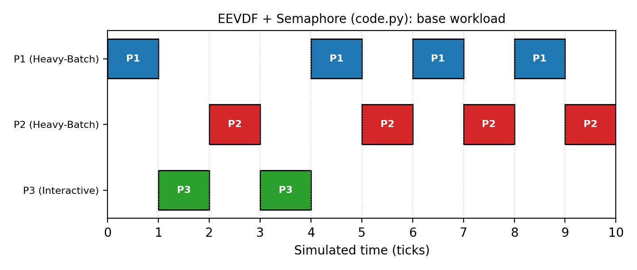
Figure 4 – Gantt Chart of the Actual Execution of code.py
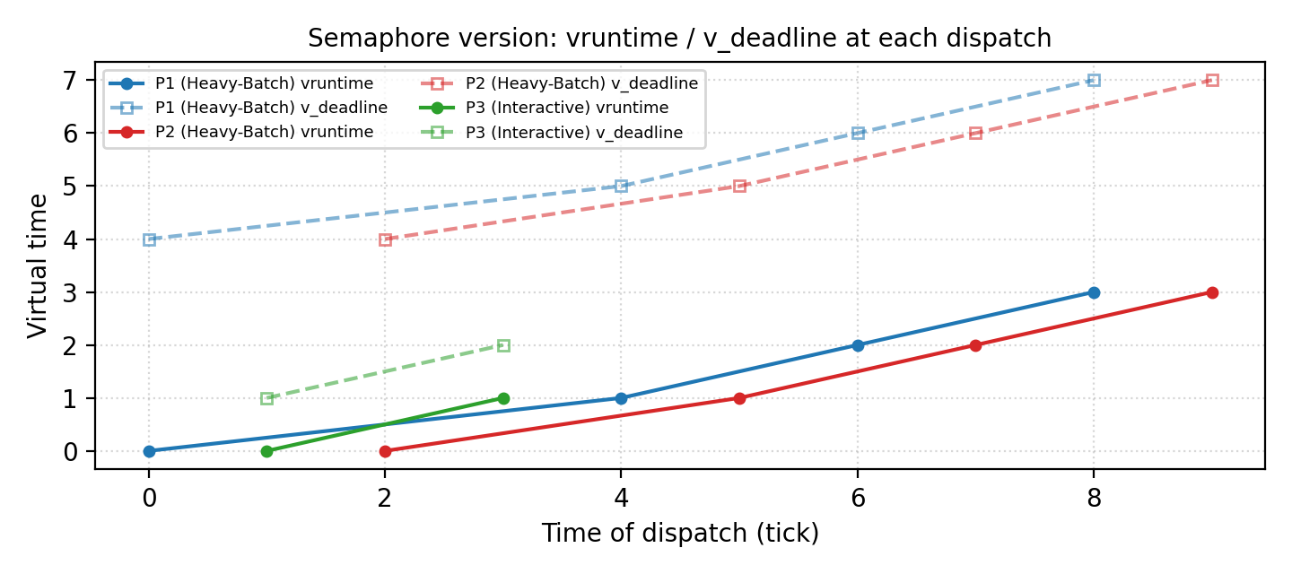
Figure 5 – Evolution of vruntime and v_deadline of Each Process at Each Dispatch Instant (from Log)
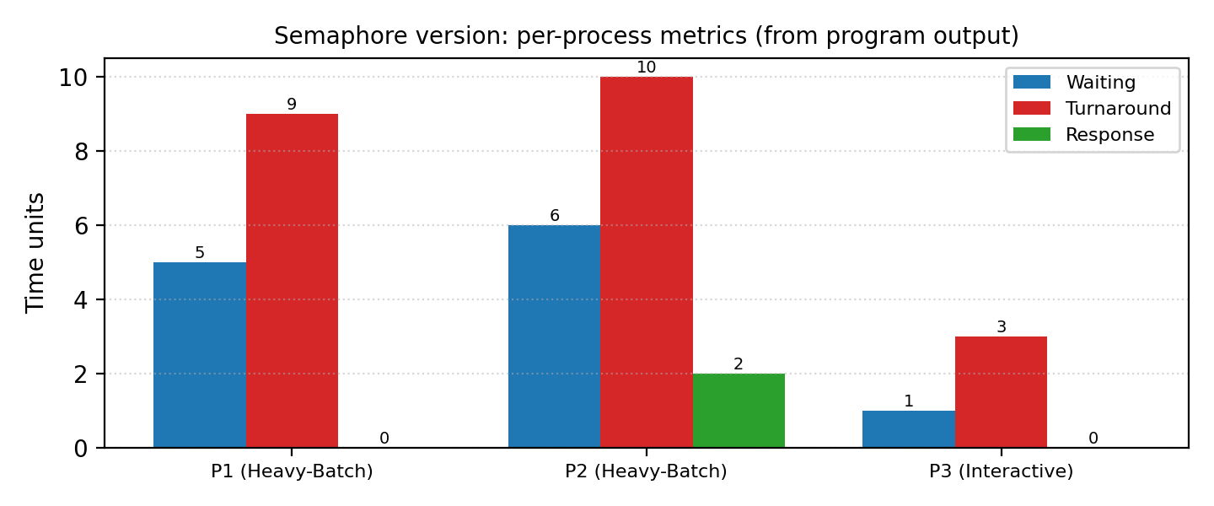
Figure 6 – Comparison of Waiting, Turnaround, and Response Metrics per Process

14. Analysis of Simulation Results

14.1 Tracing the Scheduler’s Decisions
The table below is reconstructed using the exact formulas in the code and the values recorded in the log; the “Selected” column is completely identical to the actual log.
Table 12 – Decision Trace in the Base Execution
t | Ready (vruntime) | Average | Eligible | Eligible v_deadlines | Selected
0 | P1(0) P2(0) | 0.00 | P1, P2 | 4 , 4 | P1 (tie; list order)
1 | P1(1) P2(0) P3(0) | 0.33 | P2, P3 | 4 , 1 | P3
2 | P1(1) P2(0) P3(1) | 0.67 | P2 | 4 | P2
3 | P1(1) P2(1) P3(1) | 1.00 | P1, P2, P3 | 5 , 5 , 2 | P3 (completed)
4 | P1(1) P2(1) | 1.00 | P1, P2 | 5 , 5 | P1 (tie)
5 | P1(2) P2(1) | 1.50 | P2 | 5 | P2
6 | P1(2) P2(2) | 2.00 | P1, P2 | 6 , 6 | P1 (tie)
7 | P1(3) P2(2) | 2.50 | P2 | 6 | P2
8 | P1(3) P2(3) | 3.00 | P1, P2 | 7 , 7 | P1 (completed)
9 | P2(3) | 3.00 | P2 | 7 | P2 (completed)

14.2 Interpretation
- Fast Response of Interactive Process: P3 arrives at t = 1 and executes immediately (Response = 0) because its virtual deadline (1.0) is shorter than P2’s (4.0). Although P3 is the last process to arrive, it has a turnaround time of only 3 units and finishes at t = 4.
- Cost to Batch Processes: P2 waits until t = 2 (Response = 2) and finishes with the highest waiting time (Waiting = 6).
- Apparent Alternation of P1 and P2: After P3 finishes, the two equal-weight processes alternate as P1, P2, P1, P2… because after each tick, the executed process’s vruntime exceeds the average and loses eligibility. The result is fine-grained time-sharing (at the single-tick level).
- Utilization: Because ready processes are always present, the CPU is never idle and utilization is 100%.

14.3 Supplementary Experiment: Processes with Unequal Weights
To observe the impact of weight, the exact same function and classes of code.py (without any modification) were executed with another workload: P1 with weight 2 and burst = 6, P2 with weight 1 and burst = 6, and P3 with weight 1 and burst = 3 arriving at t = 2 (slice = 4, 4, and 1).
Table 13 – Supplementary Experiment Results with Unequal Weights (Actual Execution)
Process | Weight | Arrival | Burst | Completion | Waiting | Response
P1 (W2) | 2 | 0 | 6 | 12 | 6 | 0
P2 (W1) | 1 | 0 | 6 | 15 | 9 | 1
P3 (Short) | 1 | 2 | 3 | 9 | 4 | 0

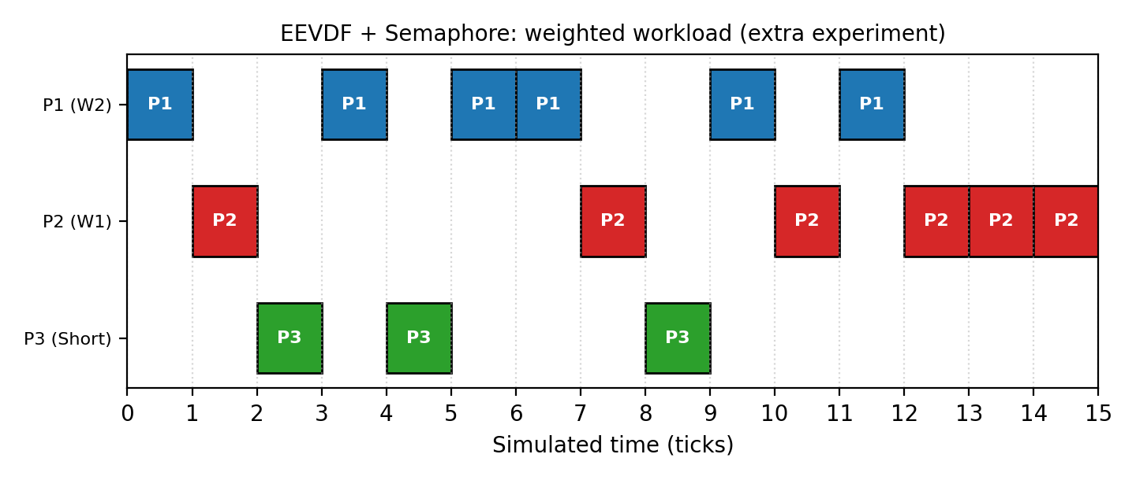
Figure 7 – Gantt Chart of the Supplementary Experiment with 2:1:1 Weights
In the first 12 ticks (until P1 finishes), the CPU share was P1: 6, P2: 3, and P3: 3—a 2:1:1 ratio consistent with their weights. This shows that despite the simplified calculation, the code respects proportional sharing on this workload. (This result does not generalize to every workload; see Section 16.3.)

14.4 Actual Role of the Semaphore: Observed Behavior
At any moment, only one turn_event is set and the scheduler waits until the tick finishes. Therefore, no two threads ever reach cpu_semaphore simultaneously and acquire() never blocks; mutual exclusion is practically provided by the event handshaking, making the semaphore redundant. This conclusion comes from reading the code; empirical proof would require adding a wait counter on the semaphore, which was outside the “no code modification” scope.

14.5 Reproducibility
The program was executed three consecutive times, and the metrics table and dispatch order were identical all three times (execution is deterministic because the scheduler enforces the order and time.sleep only consumes wall-clock time).

15. Comparison with RM and EDF Algorithms
RM and EDF are classic real-time schedulers. For a fair comparison, note that the processes in this assignment’s workload are not “periodic” and have no deadlines; therefore, deadline-compliance metrics are meaningless for them.
Important Limitation: Files comparing EEVDF against RM and EDF (such as compare_schedulers.py mentioned in the README, and the EEVDF_vs_RM_EDF and RM_EDF_Gantt_Chart folders) were not among the files provided for preparing this document. Therefore, no empirical numbers or charts are reported for RM and EDF, and the comparison below is theoretical and qualitative. If you send those files, a quantitative comparison section will be added.

15.1 Differences in Objectives and Assumptions
EEVDF is a fair, proportional-share CPU scheduler whose task model consists of weighted processes. In contrast, RM and EDF are designed for real-time scheduling of periodic tasks defined by a period, worst-case execution time, and deadline (Ref. [5]). Therefore, a direct “better/worse” comparison without considering this fundamental difference in purpose is unscientific.
Table 14 – Theoretical Comparison of EEVDF with RM and EDF
Criterion | EEVDF | RM | EDF
Primary Objective | Fair CPU share and low latency | Meeting deadlines (real-time) | Meeting deadlines (real-time)
Task Model | Process with weight and slice | Periodic; deadline = period | Periodic or aperiodic; absolute deadline
Priority Type | Dynamic (from weight, vruntime, and virtual deadline) | Static (shorter period = higher priority) | Dynamic (earliest deadline)
Schedulability Condition | No schedulability analysis needed for proportional sharing | U ≤ n(2^(1/n) − 1) is sufficient (≈ 0.693 for large n) | U ≤ 1 (uniprocessor, deadline = period)
Overload Behavior | Proportional reduction of all processes’ shares | Low-priority tasks starve | Domino effect may occur
Fairness | Core design goal | Not guaranteed | Not guaranteed
Hard Deadline Guarantee | None; virtual deadline is an internal concept | Yes (if condition holds) | Yes (if condition holds)
Decision Overhead | O(n) in repository code; balanced tree in Linux | Low (static priority) | Medium (dynamic priority queue)

15.2 Requested Metrics and Code Support
The table below shows which comparison metrics can be extracted from the output of the provided code.
Table 15 – Code Support for Comparison Metrics
Metric | Support in EEVDF Code | Support for RM/EDF
CPU Utilization | Not directly reported; computable from log | No file provided
Completed Tasks Count | Yes (completed_count / final table) | No file provided
Waiting Time | Yes | No file provided
Response Time | Yes | No file provided
Turnaround Time | Yes | No file provided
Deadline Compliance | No; processes do not have deadlines | No file provided
Scheduling Overhead | No; only via separate wall-clock measurement | No file provided
Fairness in CPU Allocation | No; extractable from log | No file provided

15.3 Summary of Comparison for Semaphore
Synchronization with a Semaphore is identical across all three algorithms (protecting the critical section), and the main difference lies in the selection rule. For this assignment’s workload, the EDF rule (if a deadline similar to slice were defined for P3) would also execute P3 early; however, without defining real deadlines, this proposition cannot be tested and is stated only as a hypothesis.

16. Advantages and Limitations

16.1 Advantages
- Simple and readable structure; all EEVDF steps (eligibility filter, virtual deadline, selection) are visible in a few lines.
- Deterministic and reproducible execution; output is identical every time.
- Fast response to the interactive process and weight-proportional sharing in the supplementary experiment.
- Log and metrics table are sufficient for analyzing Waiting, Turnaround, and Response.

16.2 Limitations
- Discrete single-tick simulation; time.sleep consumes wall-clock time but has no relation to simulation time.
- Workload of only 3 processes; scalability and behavior under heavy load have not been evaluated.
- Utilization, fairness, deadline compliance, and overhead metrics do not exist in the code itself.
- Selection complexity per tick is O(n log n) due to sorting (whereas O(n) minimum finding would suffice).

16.3 Identified Code Issues and Inconsistencies
The items below were observed while reviewing the code and were intentionally left unmodified so the documentation matches the actual code. For each item, the origin (code inspection or execution observation) is stated.
Table 16 – List of Identified Issues and Inconsistencies
# | Issue | Description | Origin
1 | Semaphore Is Redundant | Mutual exclusion is provided by the turn_event/scheduler_step_done handshake and acquire() never blocks. | Code inspection
2 | Simple Mean Instead of Weighted Mean | Eligibility uses avg_vruntime = arithmetic mean, not V = Σw·v / Σw; equivalent to theory only when weights are equal. | Code inspection
3 | Recomputing Deadline Every Tick | v_deadline is recomputed from scratch every tick; thus slice is not an uninterrupted execution quantum and P1 with slice = 4 is preempted after 1 tick. In standard EEVDF, the deadline remains fixed until the slice is consumed. | Log + code inspection
4 | Starting New Process vruntime from Zero | P3 arrives with vruntime = 0 while P1 has reached 1.0; theoretically, a newly arriving process enters with virtual time equal to V (system). Starting from zero gives newcomers an entry advantage. | Log + code inspection
5 | Deadline Ties Broken Only by List Order | In code.py, the sort key is only v_deadline, whereas in the other two files it is (v_deadline, arrival); behavioral inconsistency on ties. | File comparison
6 | Global current_time Shared in Printing | Process thread reads current_time without a lock; harmless in this design (scheduler is waiting) but an unsafe pattern. | Code inspection
7 | Idle Loop Without Waiting | In the “no process ready” branch, time advances via a busy-loop; worked properly in the idle test (without error). | Code inspection + execution
8 | Filename Mismatch with README | README refers to eevdf_semaphore.py whereas the provided file is code.py. | Comparison with README
9 | Global Clock Is Not Reset | current_time is a module-level global variable and is not zeroed at the start of run_eevdf_with_semaphore. Test: a second call to the function in the same process for a task with arrival 0 and burst = 2 gave first_run = 2 and completion = 4 (Response = 2 instead of 0). In normal single CLI execution, no issue occurs. | Empirical test

17. Conclusion
The file code.py implements an educational EEVDF scheduler on Python threads and produced identical results across three runs: average Waiting = 4.00, Turnaround = 7.33, and Response = 0.67. The interactive process P3 executed without waiting, and both batch processes finished by t = 10; in the supplementary experiment, 2:1:1 proportional sharing was also respected.
In terms of synchronization, the binary Semaphore is used properly, but in practice it is redundant because the scheduler itself serializes access. Several differences from theoretical EEVDF (simple average, recalculating deadline every tick, starting vruntime from zero) exist and have been explicitly documented in this report. Quantitative comparison with RM and EDF requires separate code and data that were unavailable.

18. Scientific References
[1] I. Stoica and H. Abdel-Wahab, “Earliest Eligible Virtual Deadline First: A Flexible and Accurate Mechanism for Proportional Share Resource Allocation,” Technical Report TR-95-22, Old Dominion University, 1995.
[2] I. Stoica, H. Abdel-Wahab, K. Jeffay, S. K. Baruah, J. E. Gehrke, and C. G. Plaxton, “A Proportional Share Resource Allocation Algorithm for Real-Time, Time-Shared Systems,” Proc. 17th IEEE Real-Time Systems Symposium (RTSS), 1996.
[3] J. Corbet, “An EEVDF CPU scheduler for Linux,” LWN.net, 2023.
[4] M. Koutný, “EEVDF is the new (sched_)normal,” SUSE Labs, conference talk (link in repository README).
[5] C. L. Liu and J. W. Layland, “Scheduling Algorithms for Multiprogramming in a Hard-Real-Time Environment,” Journal of the ACM, vol. 20, no. 1, pp. 46–61, 1973.
[6] A. Silberschatz, P. B. Galvin, and G. Gagne, Operating System Concepts, Wiley (multiple editions).
[7] E. W. Dijkstra, “Cooperating Sequential Processes,” EWD123, 1965.
[8] C. A. R. Hoare, “Monitors: An Operating System Structuring Concept,” Communications of the ACM, vol. 17, no. 10, pp. 549–557, 1974.
[9] Python Software Foundation, “threading — Thread-based parallelism” (Semaphore, Condition, Event, Lock), Python 3 documentation.
Note: The bibliographic details above were recorded from the author’s memory and should be verified by the student against the original sources (page numbers, publisher, and exact edition year) for final academic citation.

Appendix A: Execution Environment and Methodology
Table 17 – Execution Environment
Item | Value
Language and Version | Python 3.12.3 (Linux)
Execution Command | python3 code.py
Base Runs Count | 3 (identical output)
Supplementary Execution | Weighted workload with the exact same classes (without modifying code)
Log-to-Chart Conversion | Separate script with matplotlib, parsing log text

