Eshragh
Department of Computer Engineering
Course: Operating Systems
EEVDF Scheduler with Monitor
EEVDF Scheduling with Monitor
Scientific and Technical Report Based on Actual Repository Code
Student: Komeil Ramezani ID: 1403176020
Course Instructor: Majid shamshirgaran
November 2026

Table of Contents
3. Introduction 4
3.1 Objective and Scope 4
3.2 Methodology 4
3.3 Limitations 4
4. Introduction and Theoretical Foundations of the EEVDF Algorithm 5
4.1 Summary of Concepts 5
5. Problem Statement (PS) Report and Problem Description 5
6. Introduction to Monitor 6
7. Program Architecture and Structure 7
8. Explanation of the Actual Code Implementation 8
8.1 Monitor Shared State 8
8.2 Internal EEVDF Selection Procedure 8
8.3 Entry Procedure request_cpu 8
8.4 Exit Procedure release_cpu 9
8.5 Process Thread Loop and Execution Section 10
9. Review of Key Functions and Classes 10
10. Algorithm Pseudocode 11
11. Program Execution Flowchart 12
12. Task, Scheduling, and Result Tables 12
13. Actual Program Output Charts and Figures 13
14. Analysis of Simulation Results 15
14.1 Base Execution Interpretation 15
14.2 Supplementary Experiment: Idle CPU and Late Arrival 15
14.3 Supplementary Experiment: Unequal Weights 15
14.4 Synchronization Behavior 16
15. Comparison with RM and EDF Algorithms 16
15.1 Differences in Objectives and Assumptions 17
15.2 Requested Metrics and Code Support 17
16. Advantages and Limitations 18
16.1 Advantages 18
16.2 Limitations 18
16.3 Identified Code Issues and Inconsistencies 18
17. Conclusion 19
18. Scientific References 19
Appendix A: Execution Environment and Methodology 20

Note: To update the Table of Contents, right-click on it and select Update Field → Update entire table.

3. Introduction

3.1 Objective and Scope
This document is the technical report for the assignment “Implementing the EEVDF Scheduler Using a Monitor”. The basis of this document is the file eevdf_monitor.py, and no part of its logic has been rewritten or modified. The focus of this document is the structural difference between a Monitor and a Semaphore: here, there is no central scheduler thread, and the EEVDF decision is made inside the Monitor itself by the process threads.

3.2 Methodology
The program was executed three times (producing identical output all three times). In addition to the base workload, the exact same classes were executed without any modification on two additional workloads (unequal weights and late arrival). All charts were created from the log text of these exact runs.
Table 1 – Examined Files
File | Role | Usage in This Document
eevdf_monitor.py | EEVDF + Monitor implementation (main file for this assignment) | Basis of the entire document
code.py | EEVDF + Semaphore implementation | For comparison only (has a separate document)
eevdf_sync_comparison.py | Comparative execution of both methods | For comparison only (has a separate document)

Repository Structure: The repository structure table based on the README is provided in “EEVDF_Semaphore.docx”. According to the README, the folder for this assignment is EEVDF_with_Monitor and claims an “object-oriented implementation inside a Monitor (threading.Condition) and comparison with Semaphore”. The folder contents were not automatically accessible to the author, so only the provided file was examined.

3.3 Limitations
- The program only produces text output; the charts were created by the author from actual logs (English labels).
- No code comparing against RM and EDF was provided; Section 15 is theoretical.
- The exact assignment prompt was unavailable; Section 5 should be verified by you against the assignment text.

4. Introduction and Theoretical Foundations of the EEVDF Algorithm
The theoretical foundations of EEVDF are covered in full in “EEVDF_Semaphore.docx”. In this document, only the concepts required to understand the code are reviewed to avoid unnecessary repetition.

4.1 Summary of Concepts
- Weight: The relative CPU share of a process; represented by weight in the code and equal to 1 in all base runs.
- Virtual Runtime (vruntime): Increases by 1 / weight as the process executes; heavier processes “age” more slowly.
- Eligibility: A process is eligible if it has not moved ahead of the average virtual runtime of ready processes (vruntime <= avg_vruntime).
- Virtual Deadline: v_deadline = vruntime + slice / weight; among eligible processes, the smallest deadline is selected.
Table 2 – Mapping Theoretical Concepts to Code Variables
Theoretical Concept | Variable in Code
Virtual runtime | vruntime
Virtual deadline | v_deadline
Weight | weight
Request / time slice | slice
Average virtual runtime (approximation of V) | avg_vruntime

5. Problem Statement (PS) Report and Problem Description
Terminology Note: “PS” is interpreted here as Problem Statement; please notify if intended otherwise.
Problem: Schedule several processes under the EEVDF algorithm such that the CPU resource, mutual exclusion lock, condition variable, and scheduling state are all encapsulated within a single Monitor object. Each process must call the entry procedure (request_cpu) to access the CPU and the exit procedure (release_cpu) to release it, waiting on the condition variable if EEVDF has not selected it or if the CPU is busy.
Table 3 – Workload Defined in run_simulation (eevdf_monitor.py)
Process | Arrival Time | Burst | Weight | Slice | Role
P1 (Heavy-Batch) | 0 | 4 | 1 | 4 | Heavy batch
P2 (Heavy-Batch) | 0 | 4 | 1 | 4 | Heavy batch
P3 (Interactive) | 1 | 2 | 1 | 1 | Latency-sensitive interactive

The metrics are defined identically to the Semaphore version: Turnaround = completion_time − arrival, Waiting = Turnaround − burst, and Response = first_run − arrival.

6. Introduction to Monitor
A Monitor is a high-level synchronization construct introduced by Hoare in 1974 (Ref. [8]). A Monitor encapsulates shared data and the procedures that operate on them into a single unit and guarantees that at any moment at most one thread is active inside its procedures (implicit mutual exclusion). To wait on a condition, a Condition Variable with wait and signal operations is used.
- wait(): The thread releases the Monitor lock, sleeps in the condition queue, and re-acquires the lock upon waking up.
- notify() / notify_all(): Wakes up one or all waiting threads. In Python, it operates with Mesa semantics (signal-and-continue); thus, a woken thread must re-evaluate the condition (while pattern). The code follows this exact pattern: while True with condition re-evaluation (Ref. [9]).
Python has no built-in language Monitor; this code constructs a Monitor via “class convention”: a Lock, a Condition built on that same Lock, and procedures that all begin with “with self.condition:”.
Table 4 – Mapping Monitor Concepts to Code
Monitor Concept | Representation in eevdf_monitor.py
Shared Data | current_time, cpu_busy, active_thread_id, registered_threads
Mutual Exclusion Lock | self.lock = threading.Lock()
Condition Variable | self.condition = threading.Condition(self.lock)
Entry Procedure | request_cpu(process)
Exit Procedure | release_cpu(process)
Internal (Private) Procedure | _select_next_eevdf_process()
Guard Condition | not cpu_busy and selected == process
Wake-Up Notification | condition.notify_all() in release_cpu and in the idle branch

7. Program Architecture and Structure
Unlike the Semaphore version, this program has no separate scheduler thread. Each of the three process threads calls request_cpu in its run loop; each thread performs the EEVDF calculation itself (inside the Monitor and under the lock) and enters only if selected. The simulation clock is also maintained inside the Monitor and updated by the threads.
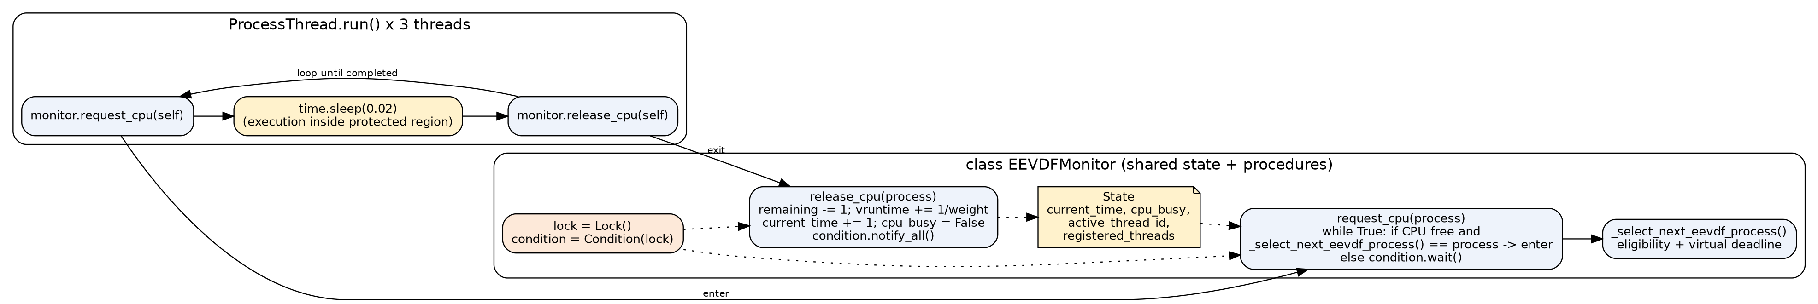
Figure 1 – Architecture of the EEVDF + Monitor Program (Constructed from the Structure of eevdf_monitor.py)
Table 5 – Architectural Characteristics of the Monitor Version
Aspect | Behavior in eevdf_monitor.py
EEVDF Decision Maker | Every waiting thread, upon waking up (distributed)
Simulation Clock | self.current_time inside Monitor; incremented in release_cpu and in the idle branch of request_cpu
CPU Mutual Exclusion | cpu_busy flag protected by lock
Tick Execution | time.sleep(0.02) in ProcessThread.run, outside the lock while cpu_busy = True
Notification | notify_all to all waiting threads after each tick

8. Explanation of the Actual Code Implementation

8.1 Monitor Shared State
def __init__(self):
# Monitor's internal mutual exclusion lock and condition variable
self.lock = threading.Lock()
self.condition = threading.Condition(self.lock)

# Shared state encapsulated within the Monitor
self.current_time = 0
self.cpu_busy = False
self.active_thread_id = None
self.registered_threads = []

def register_thread(self, thread):
with self.lock:
self.registered_threads.append(thread)

8.2 Internal EEVDF Selection Procedure
The EEVDF logic is the same as the Semaphore version (simple average for eligibility and v_deadline = vruntime + slice / weight), except that tie-breaking is performed using the key (v_deadline, arrival).
def _select_next_eevdf_process(self):
"""Internal Monitor procedure to compute Eligibility and Virtual Deadlines."""
ready_procs = [
p for p in self.registered_threads
if p.arrival <= self.current_time and not p.completed
]

if not ready_procs:
return None

# Step 1: Identify Eligible threads (Lag >= 0 -> vruntime <= avg_vruntime)
avg_vruntime = sum(p.vruntime for p in ready_procs) / len(ready_procs)
eligible_procs = [p for p in ready_procs if p.vruntime <= avg_vruntime]

if not eligible_procs:
eligible_procs = ready_procs

# Step 2: Calculate Virtual Deadline = vruntime + (slice / weight)
for p in eligible_procs:
p.v_deadline = p.vruntime + (p.slice / p.weight)

# Select thread with the earliest virtual deadline
eligible_procs.sort(key=lambda x: (x.v_deadline, x.arrival))
return eligible_procs[0]

8.3 Entry Procedure request_cpu
The while True loop evaluates the guard condition. If no ready process exists and the CPU is free, this same thread advances the clock by one unit (idle management). Otherwise, if the CPU is free and this thread is selected, it enters; otherwise, it calls condition.wait().
with self.condition:
while True:
# Advance idle clock if no tasks have arrived yet
ready_procs = [
p for p in self.registered_threads
if p.arrival <= self.current_time and not p.completed
]
if not ready_procs and not self.cpu_busy:
self.current_time += 1
self.condition.notify_all()
continue

selected = self._select_next_eevdf_process()

# Guard condition: CPU must be free AND this thread must be selected by EEVDF
if not self.cpu_busy and selected == process:
self.cpu_busy = True
self.active_thread_id = process.pid

if process.first_run == -1:
process.first_run = self.current_time

print(
f"[Time {self.current_time:2d}] 🖥️ Monitor Entered by {process.pid:<16} | "
f"vruntime: {process.vruntime:4.1f} | v_deadline: {process.v_deadline:4.1f}"
)
break
else:
# Wait inside the Monitor's condition queue (automatically releases lock)
self.condition.wait()

8.4 Exit Procedure release_cpu
with self.condition:
process.remaining -= 1
process.vruntime += 1.0 / process.weight
self.current_time += 1

print(
f"[Time {self.current_time:2d}] ✅ Monitor Exited by {process.pid:<16} | "
f"Remaining Burst: {process.remaining}"
)

if process.remaining == 0:
process.completed = True
process.completion_time = self.current_time

self.cpu_busy = False
self.active_thread_id = None

# Wake up all waiting threads to re-evaluate the EEVDF guard condition
self.condition.notify_all()

8.5 Process Thread Loop and Execution Section
def run(self):
while not self.completed:
# 1. Request access via Monitor Entry Procedure
self.monitor.request_cpu(self)

# 2. Simulate execution inside the protected critical section
time.sleep(0.02)

# 3. Release access via Monitor Exit Procedure
self.monitor.release_cpu(self)

def run_simulation():
monitor = EEVDFMonitor()

# Define workload: Two heavy batch threads and one latency-sensitive interactive thread
threads = [
ProcessThread("P1 (Heavy-Batch)", arrival=0, burst=4, weight=1, time_slice=4, monitor=monitor),
ProcessThread("P2 (Heavy-Batch)", arrival=0, burst=4, weight=1, time_slice=4, monitor=monitor),
ProcessThread("P3 (Interactive)", arrival=1, burst=2, weight=1, time_slice=1, monitor=monitor),
]

for t in threads:
monitor.register_thread(t)

print("=" * 88)
print("🚀 Starting EEVDF Scheduling with Monitor (Condition Variable) Synchronization...")
print("=" * 88)

for t in threads:
t.start()

for t in threads:
t.join()

9. Review of Key Functions and Classes
Table 6 – Classes and Functions in eevdf_monitor.py
Name | Type | Responsibility and Note
EEVDFMonitor | Class | Encapsulates lock, condition variable, clock, CPU flag, and process list
EEVDFMonitor.register_thread | Procedure | Registers thread in the shared list (under lock)
EEVDFMonitor._select_next_eevdf_process | Internal Procedure | Filters ready processes, eligibility, deadline calculation, and selection; side effect: updates v_deadline of eligible processes
EEVDFMonitor.request_cpu | Entry Procedure | Guard loop; advances clock during idle periods; records first_run and prints entry
EEVDFMonitor.release_cpu | Exit Procedure | Decrements remaining, increments vruntime and current_time, marks completion, notify_all
ProcessThread | Class (Thread) | Holds process state + reference to monitor
ProcessThread.run | Method | request_cpu → sleep(0.02) → release_cpu until completion
run_simulation | Function | Creates Monitor and three threads, registers, starts, joins, and prints metrics table

10. Algorithm Pseudocode
MONITOR EEVDFMonitor
STATE: current_time, cpu_busy, registered_threads; lock; condition(lock)

ENTRY PROCEDURE request_cpu(proc)
LOCK condition
LOOP
ready <- { p : p.arrival <= current_time AND NOT p.completed }
IF ready is empty AND NOT cpu_busy THEN
current_time++ ; notify_all ; CONTINUE // idle tick
sel <- SELECT_NEXT()
IF NOT cpu_busy AND sel = proc THEN
cpu_busy <- TRUE ; set first_run if first ; BREAK
ELSE condition.wait() // releases lock while waiting
UNLOCK

EXIT PROCEDURE release_cpu(proc)
LOCK condition
proc.remaining-- ; proc.vruntime += 1/proc.weight ; current_time++
IF proc.remaining = 0 THEN proc.completed <- TRUE ; proc.completion_time <- current_time
cpu_busy <- FALSE ; notify_all
UNLOCK

PROCEDURE SELECT_NEXT() // internal
ready <- arrived and not completed ; IF empty RETURN NONE
avg <- mean(vruntime of ready) ; elig <- { p : vruntime <= avg } (fallback: ready)
FOR p in elig: p.v_deadline <- p.vruntime + p.slice / p.weight
RETURN element of elig with minimum (v_deadline, arrival)

THREAD proc: WHILE NOT proc.completed: request_cpu(proc) ; sleep(0.02) ; release_cpu(proc)

11. Program Execution Flowchart
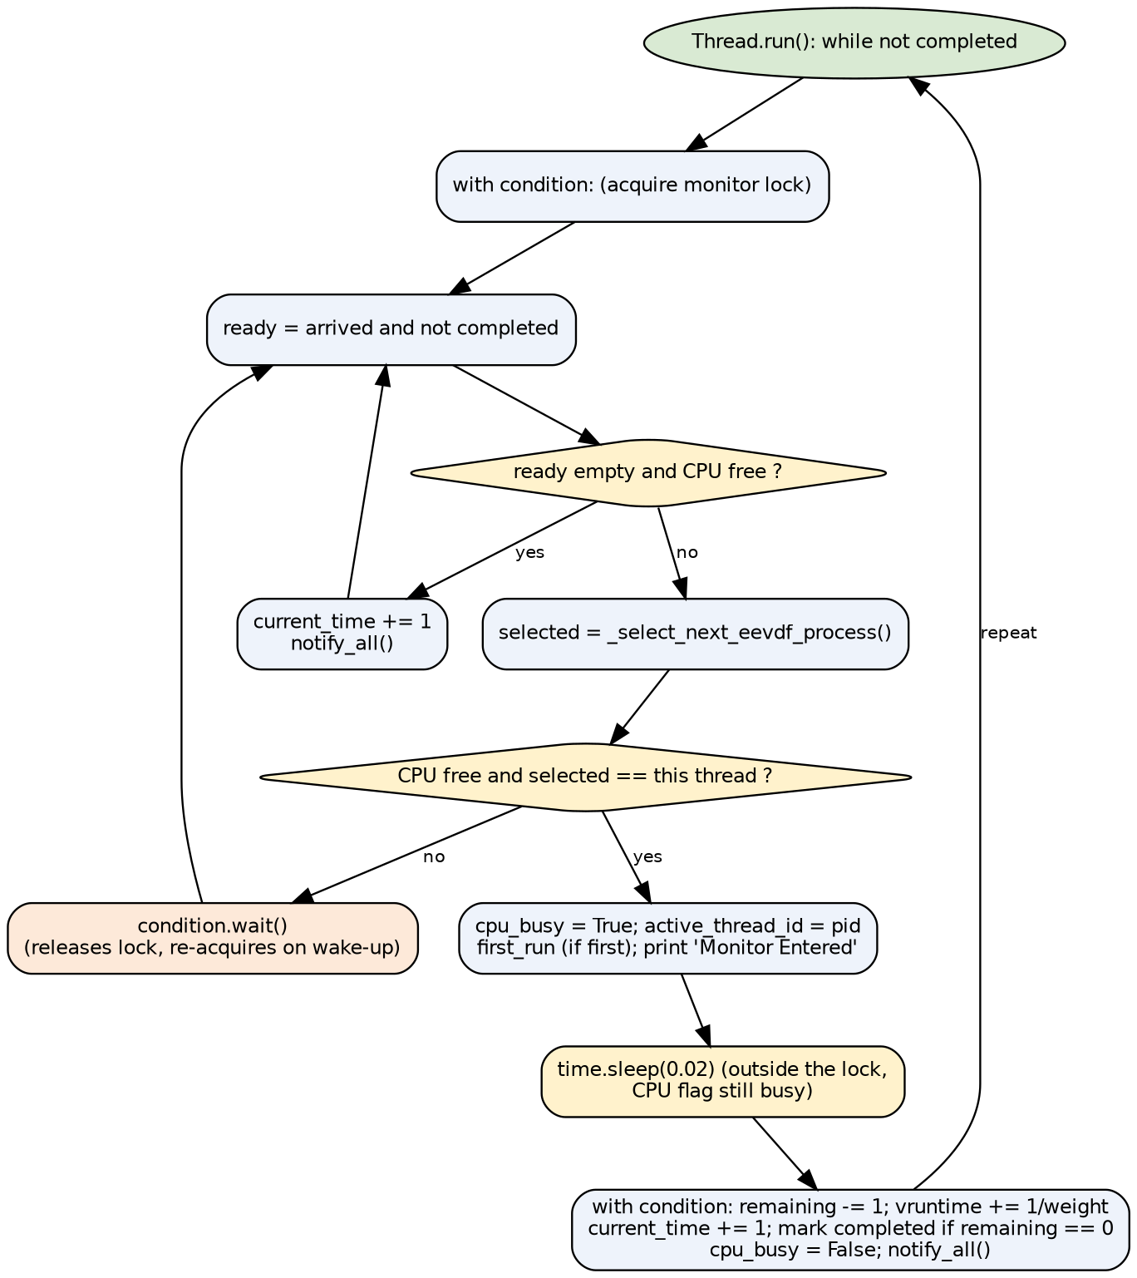
Figure 2 – Flowchart of a Process Thread Lifecycle in the Monitor Version

12. Task, Scheduling, and Result Tables
Table 7 – Actual Monitor Entry Log in the Execution of eevdf_monitor.py
Tick Start Time | Process | vruntime | v_deadline | Tick End Time
0 | P1 (Heavy-Batch) | 0.0 | 4.0 | 1
1 | P3 (Interactive) | 0.0 | 1.0 | 2
2 | P2 (Heavy-Batch) | 0.0 | 4.0 | 3
3 | P3 (Interactive) | 1.0 | 2.0 | 4
4 | P1 (Heavy-Batch) | 1.0 | 5.0 | 5
5 | P2 (Heavy-Batch) | 1.0 | 5.0 | 6
6 | P1 (Heavy-Batch) | 2.0 | 6.0 | 7
7 | P2 (Heavy-Batch) | 2.0 | 6.0 | 8
8 | P1 (Heavy-Batch) | 3.0 | 7.0 | 9
9 | P2 (Heavy-Batch) | 3.0 | 7.0 | 10

Table 8 – Final Metrics Table (Actual Program Output)
Process | Arrival | Burst | Slice | Completion | Turnaround | Waiting | Response
P1 (Heavy-Batch) | 0 | 4 | 4 | 9 | 9 | 5 | 0
P2 (Heavy-Batch) | 0 | 4 | 4 | 10 | 10 | 6 | 2
P3 (Interactive) | 1 | 2 | 1 | 4 | 3 | 1 | 0

Table 9 – Averages Printed by the Program
Metric | Value
Average Waiting Time | 4.00
Average Turnaround Time | 7.33
Average Response Time | 0.67

Table 10 – Quantities Derived from Output (Author’s Calculation)
Derived Quantity | Value | Calculation Method
Total Duration | 10 ticks | Latest completion (P2)
CPU Utilization | 100% | 10 execution ticks out of 10 ticks
CPU Share: P1 / P2 / P3 | 40% / 40% / 20% | burst ÷ 10
Context Switches | 9 | Process changes across 10 consecutive entries

13. Actual Program Output Charts and Figures
The charts were created by parsing the log text (the program itself does not generate charts).
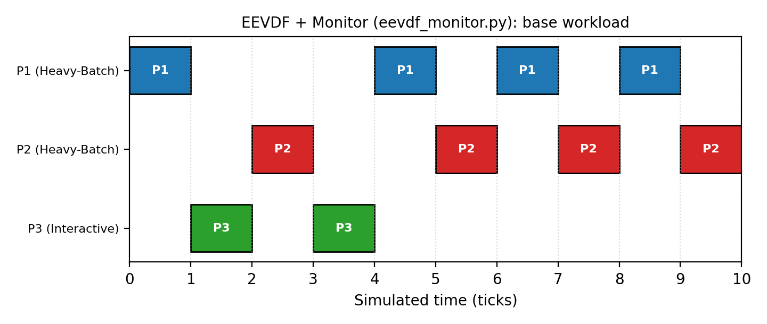
Figure 3 – Gantt Chart of the Actual Execution of eevdf_monitor.py
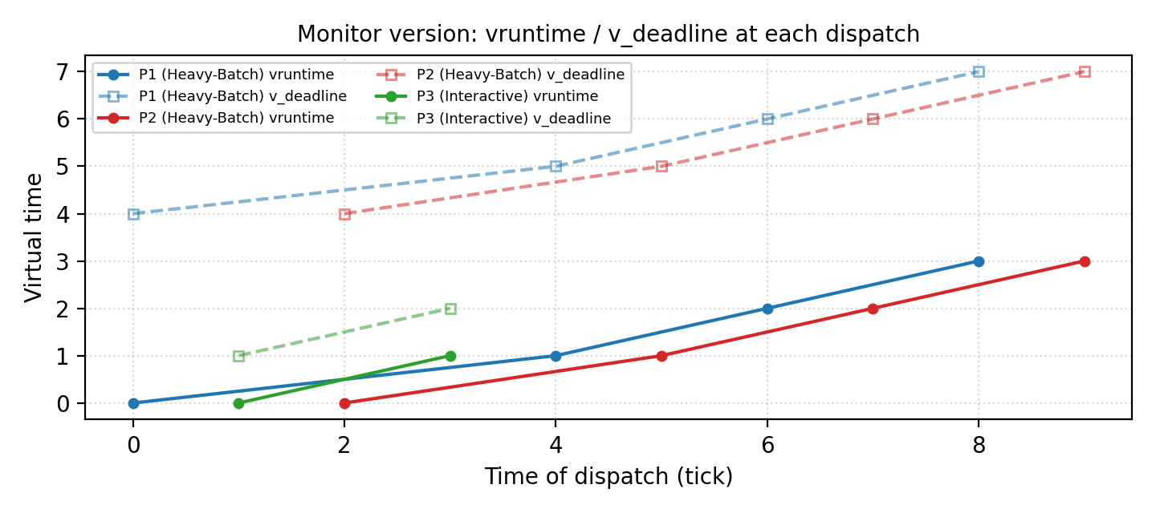
Figure 4 – Evolution of vruntime and v_deadline at Each Process’s Entry into the Monitor
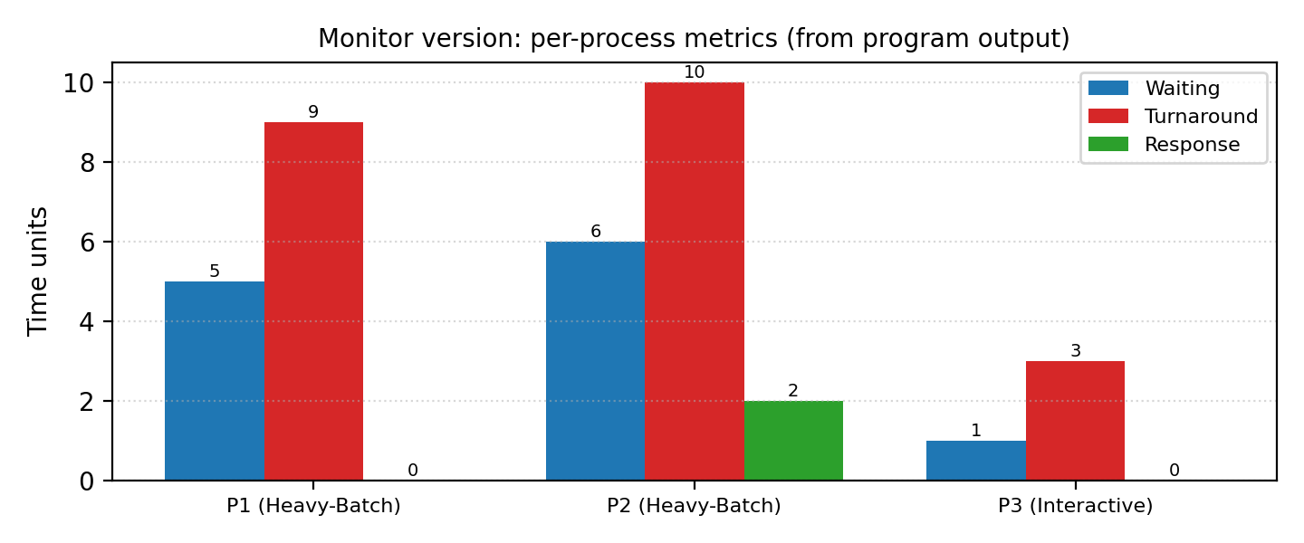
Figure 5 – Comparison of Metrics for Each Process in the Monitor Version

14. Analysis of Simulation Results

14.1 Base Execution Interpretation
The execution order is P1, P3, P2, P3, P1, P2, P1, P2, P1, P2, which is completely identical to the Semaphore version because both share the same selection rule and differ only in their synchronization mechanism. The interactive process P3 executes immediately upon arrival (t = 1, Response = 0) and finishes at t = 4. P2 has the highest waiting time with Waiting = 6.

14.2 Supplementary Experiment: Idle CPU and Late Arrival
The mechanism for advancing the clock during idle periods (a distinctive feature of this version) was tested with a workload of P1 (arrival 0, burst 2) and P2 (arrival 5, burst 2). P1 finished at t = 2, the clock was advanced to t = 5 by the threads (three idle ticks), and P2 entered the Monitor at exactly t = 5.
Table 11 – Idle Experiment Results (Actual Execution)
Process | Arrival | Burst | Completion | Waiting | Response
P1 (Early) | 0 | 2 | 2 | 0 | 0
P2 (Late) | 5 | 2 | 7 | 0 | 0

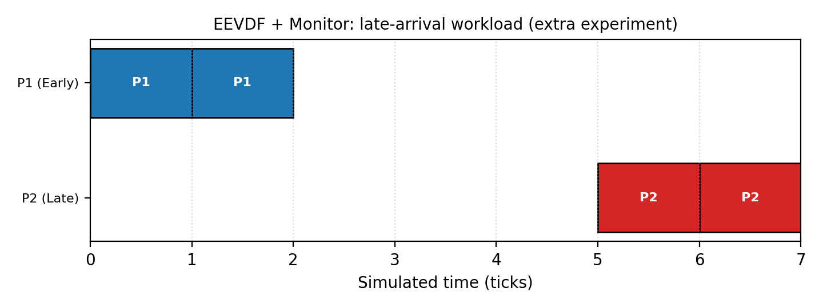
Figure 6 – Gantt Chart of the Late-Arrival Experiment; the Interval t = 2 to 5 Is Idle Time

14.3 Supplementary Experiment: Unequal Weights
With P1 (weight 2, burst 6), P2 (weight 1, burst 6), and P3 (weight 1, burst 3, arrival 2), the results and execution order were completely identical to the Semaphore version: completion at 12, 15, and 9, and CPU share in the first 12 ticks at a 2:1:1 ratio.
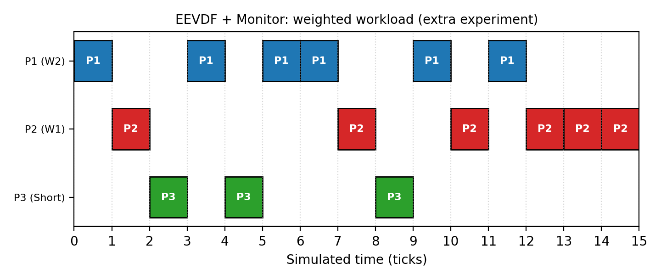
Figure 7 – Gantt Chart of the Unequal-Weights Experiment in the Monitor Version

14.4 Synchronization Behavior
- Based on reading the code, as long as multiple processes are alive, at most one thread is executing and the rest are waiting in condition.wait(); thus, the condition queue is genuinely used (unlike the Semaphore in the previous version, where acquire() never blocks). This behavior was not verified via uninstrumented logs.
- In none of the runs (3 base runs and two supplementary experiments) was deadlock or starvation observed.
- The while + condition re-evaluation pattern prevents spurious wake-ups or CPU stealing by another thread (Mesa semantics).

15. Comparison with RM and EDF Algorithms
In the Monitor version, the scheduling decision is made inside the Monitor; therefore, a real-time scheduler such as RM or EDF could also be implemented within the exact same framework simply by changing the _select_next_eevdf_process rule.
Important Limitation: Files comparing EEVDF against RM and EDF (such as compare_schedulers.py mentioned in the README, and the EEVDF_vs_RM_EDF and RM_EDF_Gantt_Chart folders) were not among the files provided for preparing this document. Therefore, no empirical numbers or charts are reported for RM and EDF, and the comparison below is theoretical and qualitative. If you send those files, a quantitative comparison section will be added.

15.1 Differences in Objectives and Assumptions
EEVDF is a fair, proportional-share CPU scheduler whose task model consists of weighted processes. In contrast, RM and EDF are designed for real-time scheduling of periodic tasks defined by a period, worst-case execution time, and deadline (Ref. [5]). Therefore, a direct “better/worse” comparison without considering this fundamental difference in purpose is unscientific.
Table 12 – Theoretical Comparison of EEVDF with RM and EDF
Criterion | EEVDF | RM | EDF
Primary Objective | Fair CPU share and low latency | Meeting deadlines (real-time) | Meeting deadlines (real-time)
Task Model | Process with weight and slice | Periodic; deadline = period | Periodic or aperiodic; absolute deadline
Priority Type | Dynamic (from weight, vruntime, and virtual deadline) | Static (shorter period = higher priority) | Dynamic (earliest deadline)
Schedulability Condition | No schedulability analysis needed for proportional sharing | U ≤ n(2^(1/n) − 1) is sufficient (≈ 0.693 for large n) | U ≤ 1 (uniprocessor, deadline = period)
Overload Behavior | Proportional reduction of all processes’ shares | Low-priority tasks starve | Domino effect may occur
Fairness | Core design goal | Not guaranteed | Not guaranteed
Hard Deadline Guarantee | None; virtual deadline is an internal concept | Yes (if condition holds) | Yes (if condition holds)
Decision Overhead | O(n) in repository code; balanced tree in Linux | Low (static priority) | Medium (dynamic priority queue)

15.2 Requested Metrics and Code Support
The table below shows which comparison metrics can be extracted from the output of the provided code.
Table 13 – Code Support for Comparison Metrics
Metric | Support in EEVDF Code | Support for RM/EDF
CPU Utilization | Not directly reported; computable from log | No file provided
Completed Tasks Count | Yes (completed_count / final table) | No file provided
Waiting Time | Yes | No file provided
Response Time | Yes | No file provided
Turnaround Time | Yes | No file provided
Deadline Compliance | No; processes do not have deadlines | No file provided
Scheduling Overhead | No; only via separate wall-clock measurement | No file provided
Fairness in CPU Allocation | No; extractable from log | No file provided

16. Advantages and Limitations

16.1 Advantages
- Complete encapsulation of state and procedures in a single object; changing the scheduling rule modifies only one procedure.
- No need for a separate scheduler thread or handshaking Events.
- Idle and late-arrival management exists in the code and worked properly in testing.
- Tie-breaking with (v_deadline, arrival) provides more deterministic behavior than the Semaphore version.

16.2 Limitations
- Computational overhead: after each notify_all, all waiting threads wake up and each executes _select_next_eevdf_process (with O(n log n) complexity); totaling roughly n selections per tick.
- Discrete single-tick simulation with time.sleep; only 3 processes.
- Utilization, fairness, deadline, and overhead metrics are not reported in the code.

16.3 Identified Code Issues and Inconsistencies
Table 14 – List of Identified Issues and Inconsistencies
# | Issue | Description | Origin
1 | Side Effect in Selection Procedure | _select_next_eevdf_process overwrites v_deadline of eligible processes on every call; every woken thread performs this. The logical result does not change, but the design is not clean. | Code inspection
2 | Unused active_thread_id | Assigned and cleared, but never read in any condition. | Code inspection
3 | release_cpu Does Not Check Ownership | Any thread could call release_cpu without proper entry and set cpu_busy to False. | Code inspection
4 | Printing Inside Critical Section | print occurs inside the Monitor and under the lock; I/O inside a lock increases lock hold time. | Code inspection
5 | notify_all for All Waiting Threads | “Thundering Herd” phenomenon; negligible for 3 processes, but not scalable. | Code inspection
6 | Simple Mean Instead of Weighted Mean | Same as Semaphore version; equivalent to theoretical definition when weights are equal. | Code inspection
7 | Recomputing Deadline Every Tick & Starting vruntime from Zero | Same as Semaphore version; slice is not an execution quantum and newly arriving processes have an entry advantage. | Log observation
8 | Tie-Breaking Inconsistency with code.py | This file uses (v_deadline, arrival) whereas code.py uses only v_deadline. | File comparison

17. Conclusion
The file eevdf_monitor.py implements the EEVDF scheduler as a Monitor (Lock + Condition) and reaches the exact same results table as the Semaphore version in the base execution (average Waiting 4.00, Turnaround 7.33, and Response 0.67). The main difference lies in architecture: distributed decision-making, the clock inside the Monitor, and genuine use of the condition queue. Idle management worked properly in the supplementary experiment. The cost of this design is broadcast wake-ups and repeated selection, which is negligible for 3 processes.

18. Scientific References
[1] I. Stoica and H. Abdel-Wahab, “Earliest Eligible Virtual Deadline First: A Flexible and Accurate Mechanism for Proportional Share Resource Allocation,” Technical Report TR-95-22, Old Dominion University, 1995.
[2] I. Stoica, H. Abdel-Wahab, K. Jeffay, S. K. Baruah, J. E. Gehrke, and C. G. Plaxton, “A Proportional Share Resource Allocation Algorithm for Real-Time, Time-Shared Systems,” Proc. 17th IEEE Real-Time Systems Symposium (RTSS), 1996.
[3] J. Corbet, “An EEVDF CPU scheduler for Linux,” LWN.net, 2023.
[4] M. Koutný, “EEVDF is the new (sched_)normal,” SUSE Labs, conference talk (link in repository README).
[5] C. L. Liu and J. W. Layland, “Scheduling Algorithms for Multiprogramming in a Hard-Real-Time Environment,” Journal of the ACM, vol. 20, no. 1, pp. 46–61, 1973.
[6] A. Silberschatz, P. B. Galvin, and G. Gagne, Operating System Concepts, Wiley (multiple editions).
[7] E. W. Dijkstra, “Cooperating Sequential Processes,” EWD123, 1965.
[8] C. A. R. Hoare, “Monitors: An Operating System Structuring Concept,” Communications of the ACM, vol. 17, no. 10, pp. 549–557, 1974.
[9] Python Software Foundation, “threading — Thread-based parallelism” (Semaphore, Condition, Event, Lock), Python 3 documentation.
Note: The bibliographic details above were recorded from the author’s memory and should be verified by the student against the original sources (page numbers, publisher, and exact edition year) for final academic citation.

Appendix A: Execution Environment and Methodology
Table 15 – Execution Environment
Item | Value
Language and Version | Python 3.12.3 (Linux)
Execution Command | python3 eevdf_monitor.py
Base Execution | 3 runs; identical output
Supplementary Execution | Two additional workloads with the exact same classes (without modifying code)

