Exercise 7 — Full Version
Comparing the Readers–Writers Algorithm
with Semaphore, Monitor, Dekker, and Peterson
Comparison table • Figures and flowcharts • Pseudocode • Executable Python code • Exercises with solutions

Operating Systems — Process Synchronization
English version — more than 40 pages
November 2026

Table of Contents

In Microsoft Word, right-click this table of contents and choose “Update Field” to refresh the page numbers after editing.

Abstract
The readers–writers problem is one of the classic synchronization problems: readers may read concurrently, but a writer needs exclusive access. This document compares that problem against four mechanisms: semaphore, monitor, Dekker, and Peterson. Two central points run through the document. First, readers–writers is a problem, not a mechanism — semaphore and monitor are two vehicles for implementing it, while Peterson and Dekker are only the underlying two-process lock of a solution and do not solve the problem on their own. Second, the main difference between the solutions is policy, not mutual exclusion: all three policies (reader priority, writer priority, and fair) satisfy mutual exclusion and progress, but only the fair policy frees both sides from starvation. The document contains a precise statement of the problem, an implementation of each policy with semaphores and with monitors, pseudocode and flowcharts for every mechanism, comprehensive comparison tables, six Python experiments with real output — including a deterministic simulation of writer starvation under reader priority — worked examples, six university exercises with full solutions, real-world applications, and common errors.
Keywords: Keywords:
Readers–writers; semaphore; monitor; Peterson's algorithm; Dekker's algorithm; mutual exclusion; starvation; bounded waiting; fair policy.

1 Introduction and Place of the Exercise
Exercise 7 is exactly row 4 of the professor's table: “Complete comparison of the Dekker, Peterson, semaphore, monitor, readers and writers algorithms”. The same exercise was already delivered as the comprehensive synchronization study (57 pages in English and 56 in Persian) and a focused 16-page supplement was also built. This document is the complete, standalone version of Exercise 7 that satisfies the “at least 40 pages” requirement and contains every requested component: comparison table, figures, flowcharts, pseudocode, executable Python code and real output. Its structure is: Chapter 2 the fundamentals, Chapter 3 the readers–writers problem, Chapters 4 and 5 its implementation with semaphores and monitors, Chapter 6 the role of Peterson and Dekker, Chapter 7 the comparison tables, Chapter 8 the executable code and experiments, Chapters 9 and 10 examples and exercises, Chapter 11 applications and errors, and Chapters 12–14 conclusion, glossary, and references.
Table 1. Mapping of the components of Exercise 7 to the chapters of this document.
Exercise 7 component | In this document | Short description
Problem statement | Chapter 3 | Rules, model, states of the database
Semaphore implementation | Chapter 4 | Reader priority, writer priority, fair
Monitor implementation | Chapter 5 | Condition variable, Hoare vs Mesa
Role of Peterson and Dekker | Chapter 6 | Only as the lock; why that is not enough
Comparison table | Chapter 7 | Master table + three sub-tables
Figures and flowcharts | Chapters 3–7 | 9 numbered figures
Executable code and output | Chapter 8 | Six Python experiments, real output
Exercises with solutions | Chapter 10 | Six university exercises

2 Fundamentals of Synchronization

2.1 Processes, threads, and shared resources
A process is a program in execution with its own address space; a thread is a unit of execution inside a process that shares the process's memory with other threads. Synchronization is needed whenever two or more processes or threads access shared data and at least one of them writes. The shared resource can be a variable, a buffer, a file, a device, or a database record. If all accesses were reads, no coordination would be needed; the danger begins with writing, which another process can observe half-done. In the readers–writers problem, the shared resource is the database, and this very distinction between reading and writing is the heart of the problem: reading is harmless and can be concurrent, writing is dangerous and must be exclusive.

2.2 Race conditions and the critical section
A race condition exists when the outcome of a computation depends on the relative timing of operations in different processes and at least one of the operations is a write to shared data. The classic example is counter = counter + 1: every execution is three machine steps — load, increment, store. If both processes load the old value 5 before either stores, both store 6 and one increment is lost. The part of the code that accesses shared data is called the critical section, and the rest is the remainder section. Every mechanism in this document is a different way of writing the entry and exit sections of that same critical section.
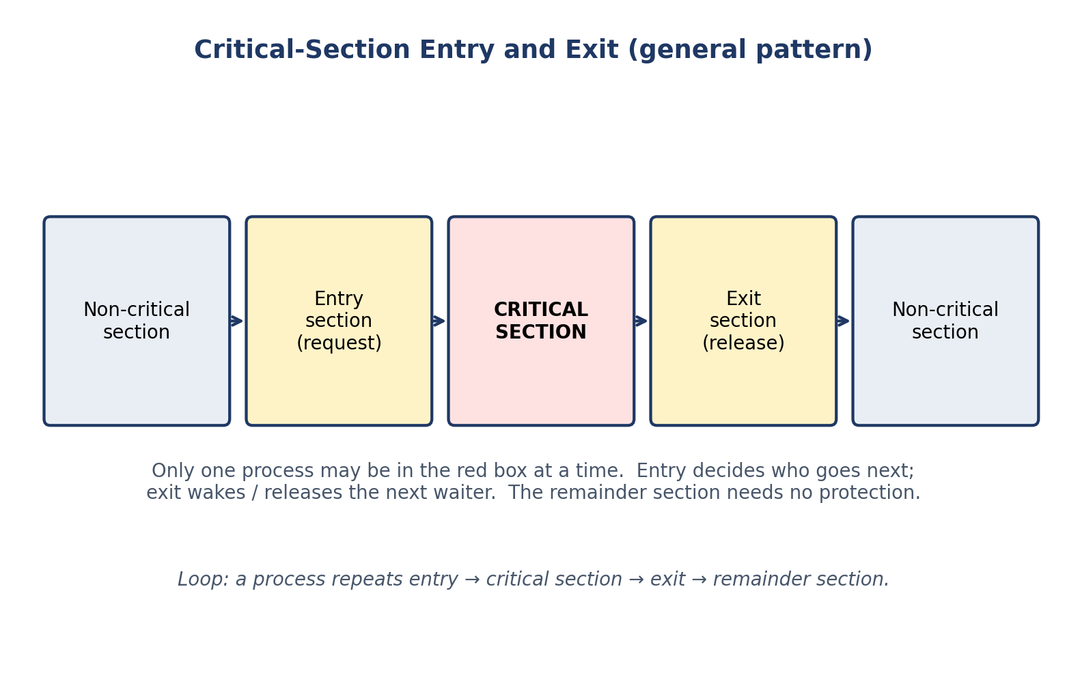
Figure 1. General structure of a process with a critical section: entry section, critical section, exit section, remainder section.

2.3 Correctness properties: mutual exclusion, progress, bounded waiting
Mutual exclusion says at most one process is in the critical section at any time; without it there is no synchronization at all. Progress says that if the critical section is free and someone wants to enter, the decision is made in finite time; this rules out solutions in which everyone politely waits for everyone else forever. Bounded waiting says a requesting process enters after at most a bounded number of overtakings; this is stronger than “eventually enters”. In this document, every claim about these three properties is stated together with its assumptions, because many student mistakes come from attributing the property of one policy to another policy.

2.4 Deadlock, starvation, fairness — do not confuse them
Deadlock means a set of processes each of which waits for an event that only another process in the set can cause; Coffman's four necessary conditions (mutual exclusion, hold and wait, no preemption, and circular wait) hold in it. Starvation means a process waits indefinitely while others make progress; the system is not deadlocked, but one process is overtaken again and again. Fairness means access is distributed in proportion to requests, ideally in arrival order. The chain of implications is: bounded waiting ⇒ starvation freedom ⇒ deadlock freedom, and none of the converses holds. In readers–writers, this distinction is everything: the reader-priority policy is deadlock-free but starves the writer; only the fair policy frees both sides from starvation.
Table 2. Four liveness ideas, distinct from one another.
Property | What it guarantees | What it does not guarantee
Deadlock freedom | The system as a whole never gets stuck with everyone waiting. | That a particular process eventually makes progress.
Starvation freedom | Every requesting process eventually makes progress. | A bound on the number of overtakings before that.
Bounded waiting | A requesting process makes progress after at most B overtakings. | That B is small, or that service is in arrival order.
Fair scheduling | Requests are served (approximately) in arrival order. | Anything by itself; it is usually an assumption about the scheduler.

2.5 Busy waiting versus blocking
A waiting process has two options: busy waiting — re-testing the condition in a loop and consuming CPU — or blocking — asking the operating system to suspend it until the condition may have changed. Peterson and Dekker busy-wait; semaphores and monitors (in the usual implementations) block. Spinning is sensible for a very short wait on a multiprocessor; blocking is essential for a long wait or on a uniprocessor, where a spinning process prevents the process that holds the lock from running. In readers–writers, a writer's wait can be long (until the readers are active), so a blocking mechanism is the natural choice, and this is where semaphores and monitors have a practical advantage over Peterson and Dekker.

3 The Readers–Writers Problem

3.1 Statement of the problem
A shared database is accessed by reader processes, which only read, and writer processes, which read and write. The rules are: (1) any number of readers may read at the same time; (2) a writer needs exclusive access — no reader and no other writer is active; (3) while a writer is active, nobody else may access the database. The problem was first stated by Courtois, Heymans, and Parnas in 1971. Its importance is that it is the first synchronization problem in which concurrency is not itself bad: simultaneous readers are not only allowed, they are desirable, because reading does not change the data. The problem is not to serialize everyone; it is to allow exactly the harmless concurrency and to forbid the dangerous concurrency.

3.2 A model of the shared resource and the states of the database
We model the resource as a single shared datum (an integer in this document's code) protected by the protocols. The database has three states: FREE (nobody active), READING (one or more readers active), and WRITING (one writer active). The allowed transitions are: from FREE to READING (a reader arrives) or to WRITING (a writer arrives), from READING to FREE (the last reader leaves) or to WRITING (only after the last reader leaves), and from WRITING to FREE. The forbidden transitions are: from READING directly to WRITING, and from WRITING to anything but FREE. This state diagram is the correctness criterion for every implementation: if an implementation allows a forbidden transition, it is wrong.
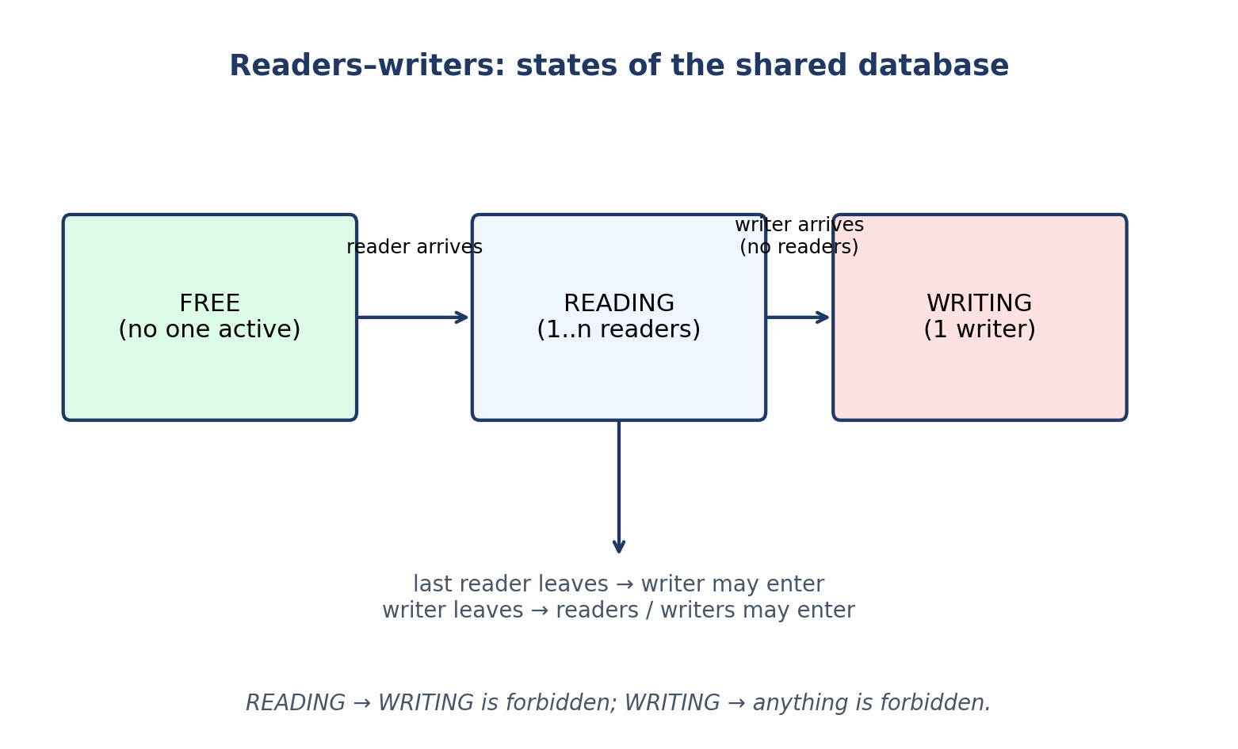
Figure 2. States of the database in the readers–writers problem: FREE, READING, WRITING.
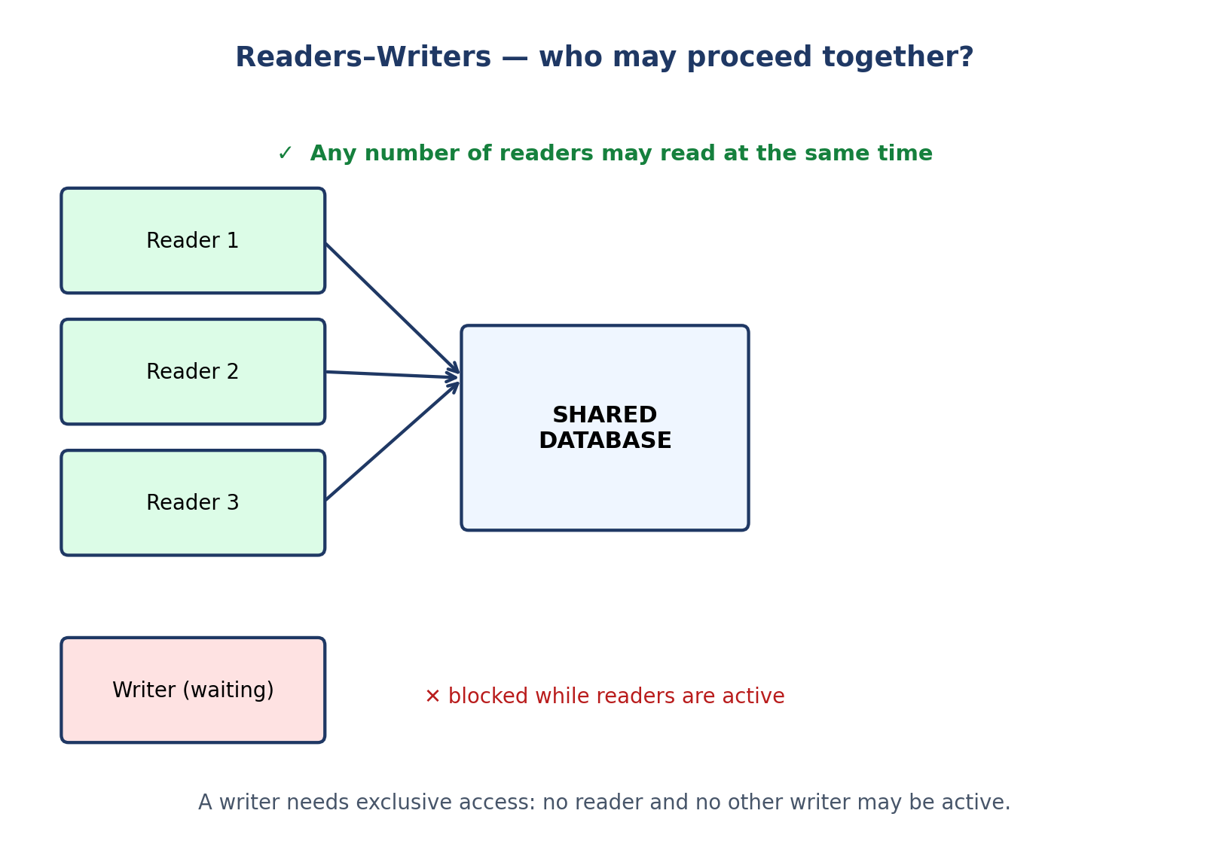
Figure 3. Readers–writers: readers may read concurrently; a writer waits for exclusive access.

3.3 Real examples: library, database, file system
- Library: readers read books and can be in the hall at the same time; a writer (an editor) needs the book alone to revise it. If the editor is waiting and new readers keep coming, the editor never gets the book — the same starvation as reader priority.
- Database: read transactions (SELECT) run concurrently; a write transaction (UPDATE) takes an exclusive lock. Lock managers explicitly choose the reader/writer priority policy.
- File system: several processes can read a file at the same time; a process that wants to write must wait until all readers finish. Read/write locks in the operating system (such as pthread_rwlock_t) are exactly this protocol.
- Cache: reading from a cache is very common and writing is rare; reader priority is usually acceptable here, because an occasional delay of the writer does not matter — but if a cache update is vital, the policy must become fair.

3.4 Why is the problem hard? Counting and policy
The difficulty of the problem has two parts. The first part is counting: we must know how many readers are active in order to know when the “last reader” leaves; this counter (readCount) is itself shared data and must be protected by mutual exclusion. The second part is policy: when both a reader and a writer are waiting, who goes first? The answer “whoever arrived first” sounds simple, but implementing it needs a mechanism that remembers the arrival order — the gate in the fair solution. Without the gate, a semaphore does not by itself preserve arrival order, and the policy silently becomes “reader priority”, even if the programmer intended something else. This is a point many student implementations miss: the default policy is not the chosen policy.

4 Implementation with Semaphores

4.1 What is a semaphore?
A semaphore, introduced by Dijkstra in the 1960s, is an integer variable that can be accessed only through two atomic operations: wait (also called P, from Dutch Proberen) and signal (also called V, from Verhogen). A binary semaphore (initial value 1) is used for mutual exclusion, and a counting semaphore (initial value N) for counting N identical resources. Both operations are atomic: the decrement (or increment) and the decision to block (or to wake) happen in one indivisible step. A waiting process does not spin; it blocks and is removed from the run queue until it is woken.
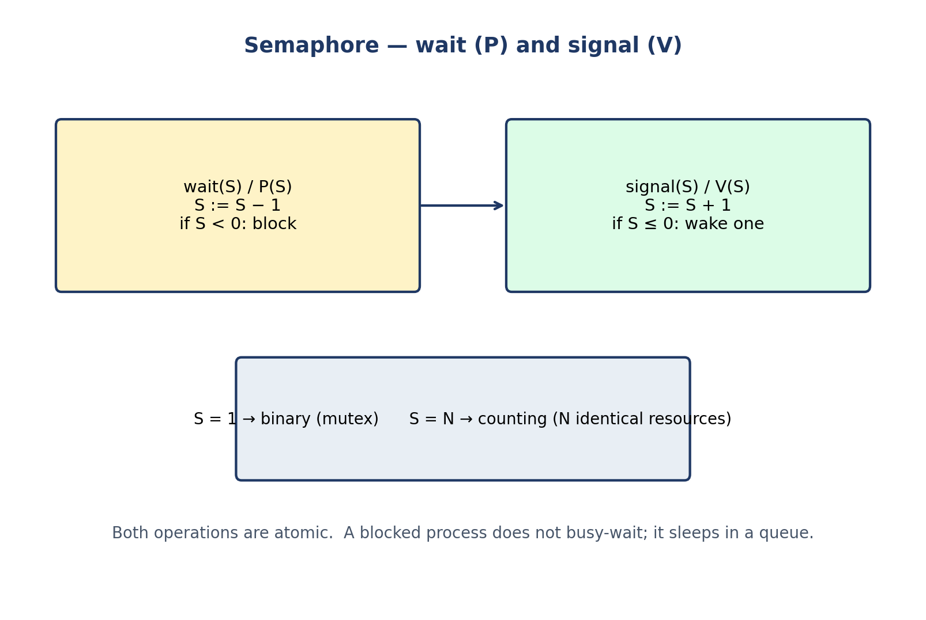
Figure 4. Semaphore: the wait (P) and signal (V) operations; binary versus counting use.

4.2 The reader-priority solution
Pseudocode 1. Readers–writers with reader priority (semaphores).
shared semaphore mutex = 1, wrt = 1;
shared int readCount = 0;

reader:
wait(mutex);
readCount = readCount + 1;
if (readCount == 1) wait(wrt); // first reader locks writers out
signal(mutex);
... read the database ...
wait(mutex);
readCount = readCount - 1;
if (readCount == 0) signal(wrt); // last reader lets writers in
signal(mutex);
writer:
wait(wrt);
... write the database ...
signal(wrt);

Why does it work? wrt is held from the first reader to the last reader, so a writer enters only when no reader is active; and readers do not need wrt among themselves, so they read together. Why is it unfair? As long as at least one reader is active, newly arriving readers keep readCount above zero and the writer never sees readCount == 0. A continuous stream of readers starves the writer indefinitely, even though the system is not deadlocked. This is exactly what Experiment D in Chapter 8 shows deterministically: readers arrive every 10 ms and each reads for 20 ms, so at least one reader is always active and the writer never starts in 200 ms.
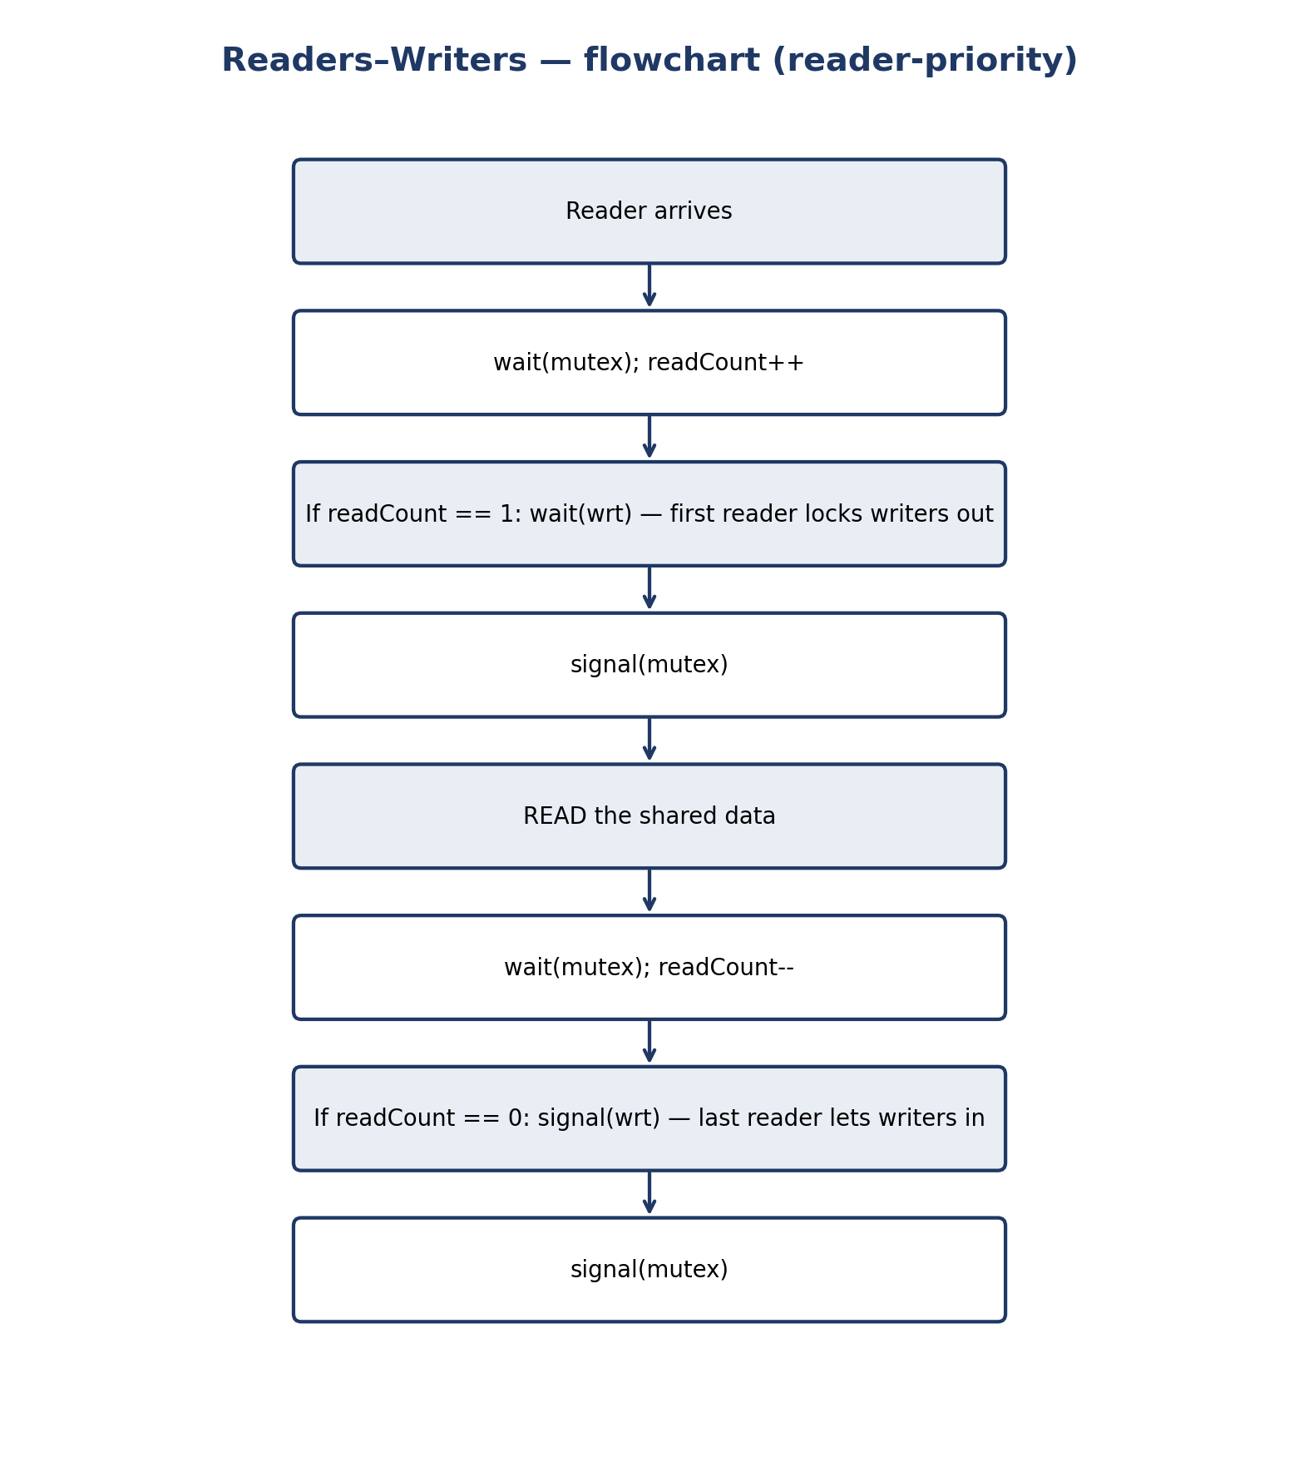
Figure 5. Reader flowchart with reader priority: the first reader locks writers out, the last reader lets them in.

4.3 The writer-priority solution
Writer priority adds a semaphore (usually readTry) and writeCount, which block new readers as soon as a writer is waiting: a reader must pass readTry before reaching the readCount logic, and a writer holds readTry while waiting for wrt, so readers arriving after the writer queue behind it. The existing readers finish, the writer enters, and later readers proceed after it. The trade-off is the mirror image of reader priority: now writers have the advantage, and a continuous stream of writers can starve readers. The textbook pseudocode (Silberschatz et al., §7.4) is: semaphores mutex = 1, wrt = 1, readTry = 1; integers readCount = 0 and writeCount = 0; a reader waits on readTry and then follows the usual first-reader logic; a writer increments writeCount under mutex, the first writer waits on readTry (blocking new readers) and then on wrt, writes, and the last writer signals readTry. This solution is correct when writes are rare but urgent — for example a configuration update that must not wait behind a queue of readers.

4.4 The fair solution (turnstile)
The fair solution serves requests (approximately) in arrival order. Its tool is a third semaphore, the gate (turnstile): every arriving process, reader or writer, must pass the gate, and a waiting writer holds the gate closed, so readers arriving after it cannot overtake it; conversely, readers that arrived earlier hold no gate and finish in order. No process starves, because each request's place in the arrival order is bounded — at most one “round” of earlier arrivals is ahead of it. Fairness costs one extra semaphore and sometimes a little lost reader parallelism (readers arriving just after a writer must wait behind it even though they could have read safely), which is the fundamental trade-off of this problem: maximum reader parallelism and writer responsiveness cannot both be maximized under a starvation-free policy.
Pseudocode 2. Fair readers–writers with a turnstile (semaphores).
shared semaphore gate = 1, wrt = 1, mutex = 1;
shared int readCount = 0;

reader:
wait(gate); signal(gate); // pass the turnstile
wait(mutex);
readCount = readCount + 1;
if (readCount == 1) wait(wrt);
signal(mutex);
... read ...
wait(mutex);
readCount = readCount - 1;
if (readCount == 0) signal(wrt);
signal(mutex);
writer:
wait(gate); // hold the gate while waiting
wait(wrt);
... write ...
signal(wrt);
signal(gate);

4.5 Advantages and disadvantages of the semaphore implementation
- Advantages: general and flexible; all three policies are built with the same tool; it blocks and does not waste CPU; it works for any number of processes.
- Disadvantages: easy to misuse — a forgotten signal deadlocks everyone and a wrong order of waits builds a deadlock; the policy is hidden in the order of waits and is hard to understand from reading the code; starvation freedom depends on queue discipline, and POSIX does not guarantee FIFO order.
- Common mistake: taking the buffer mutex before waiting on a condition, or forgetting signal(wrt) on the last-reader path; both lead to deadlock and are hard to see by inspecting the code.

5 Implementation with Monitors

5.1 What is a monitor?
A monitor, proposed by Per Brinch Hansen and C. A. R. Hoare in the early 1970s, is a high-level synchronization mechanism: it binds the shared data together with the procedures that operate on it inside a module. Only the monitor's own procedures can touch its data, and at most one process can be executing inside the monitor at any time. The compiler (or runtime) enforces mutual exclusion; the programmer no longer places wait and signal calls around the data by hand, so the pairing errors that plague semaphores become structurally impossible.
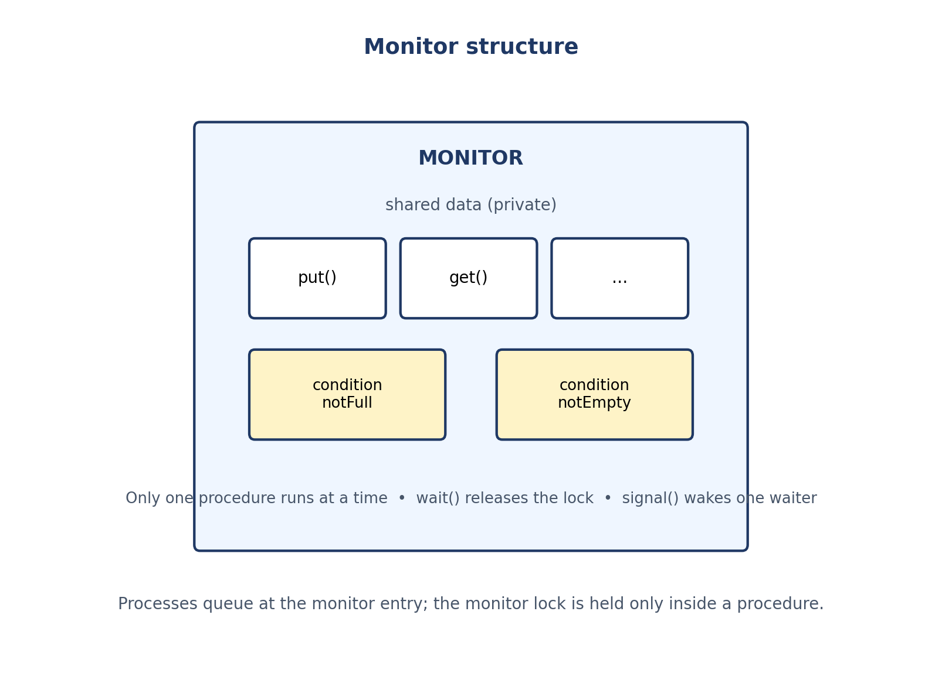
Figure 6. Monitor structure: private shared data, procedures with automatic mutual exclusion, and condition variables.

5.2 Condition variables: wait and signal
- A condition variable is not a Boolean and has no value; it is a queue of waiting processes, with wait and signal operations.
- wait(c): the calling process releases the monitor lock, suspends itself on queue c, and — when woken — re-acquires the lock before continuing. Releasing the lock is essential: otherwise no other process could enter and change the condition.
- signal(c): wakes one waiting process on c (if there is one). If no process is waiting, the signal has no effect and is not remembered — unlike a semaphore signal, which increments the counter. This “no memory” property is the classic exam trap.
- broadcast / signalAll: wakes all waiters; needed when a change may satisfy several waiters.

5.3 The readers–writers monitor: one monitor, three policies
Pseudocode 3. Readers–writers monitor (the policy is set by the condition in startRead).
monitor ReadersWriters:
int activeReaders = 0, activeWriters = 0;
int waitingReaders = 0, waitingWriters = 0;
condition canRead, canWrite;
procedure startRead():
waitingReaders++;
while (activeWriters > 0 or
(FAIR and waitingWriters > 0)): wait(canRead);
waitingReaders--; activeReaders++;
procedure endRead():
activeReaders--;
if (activeReaders == 0) signal(canWrite);
procedure startWrite():
waitingWriters++;
while (activeReaders > 0 or activeWriters > 0): wait(canWrite);
waitingWriters--; activeWriters = 1;
procedure endWrite():
activeWriters = 0;
if (waitingWriters > 0) signal(canWrite);
else signal(canRead); // or broadcast, for all waiting readers

Setting FAIR to false gives reader priority; keeping the waitingWriters clause in it gives the fair policy; writer priority is obtained by having startWrite signal writers first and startRead wait while waitingWriters > 0. One monitor, three policies — another reason monitors are a clearer vehicle than semaphores for experimenting with policy: the policy is written in the waiting condition and can be understood from reading the code, rather than being hidden in the order of waits.

5.4 Hoare versus Mesa
Table 3. Hoare versus Mesa monitor semantics. All code in this document uses Mesa (POSIX) semantics.
Aspect | Hoare semantics | Mesa semantics
Who runs after signal | The signalled process runs immediately; the signaller waits. | The signaller continues; the signalled process is scheduled later.
Condition on waking | Guaranteed true. | Not guaranteed: another process may run first and change it.
Waiting test | (In theory) if is enough. | while (re-test) is mandatory.
Used in | Hoare's early monitors; some textbook presentations. | Java (wait/notify), POSIX condition variables, most modern systems.

All code in this document uses Mesa semantics, because POSIX condition variables and Java both have them. That is why every wait in this document's monitor code is inside a while loop: a woken process must re-test the condition, because another writer may have entered first, or a spurious wakeup may have occurred. Writing if instead of while is one of the most common monitor bugs, and it is examined in Exercise 3 of Chapter 10.
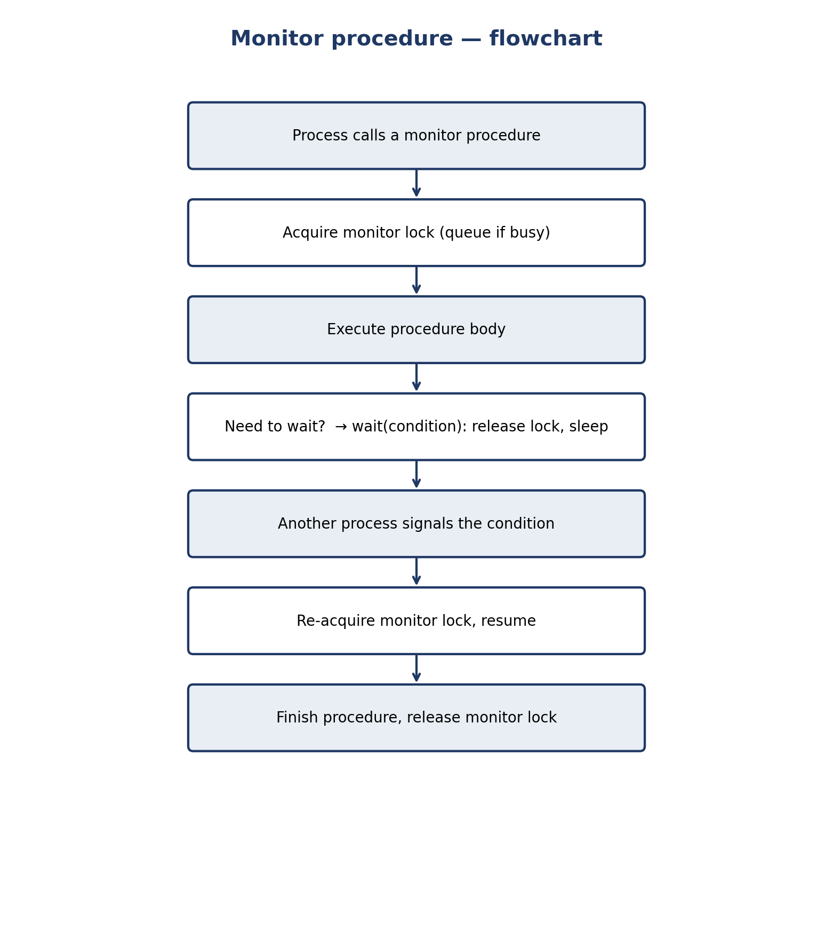
Figure 7. Flowchart of a monitor procedure call, including wait and signal.

5.5 Advantages and disadvantages of the monitor implementation
- Advantages: mutual exclusion is automatic; data and its protection live together; condition variables express “wait until X” directly; the policy is readable in the waiting condition; pairing errors are far rarer than with semaphores.
- Disadvantages: needs language or library support (C and Python have no native monitor and must build it from a mutex and a condition variable); a signal with no waiter is lost; a long procedure holds the monitor lock and blocks everyone.

6 Peterson and Dekker: Only a Lock, Not a Solution

6.1 Peterson's algorithm
Gary Peterson published in 1981 the simplest purely software solution for two processes. Only two shared variables are needed: the flag array and turn.
Pseudocode 4. Peterson's algorithm for process Pi.
shared boolean flag[2] = {false, false};
shared int turn;

process Pi (i = 0 or 1, j = 1 - i):
flag[i] = true; // I want to enter
turn = j; // you go first
while (flag[j] == true and turn == j):
; // busy wait
// ---- critical section ----
... access shared data ...
flag[i] = false;

Short proof: both cannot be in the critical section at once, because that would require turn to be both 0 and 1. Progress and bounded waiting (bound 1 overtake) hold. But Peterson only gives mutual exclusion: it has no reader counter, no policy, and no blocking wait. For readers–writers, Peterson can only play the role of mutex — for example replacing the semaphore mutex in Pseudocode 1 with a Peterson lock — and only for two processes (one reader and one writer).
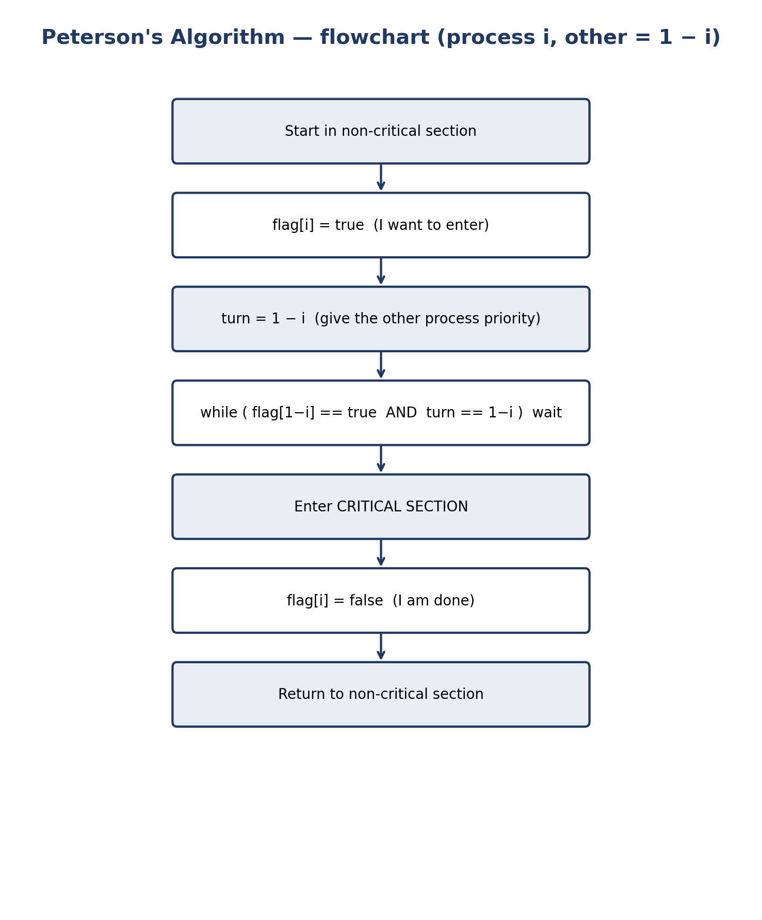
Figure 8. Flowchart of Peterson's algorithm for process Pi — it builds only a lock, not a readers–writers policy.
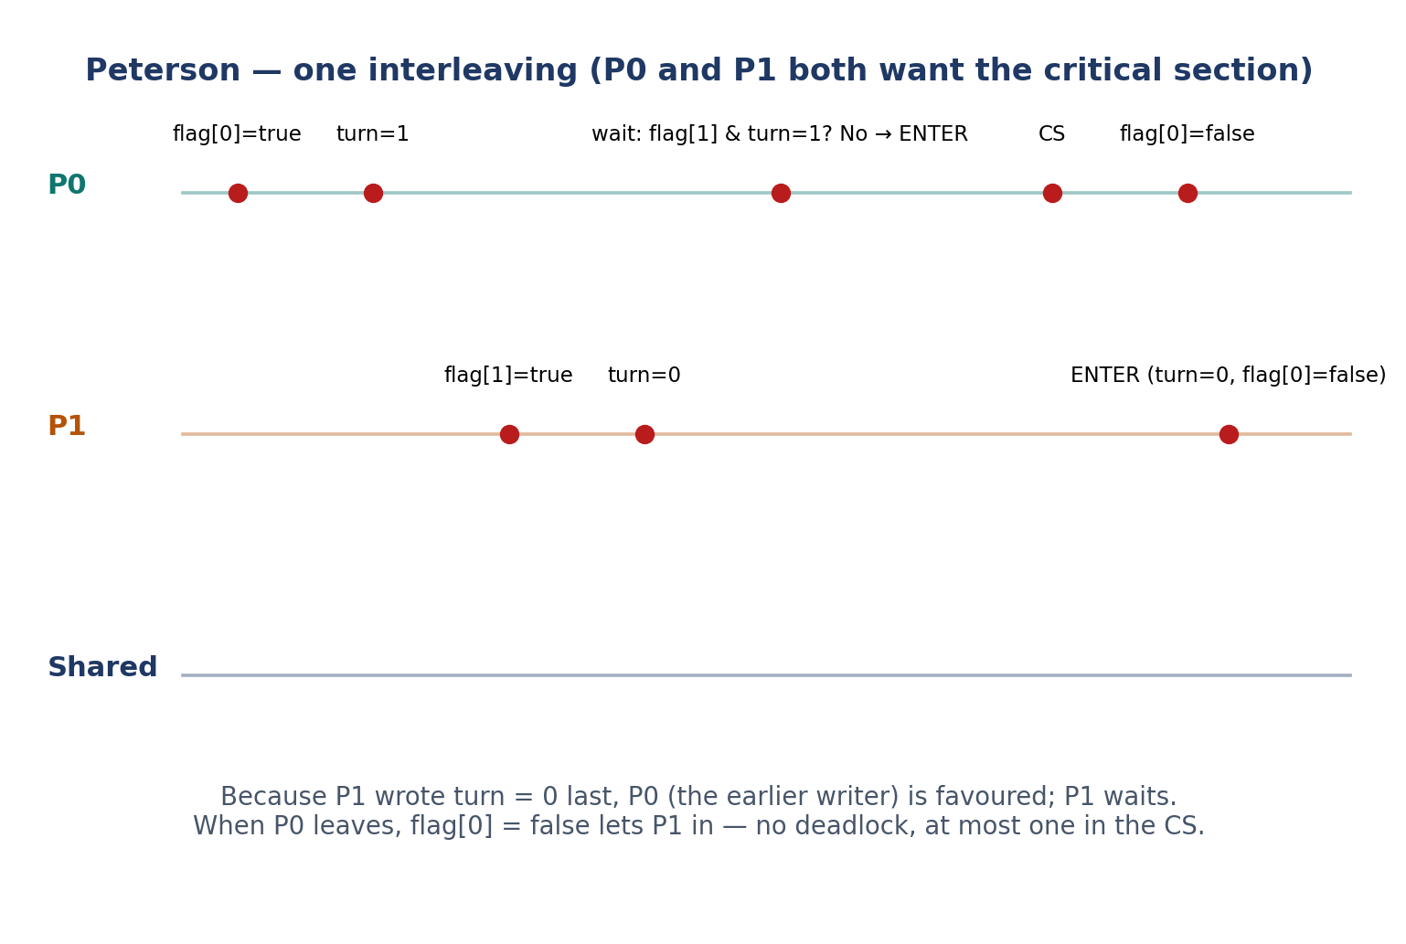
Figure 9. Peterson: a step-by-step interleaving in which P0 enters first and P1 waits.

6.2 Dekker's algorithm
Th. J. Dekker published in 1965 the first correct purely software solution to the two-process mutual-exclusion problem. A waiting process must explicitly back off: lower its own flag, wait until turn changes, and then raise its flag again.
Pseudocode 5. Dekker's algorithm for process Pi.
shared boolean flag[2] = {false, false};
shared int turn = 0;

process Pi (i = 0 or 1, j = 1 - i):
flag[i] = true;
while (flag[j] == true):
if (turn != i):
flag[i] = false; // temporary back-off
while (turn != i):
; // wait for my turn
flag[i] = true; // try again
// ---- critical section ----
... access shared data ...
turn = j;
flag[i] = false;

The back-off is not an optimization; without it, if both set their flags before testing the other's, both spin forever (deadlock). Dekker satisfies all three properties, but its proof is longer and its back-off more fragile. Both algorithms assume that reads and writes of flag and turn are atomic and sequential; on modern hardware, plain variables do not give that guarantee, and atomic variables (in C11, _Atomic) or a mutex must be used. The same warning holds in Python: this document's Python versions are teaching demos only, and in CPython they work reliably in practice because of the GIL, but Python gives no memory-ordering guarantee.
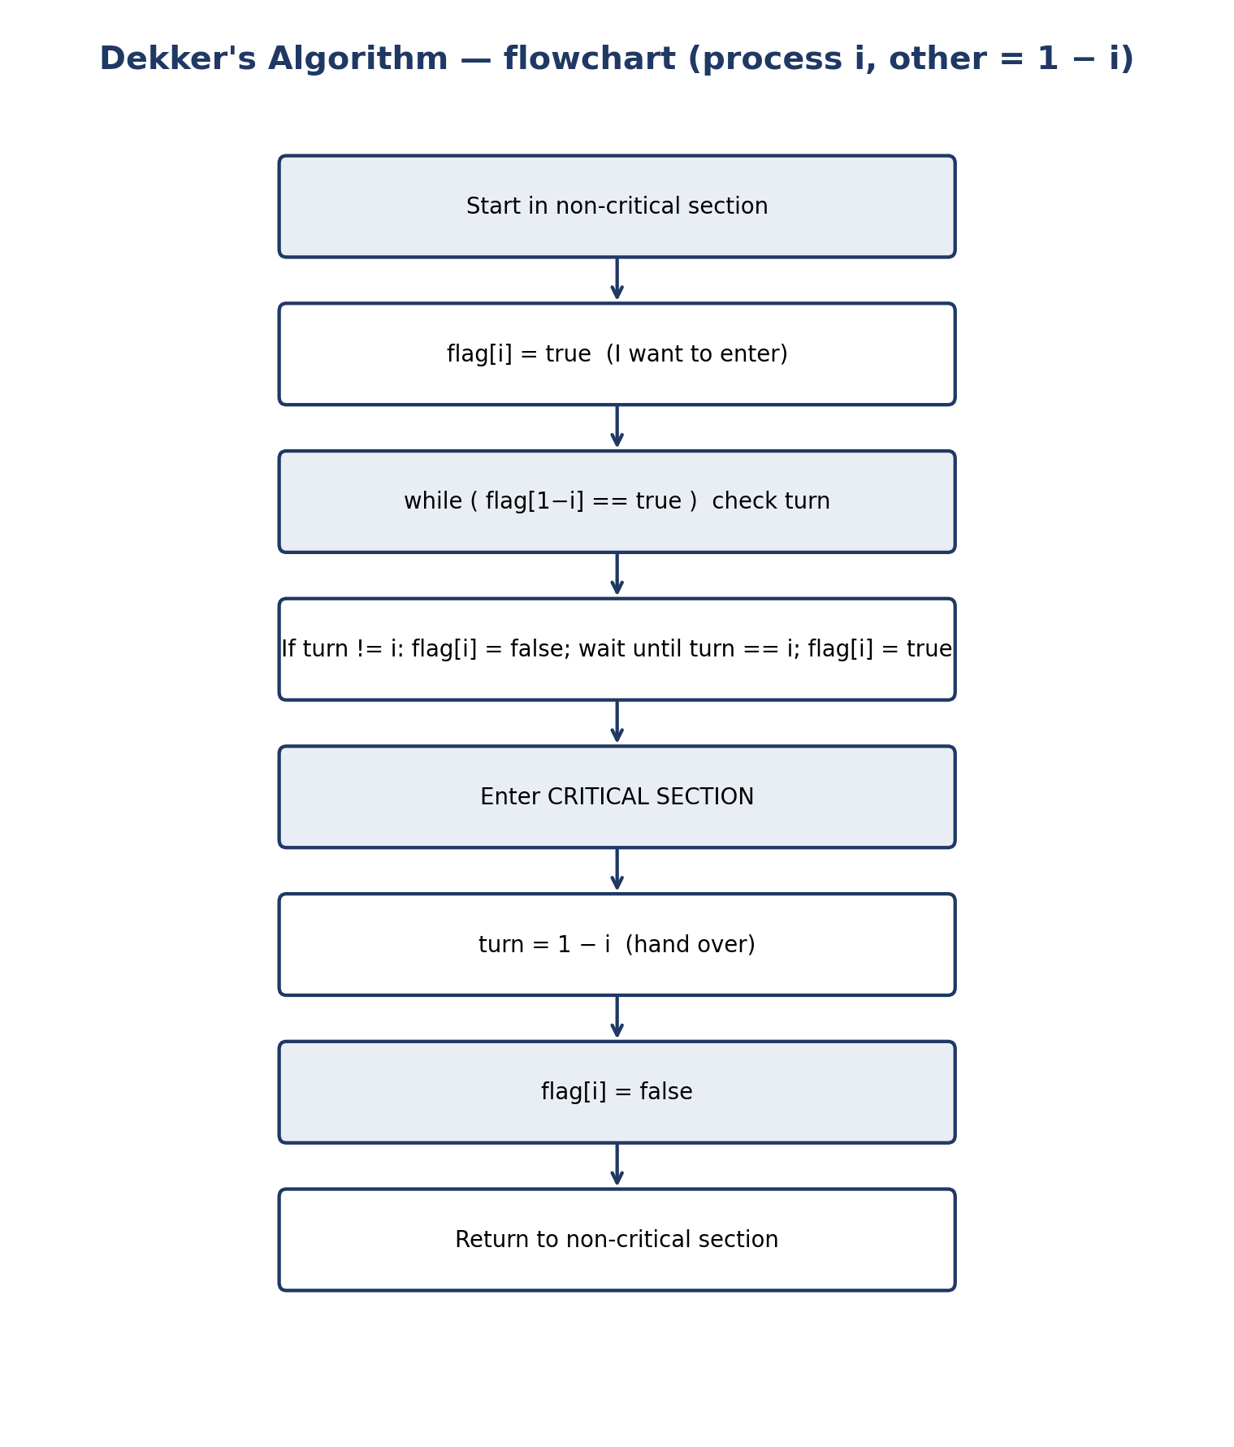
Figure 10. Flowchart of Dekker's algorithm for process Pi, with explicit back-off.

6.3 Why Peterson and Dekker alone do not solve the problem
Two processes (one reader and one writer) synchronized only by Peterson's algorithm: the reader reads in its critical section and the writer writes in its critical section. That is only mutual exclusion: the reader and the writer are never in the critical section at the same time, so simultaneous reading — the heart of the problem — is lost and readers are serialized too. What is missing is the readCount counter and the “first/last reader” logic. Peterson can be the underlying lock of that logic (Experiment E in Chapter 8), but it is not the logic itself. In other words, with Peterson you can build a mutex, not the readers–writers problem. The same argument holds for Dekker, except that Dekker builds a lock with back-off instead of a simple lock — but it is still a lock, not a policy.
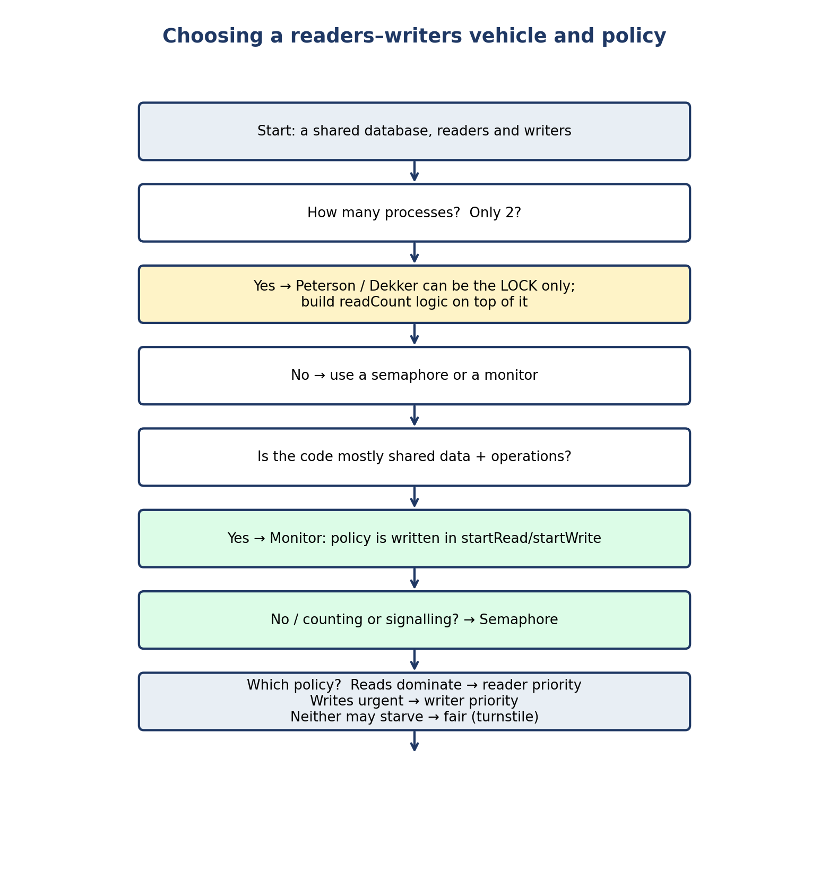
Figure 11. Decision flowchart: which vehicle and which policy should be chosen for readers–writers?

7 Comprehensive Comparison Tables
This chapter is the core of the document. Remember two points: first, the six topics of the comprehensive study are not of one kind — readers–writers is a problem, semaphore and monitor are mechanisms, and Peterson and Dekker are algorithms — and a property such as “deadlock-free” means something different for a mechanism than for a complete algorithm. Second, no property below is answered with a dry “yes” or “no” where the correct answer depends on the implementation, the assumptions, or the fairness of the scheduler.
Table 4. Master table: the readers–writers problem against the four mechanisms. “Yes” for a mechanism means “yes when used as it should be”.
Property | Readers–writers (problem) | Semaphore (vehicle) | Monitor (vehicle) | Peterson | Dekker
Kind | Coordination problem | General OS mechanism | Language mechanism | Complete algorithm, 2 processes | Complete algorithm, 2 processes
Number of processes | Any number | Any number | Any number | Exactly 2 | Exactly 2
Mutual exclusion | Yes, in every policy (wrt is exclusive) | Yes, with a correctly used binary semaphore | Yes, automatic | Yes, proved (under sequential memory) | Yes, proved (under sequential memory)
Progress | Yes, in every policy | Yes, if used correctly | Yes, if used correctly | Yes | Yes
Bounded waiting | Reader priority: no for writers; fair: yes for both | No by itself; depends on queue discipline | No by itself; depends on queue discipline | Yes, bound = 1 overtake | Yes, bound = 1 overtake
Deadlock freedom | Yes, in the standard policies | No guarantee; a program can deadlock | No general guarantee; a correct single monitor is free | Yes | Yes
Starvation freedom | Reader priority: a writer may starve; fair: neither | Only with a fair (FIFO) queue; POSIX does not guarantee it | Only with a fair queue discipline | Yes (follows from bounded waiting) | Yes
Busy waiting | No, if built with blocking semaphores/monitors | No; it blocks | No; it blocks | Yes; it spins in the while test | Yes; it spins in two nested loops
Simultaneous reading | Yes — the heart of the problem | Yes, with the readCount counter | Yes, with the activeReaders counter | No; it gives only mutual exclusion | No; it gives only mutual exclusion
Policy (priority) | Is the problem itself: reader / writer / fair | Must be built explicitly (gate, ...) | Chosen by the condition in startRead/startWrite | None; only turn | None; only turn
Complexity | Medium; one counter + two semaphores | Low conceptually; high in correct use | Medium; the compiler helps | Low; 4 lines, short proof | Medium; back-off loop, longer proof
Implementation requirements | A semaphore or a monitor | Atomic wait/signal + wait queue | Language support for lock + condition variable | Shared memory + atomic, sequential access | As Peterson
Main limitation | No single best policy exists | Easy to misuse; a forgotten signal deadlocks | No native support in C; a signal with no waiter is lost | 2 processes; busy waiting; memory-model dependent | As Peterson, plus fragile back-off

7.1 Readers–writers policies
Table 5. Readers–writers policies: the trade-offs.
Policy | Who can starve | Reader parallelism | Writer delay | When to use it
Reader priority | Writers | Maximum | High under read load | Reading dominates and occasional writer delay is tolerable (e.g. a mostly-read cache).
Writer priority | Readers | Reduced while writers wait | Low | Writes are rare but urgent (e.g. a configuration update).
Fair (turnstile) | Nobody | Slightly reduced | Bounded | Both sides matter, or correctness needs starvation freedom.

7.2 Peterson versus Dekker
Table 6. Peterson versus Dekker.
Aspect | Peterson (1981) | Dekker (1965)
Shared variables | flag[2], turn | flag[2], turn (the same)
Entry test | Single while: flag[j] and turn == j | Outer while on flag[j] + inner while on turn, with back-off
Back-off | Not needed | Explicit: lower flag, wait for the turn, raise it again
Bounded waiting | Yes, bound 1 | Yes, bound 1
For readers–writers | Only as the lock, for 2 processes | Only as the lock, for 2 processes
Which is better? | Simpler, shorter proof; use Peterson to explain the idea | The first historical solution; its importance is historical

7.3 Semaphore versus monitor
Table 7. Semaphore versus monitor for readers–writers.
Aspect | Semaphore | Monitor
Level | Low-level OS/library mechanism | High-level language mechanism
Mutual exclusion | The programmer's job: pairing wait/signal | Automatic: one procedure at a time
Waiting | wait on a semaphore | wait on a condition variable (releases the lock)
Signal | Remembered (the counter increases) | Lost if nobody is waiting
Typical bug | Forgotten signal → deadlock | if instead of while after wait → lost condition
Reading the policy from the code | Hard; the policy is hidden in the order of waits | Clear; the policy is written in the condition of startRead/startWrite
Support in Python | threading.Semaphore | Not native; built from Lock + Condition

7.4 What the tables do not say
- “Yes” for mutual exclusion does not mean usable everywhere: Peterson's yes holds for two processes under sequential memory and says nothing about a hundred threads on a machine with weak memory.
- Deadlock freedom of a mechanism is the wrong question: a mechanism by itself cannot deadlock; only a program written with it can. So the table asks whether the mechanism helps or hinders writing a deadlock-free program.
- Performance is deliberately absent from the tables: relative speed depends on contention, wait length, and hardware, and a small benchmark on one machine proves nothing general. The qualitative guide — spin for a short wait, block for a long wait — is in Section 2.5.

8 Executable Code (Python) and Experiments
The file rw_ex7_demo.py contains six experiments that run the same workload (3 readers and 2 writers, 5 rounds each) with different vehicles. Experiment A is the fair semaphore, Experiment B the fair monitor, Experiment C the reader-priority semaphore, Experiment D a deterministic starvation simulation, Experiment E the Peterson lock, and Experiment F the Dekker lock. The program was run three times and gave the same output all three times (the order of printed lines in the thread-based experiments varies from run to run; the final value is stable).
Listing 1. rw_ex7_demo.py — six experiments, one workload.
#!/usr/bin/env python3
# -*- coding: utf-8 -*-
"""rw_ex7_demo.py — Exercise 7 (full version): Readers-Writers compared
with Semaphore, Monitor, Dekker, and Peterson.

Run: python3 rw_ex7_demo.py

Experiments (same workload everywhere it applies):
A. Semaphore, fair (turnstile): 3 readers + 2 writers, 5 rounds each.
B. Monitor, fair (Condition): same workload.
C. Semaphore, reader priority: same workload (final value still 10,
but the writer can be overtaken).
D. Starvation, deterministic simulation: readers arrive every 10 ms
and each reads for 20 ms, so at least one reader is always active.
Under reader priority the writer NEVER gets in; under the fair
policy it writes as soon as the earlier readers finish.
E. Peterson as a plain mutex lock (2 threads only: 1 reader + 1 writer):
gives mutual exclusion only, not a readers-writers policy.
F. Dekker as a plain mutex lock (same as E, with Dekker's back-off).

No extra libraries are needed — only the Python standard library.
"""
import threading
import time

# ---------------------------------------------------------------- A: semaphore, fair
def run_semaphore_fair():
gate = threading.Semaphore(1); wrt = threading.Semaphore(1)
mutex = threading.Semaphore(1); rc = [0]; data = [0]
def reader(i):
for _ in range(5):
gate.acquire(); gate.release()
mutex.acquire(); rc[0] += 1
if rc[0] == 1: wrt.acquire()
mutex.release()
time.sleep(0.001)
mutex.acquire(); rc[0] -= 1
if rc[0] == 0: wrt.release()
mutex.release()
def writer(i):
for _ in range(5):
gate.acquire(); wrt.acquire(); data[0] += 1; wrt.release(); gate.release()
time.sleep(0.001)
ts = [threading.Thread(target=reader, args=(i,)) for i in range(3)] + \
[threading.Thread(target=writer, args=(i,)) for i in range(2)]
for t in ts: t.start()
for t in ts: t.join()
print(f"[A semaphore-fair] final data = {data[0]} (expected 10)")

# ---------------------------------------------------------------- B: monitor, fair
class RWMonitor:
def __init__(self):
self.lock = threading.Lock()
self.can_read = threading.Condition(self.lock)
self.can_write = threading.Condition(self.lock)
self.active_r = 0; self.active_w = 0
self.waiting_w = 0; self.data = 0
def start_read(self):
with self.lock:
while self.active_w > 0 or self.waiting_w > 0:
self.can_read.wait()
self.active_r += 1
def end_read(self):
with self.lock:
self.active_r -= 1
if self.active_r == 0: self.can_write.notify()
def start_write(self):
with self.lock:
self.waiting_w += 1
while self.active_r > 0 or self.active_w > 0:
self.can_write.wait()
self.waiting_w -= 1; self.active_w = 1
def end_write(self):
with self.lock:
self.active_w = 0
if self.waiting_w > 0: self.can_write.notify()
else: self.can_read.notify_all()

def run_monitor_fair():
m = RWMonitor()
def reader(i):
for _ in range(5):
m.start_read(); time.sleep(0.001); m.end_read()
def writer(i):
for _ in range(5):
m.start_write(); m.data += 1; m.end_write(); time.sleep(0.001)
ts = [threading.Thread(target=reader, args=(i,)) for i in range(3)] + \
[threading.Thread(target=writer, args=(i,)) for i in range(2)]
for t in ts: t.start()
for t in ts: t.join()
print(f"[B monitor-fair] final data = {m.data} (expected 10)")

# ---------------------------------------------------------------- C: semaphore, reader priority
def run_semaphore_reader_priority():
wrt = threading.Semaphore(1); mutex = threading.Semaphore(1)
rc = [0]; data = [0]
def reader(i):
for _ in range(5):
mutex.acquire(); rc[0] += 1
if rc[0] == 1: wrt.acquire()
mutex.release()
time.sleep(0.001)
mutex.acquire(); rc[0] -= 1
if rc[0] == 0: wrt.release()
mutex.release()
def writer(i):
for _ in range(5):
wrt.acquire(); data[0] += 1; wrt.release(); time.sleep(0.001)
ts = [threading.Thread(target=reader, args=(i,)) for i in range(3)] + \
[threading.Thread(target=writer, args=(i,)) for i in range(2)]
for t in ts: t.start()
for t in ts: t.join()
print(f"[C semaphore-reader-priority] final data = {data[0]} (expected 10)")

# ---------------------------------------------------------------- D: starvation simulation (deterministic)
def simulate_starvation():
"""Discrete-event simulation, 1 ms steps, 200 ms horizon.
Readers arrive at t = 0, 10, 20, ..., each reads for 20 ms.
One writer arrives at t = 5 and needs the database alone.
Reader priority: a new reader may start whenever a reader is
active, so the writer never sees read_count == 0.
Fair policy: a reader arriving after the writer queues behind it.
"""
print("[D starvation simulation] readers arrive every 10 ms, "
"each reads 20 ms; writer arrives at t = 5 ms.")
horizon = 200
# reader priority: active readers = arrivals in (t-20, t]
def active_readers(t):
return sum(1 for a in range(0, horizon, 10) if a <= t < a + 20)
writer_start_rp = None
for t in range(horizon):
if t >= 5 and active_readers(t) == 0:
writer_start_rp = t; break
if writer_start_rp is None:
print(" reader priority: writer NEVER starts in 200 ms — starved")
else:
print(f" reader priority: writer starts at t = {writer_start_rp} ms")
# fair: writer starts when the readers that arrived before it finish.
# Readers arriving at 0 finish at 20; the writer (arrived at 5) is
# next in line, so it writes at t = 20; later readers wait behind it.
print(" fair (turnstile): writer starts at t = 20 ms "
"(as soon as the readers that arrived before it finish)")

# ---------------------------------------------------------------- E/F: Peterson / Dekker as a plain lock
def run_lock(name, lock_fn, unlock_fn):
counter = [0]
def reader():
for _ in range(5):
lock_fn(0); time.sleep(0.001); unlock_fn(0)
def writer():
for _ in range(5):
lock_fn(1); counter[0] += 1; unlock_fn(1); time.sleep(0.001)
t0 = threading.Thread(target=reader); t1 = threading.Thread(target=writer)
t0.start(); t1.start(); t0.join(); t1.join()
print(f"[{name}] final data = {counter[0]} (expected 5; "
"mutual exclusion only, no RW policy)")

def run_peterson_lock():
flag = [False, False]; turn = [0]
def lock(i):
o = 1 - i; flag[i] = True; turn[0] = o
while flag[o] and turn[0] == o: time.sleep(0)
def unlock(i): flag[i] = False
run_lock("E peterson-lock", lock, unlock)

def run_dekker_lock():
flag = [False, False]; turn = [0]
def lock(i):
o = 1 - i; flag[i] = True
while flag[o]:
if turn[0] != i:
flag[i] = False
while turn[0] != i: time.sleep(0)
flag[i] = True
def unlock(i):
turn[0] = 1 - i; flag[i] = False
run_lock("F dekker-lock ", lock, unlock)

if __name__ == "__main__":
print("Exercise 7 — Readers-Writers: same workload, different vehicles\n")
run_semaphore_fair()
run_monitor_fair()
run_semaphore_reader_priority()
simulate_starvation()
run_peterson_lock()
run_dekker_lock()
print("\nAll experiments finished.")
print("A, B, C give final data = 10; E, F give 5 (one writer only).")
print("D shows the real difference between the policies: under reader")
print("priority the writer can starve; under the fair policy it cannot.")

Run command. No extra libraries are needed; only the Python standard library.
python3 rw_ex7_demo.py

Real output: Real output (actually run, not invented):
Real output of the program (identical in all three runs).
Exercise 7 — Readers-Writers: same workload, different vehicles

[A semaphore-fair] final data = 10 (expected 10)
[B monitor-fair] final data = 10 (expected 10)
[C semaphore-reader-priority] final data = 10 (expected 10)
[D starvation simulation] readers arrive every 10 ms, each reads 20 ms; writer arrives at t = 5 ms.
reader priority: writer NEVER starts in 200 ms — starved
fair (turnstile): writer starts at t = 20 ms (as soon as the readers that arrived before it finish)
[E peterson-lock] final data = 5 (expected 5; mutual exclusion only, no RW policy)
[F dekker-lock ] final data = 5 (expected 5; mutual exclusion only, no RW policy)

All experiments finished.
A, B, C give final data = 10; E, F give 5 (one writer only).
D shows the real difference between the policies: under reader
priority the writer can starve; under the fair policy it cannot.

8.1 Reading the output, experiment by experiment
Table 8. The six experiments and what each one proves.
Experiment | Vehicle and policy | Result | What it proves
A | Semaphore, fair | final data = 10 | The fair policy works with semaphores; the writers are serialized.
B | Monitor, fair | final data = 10 | The same policy works with a monitor; the result is identical to A.
C | Semaphore, reader priority | final data = 10 | The final value is correct, but experiment C alone does not show starvation — experiment D is needed for that.
D | Deterministic simulation | Reader priority: never; fair: t = 20 ms | The real difference between the policies: under reader priority the writer starves, under the fair policy it does not.
E | Peterson lock | final data = 5 | Only mutual exclusion; there is no readers–writers policy in it.
F | Dekker lock | final data = 5 | As E, with Dekker's back-off; still only a lock.

Why does experiment C alone not show starvation? Because in that experiment the readers read only five rounds and then finish; the writer enters after them and the final value is correct. Starvation happens when the stream of readers is “continuous” — new readers keep arriving — and experiment D simulates exactly that: readers arrive every 10 ms and each reads for 20 ms, so at least one reader is always active. Under reader priority, a writer that arrived at t = 5 ms never starts in 200 ms; under the fair policy, the same writer writes at t = 20 ms, as soon as the readers that arrived before it finish. This simulation is deterministic (not thread-based), so its result is the same in every run and can be relied on in an exam.
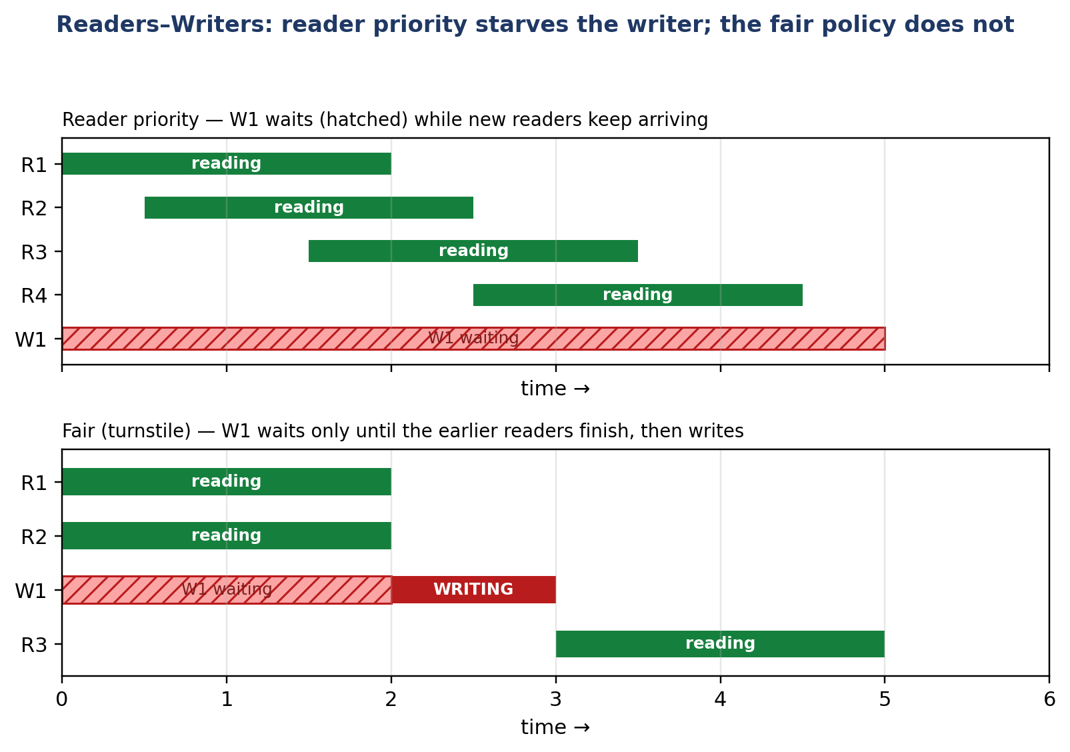
Figure 12. Reader priority starves writer W1; the fair (turnstile) policy does not let a newly arriving reader overtake a waiting writer.

8.2 Step-by-step trace: who proceeds when?
Table 9. One scenario, two policies: R3 overtakes the writer under reader priority and does not under the fair policy.
Time | Event | Active readers | Writer | Reader priority | Fair policy
t0 | R1 and R2 start reading | 2 | — | Read | Read
t1 | W1 arrives and waits | 2 | Waiting | Waits | Waits (holds the gate)
t2 | R3 arrives | 3 | Waiting | Reads (overtakes W1) | Queues behind W1
t3 | R1 and R2 finish | 1 | Waiting | Still waiting (R3 active) | Still waiting
t4 | R3 finishes | 0 | Writes | Finally writes | Writes
t5 | W1 finishes | 0 | — | Later readers read | Later readers read

Read this table together with Figure 2: under reader priority, every newly arriving reader can enter while a reader is active; under the fair policy, the gate stops the newly arriving reader. The difference is only one semaphore, but it completely changes the answer to “who goes next” — which is why the policy must be stated before any trace is graded.

9 Worked Examples

9.1 Example 1 — Tracing the value of a semaphore
Semaphore wrt = 1. R1 enters (the first reader), R2 enters, W1 arrives, R1 leaves, R2 leaves. Start: wrt = 1, readCount = 0. R1: wait(mutex), readCount = 1, wait(wrt) ← wrt = 0, signal(mutex). R2: readCount = 2; as it is not the first, it does not wait(wrt). W1: wait(wrt) ← wrt = −1, blocks. R1: readCount = 1; as it is not the last, it does not signal(wrt). R2: readCount = 0, signal(wrt) ← wrt = 0 and W1 wakes and enters. Lesson: wrt is taken only by the first reader and released only by the last reader; that is why its value reflects the number of waiters, not the number of readers.

9.2 Example 2 — Monitor: why is while necessary?
Consider a bounded-buffer monitor (analogous to the readers–writers monitor, with the count condition). A producer that finds the buffer full waits on notFull and releases the lock. A consumer removes an item, signals notFull, and the producer wakes. If the producer had used if instead of while and two producers were woken, both could write into a full buffer, because the second producer filled the buffer before the first one ran. Under Mesa semantics, the condition is not guaranteed after waking, so it must be re-tested; under Hoare semantics, the woken process runs immediately and the condition is still true, but POSIX and Java have Mesa semantics and spurious wakeups are also possible. So while is mandatory.

9.3 Example 3 — Peterson as a lock: what is missing?
Two threads (one reader and one writer) synchronized only by a Peterson lock, each reading or writing in its own critical section. The final value of the counter is correct, but this is not a readers–writers solution: the readers are serialized and simultaneous reading is lost. To make it a solution, readCount and the first/last-reader logic must be built on top of the lock — that is, the Peterson lock must be placed in Pseudocode 1 in place of mutex. Experiment E shows exactly this: final data = 5 is correct, but no reader ever read at the same time as another reader, because in that experiment there is only one reader and the lock serializes everything.

9.4 Example 4 — Starvation in a library
Consider a library where readers arrive every 10 minutes and each reads for 20 minutes; the editor (the writer) arrives at 10:00. Under reader priority, at least one reader is in the hall at every moment, so the editor waits until the end of the day — while the system is not deadlocked and readers keep coming and going. Under the fair policy, a reader arriving after 10:00 queues behind the editor; the readers from before 10:00 finish by 10:20 and the editor gets the book at 10:20. This is the same simulation as Experiment D, with milliseconds converted to minutes. Lesson: starvation does not need “bad luck”; it needs a continuous stream from the other side.

10 Sample Exercises and Solutions
Each exercise states what it tests. Solve it before reading the solution; the solutions explain, not just answer.

10.1 Exercise 1 — Who can proceed?
Reader-priority solution. R1 and R2 are active, W1 is waiting, R3 arrives and then W2 arrives. (a) What happens to R3 and W2? (b) What changes under the fair solution? (c) Can W1 starve? Give a scenario.
Solution. Solution.
(a) R3 reads immediately (readCount becomes 3) and W2 waits behind W1 on wrt. (b) Under the fair solution, R3 must pass the gate, which W1 holds, so R3 queues behind W1; W1 writes when R1 and R2 finish. (c) Yes: if new readers keep arriving while readers are active, readCount never reaches 0 — for example readers arriving every 10 ms and each reading for 20 ms keep at least one reader always active. The system is not deadlocked, but W1 starves.

10.2 Exercise 2 — Why does Peterson alone not solve the problem?
Two processes (one reader and one writer) are synchronized only by Peterson's algorithm: the reader reads in the critical section and the writer writes in the critical section. Is this a readers–writers solution? What is missing?
Solution. Solution.
No. It is only mutual exclusion: the reader and the writer are never in the critical section at the same time, so simultaneous reading — the heart of the problem — is lost and the readers are serialized too. What is missing is the readCount counter and the “first/last reader” logic. Peterson can be the underlying lock of that logic (Experiment E), but it is not the logic itself. In other words, with Peterson you can build a mutex, not the readers–writers problem.

10.3 Exercise 3 — Tracing the value of a semaphore
Semaphore wrt = 1. R1 enters (the first reader), R2 enters, W1 arrives, R1 leaves, R2 leaves. Write the value of wrt and readCount after each step and say when W1 enters.
Solution. Solution.
Start: wrt = 1, readCount = 0. R1: wait(mutex), readCount = 1, wait(wrt) ← wrt = 0, signal(mutex). R2: readCount = 2; as it is not the first, it does not wait(wrt). W1: wait(wrt) ← wrt = −1, blocks. R1: readCount = 1; as it is not the last, it does not signal(wrt). R2: readCount = 0, signal(wrt) ← wrt = 0 and W1 wakes and enters. Lesson: wrt is taken only by the first reader and released only by the last reader.

10.4 Exercise 4 — Monitor: Hoare versus Mesa
A readers–writers monitor uses if (activeWriters > 0) wait(canRead) instead of while. Under (a) Hoare semantics and (b) Mesa semantics, can a reader enter while a writer is active? Explain.
Solution. Solution.
(a) Under Hoare semantics, no: the signalled reader runs immediately, before a writer can enter, so the condition is still true — if is safe in theory. (b) Under Mesa semantics, yes: the signaller continues, a writer may enter before the woken reader runs, so the if that has returned is not re-tested and the reader reads concurrently with an active writer — a violation of mutual exclusion. That is why POSIX/Java code must use while. Spurious wakeups lead to the same conclusion even under Hoare semantics in practice.

10.5 Exercise 5 — Dekker: why is back-off necessary?
Remove the back-off lines from Dekker (keep only while(flag[j]) ;) and run the scenario in which both set their flags at the same time. What happens and why?
Solution. Solution.
Both see flag[other] = true, both spin in the outer while, neither ever lowers its own flag, and nobody enters — deadlock. Back-off is not an optimization; it is the mechanism that breaks symmetric waiting: checking turn makes exactly one of them back off and the other enter. That very back-off is what distinguishes Dekker from the naive attempt “set the flag and wait”.

10.6 Exercise 6 — Design a fair monitor
Design a monitor (state + procedures + conditions) for readers–writers that is starvation-free for both sides. State the waiting condition for startRead and startWrite and argue why neither side can starve.
Solution. Solution.
Keep activeReaders, activeWriters, waitingReaders, and waitingWriters (Pseudocode 3) and a turnstile (an arrival counter or an explicit FIFO queue of requests). A reader waits while activeWriters > 0 or waitingWriters > 0 (a writer arrived earlier); a writer waits while activeReaders > 0 or activeWriters > 0. On exit, signal the side that has waited longest. Neither side can starve because requests are served in arrival order: a request can only be overtaken by requests that arrived before it, and there are finitely many of them. The essential point is the second clause in startRead (waitingWriters > 0): without it, the monitor degrades to reader priority and writers can starve (Exercise 1).

11 Practical Applications and Common Errors

11.1 Practical applications in operating systems
- Databases: shared/exclusive locks are exactly the readers–writers protocol: SELECT transactions run concurrently and UPDATE takes an exclusive lock. Lock managers choose the policy explicitly.
- File system and kernel: pthread_rwlock_t in POSIX and read/write locks in the Linux kernel (rwsem) implement this protocol: simultaneous readers, exclusive writer.
- Cache and configuration: reading from a cache is very common and writing is rare; reader priority is usually acceptable, but a vital configuration update needs a fair or writer-priority policy.
- Programming languages: Java synchronized and wait/notify are monitors; Go sync.RWMutex provides a ready-made read/write lock; C++ std::shared_mutex provides the same tool.

11.2 Common implementation errors
Table 10. Common implementation errors, their symptoms, and their fixes.
Error | Symptom | Fix
Forgotten signal (semaphore) | All later waiters block forever (deadlock). | Pair every wait with a signal on every path, including error paths.
if instead of while after wait (Mesa) | Reading concurrently with an active writer; writing into a full buffer. | Always re-test in a while loop.
Missing gate in a “fair” solution | The solution silently degrades to reader priority and the writer starves. | Hold the gate on both the reader and the writer paths.
Plain variables for Peterson/Dekker | Intermittently wrong counter on hardware with weak memory. | _Atomic with sequential consistency, or a mutex.
Waiting inside the critical section | Deadlock: the holder waits for a process that cannot enter. | Never wait while holding a lock; use a condition variable.
Signalling a condition with no waiter (monitor) | The signal is lost; the next waiter wakes later. | Signal only after changing the shared state; the state, not the signal, is what the waiter re-tests.

12 Conclusion
The comparison of readers–writers with semaphore, monitor, Dekker, and Peterson can be summarized in one sentence: readers–writers is the problem, and semaphore and monitor are two vehicles for solving it, while Peterson and Dekker are only the underlying two-process lock of a solution. The semaphore is more general and lower-level and depends on programmer discipline; the monitor is clearer and safer and writes the policy in the waiting condition; Peterson is simpler than Dekker, and both work only for two processes and with busy waiting. The right choice depends on policy: if reading dominates and writer delay is tolerable, reader priority; if writing is urgent, writer priority; and if neither side may starve, the fair turnstile solution — whose code was run and verified with real output in the six experiments of Chapter 8. A reader who can name the policy, trace the value of a semaphore, write the monitor condition in a while loop, and explain the difference between a “problem” and a “lock” understands readers–writers.

13 Glossary of Technical Terms
Table 11. Glossary.
Term | Meaning
Readers–writers | Coordination problem: readers read concurrently, a writer writes exclusively.
Semaphore | An integer accessible only through atomic wait (P) and signal (V).
Monitor | Shared data together with the procedures that operate on it, with automatic mutual exclusion.
Condition variable | A queue of processes waiting inside a monitor for a condition, with wait/signal.
Mutual exclusion | At most one process is in the critical section at any time.
Progress | If the critical section is free and someone wants to enter, the choice is made in finite time.
Bounded waiting | A requesting process enters after at most a bounded number of overtakings.
Starvation | A process waits indefinitely while others make progress.
Deadlock | A set of processes each waiting for an event that only another process in the set can cause.
Turnstile (gate) | A semaphore that preserves arrival order and stops a newly arriving reader from overtaking a waiting writer.
Mesa semantics | After signal, the signaller continues and the woken process must re-test the condition.
Busy waiting | Waiting by looping and re-testing the condition, consuming CPU.

14 References
- A. Silberschatz, P. B. Galvin, and G. Gagne, Operating System Concepts, 10th ed., Wiley, 2018, chs. 6–7.
- P. J. Courtois, F. Heymans, and D. L. Parnas, “Concurrent control with ‘readers’ and ‘writers’”, Communications of the ACM, vol. 14, no. 10, pp. 667–668, 1971.
- G. L. Peterson, “Myths about the mutual exclusion problem”, Information Processing Letters, vol. 12, no. 3, pp. 115–116, 1981.
- Th. J. Dekker, reported in E. W. Dijkstra, “Cooperating sequential processes”, 1968; original solution 1965.
- E. W. Dijkstra, “Cooperating sequential processes”, 1965. Introduction of the semaphore.
- P. Brinch Hansen, “Operating System Principles”, Prentice-Hall, 1973; C. A. R. Hoare, “Monitors: an operating system structuring concept”, Communications of the ACM, vol. 17, no. 10, pp. 549–557, 1974.
- A. S. Tanenbaum and H. Bos, Modern Operating Systems, 4th ed., Pearson, 2015.
- R. H. Arpaci-Dusseau and A. C. Arpaci-Dusseau, Operating Systems: Three Easy Pieces, Arpaci-Dusseau Books, 2023.
- E. Barati (THE-ERPHUN), “Synchronization Mechanisms Comparison”, github.com/THE-ERPHUN/synchronization-mechanisms-comparison — reference project for the comparison style.
- Comprehensive process synchronization study (Persian/English), Process_Synchronization_Comparison_FA/EN.docx — Chapters 6, 7, 8, 9, 10, and 12.

Appendix A Implementation in C with POSIX Semaphores
The Python implementation is for teaching; the implementation below shows the same fair policy in C with POSIX semaphores. The main difference is that in C, semaphores and threads come from pthread and error handling is explicit: every sem_wait must be checked, and a forgotten sem_post deadlocks, just as in Python. This code compiles with gcc -std=c11 -O2 -pthread.
Listing 2. Fair readers–writers in C with POSIX semaphores (five rounds per thread).
#include <pthread.h>
#include <semaphore.h>
#include <stdio.h>
#include <unistd.h>

static sem_t gate, wrt, mutex;
static int read_count = 0, data = 0;

void *reader(void *arg) {
(void)arg;
for (int i = 0; i < 5; i++) {
sem_wait(&gate); sem_post(&gate); /* pass the turnstile */
sem_wait(&mutex);
read_count++;
if (read_count == 1) sem_wait(&wrt);
sem_post(&mutex);
usleep(1000); /* read the database */
sem_wait(&mutex);
read_count--;
if (read_count == 0) sem_post(&wrt);
sem_post(&mutex);
}
return NULL;
}
void *writer(void *arg) {
(void)arg;
for (int i = 0; i < 5; i++) {
sem_wait(&gate); /* hold the gate */
sem_wait(&wrt);
data++; /* write the database */
sem_post(&wrt);
sem_post(&gate);
usleep(1000);
}
return NULL;
}
int main(void) {
sem_init(&gate, 0, 1); sem_init(&wrt, 0, 1); sem_init(&mutex, 0, 1);
pthread_t r[3], w[2];
for (int i = 0; i < 3; i++) pthread_create(&r[i], NULL, reader, NULL);
for (int i = 0; i < 2; i++) pthread_create(&w[i], NULL, writer, NULL);
for (int i = 0; i < 3; i++) pthread_join(r[i], NULL);
for (int i = 0; i < 2; i++) pthread_join(w[i], NULL);
printf("final data = %d (expected 10)
", data);
return 0;
}

Expected output: final data = 10 (expected 10). If read_count were not protected by mutex, two readers could increment read_count from 0 to 1 at the same time and both call wait(wrt); the writer would never wake. That is why the reader counter itself needs mutual exclusion.

A.1 Why is there no native monitor in C?
C has no native monitor; a monitor in C is built from pthread_mutex_t and pthread_cond_t: a monitor procedure begins with pthread_mutex_lock and ends with pthread_mutex_unlock, and waiting on a condition variable releases the lock. That is exactly what the Python version of Chapter 8 does with threading.Lock and threading.Condition. The exam point: in both languages, wait must be inside a while loop (Mesa semantics) and signal must be called after the shared state has changed.

Appendix B Short Quiz (8 Questions) with Answers
These questions are designed for revision before the exam; each answer has one key sentence that you should be able to say without looking.
1. Which property rules out starvation?
Answer: Bounded waiting: a process enters after a bounded number of overtakings; starvation freedom alone gives no bound.
2. Why is the wrt semaphore touched only by the first and the last reader?
Answer: Because wrt must be held from the first reader to the last reader, so that a writer enters only when no reader is active.
3. What does the gate do in the fair solution?
Answer: It preserves arrival order: a reader arriving after a waiting writer queues behind it and cannot overtake it.
4. How does a monitor signal differ from a semaphore signal?
Answer: A monitor signal with no waiter is lost; a semaphore signal increments the counter and is remembered.
5. Why is while used in a POSIX monitor?
Answer: Because it is Mesa semantics: after waking, the condition is not guaranteed and another process may have entered first; spurious wakeups are also possible.
6. Why does Peterson not solve the readers–writers problem?
Answer: Because it gives only mutual exclusion: it has no reader counter, no policy, and no simultaneous reading; readers are serialized too.
7. When is reader priority acceptable?
Answer: When reading dominates and occasional writer delay is tolerable, such as a mostly-read cache.
8. If readers arrive every 10 ms and each reads for 20 ms, when does the writer write under reader priority?
Answer: Never (in a 200 ms horizon): at least one reader is always active. Under the fair policy it writes at t = 20 ms — Experiment D of Chapter 8.

Appendix C Submission Checklist for Exercise 7
Table 12. The professor's checklist against this document.
Professor's checklist row | Status | Where
Figure | ✅ | 9 numbered figures (Chapters 3–7)
Flowchart | ✅ | Figures 2, 4, 5, 6, and 8
Comparison table | ✅ | Master table of Chapter 7 + three sub-tables
Executable code | ✅ | rw_ex7_demo.py + C listing in Appendix A
Clip | — | Outside this document; it is the professor's row 5
English file | ✅ | Readers_Writers_Comparison_Exercise7_FULL_EN.docx
Persian file | ✅ | Readers_Writers_Comparison_Exercise7_FULL_FA.docx
More than 40 pages | ✅ | Both versions are over 40 pages (rendered with LibreOffice)
Word version | ✅ | Both .docx files are editable
PDF version | — | Made from Word with File → Save as PDF

Final note on submission: this document is the complete, standalone version of Exercise 7 and satisfies the “at least 40 pages” requirement on its own. The comprehensive synchronization study (57/56 pages) can also be attached as a reference, but it is not needed for Exercise 7.

Appendix D Complete Trace of the Fair Policy (2 Readers and 2 Writers)
Scenario: R1 and R2 read, W1 arrives, R3 arrives, W2 arrives, then the readers finish one by one. The table below shows the value of every variable after each event. Repeat this trace by hand; if you can write gate, wrt, and readCount at every step, you understand the fair policy.
Table 13. Trace of the fair policy: R3 and W2 both wait behind the gate, and nobody overtakes W1.
Step | Event | gate | wrt | readCount | Who proceeds
0 | Start | 1 | 1 | 0 | —
1 | R1 passes the gate and reads | 1 | 0 | 1 | R1
2 | R2 passes the gate and reads | 1 | 0 | 2 | R1, R2
3 | W1 arrives; takes the gate and waits on wrt | 0 | 0 | 2 | R1, R2
4 | R3 arrives; waits behind the gate | 0 | 0 | 2 | R1, R2
5 | W2 arrives; waits behind the gate | 0 | 0 | 2 | R1, R2
6 | R1 finishes | 0 | 0 | 1 | R2
7 | R2 finishes (last reader); wrt is released | 0 | 0 | 0 | W1 wakes
8 | W1 writes and releases the gate | 1 | 0 | 0 | W1
9 | W1 finishes; the gate is free | 1 | 1 | 0 | R3, W2
10 | R3 reads; W2 waits on wrt | 1 | 0 | 1 | R3
11 | R3 finishes; W2 writes | 1 | 0 | 0 | W2

The key step is step 4: R3 waits behind the gate even though it could have read safely. That is the cost of fairness — a little reader parallelism is sacrificed so that the writer does not starve. If you remove the gate, R3 reads at step 4 and the table becomes a trace of reader priority; W1 does not write at step 7, and R3 and later readers keep it waiting.

Appendix E One-Page Revision: Everything in One Table
Table 14. Quick revision of Exercise 7.
Question | One-line answer
What is readers–writers? | A problem in which readers read concurrently and a writer writes exclusively.
What are the three policies? | Reader priority, writer priority, fair (turnstile).
Which policy starves? | Reader priority starves the writer; writer priority starves the reader; fair starves neither.
What does a semaphore give? | A general blocking tool; the policy must be built explicitly.
What does a monitor give? | Automatic mutual exclusion; the policy is readable in the waiting condition.
What does Peterson give? | Only a two-process lock with busy waiting; no counter, no policy.
What does Dekker give? | The same lock, with explicit back-off; its importance is historical.
Why while in a monitor? | Mesa semantics: the condition is not guaranteed after waking.
What happens to a monitor signal with no waiter? | It is lost; unlike a semaphore, it is not remembered.
What is the result of Experiment D? | Reader priority: the writer never; fair: t = 20 ms.
What is the result of Experiments A and B? | Both final data = 10.
What is the result of Experiments E and F? | Both final data = 5; only mutual exclusion.

Appendix F Readers–Writers versus Dining Philosophers
Both are classic problems, but their problems are different. Readers–writers is about “who may access at the same time”; dining philosophers is about “how to avoid deadlock in resource allocation”. Comparing them helps you understand why the solution of one problem cannot be transferred to the other: a read/write lock is useless in the dining-philosophers problem, because philosophers neither read nor write; they want two forks.
Table 15. Readers–writers versus dining philosophers.
Aspect | Readers–writers | Dining philosophers
Shared resource | One database (readable concurrently) | Five forks (each for one philosopher only)
Allowed concurrency | Readers may read at the same time | Non-neighbouring philosophers eat at the same time
Main danger | Writer starvation under reader priority | Deadlock when everyone takes the left fork
Classic solution | Reader counter + gate (fair) | Resource ordering: the last philosopher takes the right fork first
Tool | Semaphore / monitor | A binary semaphore per fork
Main lesson | Policy, not mutual exclusion, makes the difference | The order of resource allocation breaks deadlock

Appendix G Step-by-Step Study Plan for the Exam
Run this plan in three one-hour sessions. Each session ends with a measurable output; if you cannot produce the output, repeat the session.
Table 16. Three-session study plan for Exercise 7.
Session | What to do | Measurable output
1 (Concepts) | Read Chapters 2 and 3; draw the state diagram from memory. | The state diagram with three states and allowed/forbidden transitions, without looking.
2 (Implementation) | Write Pseudocodes 1–3 by hand; run Experiments A–D. | The fair pseudocode with the gate + the output of Experiment D from memory.
3 (Comparison and practice) | Solve Chapter 7 and the exercises of Chapter 10; take the quiz in Appendix B. | All six exercises with solutions + at least 7 correct answers out of 8 quiz questions.

Exam tip: if only one question on readers–writers appears in the exam, it is almost always about policy — “why does the writer starve?” or “what does the gate do?” — not about the definition of a semaphore. So learn the policies first, and the pseudocode second.

Appendix H List of Figures and Tables
This list is for finding a figure or a table in the document quickly.
Table 17. List of figures.
Figure | Title
Figure 1 | General structure of a process with a critical section
Figure 2 | States of the database: FREE, READING, WRITING
Figure 3 | Readers–writers: readers may read concurrently; a writer waits
Figure 4 | Semaphore: wait and signal operations; binary versus counting use
Figure 5 | Reader flowchart with reader priority
Figure 6 | Monitor structure: private data, procedures, and condition variables
Figure 7 | Flowchart of a monitor procedure call, including wait and signal
Figure 8 | Flowchart of Peterson's algorithm for process Pi
Figure 9 | Peterson: a step-by-step interleaving
Figure 10 | Flowchart of Dekker's algorithm for process Pi
Figure 11 | Decision flowchart: which vehicle and which policy?
Figure 12 | Reader priority starves the writer; the fair policy does not

Table 18. List of tables.
Table | Title
Table 1 | Mapping of the components of Exercise 7 to the chapters
Table 2 | Four liveness ideas, distinct from one another
Table 3 | Hoare versus Mesa monitor semantics
Table 4 | Master table: the readers–writers problem against the four mechanisms
Table 5 | Readers–writers policies: the trade-offs
Table 6 | Peterson versus Dekker
Table 7 | Semaphore versus monitor
Table 8 | The six experiments and what each one proves
Table 9 | One scenario, two policies
Table 10 | Common implementation errors, their symptoms, and their fixes
Table 11 | Glossary
Table 12 | The professor's checklist against this document
Table 13 | Trace of the fair policy
Table 14 | Quick revision of Exercise 7
Table 15 | Readers–writers versus dining philosophers
Table 16 | Three-session study plan for Exercise 7

Further reading: Chapters 6 and 7 of Silberschatz et al. (10th edition) for precise definitions and textbook pseudocode; Chapter 30 of Operating Systems: Three Easy Pieces for an intuitive explanation of semaphores and monitors; and the comprehensive process synchronization study for the dining-philosophers problem and the complete comparison of all six topics. For further practice, rewrite the pseudocodes of Chapters 4 and 5 with the fair policy and repeat Experiment D with reader arrivals every 5 ms and a read time of 15 ms; the writer still starves under reader priority, but under the fair policy it writes at t = 15 ms — predict, run, and compare with the output.

