Process Synchronization:
A Comparative Study
Peterson's Algorithm • Dekker's Algorithm • Semaphore • Monitor •
Readers–Writers Problem • Dining Philosophers Problem

A Comprehensive Academic and Educational Study
Operating Systems — Concurrency and Process Synchronization
English Edition
November 2026

Table of Contents

In Microsoft Word, right-click this table of contents and choose “Update Field” to refresh the page numbers after editing.

Abstract
When several processes or threads share a resource, uncoordinated access can produce race conditions, lost updates, inconsistent data, deadlock, and starvation. This document studies six fundamental answers to that problem: two classical software algorithms for two processes (Peterson's and Dekker's algorithms), two general synchronization primitives (semaphores and monitors), and two classical coordination problems (readers–writers and dining philosophers). For each topic it gives the history, the exact algorithm, a step-by-step execution, a proof sketch for mutual exclusion, progress, and bounded waiting, a complete compilable C/POSIX-threads implementation, flowcharts and execution diagrams, worked examples, and university-level exercises with solutions. A dedicated theory chapter defines the correctness properties precisely — including the frequently confused distinction between deadlock freedom, starvation freedom, bounded waiting, and fair scheduling — and a final comparison chapter evaluates all six topics against the same thirteen properties, with the reasoning and the assumptions behind every judgement stated explicitly. The reference study that inspired the comparison style is the open repository by Barati and the Eshragh Institute document “A Comparative Study of Synchronization Mechanisms” (Semaphore, Monitor, Peterson, Dekker) [1]; the present document is independently written, extends that comparison to six topics, and corrects the common oversimplification of answering every property with a bare Yes or No.
mutual exclusion; critical section; Peterson's algorithm; Dekker's algorithm; semaphore; monitor; readers–writers; dining philosophers; deadlock; starvation; bounded waiting; POSIX threads.

How to use this document
- For a first reading: Chapters 3–5 (concepts and correctness properties), then one topic chapter at a time, then Chapter 12 (comparison).
- For revision before an exam: the comparison tables in Chapter 12, the worked examples in Chapter 13, and the exercises in Chapter 14.
- For laboratory work: compile and run the C programs in Chapters 6–11 (commands are given with each listing); every sample output in this document is labelled illustrative, because thread interleavings vary from run to run.
- A note on honesty about code: the Peterson and Dekker listings use C11 _Atomic variables with sequential consistency. The classical textbook pseudocode is correct only under atomic reads/writes and a suitable memory ordering; a naïve translation with plain variables is not safe on modern hardware. Section 6.8 and Section 7.8 explain why.

1 Introduction
Modern computers execute many activities concurrently: threads in one application, processes in an operating system, and interrupt handlers all run interleaved on one or more processors. Concurrency is what makes a system responsive and efficient, but it creates a new class of errors. Two processes that each execute counter = counter + 1 can finish with the counter increased by one instead of two, because the read–increment–write sequence of one process can be interleaved with that of the other. Neither process is wrong on its own; the error is in the interleaving. Such an error is called a race condition, and the code that accesses the shared resource is called the critical section.
A synchronization mechanism is a disciplined way of deciding who may enter a critical section, and when. This document compares six of them. Peterson's and Dekker's algorithms are pure software solutions for exactly two processes: they use only shared memory, no special hardware instruction, and no operating-system support. Semaphores and monitors are general primitives provided (directly or by construction) by operating systems and programming languages, and they work for any number of processes. Readers–writers and dining philosophers are not primitives at all but classical problems: they state a coordination requirement precisely, and each admits several solutions with different trade-offs — reader priority against writer priority, deadlock freedom against fairness. Keeping the distinction between primitives, algorithms, and problems straight is essential, and Chapter 12 makes it explicit.
The remainder of the document is organized as follows. Chapter 2 fixes the vocabulary (process, thread, critical section, race condition). Chapter 3 defines the correctness properties. Chapters 4–5 are short: they set up the shared model used by the two-process algorithms. Chapters 6–11 treat the six topics in depth. Chapter 12 compares them. Chapters 13–14 give worked examples and exercises with solutions. Chapters 15–16 discuss real operating-system applications and common implementation errors. Chapter 17 concludes, Chapter 18 is a glossary, and Chapter 19 lists the references.

1.1 The reference project
The comparison style of this document follows the repository THE-ERPHUN/synchronization-mechanisms-comparison (Barati, Eshragh Institute of Higher Education), which compares semaphore, monitor, Peterson, and Dekker in a single study with flowcharts, step-by-step tables, and summary tables [1]. That repository was accessible at the time of writing and its accompanying document was consulted for structure. Everything in this document — the proofs, the code, the diagrams, the exercises, and the two new topics — is independently written, and where the reference document simplifies (for example, its Yes/No summary tables), this document gives the assumption-dependent reasoning instead.

1.2 Conventions
- Processes and threads. The classical algorithms speak of processes; the C code uses POSIX threads, which share memory in one process. The synchronization logic is identical, and the document says “process” for the theory and “thread” for the code.
- Numbering. Processes are numbered 0 and 1 in the two-process algorithms, 0…4 for the philosophers, and 0…n−1 in general. i denotes the current process and 1 − i (or j) the other one.
- Pseudocode vs. code. Pseudocode is language-independent and states the idea; the C listings are complete, compilable programs with headers, compilation and run commands, and an explanation of every important function.
- Sample output. All sample outputs are labelled “Illustrative sample output”. Thread scheduling is non-deterministic, so the exact interleaving in any real run will differ; only the invariants (for example, the final counter value) are guaranteed.

2 Fundamental Concepts of Process Synchronization

2.1 Process, thread, and shared resource
A process is a program in execution, with its own address space; a thread is a unit of execution inside a process that shares the process's memory with the other threads. Synchronization is needed whenever two or more processes or threads access shared data and at least one of them writes it. A shared resource may be a variable, a buffer, a file, a device, or a database record. If all accesses were reads, no coordination would be needed; the danger begins with a write that can be observed mid-way by another process.

2.2 Race condition
A race condition exists when the outcome of a computation depends on the relative timing (interleaving) of operations in different processes, and at least one of the operations is a write to shared data. The classic example is counter = counter + 1 executed by two processes. Each execution is three machine steps — load, increment, store. If both load the old value 5 before either stores, both store 6, and one increment is lost. The program is not deterministic: the same input can give different outputs on different runs. Race conditions are hard to debug precisely because they depend on timing.

2.3 Critical section
The critical section (CS) is the part of a process's code that accesses shared data. The rest is the remainder section. A correct solution must guarantee that at most one process is in its critical section at any time, while not preventing processes from doing useful work elsewhere. Figure 1 shows the general shape of every solution in this document: an entry section that requests permission, the critical section itself, an exit section that releases permission, and the remainder section.
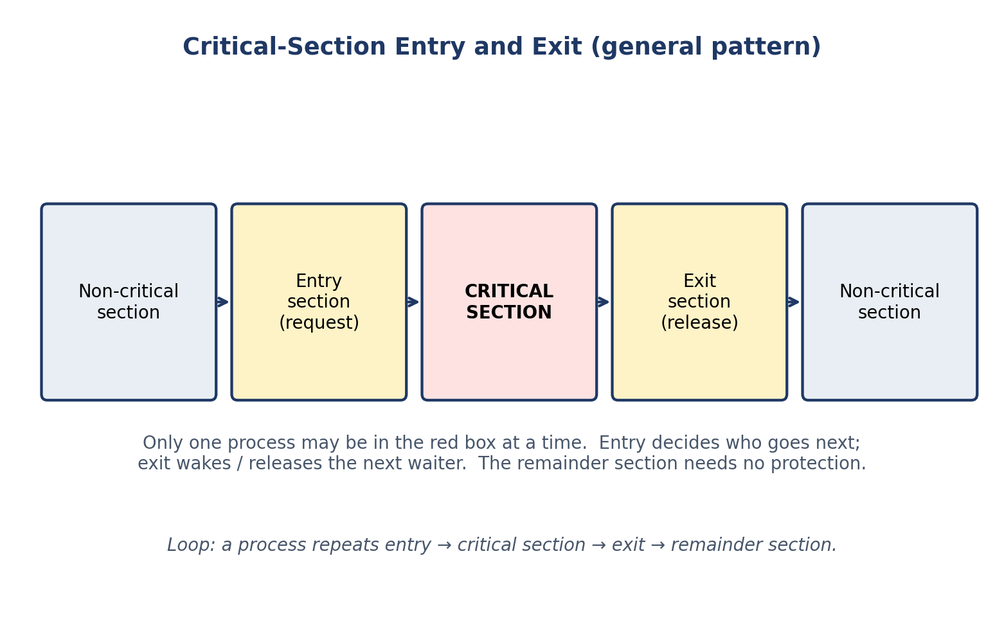
Figure 1. General structure of a process with a critical section: entry section, critical section, exit section, remainder section.
Every algorithm in this document is a different way of writing the entry and exit sections. The critical section itself — what the process does with the data — is the same; only the guard changes.

2.4 Atomic operations and interleaving
An operation is atomic if it appears to happen instantaneously: no other process can observe it half-finished. Load and store of a single aligned machine word are usually atomic on real hardware; a read-modify-write sequence such as counter++ is not. Synchronization primitives (semaphore wait/signal, test-and-set, compare-and-swap) are atomic by construction, usually with hardware help. The two-process software algorithms in Chapters 6–7 are remarkable precisely because they build mutual exclusion out of ordinary atomic loads and stores alone — but that is also why their correctness depends on the memory model, as Sections 6.8 and 7.8 explain.

2.5 Busy waiting versus blocking
When a process cannot enter its critical section, it has two options. It can busy-wait (spin): loop, re-testing a condition, until it becomes true — wasting CPU time but reacting immediately when the condition changes. Or it can block: ask the operating system to suspend it and wake it when the condition may have changed — saving CPU time at the cost of a context switch. Peterson and Dekker busy-wait; semaphores and monitors (in their usual implementations) block. Neither is always better: spinning is reasonable for a very short wait on a multiprocessor; blocking is essential for a long wait or a uniprocessor, where a spinning process would prevent the process holding the lock from ever running.

3 Correctness Properties
A synchronization solution is judged by the properties it guarantees. This chapter defines them formally. The definitions follow Silberschatz, Galvin and Gagne [2] and Arpaci-Dusseau and Arpaci-Dusseau [4], with the distinctions of Section 3.10 added because textbooks and students frequently confuse them.

3.1 Mutual exclusion
Definition. At most one process is in its critical section at any time. Formally, if process Pi is in its critical section, no other process Pj (j ≠ i) is in its critical section at the same moment. This is the non-negotiable property: without it, there is no synchronization at all. Example: two processes incrementing a shared counter must never both be inside the increment code simultaneously; otherwise an update is lost (Section 2.2). Every solution in this document aims at mutual exclusion; the differences are in what else they guarantee and at what cost.

3.2 Progress
Definition. If no process is in its critical section and some processes wish to enter, then the decision about which process enters next cannot be postponed indefinitely; a process that is not in its remainder section must be able to participate, and the choice must be made in finite time. Progress is a liveness property about the system as a whole: it rules out solutions in which everyone politely waits for everyone else forever, even though the critical section is free. It does not promise that a particular process will be chosen — only that somebody will be. A strict turn-taking scheme (P0, P1, P0, P1, …) violates progress: if P0 is in its remainder section and has no interest in the critical section, P1 still cannot enter.

3.3 Bounded waiting
Definition. Once a process has requested entry to its critical section, there is a finite bound on the number of times other processes may enter before its request is granted. Bounded waiting rules out starvation of an individual process in a strong sense: it is not enough that the process eventually enters, it must enter after at most a bounded number of overtakes. For Peterson's algorithm the bound is 1: once Pi has set flag[i] = true and turn = j, at most one entry by Pj can precede Pi's entry, because Pj's exit sets turn back in a way that lets Pi in (proved in Section 6.5).

3.4 Deadlock
Definition. A set of processes is deadlocked if every process in the set is waiting for an event that only another process in the set can cause, so no process in the set ever proceeds. Coffman's four necessary conditions are: (1) mutual exclusion — resources are held exclusively; (2) hold and wait — a process holds resources while waiting for more; (3) no preemption — resources cannot be taken away forcibly; (4) circular wait — a cycle of processes each waiting for a resource held by the next. Breaking any one condition prevents deadlock. In the dining philosophers, all four conditions hold in the naïve solution, which is why it deadlocks (Section 11.5).

3.5 Starvation
Definition. A process starves if it waits indefinitely for a resource even though other processes keep making progress. Unlike deadlock, the system as a whole is healthy — other processes enter and leave — but one process is repeatedly overtaken. Starvation is usually caused by an unfair policy (for example, reader priority in readers–writers: a continuous stream of readers can keep a writer waiting forever) or by an unfair scheduler. A solution can be deadlock-free and still starve a process; deadlock freedom and starvation freedom are different guarantees and must be checked separately.

3.6 Fairness
Definition. Access is distributed fairly if processes that request entry are served in an order related to their requests — most strictly first-come, first-served (FCFS), more loosely that no process waits disproportionately longer than others. Fairness is a policy goal rather than a single formal property: bounded waiting is one precise way of capturing it, FCFS ordering is a stronger one. A fair scheduler (one that eventually runs every ready process) is an assumption many starvation-freedom arguments depend on, not something the synchronization algorithm itself provides.

3.7 Race conditions (recap)
A race condition is a timing-dependent outcome caused by unsynchronized access to shared data (Section 2.2). Mutual exclusion eliminates races in the critical section; it does not eliminate races elsewhere. A program can be free of races in its critical section and still have a race on a flag variable that is read and written outside any protection — which is exactly the bug in a naïve Peterson implementation with plain variables on a relaxed memory model.

3.8 Critical section (recap)
See Section 2.3. Two practical points: the critical section should be as short as possible (it serializes all processes), and it must never contain a blocking wait for another process — waiting inside a critical section while holding the lock is an invitation to deadlock.

3.9 Busy waiting
Busy waiting (spinning) means a waiting process consumes CPU cycles re-testing a condition. It is simple, needs no operating-system support, and has the lowest latency when the wait is short. Its cost is wasted CPU and, on a uniprocessor, a real hazard: if the spinning process never yields, the process that could release the condition never runs. That hazard is why Peterson and Dekker are textbook algorithms and are rarely used as-is in production operating systems, which prefer blocking primitives.

3.10 Blocking synchronization
Blocking synchronization suspends the waiting process (moves it to a wait queue) until another process signals that the condition may have changed. It wastes no CPU, but it costs a context switch and a wake-up, and it needs operating-system or library support for queues and atomic sleep/wake. Semaphores and monitors are blocking primitives; their correctness argument must therefore also cover the wake-up discipline (who is woken, and whether the woken process must re-test the condition).

3.11 Deadlock freedom, starvation freedom, bounded waiting, fair scheduling — do not confuse them
Table 1. The four liveness ideas, distinguished. Bounded waiting implies starvation freedom; starvation freedom implies deadlock freedom; neither converse holds.
Property | What it guarantees | What it does NOT guarantee
Deadlock freedom | The system as a whole never gets stuck with everybody waiting. | That a particular process ever proceeds.
Starvation freedom | Every requesting process eventually proceeds. | A bound on how many times it is overtaken first.
Bounded waiting | A requesting process proceeds after at most B overtakes (B fixed). | That B is small, or that service is in arrival order.
Fair scheduling (FCFS) | Requests are served in (approximately) arrival order. | Anything by itself: it is usually an assumption about the scheduler, not a property of the algorithm.

Implication chain: bounded waiting ⇒ starvation freedom ⇒ deadlock freedom. The converses fail: a system can be deadlock-free yet starve a process (reader-priority readers–writers); starvation-free yet without a finite bound on overtakes in the worst case. And none of these follows from mutual exclusion alone. In the comparison tables of Chapter 12, a claim of starvation freedom or bounded waiting is only made where it can be justified under the stated assumptions, and the assumptions (for example, a fair scheduler, or sequentially consistent memory) are written next to the claim.

4 The Two-Process Problem
Peterson and Dekker solve the same problem for exactly two processes, P0 and P1. Each process repeatedly executes: entry section → critical section → exit section → remainder section. The entry section may read and write shared variables, but nothing else may be used — no test-and-set instruction, no semaphore, no operating-system call. The challenge is to write an entry section, using only atomic loads and stores of shared variables, that satisfies mutual exclusion, progress, and bounded waiting. Attempts that use only one flag variable fail: if each process sets its own flag and then waits while the other's flag is set, both can set their flag before either tests, and both wait forever (deadlock); if each waits only while the other has priority, both can enter together (mutual exclusion violated). The successful algorithms combine a flag array (“I want to enter”) with a turn variable (“you go first”) so that the two failure modes cancel each other out.

5 Shared Variables in the Two-Process Algorithms
Table 2. Shared variables of Peterson's and Dekker's algorithms.
Variable | Type | Meaning
flag[0], flag[1] | boolean, initially false | flag[i] = true means Pi wants to enter its critical section.
turn | integer 0 or 1 | turn = i means Pi has priority (the other waits while flag[i] is set).
shared data | e.g. counter | The data the critical section protects; not part of the algorithm itself.

Both algorithms use exactly these two shared variables; they differ in how the test and the back-off are organized. Peterson's test is a single while condition; Dekker's is a loop with an explicit back-off step. That structural difference explains why Peterson's correctness proof is shorter and why Dekker's algorithm is the historically earlier solution (1965) and Peterson's the simpler later one (1981).

6 Peterson's Algorithm

6.1 Introduction and historical background
Gary L. Peterson published his algorithm in 1981 (“Myths about the mutual exclusion problem”, Information Processing Letters 12(3), 1981) [5]. It was a surprise: earlier solutions for two processes were intricate, and Peterson's fits in a few lines, yet it satisfies all three correctness properties. Its simplicity made it the standard textbook example of a software-only solution — and, decades later, the standard cautionary example about memory models, because hardware and compilers that reorder memory accesses break exactly the ordering the proof assumes (Section 6.8).

6.2 Problem definition
Two processes, P0 and P1, share a critical section. Design entry and exit sections using only shared variables flag[0..1] and turn, with atomic loads and stores, satisfying mutual exclusion, progress, and bounded waiting.

6.3 Shared variables
flag[i] (boolean, initially false): Pi's intention. turn (0 or 1): whichever process wrote turn last has given priority to the other. The pair works together: flag says “I want in”, turn says “but you go first”.

6.4 Algorithm and pseudocode
Algorithm 1. Peterson's algorithm for process Pi.
shared boolean flag[2] = {false, false};
shared int turn; // 0 or 1

process Pi (i = 0 or 1, j = 1 - i):
loop forever:
// ---- entry section ----
flag[i] = true; // I want to enter
turn = j; // you go first
while (flag[j] == true and turn == j):
; // busy wait
// ---- critical section ----
... access shared data ...
// ---- exit section ----
flag[i] = false; // I am done
// ---- remainder section ----
...

- flag[i] = true announces intent, so the other process can see that Pi is competing.
- turn = j is the polite gesture: Pi yields priority to Pj. Whoever writes turn last is the one who waits, because turn then names the other process.
- while (flag[j] and turn == j) waits only while Pj is interested and Pj has priority. If Pj is not interested (flag[j] is false), Pi enters at once. If Pj is interested but turn = i (Pj yielded to Pi), Pi enters at once.
- flag[i] = false withdraws intent, so a waiting Pj can enter.

6.5 Step-by-step execution
Interleaving A — P0 alone. P0 sets flag[0] = true, turn = 1, tests flag[1] (false), and enters immediately. Interleaving B — both want in, P0 first. P0 sets flag[0] = true, turn = 1; P1 sets flag[1] = true, turn = 0. Now turn = 0, so P0's test (flag[1] and turn == 1) is false and P0 enters, while P1's test (flag[0] and turn == 0) is true and P1 waits. The process that wrote turn last waits; the earlier writer enters. Interleaving C — P0 inside, P1 arrives. P1 sets flag[1] = true, turn = 0, and waits because flag[0] is true and turn is 0. When P0 leaves and sets flag[0] = false, P1's test becomes false and P1 enters. No scenario lets both tests be false simultaneously while both are interested: that would require turn to be both 0 and 1, which is the heart of the mutual-exclusion proof.
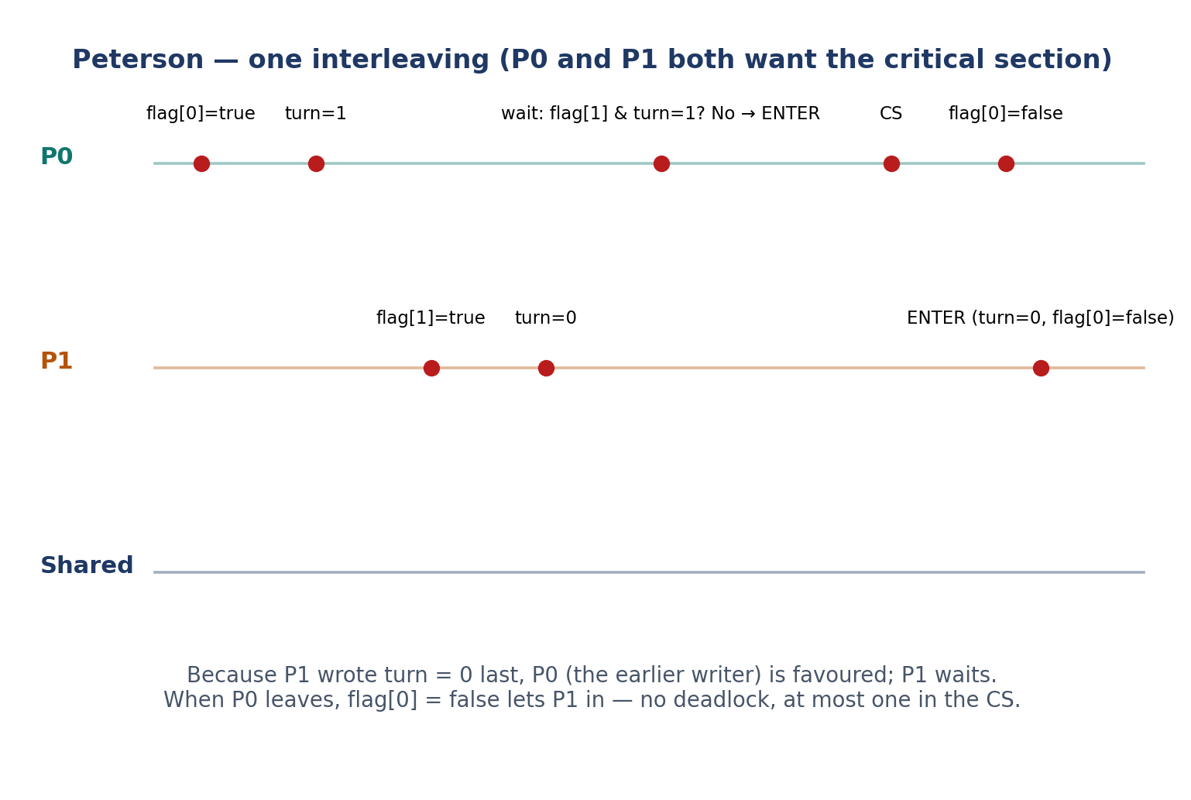
Figure 2. Peterson's algorithm: a step-by-step interleaving in which P0 enters first and P1 waits.
Table 3. Peterson's algorithm: trace of the interleaving in Figure 2 (compare Table 2 of the reference document).
Time | Event | flag[0] | flag[1] | turn | Who may enter
0 | Both in remainder section | false | false | — | Nobody needs to
1 | P0 sets flag, then turn | true | false | 1 | P0 (P1 not interested)
2 | P1 sets flag, then turn | true | true | 0 | P0 (turn favours P0)
3 | P0 enters CS; P1 spins | true | true | 0 | P0 only
4 | P0 leaves, flag[0] = false | false | true | 0 | P1

6.6 Mutual exclusion, progress, and bounded waiting
Mutual exclusion. Suppose, for contradiction, that P0 and P1 are in their critical sections together. Then both passed their while test: for P0, flag[1] was false or turn was 0 at the moment it passed; for P1, flag[0] was false or turn was 1. Consider who wrote turn last before both entered. If P0 wrote last, turn = 1, so P1 could only have passed if flag[0] was false — but flag[0] was set true before P0 wrote turn and stays true until P0 leaves, contradiction. The symmetric argument holds if P1 wrote last. So both cannot be inside together. Progress. If no process is in the critical section and one wishes to enter, its test fails at once if the other is uninterested; if both are interested, exactly one of them sees turn favouring it and enters, so the decision is made. Bounded waiting. Suppose P0 is waiting (flag[0] = true, turn = 1). P1 can enter at most once before P0: to enter again, P1 must leave, set flag[1] = false, and re-enter, which requires setting turn = 0 — but then P0's test becomes false and P0 enters before P1's next entry. Bound = 1 overtake.

6.7 Advantages and disadvantages
- Advantages: pure software, no special hardware, no OS support; simple to understand and prove; satisfies all three properties; no deadlock.
- Disadvantages: busy waiting wastes CPU; only two processes; assumes atomic, sequentially consistent memory accesses — false for plain variables on modern hardware (Section 6.8); the proof assumes each process eventually leaves its critical section.

6.8 Limitations and assumptions — read this before using the code
The classical proof assumes (a) each load and store of flag and turn is atomic, (b) the two assignments flag[i] = true and turn = j happen in program order as observed by the other process, and (c) a process that enters its critical section eventually leaves it. On a modern machine, (b) fails for plain C variables: the compiler may reorder the stores, and the CPU may make a store visible to the other core late. That can produce mutual-exclusion failure in a naïve implementation, and it has been demonstrated in practice. Therefore the C listing below uses C11 _Atomic variables with the default sequentially-consistent ordering (atomic_store / atomic_load), which restores the assumed ordering. In C++ the equivalent is std::atomic with memory_order_seq_cst; in Java, volatile fields (plus the Java memory model's guarantees) are the usual vehicle. The algorithm is a teaching algorithm and a proof of possibility — production code should use a mutex.

6.9 Practical example
Two threads maintain a shared bank balance. Each thread repeatedly deposits one unit inside the critical section. Without synchronization the final balance is usually less than the number of deposits (lost updates, Section 2.2). With Peterson's algorithm the final balance is exact: counter = 2 × NITER in the listing below, every run. Replace the single increment with any short operation on shared state — appending to a log, updating a shared queue's head pointer — and the same protection applies, provided the whole operation stays inside the critical section.

6.10 Source code (C11 / POSIX threads)
Listing 1. Peterson's algorithm in C11 with POSIX threads.
/* peterson.c — Peterson's algorithm for two threads (C11).
Compile: gcc -std=c11 -O2 -pthread -o peterson peterson.c
Run: ./peterson
IMPORTANT: correctness here relies on C11 _Atomic variables with
sequentially-consistent ordering. Plain (non-atomic) bool/int
variables are NOT safe on modern optimizing compilers / hardware:
the compiler or CPU may reorder the writes to flag[] and turn.
See Section 6.8 for the full discussion. */
#include <stdio.h>
#include <stdatomic.h>
#include <pthread.h>
#include <unistd.h>

#define NITER 200000
static _Atomic int flag[2] = {0, 0}; /* flag[i] = thread i wants in */
static _Atomic int turn = 0; /* whose turn it is to wait */
static long shared_counter = 0; /* protected shared data */

static void *worker(void *arg) {
long id = (long)arg; /* 0 or 1 */
long other = 1 - id;
for (int k = 0; k < NITER; k++) {
/* ---- entry section ---- */
atomic_store(&flag[id], 1); /* I am interested */
atomic_store(&turn, (int)other); /* politely yield */
while (atomic_load(&flag[other]) &&
atomic_load(&turn) == other) /* busy wait */
; /* spin */
/* ---- critical section ---- */
shared_counter++; /* only one thread here */
/* ---- exit section ---- */
atomic_store(&flag[id], 0);
/* remainder section (nothing here) */
}
return NULL;
}
int main(void) {
pthread_t t0, t1;
pthread_create(&t0, NULL, worker, (void *)0L);
pthread_create(&t1, NULL, worker, (void *)1L);
pthread_join(t0, NULL); pthread_join(t1, NULL);
printf("counter = %ld (expected %d)\n", shared_counter, 2 * NITER);
return 0;
}

Build: Compilation and execution.
Build commands for Listing 1.
gcc -std=c11 -O2 -pthread -o peterson peterson.c
./peterson

Illustrative sample output: counter = 400000 (expected 400000). The exact interleaving varies; the final counter does not. Important functions: atomic_store(&flag[id], 1) announces intent; atomic_store(&turn, other) yields priority; the while loop is the busy-wait entry test; atomic_store(&flag[id], 0) is the exit. Testing: run the program several times and with NITER = 1000000; also try removing the _Atomic qualifier (plain bool) and observe that the result may still usually be correct on x86 — which is exactly why the bug is dangerous: it is intermittent and hardware-dependent, not reliably reproducible.

6.11 Flowchart and execution diagram
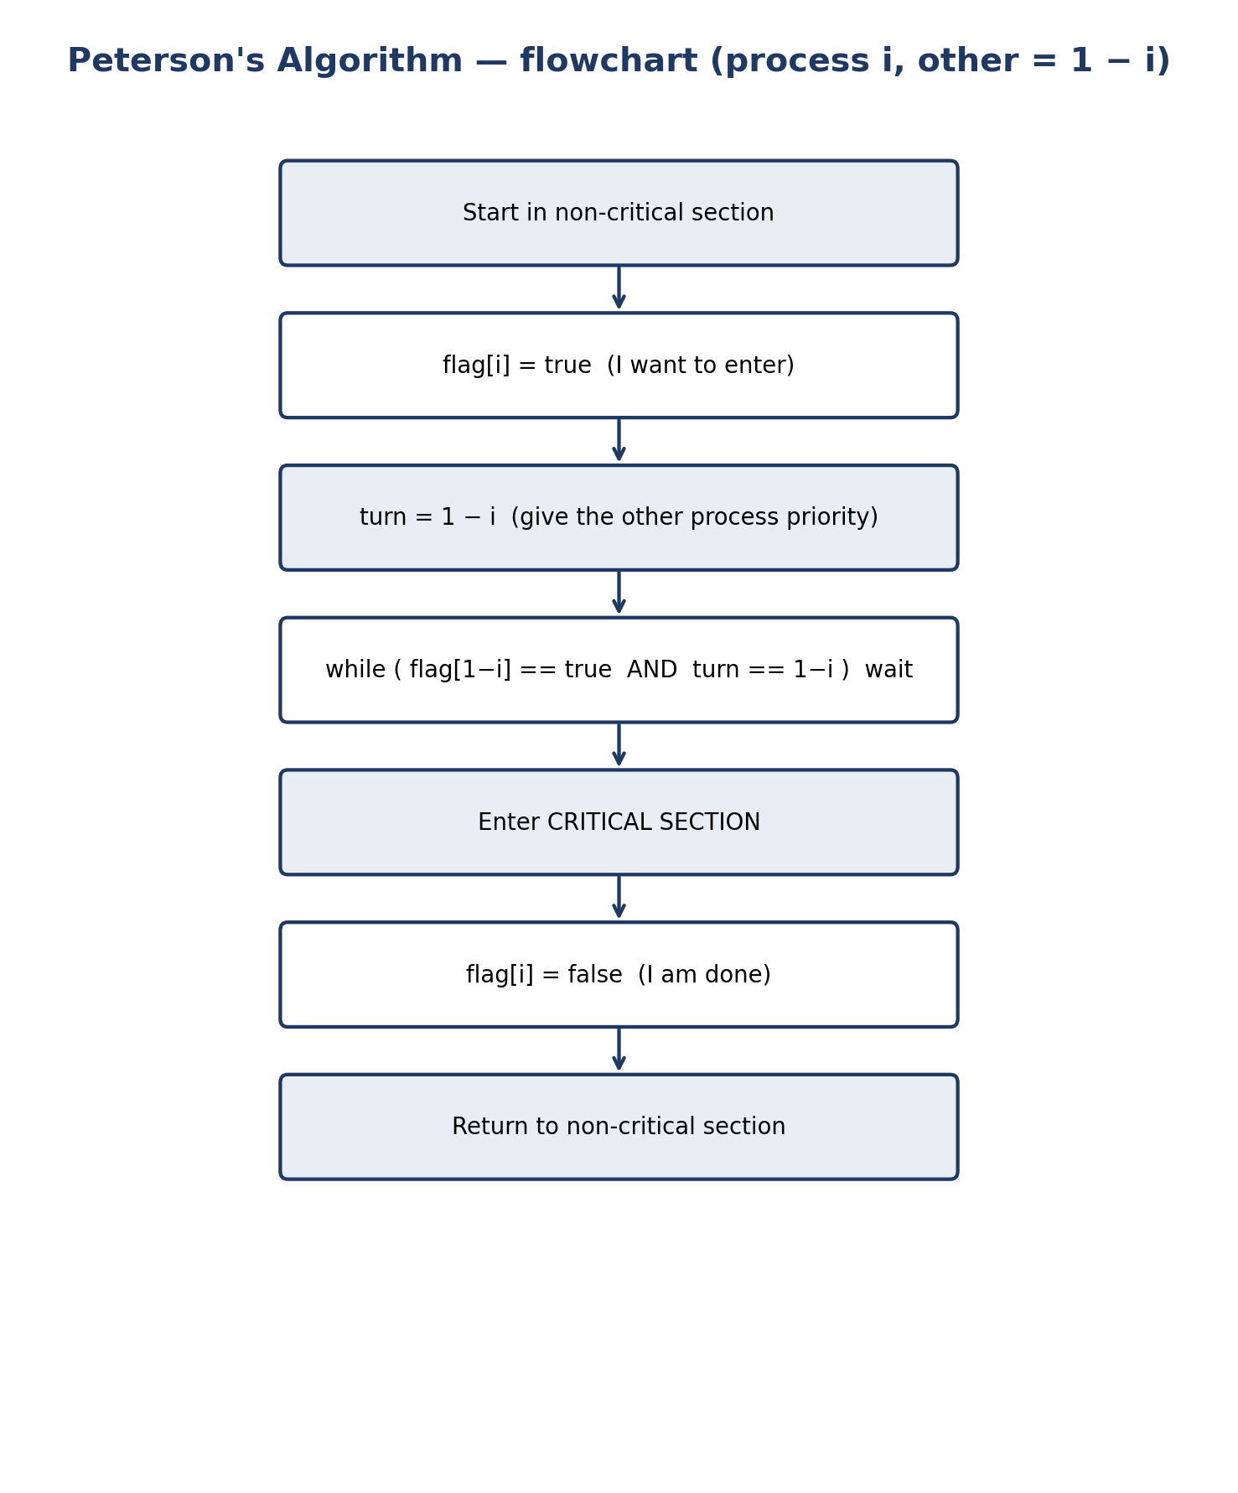
Figure 3. Flowchart of Peterson's algorithm for process Pi.
The flowchart in Figure 3 and the timeline in Figure 2 should be read together: the flowchart is the static control flow; the timeline is one dynamic interleaving. The critical-section entry-and-exit shape shared by all solutions in this document is in Figure 1.

7 Dekker's Algorithm

7.1 Introduction and historical background
Th. J. Dekker published the first known correct software solution to the two-process mutual-exclusion problem in 1965 [6]. It predates Peterson by sixteen years and is considerably more intricate: the waiting process must explicitly back off (lower its flag) when it is not its turn, and then raise its flag again when its turn arrives. Dekker's algorithm is historically important — it proved that mutual exclusion was achievable in software alone — and pedagogically important, because its awkwardness shows why Peterson's simplification mattered. Both assume the same memory model (Section 6.8 applies word for word).

7.2 Problem definition
Identical to Peterson's problem (Section 6.2): two processes, shared variables flag[0..1] and turn, atomic loads/stores only, satisfying mutual exclusion, progress, and bounded waiting.

7.3 Shared variables
The same pair as Peterson: flag[i] = true means Pi wants to enter; turn = i means it is Pi's turn to insist — the other process backs off. The difference is not the variables but the discipline for testing and backing off.

7.4 Algorithm and pseudocode
Algorithm 2. Dekker's algorithm for process Pi.
shared boolean flag[2] = {false, false};
shared int turn = 0; // 0 or 1

process Pi (i = 0 or 1, j = 1 - i):
loop forever:
// ---- entry section ----
flag[i] = true;
while (flag[j] == true):
if (turn != i):
flag[i] = false; // back off politely
while (turn != i):
; // wait for my turn
flag[i] = true; // try again
// ---- critical section ----
... access shared data ...
// ---- exit section ----
turn = j; // hand the turn over
flag[i] = false;
// ---- remainder section ----
...

7.5 Step-by-step execution and the turn-taking mechanism
Turn-taking is the heart of Dekker. Suppose both processes raise their flags. Each sees the other's flag and checks turn. The process whose turn it is not lowers its flag and waits until turn changes; the other proceeds. The process in the critical section hands the turn over on exit (turn = j), so a process that backed off will find turn == i when it re-tests. Example: P0 and P1 both set their flags; turn = 0. P0's inner test turn != 0 is false, so P0 waits only while flag[1] is true — but P1, seeing turn != 1, lowers flag[1], so P0's outer test becomes false and P0 enters. P1 waits in its inner loop until P0 exits and sets turn = 1, then raises flag[1] again and enters. The back-off is what prevents the deadlock of the naïve “set flag and wait while the other's flag is set” attempt: exactly one process backs off, because turn names only one of them.

7.6 Mutual exclusion, progress, and bounded waiting
Mutual exclusion. A process enters only when the other's flag is false. The other's flag is true from its entry attempt until its exit, except for a process that has backed off — and a backed-off process cannot be in its critical section, because it re-raises its flag only after observing turn == i and then must re-test the other's flag. A careful case analysis on the last writer of turn shows both cannot pass the outer test together. Progress. If one process is uninterested, the other's outer test is false at once; if both are interested, exactly one holds the turn and the other backs off, so one enters. Bounded waiting. Once Pi is waiting with turn = i (or after it backs off and waits for turn = i), Pj can enter at most once before handing the turn to Pi; after that, Pi's re-raised flag and turn == i let it enter. (Some presentations state the bound for Dekker as one overtake; either way it is finite, and therefore starvation-free.)

7.7 Advantages, disadvantages, and limitations
- Advantages: historically the first correct software solution; pure software; satisfies all three properties for two processes.
- Disadvantages: more complex and harder to prove than Peterson; busy waiting in two nested loops; only two processes; same memory-model assumptions as Peterson; the back-off step is easy to get wrong (omitting the re-raise of flag[i], or setting turn in the wrong place, breaks the algorithm).
- Assumptions: atomic, sequentially consistent accesses; eventual exit from the critical section; no process fails (crashes) inside its critical section — if it did, the other would wait forever.

7.8 Practical example and source code (C11 / POSIX threads)
Practical example: the same shared-counter experiment as Section 6.9. Two threads each increment a counter 200,000 times under Dekker's algorithm; the correct final value is 400,000. In a teaching laboratory, running the Peterson and Dekker programs side by side is instructive: identical result, visibly different code shapes, and the same performance character (spinning).
Listing 2. Dekker's algorithm in C11 with POSIX threads.
/* dekker.c — Dekker's algorithm for two threads (C11, _Atomic).
Compile: gcc -std=c11 -O2 -pthread -o dekker dekker.c
Run: ./dekker
Same warning as Peterson: use _Atomic with sequential consistency.
Dekker's original (1965) formulation is longer because it has no
single combined test; the inner loop below is the classic form. */
#include <stdio.h>
#include <stdatomic.h>
#include <pthread.h>

#define NITER 200000
static _Atomic int flag[2] = {0, 0};
static _Atomic int turn = 0;
static long shared_counter = 0;

static void *worker(void *arg) {
long id = (long)arg, other = 1 - id;
for (int k = 0; k < NITER; k++) {
atomic_store(&flag[id], 1);
while (atomic_load(&flag[other])) {
if (atomic_load(&turn) != id) {
atomic_store(&flag[id], 0); /* back off */
while (atomic_load(&turn) != id) ; /* wait my turn */
atomic_store(&flag[id], 1);
}
}
shared_counter++; /* critical section */
atomic_store(&turn, (int)other); /* hand turn over */
atomic_store(&flag[id], 0);
}
return NULL;
}
int main(void) {
pthread_t t0, t1;
pthread_create(&t0, NULL, worker, (void *)0L);
pthread_create(&t1, NULL, worker, (void *)1L);
pthread_join(t0, NULL); pthread_join(t1, NULL);
printf("counter = %ld (expected %d)\n", shared_counter, 2 * NITER);
return 0;
}

Build commands for Listing 2.
gcc -std=c11 -O2 -pthread -o dekker dekker.c
./dekker

Illustrative sample output: counter = 400000 (expected 400000). Key points: the outer while loop tests the other's flag; the inner while loop waits for the turn; flag[i] is lowered before that wait and raised again afterwards — omitting either step breaks the algorithm. Test by commenting out the re-raise line and watching the program hang (deadlock) on some runs.

7.9 Flowchart
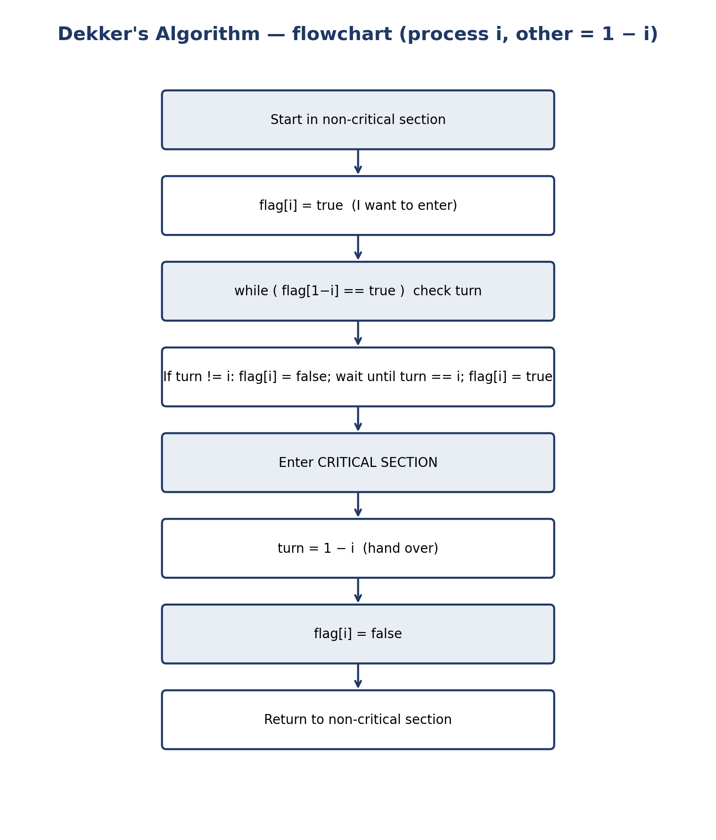
Figure 4. Flowchart of Dekker's algorithm for process Pi, showing the explicit back-off.

8 Semaphore

8.1 Definition and theoretical background
A semaphore, introduced by Edsger W. Dijkstra in the 1960s [7], is an integer variable that can be accessed only through two atomic operations: wait (P, from Dutch proberen, “to test”) and signal (V, from verhogen, “to increment”). A semaphore is the operating system's answer to the limits of Peterson and Dekker: instead of spinning on shared variables, a process that cannot proceed blocks, and the operating system wakes it later. Because the operations are atomic and blocking, a semaphore works for any number of processes and for counting identical resources, not just for mutual exclusion.

8.2 Binary and counting semaphores
- Binary semaphore (mutex semaphore). Takes only the values 0 and 1, initialized to 1. The first process to wait succeeds and the semaphore becomes 0; later processes block until a signal restores it to 1. This is the semaphore used for mutual exclusion.
- Counting semaphore. Takes any non-negative integer value, initialized to N. It counts N identical resources (for example, N empty buffer slots, or N identical printers). A wait decrements it; a signal increments it. When it is 0, the next waiter blocks. A binary semaphore is the special case N = 1.
In many textbook presentations the value S is allowed to go negative, with |S| equal to the number of waiting processes. Real implementations (POSIX sem_t) keep a separate wait queue and S never goes below zero; the negative-value view is a useful invariant for hand-tracing, and it is used in the exercises in Chapter 14, where the convention is stated explicitly each time.

8.3 wait(P) and signal(V) operations
Algorithm 3. Semaphore operations (textbook negative-value presentation).
wait(S): // P(S), atomic
S = S - 1;
if (S < 0) block this process on S's queue;

signal(S): // V(S), atomic
S = S + 1;
if (S <= 0) wake one process from S's queue;

Both operations are atomic: the decrement (or increment) and the decision to block (or wake) happen as one indivisible step. That atomicity is what a semaphore adds over a plain integer, and it is implemented by the kernel or the threading library, typically with a hardware atomic instruction and interrupts disabled briefly, or with a spinlock around a short critical path. The waiting process does not spin: it is removed from the run queue until it is woken.
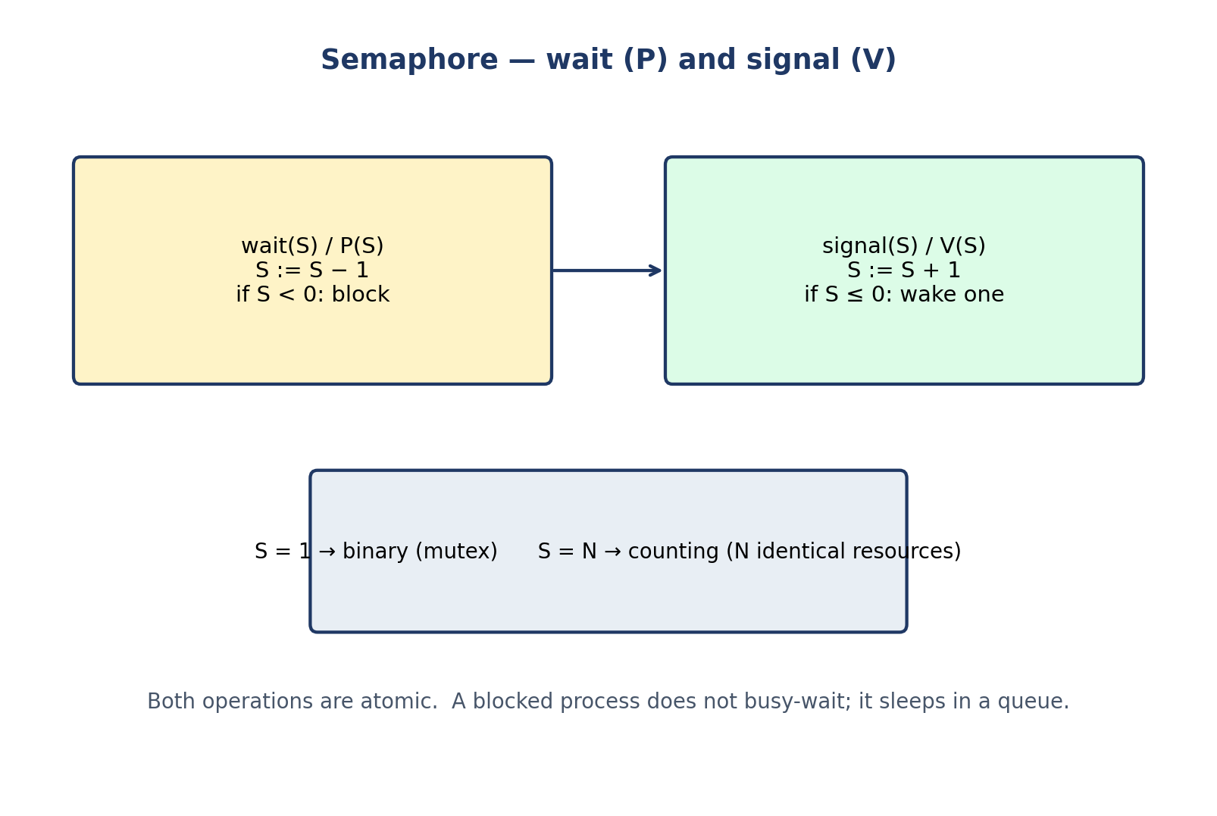
Figure 5. Semaphore wait (P) and signal (V): binary versus counting use.

8.4 Mutual exclusion and critical-section protection
Algorithm 4. Protecting a shared counter with a binary semaphore.
shared semaphore mutex = 1; // binary semaphore
shared int counter = 0;

process i:
wait(mutex); // entry
counter = counter + 1; // critical section
signal(mutex); // exit

The first process to execute wait finds mutex = 1, decrements it to 0, and enters. Any other process finds mutex = 0, decrements it to −1, and blocks. When the first process signals, mutex returns to 0 and one waiter is woken. Mutual exclusion holds because mutex = 1 is the single “permission token” and only the process that took it can return it.

8.5 Synchronization examples: bounded buffer and rendezvous
Beyond mutual exclusion, semaphores express synchronization between processes. The bounded buffer (producer–consumer) uses three semaphores: empty (initially N, the number of free slots), full (initially 0, the number of filled slots), and mutex (initially 1, protecting the buffer indices). A producer waits on empty, then mutex, inserts, signals mutex, then full; a consumer waits on full, then mutex, removes, signals mutex, then empty. The order matters: waiting on mutex before empty can deadlock (a producer holding mutex while waiting for a slot blocks the consumer that could free a slot). A rendezvous — two processes that must both arrive before either proceeds — is two semaphores, or one semaphore used as a signal. These patterns are the standard vocabulary of semaphore programming, and Chapter 13 traces them numerically.

8.6 Deadlock and starvation considerations
Semaphores do not prevent deadlock by themselves: they are a tool that can build deadlock-free solutions or deadlocking ones. Deadlock arises when processes acquire semaphores in different orders and wait in a cycle (Section 3.4), or when a wait is forgotten and never matched by a signal. Starvation arises if the wait queue is not FIFO: a newly arriving process can repeatedly overtake a waiting one. POSIX semaphores do not guarantee FIFO wake-up order, so starvation freedom with semaphores is an implementation property, not a property of the semaphore concept. In the comparison tables this is recorded as “depends on the implementation / queue discipline”, never as an unconditional Yes.

8.7 Advantages and disadvantages
- Advantages: general and flexible — mutual exclusion, signalling, rendezvous, resource counting, all from one primitive; blocks instead of spinning; works for any number of processes.
- Disadvantages: easy to misuse — a forgotten signal deadlocks everyone, a signal in the wrong place can allow two processes in, and an unmatched wait/signal pair is hard to spot by inspection; no structural protection (the compiler cannot check that wait and signal are paired); debugging requires tracing the semaphore value over time.

8.8 Practical example and source code
Listing 3 has two parts. Part (a) repeats the shared-counter experiment with a binary semaphore: 2 × 100,000 increments give exactly 200,000. Part (b) is the bounded buffer with N = 5 slots, one producer and one consumer exchanging the values 0…19 in order. Note the disciplined pairing: every sem_wait is matched by a sem_post on every path, and the buffer mutex is never held while waiting on empty or full.
Listing 3. Binary semaphore and bounded buffer in C (POSIX semaphores).
/* semaphore_demo.c — binary semaphore (mutex) + counting semaphore.
Compile: gcc -std=c11 -O2 -pthread -o sem_demo semaphore_demo.c
Run: ./sem_demo
Demonstrates (a) a binary semaphore protecting a counter and
(b) a bounded buffer with empty/full counting semaphores. */
#include <stdio.h>
#include <semaphore.h>
#include <pthread.h>

#define NITER 100000
static sem_t mutex; /* binary semaphore, initial value 1 */
static long counter = 0;

static void *incrementer(void *arg) {
(void)arg;
for (int i = 0; i < NITER; i++) {
sem_wait(&mutex); /* P(mutex): enter critical section */
counter++;
sem_post(&mutex); /* V(mutex): leave critical section */
}
return NULL;
}
/* --- bounded buffer (part b): N slots, producers/consumers --- */
#define NBUF 5
static int buf[NBUF], in = 0, out = 0;
static sem_t empty_slots, full_slots, buf_mutex;
static void *producer(void *arg) {
for (int i = 0; i < 20; i++) {
sem_wait(&empty_slots); /* wait for a free slot */
sem_wait(&buf_mutex);
buf[in] = i; in = (in + 1) % NBUF;
sem_post(&buf_mutex);
sem_post(&full_slots); /* one more full slot */
}
(void)arg; return NULL;
}
static void *consumer(void *arg) {
for (int i = 0; i < 20; i++) {
sem_wait(&full_slots);
sem_wait(&buf_mutex);
int v = buf[out]; out = (out + 1) % NBUF;
sem_post(&buf_mutex);
sem_post(&empty_slots);
printf("consumed %d\n", v);
}
(void)arg; return NULL;
}
int main(void) {
sem_init(&mutex, 0, 1);
pthread_t a, b; pthread_create(&a, NULL, incrementer, NULL);
pthread_create(&b, NULL, incrementer, NULL);
pthread_join(a, NULL); pthread_join(b, NULL);
printf("counter = %ld (expected %d)\n", counter, 2 * NITER);
sem_init(&empty_slots, 0, NBUF); sem_init(&full_slots, 0, 0);
sem_init(&buf_mutex, 0, 1);
pthread_t p, c; pthread_create(&p, NULL, producer, NULL);
pthread_create(&c, NULL, consumer, NULL);
pthread_join(p, NULL); pthread_join(c, NULL);
sem_destroy(&mutex); sem_destroy(&empty_slots);
sem_destroy(&full_slots); sem_destroy(&buf_mutex);
return 0;
}

Build commands for Listing 3.
gcc -std=c11 -O2 -pthread -o sem_demo semaphore_demo.c
./sem_demo

Illustrative sample output: counter = 200000 (expected 200000), then consumed 0 … consumed 19 in order. Important functions: sem_init(&mutex, 0, 1) creates a thread-shared binary semaphore (the second argument 0 means “shared between threads of this process”, not between processes); sem_wait / sem_post are P and V; sem_destroy frees the semaphore. Testing: change NBUF to 1 and confirm the output order is unchanged (only the throughput changes); swap the two waits in the producer and observe the deadlock (then restore the order).

9 Monitor

9.1 Definition and theoretical background
A monitor, proposed by Per Brinch Hansen and by C. A. R. Hoare in the early 1970s [8, 9], is a high-level synchronization construct: it bundles shared data together with the procedures that operate on it, inside a module. Only the monitor's own procedures may touch its data, and at most one process may be executing inside a monitor at a time. The compiler (or runtime) enforces the mutual exclusion; the programmer no longer places wait and signal calls around data by hand, so the pairing errors that plague semaphores become structurally impossible. A monitor is a language construct (Java's synchronized methods and objects are its best-known descendant) rather than a single operating-system primitive.
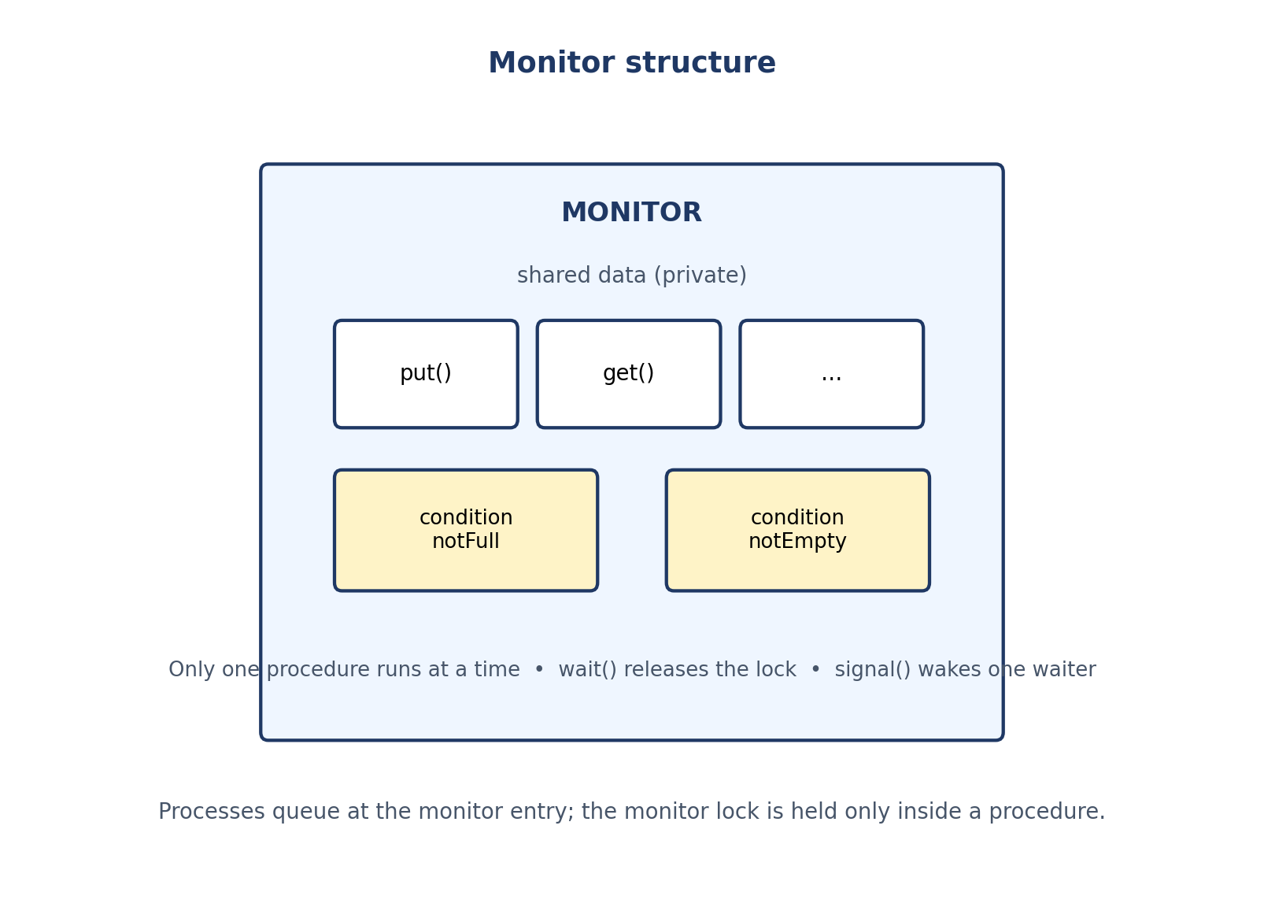
Figure 6. Monitor structure: private shared data, procedures with automatic mutual exclusion, and condition variables.

9.2 Monitor structure and mutual exclusion
A monitor has three parts: (1) private shared data, invisible outside the monitor; (2) procedures (methods) that are the only way to access that data; (3) an entry queue of processes waiting to get in. The monitor lock is acquired on entry to any procedure and released on exit. Because the lock is held for the whole procedure, mutual exclusion is automatic. A procedure that needs a condition to become true cannot simply wait inside the monitor while holding the lock — that would block everyone else — so monitors provide condition variables (Section 9.3).

9.3 Condition variables: wait() and signal()
- condition variable is not a boolean and has no value; it is a queue of waiting processes, plus the operations wait and signal.
- wait(c): the calling process releases the monitor lock, suspends itself on c's queue, and — when woken — re-acquires the lock before resuming. Releasing the lock is essential: otherwise no other process could enter and change the condition.
- signal(c): wakes one process waiting on c (if any). If no process is waiting, the signal has no effect and is not remembered — unlike a semaphore signal, which increments a counter. This “no memory” property is a classic exam trap.
- broadcast / signalAll: wakes all waiters; needed when a change may satisfy several waiters or different conditions share one variable.
The bounded-buffer monitor uses two condition variables, notFull and notEmpty. A producer that finds the buffer full waits on notFull; a consumer that removes an item signals notFull. Symmetric logic holds for notEmpty. Because a signal is not remembered, the waiting condition must be re-tested after waking (see Section 9.4): the code uses while, not if.

9.4 Hoare versus Mesa monitor semantics
Table 4. Hoare versus Mesa monitor semantics. The C code in this document uses Mesa semantics (POSIX).
Aspect | Hoare semantics | Mesa semantics
Who runs after signal | The signalled (waiting) process runs immediately; the signaller waits. | The signaller continues; the signalled process is scheduled later.
Condition on waking | Guaranteed true (the waiter runs before anyone can change it). | Not guaranteed: another process may run first and change it.
Waiting test | if is enough (in theory). | while (re-test) is mandatory.
Used by | Early Hoare monitors; some textbook presentations. | Java (wait/notify), POSIX condition variables, most modern systems.

All code in this document uses Mesa semantics, because POSIX condition variables and Java both do. That is why every wait in Listing 4 is inside a while loop: a woken process must re-check count == NBUF, because another producer may have filled the buffer first, or a spurious wake-up may have occurred (POSIX permits spurious wake-ups). Writing if instead of while is one of the commonest monitor bugs (Section 16).

9.5 Deadlock and starvation; advantages and disadvantages
- Deadlock: a monitor does not prevent deadlock by itself — two monitors with procedures that call each other can deadlock, and waiting forever on a condition that is never signalled is a deadlock in effect. But the classic single-monitor errors of semaphores (forgotten signal, wrong pairing) are structurally reduced.
- Starvation: depends on the entry-queue and condition-queue discipline; it is not guaranteed by the monitor concept, so the table records it as implementation-dependent.
- Advantages: mutual exclusion is automatic; data and its protection live together (modularity); condition variables express “wait until X” directly; far fewer pairing errors than semaphores.
- Disadvantages: needs language or library support (C has no native monitor — Listing 4 builds one from a mutex and condition variables); condition variables are still easy to misuse (signal with no waiter is lost; signalAll can cause a thundering herd); a long procedure holds the monitor lock and blocks everyone.

9.6 Practical example and source code (C: monitor built from mutex + condition variables)
C does not provide a native monitor construct, so Listing 4 constructs one explicitly and says so: the BoundedBuffer struct is the monitor, its fields are private to the file, only bb_put and bb_get touch them, and the pthread mutex is the monitor lock. The two pthread condition variables are the monitor's condition variables. Every procedure follows the same pattern: lock, while-test-and-wait, modify, signal, unlock.
Listing 4. Bounded-buffer monitor in C (pthread mutex + condition variables, Mesa semantics).
/* monitor_demo.c — a monitor in C, built from pthread mutex + condvars.
Compile: gcc -std=c11 -O2 -pthread -o monitor_demo monitor_demo.c
Run: ./monitor_demo
C has NO native monitor construct. The struct below is the monitor:
its data are private to the file, only its procedures touch them,
and exactly one thread runs inside a procedure at a time because
every procedure locks mon->lock on entry and unlocks on exit.
Condition variables (notFull / notEmpty) are the monitor's
condition variables; pthread_cond_wait() releases the lock while
waiting, exactly as monitor wait() must. */
#include <stdio.h>
#include <pthread.h>
#define NBUF 5
typedef struct {
pthread_mutex_t lock; /* the monitor lock */
pthread_cond_t notFull; /* wait here when buffer full */
pthread_cond_t notEmpty; /* wait here when buffer empty */
int buf[NBUF], count, in, out; /* private shared data */
} BoundedBuffer;
static void bb_init(BoundedBuffer *m) {
pthread_mutex_init(&m->lock, NULL);
pthread_cond_init(&m->notFull, NULL);
pthread_cond_init(&m->notEmpty, NULL);
m->count = m->in = m->out = 0;
}
static void bb_put(BoundedBuffer *m, int item) { /* monitor procedure */
pthread_mutex_lock(&m->lock);
while (m->count == NBUF) /* Mesa semantics: re-test */
pthread_cond_wait(&m->notFull, &m->lock); /* wait(): release + sleep */
m->buf[m->in] = item; m->in = (m->in + 1) % NBUF; m->count++;
pthread_cond_signal(&m->notEmpty); /* signal(): wake one */
pthread_mutex_unlock(&m->lock);
}
static int bb_get(BoundedBuffer *m) { /* monitor procedure */
pthread_mutex_lock(&m->lock);
while (m->count == 0)
pthread_cond_wait(&m->notEmpty, &m->lock);
int v = m->buf[m->out]; m->out = (m->out + 1) % NBUF; m->count--;
pthread_cond_signal(&m->notFull);
pthread_mutex_unlock(&m->lock);
return v;
}
static BoundedBuffer bb;
static void *producer(void *arg) {
(void)arg;
for (int i = 0; i < 10; i++) bb_put(&bb, i);
return NULL;
}
static void *consumer(void *arg) {
(void)arg;
for (int i = 0; i < 10; i++) printf("got %d\n", bb_get(&bb));
return NULL;
}
int main(void) {
bb_init(&bb);
pthread_t p, c;
pthread_create(&p, NULL, producer, NULL);
pthread_create(&c, NULL, consumer, NULL);
pthread_join(p, NULL); pthread_join(c, NULL);
return 0;
}

Build commands for Listing 4.
gcc -std=c11 -O2 -pthread -o monitor_demo monitor_demo.c
./monitor_demo

Illustrative sample output: got 0, got 1, … got 9, in order. Important functions: pthread_cond_wait(&m->notFull, &m->lock) atomically releases the lock and sleeps, and re-acquires the lock on waking; pthread_cond_signal wakes one waiter. Testing: change the while to if in bb_get and run with several producers/consumers to see occasional failures; restore while and the failures disappear.

9.7 Flowchart
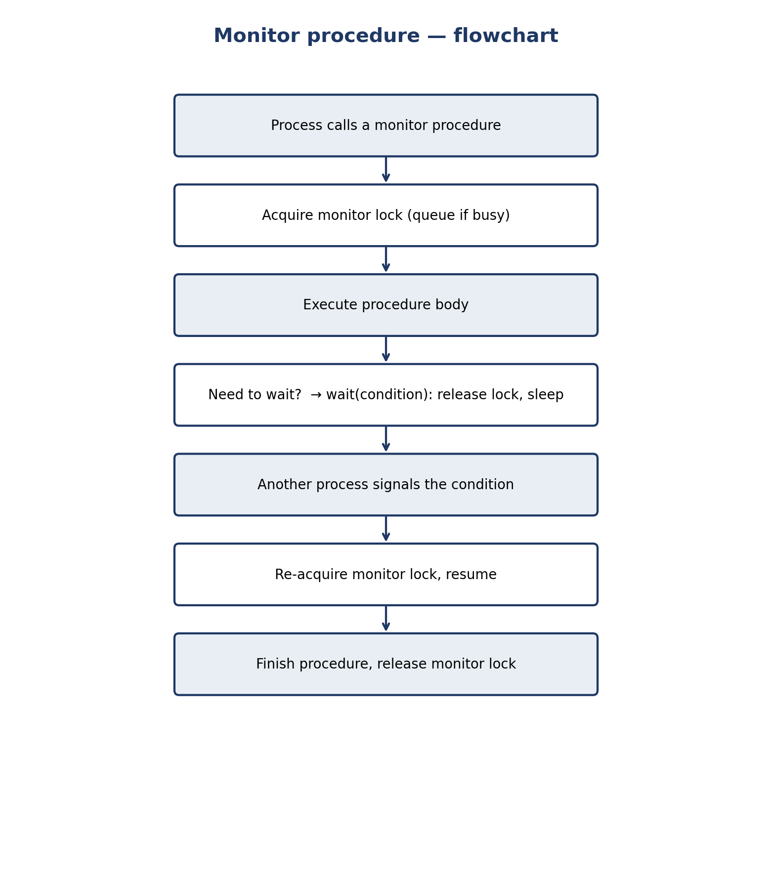
Figure 7. Flowchart of a monitor procedure call, including wait and signal.

10 Readers–Writers Problem

10.1 Problem definition
A shared database (or file, or data structure) is accessed by reader processes, which only read, and writer processes, which read and write. The rules are: any number of readers may read simultaneously; a writer needs exclusive access (no reader and no other writer active); when a writer is active, nobody else may access. The problem, first stated by Courtois, Heymans and Parnas in 1971 [10], is to design entry/exit protocols for readers and writers that satisfy these rules and choose a policy for who waits when both kinds are present.

10.2 Shared resource model
Model the resource as a single shared data item (an integer in the listings) guarded by protocols, with the counters and semaphores of the subsections below. The read side is a counting problem (how many readers are active?); the write side is a mutual-exclusion problem (is anyone active?). One counter, readCount, and two semaphores, mutex and wrt, express the classical solutions; the fair solution adds a third semaphore as a turnstile (Section 10.6).
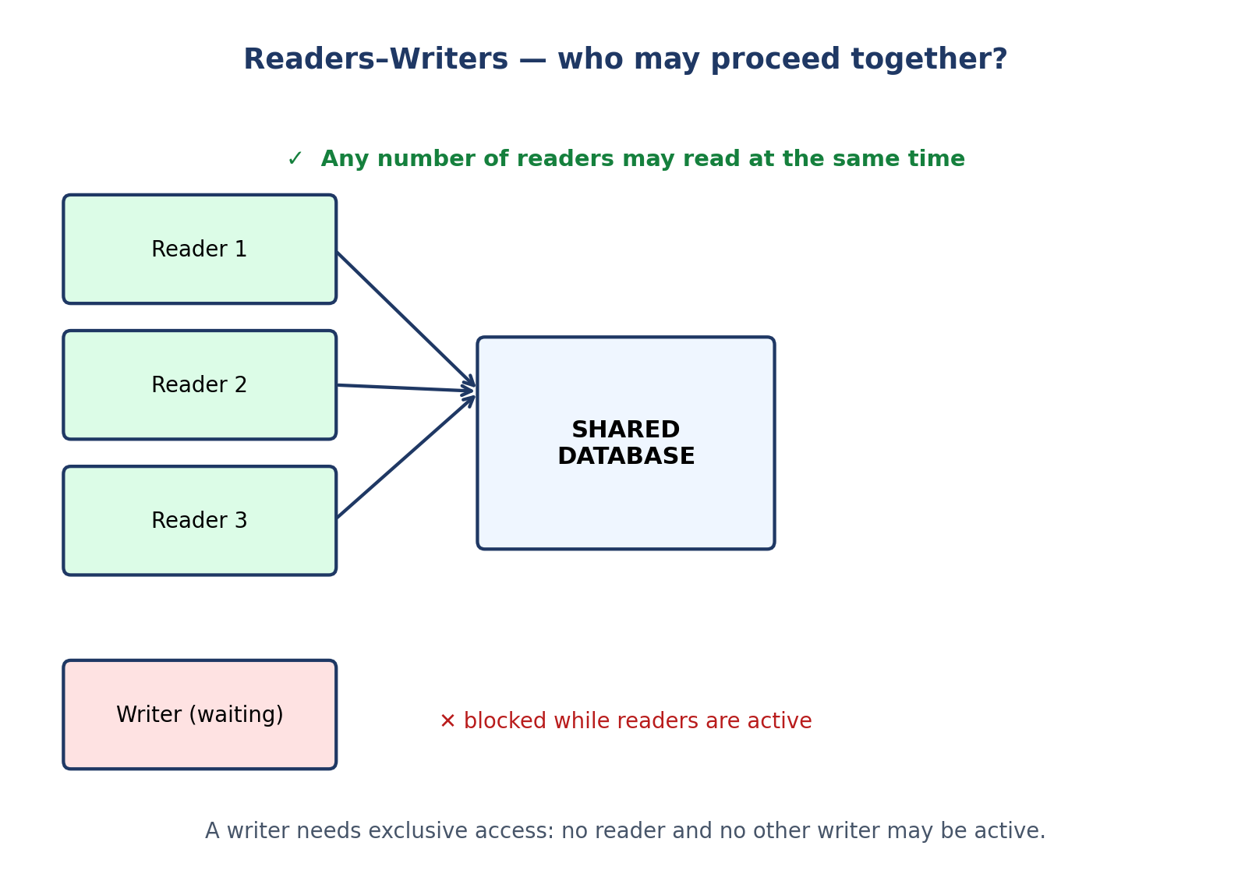
Figure 8. Readers–writers: simultaneous readers are allowed; a writer waits for exclusive access.

10.3 Reader-priority solution
Algorithm 5. Reader-priority readers–writers (semaphores).
shared semaphore mutex = 1, wrt = 1;
shared int readCount = 0;

reader:
wait(mutex);
readCount = readCount + 1;
if (readCount == 1) wait(wrt); // first reader locks writers out
signal(mutex);
... read the database ...
wait(mutex);
readCount = readCount - 1;
if (readCount == 0) signal(wrt); // last reader lets writers in
signal(mutex);
writer:
wait(wrt);
... write the database ...
signal(wrt);

Why it works: wrt is held by the first reader until the last reader leaves, so a writer can enter only when no reader is active; and readers among themselves need no wrt, so they proceed together. Why it is unfair: as long as at least one reader is active, newly arriving readers keep readCount above zero and the writer never sees readCount == 0. A continuous stream of readers starves a writer indefinitely, even though the system is not deadlocked.

10.4 Writer-priority solution
Writer priority adds a semaphore (and usually a writeCount and a readTry semaphore) that blocks new readers as soon as a writer is waiting: a reader must pass readTry before reaching the readCount logic, and a writer holds readTry while it waits for wrt, so readers arriving after the writer queue behind it. Existing readers finish, the writer enters, and later readers proceed after it. The trade-off is the mirror image: writers are now favoured, and a continuous stream of writers can starve readers. The textbook writer-priority pseudocode (Silberschatz et al. [2], §7.4) is: semaphores mutex = 1, wrt = 1, readTry = 1; integer readCount = 0, writeCount = 0; a reader waits on readTry, then the usual first-reader logic; a writer increments writeCount under mutex, the first writer waits on readTry (blocking new readers) and then on wrt, writes, and the last writer signals readTry.

10.5 Fair (starvation-free) solution
A fair solution serves requests in (approximately) arrival order. The listing in Section 10.7 uses a turnstile (“gate”) semaphore: every arriving process, reader or writer, must pass the gate, and a writer that is waiting holds the gate closed, so readers arriving after it cannot overtake it; conversely, readers that arrived earlier hold no gate and finish in order. No process starves, because each request's position in the arrival order is bounded — at most one “round” of earlier arrivals precedes it. Fairness costs one extra semaphore and, occasionally, some lost parallelism (readers arriving just after a writer must wait behind it even though they could have read safely), which is the fundamental trade-off of this problem: maximum reader parallelism and writer responsiveness cannot both be maximized under a starvation-free policy.

10.6 Semaphore and monitor implementations
Semaphore implementation: Algorithms 5 and the writer-priority variant above. Monitor implementation: a monitor with operations startRead, endRead, startWrite, endWrite; two condition variables (canRead, canWrite) and counters of active/waiting readers and writers, with the policy (reader priority, writer priority, or fair) chosen by the conditions under which startRead and startWrite wait:
Algorithm 6. Monitor-based readers–writers (policy set by the startRead condition).
monitor ReadersWriters:
int activeReaders = 0, activeWriters = 0;
int waitingReaders = 0, waitingWriters = 0;
condition canRead, canWrite;
procedure startRead():
waitingReaders++;
while (activeWriters > 0 or
(FAIR and waitingWriters > 0)): wait(canRead);
waitingReaders--; activeReaders++;
procedure endRead():
activeReaders--;
if (activeReaders == 0) signal(canWrite);
procedure startWrite():
waitingWriters++;
while (activeReaders > 0 or activeWriters > 0): wait(canWrite);
waitingWriters--; activeWriters = 1;
procedure endWrite():
activeWriters = 0;
if (waitingWriters > 0) signal(canWrite);
else signal(canRead); // or broadcast, for all waiting readers

Setting the FAIR clause to false gives reader priority; leaving the waitingWriters term in gives a fair policy; preferring writers is achieved by making startWrite signal writers first and having startRead wait while waitingWriters > 0. One monitor, three policies — another reason monitors are a clearer vehicle than semaphores for policy experiments.

10.7 Mutual exclusion, progress, bounded waiting, and starvation analysis
Table 5. Readers–writers policies compared. Every policy satisfies mutual exclusion and progress; they differ on starvation.
Policy | Mutual exclusion | Progress | Bounded waiting / starvation
Reader priority | Yes: wrt is exclusive. | Yes: somebody proceeds whenever the database is free. | No for writers: a stream of readers can starve a writer. Bounded waiting fails for writers.
Writer priority | Yes: wrt is exclusive. | Yes. | No for readers: a stream of writers can starve a reader.
Fair (turnstile) | Yes: wrt is exclusive. | Yes. | Yes for both: arrival order bounds overtakes; neither side starves (assuming fair semaphore queues).

10.8 Practical example and source code (fair solution)
Listing 5 implements the fair solution: three readers and two writers each run five rounds over one shared integer. Readers print the value they see; writers increment it. The final value is 10 whatever the interleaving, because writers are serialized and readers never observe a half-written value.
Listing 5. Fair (starvation-free) readers–writers in C with POSIX semaphores.
/* rw_fair.c — starvation-free readers-writers (fair solution).
Compile: gcc -std=c11 -O2 -pthread -o rw_fair rw_fair.c
Run: ./rw_fair
Idea: a "gate" (turnstile) semaphore serialises arrivals. A new
reader must pass the gate, but a waiting writer holds the gate
closed, so readers arriving after a writer cannot overtake it.
No reader or writer can starve: requests are served in arrival
order at the gate, and the first reader / writer in line is the
one that eventually opens the database. */
#define _DEFAULT_SOURCE
#include <stdio.h>
#include <semaphore.h>
#include <pthread.h>
#include <unistd.h>

static sem_t gate; /* turnstile: FIFO-ish arrival order */
static sem_t wrt; /* 1 = database free; 0 = writer/reader in */
static sem_t mutex; /* protects readCount */
static int readCount = 0;
static int data = 0; /* the shared database (one integer) */

static void *reader(void *arg) {
long id = (long)arg;
for (int i = 0; i < 5; i++) {
sem_wait(&gate); sem_post(&gate); /* pass the turnstile */
sem_wait(&mutex);
readCount++;
if (readCount == 1) sem_wait(&wrt); /* first reader locks out writers */
sem_post(&mutex);
printf("reader %ld reads data = %d\n", id, data); /* reading */
sem_wait(&mutex);
readCount--;
if (readCount == 0) sem_post(&wrt); /* last reader lets writers in */
sem_post(&mutex);
usleep(1000);
}
return NULL;
}
static void *writer(void *arg) {
long id = (long)arg;
for (int i = 0; i < 5; i++) {
sem_wait(&gate); /* hold the gate while waiting */
sem_wait(&wrt); /* exclusive access */
data++; /* writing */
printf("writer %ld writes data = %d\n", id, data);
sem_post(&wrt);
sem_post(&gate);
usleep(1000);
}
return NULL;
}
int main(void) {
sem_init(&gate, 0, 1); sem_init(&wrt, 0, 1); sem_init(&mutex, 0, 1);
pthread_t r[3], w[2];
for (long i = 0; i < 3; i++) pthread_create(&r[i], NULL, reader, (void *)i);
for (long i = 0; i < 2; i++) pthread_create(&w[i], NULL, writer, (void *)i);
for (int i = 0; i < 3; i++) pthread_join(r[i], NULL);
for (int i = 0; i < 2; i++) pthread_join(w[i], NULL);
printf("final data = %d (expected 10)\n", data);
return 0;
}

Build commands for Listing 5.
gcc -std=c11 -O2 -pthread -o rw_fair rw_fair.c
./rw_fair

Illustrative sample output: interleaved “reader … reads data = …” and “writer … writes data = …” lines, ending with final data = 10 (expected 10). Testing: remove the gate waits (delete the two lines touching gate) and run with a reader loop that never sleeps — the writer's progress becomes erratic and demonstrably delayed, the reader-priority starvation in miniature; restore the gate and the interleaving becomes regular.

10.9 Flowchart
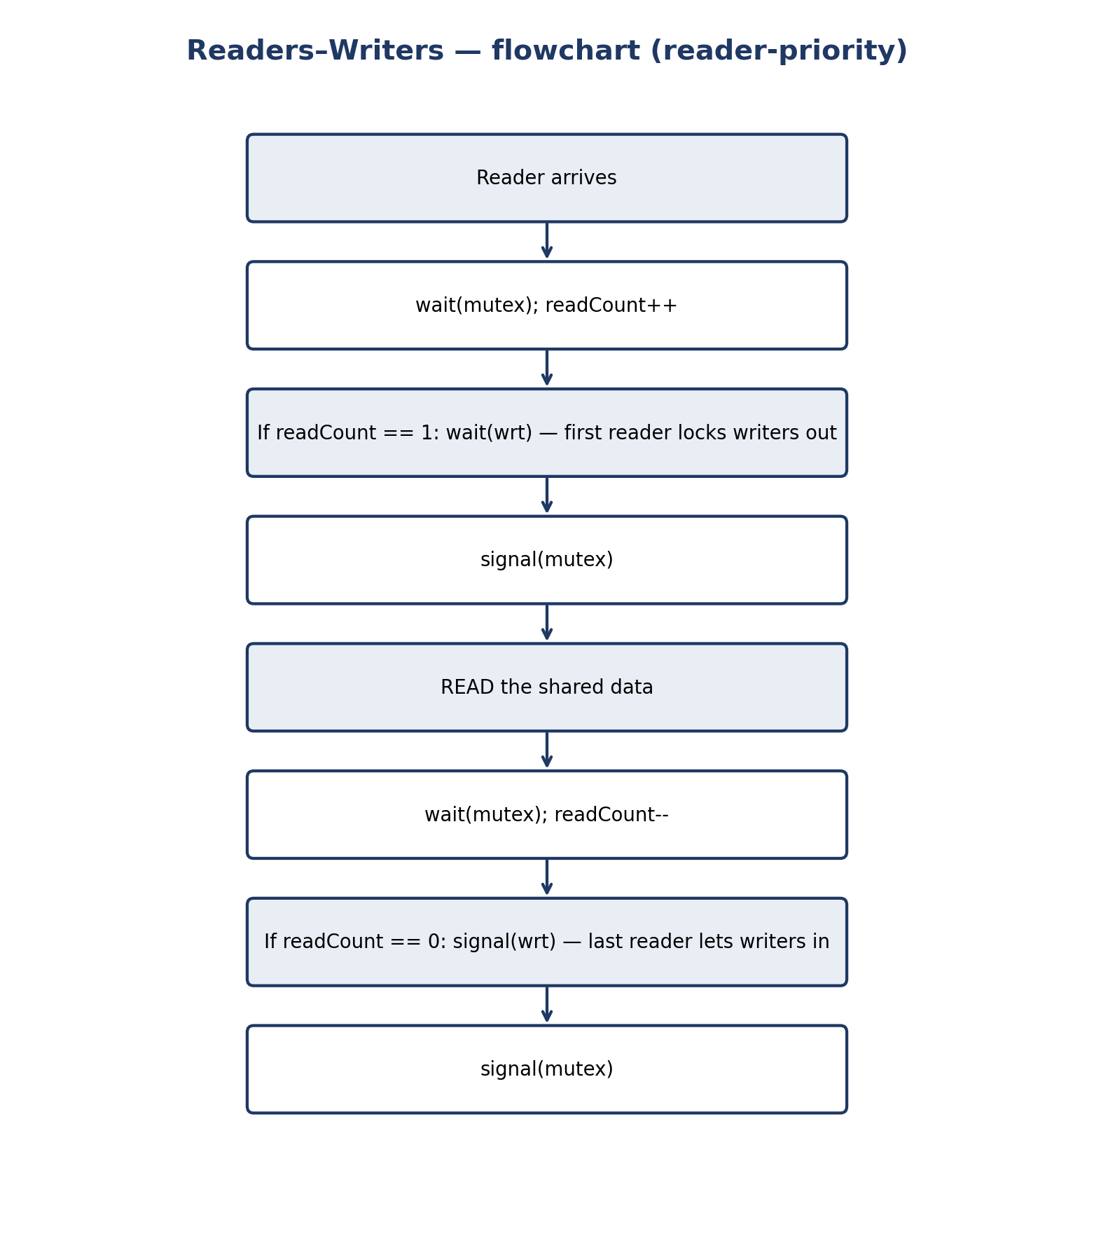
Figure 9. Flowchart of the reader-priority reader: first reader locks writers out, last reader lets them in.

11 Dining Philosophers Problem

11.1 Problem definition
Five philosophers sit around a round table with a bowl of spaghetti in the middle and one fork between each pair — five forks for five philosophers [11]. A philosopher thinks, becomes hungry, picks up the two forks nearest to them (left and right), eats, puts both forks down, and thinks again. A philosopher needs both forks to eat; with one fork they must wait. The problem is to design a protocol so that philosophers can eat without deadlock (everyone holding one fork and waiting forever) and without starvation (one philosopher never getting both forks). It is the standard model of resource allocation with two resources per process, and of everything that can go wrong with it.

11.2 Resource allocation model and philosopher states
Table 6. Philosopher states.
State | Meaning | What the philosopher holds
THINKING | Not interested in the forks; may think indefinitely. | No forks.
HUNGRY | Wants to eat; trying to acquire both forks. | Zero or one fork (in the naïve solution).
EATING | Has both forks and is eating. | Both forks (left and right).

The allocation graph has processes (philosophers) and resources (forks), each fork with one instance. A philosopher holding a fork and waiting for the other is the textbook instance of hold-and-wait; a cycle of such waits is circular wait; since a fork cannot be taken from a philosopher, there is no preemption; and a fork is used exclusively. All four of Coffman's conditions can hold, which is why this toy problem is an exact model of deadlock in real systems — allocate disk blocks, database locks, or memory pages, and the same structure appears (Chapter 15).
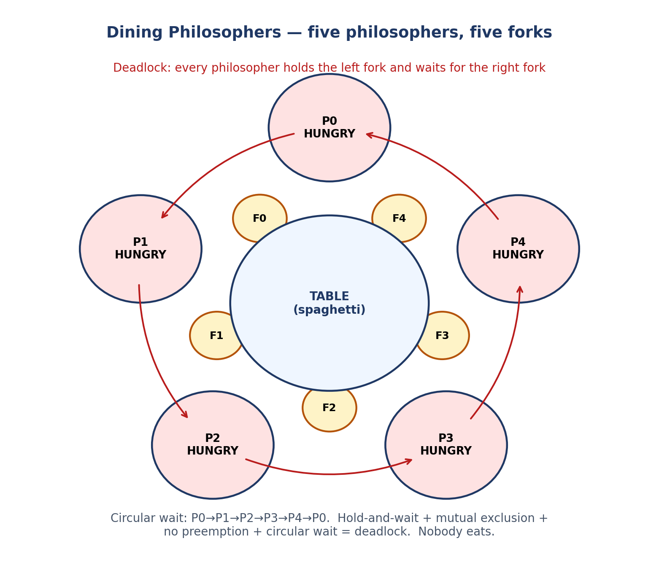
Figure 10. Dining philosophers: the deadlock — every philosopher is HUNGRY, holding the left fork and waiting for the right.

11.3 Classical semaphore solution (Dijkstra / Silberschatz)
Algorithm 7. Semaphore solution to dining philosophers (Silberschatz et al.).
shared semaphore mutex = 1; // protects state[]
shared semaphore s[5] = {0, 0, 0, 0, 0}; // one per philosopher
shared enum state[5] = {THINKING, ...}; // THINKING / HUNGRY / EATING

test(i): // may philosopher i eat? (called while holding mutex)
if (state[i] == HUNGRY and state[(i+4)%5] != EATING
and state[(i+1)%5] != EATING):
state[i] = EATING;
signal(s[i]); // wake i if it was waiting

philosopher i:
loop forever:
think();
wait(mutex);
state[i] = HUNGRY;
test(i); // try to get both forks
signal(mutex);
wait(s[i]); // block until test() lets me eat
... eat ...
wait(mutex);
state[i] = THINKING;
test((i+4)%5); // may the left neighbour eat now?
test((i+1)%5); // may the right neighbour eat now?
signal(mutex);

Why it is deadlock-free: philosopher i only becomes EATING inside test(i), which checks both neighbours, and test(i) runs under mutex; two neighbours can never be EATING at once, and because a philosopher acquires both forks “atomically” (in one test, under mutex), no philosopher ever holds one fork while waiting for another — hold-and-wait is broken. One philosopher can always eat: if all five are hungry, at least one has two non-eating neighbours (with five in a circle, the eating philosophers are never adjacent, and at least one gap exists). Starvation, however, is not guaranteed: the waiting semaphore queues and the test order can let a philosopher be overtaken repeatedly, so the classical solution is deadlock-free but not provably starvation-free without a fair queue discipline (see Section 11.7).

11.4 Monitor-based solution
The same test() logic, as a monitor: state[] is the monitor's private data, test(i) is a private monitor procedure, and each philosopher waits on its own condition variable self[i] instead of a semaphore. The translation is almost mechanical — wait(s[i]) becomes wait(self[i]), signal(s[i]) becomes signal(self[i]) — which shows the close kinship of the two mechanisms (Chapter 12 compares them). The monitor version is clearer because mutual exclusion is automatic: there is no explicit mutex semaphore to forget. The deadlock-freedom and starvation arguments are unchanged, and they still depend on the queue discipline.

11.5 Deadlock scenario
Naïve solution, step by step: (1) all five become hungry at the same time; (2) each executes wait(fork[i]) — the left fork — and succeeds, because every fork is free; (3) each executes wait(fork[(i+1) % 5]) — the right fork — and blocks, because it is held by the neighbour on the right; (4) nobody can proceed: each holds one fork and waits for a fork held by someone else; nobody puts a fork down, because eating is the only way forks are released. Five processes, all blocked, forever — Figure 8 shows the wait cycle P0→P1→P2→P3→P4→P0. Every one of Coffman's four conditions is present, and checking them off against the scenario is a standard exam exercise (Chapter 14, Exercise 14.6).

11.6 Starvation scenario
Even without deadlock, starvation is possible. Suppose philosophers 0 and 2 eat in strict alternation: whenever 1 becomes hungry, one of its neighbours is eating or about to eat, so test(1) keeps failing. If the scheduler is unlucky (or the neighbours are merely fast eaters), philosopher 1 can wait indefinitely while the table as a whole makes progress. This is the difference between “the system never deadlocks” and “every philosopher eventually eats”: the classical solution guarantees the first, not the second, unless a fair queue is assumed.

11.7 Deadlock prevention: resource ordering, waiter, and other techniques
Table 7. Deadlock prevention for dining philosophers.
Technique | Coffman condition broken | How it works | Cost
Resource ordering (asymmetric) | Circular wait | Number the forks 0…4; each philosopher takes the lower-numbered fork first. P4 takes F0 before F4, so the cycle cannot close. | Slight asymmetry; the last philosopher's order is reversed.
Waiter / arbitrator | Hold-and-wait (in effect) | A waiter semaphore (initially 4) must be acquired before sitting down: at most 4 philosophers can hold forks, so at least one can eat. | One extra semaphore; slight loss of parallelism.
Atomic acquisition (test()) | Hold-and-wait | A philosopher gets both forks in one atomic step or waits with none (Algorithm 7). | Needs the mutex + test discipline.
Limit philosophers / Chandy–Misra | Circular wait | At most 4 seated, or a token (hygienic) protocol where a fork is passed only when clean/dirty rules allow. | Extra machinery; Chandy–Misra is starvation-free but subtle.

Resource ordering is the most exam-friendly answer because it is a one-line rule with a clear proof: the wait-for graph has edges only from a lower-numbered fork to a higher-numbered one (except P4, whose edge is reversed and so can never close a cycle), hence no cycle is possible. The waiter is the easiest to implement for an arbitrary number of philosophers: “at most N − 1 may try at once”. The Chandy–Misra solution (1984) [12] gives a fully distributed, starvation-free protocol using clean/dirty fork tokens and request messages; it is included here as a named technique because a good answer should show awareness beyond the two textbook fixes, not because its full protocol is needed for the exam.
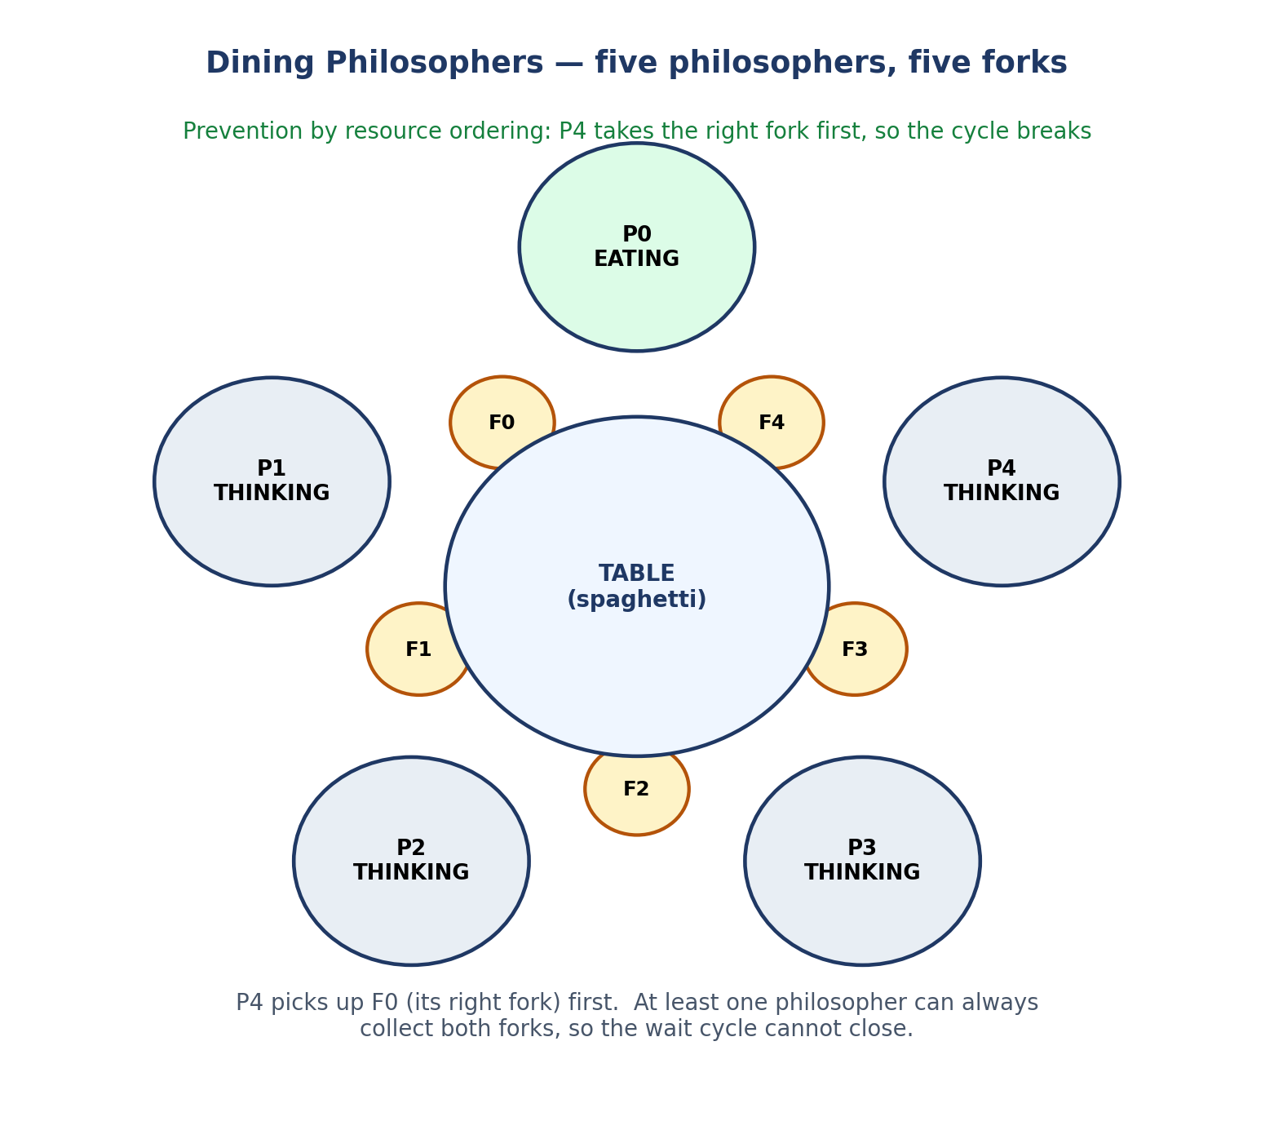
Figure 11. Deadlock prevention by resource ordering: P4 takes its right fork (F0) first; the wait cycle cannot close.

11.8 Mutual exclusion, progress, bounded waiting, and fairness
Table 8. Dining philosophers solutions compared.
Solution | Mutual exclusion | Deadlock-free | Starvation-free
Naïve (one fork at a time) | Yes (each fork is a binary semaphore). | No — Figure 8. | No.
Semaphore test() (Algorithm 7) | Yes. | Yes. | Only with a fair queue discipline for s[i] and mutex; not guaranteed by the algorithm alone.
Resource ordering (Listing 6) | Yes. | Yes. | Not guaranteed without fairness in the fork queues: a philosopher can still be overtaken.
Waiter (at most 4 seated) | Yes. | Yes. | Not guaranteed without fairness.
Chandy–Misra (1984) | Yes. | Yes. | Yes (by construction).

11.9 Practical example and source code (resource ordering)
Listing 6 uses resource ordering in C. Each philosopher eats three meals; the printout shows them eating in varying order and all finishing. Compare this with the naïve version (take left, then right): if all five pick up the left fork simultaneously, the program hangs — try it in a laboratory by swapping the take order to always-left-first, with a timeout, and observe the deadlock. The lesson is deliberately visceral: a deadlock you have watched happen is understood better than one you have only read about.
Listing 6. Dining philosophers in C: deadlock-free by resource ordering.
/* dining.c — Dining Philosophers, deadlock-free by resource ordering.
Compile: gcc -std=c11 -O2 -pthread -o dining dining.c
Run: ./dining
Rule: philosopher i takes fork min(i,(i+1)%5) first, then the other
fork. Philosopher 4 therefore takes fork 0 before fork 4, breaking
the circular wait. At most four philosophers can hold one fork
while waiting, so at least one can always eat. Also shown in the
text: the classic semaphore test()/take() solution and the waiter
(arbitrator) solution that allows at most four philosophers to sit
down at once. */
#define _DEFAULT_SOURCE
#include <stdio.h>
#include <semaphore.h>
#include <pthread.h>
#include <unistd.h>

#define N 5
static sem_t fork_sem[N];
static void think(int id) { printf("P%d thinking\n", id); usleep(1000); }
static void eat(int id) { printf("P%d EATING\n", id); usleep(1000); }
static void *philosopher(void *arg) {
int id = (int)(long)arg;
int left = id, right = (id + 1) % N;
int first = left < right ? left : right; /* lower-numbered fork */
int second = left < right ? right : left;
for (int meal = 0; meal < 3; meal++) {
think(id);
sem_wait(&fork_sem[first]); /* pick up forks in order */
sem_wait(&fork_sem[second]);
eat(id);
sem_post(&fork_sem[second]); /* put forks down */
sem_post(&fork_sem[first]);
}
printf("P%d finished\n", id);
return NULL;
}
int main(void) {
pthread_t t[N];
for (int i = 0; i < N; i++) sem_init(&fork_sem[i], 0, 1);
for (long i = 0; i < N; i++) pthread_create(&t[i], NULL, philosopher, (void *)i);
for (int i = 0; i < N; i++) pthread_join(t[i], NULL);
printf("All philosophers ate 3 meals each. No deadlock.\n");
return 0;
}

Build commands for Listing 6.
gcc -std=c11 -O2 -pthread -o dining dining.c
./dining

Illustrative sample output: interleaved “P0 thinking”, “P0 EATING”, …, ending with “All philosophers ate 3 meals each. No deadlock.” The eating order varies run to run; the invariant is that all five finish. Important functions: sem_wait(&fork_sem[first]) / sem_wait(&fork_sem[second]) take forks in global order; the order is the entire prevention mechanism. Testing: run under timeout 5 ./dining; then build the naïve variant (first = left always) and watch timeout kill it.

11.10 Flowchart
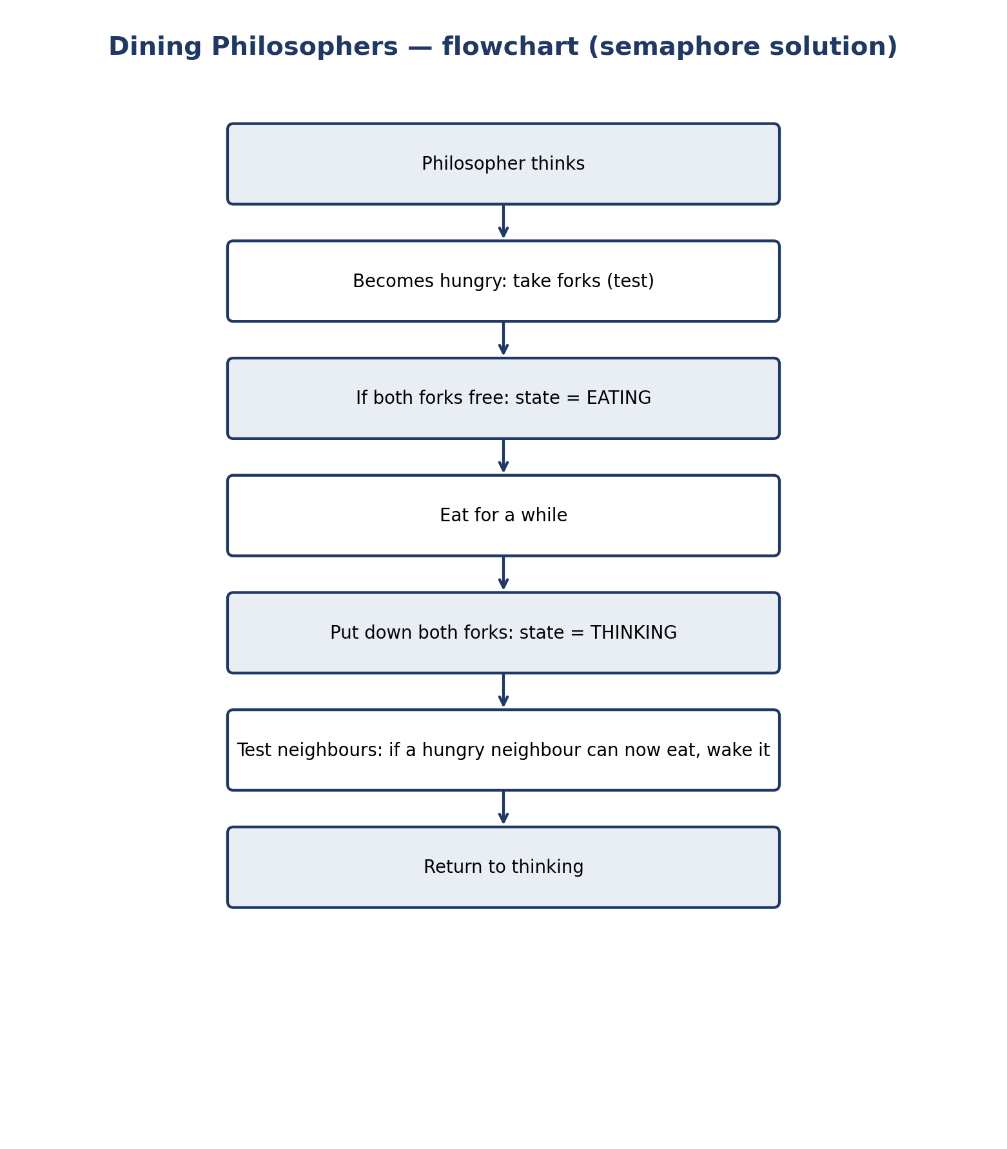
Figure 12. Flowchart of a dining philosopher in the semaphore (test) solution.

12 Comprehensive Comparison Tables
This chapter is the core of the document. Two things must be kept in mind. First, the six topics are not the same kind of thing: Peterson and Dekker are complete algorithms for two processes; semaphore and monitor are general primitives; readers–writers and dining philosophers are problems, each with several solutions. Table 8 makes that distinction before any property is compared, because a property such as “deadlock-free” means something different for a primitive (which can be used well or badly) than for a complete algorithm. Second, no property below is answered with a bare Yes or No where the correct answer depends on implementation, assumptions, or scheduling fairness. The reasoning is written in the cell, and the key assumptions — fair semaphore/monitor queues, sequentially consistent memory, processes eventually leaving the critical section — are stated wherever a judgement depends on them.
Table 9. Primitives, algorithms, and problems — the distinction that frames every table that follows.
Topic | Kind | Scope | What it provides
Peterson | Complete algorithm | Exactly 2 processes | Entry/exit protocol guaranteeing ME, progress, bounded waiting.
Dekker | Complete algorithm | Exactly 2 processes | Same guarantee as Peterson, with an explicit back-off.
Semaphore | Primitive (OS / library) | Any number of processes | Atomic wait/signal on an integer; builds ME, signalling, counting.
Monitor | Language construct | Any number of processes | Data + procedures with automatic ME + condition variables.
Readers–Writers | Classical problem | Any number of readers/writers | A coordination requirement; solutions differ by policy.
Dining Philosophers | Classical problem | 5 (or n) philosophers | A resource-allocation requirement; solutions differ by prevention technique.

12.1 Master comparison: all six topics against thirteen properties
Table 10. Master comparison. *For the two problems, the entry describes the standard policies/solutions, not the problem statement itself. “Yes” for a primitive means “yes when used as intended”; the failure modes are in the deadlock/starvation rows.
Property | Peterson | Dekker | Semaphore | Monitor | Readers–Writers* | Dining Phil.*
Mutual exclusion | Yes, proved (Sec. 6.6), under SC memory. | Yes, proved (Sec. 7.6), under SC memory. | Yes, with a binary semaphore used correctly. | Yes, automatic: one procedure at a time. | Yes, in every policy: writers excluded (wrt). | Yes, in every solution: each fork is exclusive.
Progress | Yes. | Yes. | Yes, if used correctly (a free CS is entered). Misuse can block progress. | Yes, if used correctly. | Yes, in every policy. | Yes for test()/ordering/waiter solutions; No for the naïve solution (deadlock).
Bounded waiting | Yes, bound = 1 overtake. | Yes, bound = 1 overtake. | Not by the primitive alone: depends on the wait-queue discipline (FIFO ⇒ yes). | Not by the construct alone: depends on entry/condition queue discipline. | Reader-priority: No for writers. Writer-priority: No for readers. Fair: Yes for both. | Not guaranteed by test()/ordering/waiter alone; Chandy–Misra: Yes.
Deadlock freedom | Yes, under the stated assumptions. | Yes. | No guarantee: processes can deadlock by acquiring semaphores in a cycle or forgetting a signal. | No guarantee in general (monitors calling monitors; unsignalled waits). Single monitor for a buffer: deadlock-free if programmed correctly. | Yes for every standard policy (no wait cycle is created). | Naïve: No. test()/ordering/waiter/Chandy–Misra: Yes.
Starvation freedom | Yes (follows from bounded waiting). | Yes. | Only with a fair (e.g. FIFO) queue; POSIX does not guarantee FIFO wake-up. | Only with a fair queue discipline. | Reader-priority: writers can starve. Writer-priority: readers can starve. Fair: both are starvation-free. | test()/ordering/waiter: only with fair queues. Chandy–Misra: Yes.
Fairness | Fair: turn alternates by last writer; FCFS-like for two processes. | Fair: turn is handed over on exit. | No fairness built in; queue order decides. | No fairness built in; queue order decides. | Policy is the fairness decision: reader, writer, or fair. | Fairness is the policy decision; the classical solution is not fair by itself.
Busy waiting | Yes — spins in the while test. | Yes — spins in two nested loops. | No (usual implementation): blocks in a queue. | No: blocks on condition variables / entry queue. | No when built on blocking semaphores/monitors. | No when built on blocking semaphores/monitors.
Preemption | If a process is preempted inside the CS, the other spins until it resumes (on a uniprocessor, the spinner can starve the holder if it never yields). | Same as Peterson; the backed-off process waiting for turn is also vulnerable. | A preempted holder blocks others until it runs again; the waiters consume no CPU. | Same as semaphore. | A preempted writer/reader holds wrt / readCount and delays the others. | A preempted eater holds both forks; others wait.
Scalability | No: exactly 2 processes. (Peterson generalizes to n, but the n-process form is rarely used.) | No: exactly 2 processes. | Yes: any number; counting semaphores scale to N resources. | Yes: any number of processes may call a monitor. | Yes: any number of readers/writers. | Yes: any n philosophers (deadlock analysis generalizes).
Complexity | Low: 4 lines; proof is short. | Medium: back-off loop; proof is longer. | Low conceptually; high in correct usage — discipline is the programmer's job. | Medium: monitor + condition variables; the compiler helps. | Medium: one counter + two semaphores (reader priority); fair adds one more. | Medium–high: test() discipline, or ordering/waiter rules.
Number of processes | 2 | 2 | Any | Any | Any | 5 (classical); n in general
Implementation requirements | Shared memory + atomic, SC loads/stores. No hardware primitive, no OS call. | Same as Peterson. | Atomic wait/signal (kernel or library) + wait queues. | Language/runtime support for a monitor lock + condition variables (or built from mutex + condvars, as in C). | Semaphores or a monitor. | Semaphores or a monitor (plus mutex for test()).
Main limitations | 2 processes; busy-wait; depends on the memory model; assumes eventual exit from CS. | Same as Peterson, plus a more fragile back-off. | Easy to misuse; no structural checking; fairness is implementation-dependent. | No native support in C; signal is not remembered; long procedures block everyone. | No single best policy — reader, writer, and fair trade off. | Naïve solution deadlocks; starvation-freedom needs a fair discipline or Chandy–Misra.

12.2 Peterson versus Dekker
Table 11. Peterson versus Dekker.
Aspect | Peterson (1981) | Dekker (1965)
Shared variables | flag[2], turn | flag[2], turn (identical)
Entry test | Single while: flag[j] and turn == j | Outer while on flag[j] + inner while on turn, with back-off
Back-off | None needed: yielding is done by writing turn | Explicit: lower flag[i], wait for turn, raise flag[i] again
Bounded waiting | Yes, bound 1 | Yes, bound 1
Proof length | Short (turn argument) | Longer (case analysis on back-off)
Busy waiting | One spin loop | Two nested spin loops
Fragility | Reordering the two assignments breaks it | Omitting the re-raise of flag, or misplacing turn = j, breaks it
When to use | Teaching, and as the standard two-process example | History; use Peterson for new explanations

Verdict: for any new purpose, Peterson is the better algorithm — simpler, shorter proof, same guarantees. Dekker matters because it was first: it proved that a software-only solution existed at all.

12.3 Semaphore versus Monitor
Table 12. Semaphore versus monitor.
Aspect | Semaphore | Monitor
Level | Low-level OS/library primitive | High-level language construct
Mutual exclusion | Programmer's job: pair wait/signal correctly | Automatic: one procedure at a time
Waiting | wait() on a semaphore | wait() on a condition variable (releases the lock)
Signalling | signal() increments (and is remembered) | signal() wakes one waiter (and is NOT remembered if nobody waits)
Typical bug | Forgotten or misplaced signal → deadlock | if instead of while after wait → lost condition (Mesa)
Expressiveness | More general: counting, rendezvous, signalling | Clearer for shared-data problems; counting needs extra variables
Support in C | POSIX sem_t | None natively — build from pthread mutex + condvars
Support in Java | java.util.concurrent.Semaphore | synchronized methods + wait/notify (built in)

Verdict: a monitor is a semaphore discipline wrapped in a language construct. When a problem is “shared data + operations on it” (bounded buffer, readers–writers), a monitor is clearer and safer. When the problem is “count N identical resources” or “signal an event”, a semaphore is the more direct tool. Real systems use both: POSIX threads give mutexes and condition variables (the pieces of a monitor) and semaphores, and the programmer chooses per problem.

12.4 Readers–writers policies
Table 13. Readers–writers policies: trade-offs.
Policy | Who can starve | Reader parallelism | Writer latency | Use when
Reader priority | Writers | Maximal | High under read load | Reads dominate and occasional writer delay is tolerable (e.g. a read-mostly cache).
Writer priority | Readers | Reduced when writers wait | Low | Writes are rare but urgent (e.g. a configuration update).
Fair (turnstile) | Nobody | Slightly reduced | Bounded | Both sides matter, or correctness requires starvation freedom.

12.5 Dining philosophers solutions
Table 14. Dining philosophers solutions: at most two of five philosophers can eat at once (non-adjacent), in every solution.
Solution | Deadlock | Starvation | Parallelism (max eaters)
Naïve (left, then right) | Deadlocks | — | Up to 2 (but may be 0)
test() (Algorithm 7) | Free | Possible without fair queues | 2 (non-adjacent)
Resource ordering | Free | Possible without fair queues | 2
Waiter (at most 4) | Free | Possible without fair queues | 2
Chandy–Misra | Free | Free | 2

12.6 What the tables do not say
- A “Yes” for mutual exclusion does not mean the solution is usable everywhere: Peterson's Yes holds for two processes under sequentially consistent memory, and says nothing about a hundred threads on a relaxed-memory machine.
- Deadlock freedom of a primitive is the wrong question: a primitive cannot deadlock by itself, only a program written with it can. The table therefore asks whether the primitive helps or hinders writing a deadlock-free program.
- Performance is absent from the tables on purpose: relative speed depends on contention, wait length, and hardware, and a small benchmark on one machine proves nothing general. The qualitative guidance — spin for a short wait, block for a long one — is in Sections 2.5 and 6.7.

13 Worked Examples

13.1 Peterson: tracing a shared counter (simple example)
Two threads each increment counter 3 times, without synchronization the final value could be anywhere from 3 to 6; with Peterson (Listing 1) it is 6, always. Trace one possible interleaving: P0 enters (counter 0 → 1), leaves; P1 enters (1 → 2), leaves; P0 enters (2 → 3) — the serial order is an ordering of the six critical sections, and every interleaving is some such serial order. That is the definition of correctness here: the concurrent execution is equivalent to some serial execution.

13.2 Dekker: why the back-off is necessary
Delete the back-off lines from Dekker (keep only while(flag[j]) ;) and rerun the scenario where both set their flags at the same time. Both see flag[other] = true, both spin in the outer while, neither ever lowers its flag, and nobody enters — deadlock. The back-off is not an optimization; it is the mechanism that breaks the symmetric wait. Restoring the turn check makes exactly one of them back off, and the deadlock disappears.

13.3 Semaphore: tracing wait/signal values (step-by-step)
Binary semaphore mutex = 1; three processes each do wait(mutex); CS; signal(mutex). Suppose P1 waits first (mutex 1 → 0, enters), P2 waits (0 → −1, blocks), P3 waits (−1 → −2, blocks). P1 signals (−2 → −1, wakes P2). P2 enters, signals (−1 → 0, wakes P3). P3 enters, signals (0 → 1). The value traces the queue: negative values count waiters. A common exam variant asks for the same trace with a counting semaphore initialized to 2 — the first two waiters proceed, the third blocks — see Exercise 14.3.

13.4 Monitor: bounded buffer, step by step
Buffer N = 2, initially empty. Producer A puts x (count 1), puts y (count 2). Producer B calls put: count == 2, so it waits on notFull and releases the lock. Consumer C calls get: removes x (count 1), signals notFull, and B wakes, re-acquires the lock, re-tests count (1 < 2, so it proceeds), puts z (count 2). The re-test after waking is the step students skip: if B had used if instead of while, and two producers had been woken, both could put into a full buffer. Section 9.4 explains why the while is mandatory under Mesa semantics.

13.5 Readers–writers: who can proceed?
Scenario (reader priority): readers R1, R2 active; writer W1 waiting; reader R3 arrives. R3 passes the mutex, increments readCount to 3, and reads — R3 overtakes W1, which is exactly the reader-priority starvation mechanism. Under the fair solution (Listing 5), R3 must pass the gate, which W1 holds while waiting, so R3 queues behind W1; W1 writes when R1 and R2 finish, and R3 reads after that. One extra semaphore changes the answer to “who proceeds next” completely — which is why policy must be stated before a trace can be graded.

13.6 Dining philosophers: tracing states
Five philosophers, state array, initial state all THINKING. Event sequence: P0 hungry → test(0) → neighbours thinking → EATING. P1 hungry → test(1) → neighbour P0 eating → stays HUNGRY (blocked on s[1]). P2 hungry → test(2) → neighbours P1 (hungry, not eating) and P3 (thinking) → EATING. P3 hungry → neighbour P2 eating → HUNGRY. P4 hungry → neighbour P0 eating → HUNGRY. Now two eat (P0, P2 — the maximum, non-adjacent), three wait. When P0 finishes, test(4) and test(1) run: P1's neighbours are P0 (now thinking) and P2 (eating) → still hungry; P4's neighbours are P3 (hungry) and P0 (thinking) → EATING. The trace shows how test() on finishing wakes exactly the neighbours that can now eat, and how the “at most two eat” bound arises from non-adjacency.

14 Sample Exercises and Solutions
Each exercise states what is being tested. Work it before reading the solution; the solutions explain, they do not just give the answer.

14.1 Exercise 1 — Does this algorithm satisfy the three properties?
Consider this entry section for two processes (flag[i] only, no turn): flag[i] = true; while (flag[j]) ; — critical section — flag[i] = false. Does it satisfy (a) mutual exclusion, (b) progress, (c) bounded waiting? Justify each answer.
Solution. Solution.
(a) Yes, mutual exclusion holds: a process enters only when flag[j] is false, and flag[j] is true from Pj's entry until its exit, so both cannot pass together. (b) No, progress fails: if both set their flags before either tests, both spin forever while the critical section is free — a deadlock with nobody inside. (c) No, bounded waiting fails: the same scenario starves both indefinitely (the bound is not finite). The example shows that mutual exclusion alone is easy; progress is the property the flag-only attempt fails, and it is why turn (or a back-off) is needed.

14.2 Exercise 2 — Identify the race condition
Two threads run counter++ with no synchronization, 10,000 times each. The final value is often below 20,000 but never above it. Explain, with an interleaving, why it is below, why never above, and what single change fixes it.
Solution. Solution.
counter++ is load–increment–store. If thread A loads 100, thread B loads 100, both store 101, one increment is lost (Section 2.2) — the value can only be lost, never duplicated, because a store always writes old + 1 for the value that was loaded; no interleaving creates two increments from one load. It is never above 20,000 because each of the 20,000 executions contributes at most one to the final stored value. The fix is to make the three steps atomic with respect to each other — put them in a critical section (a mutex, a binary semaphore, or Peterson/Dekker for two processes) — and verify with Listing 1 that the result is then exactly 20,000.

14.3 Exercise 3 — Trace semaphore values
Counting semaphore S = 2 (two identical printers). Processes A, B, C, D each execute wait(S); use printer; signal(S), in that arrival order. Trace S after every operation, stating which processes block and which are woken. (Use the textbook convention: S may go negative, |S| = number waiting.)
Solution. Solution.
A waits: 2 → 1, proceeds. B waits: 1 → 0, proceeds. C waits: 0 → −1, blocks (one waiter). D waits: −1 → −2, blocks (two waiters). A signals: −2 → −1, wakes C. C proceeds; B signals: −1 → 0, wakes D; D proceeds. C signals: 0 → 1; D signals: 1 → 2. The lesson: a counting semaphore initialized to N lets N processes in, and the negative values are a queue-length counter, not an error.

14.4 Exercise 4 — Readers and writers: who proceeds?
Reader-priority solution. At time t, readers R1, R2 are active, writer W1 is waiting, and reader R3 arrives, then writer W2 arrives. (a) What happens to R3 and W2? (b) What changes under the fair solution? (c) Can W1 starve under reader priority? Give a scenario.
Solution. Solution.
(a) R3 reads immediately (readCount becomes 3; the first-reader lock on wrt is already held). W2 waits on wrt behind W1. (b) Under the fair solution, R3 must pass the gate, which W1 holds while waiting, so R3 queues behind W1; W1 proceeds when R1, R2 finish, then W2, then R3 (arrival order at the gate). (c) Yes: if new readers keep arriving while readers are active, readCount never reaches 0 and W1 waits forever — for example, readers arriving every 10 ms, each reading for 20 ms, keep at least one reader active at all times. The system is not deadlocked, but W1 starves.

14.5 Exercise 5 — Monitor semantics: Hoare vs. Mesa
A bounded-buffer monitor uses if (count == N) wait(notFull) instead of while. Under (a) Hoare and (b) Mesa semantics, can two producers both insert into a full buffer? Explain.
Solution. Solution.
(a) Under Hoare semantics, no: the signalled producer runs immediately, before any other producer can insert, so the condition (not full) is still true when it resumes — if is safe in theory. (b) Under Mesa semantics, yes: the signaller continues, another producer may fill the buffer before the woken producer runs, so its resumed if does not re-test and it writes into a full buffer — overflow. That is why POSIX/Java code must use while. Spurious wake-ups give the same conclusion even under Hoare semantics in practice.

14.6 Exercise 6 — Dining philosophers: deadlock analysis
Five philosophers use the naïve solution (take left fork, then right fork, both binary semaphores). (a) Give an interleaving that deadlocks. (b) Name the four Coffman conditions and show each holds in your interleaving. (c) Would limiting the table to four philosophers prevent deadlock? Why?
Solution. Solution.
(a) All five become hungry and each takes its left fork before any takes a right fork (Section 11.5). Each then blocks on its right fork, held by its right neighbour. (b) Mutual exclusion: each fork is held exclusively. Hold-and-wait: each holds its left fork while waiting for its right fork. No preemption: a fork cannot be taken from its holder. Circular wait: P0 waits for P1's fork, P1 for P2's, …, P4 for P0's — a cycle. All four hold, so deadlock is possible (and, in this interleaving, actual). (c) Yes: with at most four philosophers, at least one fork is free, so at least one philosopher can take both forks — more precisely, the wait cycle needs all five forks held, which cannot happen with four philosophers. This is the waiter solution with a semaphore initialized to 4 (Section 11.7).

14.7 Exercise 7 — Peterson under a weak memory model
A student implements Peterson with plain (non-atomic) bool flag[2] and int turn in C. On x86 the program usually prints the correct counter, on another machine it occasionally prints a wrong one. Explain why “usually correct on x86” does not prove the program correct, and name the fix.
Solution. Solution.
x86 has a strong memory model (stores are not reordered with each other in the way the bug needs), and a simple compile may not reorder the two stores either, so the bug is latent — the test cannot observe a failure that the hardware happens not to exhibit. On a machine with a weaker model (for example, ARM) the store to turn can become visible before the store to flag, and the mutual-exclusion proof, which assumes program order is observed order, no longer holds; the wrong counter is the symptom. “Usually correct” is a statement about a test, not a proof. The fix: use C11 _Atomic with sequential consistency (Listing 1) or a mutex — an ordering guarantee, not a hope about the hardware.

14.8 Exercise 8 — Design: a fair readers–writers monitor
Design a monitor (state + procedures + conditions) for readers–writers that is starvation-free for both sides. State the waiting condition for startRead and startWrite, and argue why neither side starves.
Solution. Solution.
Keep activeReaders, activeWriters, waitingReaders, waitingWriters (Algorithm 6) and a turnstile (an arrival counter, or an explicit FIFO queue of requests). A reader waits while activeWriters > 0 or waitingWriters > 0 (a writer arrived earlier); a writer waits while activeReaders > 0 or activeWriters > 0. On exit, signal the longest-waiting side. Neither side starves because requests are served in arrival order: a request can be overtaken only by requests that arrived before it, a finite number. The essential point is the second disjunct in startRead (waitingWriters > 0): without it, the monitor degenerates to reader priority and writers can starve (Exercise 14.4).

15 Practical Applications in Operating Systems
- Kernels: spinlocks protect short kernel critical sections on multiprocessors (busy waiting is acceptable because the holder runs on another CPU and the wait is short); mutexes and semaphores protect longer ones, where blocking is essential.
- File systems and databases: readers–writers locks (pthread_rwlock_t, database shared/exclusive locks) guard files and tables: many transactions read, one writes. Database lock managers choose reader/writer priority policies explicitly, with the trade-offs of Section 10.
- Device drivers and interrupt handlers: interrupt disabling and deferred work (bottom halves) play the role of entry/exit sections around data shared with interrupt handlers.
- Resource allocation: the dining philosophers models any allocation of two (or more) resources per process — memory pages, disk blocks, database locks, GPU buffers — and the deadlock-prevention techniques (ordering, waiter/limit, atomic acquisition) are used in allocators and lock managers, including the kernel's lock-ordering rules that prevent circular waits.
- Language runtimes: Java synchronized and wait/notify are monitors; Go's sync.Mutex and channels are a different (message-passing) answer to the same problem; C++ std::mutex and std::condition_variable are the monitor's building blocks.
The practical moral is that no single mechanism wins everywhere: short waits favour spinlocks, long waits favour blocking, shared-data problems favour monitors, resource counting favours semaphores, and two-process problems are the only place Peterson and Dekker belong. Choosing well means naming the waiting time, the process count, and the policy — the same three questions the comparison tables ask.

16 Common Implementation Errors
Table 15. Common implementation errors, their symptoms, and their fixes.
Error | Symptom | Fix
Forgotten signal (semaphore) | All later waiters block forever (deadlock). | Pair every wait with a signal on every path, including error paths (use a wrapper / RAII).
Signal before wait in the wrong order | Two processes in the critical section. | Wait first, signal after the critical section; review the order.
if instead of while after wait (Mesa) | Writing into a full buffer / reading an empty one. | Always re-test in a while loop (Section 9.4).
Plain variables for Peterson/Dekker | Intermittent wrong counter on weak-memory hardware. | _Atomic with sequential consistency, or a mutex (Section 6.8).
Waiting inside a critical section | Deadlock: the holder waits for a process that cannot enter. | Never wait while holding the lock; use a condition variable, which releases it.
Holding the buffer mutex while waiting on empty/full | Producer blocks the consumer that could free a slot. | Wait on empty/full before acquiring the buffer mutex (Section 8.5).
Signalling a condition with no waiter (monitor) | Signal is lost; a later waiter sleeps forever. | Signal only after changing shared state; the state, not the signal, is what the waiter re-tests.
Lock ordering violations | Deadlock between two locks. | Define a global lock order and take locks only in that order.

17 Conclusion
Six topics, one question: who may proceed, and when? Peterson and Dekker answer it for two processes with nothing but shared memory, and their simplicity is also their limit — two processes, busy waiting, and a dependence on the memory model. Semaphores answer it for any number of processes with an atomic, blocking primitive, at the price of programmer discipline. Monitors answer it by moving that discipline into a language construct, at the price of needing language support. Readers–writers and dining philosophers are not answers but questions — precisely stated coordination problems — and their interest is in the trade-offs between their solutions: reader priority against writer priority against fairness, and deadlock freedom against starvation freedom. The comparison tables in Chapter 12 are the place to return to: they record not only what each mechanism guarantees, but the assumptions each guarantee depends on. A reader who can state those assumptions — fair queues, sequential consistency, eventual exit from the critical section — and can trace a semaphore value, a philosopher's state, or a turn variable through an interleaving, understands process synchronization.

18 Glossary of Technical Terms
Table 16. Glossary.
Term | Meaning
Atomic operation | An operation that appears instantaneous; it cannot be observed half-finished.
Bounded waiting | A requesting process is overtaken at most a bounded number of times before entering.
Busy waiting (spinning) | Waiting by looping and re-testing a condition, consuming CPU.
Condition variable | A queue of processes waiting inside a monitor for a condition, with wait/signal.
Critical section | Code that accesses shared data and must run with at most one process inside.
Deadlock | A set of processes each waiting for an event only another in the set can cause.
Fairness | Access distributed in proportion to requests, ideally in arrival order.
Monitor | Shared data plus the procedures that operate on it, with automatic mutual exclusion.
Mutual exclusion | At most one process in its critical section at a time.
Progress | If the critical section is free and someone wants in, the choice is made in finite time.
Race condition | An outcome that depends on the interleaving of operations on shared data.
Remainder section | Code outside the critical section that needs no synchronization.
Semaphore | An integer accessed only through atomic wait (P) and signal (V).
Starvation | A process waits indefinitely while others keep proceeding.

19 References
- E. Barati (THE-ERPHUN), “Synchronization Mechanisms Comparison” (GitHub repository), github.com/THE-ERPHUN/synchronization-mechanisms-comparison, and the accompanying document “A Comparative Study of Synchronization Mechanisms: Monitor, Semaphore, Peterson's Algorithm, and Dekker's Algorithm”, Eshragh Institute of Higher Education. Reference project for this document's comparison style.
- A. Silberschatz, P. B. Galvin, and G. Gagne, Operating System Concepts, 10th ed., Wiley, 2018. Chapters 6–7 (synchronization, semaphores, monitors) and the readers–writers and dining-philosophers treatments.
- A. S. Tanenbaum and H. Bos, Modern Operating Systems, 4th ed., Pearson, 2015. Chapters 2 and 6 (processes, mutual exclusion, deadlock).
- R. H. Arpaci-Dusseau and A. C. Arpaci-Dusseau, Operating Systems: Three Easy Pieces, Arpaci-Dusseau Books, 2023. Chapters on concurrency, locks, semaphores, and condition variables (freely available).
- G. L. Peterson, “Myths about the mutual exclusion problem”, Information Processing Letters, vol. 12, no. 3, pp. 115–116, 1981.
- Th. J. Dekker, reported in E. W. Dijkstra, “Cooperating sequential processes”, in Programming Languages, F. Genuys (ed.), Academic Press, 1968; original solution 1965.
- E. W. Dijkstra, “Cooperating sequential processes”, 1965 (reprinted in Programming Languages, 1968). The introduction of the semaphore (P/V operations).
- P. Brinch Hansen, “Operating System Principles”, Prentice-Hall, 1973. The monitor concept.
- C. A. R. Hoare, “Monitors: an operating system structuring concept”, Communications of the ACM, vol. 17, no. 10, pp. 549–557, 1974.
- P. J. Courtois, F. Heymans, and D. L. Parnas, “Concurrent control with ‘readers’ and ‘writers’”, Communications of the ACM, vol. 14, no. 10, pp. 667–668, 1971.
- E. W. Dijkstra, “Hierarchical ordering of sequential processes”, Acta Informatica, vol. 1, pp. 115–138, 1971. Contains the dining philosophers problem as formulated by Dijkstra (also attributed in discussion to Hoare).
- K. M. Chandy and J. Misra, “The drinking philosophers problem”, ACM Transactions on Programming Languages and Systems, vol. 6, no. 4, pp. 632–646, 1984.
- The Open Group, POSIX.1-2017 (IEEE Std 1003.1-2017): pthread_mutex_t, pthread_cond_t, sem_t — documentation for the POSIX threads and semaphore interfaces used in the C listings.
- J. Corbet, A. Rubini, and G. Kroah-Hartman, Linux Device Drivers, 3rd ed., O'Reilly, 2005. Chapters on concurrency and locking in the Linux kernel (spinlocks, semaphores, lock ordering).
Note on sources. Note on sources.
Only verifiable sources are listed above; no DOI or quotation has been invented. Where the reference project or a textbook states a result without a primary source (for example, the dating of Dekker's algorithm), this document attributes it in the terms the secondary literature uses and flags the attribution in the text.

