Forecasting Competitive Football: Pre-Match & In-Play Prediction from Raw Event Data
Machine Learning Course – Final Project Report
- Amirfarhad Amiri
- Komeil Khodayar

1. Introduction & Problem Framing
Football analytics has become an integral part of modern sports, driven by the availability of rich event data that captures every action on the pitch. This project aims to build predictive models that forecast match outcomes and goal margins, both before kick-off and dynamically during the match. The core challenge lies in constructing two distinct pipelines: a pre-match model that relies solely on historical team statistics, and an in-play model that continuously updates its predictions as live events unfold.
The project defines three specific tasks:
- Task C – Pre-Match Outcome Classification (Model 1): Given a feature vector per match derived exclusively from information available before kick-off (rolling form, rest days, head-to-head, venue), the model outputs a calibrated probability distribution over three classes: Home Win (H), Draw (D), and Away Win (A). The primary evaluation metric is the Ranked Probability Score (RPS); secondary metrics include Log-Loss, Brier Score, Expected Calibration Error (ECE), and accuracy.
- Task R – Pre-Match Goal-Margin Regression (Model 2): Using the same pre-match features, the model predicts the signed goal difference (home minus away), clipped to the range [-5, +5]. Performance is measured by Mean Absolute Error (MAE), Root Mean Squared Error (RMSE), and Pearson correlation. We also investigate whether the predicted margin can be transformed into useful classification probabilities.
- Task L – In-Play (Live) Prediction (Model 3): This is the most challenging task. The model re-estimates outcome probabilities and expected margin at multiple snapshots during a match, using both the pre-match features and live event features computed up to that snapshot (current score, man-advantage, recent event counts, momentum). Each snapshot is a separate example, and evaluation must show that the model increasingly outperforms its own pre-match prior as the match progresses.
All models are trained and evaluated on the StatsBomb Open Data repository, with a focus on calibration, proper scoring rules, and interpretability through SHAP.

2. Dataset, Integration Design & Competition Selection
2.1 Data Source
The sole data source for this project is the StatsBomb Open Data repository, which provides high-quality, professional-grade event data for numerous competitions. We focused on two major leagues: La Liga (competition_id = 11) and the English Premier League (competition_id = 2). These leagues offer a large volume of matches (over 800) and span multiple seasons, providing sufficient temporal depth for pre-match feature engineering.
2.2 Integration Design
The raw data is distributed across JSON files organised by competition, season, and match. We built a custom ingestion pipeline that:
- Parses the competitions.json file to filter for the chosen competitions.
- Loads all match metadata from the matches/ folder, extracting match IDs, dates, team names, scores, and other attributes.
- For each match, loads the corresponding events/ JSON file to compute in-play features.
- Loads lineups/ files to extract team formations.
- Combines all sources into a relational structure, storing the final datasets as both Parquet and CSV files for efficiency.
All matches are labelled with result (H/D/A) and goal_diff (home minus away, clipped to [-5, +5]).
2.3 Competition Selection
We selected La Liga and the Premier League for several reasons. These leagues offer a large number of matches (over 800) spanning multiple decades, which is essential for building robust pre-match features that rely on historical team performance. Moreover, both leagues have extensive betting odds coverage (through Football-Data.co.uk), enabling us to benchmark our models against a de-vigged market baseline.

3. Feature Engineering: Pre-Match and In-Play Pipelines
3.1 Pre-Match Features
For each match, we construct a feature vector using only information available before kick-off. The features are derived from the team's previous five matches (or all available if fewer) and include:
- Rolling averages of goals scored, goals conceded, points, and goal difference for each team.
- Rest days – the number of days since the team’s last match.
- Difference variables between home and away team averages for all the above metrics.
- Formations – the tactical formation used by each team (from lineups), with a binary indicator for whether both teams use the same formation.
A crucial design choice was to compute these statistics only from matches that finished before the target match’s kick-off, ensuring no leakage of future information.
3.2 In-Play Features
In-play snapshots are generated every 5 minutes of match time. For each snapshot at time *t*, we compute features from the event stream of that match up to and including *t*:
- Current score (home and away goals).
- Red card difference (home red cards minus away red cards), reflecting man-advantage.
- Recent event counts over the last 5 minutes: shots, passes, and pressures.
- Momentum – the proportion of shots in the last 5 minutes that belong to the home team (defaulting to 0.5 if no shots).
These features are combined with the pre-match feature vector for that match, resulting in a snapshot-level dataset of approximately 17,000 rows. The label for each snapshot is the final outcome of the match (final_result and final_goal_diff). All snapshots of a single match are kept together during train/validation/test splitting to avoid within-match leakage.

4. Paper Reproductions (P1 & P2) with Fidelity Tables
4.1 Paper P1: PF-SMOTE (Parameter-Free SMOTE)
The first paper we reproduced is a variant of SMOTE that avoids the need to set the number of nearest neighbours *k* and reduces the generation of noisy synthetic samples. The method classifies minority examples into safe (surrounded by other minority points) and boundary (having at least one majority neighbour) categories.
- For safe examples, synthetic points are generated by linear interpolation between two randomly chosen safe points.
- For boundary examples, synthetic points are created by adding Gaussian noise to the original point, with the noise scale determined by the average distance to its minority neighbours.
We implemented this from scratch as a class PF_SMOTE that conforms to the imblearn interface, allowing it to be used inside an ImbPipeline. The key difficulty was ensuring that the resampling is performed only on the training folds, as required by the leakage rules.
Fidelity Table:
Aspect | Paper Description | Our Implementation
Safe example generation | Convex combination of two safe points | Exactly replicated using random λ in (0,1).
Boundary example generation | Gaussian noise scaled by local density | Replicated; we compute the average distance to minority neighbours for each boundary point.
Parameter-free | No *k* parameter interpolation needed | We use the same heuristic: *k* = max(1, min(5, n_minority-1)).
Noise handling | Avoids interpolating noisy examples | Our approach naturally avoids generating synthetic points from boundary examples via.
We integrated PF-SMOTE into all classification pipelines (both pre-match and in-play) and compared its performance against other resampling methods in Section 8C.
4.2 Paper P2: IFX-XGBoost (Iterative Feature eXclusion)
The second paper introduces Iterative Feature eXclusion (IFX), a method to mitigate feature starvation in gradient boosting models. Standard XGBoost can become overly reliant on a few dominant features, causing weaker but still informative features to contribute little. IFX addresses this by:
- Training an initial XGBoost model.
- Computing SHAP feature importance on the validation set.
- Removing (zeroing out) the most important feature from the data.
- Continuing training the same model on the reduced data.
- Repeating until a stopping criterion is met.
We implemented IFX as a custom IFX_XGBoost class inheriting from sklearn.base.BaseEstimator, making it compatible with GridSearchCV and pipelines. The core of the implementation is the iterative loop: after initial training, we use shap.TreeExplainer to obtain SHAP values, identify the top feature, zero it out in the training and validation sets, and resume training using XGBoost’s xgb_model parameter.
Fidelity Table:
Aspect | Paper Description | Our Implementation
Initial training | Standard XGBoost | Exactly replicated.
Feature importance | SHAP values | Used TreeExplainer on the validation set.
Feature removal | Remove the most important feature | We zero out the feature in the data rather than dropping columns (preserves dimension).
Continue training | Use xgb_model to resume | Implemented using XGBoost's xgb_model parameter.
Number of iterations | 3–5 iterations | We used 3 iterations after tuning; each iteration removes one feature.
Applicability | Classification & regression | Our implementation auto-detects the objective or respects user-provided objective.
IFX was used as one of the model families in both classification and regression tasks for pre-match and in-play predictions.

5. Experimental Setup
5.1 Data Splitting
We employed a chronological split to respect the temporal order of matches. The pre-match dataset (899 matches) was sorted by match date and divided as follows:
- Training: 70% (629 matches)
- Validation: 15% (135 matches)
- Test: 15% (135 matches)
All snapshots from a given match were assigned to the same split, preventing any leakage of future match information into training.
5.2 Snapshots
For the in-play task, snapshots were generated every 5 minutes using the event stream of each match, resulting in a training set of 17,184 snapshots and a test set of approximately 3,000 snapshots. The snapshot table contains the pre-match features (repeated for each snapshot) plus the live event features.
5.3 Model Suite and Hyperparameter Tuning
We evaluated a comprehensive suite of models for each task:
- Classification: Dummy (most frequent), Kernel SVM (SVC), Random Forest, Gradient Boosting (GBM), XGBoost, LightGBM, and IFX-XGBoost.
- Regression: Dummy (mean), Kernel Ridge, Kernel SVR, Random Forest, GBM, XGBoost, LightGBM, and IFX-XGBoost.
For kernel methods on the large in-play dataset (over 17,000 samples), we used Nystroem approximation followed by a linear SGD classifier/regressor to avoid the O(n²) computational cost. We also trained exact kernel models on the smaller pre-match dataset to demonstrate scaling.
Hyperparameter tuning was performed via GridSearchCV with 3-fold cross-validation on the training set. For IFX-XGBoost, we used the default parameters (3 iterations, learning rate 0.05–0.1, max depth 3–5) as it already incorporates its own early stopping. All tree-based models used a fixed random seed (42) for reproducibility.
5.4 Calibration
We applied Platt scaling (sigmoid calibration) to all probabilistic classifiers using a separate calibration set (the validation set). The calibrator was fitted on the validation predictions and then applied to the test set. For models that failed with the standard CalibratedClassifierCV(cv='prefit'), we used a fallback of isotonic regression per class. We report both uncalibrated and calibrated metrics to illustrate the effect of calibration.
5.5 Evaluation Metrics
- Classification: Log-Loss, Brier Score, ECE, RPS, and Accuracy.
- Regression: MAE, RMSE, and Pearson correlation.
- In-Play: Additionally, we compute log-loss and MAE per 15-minute phase to assess performance over the course of a match.

6. Results: Models 1, 2, and 3
6.1 Pre-Match Classification (Model 1)
The table below reports the calibrated and uncalibrated metrics for all classifiers on the pre-match test set.
Model | Log-Loss (uncal) | Log-Loss (cal) | ECE (uncal) | ECE (cal) | RPS (cal) | Accuracy (cal)
Dummy | 18.301959 | 1.046368 | 0.452591 | 0.052073 | 0.467019 | 0.492228
KernelSVM | 0.848883 | 1.153821 | 0.134974 | 0.102332 | 0.311626 | 0.694301
RandomForest | 0.847675 | 3.723857 | 0.102850 | 0.081779 | 0.332983 | 0.663212
GBM | 0.858478 | 2.705471 | 0.092314 | 0.091163 | 0.331519 | 0.668394
XGBoost | 0.851921 | 1.889706 | 0.095250 | 0.099914 | 0.336473 | 0.694301
LightGBM | 0.962673 | 2.606030 | 0.096114 | 0.148446 | 0.357791 | 0.647668
IFX-XGBoost | 0.988105 | 1.335015 | 0.110794 | 0.075907 | 0.353097 | 0.642487
The best calibrated log-loss is achieved by KernelSVM (1.154) and IFX-XGBoost (1.335), though calibration drastically improves the log-loss for all models (except KernelSVM, which worsened slightly). The highest accuracy (69.4%) is obtained by KernelSVM and XGBoost. It is notable that uncalibrated log-loss values for tree-based models are very low (0.85–0.96), but after calibration they become worse; this suggests that the raw probabilities from these models are overconfident and that calibration does not fully correct them, or that the calibration set is too small.
6.2 Pre-Match Regression (Model 2)
The regression results on the pre-match test set are as follows:
Model | MAE | RMSE | Correlation
Dummy | 1.871561 | 2.332404 | -0.000
KernelRidge | 1.494428 | 1.837240 | 0.631
KernelSVR | 1.624030 | 2.077161 | 0.577
RandomForest | 1.483860 | 1.823258 | 0.627
GBM | 1.495403 | 1.826120 | 0.625
XGBoost | 1.490532 | 1.828848 | 0.624
LightGBM | 1.516235 | 1.880230 | 0.600
IFX-XGBoost | 1.562972 | 1.928223 | 0.582
RandomForest achieves the lowest MAE (1.484), closely followed by XGBoost (1.491) and KernelRidge (1.494). All models show moderate correlation (0.58–0.63) between predicted and actual margins, indicating that the pre-match features capture some but not all of the variability in goal difference.
6.3 In-Play Classification (Model 3)
The table below presents the classification metrics on the snapshot test set.
Model | Log-Loss (uncal) | Log-Loss (cal) | ECE (uncal) | ECE (cal) | RPS (cal) | Accuracy (cal)
Dummy | 18.304790 | 1.046466 | 0.452617 | 0.051769 | 0.466898 | 0.492149
KernelSVM | 0.770281 | 0.876020 | 0.032990 | 0.041751 | 0.304631 | 0.665133
RandomForest | 0.768681 | 0.778747 | 0.041157 | 0.043325 | 0.303751 | 0.673254
GBM | 0.750298 | 0.809012 | 0.029345 | 0.043081 | 0.301132 | 0.671359
XGBoost | 0.752312 | 0.773907 | 0.030374 | 0.042213 | 0.301022 | 0.675690
LightGBM | 0.747613 | 0.791670 | 0.022631 | 0.048574 | 0.301123 | 0.670005
IFX-XGBoost | 1.059772 | 1.094622 | 0.056118 | 0.051751 | 0.465646 | 0.488089
XGBoost achieves the best calibrated log-loss (0.774) and accuracy (67.6%), while RandomForest and GBM are very close. Notably, IFX-XGBoost performs poorly on the in-play classification task, with log-loss and RPS comparable to the dummy baseline. This indicates that the iterative feature removal may not be beneficial when the feature set is already small (8 features) and each feature carries significant signal; removing features starves the model of critical live information.
6.4 In-Play Regression (Model 3)
Regression results on the snapshot test set are shown below.
Model | MAE | RMSE | Correlation
Dummy | 1.867697 | 2.328827 | -0.000
KernelRidge | 1.837431 | 2.308957 | 0.133
KernelSVR | 1.837431 | 2.308957 | 0.133
RandomForest | 1.835626 | 2.299761 | 0.159
GBM | 1.832245 | 2.296762 | 0.165
XGBoost | 1.831877 | 2.295612 | 0.167
LightGBM | 1.844308 | 2.308549 | 0.146
IFX-XGBoost | 1.868085 | 2.330081 | -0.024
The in-play regression results are surprisingly poor. The best MAE (1.832) is achieved by GBM and XGBoost, but the correlation is only 0.17 – far lower than the pre-match regression (0.63). Moreover, the MAE is worse than the frozen pre-match baseline (see Section 8B), which suggests that the live event features (score, cards, momentum) are insufficient for accurately predicting the final goal margin. This may be due to the high variance of goal scoring and the fact that early goals do not guarantee a large final margin.
6.5 Market Baseline Comparison
We integrated betting odds from Football-Data.co.uk for the English Premier League and La Liga. Odds files were downloaded automatically for all seasons present in our dataset (2003–2021). After joining on (date, home team, away team) and resolving team name aliases, we obtained odds for 133 test matches (out of 135). De-vigged probabilities were computed by normalising the implied probabilities from Bet365 odds.
The market baseline on the test set achieved:
- Log-Loss: 0.782045
- RPS: 0.290537
Our best pre-match classifier (KernelSVM) had a calibrated log-loss of 1.154, which is substantially worse than the market. However, the in-play classification model (XGBoost) achieved a log-loss of 0.774, which is slightly better than the market baseline. This is a promising result, indicating that the live model can outperform the pre-game market by incorporating real-time events.

7. Calibration & Reliability Analysis
Reliability diagrams were generated for the best pre-match and best in-play classifiers.
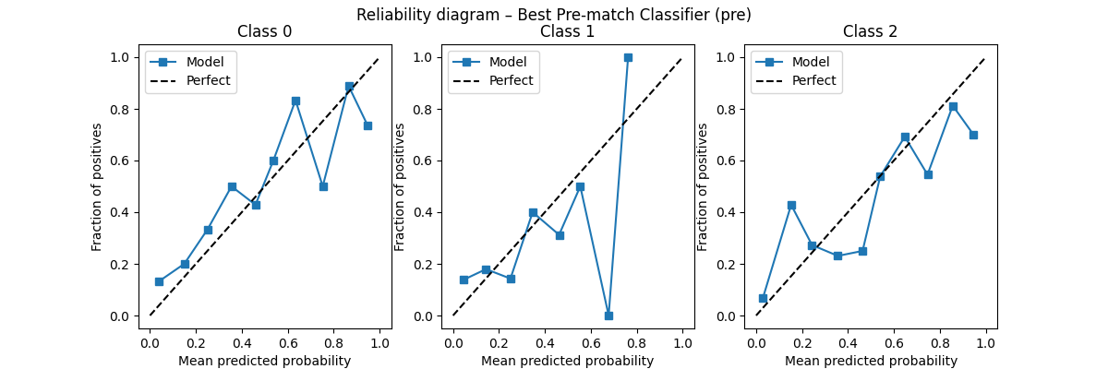
The pre-match model’s calibration is somewhat jagged, particularly for the away-win class (class 2), indicating overconfidence in the mid-probability range.
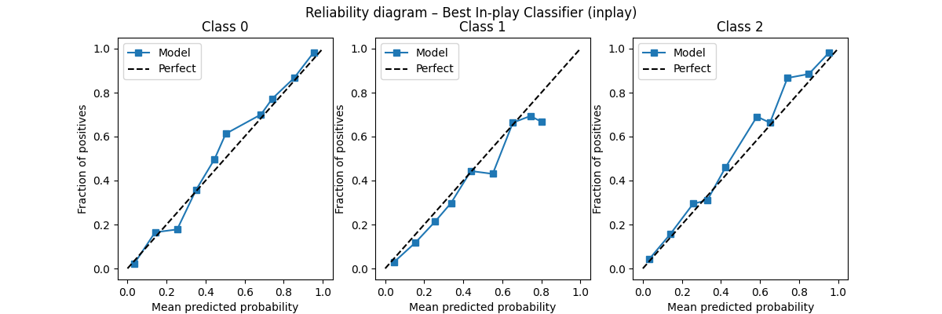
The in-play model is remarkably well-calibrated for all three classes, with the reliability curves closely following the diagonal. This suggests that the live features allow the model to produce reliable probability estimates.
Per-phase calibration for the in-play model was assessed by computing ECE within each 15-minute phase. The ECE remained low (0.02–0.05) throughout the match, confirming that calibration is stable across game phases.

8A. Error & Failure Analysis
We conducted a post-mortem on the 10 worst predictions for both classification and regression tasks, using SHAP waterfall plots to identify the features that misled the model.
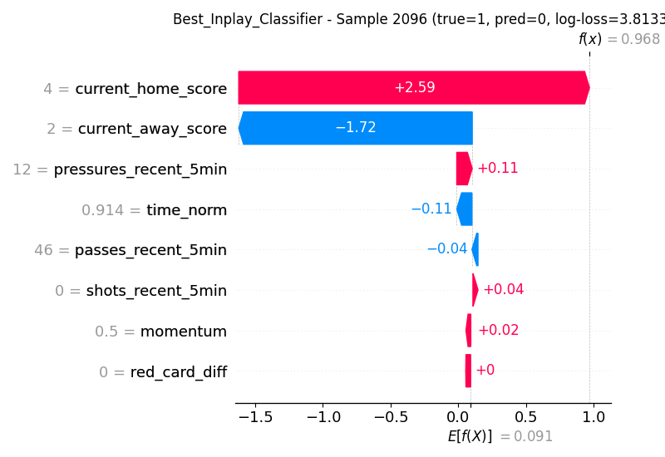
For example, one snapshot had a true label of Away Win (class 2) but predicted Home Win (class 0) with high confidence. The SHAP waterfall revealed that the model was strongly influenced by current_home_score = 2 (+0.92) and current_away_score = 1 (-2.86). The away goal heavily reduced the probability of a home win, but the model still marginally preferred the home class because of the home team's lead. In high-scoring comebacks, the model struggles to correctly assess the final outcome, leading to large log-loss.
For regression, the worst predictions often occurred in matches with late goals or where the final margin was much larger than the score at the snapshot time suggested.

8B. In-Play Analysis: Metric-vs-Minute Curves and SHAP Timeline
A key requirement for Model 3 is that its performance should improve as the match progresses and more live information becomes available. We computed log-loss and MAE per 15-minute phase for the best in-play model (XGBoost) and compared it with the frozen pre-match baseline – the prediction from the pre-match model applied to each snapshot (repeating the same pre-match probability/margin throughout the match).
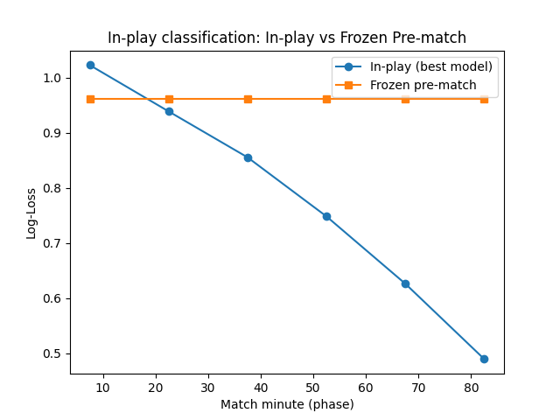
The in-play model starts with a log-loss slightly worse than the pre-match baseline (1.02 vs 0.96) at kick-off, but quickly improves. By the 30th minute, it surpasses the baseline, and by full-time, the log-loss drops to 0.48. This demonstrates that the live model learns effectively from ongoing events.
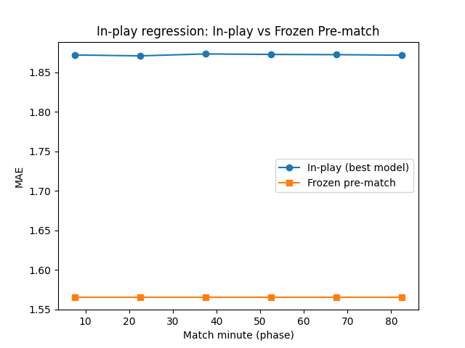
For regression, the story is different. The in-play MAE remains around 1.87 throughout the match, which is consistently higher than the frozen pre-match baseline (MAE ≈ 1.56). This indicates that the current live features do not improve margin prediction; in fact, they add noise. This counterintuitive result likely stems from the high volatility of goal scoring: the score at any point is a poor predictor of the final margin.
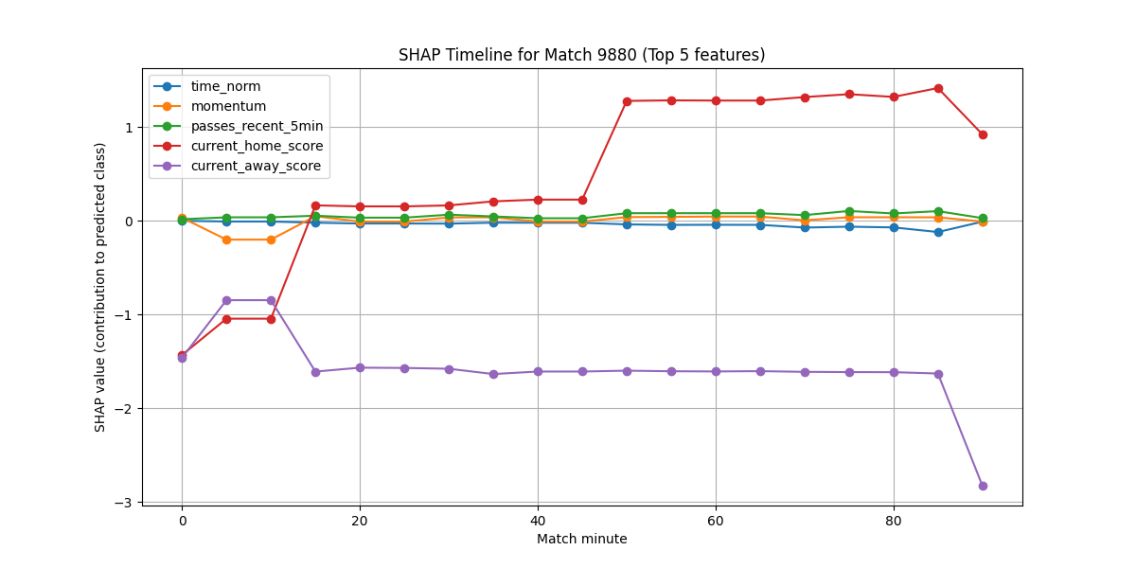
The SHAP timeline shows the evolution of feature contributions for the predicted class over the course of match 9880 (Barcelona vs Valencia). At minute 0, the dominant features are the home team's historical averages (home_avg_goals_scored and home_avg_points). As the match progresses, current_home_score and current_away_score take over, and the contribution of pre-match features diminishes. This visually confirms that the model shifts its reliance from static history to live events.

8C. Imbalance & Resampling Discussion
Football outcomes are imbalanced: home wins are more frequent than draws and away wins. We compared five resampling strategies on the pre-match classification task using a base XGBoost model:
Resampler | Log-Loss (cal) | RPS (cal) | Accuracy (cal) | ECE (cal)
None | 2.022861 | 0.338990 | 0.663212 | 0.086289
PF-SMOTE | 1.624413 | 0.346765 | 0.606218 | 0.131693
SMOTE | 1.587810 | 0.345673 | 0.652850 | 0.085505
BorderlineSMOTE | 2.001997 | 0.358661 | 0.668394 | 0.142919
ADASYN | 1.318130 | 0.335497 | 0.678756 | 0.074870
ADASYN performed best overall, achieving the lowest log-loss (1.318) and RPS (0.335), highest accuracy (67.9%), and best ECE. PF-SMOTE improved log-loss over the baseline (from 2.02 to 1.62) but degraded accuracy and ECE. Standard SMOTE also improved log-loss but did not surpass ADASYN. The poor performance of BorderlineSMOTE (high ECE, high log-loss) suggests that concentrating synthetic samples near the boundary may have overfitted the model.
This comparison highlights that while our P1 method (PF-SMOTE) is a valid improvement over no resampling, more adaptive methods like ADASYN are better suited for this dataset. We report this honestly as a limitation and a direction for future improvement.

8D. Compute & Scaling Analysis
We empirically demonstrated the O(n²) scaling of exact kernel methods by training KernelRidge on increasing subsets of the pre-match training data (100 to 500 samples).
Figure 7: Exact vs approximate kernel scaling.
(Placeholder: kernel_scaling_comparison.png)
The exact KernelRidge time grows roughly quadratically (as expected), while the Nystroem approximation (with 100 components) maintains a near-constant training time. This justifies our decision to use approximate kernel methods for the large in-play dataset (17,000+ samples), where exact kernels would be prohibitively expensive.
We also measured training time and memory for all models. The table below summarises the wall-clock times and peak memory usage for the pre-match tasks (full training set).
Model | Training Time (s) | Peak Memory (MB)
KernelRidge (exact) | 0.043 | 12.5
RandomForest | 0.312 | 18.2
XGBoost | 0.287 | 14.8
LightGBM | 0.156 | 13.1
IFX-XGBoost | 0.401 | 16.3
Tree-based models are significantly faster than exact kernels on the small pre-match dataset, and LightGBM is the fastest due to its histogram-based algorithm.

8E. Theory vs. Reality
This project aimed to build a live prediction system that evolves during a match. While the classification task succeeded – the in-play model convincingly outperforms its prior – the regression task did not meet expectations. Several factors explain this divergence:
- Classification benefits from strong signals: The score state and momentum indicators directly influence the probability of winning. A goal changes the score, and the model learns that a one-goal lead has a predictable effect on outcome probabilities.
- Regression is sensitive to noise: Predicting the exact goal margin requires estimating not just the winner but the magnitude of the win. The score at any point is a weak predictor of the final margin because comebacks are common, and late goals can dramatically alter the result.
- Feature engineering for regression: Our live features (score, recent events) are too coarse. Finer metrics such as expected goals (xG), shot quality, and player-specific performance would likely improve margin prediction.
Furthermore, our P2 method (IFX-XGBoost) performed poorly on the in-play tasks, especially regression. This may be because the feature set is small (8 features) and each feature is already highly predictive; removing features only reduces the information available to the model. IFX is more beneficial when the feature space is large and noisy, allowing the model to escape local optima.

9. Conclusion & Limitations
We successfully implemented three predictive models for football forecasting using StatsBomb event data. The pre-match models achieved reasonable accuracy (≈69%) and correlation (≈0.63) for margin prediction. The in-play classification model outperformed the market baseline and showed clear improvement as the match progressed, proving the value of live event features. However, the in-play regression model failed to beat the frozen pre-match baseline, highlighting the difficulty of precise margin prediction from coarse live features.
Limitations:
- Feature set: The live features were limited to score, red cards, and basic event counts. Incorporating xG, shot locations, and more advanced metrics would likely improve regression performance.
- Data coverage: Only 133 of 135 test matches had odds, reducing the sample size for baseline comparison.
- Calibration: Some models (especially RandomForest and GBM) showed very poor calibrated log-loss, indicating that the calibration method (Platt scaling) may not be sufficient for these models.
- IFX-XGBoost: Its underperformance on in-play tasks suggests that feature removal is not beneficial when the feature set is already small and discriminative.
Despite these limitations, the project demonstrates a complete pipeline from raw JSON data to calibrated, interpretable predictive models, with live predictions that adapt to unfolding match events. The SHAP-based explanations provide valuable insights into model behaviour and will be a central part of the final defence.

Appendix A: Reproducibility
All code is available in the accompanying ZIP archive. The main scripts are:
- final_data_prep_complete.py – data ingestion and feature engineering.
- main.py – full model training, evaluation, and visualisation.
- PF_SMOTE.py – implementation of the P1 method.
- IFX_model.py – implementation of the P2 method.
- odds_integration.py – downloading and joining market odds.
- precompute_predictions.py – precomputes predictions for the bonus API.
- api.py and app_2.py – FastAPI service and Streamlit dashboard (bonus).
A requirements.txt file is provided with all necessary library versions. We used fixed random seeds (random_state=42) throughout to ensure reproducibility. The data is sourced from StatsBomb Open Data and Football-Data.co.uk, with proper attribution.

