1. Login /Sign Up
2. Profile Edit
3. Selling
4. Event
5. I m good at
6. Profile view
7. By 24 Jan 2019

<https://www.slideshare.net/EdurekaIN> - amazing work

set - restriction

able to download if have enabled for download

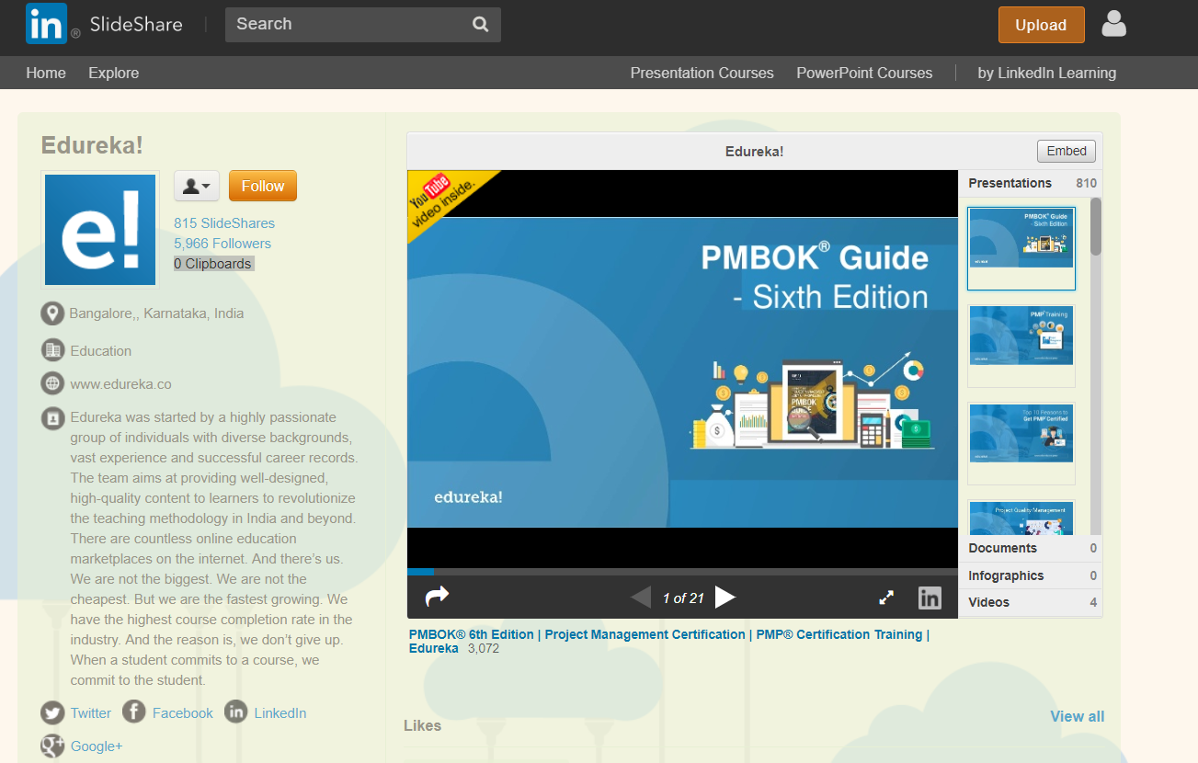

<https://parttimepost.com/dashboard/> - I am good at

