（一）小模型
#include <stdio.h>
#include <math.h>
#include <stdlib.h>
#define PI 3.14159265
#define FM 30
#define R 4 //此时t=0.06就可以停止k
#define KMAX 1000
#define T1 (2*PI*FM)
#define DT 0.002 //0.002秒为时间间隔
//Personal Setup
#define IN 101
#define JN 101
#define SI 50
#define SJ 50
#define DH 30
#define VSTART 1500
#define TIME1 400
#define TIME2 850

void main()
{
FILE *fp;
int i,j,k;
float v[IN][JN],delta[IN][JN];
double u1[IN][JN],u2[IN][JN],u3[IN][JN],w[KMAX];
double t1,t2;

void exchange(double [IN][JN],double [IN][JN],double [IN][JN]);

for(i=0;i<IN;i++)
for(j=0;j<JN;j++)
{
v[i][j]=VSTART;
u1[i][j]=0;u2[i][j]=0;u3[i][j]=0;
}
for(k=0;k<KMAX;k++)
{
w[k]=exp(-pow(T1/R,2)*pow(k*DT,2))*cos(T1*k*DT);
}
for(i=0;i<IN;i++)
for(j=0;j<JN;j++)
delta[i][j]=0;
delta[SI][SJ]=1;
//START
k=1;
while(k<TIME1)
{
k++;
for(i=2;i<IN-2;i++)
for(j=2;j<JN-2;j++)
{
t1=-1.0/12*(u2[i-2][j]+u2[i+2][j])+4.0/3*(u2[i-1][j]+u2[i+1][j])-5.0/2*u2[i][j];
t2=-1.0/12*(u2[i][j-2]+u2[i][j+2])+4.0/3*(u2[i][j-1]+u2[i][j+1])-5.0/2*u2[i][j];
u3[i][j]=2*u2[i][j]-u1[i][j]+pow(v[i][j],2)*pow(DT,2)/pow(DH,2)*(t1+t2)+delta[i][j]*w[k];
}
if(k!=TIME1) exchange(u1,u2,u3);
}
if(fp=fopen("xiaomoxing1.dat","w"))
{
fprintf(fp,"%d\n",IN);fprintf(fp,"%d\n",JN);
for(i=0;i<IN;i++)
for(j=0;j<JN;j++)
fprintf(fp,"%f\n",u3[i][j]);
fclose(fp);
}
exchange(u1,u2,u3);
while(k<TIME2)
{
k++;
for(i=2;i<IN-1;i++)
for(j=2;j<JN-1;j++)
{
t1=-1.0/12*(u2[i-2][j]+u2[i+2][j])+4.0/3*(u2[i-1][j]+u2[i+1][j])-5.0/2*u2[i][j];
t2=-1.0/12*(u2[i][j-2]+u2[i][j+2])+4/3*(u2[i][j-1]+u2[i][j+1])-5.0/2*u2[i][j];
u3[i][j]=2*u2[i][j]-u1[i][j]+pow(v[i][j],2)*pow(DT,2)/pow(DH,2)*(t1+t2)+delta[i][j]*w[k];
}
if(k!=TIME2) exchange(u1,u2,u3);
}
if(fp=fopen("xiaomoxing2.dat","w"))
{
fprintf(fp,"%d\n",IN);fprintf(fp,"%d\n",JN);
for(i=0;i<IN;i++)
for(j=0;j<JN;j++)
fprintf(fp,"%f\n",u3[i][j]);
fclose(fp);
}
}
void exchange(double u1[IN][JN],double u2[IN][JN],double u3[IN][JN])
{
int i,j;
for(i=0;i<IN;i++)
for(j=0;j<=JN;j++)
u1[i][j]=u2[i][j];
for(i=0;i<IN;i++)
for(j=0;j<=JN;j++)
u2[i][j]=u3[i][j];
}
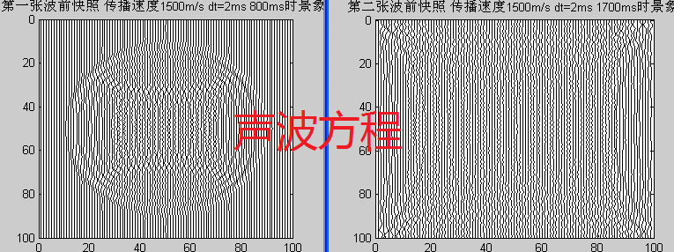
%小模型显示m文件
load xiaomoxing1.dat;
m=xiaomoxing1(1);n=xiaomoxing1(2);dx=1;dz=1;
for i=1:n
for j=1:m
x(j)=(i-1)*dx+xiaomoxing1((j-1)*n+i+2)*1.5*dx;
y(j)=(j-1)*dz;
end
plot(x,y,'k');axis ij;hold on
end
title('第一张波前快照 传播速度1500m/s dt=2ms 800ms时景象')
figure;
load xiaomoxing2.dat;
m=xiaomoxing2(1);n=xiaomoxing2(2);dx=1;dz=1;
for i=1:n
for j=1:m
x(j)=(i-1)*dx+xiaomoxing2((j-1)*n+i+2)*1.5*dx;
y(j)=(j-1)*dz;
end
plot(x,y,'k');axis ij,hold on
end
title('第二张波前快照 传播速度1500m/s dt=2ms 1700ms时景象')
**************************************************************************************************************************************************************************************
（二）大模型
#include <stdio.h>
#include <math.h>
#include <stdlib.h>
#define PI 3.14159265
#define FM 20
#define R 4 //此时t=0.06就可以停止k
#define KMAX 1100
#define T1 (2*PI*FM)
#define DT 0.0005 //0.002秒为时间间隔
//Personal Setup
#define IN 1001 //横轴点数
#define JN 201 //纵轴点数
#define SI 300 //震源横坐标
#define SJ 5 //震源纵坐标
#define DH 4
#define VSTART1 2000
#define VSTART2 3000
#define VSTART3 4000
//#define TIME1 500
#define TIME1 576
void main()
{
FILE *fp;
int i,j,k;
float v;int delta;
double **u1,**u2,**u3,w[KMAX];
double t1,t2;

void exchange(double**,double**,double**);

//Open it
u1=(double **)malloc(IN*sizeof(double*));
for(i=0;i<IN;i++)
u1[i]=(double*)malloc(JN*sizeof(double));
u2=(double **)malloc(IN*sizeof(double*));
for(i=0;i<IN;i++)
u2[i]=(double*)malloc(JN*sizeof(double));
u3=(double **)malloc(IN*sizeof(double*));
for(i=0;i<IN;i++)
u3[i]=(double*)malloc(JN*sizeof(double));
//Close it
for(i=0;i<IN;i++)
for(j=0;j<JN;j++)
{
u1[i][j]=0;u2[i][j]=0;u3[i][j]=0;
}
for(k=0;k<KMAX;k++)
{
w[k]=exp(-pow(T1/R,2)*pow(k*DT,2))*cos(T1*k*DT);
}
//START
for(k=0;k<TIME1;k++)
{ printf("k=%d\n",k);
for(i=2;i<IN-2;i++)
{
for(j=2;j<JN-2;j++)
{
if(i==SI&&j==SJ) delta=1; else delta=0;
if(j<JN/3) v=VSTART1;
else if(j<JN/3*2) v=VSTART2;
else v=VSTART3;
if(i>300&&i<303&&j>80&&j<83) v=4000;
t1=-1.0/12*(u2[i-2][j]+u2[i+2][j])+4.0/3*(u2[i-1][j]+u2[i+1][j])-5.0/2*u2[i][j];
t2=-1.0/12*(u2[i][j-2]+u2[i][j+2])+4.0/3*(u2[i][j-1]+u2[i][j+1])-5.0/2*u2[i][j];
u3[i][j]=2*u2[i][j]-u1[i][j]+pow(v*DT/DH,2)*(t1+t2)+delta*w[k];
}
}
if(k!=TIME1) exchange(u1,u2,u3);
}
if(fp=fopen("damoxing3.dat","w"))
{
fprintf(fp,"%d\n",IN);fprintf(fp,"%d\n",JN);
for(i=0;i<IN;i++)
for(j=0;j<JN;j++)
fprintf(fp,"%lf\n",u3[i][j]);
fclose(fp);
}
for(i=0;i<IN;i++)
{
free(u1[i]);free(u2[i]);free(u3[i]);
}
u1=u2=u3=NULL;
}

void exchange(double **u1,double **u2,double **u3)
{
int i,j;
for(i=0;i<IN;i++)
for(j=0;j<JN;j++)
u1[i][j]=u2[i][j];
for(i=0;i<IN;i++)
for(j=0;j<JN;j++)
u2[i][j]=u3[i][j];
}

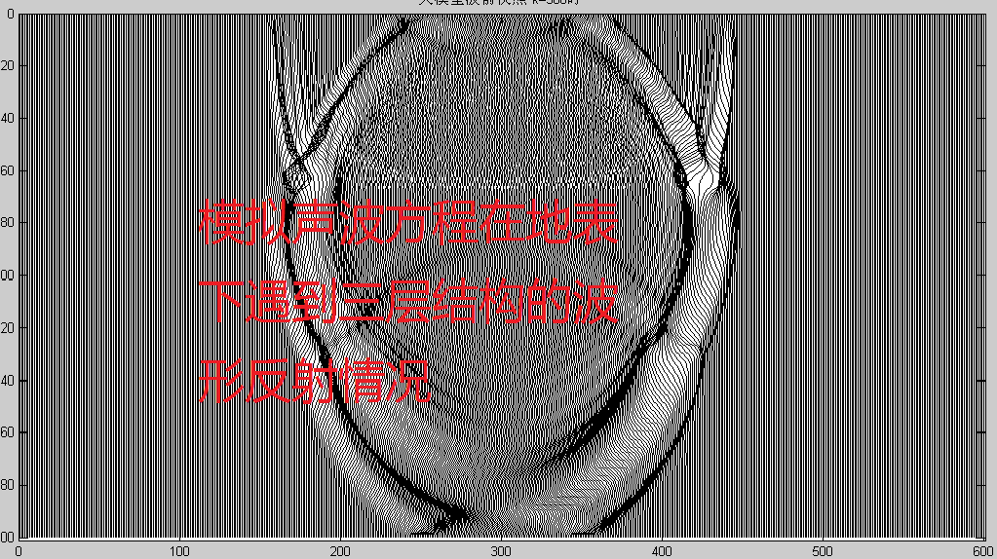
大模型波前快照
clear
load damoxing3.dat
m=damoxing3(1);
n=damoxing3(2);
dx=1;dz=1;
for p=1:1:m
for q=1:1:n
x(q)=(p-1)*dx+damoxing3((p-1)*n+q+2)*15*dx;
y(q)=(q-1)*dz;
end
plot(x,y,'k');title('大模型波前快照k=500时');
axis ij;xlabel('x'),ylabel('z')
hold on
end
axis([0 601 0 201]);
**************************************************************************************************************************************************************************************

