**MACHINE LEARNING MODEL DEPLOYMENT WITH IBM WATSON STUDIO**

TEAM LEADER:

1. NAME: NIRUPAMA K  
   REG NO:211521243110

TEAM MEMBERS:

1. NAME: NEHA SHRUTHI U  
   REG NO:211521243109
2. NAME: ASWATHI SWARNA SREE  
   REG NO:211521243025
3. NAME: PRIYADHARSHINI N  
   REG NO: 211521243121

**MACHINE LEARNING MODEL DEPLOYMENT WITH IBM WATSON STUDIO**

**Machine Learning:**

Machine learning is a subset of artificial intelligence(AI)that focuses on developing algorithms and techniques that enables computers to learn from and make predictions or decision based on data.The core idea behind machine learning is to recognize complex pattern in data and use them to make intelligent decisions or predictions.

There are several types of machine learning techniques,including:

**1.Supervised Learning:**In supervised learning,the algorithm is trained on labelled data,where the input data is paired with the corresponding correct output.The algorithm learns to map the input data to the correct output and can then make predictions on new,unseen data.

**2.Unsupervised Learning:**Unsupervised learning involves training algorithms on unlabeled data.The system tries to learn the patterns and the structure from the data without any supervision.Clustering and association are common unsupervised learning technique.

**3.Semi**-**Supervised Learning:**This type of learning falls between supervised and unsupervised learning.In semi-supervised learning,the algorithm is trained on the dataset that contain both labelled and unlabeled data.

**4.Reinforcement Learning:**Reinforcement learning involves agent that interacts with an environment and learn to make decision by receiving rewards or penalties.The agent learns to achieve a goal in an uncertain,potentially complex environment.

5. **Deep Learning:** Deep learning is a subset of machine learning where artificial neural networks, particularly deep neural networks, are used to model and solve complex patterns. Deep learning techniques have been particularly successful in tasks such as image recognition and natural language processing.

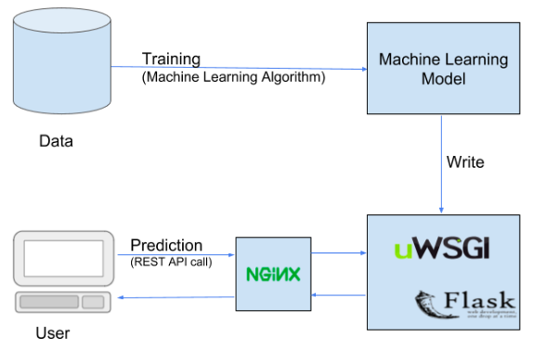

Figure 1:Machine learning deployment structure.

**Problem definition:**

* **Problem:** The project involves training a machine learning model using IBM Cloud Watson Studio and deploying it as a web service.
* **Goal:** The goal is to become proficient in predictive analytics by creating a model that can predict outcomes in real-time. The project encompasses defining the predictive use case, selecting a suitable dataset, training a machine learning model,deploying the model as a web service, and integrating it into applications.

**Benefits:**

**1.Increased Accuracy:**Machine learning algorithms can process vast amount of structured and unstructured data.This ability to analyze diverse data sources results in more accurate risk assessment and pricind models.

**2.Cost Eficiency:**

* **Resource Optimization:**By automating various processes,machine learning reduces the need for manual intervention.This leads to cost saving for insurance companies.
* **Predictive Maintance:**Machine Learning predicts maintance needs for insured assets,preventing costly damages and accidents.

**3.Improved Customer Experience:**

* **Personalization:**Machine learning enables the tailoring of insurance products to individual customer profiles.Customers receive personalized policies and recommendations,enhancing their overall experience.
* **Quick Responses:**Chatbot powered by machine learning can provide instant reponses to customer queries,improving customer satisfaction and engagement.

**4.Fraud Detection and Prevention:**

* **Pattern Recognition:**Machine learning algorithms can identify patterns indicative of fraudulent activities.This helps in real time fraud detection and prevents financial losses for insurance companies.

**Abstract:**

Machine learning deployment plays a pivotal role in transforming raw data into actionable insights, enabling informed decision-making across various sectors. This abstract explores the fundamental aspects of machine learning deployment, focusing on its significance, challenges, and best practices. The process involves several key stages, including data collection and preprocessing, model training and evaluation, integration into existing systems, and continuous monitoring for real-time adjustments. Challenges such as data privacy, model interpretability, and ethical considerations are addressed through robust methodologies. Successful deployment hinges on collaborative efforts between data scientists, domain experts, and IT professionals, ensuring the seamless integration of machine learning models into operational workflows. Emphasizing the importance of ongoing monitoring and iterative improvements, this abstract highlights how effective machine learning deployment drives innovation, enhances efficiency, and fosters data-driven decision-making in diverse industries.

**Software required:**

IBM Watson Studio is a comprehensive platform for data scientists, developers, and domain experts to collaboratively build, train, and deploy machine learning models. When it comes to deploying machine learning models using IBM Watson Studio, several tools and components are commonly utilized:

**1. Watson Machine Learning:**

* **Watson Machine Learning Service:** This is a component of IBM Watson Studio that enables users to deploy, monitor, and manage machine learning models. It supports various machine learning frameworks, including TensorFlow, PyTorch, and scikit-learn.
* **Watson Machine Learning Deployments:** Watson Machine Learning allows you to deploy machine learning models as web services (REST APIs) or batch deployments. Models can be deployed in the cloud or on-premises infrastructure.

**2. IBM Cloud:**

* **IBM Cloud Kubernetes Service:** Watson Machine Learning models can be deployed on Kubernetes clusters using IBM Cloud Kubernetes Service. Kubernetes provides a scalable and reliable platform for deploying containerized applications, including machine learning models.
* **IBM Cloud Pak for Data:** IBM Cloud Pak for Data is an integrated data and AI platform that provides capabilities for data management, AI model development, and deployment. It includes Watson Machine Learning for model deployment and monitoring.

**3. Open Source Tools:**

* **Docker:** Docker containers can be used to package machine learning models and their dependencies, ensuring consistency between development and deployment environments.
* **Kubernetes:** Kubernetes is commonly used for orchestrating Docker containers in production. It provides tools for scaling, load balancing, and managing the lifecycle of containerized applications, including machine learning models.

**4. Integration Services:**

* **IBM Cloud Integration:** Integration services allow you to connect Watson Machine Learning deployments with other IBM Cloud services and external applications, enabling seamless data flow and communication.
* **IBM API Connect:** API Connect provides capabilities for creating, managing, and securing APIs. It can be used to expose machine learning models deployed on Watson Machine Learning as APIs.

**5. Monitoring and Management:**

* **Watson OpenScale:** Watson OpenScale is an IBM service that provides tools for monitoring and managing machine learning models in production. It helps detect and mitigate bias, provides explanations for model predictions, and ensures model fairness and accuracy.

These components and services within the IBM ecosystem work together to facilitate the deployment, scaling, monitoring, and management of machine learning models developed using IBM Watson Studio. They ensure that machine learning solutions are seamlessly integrated into business processes and can be effectively maintained and optimized over time.

**6.Anaconda Navigator:**

* **Jupyter Notebook** is a notebook authoring application, under the project jupyter umbrella. Built on the power of the computational notebook format, **Jupyter Notebook** offers fast, interactive new ways to prototype and explain your code, explore and visualize your data, and share your ideas with others.

**Design Thinking:**

Design thinking is a problem-solving approach that prioritizes understanding the user's needs and experiences to create innovative solutions. When applied to machine learning deployment using IBM Watson Studio, it involves a user-centric, iterative process to ensure that the deployed ML model effectively addresses the users' requirements. Here's a step-by-step guide to applying design thinking principles in your machine learning deployment project using IBM Watson Studio:

**1. Empathize:**

* **Understand Stakeholder Needs:** Talk to stakeholders including end-users, data scientists, and business leaders to understand their goals, challenges, and expectations from the machine learning solution.
* **User Personas:** Create user personas to represent different user types. Understand their pain points and how machine learning could solve their problems.

**2. Define:**

* **Problem Statement:** Clearly define the problem you're trying to solve with machine learning. Define specific, measurable goals that align with business objectives.
* **Success Metrics:** Establish key performance indicators (KPIs) that will be used to measure the success of the deployed machine learning model.

**3. Ideate:**

* **Brainstorming:** Conduct brainstorming sessions with cross-functional teams to generate diverse ideas on how machine learning can solve the defined problem.
* **Idea Prioritization:** Prioritize the ideas based on feasibility, impact, and alignment with user needs and business goals.

**4. Prototype:**

* **Create Prototypes:** Use IBM Watson Studio to create prototypes of machine learning models based on the prioritized ideas. Experiment with different algorithms and features to find the most effective solution.
* **Iterative Prototyping:** Continuously refine the prototypes based on feedback from stakeholders and user testing.

**5. Test:**

* **User Testing:** Conduct usability testing and gather feedback from end-users. Understand how users interact with the prototype and identify any pain points or areas of improvement.
* **Performance Testing:** Evaluate the performance of the machine learning model using test datasets. Ensure that the model meets the defined success metrics.

**6. Implement:**

* **Development:** Develop the final machine learning model using IBM Watson Studio. Fine-tune the model based on the insights gathered during the testing phase.
* **Integration:** Integrate the machine learning model into the target application or system. Ensure seamless communication between the application and IBM Watson Studio for real-time data processing and predictions.

**7. Iterate:**

* **Feedback Loop:** Establish a feedback loop with users and stakeholders even after deployment. Gather feedback on the deployed solution and use it to make iterative improvements.
* **Continuous Monitoring:** Implement monitoring mechanisms to track the performance of the deployed machine learning model in real-world scenarios. If necessary, reiterate the design thinking process based on new insights and feedback.

**DataSet Model:**

Creating a machine learning model for insurance typically involves using historical data to predict future events or outcomes, such as customer churn, claim approval, fraud detection, or pricing. Below is a general outline of how you could approach building a machine learning model for insurance using a hypothetical dataset. Please note that the specific steps and techniques can vary based on the nature of the problem you're trying to solve and the dataset you have.

**1. Understanding the Problem:**

* **Define the Problem:** Clearly define the problem you want to solve. For example, predicting customer churn, detecting fraudulent claims, or estimating the cost of insurance policies.
* **Define Success Criteria:** Determine how you will measure the success of your model. It could be accuracy, precision, recall, or any other relevant metric.

**2. Data Collection and Preparation:**

* **Data Collection:** Gather historical data related to the problem you're trying to solve. This could include customer details, policy information, claims history, etc.
* **Data Cleaning:** Clean the dataset by handling missing values, outliers, and inconsistencies in the data.
* **Feature Selection:** Identify relevant features (attributes) in your dataset that can influence the outcome. This might involve domain knowledge and statistical analysis.

**3. Data Preprocessing:**

* **Feature Engineering:** Create new features from existing data that might be more informative for the problem at hand.
* **Normalization/Standardization:** Scale numerical features to a similar range to avoid biases in the model.
* **One-Hot Encoding:** Convert categorical variables into a numerical format that machine learning algorithms can work with.

**4. Model Selection and Training:**

* **Selecting a Model:** Choose an appropriate machine learning algorithm for your problem. Common algorithms for insurance problems include logistic regression, decision trees, random forests, and neural networks.
* **Training the Model:** Split the data into training and testing sets. Train your chosen model on the training data.

**5. Model Evaluation:**

* **Evaluate Performance:** Use appropriate metrics (accuracy, precision, recall, F1-score) to evaluate how well your model performs on the test data.
* **Tuning:** Fine-tune your model by adjusting hyperparameters or trying different algorithms to improve performance.

**6. Deployment and Monitoring:**

* **Deployment:** Once you have a well-performing model, deploy it into your insurance system. This could involve creating APIs to integrate the model with your application.
* **Monitoring:** Continuously monitor the model's performance in real-world scenarios. If the model's performance drops, retrain it with new data.

**7. Interpretability and Fairness (Optional but Important):**

* **Interpretability:** For certain insurance applications (e.g., credit scoring), it's essential to understand how the model is making decisions. Use techniques like SHAP values or LIME to interpret the model's predictions.
* **Fairness:** Ensure that your model is fair and not biased against particular groups. Evaluate fairness metrics to identify and mitigate biases.

**8. Iterative Improvement:**

* **Feedback Loop:** Gather feedback from end-users and stakeholders. Use this feedback, along with new data, to iterate on your model. Continuous improvement is key to maintaining model relevance and accuracy.

**IBM Watson Studio:**

IBM Watson Studio gives you the environment and tools to solve business problems by collaboratively working with data. You can choose the tools needed to analyze and visualize data; to cleanse and shape the data; to ingest streaming data; or to create, train, and deploy machine learning models.

* Create projects to organize the resources (such as data connections, data assets, collaborators, and notebooks) to achieve an analytics goal.
* Access data from connections to your cloud or on-premises data sources.
* Upload files to the project’s object storage.
* Create and maintain data catalogs to discover, index, and share data.
* Refine data by cleansing and shaping the data to prepare it for analysis.
* Perform data science tasks by creating Jupyter Notebooks for Python or Scala to run code that processes data and then view the results inline. Alternavitely, you can use RStudio for R.
* Create, test, and deploy machine learning and deep learning models.
* Visualize your data.

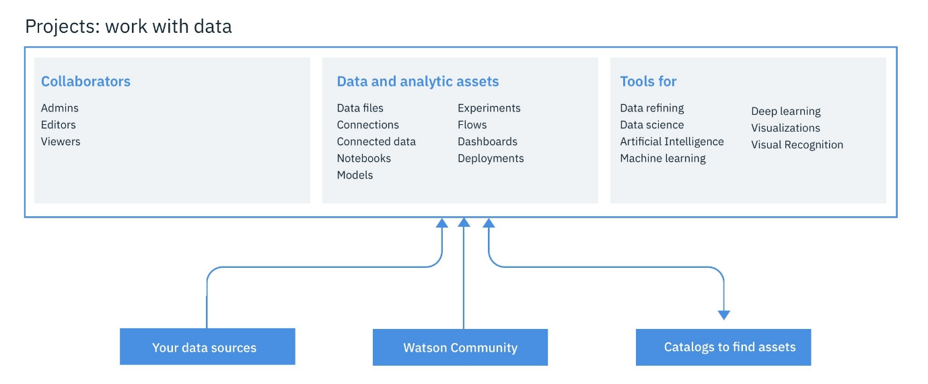

Figure No 2:IBM Watson Studio Structure.

In the context of data science, IBM Watson Studio can be viewed as an integrated, multirole collaboration platform that supports the developer, data engineer, business analyst, and the data scientist in the process of solving a data science problem. For the developer role, other components of the IBM Cloud platform might be relevant as well in building applications that use machine learning services. However, the data scientist can build machine learning models using a variety of tools, ranging from:

* [AutoAI Model Builder](https://dataplatform.cloud.ibm.com/docs/content/wsj/analyze-data/autoai-overview.html?audience=wdp&context=wdp): A graphical tool requiring no programming skills
* [SPSS Modeler Flows](https://dataplatform.cloud.ibm.com/docs/content/wsd/spss-modeler.html): Adopts a diagrammatic style
* [RStudio](https://dataplatform.cloud.ibm.com/docs/content/wsj/analyze-data/rstudio-overview.html) and [Jupyter Notebooks](https://dataplatform.cloud.ibm.com/docs/content/wsj/analyze-data/notebooks-parent.html?linkInPage=true): Using a programmatic style

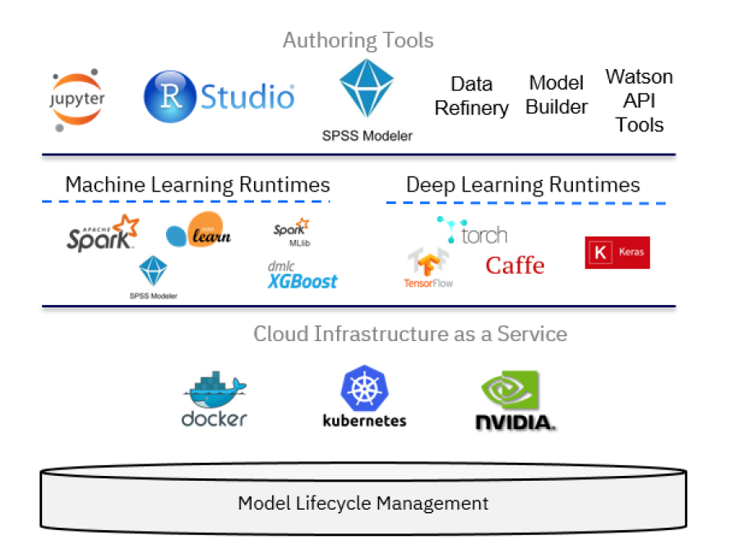

Figure No 2:Lifecycle.

A key component of IBM Watson Studio is the IBM Watson Machine Learning service and its set of REST APIs that can be called from any programming language to interact with a machine learning model. The focus of the IBM Watson Machine Learning service is deployment, but you can use IBM SPSS Modeler or IBM Watson Studio to author and work with models and pipelines. Both SPSS Modeler and IBM Watson Studio use Spark MLlib and Python scikit-learn and offer various modeling methods that are taken from machine learning, artificial intelligence, and statistics.

**Conclusion:**

In conclusion, machine learning deployment plays a pivotal role in transforming data-driven insights into actionable solutions. As businesses increasingly recognize the value of harnessing machine learning algorithms, the deployment phase becomes critical in ensuring that these models deliver tangible benefits. Here are key points to consider in concluding the importance of machine learning deployment:

1. Decision-Making Power: Machine learning models, when effectively deployed, empower businesses to make data-driven decisions. Whether it's predicting customer behavior, optimizing supply chains, or enhancing user experiences, deployed models provide valuable insights that guide strategic actions.
2. Operational Efficiency: Deployed machine learning models automate processes, leading to increased operational efficiency. Tasks that previously required significant time and resources can now be accomplished swiftly and accurately, freeing up human resources for more creative and strategic tasks.
3. Innovation Catalyst: Machine learning deployment fosters innovation by enabling the development of intelligent applications. These applications can range from recommendation systems and chatbots to autonomous vehicles, revolutionizing industries and creating new business opportunities.
4. Competitive Advantage: Businesses that effectively deploy machine learning gain a competitive advantage. They can adapt to changing market demands, personalize customer experiences, and optimize operations in ways that competitors reliant solely on traditional methods cannot match.
5. Continuous Improvement: Deployment is not the end but a beginning of a feedback loop. Continuous monitoring and feedback from deployed models allow for iterative improvements. This constant refinement ensures that models remain relevant and accurate, adapting to evolving datasets and business requirements.
6. Ethical Considerations: Ethical deployment of machine learning models is crucial. Ensuring fairness, transparency, and accountability in algorithms is not just a moral imperative but also essential for building trust among users and stakeholders.
7. Challenges and Learning Opportunities: Deployment comes with challenges such as data privacy, security, and model interpretability. Overcoming these challenges presents valuable learning opportunities, encouraging the development of best practices that benefit the entire industry.