

A PROJECT REPORT

ON

**MAILER SYSTEM**

DONE BY

Komal Manwar

(EBTSOC0920318261)

Under the Guidance of,

**Mr. V JAYANTH**

**Technical Trainer**

**NASSCOM PROJECT**

**­**

**ABSTRACT :**

The complete mailing system is developed for facilitating communication within an organization. This eases the communication among the employees of a company. It will work as a private organization portal with which any registered employee can mail/message any other registered employee without even bothering about their contact details. The ids of all the registered employees of a particular group will be made available under the employee’s profile.

**­­­­**

**Contents:**

1. Objective……………………………………………………………………………………...4
2. Existing System……………………………………………………………………………….4
3. Proposed System……………………………………………………………………………...4
4. Module description…………………………………………………………………………...5
5. E-R Diagram…………………………………………………………………………………..6
6. Use Case Diagram…………………………………………………………………………….7
7. Conclusion…………………………………………………………………………………….8
8. References……………………………………………………………………………………..8

**Snapshots**

**Objective :**

A mailer application for a company that can be used by the employees of the company only. It can be run on interanet. Each user can send mails, receive mails and delete mails after getting logged in!

**Existing System:**

Most of the companies presently use public mailing systems or communication modes like gtalk, yahoo mail etc. It is really hard to remember each and every employee’s gtalk or yahoo id. Moreover, the System must be connected to internet to send or receive mails.

**Proposed System:**

Although this Complete Mailing System is similar to that of internet mailing system, the major difference is that the former doesn’t need an internet connection to send or receive messages. This application will be more of a personalized mailing environment when compared to the conventional one.

**Module Description:**

**Users of the System:**

1. User
2. Admin

**1. User**

1. Can register
2. Can login and logout
3. Can send mails
4. Can see inbox
5. Can see sent mails
6. Can see trash
7. Can search other employees email id
8. Can view and update profile

**2. Admin**

1. Can unauthorize the user
2. can see current logged in members

**E-R Diagram:**

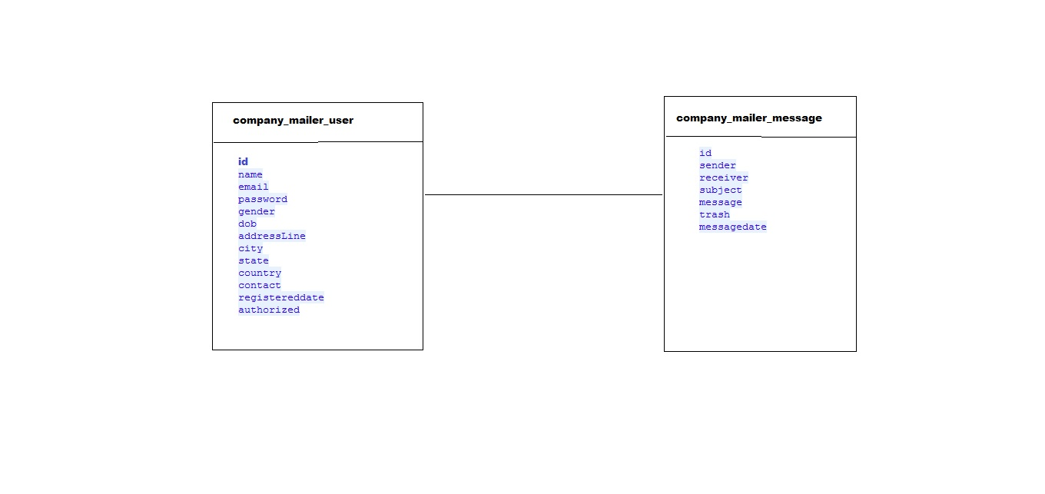

**Use-Case:**

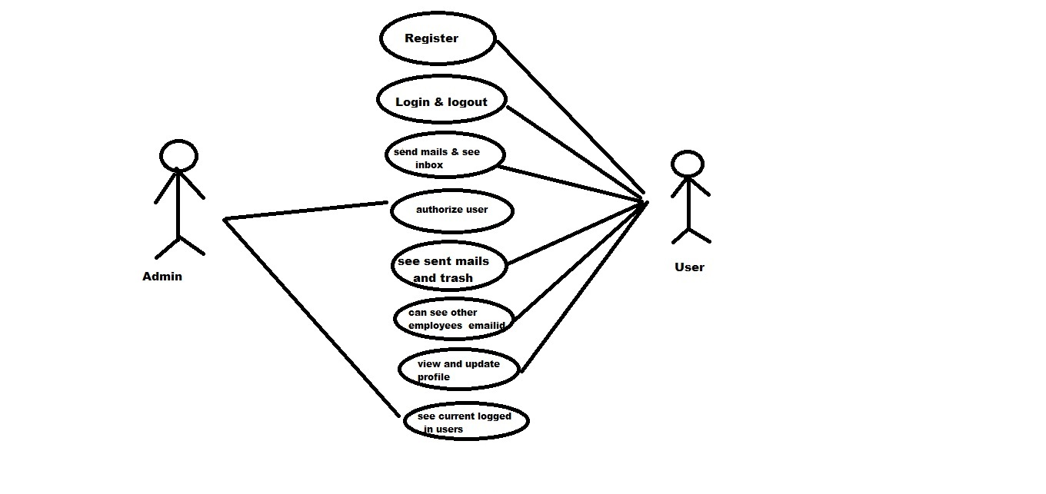

**Conclusion:**

In this Mailer System, I make the simple mail provider system in which

user can send mail by using java and database MySQL. This is the mini project

which is very easy to use. This web application can help us to build company’s

own mailing system for their employees.

**References:**

<https://www.mysql.com/products/connector/>

<http://www.java2s.com/>

<https://www.javatpoint.com/java-tutorial>

***Snapshots:***

