CONSOLIDATED ABL REPORT
HTML & CSS Web Development Projects
Prepared by: K. Rithwik
Roll Number:26000930
Section :CSM-2
This report presents three beginner-friendly websites built with HTML and internal CSS. It includes project objectives, key features, screenshots of the rendered webpages, and a conclusion.
Academic Year 2026

Project 1: My Portfolio Website
Objective
To create a personal portfolio that introduces the student, highlights technical skills and projects, and provides contact information.
Key Features
Home and hero section; About Me; technical skills cards; project cards; contact section; navigation links; hover effects; responsive styling.

Project 1: My Portfolio Website
Screenshot 1.1 — Portfolio introduction, navigation, About Me, and skills.
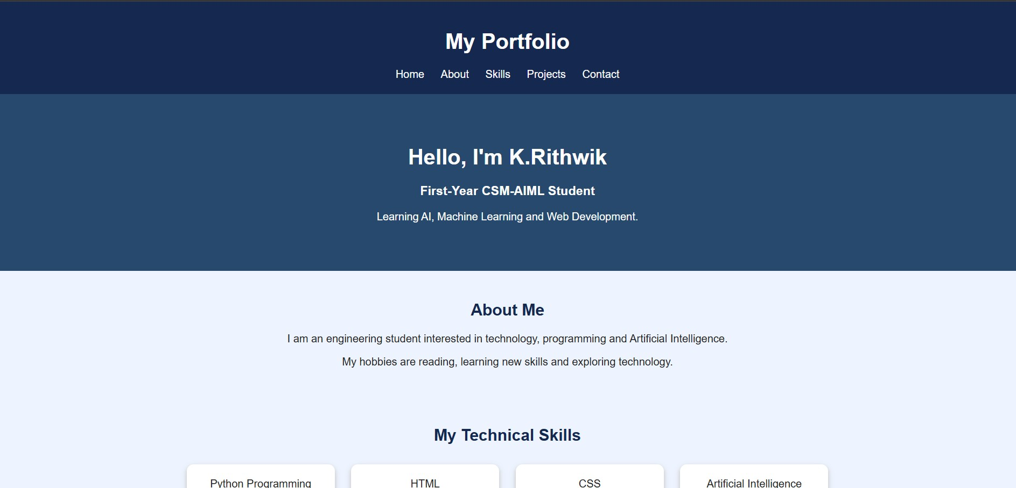

Project 1: My Portfolio Website
Screenshot 1.2 — Skills, projects, contact information, and footer.
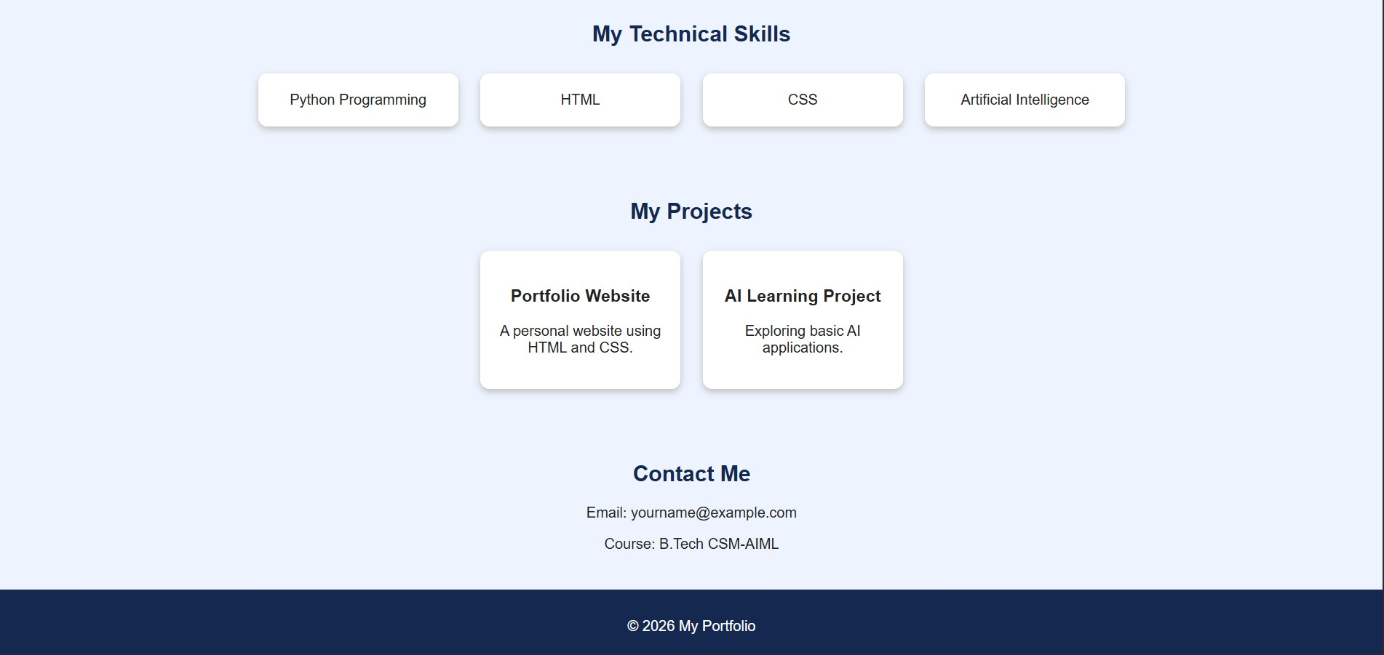

Project 2: AI & ML Learning Hub
Objective
To provide a simple educational webpage introducing Artificial Intelligence, Machine Learning, Deep Learning, applications, and career pathways.

Key Features
Navigation links; introductory hero section; AI and ML information cards; healthcare, education, and transportation applications; career opportunities; hover effects; responsive card layout.

Screenshot 2.1 — Learning Hub introduction and Artificial Intelligence section.
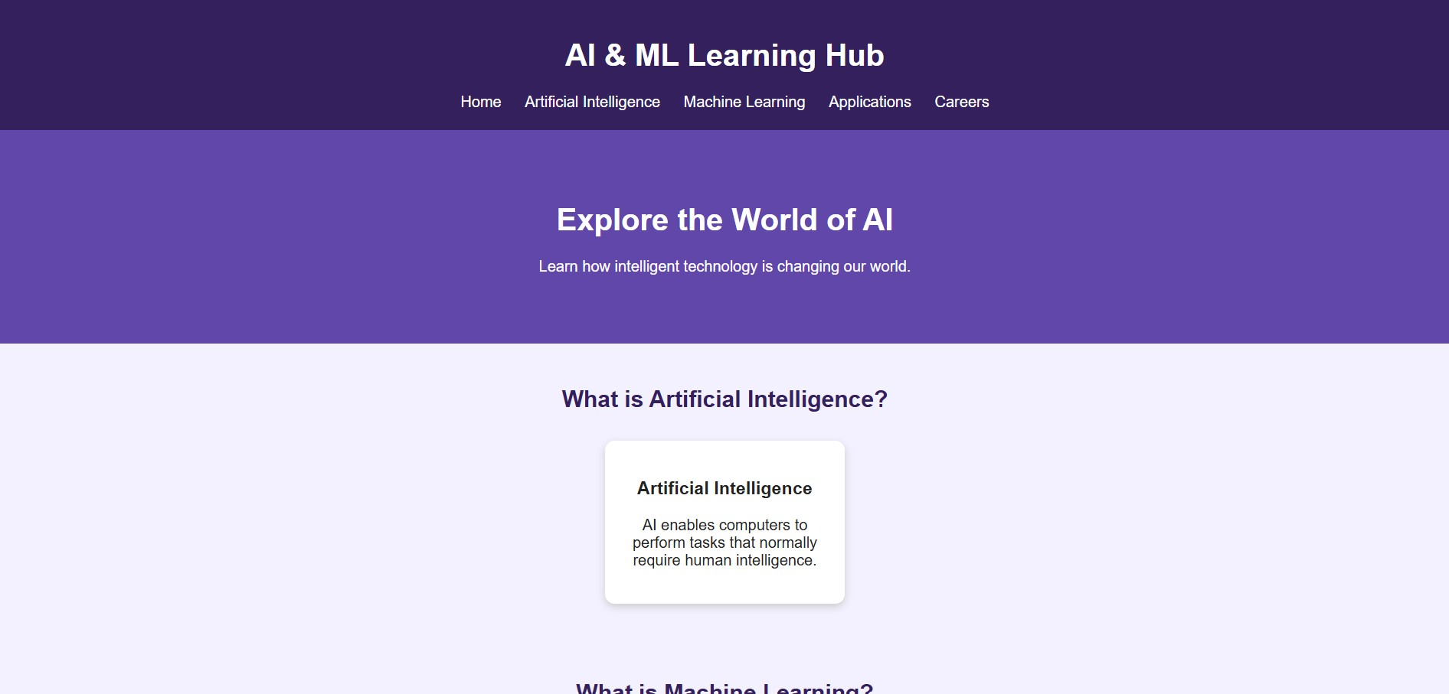
Screenshot 2.2 — Machine Learning, Deep Learning, and AI applications.
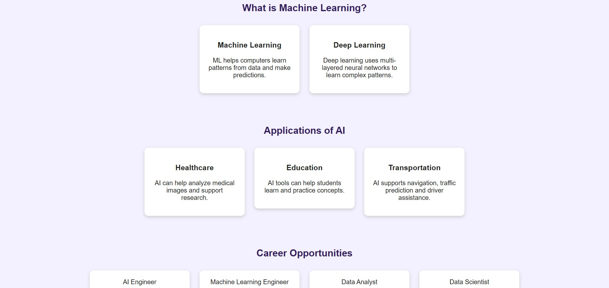
Screenshot 2.3 — Applications, career opportunities, and footer.
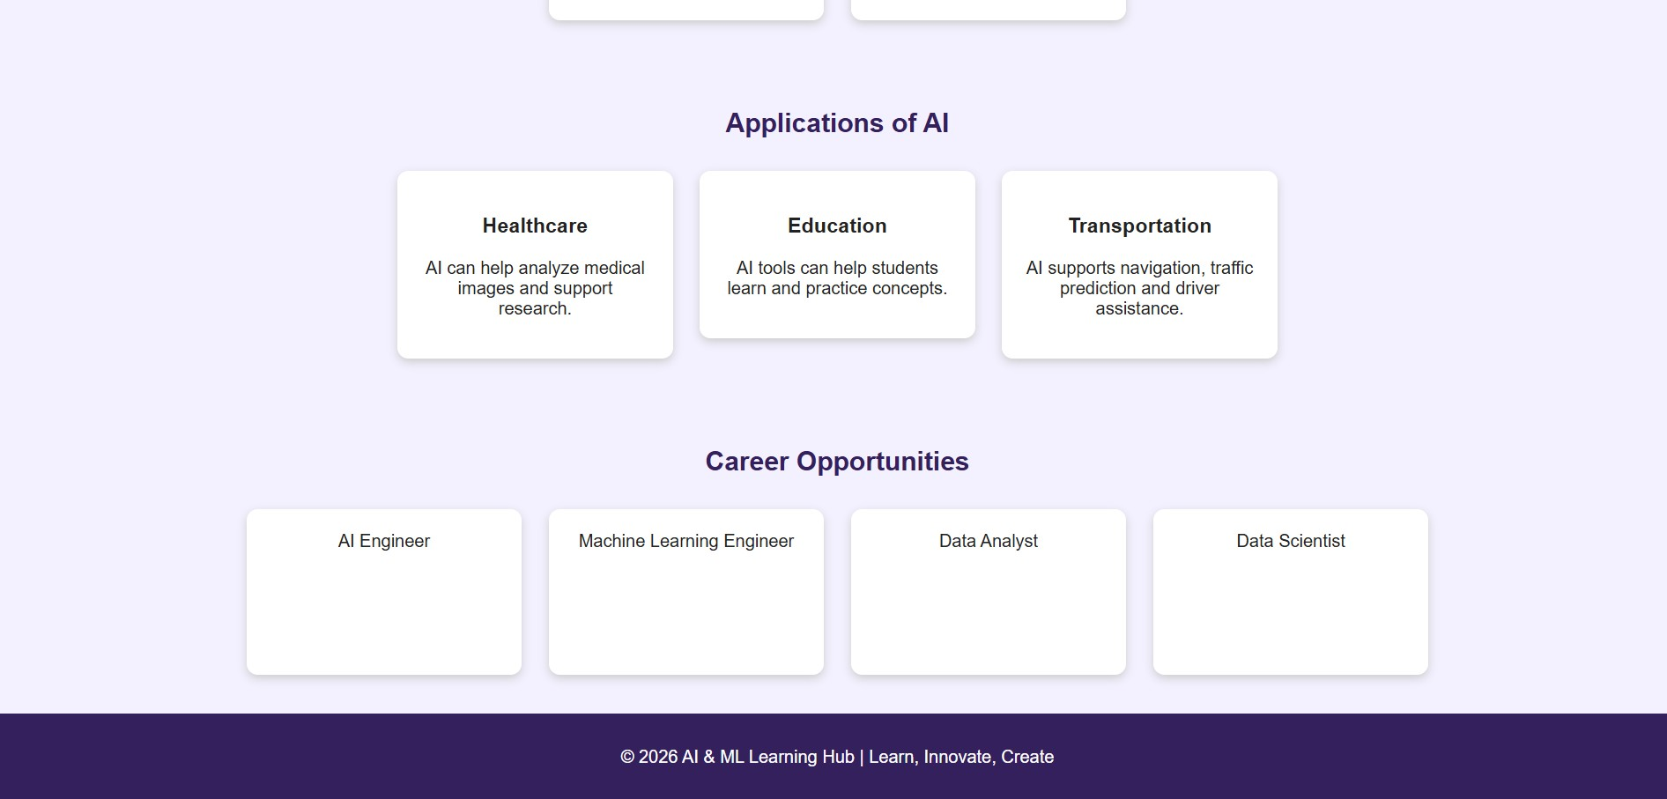

Project 3: NRI Engineering College Website
Objective
To design a college information webpage presenting departments, campus facilities, admissions guidance, and contact information.

Key Features
College header and navigation; welcome banner; college overview; department cards; campus facilities; admissions information; contact section; hover effects; responsive styling.
Screenshot 3.1 — College header, welcome banner, overview, and departments.
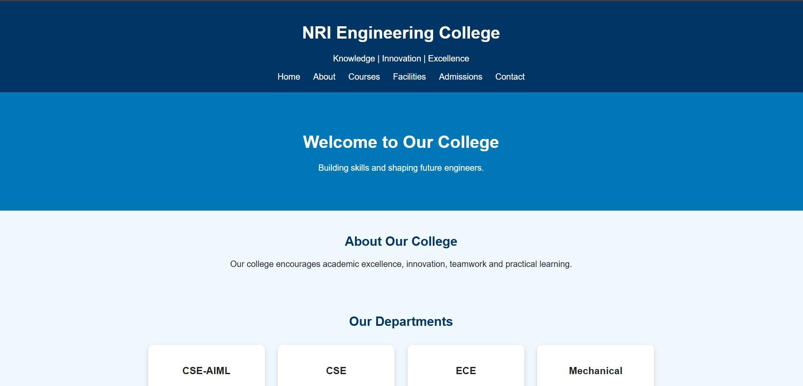
Screenshot 3.2 — Department cards, facilities, admissions, and contact section.
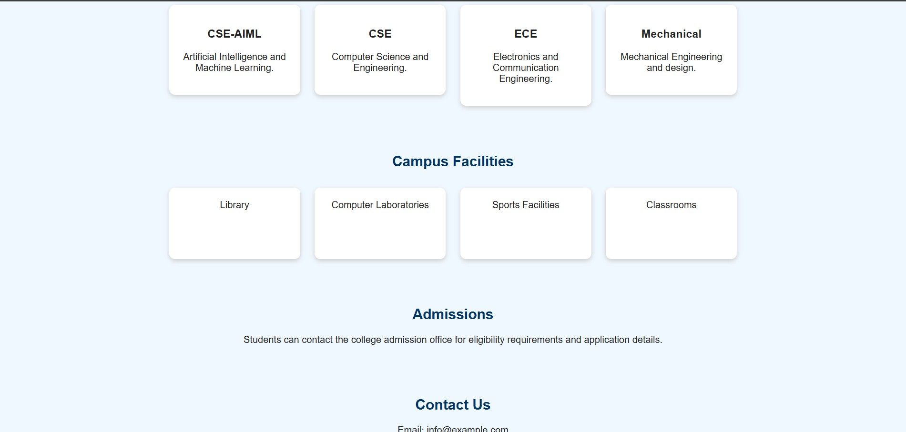
Screenshot 3.3 — Contact details and footer.


Conclusion
These projects demonstrate practical use of HTML for structuring content and internal CSS for colors, spacing, navigation, cards, hover effects, and responsive layouts. The portfolio introduces personal skills and projects, the Learning Hub explains AI and ML concepts, and the college website organizes information for prospective students and visitors. Together, they build foundational web-development skills.
End of Report

