Interactive Dashboard (Power BI Report)

Customer Segmentation & Sales Analytics Dashboard using MySQL & Power BI

Project Overview

This project focuses on analyzing online retail sales and customer behavior using MySQL and Power BI. The goal is to understand sales performance, identify valuable customer groups, and analyze customer purchasing behavior using RFM analysis.

Objective
- Analyze sales and revenue trends
- Identify top-performing products and countries
- Analyze customer purchasing behavior
- Calculate Recency, Frequency, and Monetary (RFM) metrics
- Segment customers based on their RFM scores
- Provide data-driven insights for customer retention and business decisions
Tools Used: MySQL, SQL, Microsoft Power BI Desktop, DAX
Dataset: UCI Online Retail Dataset — 541,909 transaction records and 8 variab
Report Structure:
Title | Purpose
Sales Overview Dashboard | Provides high-level analysis of revenue, orders, customers, products, and countries
Customer Segmentation & RFM Dashboard | Analyzes customer value, purchasing behavior , loyalty and customer segments .

Page 1: Sales Overview
Description
Provides a high-level summary of the company's sales performance and revenue trends.
Key Metrics
- Total Revenue: 8.91M
- Total Customers: 4.34K
- Total Orders: 18.53K
- High-Value Customers: 1.31K
- Average Order Value: 480.87
- Units Sold: 5.17M
- Average Units per Order: 278.86
Visual Analysis
- Monthly Revenue Trend: Shows changes in revenue across the months.
- Top Products by Revenue: Identifies products generating the highest revenue.
- Top Countries by Revenue: Shows the leading countries based on revenue contribution.
- Top Products by Units Sold: Identifies the most frequently sold products by quantity.
- Average Order Value Trend: Shows how average order value changes over time.
FIG 1: SALES OVERVIEW
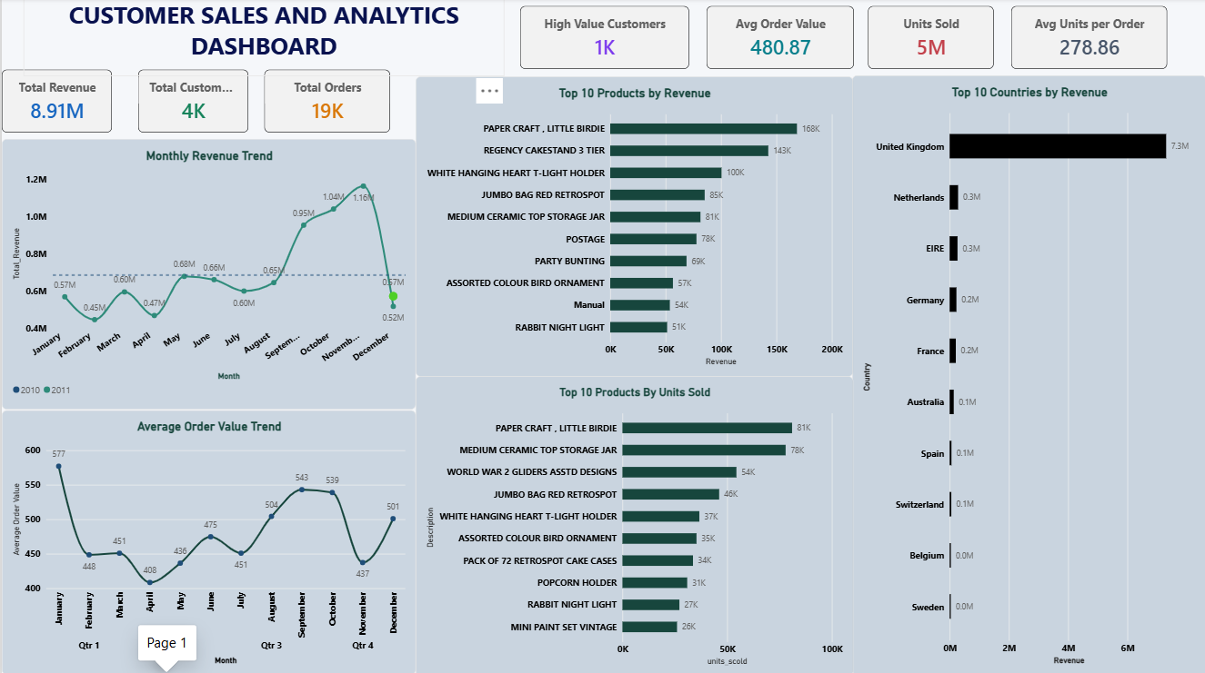
Page 2: Customer Segmentation & RFM Analysis
Description
Focuses on understanding customer value, purchasing behavior, loyalty, and customer segments using RFM analysis.
Key Analysis
- RFM Analysis: Customers evaluated using Recency, Frequency, and Monetary value.
- Customer Segmentation: Customers classified into High-Value, Loyal, At-Risk, and Lost segments.
- Customer Distribution: Compares the number of customers across different segments.
- Monetary Analysis: Compares average customer spending across segments.
- Frequency Analysis: Compares average purchase frequency across segments.
- Recency vs Monetary: Identifies relationships between customer recency and spending.
- Customer Details: Provides customer-level RFM information.
- Interactive Filtering: Country and Customer Segment slicers allow focused analysis
Fig 2: Customer Segmentation & RFM analysis
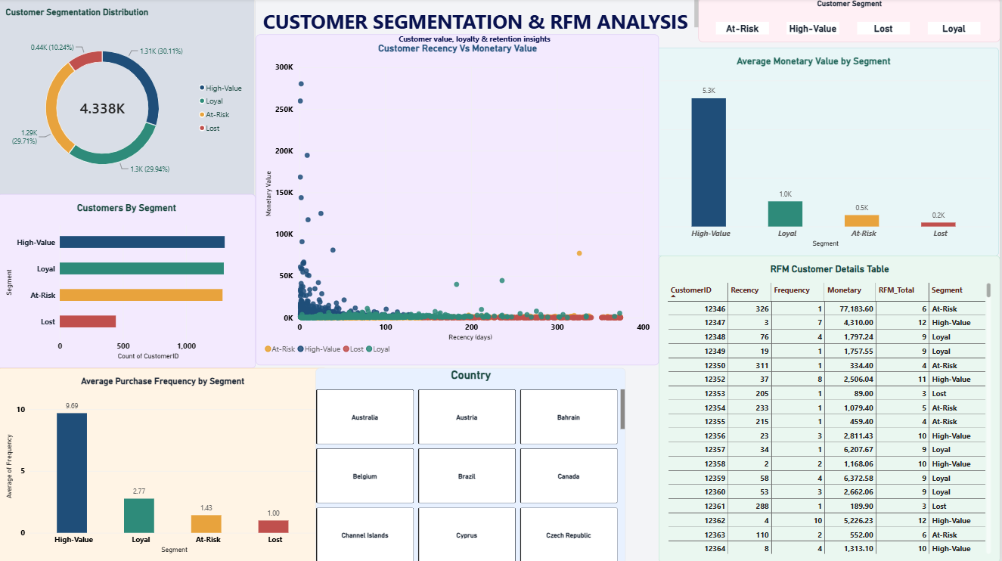
Key Insights
- Total revenue analyzed is approximately 8.91M.
- The analysis includes 4,338 identified customers.
- High-Value customers form the largest customer segment with 1,306 customers.
- Loyal and At-Risk customers contain 1,299 and 1,289 customers respectively.
- 444 customers fall into the Lost segment.
- The United Kingdom contributes the majority of revenue among the countries shown in the top-10 ranking.
- RFM analysis helps identify customers with high monetary value and strong purchasing behavior.
- The dashboard provides a combined view of sales performance and customer value, supporting more focused business analysis.
Business Recommendations

Recommendation 1 — Focus on High-Value Customers:
Develop personalized offers and loyalty strategies to retain high-value customers.

Recommendation 2 — Re-engage At-Risk Customers
Use targeted promotions and follow-up campaigns to encourage customers who are becoming inactive.

Recommendation 3 — Retain Loyal Customers
Provide loyalty rewards and exclusive offers to maintain repeat purchasing behavior.

Recommendation 4 — Improve Lost Customer Re-engagement
Identify lost customers with previous high spending and target them with suitable win-back campaigns.

Recommendation 5 — Optimize Product Performance
Use product-level sales and quantity analysis to identify products that contribute strongly to revenue and sales volume.

Project Outcome:
Created an interactive Sales and Customer Segmentation Dashboard using MySQL and Power BI, combining SQL-based data cleaning, RFM analysis, customer segmentation, and business visualization to support sales performance and customer retention analysis.

