Interactive Dashboard (Power BI Report)
Employee Attrition Prediction Dashboard using Power BI

Project Overview
This project focuses on analyzing employee attrition using Power BI. The goal is to identify patterns, understand key factors influencing employee turnover, and predict high-risk employees.

Objective
- Analyze employee attrition trends
- Identify high-risk employee segments
- Provide data-driven recommendations for retention
Tool Used: Microsoft Power BI Desktop
Dataset: IBM HR Analytics Employee Attrition Dataset — 1470 employee records, 35 attributes
Report Structure:
Title | Purpose
Attrition Overview Dashboard | Provides high-level analysis of employee attrition across departments, roles, and demographics
Risk & Predictive Analysis Dashboard | Identifies high-risk employees and analyzes factors influencing attrition

Page 1: Attrition Overview Description

Provides a high-level summary of employee attrition across the organization.

Key Metrics:
- Total Employees: 1470
- Attrition Count: 237
- Attrition Rate: 16.12%

Visual Analysis:
- Department Analysis: R&D and Sales show higher attrition counts
- Gender Distribution: Male employees contribute more to attrition
- Age Group Analysis: Highest attrition in 26–35 age group
- Job Role Analysis: Laboratory Technician and Sales roles show higher attrition

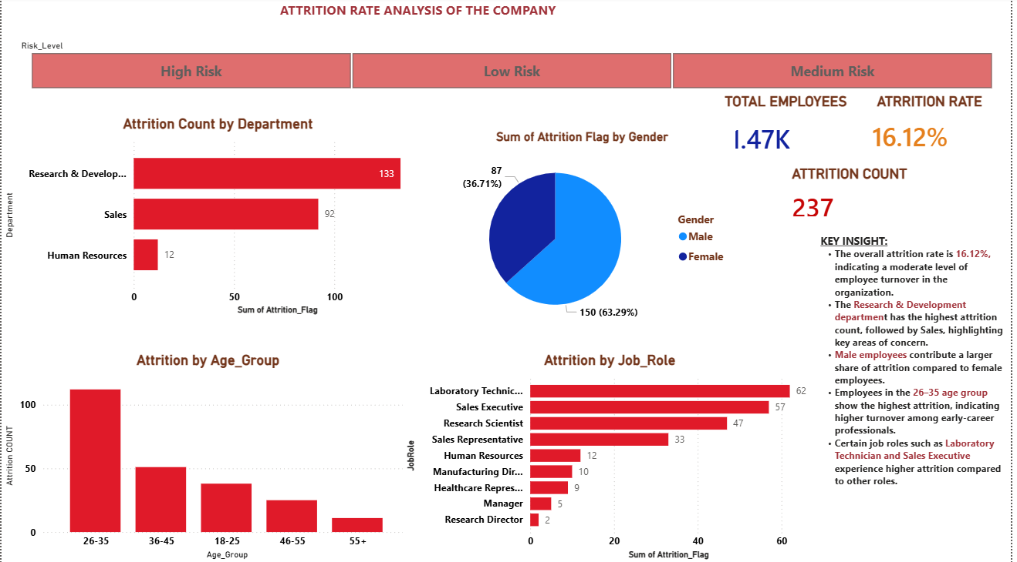
FIG 1: ATTRITION OVERVIEW
Page 2: Risk & Predictive Analysis Description
Focuses on identifying high-risk employees and understanding the drivers of attrition.

Key Analysis:
- Risk Segmentation: Employees categorized as High, Medium, and Low risk
- Overtime Impact: Employees working overtime show higher attrition
- Job Satisfaction: Lower satisfaction leads to higher attrition
- Salary Impact: Lower income groups have higher turnover
- Experience Factor: Employees with fewer years at the company are more likely to leave
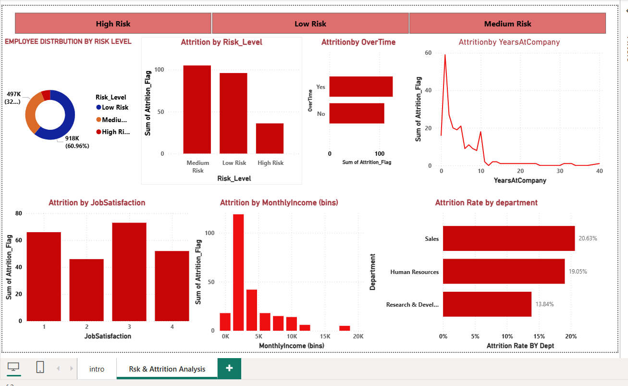

Visuals Included:
- Overall attrition rate is 16.12%, indicating moderate employee turnover
- R&D and Sales departments contribute most to attrition
- Early-career employees (26–35 years) are more likely to leave
- Overtime significantly increases attrition probability
- Job satisfaction strongly influences retention
- Lower salary groups experience higher attrition

Key Insights:
If you want slightly more impactful:
- Overall attrition rate is 16.12%, reflecting a moderate but significant employee turnover
- Sales department shows the highest attrition rate (~21%), indicating higher relative risk
- Early-career employees (26–35 age group) are more likely to leave the organization
- Overtime workload significantly increases attrition probability
- Low job satisfaction is a key driver of employee exits
- Lower income groups exhibit higher attrition trends, highlighting compensation impact
- Employees with less than 2 years of experience are at higher risk of leavin

Business Recommendations:
Recommendation 1 — Improve Work-Life Balance
Reduce excessive overtime and ensure balanced workloads to prevent employee burnout and improve retention.
Recommendation 2 — Focus on Early Employee Retention
Implement onboarding and mentorship programs to support new employees and reduce early attrition.
Recommendation 3 — Enhance Employee Engagement
Conduct regular feedback surveys and improve workplace satisfaction through recognition and career growth opportunities.
Recommendation 4 — Review Compensation Structure
Provide competitive salaries and performance-based incentives to retain employees, especially in lower income groups.
Recommendation 5 — Target High-Risk Employees
Use risk segmentation to identify high-risk employees and take proactive measures to retain them.
Recommendation 6 — Strengthen Department-Level Strategies
Focus retention strategies on departments with high attrition such as Research & Development and Sales.

