ASSIGNMENT-05

DATE-26-06-2025

Batch no-1

25VID1334-DWS

Cmd Lets Commands

What are Cmdlets?

Cmdlets are simple commands used in Windows PowerShell. They are lightweight and designed to work with data in a structured way.

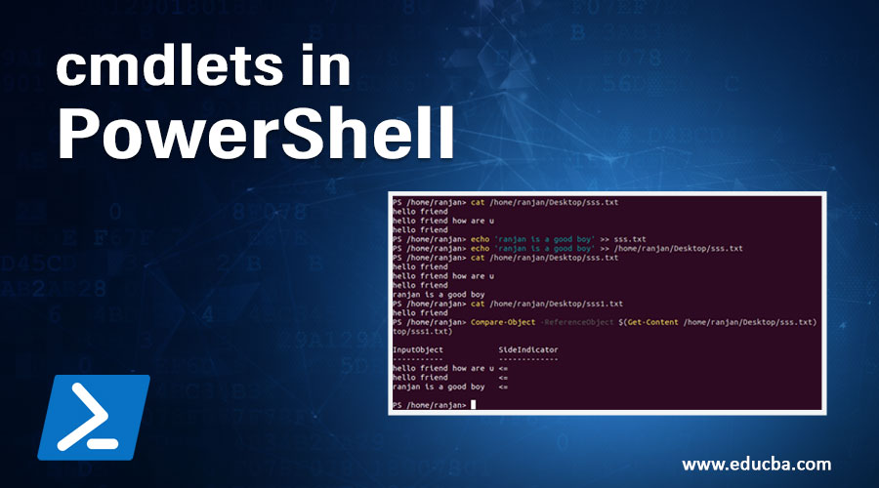

**Cmdlets and their uses:**

● Get-Command: Lists all available PowerShell commands, including cmdlets, functions,

and aliases. It helps users discover and understand the capabilities of PowerShell.

● Get-Help: Provides detailed documentation for a specific cmdlet, including syntax,

parameters, and examples. It's crucial for learning how to use a particular cmdlet

effectively.

● Get-Process: Retrieves information about running processes on the system.

● Start-Service: Starts a specified service

.

● Stop-Service: Stops a specified service.

● New-Item: Creates new files, directories, or registry keys.

● Get-Item: Retrieves information about existing files, directories, or registry keys.

● Set-Item: Modifies properties of existing files, directories, or registry keys.

● Test-Connection: A PowerShell cmdlet similar to ping for network connectivity testing.

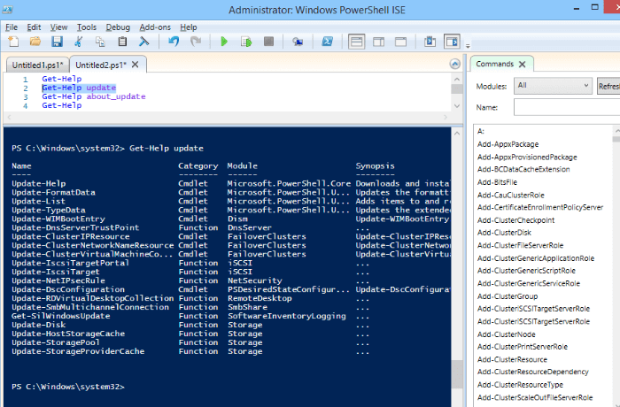

● Get-Module: Lists all loaded PowerShell modules.

● Import-Module: Imports a specific module to extend PowerShell's capabilities.

● Remove-Module: Removes a module from memory.

● Get-ExecutionPolicy: Displays the current execution policy for PowerShell scripts.

● Set-ExecutionPolicy: Sets the execution policy for PowerShell scripts.

● Get-WmiObject: Retrieves information from the Windows Management Instrumentation

(WMI) repository.

● Invoke-Expression: Executes a specified string as a PowerShell expression.

● Write-Output: Displays output to the console.

● Out-File: Writes output to a file.

● Read-Host: Reads input from the user.

● Test-Path: Checks if a specified path exists.

● Remove-Item: Deletes files, directories, or registry keys.

● New-PSDrive: Creates a new PowerShell drive.

● Get-PSDrive: Displays information about existing PowerShell drives.

● Remove-PSDrive: Removes a PowerShell drive.

● New-Object: Creates new objects.

● Invoke-WebRequest: Sends a web request.

● Invoke-RestMethod: Sends a REST API request.

**Example of a Cmdlet:**

Get-ChildItem (often shortened to Get-ChildItem or Get-CI) lists the contents of a directory. For

example, Get-ChildItem C:\Program Files would list all files and folders within the "Program