1. import java.util.ArrayList;
import java.util.List;
import java.util.Scanner;
import java.util.PriorityQueue;
import java.util.Comparator;
class Student {
private int id;
private String name;
private double cgpa;

public Student(int id, String name, double cgpa) {
this.id = id;
this.name = name;
this.cgpa = cgpa;
}

public int getID() {
return id;
}

public String getName() {
return name;
}

public double getCGPA() {
return cgpa;
}
}

class Priorities {

public List<Student> getStudents(List<String> events) {

PriorityQueue<Student> pq = new PriorityQueue<>(new Comparator<Student>() {
@Override
public int compare(Student s1, Student s2) {

if (Double.compare(s2.getCGPA(), s1.getCGPA()) != 0) {
return Double.compare(s2.getCGPA(), s1.getCGPA());
}

if (!s1.getName().equals(s2.getName())) {
return s1.getName().compareTo(s2.getName());
}

return Integer.compare(s1.getID(), s2.getID());
}
});

for (String event : events) {
String[] arr = event.split(" ");

if (arr[0].equals("ENTER")) {
pq.add(new Student(
Integer.parseInt(arr[3]),
arr[1],
Double.parseDouble(arr[2])
));
} else if (arr[0].equals("SERVED")) {
if (!pq.isEmpty()) {
pq.poll();
}
}
}

List<Student> result = new ArrayList<>();

while (!pq.isEmpty()) {
result.add(pq.poll());
}

return result;
}
}

public class Solution {
private final static Scanner scan = new Scanner(System.in);
private final static Priorities priorities = new Priorities();

public static void main(String[] args) {
int totalEvents = Integer.parseInt(scan.nextLine());
List<String> events = new ArrayList<>();

while (totalEvents-- != 0) {
String event = scan.nextLine();
events.add(event);
}

List<Student> students = priorities.getStudents(events);

if (students.isEmpty()) {
System.out.println("EMPTY");
} else {
for (Student st: students) {
System.out.println(st.getName());
}
}
}
}
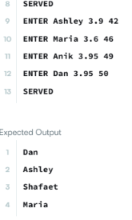
2. import java.util.ArrayList;
import java.util.List;
import java.util.Scanner;

public class Solution {
public static void main(String[] args) {
Scanner scanner = new Scanner(System.in);

int n = scanner.nextInt();
List<List<Integer>> lines = new ArrayList<>();

// Read all n lines of numbers
for (int i = 0; i < n; i++) {
int d = scanner.nextInt(); // Number of elements in this line
List<Integer> line = new ArrayList<>();
for (int j = 0; j < d; j++) {
line.add(scanner.nextInt());
}
lines.add(line);
}

int q = scanner.nextInt(); // Number of queries

// Process each query
for (int i = 0; i < q; i++) {
int x = scanner.nextInt(); // Line index (1-based)
int y = scanner.nextInt(); // Position index (1-based)

// Convert 1-based indexing to 0-based indexing
int lineIndex = x - 1;
int posIndex = y - 1;

// Check if line index and position index are within valid bounds
if (lineIndex >= 0 && lineIndex < lines.size()) {
List<Integer> targetLine = lines.get(lineIndex);
if (posIndex >= 0 && posIndex < targetLine.size()) {
System.out.println(targetLine.get(posIndex));
continue;
}
}

System.out.println("ERROR!");
}

scanner.close();
}
}

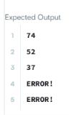
3. import java.util.*;

class BrowserHistory {

private ArrayList<String> history;
private int current;

public BrowserHistory(String homepage) {
history = new ArrayList<>();
history.add(homepage);
current = 0;
}

public void visit(String url) {

// Remove all forward history
while (history.size() > current + 1) {
history.remove(history.size() - 1);
}

// Add new URL
history.add(url);

// Move to the new page
current++;
}

public String back(int steps) {

current = Math.max(0, current - steps);

return history.get(current);
}

public String forward(int steps) {

current = Math.min(history.size() - 1, current + steps);

return history.get(current);
}
}
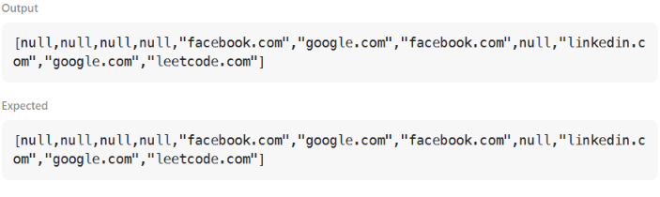
4. import java.util.ArrayList;
import java.util.List;
import java.util.Scanner;

public class Solution {
public static void main(String[] args) {
Scanner scanner = new Scanner(System.in);

int n = scanner.nextInt();
List<List<Integer>> lines = new ArrayList<>();

// Read all n lines of numbers
for (int i = 0; i < n; i++) {
int d = scanner.nextInt(); // Number of elements in this line
List<Integer> line = new ArrayList<>();
for (int j = 0; j < d; j++) {
line.add(scanner.nextInt());
}
lines.add(line);
}

int q = scanner.nextInt(); // Number of queries

// Process each query
for (int i = 0; i < q; i++) {
int x = scanner.nextInt(); // Line index (1-based)
int y = scanner.nextInt(); // Position index (1-based)

// Convert 1-based indexing to 0-based indexing
int lineIndex = x - 1;
int posIndex = y - 1;

// Check if line index and position index are within valid bounds
if (lineIndex >= 0 && lineIndex < lines.size()) {
List<Integer> targetLine = lines.get(lineIndex);
if (posIndex >= 0 && posIndex < targetLine.size()) {
System.out.println(targetLine.get(posIndex));
continue;
}
}

System.out.println("ERROR!");
}

scanner.close();
}
}

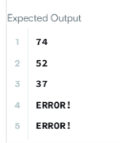

5. class MyLinkedList {

private static class Node{
int val;
Node next;
public Node(int val){
this.val = val;
}
}

Node head = null;
Node tail = null;
int current_size = 0;

public MyLinkedList() {
}

public int get(int index) {
if(index < 0 || index >= current_size)
return -1;

Node temp = head;
for(int i=0; i<index; i++){
temp = temp.next;
}
return temp.val;
}

private Node getNodeAtIndex(int index) {
if(index < 0 || index >= current_size)
return null;

Node temp = head;
for(int i=0; i<index; i++){
temp = temp.next;
}
return temp;
}

public void addAtHead(int val) {
Node newNode = new Node(val);
newNode.next = head;
head = newNode;
if(current_size == 0)
tail = head;
current_size++;
}

public void addAtTail(int val) {
if(current_size == 0)
addAtHead(val);
else {
tail.next = new Node(val);
tail = tail.next;
current_size++;
}
}

public void addAtIndex(int index, int val) {
if(index < 0 || index > current_size)
return;
else if(index == 0)
addAtHead(val);
else if(index == current_size)
addAtTail(val);
else {
Node newNode = new Node(val);
Node prevNode = getNodeAtIndex(index-1);
newNode.next = prevNode.next;
prevNode.next = newNode;
current_size++;
}
}

public void deleteAtIndex(int index) {
if(index < 0 || index >= current_size)
return;
else if(current_size == 1){
head = null;
tail = null;
} else if(index == 0){
head = head.next;
} else if(index == current_size-1){
Node previousNode = getNodeAtIndex(index-1);
previousNode.next = null;
tail = previousNode;
} else {
Node previousNode = getNodeAtIndex(index-1);
previousNode.next = previousNode.next.next;
}
current_size--;
}
}
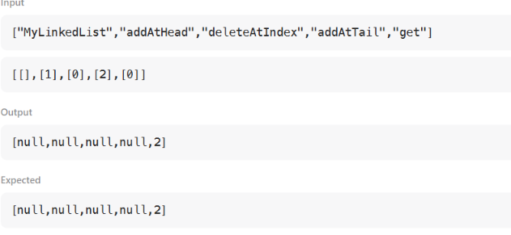
6. import java.io.*;
import java.util.*;
import java.text.*;
import java.math.*;
import java.util.regex.*;

public class Solution {

public static void main(String[] args) {
Scanner s = new Scanner(System.in);
int t = s.nextInt();
String [] pair_left = new String[t];
String [] pair_right = new String[t];

for (int i = 0; i < t; i++) {
pair_left[i] = s.next();
pair_right[i] = s.next();
}
Set<String> set = new HashSet<String>();

for (int i = 0; i < t; i++) {
set.add(pair_left[i] + " " + pair_right[i]);
System.out.println(set.size());
}
}
}
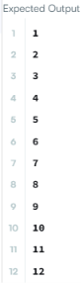

7. public class Solution {
public int removeDuplicates(int[] nums) {
if (nums.length == 0) return 0;

int k = 1; // Pointer for placing the next unique element
for (int i = 1; i < nums.length; i++) {
if (nums[i] != nums[i - 1]) {
nums[k] = nums[i];
k++;
}
}
return k;
}
}
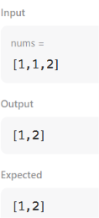
8. class Solution {
public int[] intersection(int[] nums1, int[] nums2) {
// Sort both arrays
Arrays.sort(nums1);
Arrays.sort(nums2);

// Initialize two pointers
int N = nums1.length;
int M = nums2.length;
int p1 = 0;
int p2 = 0;

// Create set that stores integers appearing in both arrays
Set<Integer> intersection = new HashSet<>();

// Iterate the pointers from left to right
while (p1 < N && p2 < M) {
// Add a value to the set if values at both pointers equal
if (nums1[p1] == nums2[p2]) {
intersection.add(nums1[p1]);
p1++;
p2++;
}
// Otherwise, increment the pointer of the smaller integer
else if (nums1[p1] < nums2[p2]) {
p1++;
}
else {
p2++;
}
}

// Convert intersection to an array
int K = intersection.size();
int[] result = new int[K];
int curr = 0;
for (int x: intersection) {
result[curr++] = x;
}

//Return the result
return result;
}
}
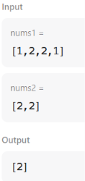
9. import java.io.*;
import java.util.*;

public class Solution {

public static void main(String[] args) {

Scanner s = new Scanner(System.in);

int n = s.nextInt();
s.nextLine();

HashMap<String, String> phoneBook = new HashMap<>();

// Store phone book entries
for (int i = 0; i < n; i++) {
String name = s.nextLine();
String phone = s.nextLine();

phoneBook.put(name, phone);
}

// Read queries until EOF
while (s.hasNextLine()) {
String query = s.nextLine();

if (phoneBook.containsKey(query)) {
System.out.println(query + "=" + phoneBook.get(query));
} else {
System.out.println("Not found");
}
}

s.close();
}
}
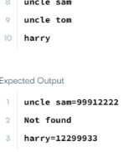
10. class Pair<U, V> {
U first;
V second;

public Pair(U u, V v) {
first = u;
second= v;
}
}

class Bucket {
List<Pair<Integer, Integer>> list;

public Bucket() {
list = new LinkedList<Pair<Integer, Integer>>();
}

public void put(int key, int val) {
for(Pair<Integer, Integer> p : list) {
if(p.first == key) {
p.second = val;
return;
}
}
list.addFirst(new Pair<Integer, Integer> (key, val));
}

public int get(int key) {
for(Pair<Integer, Integer> p : list) {
if(p.first == key) {
return p.second;
}
}
return -1;
}

public void remove(int key) {
for(Pair<Integer, Integer> p : list) {
if(p.first == key) {
list.remove(p);
return;
}
}
}
}

class MyHashMap {
Bucket[] buckets;
int keyRange = 769;

public MyHashMap() {
buckets = new Bucket[keyRange];
for(int i=0; i<keyRange; i++) {
this.buckets[i] = new Bucket();
}
}

private int getIndex(int key) {
return key % keyRange;
}

public void put(int key, int value) {
int bucketIdx = this.getIndex(key);
this.buckets[bucketIdx].put(key, value);
}

public int get(int key) {
int bucketIdx = this.getIndex(key);
return this.buckets[bucketIdx].get(key);
}

public void remove(int key) {
int bucketIdx = this.getIndex(key);
this.buckets[bucketIdx].remove(key);
}
}

