1. class Solution {
public int majorityElement(int[] nums) {
HashMap<Integer, Integer> hash = new HashMap<>();
int res = 0;
int majority = 0;

for (int n : nums) {
hash.put(n, 1 + hash.getOrDefault(n, 0));
if (hash.get(n) > majority) {
res = n;
majority = hash.get(n);
}
}

return res;
}
}
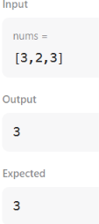
2. class Solution {
public int firstUniqChar(String s) {
int[] count = new int[26];

// Count frequency of each character
for (int i = 0; i < s.length(); i++) {
count[s.charAt(i) - 'a']++;
}

// Find the first non-repeating character
for (int i = 0; i < s.length(); i++) {
if (count[s.charAt(i) - 'a'] == 1) {
return i;
}
}

return -1;
}
}
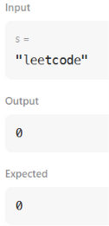
3. class Solution {
public int findShortestSubArray(int[] nums) {
int n=nums.length;
HashMap<Integer,int[]>mp=new HashMap<>();
for(int i=0;i<n;i++){
if(!mp.containsKey(nums[i])){
mp.put(nums[i],new int[]{i,i,1});
}
else{
int []arr=mp.get(nums[i]);
arr[1]=i;
arr[2]++;
mp.put(nums[i],arr);
}
}
int freq=Integer.MIN_VALUE;
int distance=Integer.MAX_VALUE;
for(int[]value:mp.values()){
if(value[2]>freq){
freq=value[2];
distance=value[1]-value[0]+1;
}
else if(value[2]==freq){
distance=Math.min(distance,value[1]-value[0]+1);
}
}
return distance;
}
}
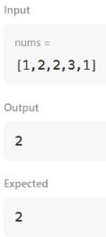
4. students = []

n = int(input())

for i in range(n):
name = input()
grade = float(input())
students.append([name, grade])

grades = sorted(set(student[1] for student in students))

second_lowest = grades[1]

names = []

for student in students:
if student[1] == second_lowest:
names.append(student[0])

names.sort()

for name in names:
print(name)
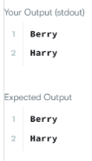
5. import java.io.*;
import java.util.*;

public class Solution {

public static void main(String[] args) {

Scanner sc = new Scanner(System.in);

int n = sc.nextInt();

ArrayList<ArrayList<Integer>> list = new ArrayList<>();

// Read the lines
for (int i = 0; i < n; i++) {

int d = sc.nextInt();

ArrayList<Integer> row = new ArrayList<>();

for (int j = 0; j < d; j++) {
row.add(sc.nextInt());
}

list.add(row);
}

// Number of queries
int q = sc.nextInt();

for (int i = 0; i < q; i++) {

int x = sc.nextInt();
int y = sc.nextInt();

// x and y are 1-based
if (x <= list.size() && y <= list.get(x - 1).size()) {
System.out.println(list.get(x - 1).get(y - 1));
} else {
System.out.println("ERROR!");
}
}

sc.close();
}
}
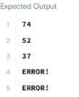
6. import java.util.ArrayList;
import java.util.List;

class Solution {
public List<List<Integer>> generate(int numRows) {
List<List<Integer>> result = new ArrayList<>();
if (numRows == 0) {
return result;
}

List<Integer> firstRow = new ArrayList<>();
firstRow.add(1);
result.add(firstRow);

for (int i = 1; i < numRows; i++) {
List<Integer> prevRow = result.get(i - 1);
List<Integer> currentRow = new ArrayList<>();
currentRow.add(1);

for (int j = 1; j < i; j++) {
currentRow.add(prevRow.get(j - 1) + prevRow.get(j));
}

currentRow.add(1);
result.add(currentRow);
}

return result;
}
}
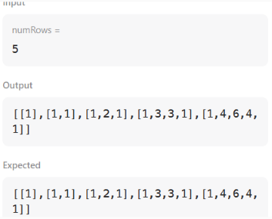
7. import java.util.*;
import java.io.*;

class Node {
Node left;
Node right;
int data;

Node(int data) {
this.data = data;
left = null;
right = null;
}
}

class Solution {

public static void preOrder(Node root) {

if (root == null) {
return;
}

System.out.print(root.data + " ");

preOrder(root.left);
preOrder(root.right);
}

public static Node insert(Node root, int data) {
if(root == null) {
return new Node(data);
} else {
Node cur;
if(data <= root.data) {
cur = insert(root.left, data);
root.left = cur;
} else {
cur = insert(root.right, data);
root.right = cur;
}
return root;
}
}

public static void main(String[] args) {
Scanner scan = new Scanner(System.in);
int t = scan.nextInt();
Node root = null;
while(t-- > 0) {
int data = scan.nextInt();
root = insert(root, data);
}
scan.close();
preOrder(root);
}
}
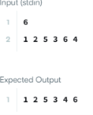
8. class Solution {
public int[] intersection(int[] nums1, int[] nums2) {
// Sort both arrays
Arrays.sort(nums1);
Arrays.sort(nums2);

// Initialize two pointers
int N = nums1.length;
int M = nums2.length;
int p1 = 0;
int p2 = 0;

// Create set that stores integers appearing in both arrays
Set<Integer> intersection = new HashSet<>();

// Iterate the pointers from left to right
while (p1 < N && p2 < M) {
// Add a value to the set if values at both pointers equal
if (nums1[p1] == nums2[p2]) {
intersection.add(nums1[p1]);
p1++;
p2++;
}
// Otherwise, increment the pointer of the smaller integer
else if (nums1[p1] < nums2[p2]) {
p1++;
}
else {
p2++;
}
}

// Convert intersection to an array
int K = intersection.size();
int[] result = new int[K];
int curr = 0;
for (int x: intersection) {
result[curr++] = x;
}

//Return the result
return result;
}
}
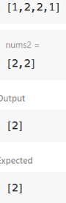
9. import java.io.*;
import java.util.*;

public class Solution {

public static void main(String[] args) {

Scanner sc = new Scanner(System.in);

int n = sc.nextInt();
sc.nextLine();

HashMap<String, String> phoneBook = new HashMap<>();

// Store names and phone numbers
for (int i = 0; i < n; i++) {
String name = sc.nextLine();
String phone = sc.nextLine();

phoneBook.put(name, phone);
}

// Read queries until end of input
while (sc.hasNextLine()) {
String query = sc.nextLine();

if (phoneBook.containsKey(query)) {
System.out.println(query + "=" + phoneBook.get(query));
} else {
System.out.println("Not found");
}
}

sc.close();
}
}
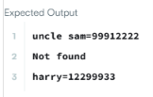
10. class Pair<U, V> {
U first;
V second;

public Pair(U u, V v) {
first = u;
second= v;
}
}

class Bucket {
List<Pair<Integer, Integer>> list;

public Bucket() {
list = new LinkedList<Pair<Integer, Integer>>();
}

public void put(int key, int val) {
for(Pair<Integer, Integer> p : list) {
if(p.first == key) {
p.second = val;
return;
}
}
list.addFirst(new Pair<Integer, Integer> (key, val));
}

public int get(int key) {
for(Pair<Integer, Integer> p : list) {
if(p.first == key) {
return p.second;
}
}
return -1;
}

public void remove(int key) {
for(Pair<Integer, Integer> p : list) {
if(p.first == key) {
list.remove(p);
return;
}
}
}
}

class MyHashMap {
Bucket[] buckets;
int keyRange = 769;

public MyHashMap() {
buckets = new Bucket[keyRange];
for(int i=0; i<keyRange; i++) {
this.buckets[i] = new Bucket();
}
}

private int getIndex(int key) {
return key % keyRange;
}

public void put(int key, int value) {
int bucketIdx = this.getIndex(key);
this.buckets[bucketIdx].put(key, value);
}

public int get(int key) {
int bucketIdx = this.getIndex(key);
return this.buckets[bucketIdx].get(key);
}

public void remove(int key) {
int bucketIdx = this.getIndex(key);
this.buckets[bucketIdx].remove(key);
}
}
