ЗАВДАННЯ НА РОБОТУ
- Написати код, що реалізує алгоритм відповідно до варіанта.
- Експерементально візначити оптимальні значення основних параметрів алгоритму.
- З його допомогою знайти екстремуми наступних функцій.

SPHERE FUNCTION
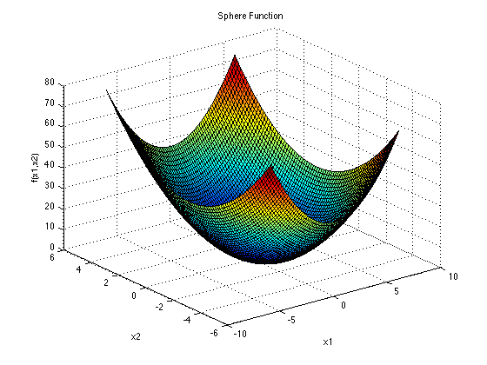
The Sphere function has (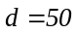) local minima and the global one. It is continuous, convex and unimodal. The function has been evaluated on the hypercube 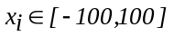for 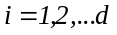.
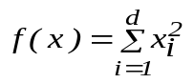.
Its global minimum is 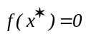 at 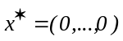.
ACKLEY FUNCTION
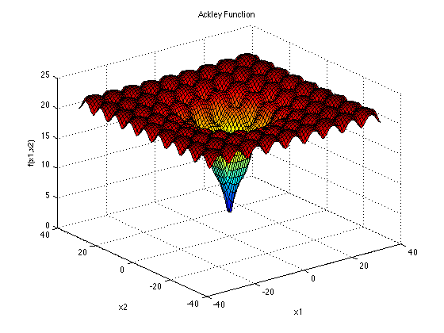
The function poses a risk for optimization algorithms to be trapped in one of its many local minima.

.
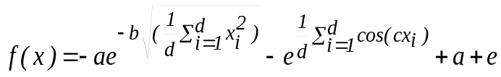
Variable values are 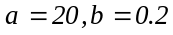, 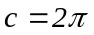and 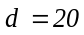
The function is evaluated on the hypercube 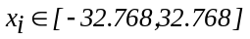 for 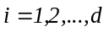. Its global minimum is at .

GRIEWANK FUNCTION

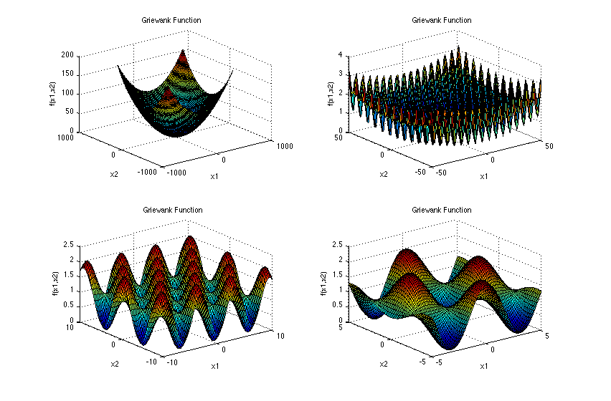
The Griewank function has many widespread local minima, which are regularly distributed.
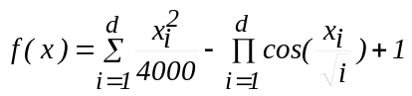
The function has been evaluated on the hypercube 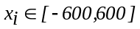for (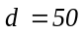). Its global minimum is at .

RASTRIGIN FUNCTION

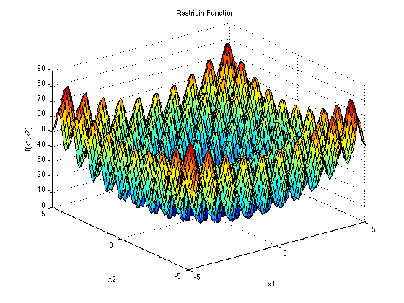
The Rastrigin function has several local minima. It is highly multimodal, but locations of the minima are regularly distributed.
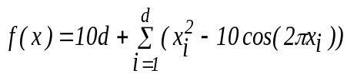.
The function is evaluated on the hypercube 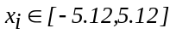for (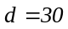). Its global minimum is at .

ROSENBROCK FUNCTION
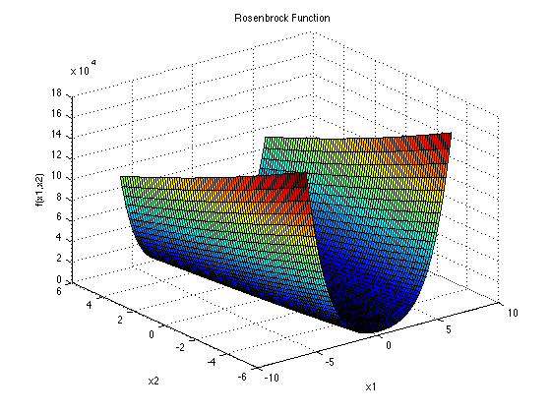
The Rosenbrock function is unimodal, and the global minimum lies in a narrow, parabolic valley. However, even though this valley is easy to find, convergence to the minimum is difficult.
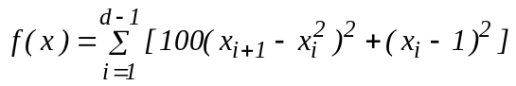.
The function is evaluated on the hypercube 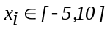for (). Its global minimum is at 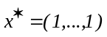.
4. Побудувати графіки залежності швидкості збіжності алгоритму від розміру популяції.

