TECHNICAL PROJECT PROPOSAL

ROADMIND
Explainable Predictive AI Co-Pilot for Advanced Driver Assistance Systems (ADAS)
An Explainable Machine Learning Framework for Predictive Road-Risk Assessment and Driver Warning

Artificial Intelligence • Machine Learning • Explainable AI • Automotive Safety

Table of Contents
1. Introduction 3
2. Project Objectives 3
3. Proposed System Workflow 5
4. System Architecture 7
5. Dataset 9
5.1 Dataset Identification and Verification 9
5.2 Dataset Summary 9
5.3 Feature Availability Mapping 10
5.4 Dataset Limitations 11
5.5 Dataset Suitability for RoadMind 11
5.6 Licensing and Access 11
6. Methodology Overview 13
6.1 Data Collection 13
6.2 Data Understanding 13
6.3 Data Preprocessing 13
6.4 Feature Engineering 13
6.5 Feature Selection 13
6.6 Dataset Splitting 14
6.7 Machine Learning Model Development 14
6.8 Risk Prediction 15
6.9 Risk Classification 15
6.10 Explainable AI 16
6.11 Driver Warning Generation 17
6.12 Model Evaluation 18
7. Scope, Assumptions, and Limitations 19
8. Future Work and ADAS Integration Roadmap 19
9. References 21

1. Introduction
Road traffic collisions remain one of the most persistent public-safety challenges worldwide, and a large share of them are attributed to human error rather than vehicle failure. Advanced Driver Assistance Systems (ADAS) — electronic in-vehicle technologies such as automatic emergency braking, lane-departure warning, and adaptive cruise control — have been developed specifically to counter this by using sensors and automated logic to detect hazards and assist the driver (NHTSA, U.S. Department of Transportation). Under the SAE automation taxonomy referenced by U.S. regulators, most ADAS features available today correspond to Level 2 partial automation: the system may assist with steering and speed, but the human driver is required to remain fully attentive and responsible for the driving task at all times.
RoadMind is proposed as a complementary layer to conventional ADAS: rather than reacting only at the moment a hazard is detected by onboard sensors, it uses machine learning to forecast elevated-risk driving conditions from contextual data — weather, visibility, road and traffic conditions, time and location, and (where available) vehicle-dynamics signals — and to classify the situation into a Low, Medium, or High risk category. Its distinguishing feature is explainability: every prediction is accompanied by a ranked set of contributing factors, generated using SHAP (SHapley Additive exPlanations), so that the driver receives a specific, interpretable reason rather than an opaque alert.
It is important to state RoadMind's scope precisely. At this stage, RoadMind is a conceptual system design and technical project proposal, grounded in a verified public dataset and established, published machine-learning and explainability techniques. It is presented as a predictive driver-assistance and risk-awareness system that supports driver decision-making — it does not control vehicle actuators, and no claim is made that it prevents accidents outright or that it has been experimentally validated on live traffic. Every technical claim, dataset statistic, and model description in this document has been cross-checked against primary or official sources, and every place where the design still requires empirical validation is explicitly marked as such.
This document sets out RoadMind's objectives, its proposed workflow and system architecture, the dataset selected to support it (verified against its official source), a stage-by-stage methodology, the proposed machine-learning and explainable-AI approach, an evaluation plan, and a discussion of scope, assumptions, and future integration with production ADAS platforms.

2. Project Objectives
The objectives below restate the goals of the source proposal in technically defensible language. Wording that would imply guaranteed accident prevention has been deliberately avoided in favor of language describing risk identification, early warning, and decision support.

A. Predictive Safety
- Identify elevated-risk driving conditions before they escalate into an incident, using a model trained on historical accident and environmental data.
- Produce a quantitative risk indicator (a probability or score) for a given combination of driving conditions, rather than a binary yes/no output.

B. Environmental and Driving-Condition Analysis
- Analyze contextual factors — weather condition, visibility, temperature, wind speed, road-related infrastructure (junctions, traffic signals), time of day, and location — that are statistically associated with recorded accidents.
- Where vehicle telemetry is available in a future integration (speed, acceleration, braking, steering), incorporate it as an additional input layer alongside environmental context.

C. Risk Classification
- Convert a continuous model output (risk probability) into interpretable Low / Medium / High categories that a driver can process in under a second.
- Define the mapping from probability to category using a documented, data-driven method rather than an arbitrarily chosen cut-off.

D. Explainable AI
- Attach a feature-level explanation to every risk prediction using SHAP, so the reasoning behind an assessment is transparent and auditable rather than a black-box output.
- Surface the top contributing factors (e.g., poor visibility, wet road, heavy traffic) in plain language alongside the numeric prediction.

E. Driver Assistance
- Translate the risk level and its explanation into a concise, actionable message that supports — and does not replace — driver judgment.
- Aim to identify elevated-risk conditions and provide early warnings that support safer decision-making, rather than claiming to guarantee accident prevention.

F. Future ADAS Integration
- Design the prediction and explanation pipeline with a modular, standardized input/output interface so that it could conceptually connect to onboard telematics or ADAS controllers in a later implementation phase.
- Align the system's risk-communication model with the SAE Level 2 framing used by NHTSA, in which the system assists an attentive driver rather than assuming control of the vehicle.

3. Proposed System Workflow
The workflow below redesigns the original project flow chart into a labeled technical diagram. The conceptual sequence — from data collection through preprocessing, prediction, explanation, and driver warning — is preserved from the source proposal; the presentation has been restructured for clarity and to make the branching risk-classification step and its inputs explicit.
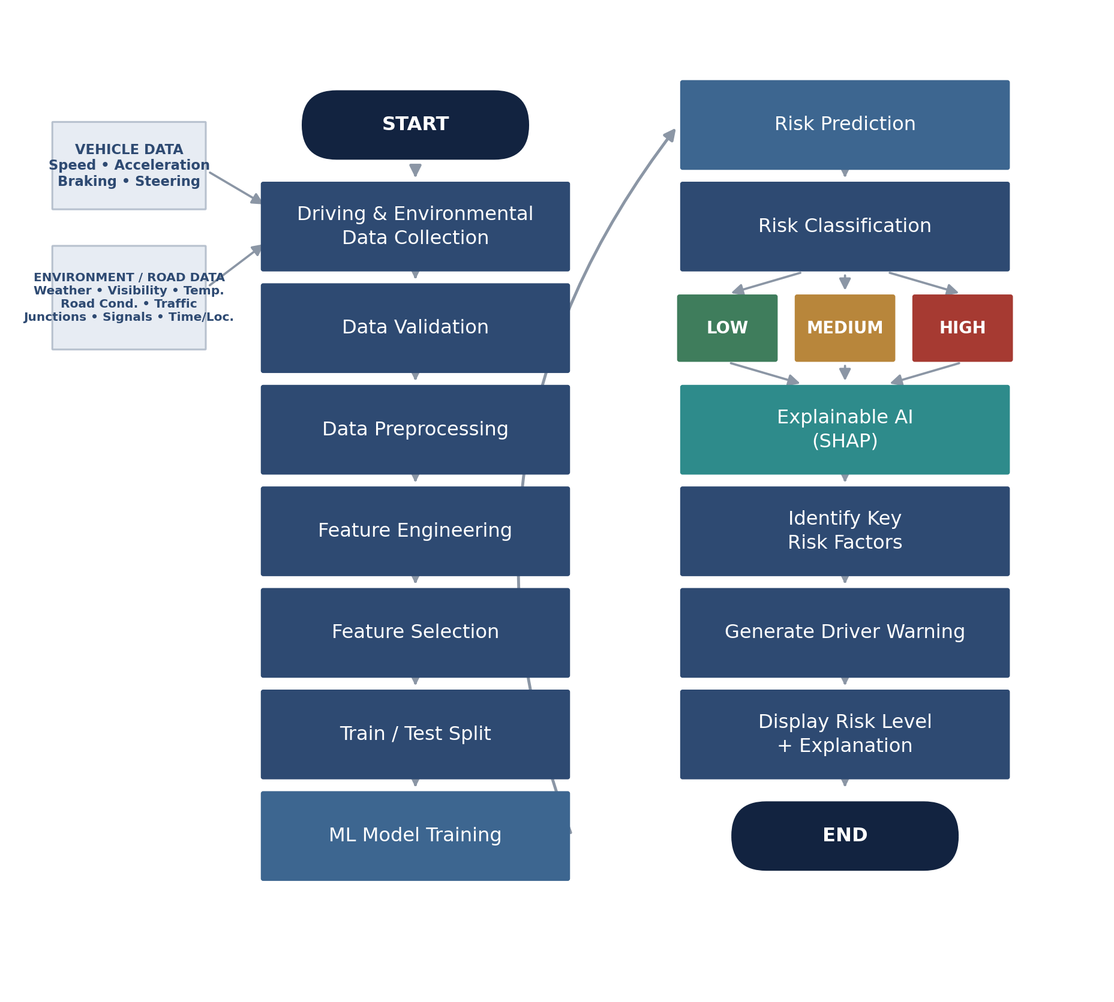
Figure 1. Proposed RoadMind system workflow, from data collection through risk classification, SHAP-based explanation, and driver warning.
The pipeline begins with two parallel input streams — vehicle data (speed, acceleration, braking, steering, where available) and environmental/road data (weather, visibility, temperature, road condition, traffic, junctions, signals, time and location) — which feed into data collection. After validation and preprocessing, engineered features pass through a trained model to produce a risk prediction, which is mapped to a Low, Medium, or High classification. SHAP explanation is then applied to identify the key factors behind that specific prediction, which are used to generate a driver-facing warning that displays both the risk level and the reasoning behind it.

4. System Architecture
At a higher level of abstraction than the workflow diagram, RoadMind can be described as a seven-layer pipeline. Each layer has a single, well-defined responsibility, which keeps the design modular and makes it easier to later replace or upgrade an individual layer (for example, swapping the ML Prediction Engine for a different model family) without redesigning the whole system.
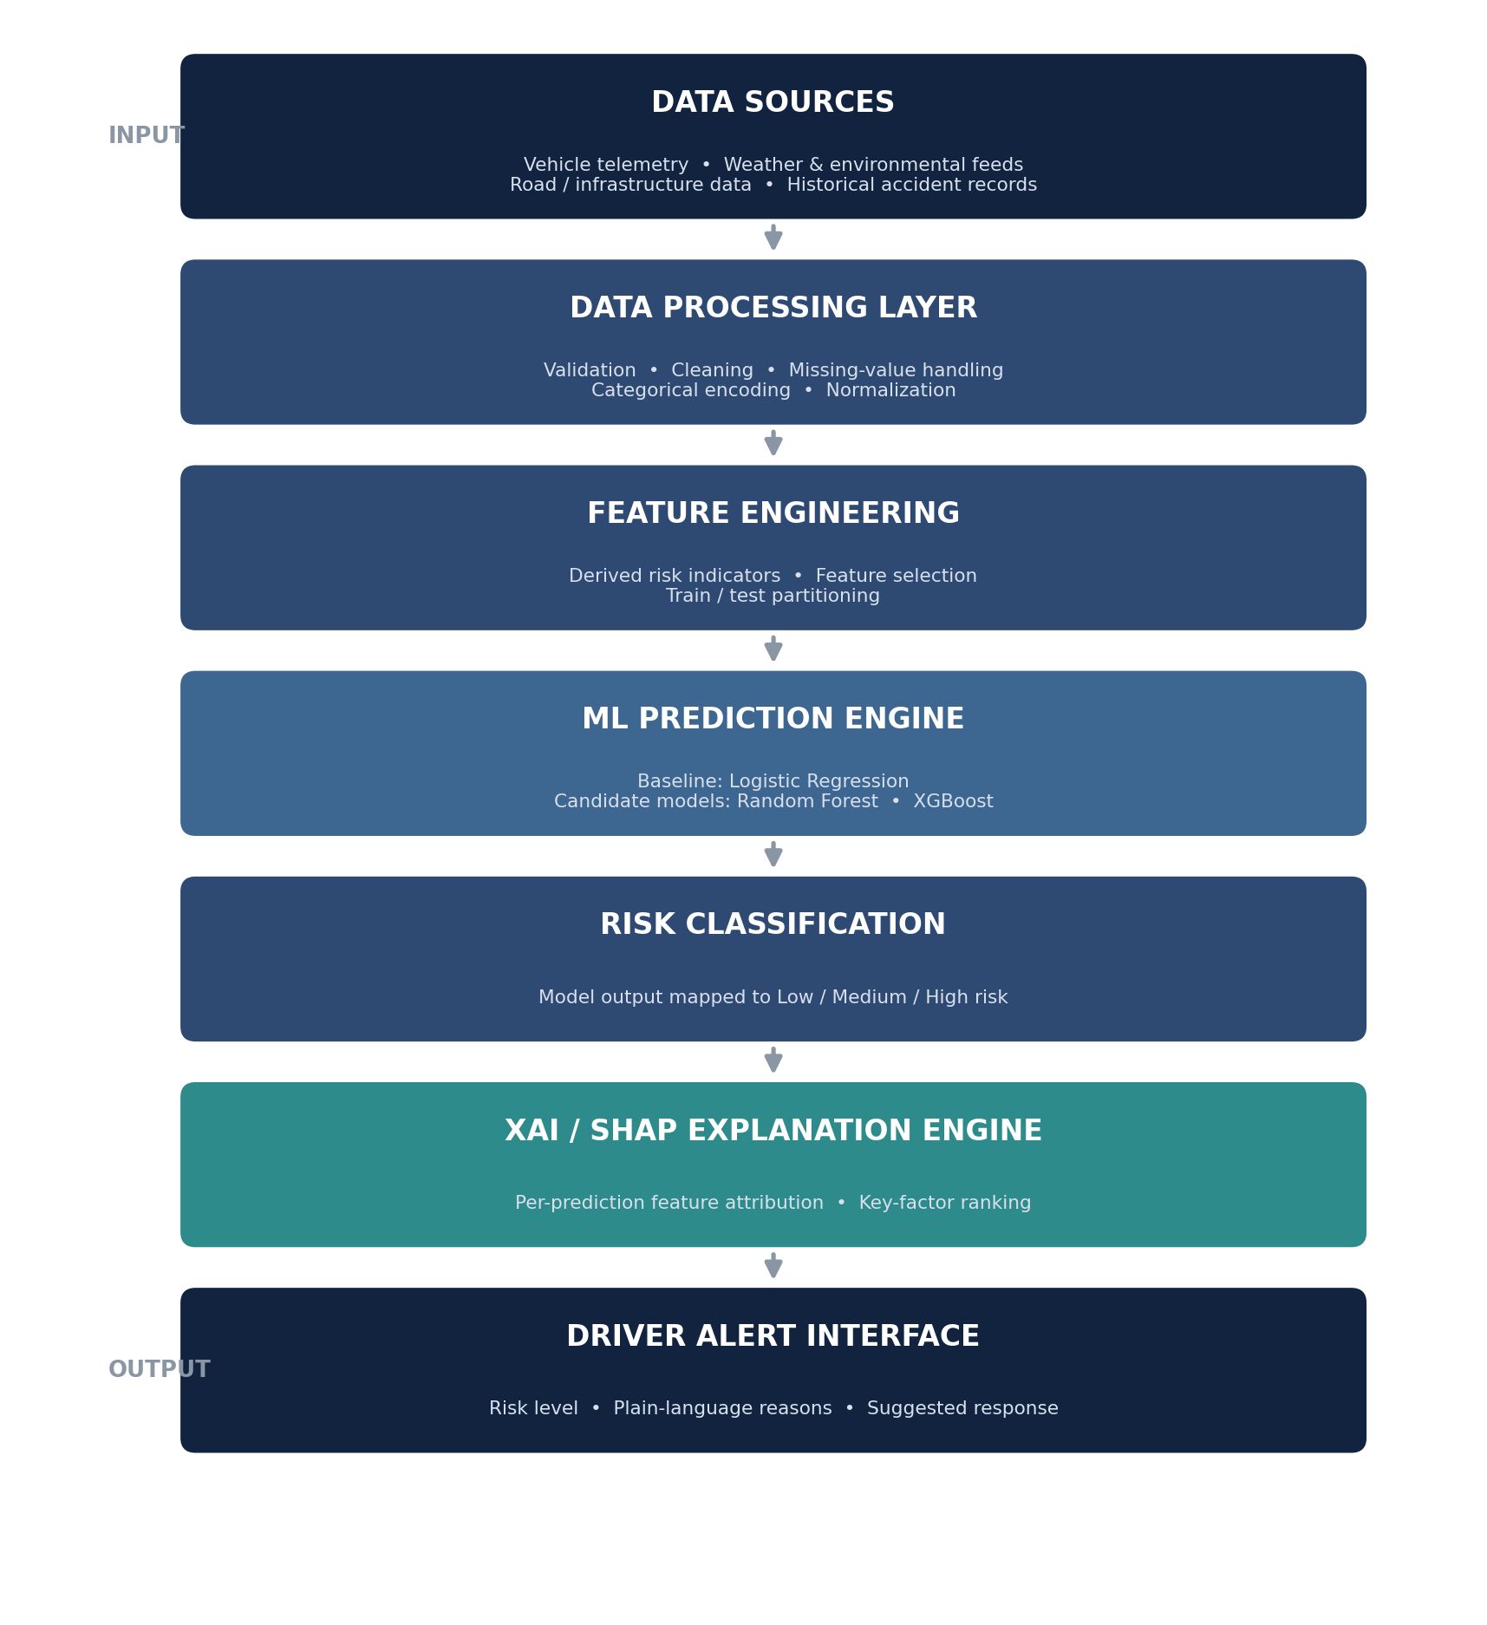
Figure 2. RoadMind system architecture: a layered view from raw data sources to the driver-facing alert interface.
The Data Sources layer aggregates vehicle telemetry, weather and environmental feeds, road/infrastructure data, and historical accident records. The Data Processing and Feature Engineering layers clean and transform this raw data into a model-ready feature set. The ML Prediction Engine produces a risk probability, which the Risk Classification layer converts into a category. The XAI / SHAP Explanation Engine attributes that prediction to specific input features, and the Driver Alert Interface renders the risk level, the plain-language reasons, and a suggested response for the driver.

5. Dataset
The source proposal references the “US Accidents Dataset.” This section verifies that dataset against its official and primary sources, documents what it actually contains, and — critically — distinguishes which RoadMind input variables are directly available in it, which must be derived, and which would require an additional data source.

5.1 Dataset Identification and Verification
The dataset is US-Accidents: A Countrywide Traffic Accident Dataset, created by Sobhan Moosavi and colleagues at the Department of Computer Science and Engineering, The Ohio State University. It was verified against two sources: the research group's official dataset page (smoosavi.org) and its public distribution on Kaggle (sobhanmoosavi/us-accidents), which is the version referenced throughout this document because it reflects the most current, extended release. The dataset is described in two peer-reviewed publications: a 2019 IEEE Big Data paper introducing the dataset, and a companion 2019 ACM SIGSPATIAL paper on accident-risk prediction using it — both full citations appear in the References section.
The data is collected in near real-time from multiple traffic and weather data providers, including departments of transportation, law-enforcement agencies, traffic cameras, and road-network sensors, and covers the contiguous United States (49 states) from February 2016 to March 2023. The current Kaggle release contains approximately 7.7 million accident records across 46 attributes. An earlier, smaller release (version 5, December 2020, ≈ 1.5 million records) is also documented on the official project page; the larger, extended release is recommended for RoadMind because it provides substantially more training examples and a longer time span for the model to learn seasonal and regional patterns.

5.2 Dataset Summary
Category | Details
Dataset | US-Accidents: A Countrywide Traffic Accident Dataset
Provider / Origin | Sobhan Moosavi et al., The Ohio State University — collected via multiple live traffic and weather data-provider APIs
Primary distribution | Kaggle: kaggle.com/datasets/sobhanmoosavi/us-accidents
Official source page | smoosavi.org/datasets/us_accidents
Records | ≈ 7.7 million accident records (7,728,394 in widely cited counts of the current release)
Attributes | 46 columns (an earlier v5 release documents 47; column count has varied slightly across releases)
Target variable | Severity — an integer 1–4 describing the accident's impact on traffic flow (see §5.4 for an important caveat on what this field actually measures)
Geographic coverage | 49 contiguous U.S. states
Time coverage | February 2016 – March 2023
Data format | CSV (tabular)
Intended use (per provider) | Real-time accident prediction, accident hotspot analysis, causal/contributing-factor studies, and the effect of environmental stimuli on accident occurrence
License | Creative Commons Attribution-NonCommercial-ShareAlike 4.0 (CC BY-NC-SA 4.0) — research / non-commercial use, with citation of the source papers
Table 1. Summary of the verified US-Accidents dataset selected for RoadMind.

5.3 Feature Availability Mapping
The source proposal lists several categories of input signal. Not all of them are present in the US-Accidents dataset as named fields. The table below maps each RoadMind concept to its actual status in the verified dataset, which is essential for keeping the project technically honest about what can be trained on today versus what would need to be added later.
RoadMind Concept | Dataset Field(s) | Status | Notes
Weather condition | Weather_Condition | Directly available | Categorical text field (rain, snow, fog, etc.)
Visibility | Visibility(mi) | Directly available | Numeric, miles
Temperature | Temperature(F) | Directly available | Numeric, °F
Wind speed | Wind_Speed(mph) | Directly available | Numeric, mph
Road surface condition (wet / dry / icy) | — | Derived / approximated | No explicit road-surface column; must be approximated from Weather_Condition and Precipitation(in), or sourced from the free-text Description field
Traffic signals | Traffic_Signal | Directly available | Boolean point-of-interest flag near the accident site
Junctions | Junction | Directly available | Boolean point-of-interest flag
Time | Start_Time / End_Time | Directly available | Local time-stamps
Location | Start_Lat / Start_Lng, City, County, State, Zipcode | Directly available | GPS coordinates and address fields
Accident severity | Severity | Directly available (proxy target) | Measures traffic-flow impact, not injury severity — see §5.4
Traffic (congestion / density) | — | Requires additional source | No real-time traffic-volume or congestion field is included; would require an external feed such as state DOT sensor or probe-vehicle data
Driver behavior (speed, acceleration, braking, steering) | — | Requires additional source | Not present in this dataset at all; would require telematics, OBD-II, or driving-simulator data — relevant to the Future Work roadmap in §8
Table 2. Mapping of RoadMind input concepts to their actual availability in the verified US-Accidents dataset.

5.4 Dataset Limitations
- Severity measures traffic impact, not injury severity: the dataset's own documentation defines Severity 1–4 as the length of the resulting traffic delay, not a medical or crash-injury severity scale. RoadMind's “risk” framing should therefore be read as risk of a traffic-impacting accident occurring under given conditions, not a prediction of injury outcome.
- Geographic and regulatory scope: coverage is limited to the contiguous United States; patterns learned from this data are not automatically generalizable to other countries' road layouts, signage, or driving norms.
- Reporting heterogeneity: because records are aggregated from multiple state and municipal data providers, reporting completeness and latency vary by region, which can introduce regional bias.
- Correlational, not causal: the dataset supports learning statistical associations between conditions and recorded accidents; it does not, by itself, establish causal mechanisms.
- No driver-behavior or real-time traffic signal: as noted in Table 2, these would need to be sourced separately for a full implementation.

5.5 Dataset Suitability for RoadMind
Despite the gaps above, this dataset is a reasonable and defensible choice for a RoadMind prototype for several reasons. It is large enough (millions of records) to support supervised learning with tree-based ensemble methods; it already contains most of the environmental and road-context variables the project depends on (weather, visibility, temperature, wind, junctions, signals, time, and location); it is a widely used, peer-reviewed, and actively maintained benchmark in the traffic-safety machine-learning literature, which makes RoadMind's design comparable to prior published work; and its column-level documentation is detailed enough to support rigorous, auditable feature engineering. The gaps that do exist (traffic density, driver telematics) are clearly scoped in Table 2 as a future-integration requirement rather than glossed over.

5.6 Licensing and Access
The dataset is distributed under a Creative Commons Attribution-NonCommercial-ShareAlike 4.0 (CC BY-NC-SA 4.0) license for research and academic use, with a request to cite the associated papers. It can be obtained from:
- Kaggle (primary distribution): kaggle.com/datasets/sobhanmoosavi/us-accidents — requires a free Kaggle account to download.
- Official project page: smoosavi.org/datasets/us_accidents — hosted directly by the research group, with the full column-level data dictionary used to build Table 2 above.
Note: Because the license restricts use to non-commercial research and academic purposes, any future move from prototype to a commercial or production ADAS deployment would require either a separate data-licensing agreement with the provider or a transition to a differently licensed / proprietary data source.

6. Methodology Overview
This section expands the source proposal's six-stage methodology into twelve concrete stages, each described in terms of what happens, why it is required, what it receives as input, what it produces as output, and which techniques or tools apply. The overall data-to-warning chain is: Data → Preprocessing → Features → Model → Risk → XAI → Warning, matching the workflow in Figure 1.

6.1 Data Collection
What happens: driving-condition and accident-outcome data is assembled from the verified US-Accidents dataset (§5). Why: a supervised risk model requires historical examples that pair input conditions with a known outcome. Input: raw CSV extracts from the dataset. Output: a consolidated raw dataset ready for validation. Techniques/tools: Python (pandas) for ingestion; the Kaggle API or direct CSV download for retrieval.

6.2 Data Understanding
What happens: exploratory data analysis (EDA) to understand distributions, missingness, and class balance (e.g., the distribution of the Severity field) before any modeling decision is made. Why: prevents downstream errors caused by unexamined assumptions about the data. Input: raw dataset. Output: a documented profile of feature distributions, missing-value rates, and target-class balance. Techniques/tools: pandas-profiling / summary statistics, histograms, correlation analysis, geographic and temporal visualization.

6.3 Data Preprocessing
What happens: duplicate removal, missing-value handling, removal of columns not relevant to risk prediction (e.g., free-text description, internal IDs), categorical encoding, and numerical scaling where required. Why: raw traffic-API data is noisy and heterogeneous; most ML algorithms require clean, numerically encoded input. Input: raw validated dataset. Output: a clean, model-ready tabular dataset. Techniques/tools: pandas for cleaning; scikit-learn transformers (OneHotEncoder / OrdinalEncoder, StandardScaler or MinMaxScaler) for encoding and scaling.

6.4 Feature Engineering
What happens: construction of risk-relevant features from raw columns — for example, deriving a coarse road-condition indicator from Weather_Condition and Precipitation(in), extracting hour-of-day and day-of-week from Start_Time, or combining Junction / Traffic_Signal / Crossing flags into a single road-complexity indicator. Why: raw fields do not always express risk-relevant structure directly; engineered features often carry more predictive signal than raw columns alone. Input: cleaned dataset. Output: an expanded feature set. Techniques/tools: pandas feature construction; domain-driven binning and aggregation.

6.5 Feature Selection
What happens: reduction of the feature set to those with genuine predictive value, using correlation analysis, model-based importance scores, or recursive feature elimination. Why: fewer, more relevant features reduce overfitting risk, improve training speed, and make SHAP explanations easier to interpret. Input: expanded feature set. Output: a final, reduced feature set used for training. Techniques/tools: scikit-learn feature_importances_, mutual-information scores, correlation-matrix pruning.

6.6 Dataset Splitting
What happens: division of the processed data into training and held-out test partitions (and, ideally, a validation fold or cross-validation scheme). Why: evaluating a model on data it was trained on gives an optimistic and unreliable estimate of real-world performance. Input: final feature set with target labels. Output: training and test partitions. Techniques/tools: scikit-learn train_test_split, with stratification on the target class to preserve class balance, and attention to temporal ordering (training on earlier years, testing on later years) to avoid optimistic leakage across time.

6.7 Machine Learning Model Development
What happens: training of candidate models to predict accident risk from the engineered features. Why: this is the core predictive component of RoadMind. Input: training partition. Output: one or more trained models, each producing a risk probability given a set of driving conditions.
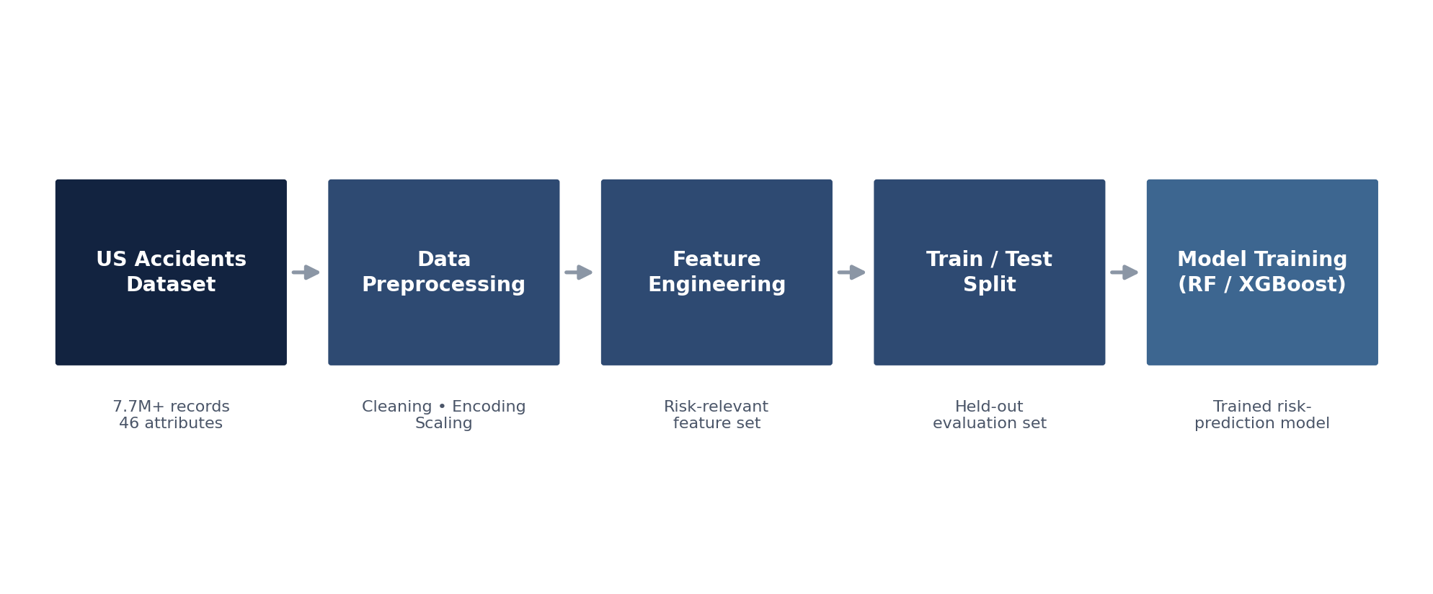
Figure 3. Dataset-to-model pipeline: from the raw US-Accidents dataset through preprocessing, feature engineering, and train/test splitting to model training.

Candidate models
A baseline is trained first, followed by two tree-based candidates, consistent with the source proposal:
- Logistic Regression (baseline): a simple, well-understood linear classifier. A baseline is useful because it sets a lower bound of expected performance — any more complex model should be justified by outperforming it — and because its coefficients are inherently interpretable, which is a useful sanity check before relying on SHAP explanations from a more complex model.
- Random Forest: an ensemble of decision trees trained on bootstrapped samples and random feature subsets, with predictions combined by majority vote or averaging (Breiman, 2001). It handles non-linear relationships and feature interactions well, is relatively robust to noisy or irrelevant features, and provides a natural feature-importance measure.
- XGBoost: a gradient-boosted tree ensemble in which trees are added sequentially, each one correcting the errors of the ones before it, with built-in regularization to control overfitting (Chen & Guestrin, 2016). XGBoost is widely reported to perform strongly on structured/tabular data of exactly the kind found in the US-Accidents dataset (a mix of categorical and numerical fields), which is why it is proposed alongside Random Forest.
Both Random Forest and XGBoost are well suited in principle to tabular accident-risk prediction because the underlying data is structured (numeric and categorical columns rather than images or free text) and the target relationship is expected to be non-linear (e.g., the effect of low visibility on risk plausibly depends on whether traffic is also heavy).
Note: No experiments have been run as part of this proposal. Model choice here is a proposed design based on published literature and the structural properties of the dataset, not an experimentally validated result. Whichever model performs best must be determined empirically during implementation, and that determination — not an a-priori claim — should decide the model used in a deployed version of RoadMind.

6.8 Risk Prediction
What happens: given a new set of driving conditions, the trained model outputs a risk probability. Why: this is the point at which the trained model becomes actionable for a specific situation, rather than a static artifact. Input: a single feature vector describing current conditions. Output: a continuous probability (e.g., an illustrative 0.87), before it is converted to a category in the next stage.
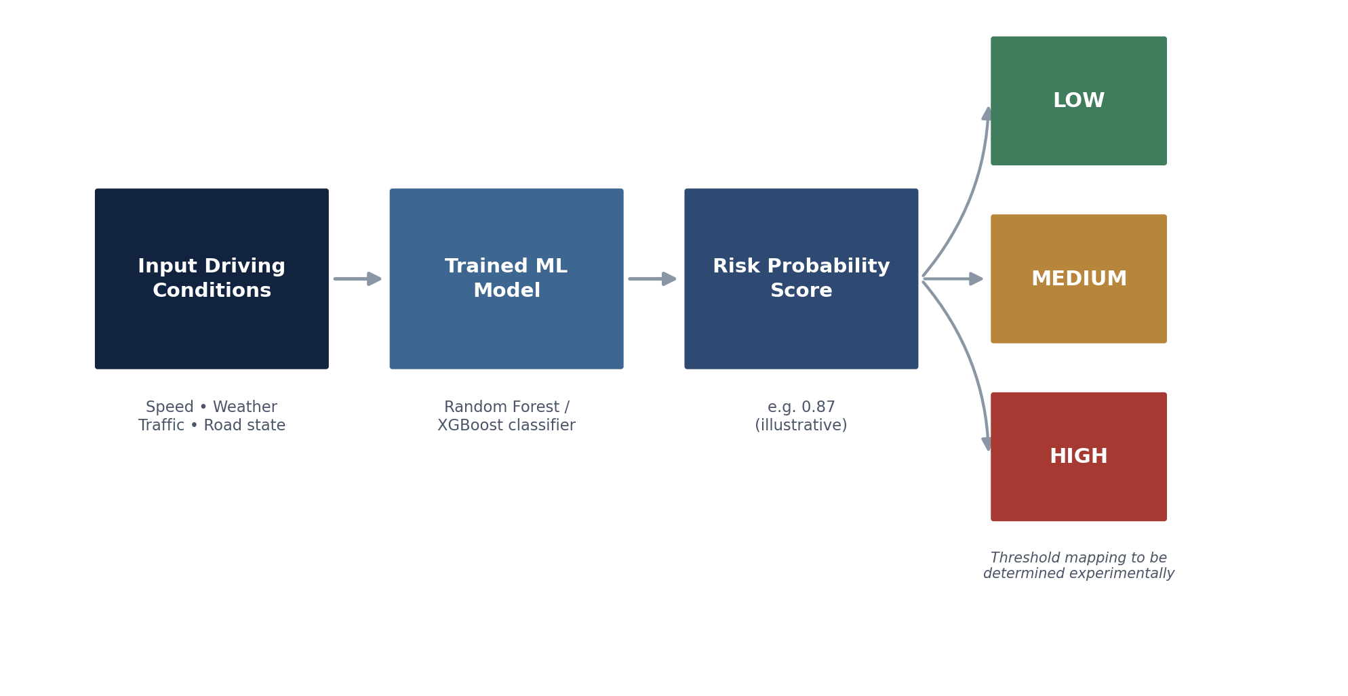
Figure 4. Risk-prediction and classification flow: from input driving conditions to a Low / Medium / High risk category.

6.9 Risk Classification
What happens: the continuous risk probability from §6.8 is mapped to Low, Medium, or High. Why: a three-tier label is far faster for a driver to process at a glance than a raw probability.
Two general approaches are possible, and the choice between them is a design decision to be resolved experimentally rather than assumed:
- Fixed probability thresholds (e.g., Low below one cut-off, High above another), which are simple and stable but must be tuned against real outcome data to avoid being arbitrary.
- Data-driven thresholds derived from the distribution of predicted probabilities in the training data (for example, tertile boundaries) or calibrated against the historical distribution of the Severity target, which adapts the class boundaries to how the model actually behaves.
Note: The source proposal does not specify exact threshold values, and none are asserted here. The class boundaries shown in Figure 4 (Low / Medium / High) represent the target output structure, not fixed numeric cut-offs; the actual thresholds must be determined experimentally once a model is trained and validated.

6.10 Explainable AI
What happens: SHAP is applied to the trained model's output for a specific prediction, decomposing it into the contribution of each input feature. Why: in a safety-critical, driver-facing context, a risk score without a reason is far less useful — and far less trustworthy — than one that explains itself; explainability also supports debugging, auditing, and eventual regulatory scrutiny of the kind NHTSA already applies to Level 2 ADAS systems. Input: the trained model and the specific feature vector being explained. Output: a ranked list of features with their signed contribution to that specific prediction.

How SHAP works
SHAP (SHapley Additive exPlanations) is a model-agnostic explanation framework introduced by Lundberg and Lee (2017), built on the concept of Shapley values from cooperative game theory. For a given prediction, SHAP treats each input feature as a “player” contributing to the model's output and computes each feature's fair share of the difference between the model's average prediction and its prediction for this specific case. The result is an additive decomposition: the baseline (average) prediction plus the sum of each feature's SHAP value equals the model's actual output for that instance. This gives SHAP two properties that matter for RoadMind: it can explain individual predictions (not just overall feature importance across the whole dataset), and the contributions are directly comparable and additive, which supports a clean “top reasons” display for the driver.
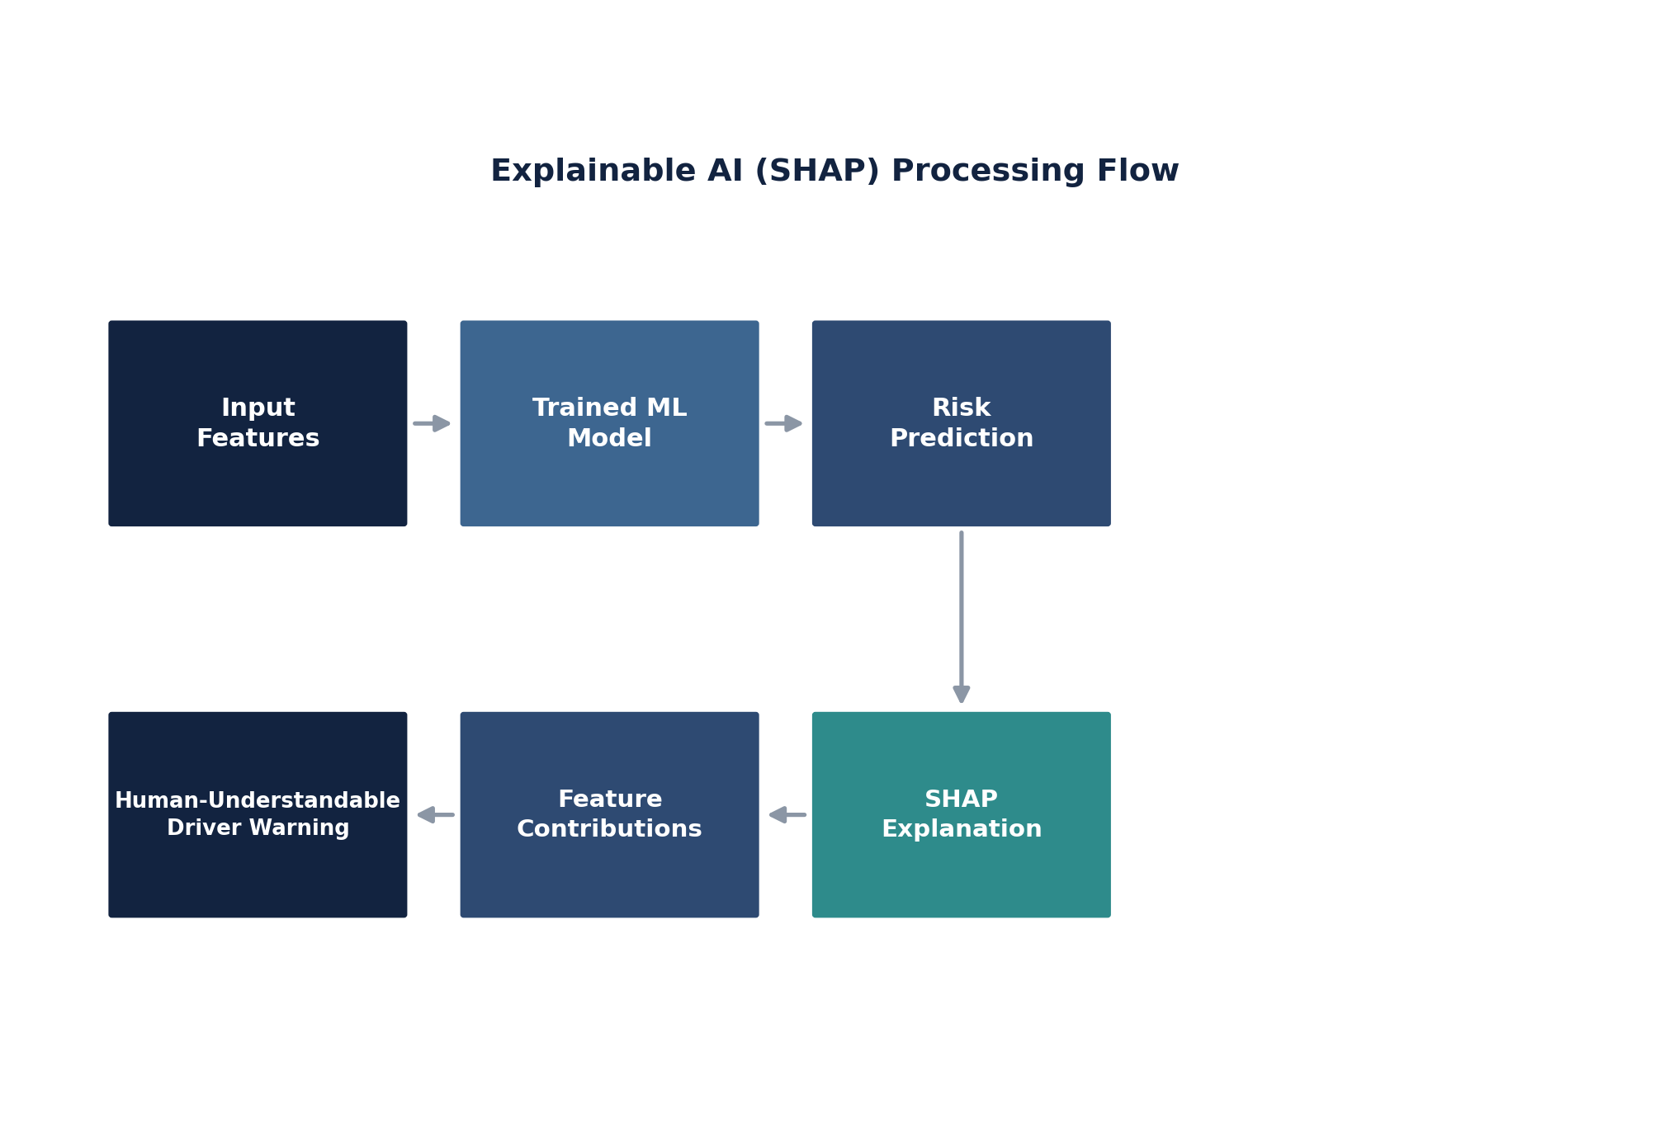
Figure 5. Explainable AI (SHAP) processing flow: from input features and a trained model, through SHAP attribution, to a human-readable driver warning.

Illustrative example
The figure below reproduces the example scenario from the source proposal — poor visibility, a wet road, heavy traffic, high speed, and rain, associated with an illustrative 87% high-risk output — purely to demonstrate how SHAP's ranked, additive output would be surfaced to a driver. The values shown are a synthetic, illustrative example for concept demonstration; they are not the output of a trained model, since no model has been trained as part of this proposal.
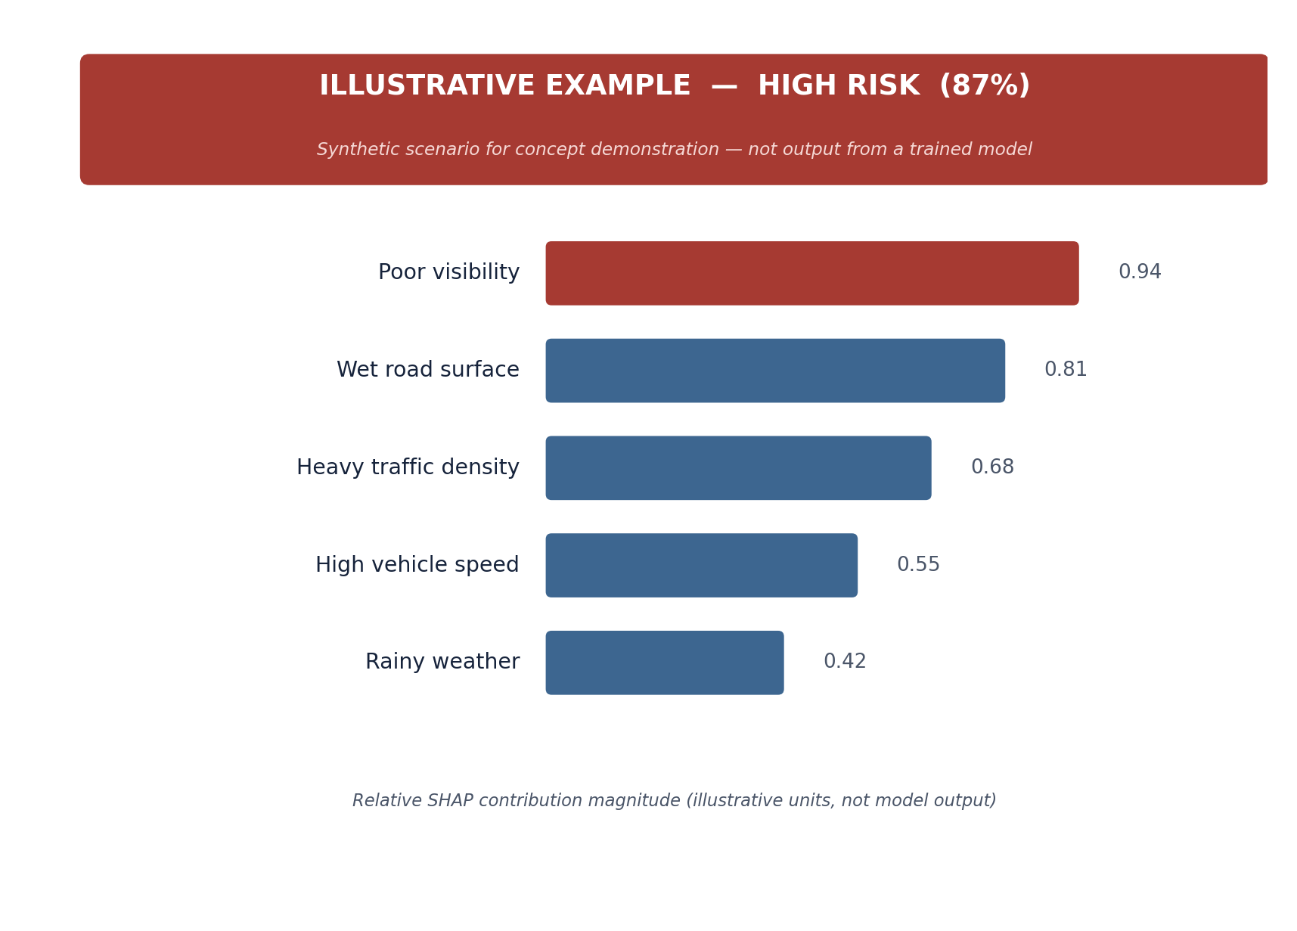
Figure 6. Illustrative SHAP-style feature-contribution chart for a synthetic high-risk scenario. Values are for concept demonstration only.

6.11 Driver Warning Generation
What happens: the risk category (§6.9) and the ranked SHAP factors (§6.10) are combined into a short, structured, driver-facing message. Why: a model output only has safety value if it reaches the driver in a form they can act on in a couple of seconds. Input: risk category + top SHAP factors. Output: a driver alert with three parts: the risk level, the leading reasons, and a suggested response.
Illustrative output, corresponding to the example in Figure 6:
HIGH RISK
“High accident-risk conditions detected.”
Reasons: Poor visibility • Wet road • Heavy traffic • High speed
Suggested response: “Reduce speed and increase following distance.”
Note: This is framed as a proposed driver-assistance output — a suggestion to support driver judgment — not a guaranteed safety intervention or an instruction the vehicle enforces automatically.

6.12 Model Evaluation
What happens: the trained model's performance is measured on the held-out test partition (§6.6) using standard classification metrics. Why: without rigorous evaluation there is no basis for trusting the model's predictions, particularly for a safety-relevant system.
Metric | What it measures | Relevance to RoadMind
Accuracy | Proportion of all predictions that are correct | Useful as a general summary, but can be misleading if risk classes are imbalanced
Precision | Of predicted High-risk cases, how many were actually high-risk | High precision reduces false alarms that could erode driver trust
Recall | Of actual high-risk cases, how many were correctly flagged | Especially important for the High-risk class — missed high-risk cases are the more costly error in a safety context
F1-score | Harmonic mean of precision and recall | Balances the two when neither can be optimized in isolation
ROC-AUC | Model's ability to rank positive cases above negative cases across thresholds | Useful for comparing candidate models independent of a chosen threshold
Confusion matrix | Full breakdown of predicted vs. actual class | Shows exactly which risk levels are being confused with which
Table 3. Proposed evaluation metrics for the RoadMind risk-classification model.
Because missing a genuinely high-risk situation is more costly than a false alarm, recall on the High-risk class should be weighted particularly heavily when comparing candidate models, even if this means accepting a lower precision. Evaluation should also account for:
- Cross-validation (e.g., k-fold, or time-based splits given the multi-year span of the data) to obtain a more reliable performance estimate than a single train/test split.
- Class imbalance — severe/high-risk events are likely to be a minority class, which may require resampling, class-weighting, or threshold adjustment.
- Data leakage — fields only known after an accident has occurred or been resolved (e.g., End_Time, Distance(mi)) must be excluded from a genuinely predictive feature set.
- Overfitting and generalization — performance should be validated on more recent, held-out time periods to test whether the model generalizes beyond the years it was trained on.
Note: No model has been trained or evaluated as part of this proposal, and no performance figures (accuracy, precision, recall, etc.) are claimed. The table above defines the evaluation plan to be executed during implementation, not a set of results.

7. Scope, Assumptions, and Limitations
To keep this proposal technically genuine, the following points consolidate the assumptions and boundaries stated throughout the document:
- Proposal stage, not a validated system: RoadMind has not been implemented, trained, or tested. All model choices, thresholds, and example outputs in this document are proposed designs or illustrative examples, clearly labeled as such, not experimental results.
- Decision-support, not vehicle control: RoadMind is presented as a predictive driver-assistance and risk-awareness system. It does not imply direct control of vehicle actuators (steering, braking, throttle) unless and until such control is actually implemented and validated.
- Retrospective data, not live telemetry: the US-Accidents dataset is historical and record-based; a production system would additionally need a real-time data pipeline, which is out of scope for this proposal.
- Risk thresholds are undetermined: the mapping from predicted probability to Low / Medium / High is a design placeholder pending experimental calibration (§6.9).
- No safety guarantee: nothing in this document should be read as a claim that RoadMind prevents accidents; it is designed to identify elevated-risk conditions and support better driver decisions.
- Non-commercial data license: the selected dataset's CC BY-NC-SA 4.0 license restricts the prototype to research/academic use; commercial deployment would require a separate licensing arrangement (§5.6).

8. Future Work and ADAS Integration Roadmap
The current proposal is deliberately scoped around a verified, static dataset and an offline model-training workflow. A plausible path toward the longer-term goal of ADAS/autonomous-driving integration (Objective F) would proceed in stages:
- Empirical model development and validation — implement and evaluate the models and evaluation plan in §6.7 and §6.12 on the verified dataset, and determine risk-classification thresholds empirically (§6.9).
- Driver-behavior data integration — incorporate a telematics, OBD-II, or driving-simulator data source to supply the vehicle-dynamics features (speed, acceleration, braking, steering) that are not present in the US-Accidents dataset (Table 2).
- Real-time / streaming inference — move from batch, historical prediction to a low-latency pipeline capable of scoring current conditions as they change.
- Edge deployment — adapt the trained model and SHAP explanation step to run within the compute and latency constraints of an in-vehicle or edge-computing environment.
- Alignment with SAE / NHTSA ADAS conventions — design the driver-alert interface and any future crash/near-miss logging to be consistent with the Level 2 ADAS framing used in NHTSA's Standing General Order on crash reporting, so the system's role (assisting, not replacing, an attentive driver) remains unambiguous.
- Regulatory and licensing review — revisit dataset licensing and any applicable automotive-safety regulatory requirements before any move toward commercial deployment.

