ANNA – LABORATORY EXPERIMENT 3
Implementation of a CNN Architecture for Pneumonia Detection from Chest X-Ray Images

Student Laboratory Report & Experiment Sheet
Course | Experiment | Student Name | Roll No.
ANNA | 3 | Gangotri Kompalwar | 202402070020
Batch/Division | C | Date | 11-8-2026
Faculty | ________________ | Academic Year | 2026-2027

1. Objective
- Understand the workflow of CNN-based image classification.
- Preprocess and load a real-world medical image dataset.
- Design and implement a CNN using TensorFlow/Keras.
- Train a CNN for Normal vs. Pneumonia classification.
- Study the effect of learning rate, batch size and dropout.
- Evaluate the model using accuracy, precision, recall, F1-score and a confusion matrix.

2. Problem Statement
Develop a CNN-based binary image classifier that classifies chest X-ray images as Normal or Pneumonia. This is an educational medical-AI experiment only; the model is not a clinical diagnostic system.
3. Dataset – What Data and Where?
Recommended teaching dataset: “Pneumonia X-Ray Images” on Kaggle. The downloaded dataset contains 5,856 JPEG chest X-ray images in two classes, Normal and Pneumonia. In the uploaded notebook, the observed split was 5,216 training, 16 validation and 624 testing images. The validation folder therefore contains only 16 images, which makes validation accuracy highly sensitive to individual samples.
Dataset: Kaggle – Pneumonia X-Ray Images
Original/reference dataset: Kaggle – Chest X-Ray Images (Pneumonia)
Folder structure:
dataset/ train/NORMAL, train/PNEUMONIA val/NORMAL, val/PNEUMONIA test/NORMAL, test/PNEUMONIA
Observed dataset counts from the uploaded notebook:
Split | NORMAL | PNEUMONIA | Total
Train | 1341 | 3875 | 5216
Validation | 8 | 8 | 16
Test | 234 | 390 | 624
Total | 1583 | 4273 | 5856

4. Software / Tools
- Google Colab or Jupyter Notebook
- Python 3.x
- TensorFlow / Keras
- NumPy, Matplotlib, Scikit-learn
- GPU runtime recommended

5. CNN Architecture to Implement
Use the following as the fixed baseline architecture. Perform hyperparameter variation only after completing the baseline run.
Layer | Configuration | Purpose
Input | 128×128×1 | Resize + grayscale
Conv2D-1 | 32 filters, 3×3, ReLU | Low-level features
MaxPool-1 | 2×2 | Down-sampling
Conv2D-2 | 64 filters, 3×3, ReLU | Intermediate features
MaxPool-2 | 2×2 | Down-sampling
Conv2D-3 | 128 filters, 3×3, ReLU | Higher-level features
MaxPool-3 | 2×2 | Down-sampling
Flatten | — | Feature vector
Dense | 128, ReLU | Classification representation
Dropout | 0.50 | Reduce overfitting
Output | 1, Sigmoid | Pneumonia probability
Notebook model-summary result: Total parameters = 3,304,193; trainable parameters = 3,304,193; non-trainable parameters = 0.

6. Baseline Hyperparameters
Parameter | Baseline | Action
Image size | 128×128 grayscale | Keep fixed
Normalization | Pixel/255 → [0,1] | Keep fixed
Optimizer | Adam | Keep fixed
Learning rate | 0.001 | Vary
Batch size | 32 | Vary
Dropout | 0.50 | Vary
Epochs | 15 maximum | Keep fixed / EarlyStopping optional
Loss | Binary cross-entropy | Keep fixed
Output | Sigmoid | Keep fixed

7. Hyperparameters to Vary
Change one major parameter at a time so that the effect of each parameter can be interpreted.
Experiment | Values | Observation
A – Learning rate | 0.001, 0.0001 | Training stability and validation performance
B – Batch size | 16, 32, 64 | Training time and validation performance
C – Dropout | 0.20, 0.50 | Overfitting vs. underfitting
Optional D – Epochs | 5, 10, 15 | Effect of training duration
Keep the dataset split, preprocessing, CNN architecture, loss function, test set and evaluation procedure fixed for fair comparison.

8. Experimental Procedure
- Open Google Colab and create a new notebook.
- Download the dataset from Kaggle and place it in Google Drive or use the Kaggle API.
- Verify the train/validation/test folders and count images in each class.
- Display sample Normal and Pneumonia X-rays.
- Resize images to 128×128 and convert them to grayscale.
- Normalize pixels to [0,1].
- Create training, validation and test data loaders.
- Build the baseline CNN given in Section 5.
- Compile using Adam, learning rate 0.001, binary cross-entropy and accuracy.
- Train for a maximum of 15 epochs and monitor validation performance.
- Plot training/validation accuracy and loss.
- Evaluate the final model on the unseen test set.
- Generate a confusion matrix and calculate accuracy, precision, recall and F1-score.
- Repeat by changing one selected hyperparameter at a time.
- Record all observations and compare the runs.
- Select the best configuration and write the conclusion and limitations.

9. Evaluation Metrics
Metric | Meaning
Accuracy | Overall percentage of correctly classified images.
Precision | Of images predicted as Pneumonia, the proportion that are actually Pneumonia.
Recall / Sensitivity | Of actual Pneumonia cases, the proportion correctly detected.
F1-score | Harmonic mean of precision and recall.
Confusion Matrix | Shows TP, TN, FP and FN and the types of errors.

10. Observation – Baseline Run
Run | LR | Batch | Dropout | Epochs | Train Acc. | Val. Acc. | Test Acc.
Baseline | 0.001 | 32 | 0.50 | 15 | 98.88 % | 87.50% | 74.67%

11. Observation – Hyperparameter Study
• The planned hyperparameter study considered the effect of learning rate, batch size and dropout on CNN performance.
• The learning rate values considered were 0.001 and 0.0001.
• The batch sizes considered were 16, 32 and 64.
• The dropout values considered were 0.20 and 0.50.
• The baseline configuration used a learning rate of 0.001, batch size of 32 and dropout of 0.50.
• The uploaded baseline run did not execute the planned hyperparameter experiments. Therefore, the effect of different learning rates, batch sizes and dropout values cannot be concluded from the current run.
• The hyperparameter study can be performed in future runs to identify the configuration that provides better validation performance and reduces overfitting.

12. Required Outputs / Figures
- Sample images from both classes.
- CNN model summary / architecture. • Training vs. validation accuracy plot.
- Training vs. validation loss plot.
- Confusion matrix.
- Final classification report.
- Hyperparameter comparison table.
- Optional: ROC curve and AUC.
Note: The uploaded notebook completed the baseline run only. No learning-rate, batch-size, dropout, or epoch variation runs were executed, so no hyperparameter metrics are fabricated.
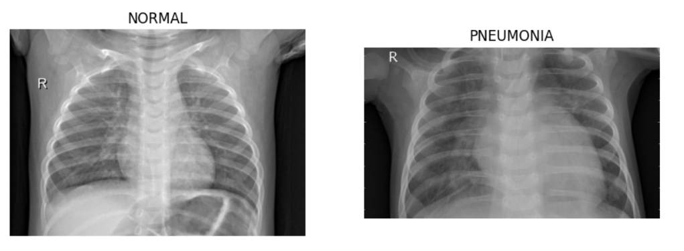
Figure 1. Sample Normal and Pneumonia chest X-ray images generated in the notebook.
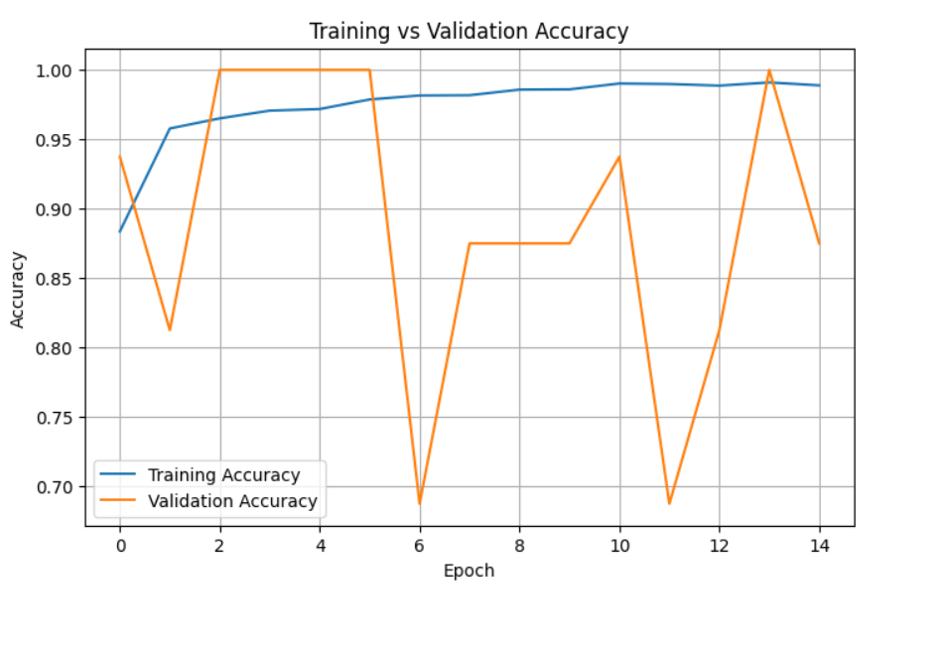
Figure 2. Training and validation accuracy over 15 epochs.
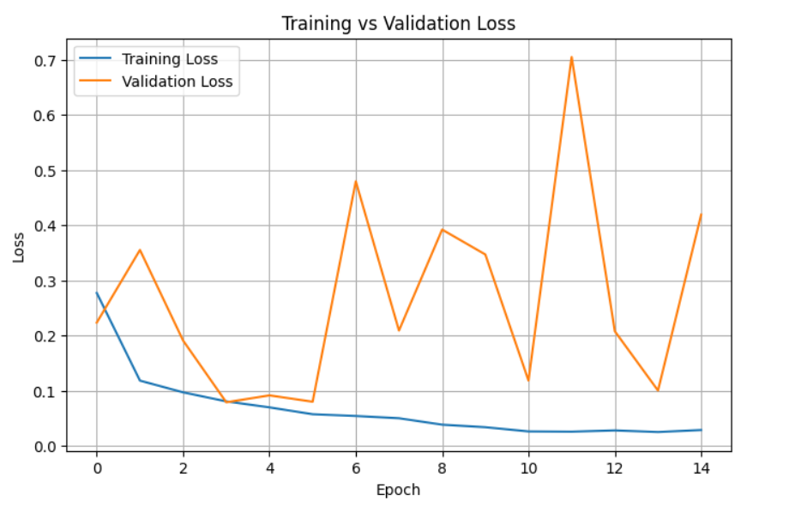
Figure 3. Training and validation loss over 15 epochs.
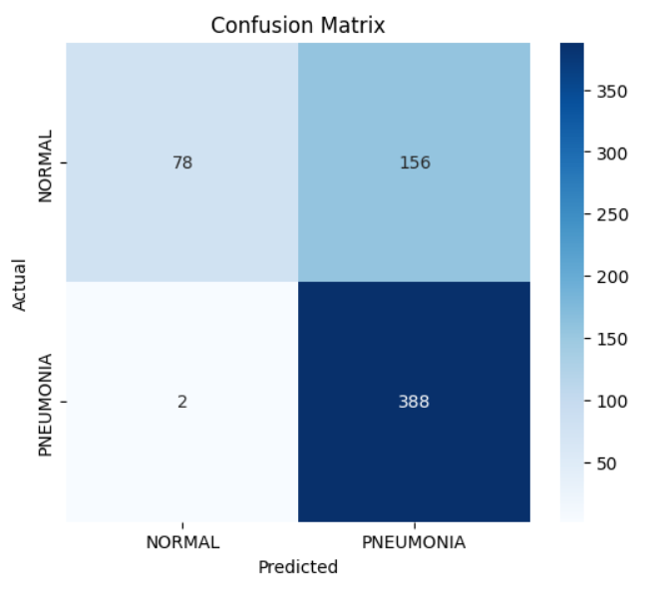

Figure 4. Confusion matrix for the baseline test-set predictions.
Final classification report from the notebook:

Baseline result summary and interpretation
- Final training accuracy: 98.89%; final validation accuracy: 87.50%; test accuracy: 74.68%.
- Test precision for Pneumonia: 71.32%; recall/sensitivity: 99.49%; F1-score: 83.08%.
- Confusion matrix: TN = 78, FP = 156, FN = 2, TP = 388.
- The model detected almost all Pneumonia cases in the test set (high recall), but produced many false positives among Normal images.
- The training accuracy increased to 98.89% while test accuracy was 74.68%, indicating a substantial generalization gap and possible overfitting.
- Validation performance was unstable because the notebook's validation set contained only 16 images. Validation accuracy reached 100% at several epochs but also fell to 68.75% at epochs 7 and 12.
- The lowest observed validation loss was 0.0790 at epoch 4; the final epoch ended with validation loss 0.4190 and validation accuracy 87.50%.

16. Conclusion and Limitations
Conclusion:
A baseline CNN with three convolutional blocks, max-pooling, a 128-unit dense layer, 0.50 dropout and a sigmoid output was successfully implemented using TensorFlow/Keras. The model achieved 74.68% test accuracy, 71.32% Pneumonia precision, 99.49% Pneumonia recall and an F1-score of 83.08%. The very high recall means the baseline missed only two Pneumonia cases in the 624-image test set, but the 156 false positives reduced precision and overall accuracy.
Limitations:
The notebook used only 16 validation images (8 Normal and 8 Pneumonia), so validation accuracy and loss are highly variable and are not a robust basis for selecting a model. The notebook also did not execute the planned hyperparameter study; therefore, the effect of learning rate, batch size and dropout cannot be concluded from the uploaded run. The experiment is educational and must not be treated as a clinical diagnostic system.

Class | Precision | Recall | F1-score | Support
NORMAL | 0.98 | 0.33 | 0.50 | 234
PNEUMONIA | 0.71 | 0.99 | 0.83 | 390
Accuracy | — | — | 0.75 | 624
Macro avg | 0.84 | 0.66 | 0.66 | 624
Weighted avg | 0.81 | 0.75 | 0.71 | 624

15. Learning Resources
- Kaggle – Pneumonia X-Ray Images
- Kaggle – Chest X-Ray Images (Pneumonia)
- Keras – Image Classification from Scratch

Student Signature: ____________________ Faculty Signature: ____________________

