
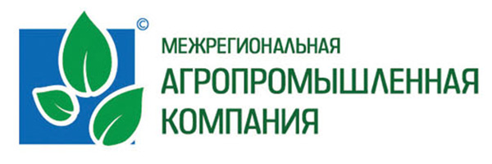
Nadia Kosinova CV
Mob.: +44 07922 814707
E-mail: kompas92@mail.ru

Relevant work experience
Skyscanner 2014
Digital Marketing Assistant

I assisted in developing international growth opportunities through management and improvement of digital, social media, content and PR channels.
Main achievements:

- Localization and customization of digital marketing activities
- Continual competitor overview of website and mobile products. It resulted in deeper outlook of the company’s advantages and disadvantages on regional and global level and provided recommendations for modifications in website and mobile apps
- Conducted SEO activities, negative keywords sandbox building, keywords search optimization
- Web content management
- Coordinated local language translations across a range of digital marketing and
social media channels

- Played a valuable part in improving Skyscanner affiliation program in Russia. My work resulted in attracting more than a hundred affiliates with half of them being especially important in terms of partnership
- Developed and executed an integrated marketing campaign
“Skyscannerpostcard” during the Fringe Festival in Edinburgh.

Interregional agro-industrial holding company 2009-2013
Marketing assistant

I was supporting marketing planning process concentrating on regional market research and analysis and production of marketing campaigns.
Main achievements:
- Secondary and desk based competitor research – an overview of the agricultural and cattle breeding markets
- Primary customer research - identified target audience and introduced segmented profiling of existing and potential customers in the dairy market
- Developed marketing communications campaign aimed at potentially profitable target segments. Owing to intensive and thorough work of our team, annual sales in 2011 increased by 9%
- Supported development and management of B2B relationships with our national (Vimmbilldann, Fosagro) and global partners (Lay’s, TOPIGS, Amity technology).

Education

The University of Edinburgh (United Kingdom) 2013-2014
MSc Marketing and Business Analysis – Postgraduate merit
The course combined two parts quantitative and qualitative. Marketing research and International marketing strategy courses helped me to master instruments of gathering information from customers and analyse it as well as to implement different marketing strategies in the international context. Business statistics and Problem Solving courses made me progress in the quantitative analysis and justify management decisions through numerical models.
My MSc dissertation investigated possible segmentation solution of online travel market in Russia. The thesis included Russian online travel market overview, design of the survey, generation and analysis of consumer behaviour data and construction of the segments with the help of SPSS software.

Moscow State University of International Relations of the Ministry of Foreign Affairs of the Russian Federation (MGIMO) (Russia) 2009-2013
Faculty of International Economic Relations – 2.1degree qualification
Courses on the world economy conjuncture, international commerce and management as well as focus on foreign languages – English and Swedish - gave me deeper understanding of different cultures and international business and economic environment

Languages
Russian (native); English (fluent); Swedish (advanced); French (intermediate).

Interests
I have been going in for ballroom and sports dancing for more than 12 years and won several regional and country competitions. I also enjoy reading, swimming and fitness.

IT skills
Microsoft Office, SPSS, Stata, Google Analytics.

