**1. (a) (2 points) Let S = $165; sigma = 44.72%; r = 2%; t = 15 days; delta = 0. For steps n = 15, use the**

**'base' BT model to compute the price tree.**

**Now report the terminal prices and the probability of reaching those prices using equation**

**(11.12). What is the risk-neutral distribution of 15-day stock prices for step n = 15?**

**Price Tree**

> BT(165,170,0.4472,0.02,15/365)

$Res

PriceE PriceA u d pu pd pv K T

3.9094 3.9094 1.02374 0.9769178 0.4941484 0.5058516 0.9999452 170 0.04109589

S D sig r typ

165 0 0.4472 0.02 c

$Prices

[,1] [,2] [,3] [,4] [,5] [,6] [,7] [,8] [,9] [,10] [,11]

[1,] 165 168.9171 172.9271 177.0323 181.2350 185.5375 189.9421 194.4513 199.0675 203.7933 208.6313

[2,] NA 161.1914 165.0181 168.9356 172.9460 177.0517 181.2549 185.5578 189.9629 194.4726 199.0893

[3,] NA NA 157.4708 161.2091 165.0362 168.9541 172.9650 177.0711 181.2748 185.5782 189.9837

[4,] NA NA NA 153.8360 157.4881 161.2268 165.0543 168.9726 172.9840 177.0905 181.2946

[5,] NA NA NA NA 150.2852 153.8529 157.5053 161.2444 165.0723 168.9911 173.0029

[6,] NA NA NA NA NA 146.8163 150.3016 153.8698 157.5226 161.2621 165.0904

[7,] NA NA NA NA NA NA 143.4274 146.8323 150.3181 153.8866 157.5398

[8,] NA NA NA NA NA NA NA 140.1168 143.4431 146.8484 150.3346

[9,] NA NA NA NA NA NA NA NA 136.8826 140.1322 143.4589

[10,] NA NA NA NA NA NA NA NA NA 133.7231 136.8976

[11,] NA NA NA NA NA NA NA NA NA NA 130.6364

[12,] NA NA NA NA NA NA NA NA NA NA NA

[13,] NA NA NA NA NA NA NA NA NA NA NA

[14,] NA NA NA NA NA NA NA NA NA NA NA

[15,] NA NA NA NA NA NA NA NA NA NA NA

[16,] NA NA NA NA NA NA NA NA NA NA NA

[,12] [,13] [,14] [,15] [,16]

[1,] 213.5842 218.6546 223.8454 229.1594 234.5996

[2,] 203.8156 208.6542 213.6076 218.6785 223.8699

[3,] 194.4939 199.1111 203.8380 208.6770 213.6310

[4,] 185.5985 190.0046 194.5152 199.1330 203.8603

[5,] 177.1100 181.3145 185.6189 190.0254 194.5365

[6,] 169.0096 173.0219 177.1294 181.3344 185.6392

[7,] 161.2798 165.1085 169.0282 173.0408 177.1488

[8,] 153.9035 157.5571 161.2975 165.1266 169.0467

[9,] 146.8645 150.3511 153.9203 157.5744 161.3151

[10,] 140.1475 143.4746 146.8806 150.3675 153.9372

[11,] 133.7377 136.9126 140.1629 143.4903 146.8967

[12,] 127.6211 130.6508 133.7524 136.9276 140.1782

[13,] NA 124.6753 127.6351 130.6651 133.7670

[14,] NA NA 121.7975 124.6890 127.6490

[15,] NA NA NA 118.9862 121.8109

[16,] NA NA NA NA 116.2397

$ValE

[,1] [,2] [,3] [,4] [,5] [,6] [,7] [,8] [,9]

[1,] 3.9094 5.435552 7.405200 9.8713211 12.859019 16.3538535 20.29724937 24.59493275 29.1407715

[2,] NA 2.418979 3.512062 4.9969363 6.953816 9.4464319 12.50346229 16.10119454 20.1569293

[3,] NA NA 1.351448 2.0619210 3.085872 4.5196208 6.46115126 8.99032048 12.1410361

[4,] NA NA NA 0.6575593 1.061883 1.6856284 2.62349858 3.99119601 5.9134727

[5,] NA NA NA NA 0.262661 0.4526836 0.76963914 1.28772796 2.1138249

[6,] NA NA NA NA NA 0.0770632 0.14311018 0.26362003 0.4808828

[7,] NA NA NA NA NA NA 0.01255262 0.02540391 0.0514123

[8,] NA NA NA NA NA NA NA 0.00000000 0.0000000

[9,] NA NA NA NA NA NA NA NA 0.0000000

[10,] NA NA NA NA NA NA NA NA NA

[11,] NA NA NA NA NA NA NA NA NA

[12,] NA NA NA NA NA NA NA NA NA

[13,] NA NA NA NA NA NA NA NA NA

[14,] NA NA NA NA NA NA NA NA NA

[15,] NA NA NA NA NA NA NA NA NA

[16,] NA NA NA NA NA NA NA NA NA

[,10] [,11] [,12] [,13] [,14] [,15] [,16]

[1,] 33.8491894 38.6778727 43.6214082 48.6825224 53.864007 59.168718 64.59958

[2,] 24.5444428 29.1358877 33.8528991 38.6821116 43.626189 48.687858 53.86991

[3,] 15.8731074 20.0618829 24.5311636 29.1390808 33.856609 38.686351 43.63097

[4,] 8.4966240 11.7829616 15.6981753 20.0325111 24.533852 29.142274 33.86032

[5,] 3.3907249 5.2872385 7.9596054 11.4658178 15.637482 20.034707 24.53654

[6,] 0.8666959 1.5384556 2.6772715 4.5353738 7.391910 11.343684 15.63920

[7,] 0.1040479 0.2105716 0.4261537 0.8624476 1.745417 3.532365 7.14878

[8,] 0.0000000 0.0000000 0.0000000 0.0000000 0.000000 0.000000 0.00000

[9,] 0.0000000 0.0000000 0.0000000 0.0000000 0.000000 0.000000 0.00000

[10,] 0.0000000 0.0000000 0.0000000 0.0000000 0.000000 0.000000 0.00000

[11,] NA 0.0000000 0.0000000 0.0000000 0.000000 0.000000 0.00000

[12,] NA NA 0.0000000 0.0000000 0.000000 0.000000 0.00000

[13,] NA NA NA 0.0000000 0.000000 0.000000 0.00000

[14,] NA NA NA NA 0.000000 0.000000 0.00000

[15,] NA NA NA NA NA 0.000000 0.00000

[16,] NA NA NA NA NA NA 0.00000

$ValA

[,1] [,2] [,3] [,4] [,5] [,6] [,7] [,8] [,9]

[1,] 3.9094 5.435552 7.405200 9.8713211 12.859019 16.3538535 20.29724937 24.59493275 29.1407715

[2,] NA 2.418979 3.512062 4.9969363 6.953816 9.4464319 12.50346229 16.10119454 20.1569293

[3,] NA NA 1.351448 2.0619210 3.085872 4.5196208 6.46115126 8.99032048 12.1410361

[4,] NA NA NA 0.6575593 1.061883 1.6856284 2.62349858 3.99119601 5.9134727

[5,] NA NA NA NA 0.262661 0.4526836 0.76963914 1.28772796 2.1138249

[6,] NA NA NA NA NA 0.0770632 0.14311018 0.26362003 0.4808828

[7,] NA NA NA NA NA NA 0.01255262 0.02540391 0.0514123

[8,] NA NA NA NA NA NA NA 0.00000000 0.0000000

[9,] NA NA NA NA NA NA NA NA 0.0000000

[10,] NA NA NA NA NA NA NA NA NA

[11,] NA NA NA NA NA NA NA NA NA

[12,] NA NA NA NA NA NA NA NA NA

[13,] NA NA NA NA NA NA NA NA NA

[14,] NA NA NA NA NA NA NA NA NA

[15,] NA NA NA NA NA NA NA NA NA

[16,] NA NA NA NA NA NA NA NA NA

[,10] [,11] [,12] [,13] [,14] [,15] [,16]

[1,] 33.8491894 38.6778727 43.6214082 48.6825224 53.864007 59.168718 64.59958

[2,] 24.5444428 29.1358877 33.8528991 38.6821116 43.626189 48.687858 53.86991

[3,] 15.8731074 20.0618829 24.5311636 29.1390808 33.856609 38.686351 43.63097

[4,] 8.4966240 11.7829616 15.6981753 20.0325111 24.533852 29.142274 33.86032

[5,] 3.3907249 5.2872385 7.9596054 11.4658178 15.637482 20.034707 24.53654

[6,] 0.8666959 1.5384556 2.6772715 4.5353738 7.391910 11.343684 15.63920

[7,] 0.1040479 0.2105716 0.4261537 0.8624476 1.745417 3.532365 7.14878

[8,] 0.0000000 0.0000000 0.0000000 0.0000000 0.000000 0.000000 0.00000

[9,] 0.0000000 0.0000000 0.0000000 0.0000000 0.000000 0.000000 0.00000

[10,] 0.0000000 0.0000000 0.0000000 0.0000000 0.000000 0.000000 0.00000

[11,] NA 0.0000000 0.0000000 0.0000000 0.000000 0.000000 0.00000

[12,] NA NA 0.0000000 0.0000000 0.000000 0.000000 0.00000

[13,] NA NA NA 0.0000000 0.000000 0.000000 0.00000

[14,] NA NA NA NA 0.000000 0.000000 0.00000

[15,] NA NA NA NA NA 0.000000 0.00000

[16,] NA NA NA NA NA NA 0.00000

Using the either of the below two lines of code, we can obtain the price plot

> PlotTree(a,X11=F,val='Price', typ='E')

> PlotTree(a,val='Price', typ='E')

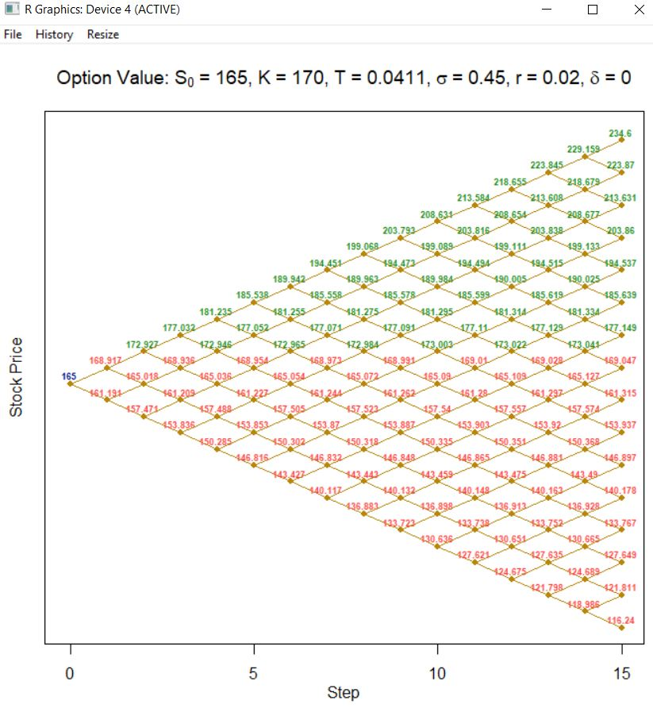

Using the formulae in the slides or using the above,

u=1.02374

d=0.9769178

p*=0.4941754

Probability of reaching these prices

prob <- function(p){

list_prob <- 0

for(i in 15:0){

calc <- p^(i) * (1-p)^(abs(15-i))

list_prob <- c(calc,list_prob)

}

return(list_prob)

}

>prob(0.4941754)

[1] 3.630774e-05 3.547157e-05 3.465465e-05 3.385655e-05 3.307683e-05 3.231507e-05 3.157085e-05

[8] 3.084377e-05 3.013343e-05 2.943946e-05 2.876146e-05 2.809908e-05 2.745196e-05 2.681974e-05

[15] 2.620207e-05 2.559864e-05 0.000000e+00

**(b) What is the price of an European put option with K = $170 for n = 15?**

By using either of the below two lines of code

> PlotTree(a,typ = "E")

> PlotTree(a,X11=F, typ = "E")

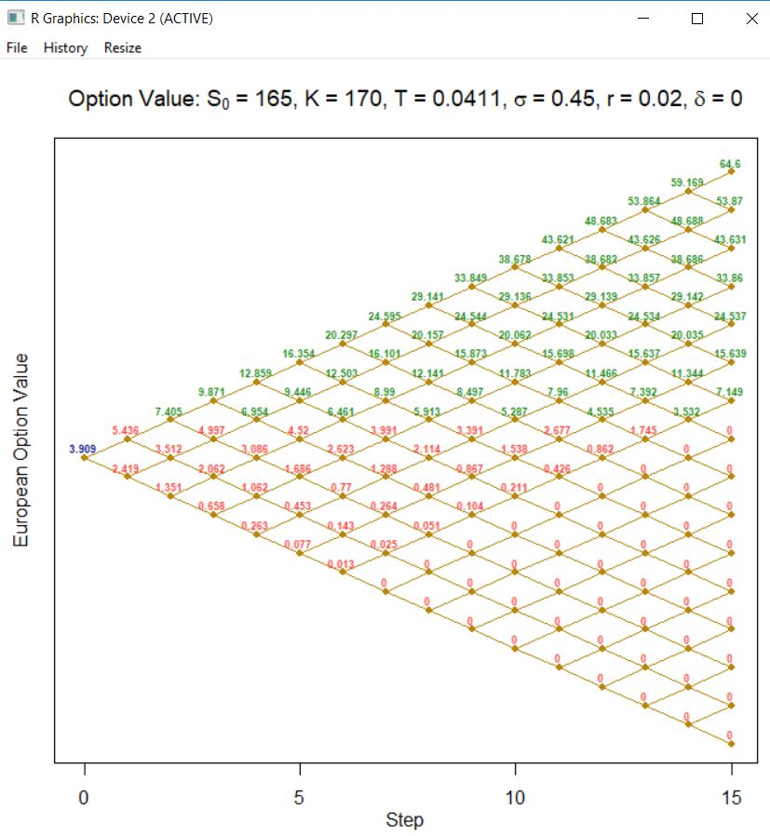

**(c) (1 point) What is the price of an European put option with K = $170 priced using the Black-**

**Scholes formula? At least how many steps of the binomial tree does it take to converge to the**

**B-S price to the nearest penny?**

p1 <- round(BS(s0,k,sig,r,t15,typ='p'),2)

Price of European put option using the Black-Scholes formula = 8.79

Therefore, it takes at least three steps of the binomial tree does it take to converge to the

B-S price to the nearest penny

**2. Let S = $156;K = $160; sigma = 23%; r = 2:5% and t = 5 months. The stock will pay a $1.5 dividend**

**in 1 and 4 months.**

**(a) (5 points) Compute a 12-step binomial tree using the Schroder method.**

**h=(5/12)/12.** We compute u, d, p, (1-p) and other required variables in excel. Using formulae provided in DM10,

DM11. Also, by following in-class example and the text book problem, we would obtain the following:

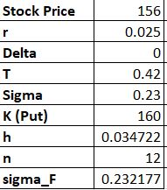 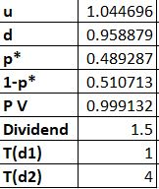 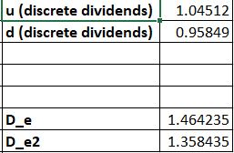

**Stock Price**

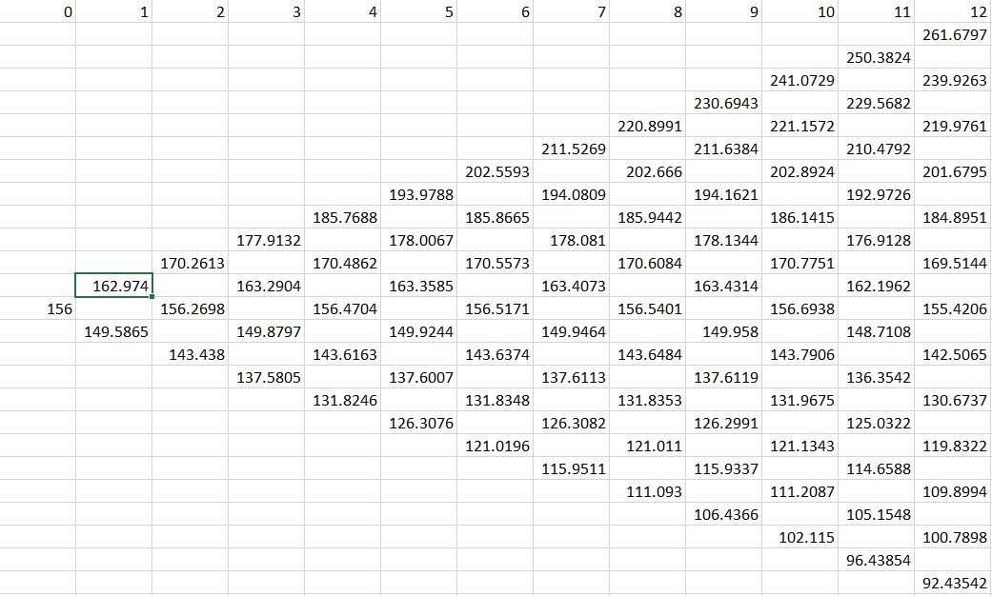

**Prepaid Forward Price**

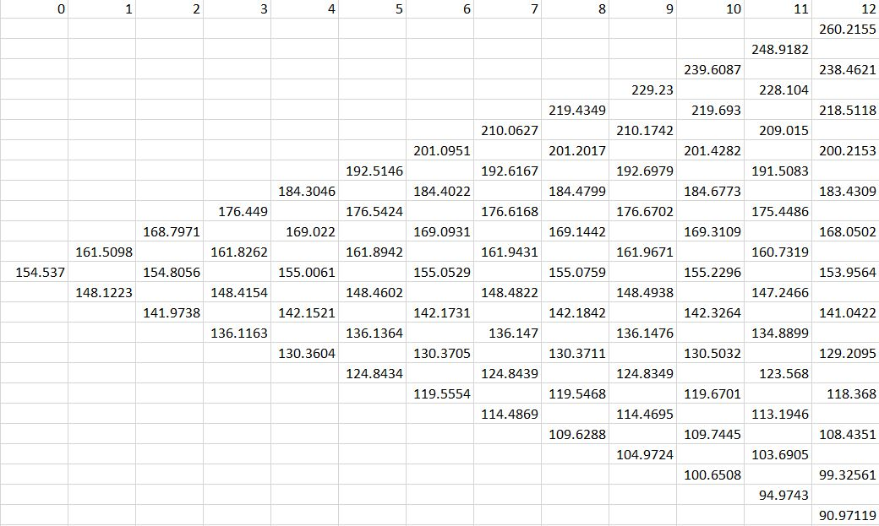

**2. (b) (4 points) Compute the price of European and American put options.**

**American Put Option**

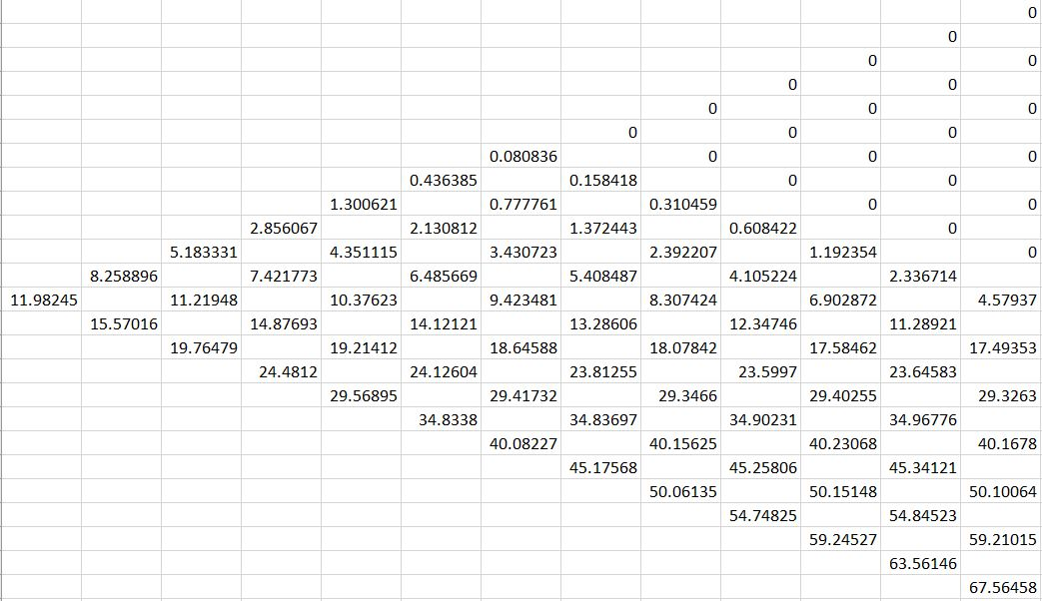

**European Put Option**

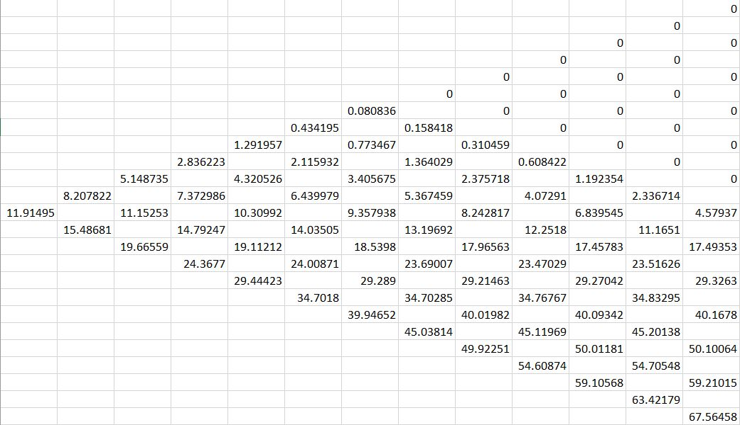

**2. (d) (4 points) Suppose the company unexpectedly increases its quarterly dividend by $0.20 each**

**quarter. What are the respective European and American call option prices?**

By making changes in the excel to earlier question, we obtain the following:

**American Call with new dividend**

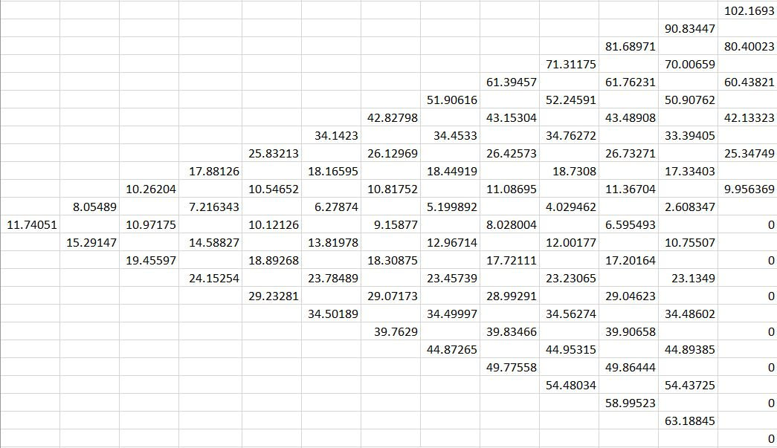

**European Call with new dividend**

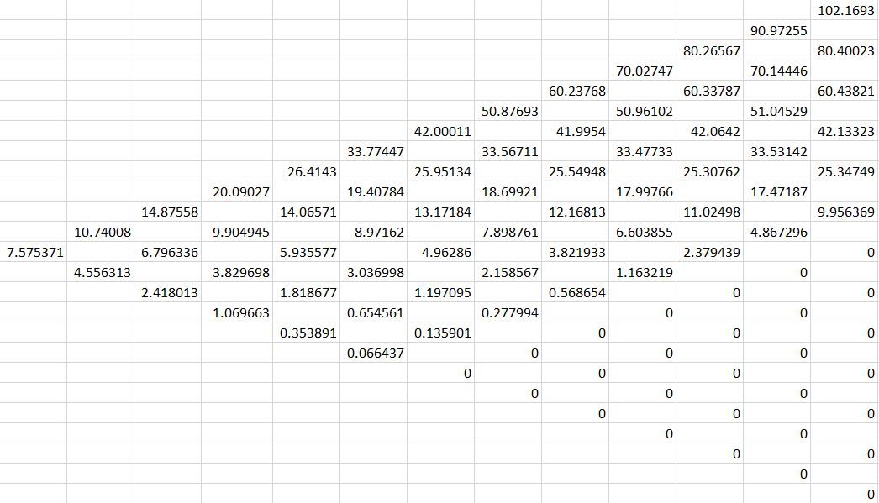

**American Put with new dividend**

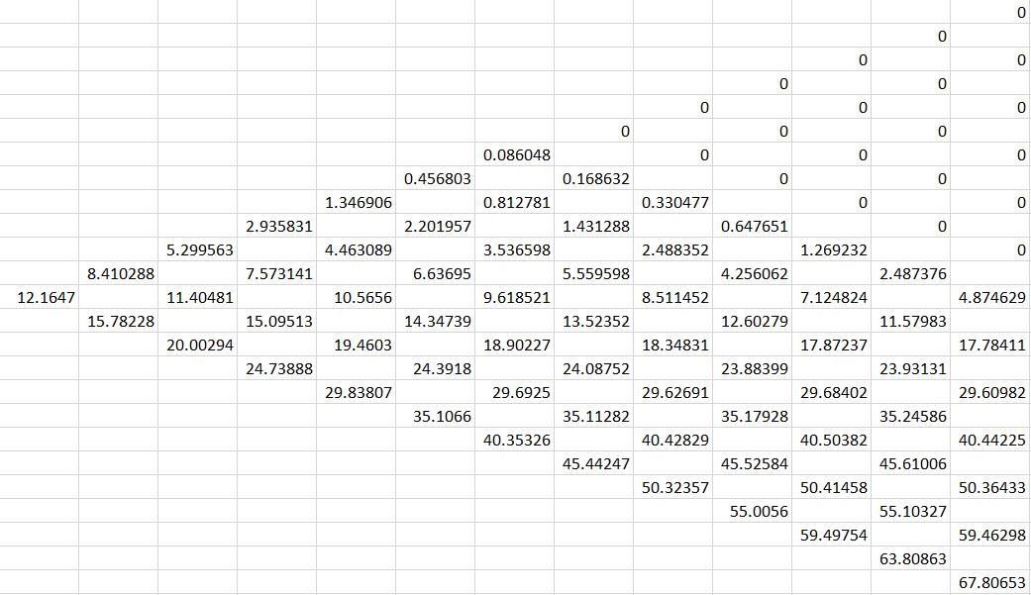

**European Put with new dividend**

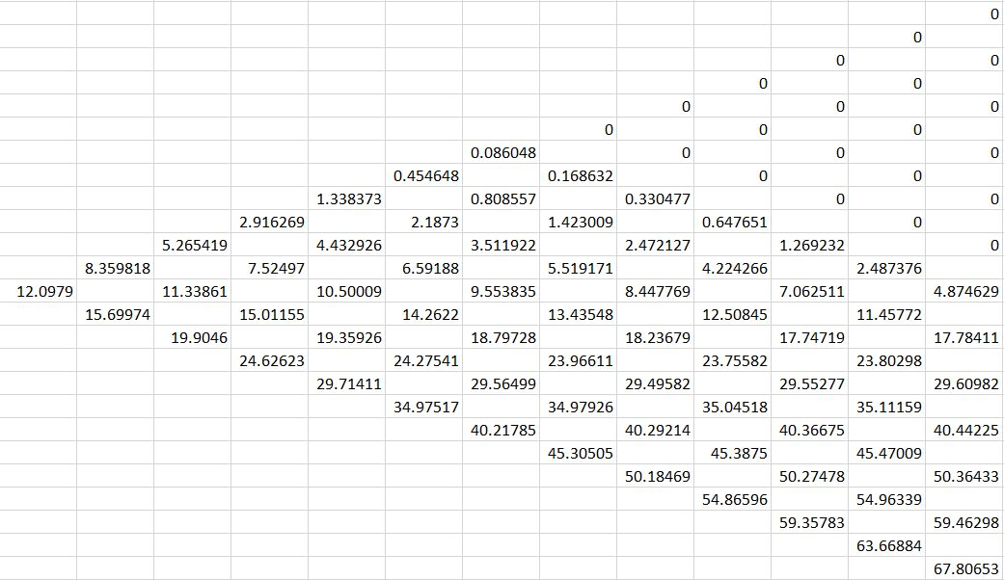

**2. (c) (2 points) Price the American put option using Black-Scholes**

With the help of formulae from DM12, we compute the following.

d1= -0.0621 and N(d1)= 0.3988

d2= -0.1746 and N(d2)= 0.4307

Therefore, price of the American put option = **10.5182**

Additionally, price of American call option = 8.1762

I have also calculated it for European Option. The values are as follows:

d1= -0.1571, d2= -0.3056, N(d1)= 0.4376, N(d2)= 0.3800

Put= **12.1311**

Call= 6.7844