Results

The comparisons are presented as a tables and figures. In the table each solution is evaluated based on the number of feasible solutions (Number of solutions, in case of random solution) and non-dominated solutions. For non-dominated, it is presented in this format $α, (β,γ)$ for single objective solutions where $α$ represents the number of non-dominated solution which is always 1, $β$ is the cost and $γ$ is the score. In the case of multi-objective solution $α, (β-δ,γ-ε)$. $β$ is the lowest cost value, $δ$ is the highest cost value. Therefore $β-δ$ represents a range of cost values. $γ$ is the lowest score value, $ε$ is the highest cost value. $γ-ε$ represents a range a score values for the non-dominated cost. Note: Random solutions has nop non-dominated solutions, this is represented with Null. The solutions were run multiple times, using 100, 500, 1000 as the number of generations.

Plot of results of comparisons are included in the zip under the plots folder. Various other plot result are presented in realistic and classical folders inside plot.

# Classical NRP

A cost ratio of 0.5 (Budget is 2524) and a nrp2.txt dataset was used.

|  |  |  |  |  |  |  |
| --- | --- | --- | --- | --- | --- | --- |
| Generations | Random | | Single-Objective | | Multi-objective | |
| Number of Solutions | Non-dominated Solution | Number of feasible Solutions | Non-dominated Solution | Number of feasible Solutions | Non-dominated Solution |
| 100 | 100 | Null | 44 | 1, (2590, 1.35) | 54 | 7, (2160-2510, 1.137-1.345) |
| 500 | 500 | Null | 100 | 1, (2510, 1.40) | 100 | 17, (2110-2490, 1.158-1.405) |
| 1000 | 1000 | Null | 100 | 1, (2500, 1.49) | 100 | 25, (1925-2410, 1.091-1.437) |

Table 1: classical NRP comparison results

From the above table, I see that the more I number of generations, the more the number of feasible solutions increases until it reaches it limit. Also the score value improves.

Below figure shows the comparison of all solutions using their non-dominated solutions in both classical and realistic NRP.

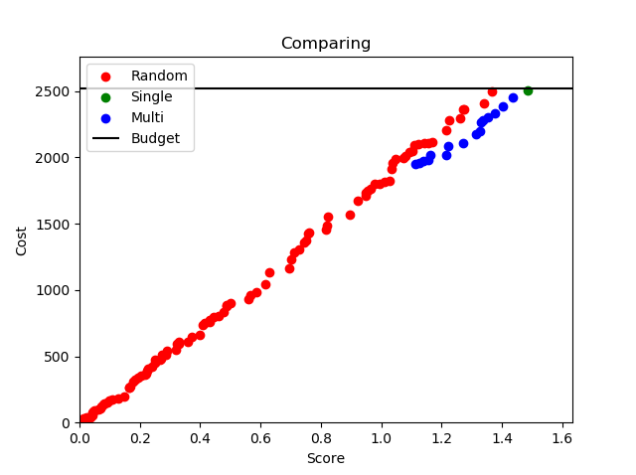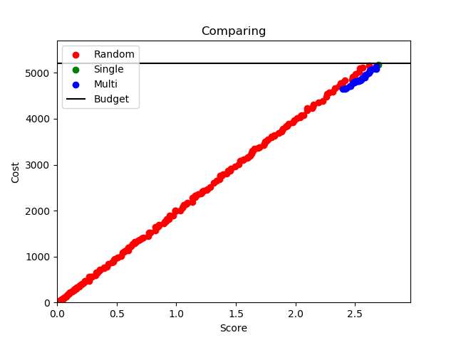

classical-nrp realistic-nrp

Figure 1: Graphical comparisons of all solutions

# Realistic NRP

A cost ratio of 0.5 (Budget is 5199.5) and a nrp-e3.txt dataset was used.

|  |  |  |  |  |  |  |
| --- | --- | --- | --- | --- | --- | --- |
| Generations | Random | | Single-Objective | | Multi-objective | |
| Number of Solutions | Non-dominated Solution | Number of feasible Solutions | Non-dominated Solution | Number of feasible Solutions | Non-dominated Solution |
| 100 | 100 | Null | 59 | 1, (5175, 2.608) | 52 | 10, (4902-5183, 2.387-2.605) |
| 500 | 500 | Null | 100 | 1, (5195, 2.645) | 100 | 14, (4712-5199.5, 2.418-2.65) |
| 1000 | 1000 | Null | 100 | 1, (5123, 2.69125) | 100 | 25, (4650-5087, 2.422-2.691) |

Table 2: Realistic NRP comparison Results

# Conclusion

The single-objective non-dominated solution is very near to multi’s highest score and highest cost solution, but ocacasionally this can be a little bit better, sometimes it is a little worse. One merit of multi over single is in letting software developer choose the size they want the next release to be rather than using the whole budget.